Project 2

CS 623

Hotel Reservation System

Prepared by
Ahmed M Khan

Use Case Diagram for Hotel Reservation Systems
Log in
Provide Reservation Details
Provide Customer Details
Make Reservations
Make Payments
Check Customer Details
Check In
Check Out
Browse Room DB
View Customer Profile
Print List
Start Up
Manage Users
Cancel Reservations
Clerk
Customer
Manager
System Administrator

Use Case | Check Customer Details
Actors | Clerk, Customer
Type | Primary & Essential
Description | Clerk enters customer’s name and date of birth to retrieve information about customer.
Sequence
Actor Actions |  | System Responses
1.Clerk requests customer to provide his/her name date of birth and zip code.  2.Clerk enters the information on the screen.  4. Clerk views the customer details. If some information is missing Clerks request the Customer to provide them and then clerk proceeds to update the information. |  | 3. Determines if customer already has a profile on the Customers Database. If not, Customer does exist message is presented. If customer exist, details about the customer is presented.

Use Case | Provide Customer Details
Actors | Clerk, Customer
Type | Primary and Essential
Description | Clerk requests the customer to provide necessary details if the customer is new or if some information is missing. Clerk updates the customer’s profile in the DB and proceeds to make reservation.
Sequence
Actor Actions |  | System Responses
1.Clerks finds the customer new or previous customer with missing information. S/he requests the customer to provide his/her details.  2. Clerk enters the information into the system.  4. Clerk views the updated profile and proceeds to make reservation. |  | 3. Updates the customer profile. If new, creates one for the customer.

Use Case | Provide Reservation Details
Actors | Clerk, Customer
Type | Primary and Essential
Description | Clerk requests the customer to provide reservations details i.e., Check In/Out dates, Type of Room etc. Clerk enters the information and tells the customer about the reservation status. If customer agrees, Clerk confirms the reservation and proceeds to ask the customer about payment method.
Sequence
Actor Actions |  | System Responses
1.Clerk requests the customer about reservation details.  2.Customer provides the necessary information and his/her preferences.  3.Clerk enters the information on the screen.  5. Clerk informs the customer about the room status. If room is available, Clerk asks the customer whether to reserve the room. |  | 4. Determines if room is available as per customer request. If so, Room details are presented. Otherwise, No rooms available message is presented.

Use Case | Make Reservation
Actors | Clerk, Customer
Type | Primary and Essential
Description | Clerk asks the customer whether s/he would like to reserve the available room. If customer agrees, clerk makes confirmation for reservation and proceeds to ask the customer how s/he would like to pay.
Sequence
Actor Actions |  | System Responses
1.Clerk tells the customer about the reservation status. And asks whether to make reservation or not.  2. If customer agrees, Clerk proceeds to confirm the reservation.  4. Customer is asked how s/he would like to payment. |  | 3. Confirms the reservation and prints out the reservation details as well as presented on the screen.

Use Case | Make payment
Actors | Clerk, Customer
Type | Primary and Essential
Description | Clerk asks the customer about the payment method. Customer tells clerk about the method. Clerks proceeds accordingly and enters the information in the system.
Sequence
Actor Actions |  | System Responses
1. Clerk asks the customer about the payment method and enters the information into the system.  3. Customer is provided with the receipt and Check In papers to sign them off. |  | 2. Systems updates the information in the billing database and generates receipt for the customer as well as for internal use.

Use Case | Check In
Actors | Clerk, Customer
Type | Primary and Essential
Description | Customer signs off the check in papers and receives keys from the clerk. Clerk updates the records that customer has been checked in.
Sequence
Actor Actions |  | System Responses
1. Customer signs off the Check in/out paper and receives keys.  2. Clerk enters the information about the check in date and time on the screen. |  | 3. System updates the information in the reservation database and customer’s profile.

Use Case | Check Out
Actors | Clerk, Customer
Type | Primary and Essential
Description | Customer returns the keys to clerk at the reception and enters information about customer’s check out.
Sequence
Actor Actions |  | System Responses
1. Customer returns room keys.  2. Clerk receives the keys and enters the information on the screen.  5. Customer is asked to make payments for the dues. |  | 3. Updates the information in the billing, reservation and customer’s profile database.  4. Determines if any dues are left. If so, they are presented on the screen.
Use Case | Browse Room Reservation DB
Actors | Clerk
Type | Secondary
Description | Clerk enters the selection and browses the room reservation DB.
Sequence
Actor Actions |  | System Responses
1.Clerk select the option to View Room Reservations.  3. Clerk enters the selection.  5. Views the report and can print to get a hard copy of the report. |  | 2. Asks the clerk to enter selection  4.Generates requested report.

Use Case | View Customer’s profile DB
Actors | Clerk
Type | Secondary
Description | Clerk enters the selection and browses the Customer’s profile DB.
Sequence
Actor Actions |  | System Responses
1.Clerk enters Customer’s Name, Date of Birth and Zip Code on the screen.  .  3. Views the report and can print to get a hard copy of the report. |  | 2. Determines if such customer’s profile exists on the DB. If so, details are presented.  4.Generates requested report.

Use Case | Start Up
Actors | Manager
Type | Primary
Description | A Manager powers on a Terminal in order to prepare it for use by Clerks. The Manager validates that the date and time are correct, after which system is ready for clerks.
Sequence
Actor Actions |  | System Responses
1. Manager powers on the terminal.  3. Validates the date and time on the terminal.  5. Clerks are ready to use them. They enter their username and password. Gets the primary application screen |  | 2. Connects it with required servers.  4. Shows logon screen.  6. Shows primary screen.

Use Case | Cancel Reservation
Actors | Clerk, Customer
Type | Primary
Description | Customer asks the clerk to cancel the reservation just made. Clerks enters the reservation number and cancels the reservation.
Sequence
Actor Actions |  | System Responses
1. Customer asks the clerk to cancel the reservation.  2. Clerk asks the customer to provide his/her reservation number.  3.Clerk enters the number on the screen.  5. Clerks views the details and proceeds to cancel the reservation. |  | 4. Determines if reservation number does exist. If so, details are presented on the screen.

Class Diagram for Hotel Reservation System

Hotel

Address: Address
Name : Text

addReservation()
CustomerDB

customerDetails()
RoomReservationDB

type : text
status : Boolean
Reception Terminal

enterReservationDetails()
enterCustomerDetails()
confirmReservation()
makePayment()
checkIn()
checkOut()
checkCustomerDetails()
Reservation

date : Date
isComplete : Boolean
time : Time

becomeComplete()
makeReservationRequest()
makePayment()
total()
ReservationRequest

roomType : Text

subtotal()
Payment

amount : roomType
Logs Completed
Uses
Looks-in
Contains
Describes
Captures
Contains
Paid-by

Screen Layouts

This is the primary window. When clerks logon, they get this screen provided that Manager has already started up the system.
This screen contains primary actions required by the clerks to fulfill the reservation request.
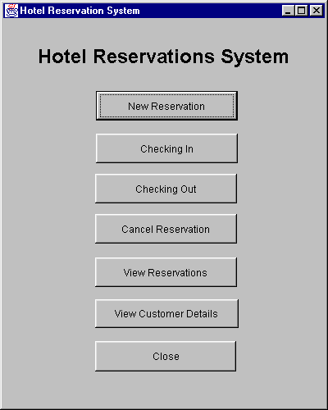

When customer arrives or calls for reservation/s, attending clerk selects the first option “ New Reservation”. Upon which clerks gets the following screen.

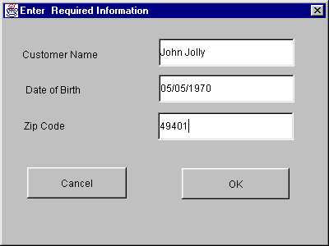

Clerk requests the customer to provide his details ( here name, date of birth and zip codes are used because usually hotels do not keep customer personnel IDs.) and enters the values. If customer exists in the DB, the following screen is shown with values, if customer does not exist on DB, blank values are presented.

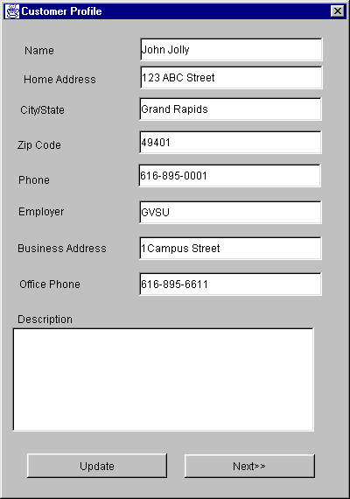

Clerk then views customer details and request the customer if changes are required. In case of any change, Clerk updates the profile and click Next.

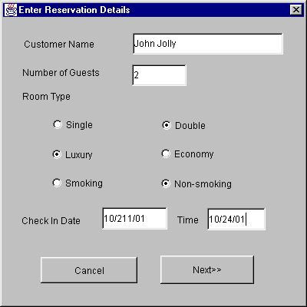

Now clerk asks the customer about Room preferences and Check In date and time.

DB generates a report which shows the available rooms as per customers preferences.
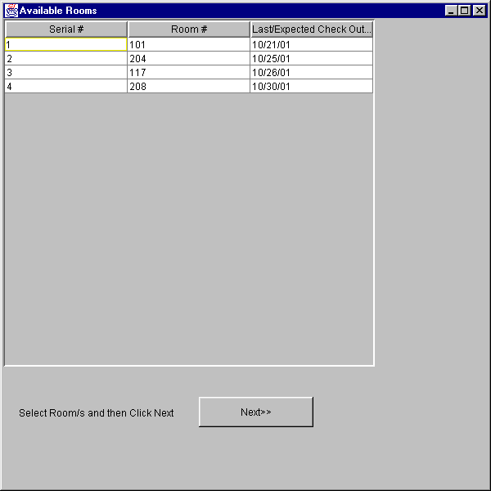
Clerk selects one of the rooms and Click Next.

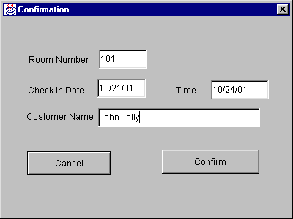
Now clerk asks the customer whether to reserve the provided room for the customer. If customer says yes, Clerk proceeds to confirm the reservations. After reservation has been confirmed, system generates a Reservation Number which depends on the date of check in/Room number and Customer First and Last Name’s Initials.

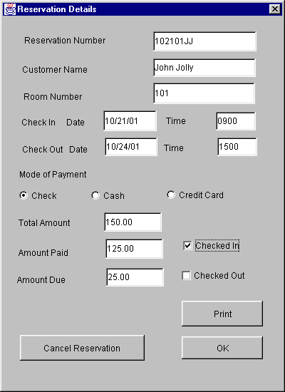

Clerks informs the customer about the amount to be paid and asks the mode of payment. At this stage if customer is unable to pay, Clerk can cancel the reservation. On completion, Clerk generates a hard copy of bills with details.

Clerk can view the details of the reservation of rooms by sorting them with date or reservation statuses.

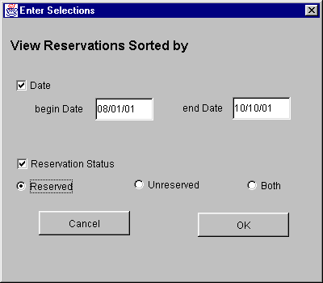

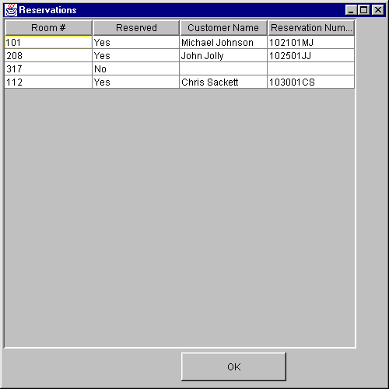
When clerk selects the option, Checking In, Checking Out or Cancel Reservations from the main menu, s/he gets the same screen as on page 16 with blank non-editable values. It prompts to enter the reservation number. Once clerk enters the number and click Ok or presses Enter, values associated with reservation number are presented. If customer has already been checked in, clerk will not be allowed to cancel the reservation.

When clerk select the option View Customer Details from the main menu, same screens are presented as on page 13 except Next option on the second screen is changed to Close.

