Project 3

CS 623

Retirement Planning Calculator

Prepared by
Ahmed M Khan

Screen Outputs:

Main Window

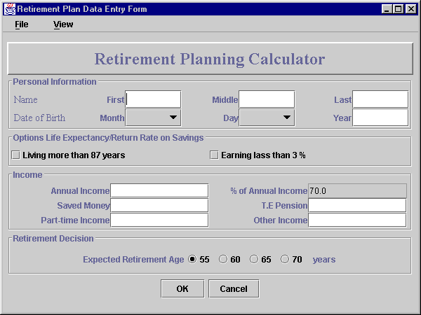

This frame is designed using GridBagLayout having six Panels. One contains heading, four for information handling and one for buttons.

Each Information Panel is designed using GridLayout.

Mandatory fields to enter:
- First Name and Last Name
- Date of Birth
- Annual Income
- Expected Retirement Age

The program if left blank by the user handles rest of the fields. Default value of ‘percentage of annual income’ is 70.0 and ‘expected retirement age’ is 55. Other fields have 0 values.

User can view the reports in two formats:
- Summary Report - displayed using dialog box
- Detailed Report – displayed using new frame

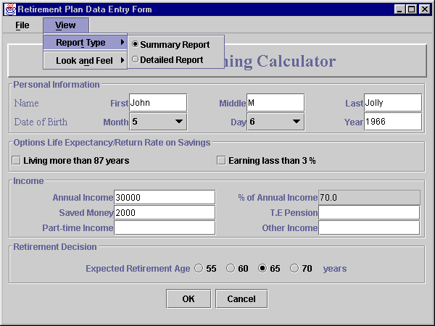

Note:
Social Security for married couples is not included in this program.

Summary report is selected by default. User can toggle between them.

When user supply all required fields and clicks OK button, the following dialog box appears,
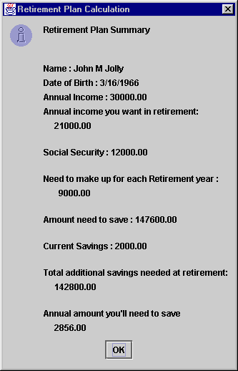

When user anticipate living longer than 87 years or earning less than a 3% real rate of return on his/her savings, s/he can select the options check box and increase the percentage of annual gross income. After selecting one of the options, % Annual Income text field becomes editable.

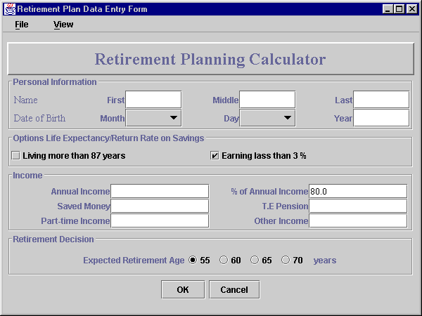

User can then change the percentage value.

When user selects the detail report option and clicks after supplying required fields, following screen appears;

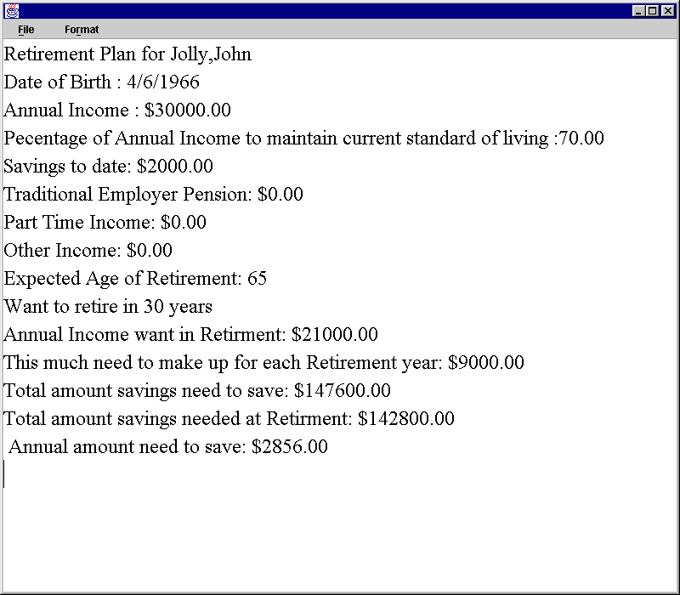

This report is displayed on text area. After displaying it, user/operator can change the contents and add remarks. This way user can print the copy with remarks. Printing facility is not provided in this program.

If user clicks Cancel and
- without viewing any reports, system exits without displaying anything.
- viewing one or more reports and summary report is selected, system displays the last records in a dialog box and exits.
- viewing reports while detail report is selected, system exits without displaying anything.

Error handling
If user clicks OK without entering anything, system displays messages in following fashion.

- If user does not enter name, system displays following error message
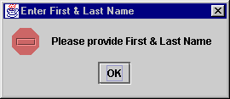

- if user does not enter annual income or retirement age, systems displays

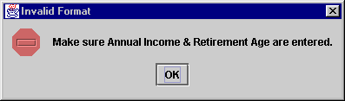

- if user enters birth year later than 1980 or before 1850, or does not enter anything in dates, system displays

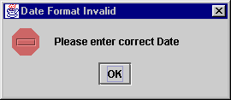

Additional Features

Look and Feel
Some users do not like Metal or Motif frames. They can select windows frame. Or in any order user prefers. These options are supplied under views menu. These options change the entire look and feel of the window.

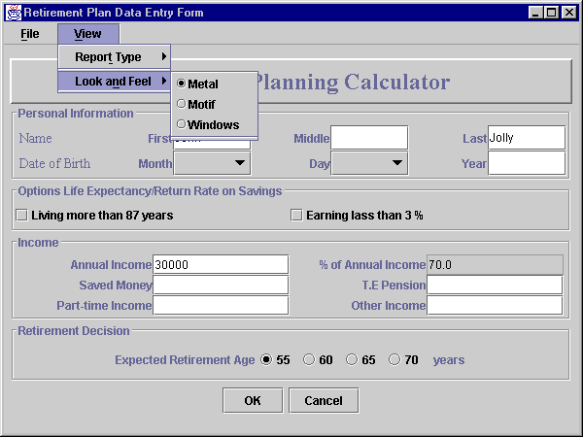

Following look and feel options are provided:
- Metal (default)
- Motif
- Windows

When user selects Motif, screen changes as follows
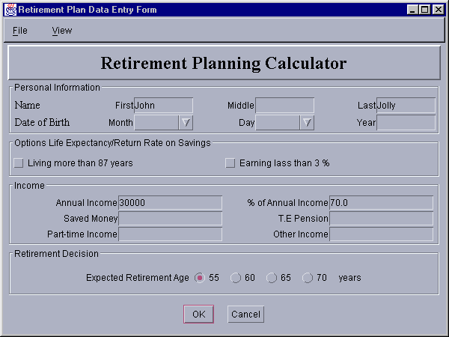
When user selects Windows, screen changes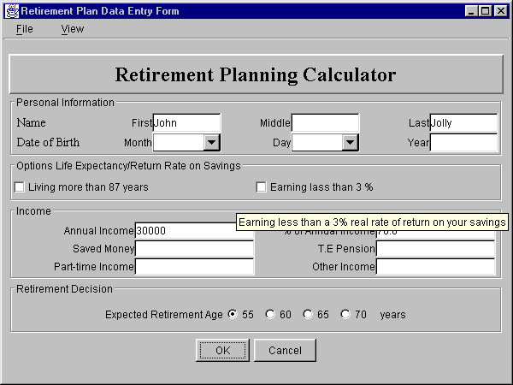

Tool Tip feature is also provided for few labels like in options that needs little more explanation.
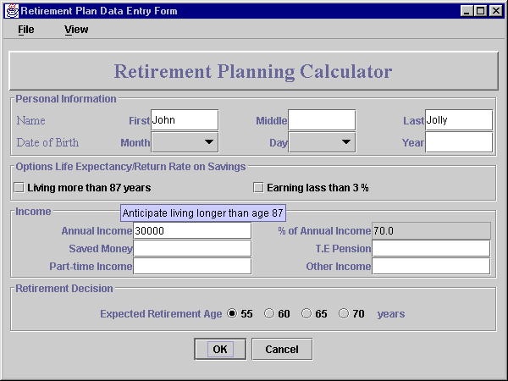

If user needs more explanation about this calculator, s/he can go to the web-site mentioned in About option under File.

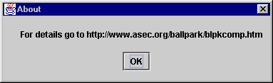

User can also exits from the system, by using Exit option under File.

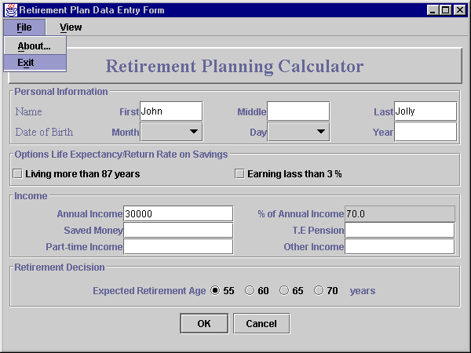

Detail Report additional features
User can change the color and fonts of the output in the text area.
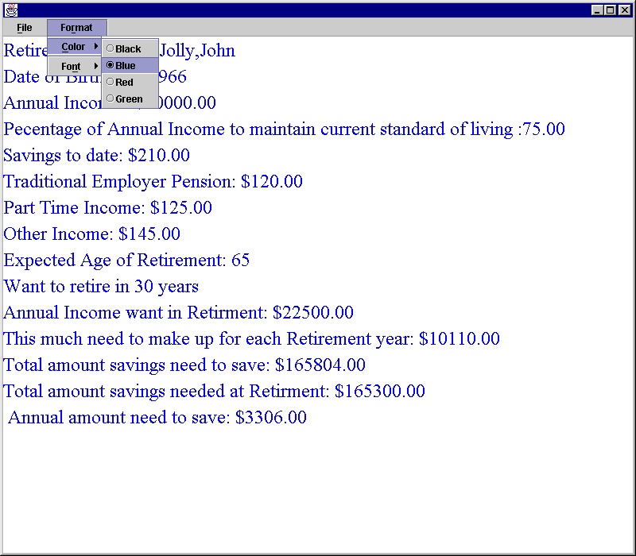

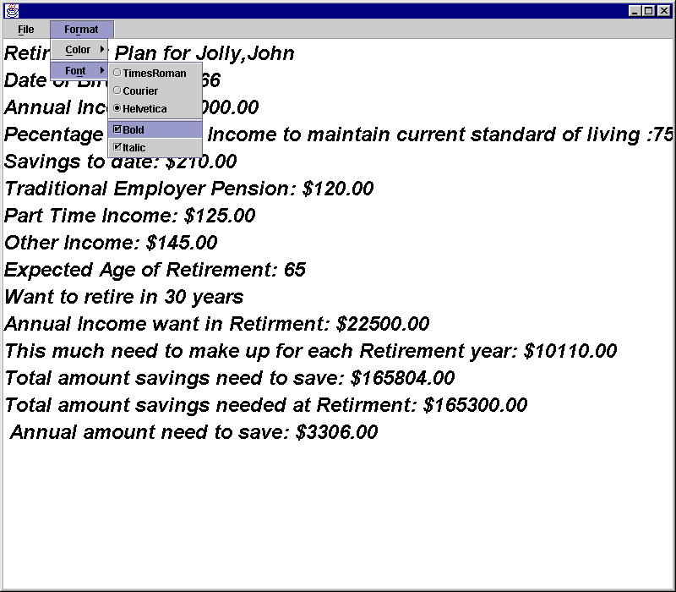
When user exits, program hides the detail report frame.

Program Listings

/*******************************************************************
* Project 3
* CS 623
* Retirement Planning Calculator
* Prepared by
* Ahmed M Khan
*/
// UserWindow.java
//This is the main application window
import java.awt.*;
import java.awt.event.*;
import javax.swing.*;
import javax.swing.border.*;
import java.text.DecimalFormat;
import javax.swing.JOptionPane;
import java.text.DateFormat;
import java.text.SimpleDateFormat;
import java.util.Calendar;
import java.util.Date;
import java.util.GregorianCalendar;

//Declaration of class UserWindow
public class UserWindow extends JFrame {
private RetPlan t;

//Labels
private JLabel nameLabel, firstNLabel, middleNLabel,lastNLabel,
dOfBLabel, monthLabel,dayLabel,yearLabel,
annualIncomeLabel,
userPerLabel, anIcRetLabel, tePensionLabel,
pTimeLabel,otherLabel, savedAmountLabel,
needYearlyLabel,
expRetAgeLabel, retInYearsLabel,
annualAmtNeedLabel,
nameFill, dateFill, rtYearsLabel;
//Text fields
private JTextField firstNField, middleNField,lastNField,
dOfBField, monthField,dayField,yearField,
annualIncomeField,
userPerField, tePensionField,
pTimeField,otherField, savedAmountField,
needYearlyField,
expRetAgeField, retInYearsField;

// Check Box for options
private JCheckBox more87, less3Per;

//Buttons
private JButton okButton, cancelButton;

private JLabel headLabel;

//Panels
private JPanel fieldPanel, labelPanel, buttonPanel, headPanel,
checkPanel,
namePanel, datePanel, optionPanel, incomePanel,
rtAgePanel;
// Combo Box
private JComboBox ageRt, yearsRt, bMonth, bDay;

//Radio Buttons
private JRadioButton age55, age60, age65, age70;
private ButtonGroup ageGroup;

private float userPer;

//Values for combo boxes
private String months[]={ " ", "1","2","3","4","5","6",
"7","8","9","10","11","12"};

private String days[]= { " ", "1", "2", "3", "4",
"5", "6", "7", "8", "9",
"10", "11", "12", "13", "14",
"15", "16", "17", "18", "19",
"20", "21", "22", "23", "24",
"25", "26", "27", "28", "29",
"30", "31" };

private String ageToRt[] = { " ", "55", "60", "65", "70" };

//This String is no longer in use
private String yrsToRt[] = {" ","10","15","20","25","30","35","40"};

//variables
private String fName,mI, lName;
private int bm=0, bd=0, by=0;
private double anInc=0.0, uPer=70.0, svAmt=0.0,
tePsn=0.0, pT=0.0, ot=0.0;
private int expAg=55, rtYrs=0, windowUsed=0;

String output;

//for look and feel and other options
private String lookNames[] = { "Metal", "Motif", "Windows" };
private String view[] = { "Summary Report", "Detailed Report" };
private JRadioButtonMenuItem viewItems[], look[];
private ButtonGroup viewGroup, lookGroup;
private UIManager.LookAndFeelInfo looks[];

//conditional variable for summary reports
private int sumReport=0;

//GridBagLayout
private GridBagLayout gbLayout;
private GridBagConstraints gbConstraints;
private Container container;

public UserWindow()
{
super( "Retirement Plan Data Entry Form" );

container = getContentPane();

gbLayout = new GridBagLayout();
container.setLayout( gbLayout );
gbConstraints = new GridBagConstraints();

//Panel for Heading
headPanel = new JPanel();
headPanel.setBorder( new BevelBorder( BevelBorder.RAISED ));
headPanel.setLayout( new FlowLayout());

headLabel = new JLabel("Retirement Planning Calculator");
headLabel.setFont( new Font( "TimesRoman", Font.BOLD, 24 ) );
headPanel.add(headLabel);

//Panel for Personal Info
namePanel = new JPanel();
namePanel.setBorder( new TitledBorder( new EtchedBorder(), "Personal Information"));
namePanel.setLayout( new GridLayout(2,7));

datePanel = new JPanel();
datePanel.setBorder( new TitledBorder( new EtchedBorder()));

//Panel for options
optionPanel = new JPanel();
optionPanel.setBorder( new TitledBorder( new EtchedBorder(), "Options Life Expectancy/Return Rate on Savings"));
optionPanel.setLayout( new GridLayout(1, 2));

//Panel for Income Info
incomePanel = new JPanel();
incomePanel.setBorder( new TitledBorder( new EtchedBorder(), "Income"));
incomePanel.setLayout( new GridLayout(3,4) );

//Panel for Retirement Age
rtAgePanel = new JPanel();
rtAgePanel.setBorder( new TitledBorder( new EtchedBorder(), "Retirement Decision"));

//Panel for Buttons
buttonPanel = new JPanel();
buttonPanel.setLayout( new FlowLayout());

//Setting up All details
nameFill = new JLabel(" Name ", SwingConstants.LEFT );
nameFill.setFont( new Font( "TimesRoman", Font.PLAIN, 14 ));
namePanel.add( nameFill );

gbConstraints.fill = GridBagConstraints.HORIZONTAL;

firstNLabel = new JLabel( "First", SwingConstants.RIGHT);
namePanel.add(firstNLabel);
firstNField = new JTextField( 10 );
namePanel.add(firstNField);

middleNLabel = new JLabel( "Middle", SwingConstants.RIGHT );
namePanel.add(middleNLabel);
middleNField = new JTextField( 10 );
namePanel.add(middleNField);

lastNLabel = new JLabel( "Last", SwingConstants.RIGHT );
namePanel.add(lastNLabel);
lastNField = new JTextField( 10 );
namePanel.add(lastNField);

dateFill = new JLabel(" Date of Birth ", SwingConstants.LEFT);
dateFill.setFont( new Font( "TimesRoman", Font.PLAIN, 14 ));
namePanel.add(dateFill);

monthLabel = new JLabel( "Month", SwingConstants.RIGHT );
namePanel.add(monthLabel);
bMonth = new JComboBox ( months );
bMonth.setMaximumRowCount(3);
namePanel.add(bMonth);

dayLabel = new JLabel( "Day", SwingConstants.RIGHT );
namePanel.add(dayLabel);
bDay = new JComboBox (days);
bDay.setMaximumRowCount(3);
namePanel.add(bDay);

yearLabel = new JLabel( "Year", SwingConstants.RIGHT );
namePanel.add(yearLabel);
yearField = new JTextField( 10 );
namePanel.add(yearField);

more87 = new JCheckBox( "Living more than 87 years" );
more87.setToolTipText("Anticipate living longer than age 87");
optionPanel.add(more87);

less3Per = new JCheckBox( "Earning lass than 3 %" );
less3Per.setToolTipText("Earning less than a 3% real rate of return on your savings");
optionPanel.add(less3Per);

gbConstraints.fill = GridBagConstraints.BOTH;
annualIncomeLabel = new JLabel( "Annual Income", SwingConstants.RIGHT );
incomePanel.add(annualIncomeLabel);

annualIncomeField = new JTextField( 10 );
incomePanel.add(annualIncomeField);

userPerLabel = new JLabel( "% of Annual Income",SwingConstants.RIGHT );
userPerLabel.setToolTipText(" Default value is 70 ");
incomePanel.add(userPerLabel);
userPerField = new JTextField( 10 );
userPerField.setText("70.0");
userPerField.setEditable(false);
incomePanel.add(userPerField);

savedAmountLabel = new JLabel( "Saved Money", SwingConstants.RIGHT );
incomePanel.add(savedAmountLabel);
savedAmountField = new JTextField( 6 );
incomePanel.add(savedAmountField);

tePensionLabel = new JLabel( "T.E Pension", SwingConstants.RIGHT );
incomePanel.add(tePensionLabel);
tePensionField = new JTextField( 6 );
incomePanel.add(tePensionField);

pTimeLabel = new JLabel( "Part-time Income", SwingConstants.RIGHT );
incomePanel.add(pTimeLabel);
pTimeField = new JTextField( 10 );
incomePanel.add(pTimeField);

otherLabel = new JLabel( "Other Income", SwingConstants.RIGHT );
incomePanel.add(otherLabel);
otherField = new JTextField( 10 );
incomePanel.add(otherField);
gbConstraints.fill = GridBagConstraints.HORIZONTAL;
expRetAgeLabel = new JLabel( "Expected Retirement Age", SwingConstants.LEFT );
rtAgePanel.add(expRetAgeLabel);

age55 = new JRadioButton( "55", true );
rtAgePanel.add( age55 );
age60 = new JRadioButton( "60", false);
rtAgePanel.add( age60 );
age65 = new JRadioButton( "65", false );
rtAgePanel.add( age65 );
age70 = new JRadioButton( "70", false );
rtAgePanel.add( age70 );

RadioButtonHandler handler4 = new RadioButtonHandler();
age55.addItemListener( handler4 );
age60.addItemListener( handler4 );
age65.addItemListener( handler4 );
age70.addItemListener( handler4 );

// create logical relationship between JRadioButtons
ageGroup = new ButtonGroup();
ageGroup.add( age55 );
ageGroup.add( age60 );
ageGroup.add( age65 );
ageGroup.add( age70 );

rtYearsLabel = new JLabel(" years", SwingConstants.LEFT);
rtAgePanel.add(rtYearsLabel);

//handler for options
CheckBoxHandler handler2 = new CheckBoxHandler();
more87.addItemListener( handler2 );
less3Per.addItemListener( handler2 );

//handler for date of birth
ComboBoxHandler handler3 = new ComboBoxHandler();
bMonth.addItemListener( handler3 );
bDay.addItemListener( handler3 );

//handler for buttons
ActionEventHandler handler = new ActionEventHandler();
okButton = new JButton( " OK " );
okButton.addActionListener( handler );
buttonPanel.add(okButton);

cancelButton = new JButton( "Cancel" );
cancelButton.addActionListener( handler );
buttonPanel.add(cancelButton);

addComponent( headPanel , 0, 0, 1, 1 );
addComponent( namePanel , 1, 0, 1, 1 );
addComponent( optionPanel , 2, 0, 1, 1 );
addComponent( incomePanel , 3, 0, 1, 1 );
addComponent( rtAgePanel , 4, 0, 1, 1 );
addComponent( buttonPanel , 5, 0, 1, 1 );

JMenuBar bar = new JMenuBar(); // create menubar
setJMenuBar( bar ); // set the menubar for the JFrame

// create File menu and Exit menu item
JMenu fileMenu = new JMenu( "File" );
fileMenu.setMnemonic( 'F' );
JMenuItem aboutItem = new JMenuItem( "About..." );
aboutItem.setMnemonic( 'A' );
aboutItem.addActionListener(
new ActionListener() {
public void actionPerformed( ActionEvent e )
{
JOptionPane.showMessageDialog( null,
"For details go to http://www.asec.org/ballpark/blpkcomp.htm",
"About", JOptionPane.PLAIN_MESSAGE );
}
}
);
fileMenu.add( aboutItem );

JMenuItem exitItem = new JMenuItem( "Exit" );
exitItem.setMnemonic( 'x' );
exitItem.addActionListener(
new ActionListener() {
public void actionPerformed( ActionEvent e )
{
System.exit( 0 );
}
}
);
fileMenu.add( exitItem );
bar.add( fileMenu ); // add File menu

// create the Format menu, its submenus and menu items
JMenu formatMenu = new JMenu( "View" );
formatMenu.setMnemonic( 'V' );

// create view submenu
JMenu viewMenu = new JMenu( "Report Type" );
viewMenu.setMnemonic( 'T' );
viewItems = new JRadioButtonMenuItem[ view.length ];
viewGroup = new ButtonGroup();
ItemHandler itemHandler = new ItemHandler();

for ( int i = 0; i < view.length; i++ ) {
viewItems[ i ] =
new JRadioButtonMenuItem( view[ i ] );
viewMenu.add( viewItems[ i ] );
viewGroup.add( viewItems[ i ] );
viewItems[ i ].addActionListener( itemHandler );
}

viewItems[ 0 ].setSelected( true );
formatMenu.add( viewMenu );
formatMenu.addSeparator();

// create Font submenu
JMenu lookMenu = new JMenu( "Look and Feel" );
lookMenu.setMnemonic( 'n' );
look = new JRadioButtonMenuItem[ lookNames.length ];
lookGroup = new ButtonGroup();

for ( int i = 0; i < look.length; i++ ) {
look[ i ] =
new JRadioButtonMenuItem( lookNames[ i ] );
lookMenu.add( look[ i ] );
lookGroup.add( look[ i ] );
look[ i ].addActionListener( itemHandler );
}

look[ 0 ].setSelected( true );
lookMenu.addSeparator();

formatMenu.add( lookMenu );
bar.add( formatMenu );

looks = UIManager.getInstalledLookAndFeels();

}

//This method displays Reports
public void displayRetPlan()
{
//Getting System date and evaluating how many years to go for retirement
Calendar calendar = new GregorianCalendar();
Date date = calendar.getTime();
DateFormat format1 = new SimpleDateFormat( "yyyy" );
rtYrs=expAg-(Integer.parseInt(format1.format( date ))-by);

if ( sumReport == 0)
{

t = new RetPlan();
//resetting values
t.resetValues();

try {
t.setRetPlan(fName,mI, lName,
bm, bd, by,
anInc, uPer, svAmt, tePsn, pT, ot,
expAg, rtYrs);
t.calRetPlan();
output = t.toString();

JOptionPane.showMessageDialog( null , output ,
"Retirement Plan Calculation",
JOptionPane.INFORMATION_MESSAGE);

windowUsed=1;

}

catch ( DateFormatException dfe) {
JOptionPane.showMessageDialog(null, " Please enter correct Date",
"Date Format Invalid",
JOptionPane.ERROR_MESSAGE);
}
}

else {
//displaying detail report
Report app = new Report(fName,mI, lName,
bm, bd, by,
anInc, uPer, svAmt, tePsn, pT, ot,
expAg, rtYrs);
windowUsed=1;
}

}

//Resetting values
public void resetFields()
{
anInc=0.0;
uPer=70.0;
svAmt=0.0;
tePsn=0.0;
pT=0.0;
ot=0.0;
}

//main method
public static void main( String args[] )
{
UserWindow window = new UserWindow();

window.setSize( 600, 450 );
window.show();
}

// for OK and Cancel buttons
private class ActionEventHandler implements ActionListener {
public void actionPerformed( ActionEvent e ) throws NeedNameException
{
if ( e.getSource() == cancelButton ){
if (windowUsed==1)
displayRetPlan();
System.exit( 0 );
} // terminate the application

else if ( e.getSource() == okButton ) {

resetFields();

try{
fName= firstNField.getText();
mI= middleNField.getText();
lName= lastNField.getText();

if( firstNField.getText().equals("") ||
lastNField.getText().equals("") )
throw new NeedNameException();

if (! (yearField.getText().equals("")) )
by = Integer.parseInt( yearField.getText());

if ( (annualIncomeField.getText().equals("")))
throw new NumberFormatException();
else
anInc = Double.parseDouble( annualIncomeField.getText());

if (! (userPerField.getText().equals("")))
uPer = Double.parseDouble( userPerField.getText());

if (! (savedAmountField.getText().equals("")))
svAmt = Double.parseDouble( savedAmountField.getText());

if (! (tePensionField.getText().equals("")))
tePsn = Double.parseDouble( tePensionField.getText());

if (! (pTimeField.getText().equals("")))
pT = Double.parseDouble( pTimeField.getText());

if (! (otherField.getText().equals("")))
ot = Double.parseDouble( otherField.getText());

if( expAg==0)
throw new NumberFormatException();

displayRetPlan();

}

catch ( NumberFormatException nfe ) {
JOptionPane.showMessageDialog( null,
"Make sure Annual Income & Retirement Age are entered.",
"Invalid Format",
JOptionPane.ERROR_MESSAGE );
}

catch ( NeedNameException nne){
JOptionPane.showMessageDialog(null,
"Please provide First & Last Name",
"Enter First & Last Name",
JOptionPane.ERROR_MESSAGE);
}

}
}
}

//for check boxes
private class CheckBoxHandler implements ItemListener {

public void itemStateChanged( ItemEvent e )
{
if ( e.getSource() == more87 || e.getSource() == less3Per )
if ( e.getStateChange() == ItemEvent.SELECTED )
userPerField.setEditable(true);
else
userPerField.setEditable(false);

}
}

//for combo boxes
private class ComboBoxHandler implements ItemListener {

public void itemStateChanged( ItemEvent e )
{
if ( e.getSource() == bMonth )
if ( e.getStateChange() == ItemEvent.SELECTED ){
bm= (bMonth.getSelectedIndex());
}

if ( e.getSource() == bDay )
if ( e.getStateChange() == ItemEvent.SELECTED )
bd= (bDay.getSelectedIndex());

if ( e.getSource() == yearsRt )
if ( e.getStateChange() == ItemEvent.SELECTED )
rtYrs= Integer.parseInt(yrsToRt[yearsRt.getSelectedIndex()]);

}
}

//for View options
class ItemHandler implements ActionListener {
public void actionPerformed( ActionEvent e )
{
for ( int i = 0; i < look.length; i++ )
if ( look[ i ].isSelected() ) {
changeTheLookAndFeel( i );
}

for ( int i = 0; i < view.length; i++ )
if ( viewItems[i].isSelected() ) {
sumReport=i;
}

}
}

// this changes the overall look and feel
private void changeTheLookAndFeel( int value )
{
try {
UIManager.setLookAndFeel(
looks[ value ].getClassName() );
SwingUtilities.updateComponentTreeUI( this );
}
catch ( Exception e ) {
e.printStackTrace();
}
}

// addComponent method putting compenents within Gridbaglayout
private void addComponent( Component cP,
int row, int column, int width, int height )
{
// set gridx and gridy
gbConstraints.gridx = column;
gbConstraints.gridy = row;

// set gridwidth and gridheight
gbConstraints.gridwidth = width;
gbConstraints.gridheight = height;

// set constraints
gbLayout.setConstraints( cP, gbConstraints );
container.add( cP ); // add component
}

//handler for radio buttons to select age
private class RadioButtonHandler implements ItemListener {
public void itemStateChanged( ItemEvent e )
{
if ( e.getSource() == age55 )
expAg=55;
else if ( e.getSource() == age60 )
expAg=60;
else if ( e.getSource() == age65 )
expAg=65;
else if ( e.getSource() == age70 )
expAg=70;

}
}

}

/*******************************************************************
* Project 3
* CS 623
* Retirement Planning Calculator
* Prepared by
* Ahmed M Khan
*/
// RetPlan.java
// RetPlan class definition
import java.text.DecimalFormat; // used for number formatting
import java.awt.*;
import java.awt.event.*;
import javax.swing.*;
import Date;
import javax.swing.JOptionPane;

// This class maintains the RetPlan
public class RetPlan extends Object {

private String firstName, mInitial, lastName;
private Date birthDate;
private double annualIncome=0.0;
private double userPercent=0.0;
private double annualIncomeRtr=0.0;

private double ssIncome=0.0, tePension=0.0, pTime=0.0, other=0.0;
private double needRtYear=0.0;

private int expRtAge=0, rtInYears=0;
private double factor1=0.0, factor2=0.0, factor3=0.0, factor4=0.0;
private double savedAmount=0.0;

private double amountSaveResult;

// Set a new RetPlan

public void setRetPlan( String fName, String mI, String lName,
int bm, int bd, int by,
double anInc, double uPer,
double svAmt,
double tepsn, double pT,
double ot,
int expAg, int rtYrs )
{
firstName=fName;
mInitial=mI;
lastName=lName;
birthDate = new Date( bm, bd, by);
annualIncome=anInc;
userPercent=uPer;
savedAmount=svAmt;
tePension= tepsn;
pTime= pT;
other=ot;
expRtAge= expAg;
rtInYears=rtYrs;

}

//Resetting values
public void resetValues( )
{
annualIncome=0.0;
userPercent=0.0;
savedAmount=0.0;
tePension= 0.0;
pTime= 0.0;
other=0.0;
expRtAge= 0;
rtInYears= 0;

}
//Calculate Plan
public void calRetPlan ()
{
annualIncomeRtr = annualIncome*userPercent/100;

if( annualIncome < 25000)
ssIncome=8000;
else if( annualIncome >= 25000 && annualIncome <=40000)
ssIncome=12000;
else if( annualIncome >40000)
ssIncome=14500;

needRtYear = annualIncomeRtr-ssIncome-tePension-pTime-other;

if (expRtAge == 55){
factor1=21.0;
factor2=8.8;
}
else if ( expRtAge == 60){
factor1=18.9;
factor2=4.7;
}
else if ( expRtAge == 65)
factor1=16.4;
else if ( expRtAge == 70)
factor1=13.6;

if ( rtInYears>=10 && rtInYears<15){
factor3=1.3;
factor4=0.085;
}
else if ( rtInYears>=15 && rtInYears<20){
factor3=1.6;
factor4=0.052;
}
else if ( rtInYears>=20 && rtInYears<25){
factor3=1.8;
factor4=0.036;
}
else if ( rtInYears>=25 && rtInYears<30){
factor3=2.1;
factor4=0.027;
}
else if ( rtInYears>=30 && rtInYears<35){
factor3=2.4;
factor4=0.02;
}
else if ( rtInYears>=35 && rtInYears<40){
factor3=2.8;
factor4=0.016;
}
else if ( rtInYears>=40){
factor3=3.3;
factor4=0.013;
}

amountSaveResult =
(((needRtYear*factor1+ssIncome*factor2)-savedAmount*factor3) * factor4) ;

}

// Convert to String in summary format
public String toString()
{
DecimalFormat precision2 = new DecimalFormat( "0.00" );

return "Retirement Plan Summary\n\n\n"+
"Name : " + firstName +" " + mInitial +" "+ lastName + "\n"+
"Date of Birth : " + birthDate.toString()+ "\n" +
"Annual Income : " + precision2.format(annualIncome)+"\n"+
"Annual income you want in retirement:\n " +
precision2.format(annualIncomeRtr) +"\n\n"+
"Social Security : " + precision2.format(ssIncome)+"\n\n"+
"Need to make up for each Retirement year :\n "+
precision2.format(needRtYear)+"\n\n"+
"Amount need to save : "+ precision2.format(needRtYear*factor1)+
"\n\n"+
"Current Savings : " + precision2.format(savedAmount) +"\n\n"+
"Total additional savings needed at retirement:" + "\n " +
precision2.format(amountSaveResult/factor4) + "\n\n" +
"Annual amount you'll need to save"+"\n "+
precision2.format( amountSaveResult);
}

//getting values for detail report
public String getFName()
{
return firstName;
}

public String getMName()
{
return mInitial;
}

public String getLName()
{
return lastName;
}

public String getDateBirth()
{
return "Date of Birth : " + birthDate.toString();
}

public String getAnIc()
{
DecimalFormat precision2 = new DecimalFormat( "0.00" );
return "Annual Income : $" + precision2.format(annualIncome);
}

public String getUserPer()
{
DecimalFormat precision2 = new DecimalFormat( "0.00" );
return "Pecentage of Annual Income to maintain current standard of living :" +
precision2.format(userPercent);
}

public String getSvAmt()
{
DecimalFormat precision2 = new DecimalFormat( "0.00" );
return "Savings to date: $" + precision2.format(savedAmount);
}

public String getTePsn()
{
DecimalFormat precision2 = new DecimalFormat( "0.00" );
return "Traditional Employer Pension: $"+ precision2.format(tePension);
}

public String getPt()
{
DecimalFormat precision2 = new DecimalFormat( "0.00" );
return "Part Time Income: $"+ precision2.format(pTime);
}

public String getOt()
{
DecimalFormat precision2 = new DecimalFormat( "0.00" );
return "Other Income: $"+ precision2.format(other);
}

public String getExpRtAg()
{
DecimalFormat precision2 = new DecimalFormat( "0.00" );
return "Expected Age of Retirement: "+ expRtAge;
}

public String getrtInYrs()
{
DecimalFormat precision2 = new DecimalFormat( "0.00" );
return "Want to retire in " + rtInYears + " years";
}

public String getAnIncRt()
{
DecimalFormat precision2 = new DecimalFormat( "0.00" );
return "Annual Income want in Retirment: $"+ precision2.format(annualIncomeRtr);
}

public String getNdRtYr()
{
DecimalFormat precision2 = new DecimalFormat( "0.00" );
return "This much need to make up for each Retirement year: $"+
precision2.format(needRtYear);
}

public String ndToSave()
{
DecimalFormat precision2 = new DecimalFormat( "0.00" );
return "Total amount savings need to save: $"+
precision2.format(needRtYear*factor1);
}

public String gettotSaving()
{
DecimalFormat precision2 = new DecimalFormat( "0.00" );
return "Total amount savings needed at Retirment: $"+
precision2.format(amountSaveResult/factor4);
}

public String getAnnualSaving()
{
DecimalFormat precision2 = new DecimalFormat( "0.00" );
return " Annual amount need to save: $" +
precision2.format(amountSaveResult);
}

}

/*******************************************************************
* Project 3
* CS 623
* Retirement Planning Calculator
* Prepared by
* Ahmed M Khan
*/
// Report.java
//This program displays report in text area
import javax.swing.*;
import java.awt.event.*;
import java.awt.*;

public class Report extends JFrame {
private RetPlan temp;
private Color colorValues[] =
{ Color.black, Color.blue, Color.red, Color.green };
private JRadioButtonMenuItem colorItems[], fonts[];
private JCheckBoxMenuItem styleItems[];
private JLabel display;
private ButtonGroup fontGroup, colorGroup;
private int style;

private JTextArea report;
private JButton okButton;
private String output;

private String firstName, mInitial, lastName;
private Date birthDate;
private int bmn=0, bdy=0, byr=0;
private double annualIncome=0.0;
private double userPercent=0.0;
private double annualIncomeRtr=0.0;

private double ssIncome=0.0, tePension=0.0, pTime=0.0, other=0.0;
private double needRtYear=0.0;

private int expRtAge=0, rtInYears=0;
private double factor1=0.0, factor2=0.0, factor3=0.0, factor4=0.0;
private double savedAmount=0.0;

private double amountSaveResult;

public Report(String fName, String mI, String lName,
int bm, int bd, int by,
double anInc, double uPer,
double svAmt,
double tepsn, double pT,
double ot,
int expAg, int rtYrs)
{

firstName=fName;
mInitial=mI;
lastName=lName;
bmn=bm;
bdy=bd;
byr=by;
annualIncome=anInc;
userPercent=uPer;
savedAmount=svAmt;
tePension= tepsn;
pTime= pT;
other=ot;
expRtAge= expAg;
rtInYears=rtYrs;

//Calls and setup RetPlan
temp = new RetPlan();
temp.resetValues();
temp.setRetPlan(firstName,mInitial, lastName,
bmn, bdy, byr,
annualIncome, userPercent, savedAmount, tePension,
pTime, other,
expRtAge, rtInYears);
temp.calRetPlan();

output = "Retirement Plan for "+ temp.getLName()+","+temp.getFName()+"\n"+
temp.getDateBirth()+"\n"+
temp.getAnIc()+"\n"+
temp.getUserPer()+"\n"+
temp.getSvAmt()+"\n"+
temp.getTePsn()+"\n"+
temp.getPt()+"\n"+
temp.getOt()+"\n"+
temp.getExpRtAg()+"\n"+
temp.getrtInYrs()+"\n"+
temp.getAnIncRt()+"\n"+
temp.getNdRtYr()+"\n"+
temp.ndToSave()+"\n"+
temp.gettotSaving()+"\n"+
temp.getAnnualSaving()+"\n";

report = new JTextArea();
report.setText( output );

JMenuBar bar = new JMenuBar(); // create Menubar
setJMenuBar( bar ); // set the Menubar for the JFrame

// create File Menu and Exit Menu item
JMenu fileReport = new JMenu( "File" );
fileReport.setMnemonic( 'F' );
JMenuItem aboutItem = new JMenuItem( "About..." );
aboutItem.setMnemonic( 'A' );
aboutItem.addActionListener(
new ActionListener() {
public void actionPerformed( ActionEvent e )
{
JOptionPane.showMessageDialog( Report.this,
"This is an example\nof using Reports",
"About", JOptionPane.PLAIN_MESSAGE );
}
}
);
fileReport.add( aboutItem );

JMenuItem exitItem = new JMenuItem( "Exit" );
exitItem.setMnemonic( 'x' );
exitItem.addActionListener(
new ActionListener() {
public void actionPerformed( ActionEvent e )
{
hide();
}
}
);
fileReport.add( exitItem );
bar.add( fileReport ); // add File Menu

// create the Format Menu, its subMenu and Menu items
JMenu formatReport = new JMenu( "Format" );
formatReport.setMnemonic( 'r' );

// create Color subMenu
String colors[] =
{ "Black", "Blue", "Red", "Green" };
JMenu colorReport = new JMenu( "Color" );
colorReport.setMnemonic( 'C' );
colorItems = new JRadioButtonMenuItem[ colors.length ];
colorGroup = new ButtonGroup();
ItemHandler itemHandler = new ItemHandler();

for ( int i = 0; i < colors.length; i++ ) {
colorItems[ i ] =
new JRadioButtonMenuItem( colors[ i ] );
colorReport.add( colorItems[ i ] );
colorGroup.add( colorItems[ i ] );
colorItems[ i ].addActionListener( itemHandler );
}

colorItems[ 0 ].setSelected( true );
formatReport.add( colorReport );
formatReport.addSeparator();

// create Font subMenu
String fontNames[] =
{ "TimesRoman", "Courier", "Helvetica" };
JMenu fontReport = new JMenu( "Font" );
fontReport.setMnemonic( 'n' );
fonts = new JRadioButtonMenuItem[ fontNames.length ];
fontGroup = new ButtonGroup();

for ( int i = 0; i < fonts.length; i++ ) {
fonts[ i ] =
new JRadioButtonMenuItem( fontNames[ i ] );
fontReport.add( fonts[ i ] );
fontGroup.add( fonts[ i ] );
fonts[ i ].addActionListener( itemHandler );
}

fonts[ 0 ].setSelected( true );
fontReport.addSeparator();

String styleNames[] = { "Bold", "Italic" };
styleItems = new JCheckBoxMenuItem[ styleNames.length ];
StyleHandler styleHandler = new StyleHandler();

for ( int i = 0; i < styleNames.length; i++ ) {
styleItems[ i ] =
new JCheckBoxMenuItem( styleNames[ i ] );
fontReport.add( styleItems[ i ] );
styleItems[ i ].addItemListener( styleHandler );
}

formatReport.add( fontReport );
bar.add( formatReport ); // add Format Menu

display = new JLabel(
"Sample Text", SwingConstants.CENTER );
report.setForeground( colorValues[ 0 ] );
report.setFont(
new Font( "TimesRoman", Font.PLAIN, 24 ) );

getContentPane().setBackground( Color.cyan );
getContentPane().add( report );

setSize( 800, 700 );
show();
}

//handler for color and fonts
class ItemHandler implements ActionListener {
public void actionPerformed( ActionEvent e )
{
for ( int i = 0; i < colorItems.length; i++ )
if ( colorItems[ i ].isSelected() ) {
report.setForeground( colorValues[ i ] );
break;
}

for ( int i = 0; i < fonts.length; i++ )
if ( e.getSource() == fonts[ i ] ) {
report.setFont( new Font(
fonts[ i ].getText(), style, 24 ) );
break;
}

repaint();
}
}

//listener for style
class StyleHandler implements ItemListener {
public void itemStateChanged( ItemEvent e )
{
style = 0;

if ( styleItems[ 0 ].isSelected() )
style += Font.BOLD;

if ( styleItems[ 1 ].isSelected() )
style += Font.ITALIC;

report.setFont( new Font(
report.getFont().getName(), style, 24 ) );

repaint();
}
}
}

/*******************************************************************
* Project 3
* CS 623
* Retirement Planning Calculator
* Prepared by
* Ahmed M Khan
*/
//Date.java
//Declaration of the Date class.

public class Date extends Object {
private int month; // 1-12
private int day; // 1-31 based on month
private int year; // any year

// Constructor: Confirm proper value for month;
// call method checkDay to confirm proper
// value for day.
public Date( int mn, int dy, int yr ) throws DateFormatException {

if ( mn > 0 && mn <= 12 ) // validate the month
month = mn;
else
month=0;

if (yr >1850 && yr < 1980)
year = yr; // age factor could be also checked
else
year =0;

day = checkDay( dy ); // validate the day

if ( month==0 || day==0 || year==0)
throw new DateFormatException();

System.out.println(
"Date object constructor for date " + toString() );
}

// Utility method to confirm proper day value
// based on month and year.
private int checkDay( int testDay )
{
int daysPerMonth[] = { 0, 31, 28, 31, 30,
31, 30, 31, 31, 30,
31, 30, 31 };

if ( testDay > 0 && testDay <= daysPerMonth[ month ] )
return testDay;

if ( month == 2 && // February: Check for leap year
testDay == 29 &&
( year % 400 == 0 ||
( year % 4 == 0 && year % 100 != 0 ) ) )
return testDay;

else
return 0;

}

// Create a String of the form month/day/year
public String toString()
{ return month + "/" + day + "/" + year; }
}

/*******************************************************************
* Project 3
* CS 623
* Retirement Planning Calculator
* Prepared by
* Ahmed M Khan
*/
//DateFormatException.java
public class DateFormatException
extends ArithmeticException {
public DateFormatException()
{
super( "Please enter correct Date" );
}

public DateFormatException( String message )
{
super( message );
}
}

/*******************************************************************
* Project 3
* CS 623
* Retirement Planning Calculator
* Prepared by
* Ahmed M Khan
*/
//Date.java
//Declaration of the Date class.

public class Date extends Object {
private int month; // 1-12
private int day; // 1-31 based on month
private int year; // any year

// Constructor: Confirm proper value for month;
// call method checkDay to confirm proper
// value for day.
public Date( int mn, int dy, int yr ) throws DateFormatException {

if ( mn > 0 && mn <= 12 ) // validate the month
month = mn;
else
month=0;

if (yr >1850 && yr < 1980)
year = yr; // age factor could be also checked
else
year =0;

day = checkDay( dy ); // validate the day

if ( month==0 || day==0 || year==0)
throw new DateFormatException();

System.out.println(
"Date object constructor for date " + toString() );
}

// Utility method to confirm proper day value
// based on month and year.
private int checkDay( int testDay )
{
int daysPerMonth[] = { 0, 31, 28, 31, 30,
31, 30, 31, 31, 30,
31, 30, 31 };

if ( testDay > 0 && testDay <= daysPerMonth[ month ] )
return testDay;

if ( month == 2 && // February: Check for leap year
testDay == 29 &&
( year % 400 == 0 ||
( year % 4 == 0 && year % 100 != 0 ) ) )
return testDay;

else
return 0;

}

// Create a String of the form month/day/year
public String toString()
{ return month + "/" + day + "/" + year; }
}

Screen Output of Earlier Version using only GridLayout:
Main Window:

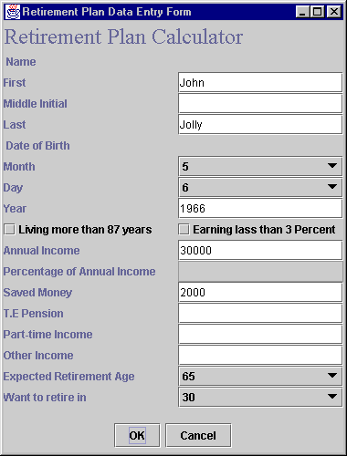

This window is not much user friendly. Its design is flat using BorderLayout directions. It provides the same background features as the newer version except;
user needs to provide the Date of birth, Retirement age and period before retiring.

This feature is automatically handled by the newer version that uses system date to calculate pre-retirement period.

When user enters the required fields, systems displays the report in a dialog box.

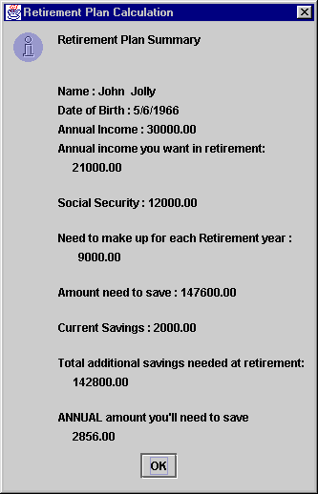

Program Listing of UserWindow.java ( older version)

// UserWindow.java
import java.awt.*;
import java.awt.event.*;
import javax.swing.*;
import java.text.DecimalFormat;
import javax.swing.JOptionPane;

public class UserWindow extends JFrame {
private RetPlan t;
private JLabel nameLabel, firstNLabel, middleNLabel,lastNLabel,
dOfBLabel, monthLabel,dayLabel,yearLabel,
annualIncomeLabel,
userPerLabel, anIcRetLabel, tePensionLabel,
pTimeLabel,otherLabel, savedAmountLabel,
needYearlyLabel,
expRetAgeLabel, retInYearsLabel,
annualAmtNeedLabel,
nameFill, nameNull, dateFill, dateNull;

private JTextField firstNField, middleNField,lastNField,
dOfBField, monthField,dayField,yearField,
annualIncomeField,
userPerField, tePensionField,
pTimeField,otherField, savedAmountField,
needYearlyField,
expRetAgeField, retInYearsField;

private JCheckBox more87, less3Per;

private JButton okButton, cancelButton;

private JLabel tL;

private JPanel fieldPanel, labelPanel, buttonPanel, headPanel,
checkPanel;

private JComboBox ageRt, yearsRt, bMonth, bDay;

private float userPer;

private String months[]={ " ", "1","2","3","4","5","6",
"7","8","9","10","11","12"};

private String days[]= { " ", "1", "2", "3", "4",
"5", "6", "7", "8", "9",
"10", "11", "12", "13", "14",
"15", "16", "17", "18", "19",
"20", "21", "22", "23", "24",
"25", "26", "27", "28", "29",
"30", "31" };

private String ageToRt[] = { " ", "55", "60", "65", "70" };
private String yrsToRt[] = {" ","10","15","20","25","30","35","40"};

private String fName,mI, lName;
private int bm=0, bd=0, by=0;
private double anInc=0.0, uPer=70.0, svAmt=0.0,
tePsn=0.0, pT=0.0, ot=0.0;
private int expAg=0, rtYrs=0;

String output;

public UserWindow()
{
super( "Retirement Plan Data Entry Form" );

Container c = getContentPane();

ActionEventHandler handler = new ActionEventHandler();

fieldPanel = new JPanel();
fieldPanel.setLayout( new GridLayout ( 17, 1 ));

labelPanel = new JPanel();
labelPanel.setLayout( new GridLayout ( 17, 1));

buttonPanel = new JPanel();
buttonPanel.setLayout( new FlowLayout( ));

headPanel = new JPanel();
headPanel.setLayout( new GridLayout (1, 1));

checkPanel = new JPanel();
checkPanel.setLayout( new FlowLayout( ));

tL = new JLabel( "Retirement Plan Calculator");
tL.setFont( new Font( "TimesRoman", Font.PLAIN, 24 ) );
headPanel.add( tL );

nameFill = new JLabel(" Name ");
labelPanel.add( nameFill);
nameNull = new JLabel( " " );
fieldPanel.add(nameNull);

firstNLabel = new JLabel( "First");
firstNField = new JTextField( 10 );
labelPanel.add( firstNLabel );
fieldPanel.add( firstNField );

middleNLabel = new JLabel( "Middle Initial" );
middleNField = new JTextField( 10 );
labelPanel.add( middleNLabel );
fieldPanel.add( middleNField );

lastNLabel = new JLabel( "Last" );
lastNField = new JTextField( 10 );
labelPanel.add( lastNLabel );
fieldPanel.add( lastNField );

dateFill = new JLabel(" Date of Birth ");
labelPanel.add( dateFill);
dateNull = new JLabel( " " );
fieldPanel.add(dateNull);

monthLabel = new JLabel( "Month" );
bMonth = new JComboBox ( months );
bMonth.setMaximumRowCount(3);
labelPanel.add( monthLabel );
fieldPanel.add( bMonth );

dayLabel = new JLabel( "Day" );
bDay = new JComboBox (days);
bDay.setMaximumRowCount(3);
labelPanel.add( dayLabel );
fieldPanel.add( bDay );

yearLabel = new JLabel( "Year" );
yearField = new JTextField( 10 );
labelPanel.add( yearLabel );
fieldPanel.add( yearField );

more87 = new JCheckBox( "Living more than 87 years" );
labelPanel.add( more87 );

less3Per = new JCheckBox( "Earning lass than 3 Percent" );
fieldPanel.add( less3Per );

annualIncomeLabel = new JLabel( "Annual Income" );
annualIncomeField = new JTextField( 10 );
annualIncomeField.addActionListener( handler );
labelPanel.add( annualIncomeLabel );
fieldPanel.add( annualIncomeField );

userPerLabel = new JLabel( "Percentage of Annual Income" );
userPerField = new JTextField( 10 );
userPerField.setEditable(false);
userPerField.addActionListener( handler );
labelPanel.add( userPerLabel );
fieldPanel.add( userPerField );

savedAmountLabel = new JLabel( "Saved Money" );
savedAmountField = new JTextField( 10 );
labelPanel.add( savedAmountLabel );
fieldPanel.add( savedAmountField );

tePensionLabel = new JLabel( "T.E Pension" );
tePensionField = new JTextField( 10 );
labelPanel.add( tePensionLabel );
fieldPanel.add( tePensionField );

pTimeLabel = new JLabel( "Part-time Income" );
pTimeField = new JTextField( 10 );
labelPanel.add( pTimeLabel );
fieldPanel.add( pTimeField );

otherLabel = new JLabel( "Other Income" );
otherField = new JTextField( 10 );
labelPanel.add( otherLabel );
fieldPanel.add( otherField );

expRetAgeLabel = new JLabel( "Expected Retirement Age" );
ageRt = new JComboBox( ageToRt );
ageRt.setMaximumRowCount(3);
labelPanel.add( expRetAgeLabel );
fieldPanel.add( ageRt );

retInYearsLabel = new JLabel( "Want to retire in" );
yearsRt = new JComboBox (yrsToRt);
yearsRt.setMaximumRowCount(3);
labelPanel.add( retInYearsLabel );
fieldPanel.add( yearsRt );

CheckBoxHandler handler2 = new CheckBoxHandler();
more87.addItemListener( handler2 );
less3Per.addItemListener( handler2 );

ComboBoxHandler handler3 = new ComboBoxHandler();
ageRt.addItemListener( handler3 );
yearsRt.addItemListener( handler3 );
bMonth.addItemListener( handler3 );
bDay.addItemListener( handler3 );

okButton = new JButton( "OK" );
okButton.addActionListener( handler );
buttonPanel.add( okButton );

cancelButton = new JButton( "Cancel" );
cancelButton.addActionListener( handler );
buttonPanel.add( cancelButton );

c.add(buttonPanel, BorderLayout.SOUTH);
c.add(labelPanel, BorderLayout.WEST);
c.add(headPanel, BorderLayout.NORTH);
c.add(fieldPanel, BorderLayout.EAST);

}

public void displayRetPlan()
{
t = new RetPlan();

t.resetValues();

t.setRetPlan(fName,mI, lName,
bm, bd, by,
anInc, uPer, svAmt, tePsn, pT, ot,
expAg, rtYrs);
t.calRetPlan();
output = t.toString();

JOptionPane.showMessageDialog( null , output ,
"Retirement Plan Calculation",
JOptionPane.INFORMATION_MESSAGE);

}

public void resetFields()
{
anInc=0.0;
uPer=70.0;
svAmt=0.0;
tePsn=0.0;
pT=0.0;
ot=0.0;
}

public static void main( String args[] )
{
UserWindow window = new UserWindow();

window.setSize( 380, 500 );
window.show();
}

// INNER CLASS DEFINITION FOR EVENT HANDLING
private class ActionEventHandler implements ActionListener {
public void actionPerformed( ActionEvent e ) throws NeedNameException
{
if ( e.getSource() == cancelButton ){
displayRetPlan();
System.exit( 0 );
} // terminate the application

else if ( e.getSource() == okButton ) {

resetFields();

try{
fName= firstNField.getText();
mI= middleNField.getText();
lName= lastNField.getText();

if( firstNField.getText().equals("") ||
lastNField.getText().equals("") )
throw new NeedNameException();

if (! (yearField.getText().equals("")) )
by = Integer.parseInt( yearField.getText());

if ( (annualIncomeField.getText().equals("")))
throw new NumberFormatException();
else
anInc = Double.parseDouble( annualIncomeField.getText());

if (! (userPerField.getText().equals("")))
uPer = Double.parseDouble( userPerField.getText());

if (! (savedAmountField.getText().equals("")))
svAmt = Double.parseDouble( savedAmountField.getText());

if (! (tePensionField.getText().equals("")))
tePsn = Double.parseDouble( tePensionField.getText());

if (! (pTimeField.getText().equals("")))
pT = Double.parseDouble( pTimeField.getText());

if (! (otherField.getText().equals("")))
ot = Double.parseDouble( otherField.getText());

if( rtYrs==0 || expAg==0)
throw new NumberFormatException();

displayRetPlan();

}

catch ( NumberFormatException nfe ) {
JOptionPane.showMessageDialog( null,
"Data still invalid. Make sure Annual Income & Retirement Age are entered.",
"Invalid Format",
JOptionPane.ERROR_MESSAGE );
}

catch ( NeedNameException nne){
JOptionPane.showMessageDialog(null, nne.toString(),
"Please provide First & Last Name",
JOptionPane.ERROR_MESSAGE);
}

}
}
}

private class CheckBoxHandler implements ItemListener {

public void itemStateChanged( ItemEvent e )
{
if ( e.getSource() == more87 || e.getSource() == less3Per )
if ( e.getStateChange() == ItemEvent.SELECTED )
userPerField.setEditable(true);
else
userPerField.setEditable(false);

}
}

private class ComboBoxHandler implements ItemListener {

public void itemStateChanged( ItemEvent e )
{
if ( e.getSource() == bMonth )
if ( e.getStateChange() == ItemEvent.SELECTED ){
bm= (bMonth.getSelectedIndex());
}

if ( e.getSource() == bDay )
if ( e.getStateChange() == ItemEvent.SELECTED )
bd= (bDay.getSelectedIndex());

if ( e.getSource() == ageRt )
if ( e.getStateChange() == ItemEvent.SELECTED )
expAg= Integer.parseInt(ageToRt[ageRt.getSelectedIndex()]);

if ( e.getSource() == yearsRt )
if ( e.getStateChange() == ItemEvent.SELECTED )
rtYrs= Integer.parseInt(yrsToRt[yearsRt.getSelectedIndex()]);

}
}

}

References

Java How to Program
3rd edition

Deitel & Deitel
Prentice Hall 1999

Up to Speed with Swing
2nd edition
Steven Gutz
Manning 2000

