Screen Outputs

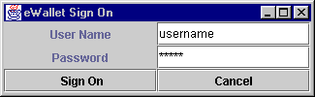

This is the first frame appears when user starts the ewallet application. Since a wallet is personal property of any person, so this wallet must be secure. So that other people having access to the user’s computer can not open this application which could have sensitive monetary information.

When user signs on, the following screen appears.

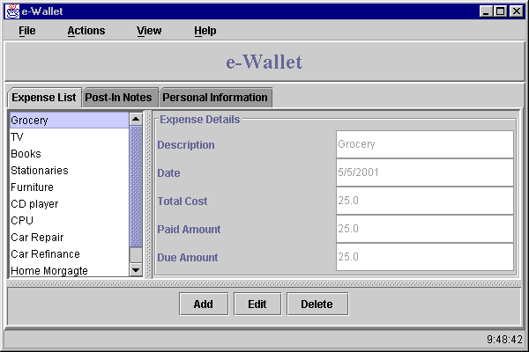
This screen has front three tabs for major required activities.
- Expense List
- Post-In Notes
- Personal Information

Calculator can be used by clicking Calculator under view menu and the time is at the bottom right of the screen.

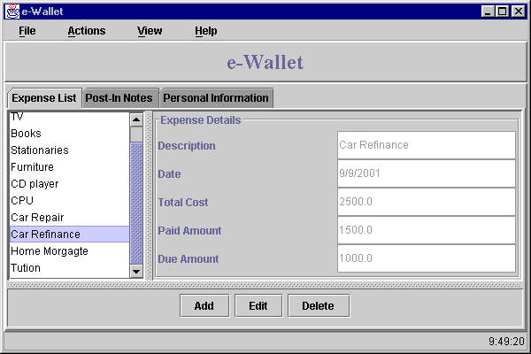

User can click any record in the list and view the details of that particular record in the other pane.

User can click on any tab and change and view the category.

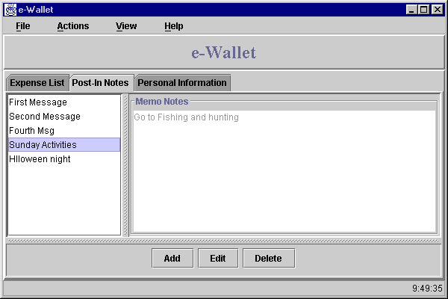

Above Post-In notes are displayed. Below Personal Information is displayed.

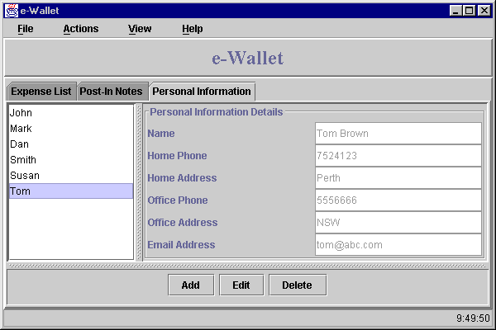
Views Options
User can even select these options from the view menu.

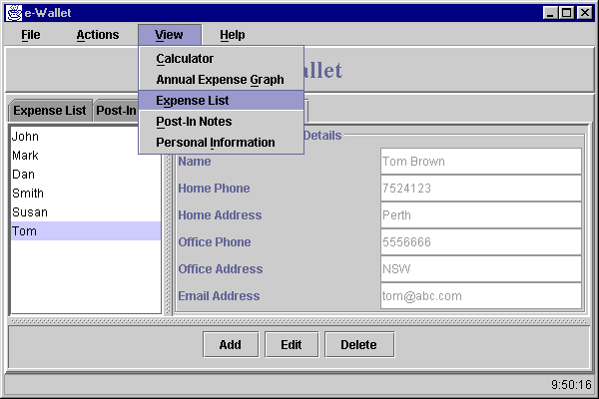

From view menu user can select Calculator to do simple calculations.

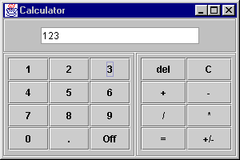

User can also select the graph of the annual expenditure.

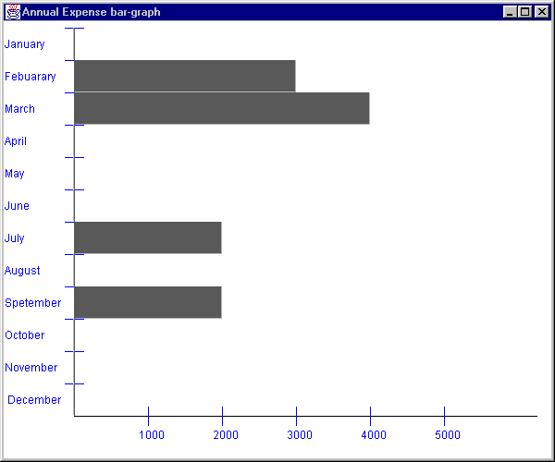

This graph shows the expenditure of 12 months in round figures. It can not exceed 5 thousand a month.

Addition, Edition & Deletion options

Additon of Records can be done by selecting Add from the Actions menu.

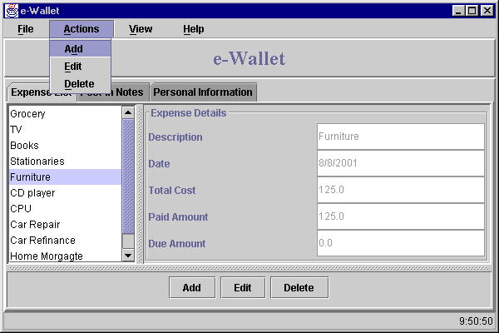

It can also be done by clicking add button at the bottom of the screen.

When user clicks Add, the following screen appears with blank fields.

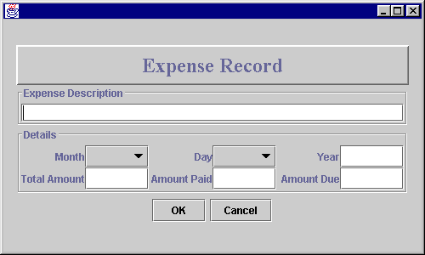

Similarly user can also do editing, but screen appears with the selected record for edition.

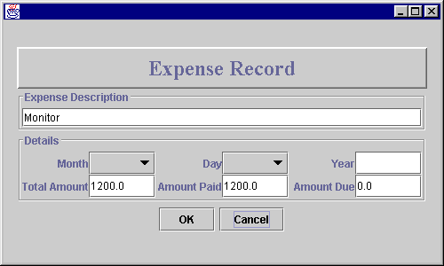

At any stage if user want to delete any records, s/he only needs to select the record from the list and click Delete. Deletion operations prompts and the delete the selected record.

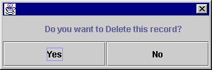

When user selects Add on Post-In Notes pane, following screen appears.

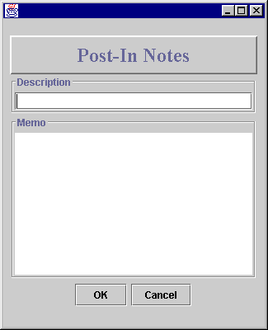

For adding records in Personal Information.

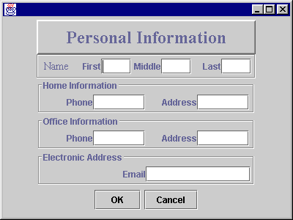
Exit
User can either sign off from the application or completely exit from the application.

