PROJECT 5

CS 623 – Graphical User Interface.
Fall 2001
Professor – Yonglei Tao

By

Shailesh Gala
Biswajit Panja
Ahmed Khan
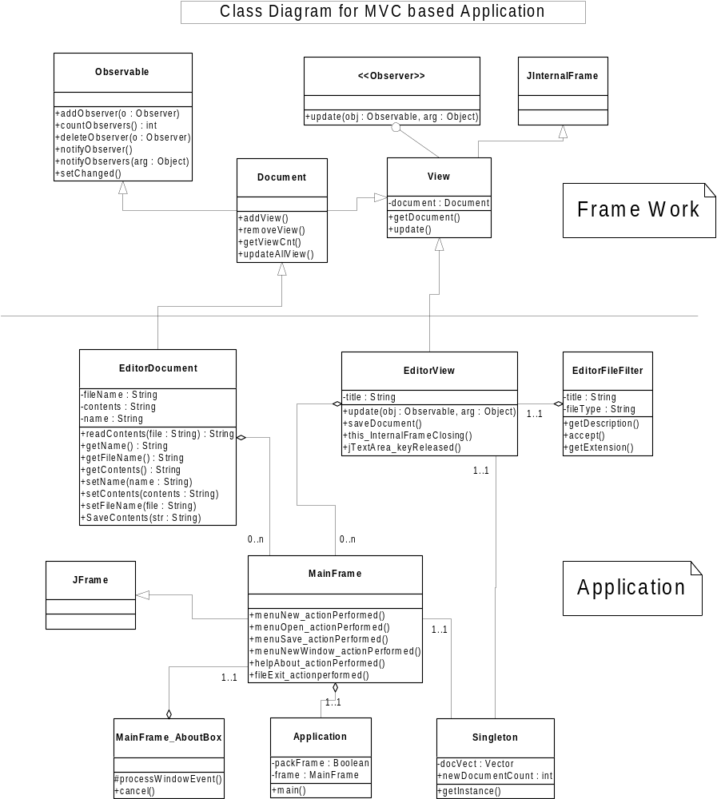
Brief description about Architecture

In the above class diagram, Model-View-Controller (MVC) architecture is utilized. The idea is simple:

- use one object to represent the data
- use another object to represent a user’s view of that data

In this application Java’s low level support for building MVC- style program is used.

- java.util.Observer - Interface
- java.util.Observable - Class

Document Class:
Document class extends Observable class provided by Java. The Observable class contains all the code required to store a list of views, or observers. It also keeps track of the document’s modified state and can send notifications to all observers.

The Document object implements an update function. The update function is the only method in the Observer interface. When the data in the Observable object i.e., Document is modified, setChanged method is called and then notifyObservers is called. The latter one has two versions, one takes no arguments and the other takes a generic object. So, after any modification document is marked as changed and all other views are called by notify. After notification changed state gets back clear state.

View Class:
The View class is responsible to know when the data changes in the document, so it is implemented with Observer interface.

Brief description about Application

EditorDocument Class:
This is an application class. This class extends Document class of the frame work. This class has methods readContents, getName, getFilename etc. The function of this class is to read the contents of the document as string, to get the file name etc.

EditorView Class:
This is an application class. This class extends View class of the frame work. There are methods update, saveDocument etc. The function of the class is to show the document to the user, it also updates all the documents when a file is saved, it shows changes in all the windows.

MainFrame Class:
This class is an application class, it extends from Jframe. This is for main frame, this has save, new, new window, close and all other function. Editor window can be open as internal frame from this window.

EditorFileFilter Class:
This application class, is for saving file in the disk. The file means the editor window. It can also open existing file from the disk.

Singleton Class:
This application class is for vector. This class keeps track of all the editor windows.

Application Class:
This class has the main function, the main window is called from here.

Working Steps of this project:
- This project should be run in Java 1.2.2 or above.
- When we run the project, the window called “Text Editor” will come. In this window there are menus file, window. Under file there are New, Open, Save, Exit.
- When new is clicked, the document window will come, and now we can write in the document window. When the save is clicked, it will show the file options where to save.
- Now when we open window from Window then new window, then it will show the same contents of the previous opened window.
- Now whatever changes made to the document window it will show in the other window too.
- Finally we can close the windows.

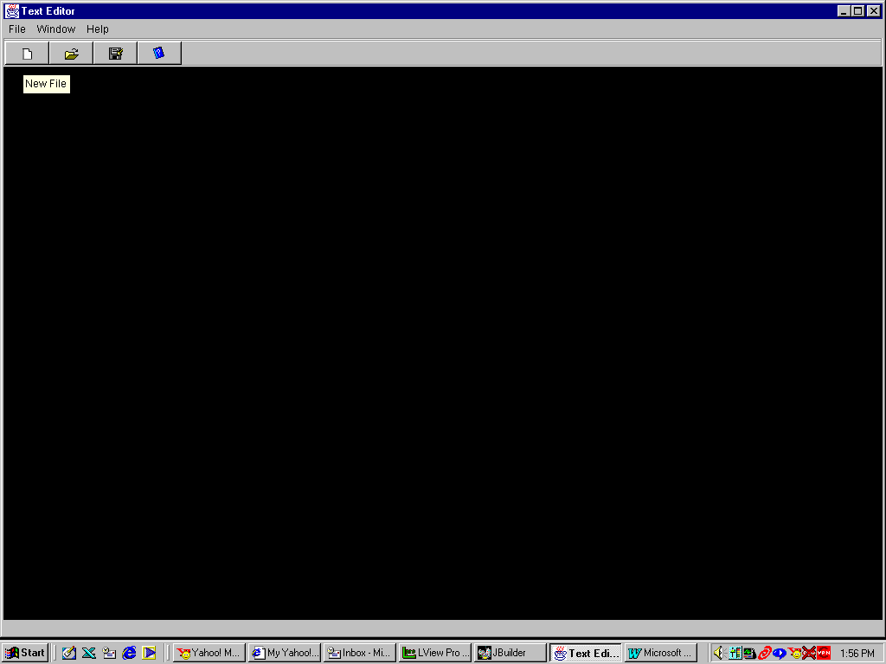
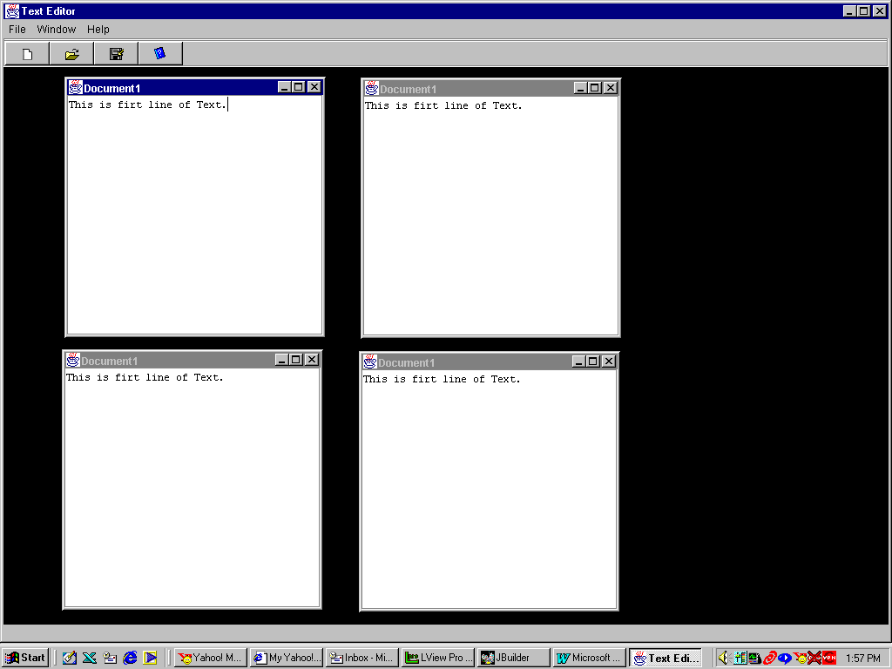
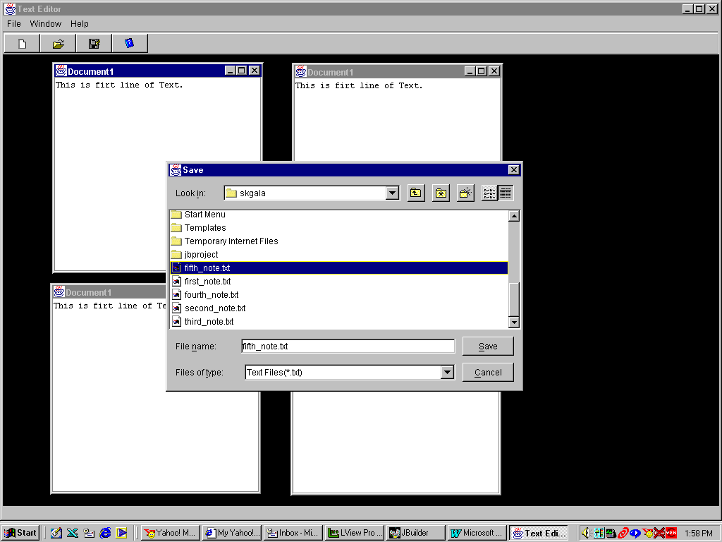
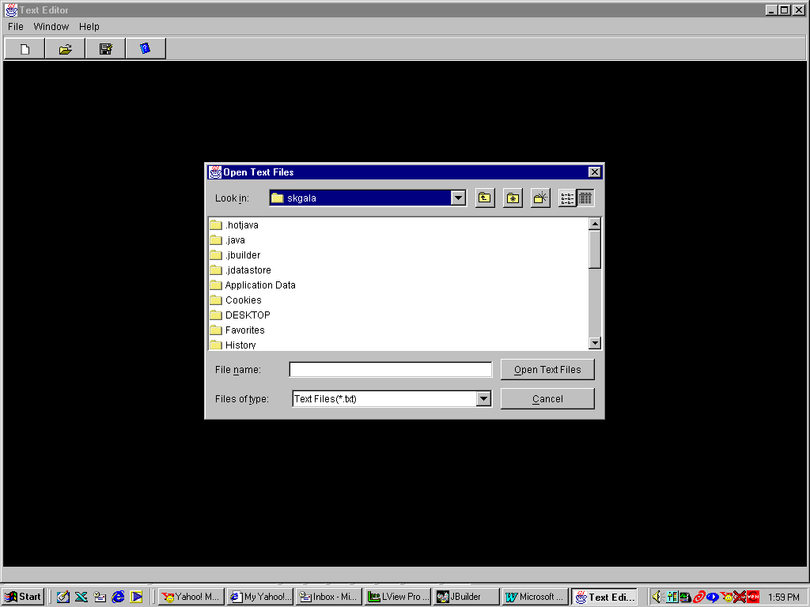
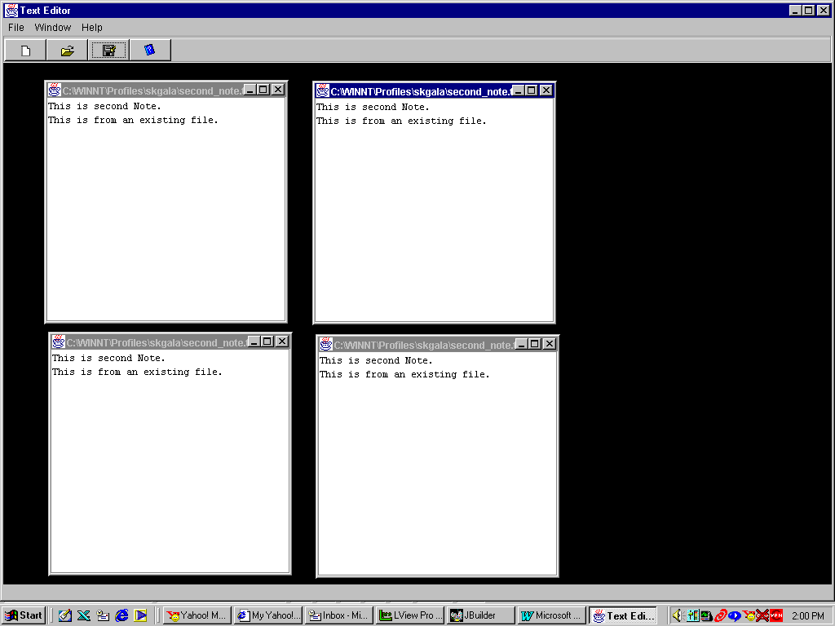
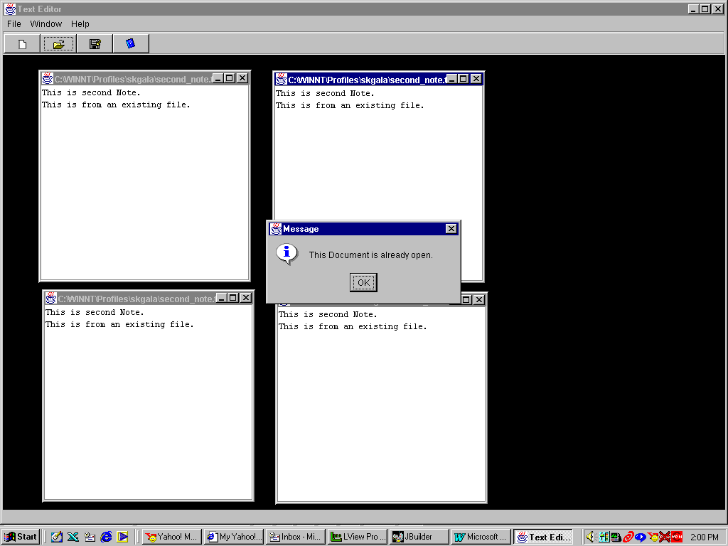
This message is given while trying to open an already open file.

/** *** FRAMEWORK ***
* Title: project5
* Class: Document
* Description: Document class makes the framework. This class is inherited from
* Observable class. Observable class provides the functionality
* of managing multiple Observer to be attached to one Observable
* class.
* Company: GVSU
* @author: Shailesh Gala, Biswajit Panja, Ahmed Khan
* @version 1.0
*/
package project5;

// Document base class
import java.util.*;

public abstract class Document extends Observable
{
// This function can be used to attach
// view to the document object.
public void addView(View v)
{
// Calling addObserver method of Observable class will
// attach given view to this document object.
addObserver(v);
}

// This function can be used to remove view currently attached to the document object.
public void removeView(View v)
{
// Calling deleteObserver method of Observable class will
// remove given view from this document object.
deleteObserver(v);
}

// This function can be used to notify the changes made to the document
// be refreshed on all the views. Following function does not
// require any arguments. Observable class requires one to
// call setChanged method to set the changed flag and then call
// to notifyObserver will call update function of the View objects.
public void updateAllViews()
{
setChanged();
notifyObservers();
}

// This function does the same as updateAllViews function, and it
// also passes an Object to all the views. This can help increase
// performance when only certain portion of the view may need to be
// refreshed.
public void updateAllViews(Object msg)
{
setChanged();
notifyObservers(msg);
}

}

/** *** FRAMEWORK ***
* Title: project5
* Class: View
* Description: View class makes the framework. This class is created by
* inheriting JInternelFrame class but it implements Observer
* interface.
* Company: GVSU
* @author: Shailesh Gala, Biswajit Panja, Ahmed Khan
* @version 1.0
*/

package project5;

// Basic View class
import java.awt.*;
import java.util.Observer;
import java.io.*;
import java.awt.event.*;
import javax.swing.*;

public abstract class View extends JInternalFrame implements Observer
{
// This variable stores link to the document attached with this view.
private Document document;

// Method to get Document instance
public Document getDocument()
{
return document;
}

// This is Constructor function for View class. It requires
// Document object to be passed as argument. Instance of view
// is attached to the Passed document object.
View(Document doc)
{
document=doc;
doc.addView(this);
}

// default implementation. This function must be over ridden by the
// sub classes. This function will be called whenever document needs
// to be refreshed on all views attached to a given document.
public void update(java.util.Observable o,Object msg)
{ }

}

/**
* Title: project5
* Class: EditorDocument
* Description: EditorDocument class is concrete implementation of Document class.
* This class stores the contents of the document and provides
* methods to store contents into a file or read from a file.
* Copyright: Copyright (c) <p>
* Company: GVSU
* @author: Shailesh Gala, Biswajit Panja, Ahmed Khan
* @version 1.0
*/

package project5;

import java.awt.*;
import java.awt.event.*;
import javax.swing.*;
import java.io.*;

// Document class
class EditorDocument extends Document
{
String fileName = new String( "" ); // Variable to store file name
String contents = new String(""); // Variable to store content of document
String name = new String( "" ); // Variable to store name for a document

// Constructor function
EditorDocument()
{
fileName = "";
}

// This function Reads contents of a file and stores it in the contents variable
// File name is passed as an argument. Content of file is returned as String.
public String readContents( String str )
{
fileName = str; // Store File Name
String s = new String( "" );
try {
// Read the file
contents = "";
BufferedReader bf = new BufferedReader( new FileReader( fileName ) );
s = bf.readLine();
while ( s != null ) {
contents = contents + s + "\n";
s = bf.readLine();
}
}
catch( FileNotFoundException e )
{
System.out.println( "File not found" );
}
catch( IOException e )
{
System.out.println( "IOException occurred" );
}
return contents;
}

// Get name of the document
public String getName() {
return name;
}

// Get file name
public String getFileName() {
return fileName;
}

// Get contents of the document
public String getContents() {
return contents;
}

// Set Name of a document
public void setName(String str) {
name = str;
}

// Set contents of a document
public void setContents(String str) {
contents = str;
}

// Set name of the file and document
public void setFileName( String str ) {
fileName = str;
name = str;
}

// This funcion saves the contents into file. One must call setFileName and
// setContents function prior to calling this function.
public int saveContents()
{
// Check that file Name has been set before.
if (fileName.compareTo( "" )== 0) {
return -1;
}
try {
// Store the contents to the file
BufferedWriter wf = new BufferedWriter( new FileWriter( fileName ) );
wf.write( contents );
wf.close();
}
catch( IOException e )
{
System.out.println( "IOException occurred" );
}
return 1;
}

}
/**
* Title: project5
* Class: EditorView
* Description: EditorView class is concrete implementation of View class.
* Copyright: Copyright (c) <p>
* Company: GVSU
* @author: Shailesh Gala, Biswajit Panja, Ahmed Khan
* @version 1.0
*/

package project5;

import java.awt.*;
import java.awt.event.*;
import javax.swing.*;
import javax.swing.event.*;

class EditorView extends View
{
JScrollPane jScrollPane = new JScrollPane(); // Scroll pane to hold text area
JTextArea jTextArea = new JTextArea(); // Text Area for editing
String title; // Variable to store tile of view

// This is constructor function. It must be passed Document object.
EditorView(Document doc)
{
super(doc); // Set relation of current view to given document

setSize( 300, 300 );
this.setClosable( true );
this.setIconifiable( true );
this.setMaximizable( true );
this.setResizable( true );
this.setBackground( Color.lightGray );

// Add InternalFrameListener to trap InternelFrameClosing event
this.addInternalFrameListener(new javax.swing.event.InternalFrameAdapter() {
public void internalFrameClosing(InternalFrameEvent e) {
this_internalFrameClosing(e);
}
});

// Add InternalFrameListener to trap internalFrameActivated event
this.addInternalFrameListener(new javax.swing.event.InternalFrameAdapter() {
public void internalFrameActivated(InternalFrameEvent e) {
this_internalFrameActivated(e);
}
});

// Add KeyListenr to trap any changes made to the text
jTextArea.addKeyListener(new java.awt.event.KeyAdapter() {
public void keyReleased(KeyEvent e) {
jTextArea_keyReleased(e);
}
});

// Initialize text area to current contents of the document.
jTextArea.setText( ((EditorDocument)getDocument()).getContents() );
jScrollPane.getViewport().add(jTextArea);
jScrollPane.setBounds( 10, 10, 200, 150 );

// Add scrollpane to center of the frame.
this.getContentPane().add(jScrollPane, BorderLayout.CENTER);
}

// This function is called whenever document has been modified in anyone
// of its view. This function needs to refresh text show in current
// object's text area.
public void update(java.util.Observable o, Object msg)
{
super.update(o, msg); // Call parent's classes update function
jTextArea.setText( ((EditorDocument)o).getContents() ); // Set text to updated value
this.setTitle( ((EditorDocument)o).getName() );
}

// This function allows user to save the contents into a file.
// It is currently called from the MainFrame, when user clicks Save menu item.
public void saveDocument()
{
// If File Name is not available, then it is a new document.
// Hence it provides user with FileChooser to enter File Name.
if ( ((EditorDocument)getDocument()).getFileName().compareTo( "" ) == 0 ) {

// Create an instance of the file chooser dialog
JFileChooser fileChooser = new JFileChooser();
// Configure some file type parameters
fileChooser.addChoosableFileFilter(
new EditorFileFilter( "txt", "Text Files" ) );
fileChooser.setApproveButtonText( "Save Text File" );

// Get a selection from the user
int returnValue = fileChooser.showSaveDialog( this );
if( returnValue == JFileChooser.APPROVE_OPTION )
{
((EditorDocument)getDocument()).setFileName(
fileChooser.getSelectedFile().getAbsolutePath() );
}
else {
return;
}
Singleton.getInstance().newDocumentCount--;
}

// Save the new text into the file
((EditorDocument)getDocument()).setContents( jTextArea.getText() );
((EditorDocument)getDocument()).saveContents();

// Refresh all views of these document
((EditorDocument)getDocument()).updateAllViews();
}

// This function is called while closing this Internel Frame.
// It removes the attachment of current view from the document.
// Also if this was the only view attached to given document,
// It removes from the vector docVect, which keeps tracks of all
// open documents.
void this_internalFrameClosing(InternalFrameEvent e) {
((EditorDocument)getDocument()).removeView( this );

// If there are no move views of current document open than
// remove from the document object from the vector oldVect
if (((EditorDocument)getDocument()).countObservers() == 0 ) {
Singleton.getInstance().docVect.remove( (EditorDocument)getDocument() );
}
}

// This function is called when a Key is Released on Text Area.
// It changes contents in all views attached to this document
void jTextArea_keyReleased(KeyEvent e) {
((EditorDocument)getDocument()).setContents( jTextArea.getText() );
((EditorDocument)getDocument()).updateAllViews();
}

// This function is called when this view is activated.
// It store reference to activated frame in the Singleton class
void this_internalFrameActivated(InternalFrameEvent e) {
Singleton.getInstance().currentFrame = this;
}
}

/**
* Title: project5
* Class: Application
* Description: Application class is starting point for running this application.
* Copyright: Copyright (c) <p>
* Company: GVSU
* @author: Shailesh Gala, Biswajit Panja, Ahmed Khan
* @version 1.0
*/
package project5;

import javax.swing.UIManager;
import java.awt.*;

public class Application {
boolean packFrame = false;
MainFrame frame = new MainFrame();

//Construct the application
public Application() {

//Validate frames that have preset sizes
//Pack frames that have useful preferred size info, e.g. from their layout
if (packFrame) {
frame.pack();
}
else {
frame.validate();
}

//Center the window
Dimension screenSize = Toolkit.getDefaultToolkit().getScreenSize();
frame.setSize( screenSize.width, screenSize.height - 30 );
frame.setLocation(0,0);
frame.setVisible(true);
}

//Main method
public static void main(String[] args) {
try {
UIManager.setLookAndFeel(UIManager.getSystemLookAndFeelClassName());
}
catch(Exception e) {
e.printStackTrace();
}
new Application();
}

}
/**
* Title: project5
* Class: MainFrame
* Description: MainFrame class is inherited from JFrame class.
* This class is the first frame opened by the application.
* It provides user with Menu and ToolBar. It shows all
* child windows inside its desktop pane.
* Copyright: Copyright (c) <p>
* Company: GVSU
* @author: Shailesh Gala, Biswajit Panja, Ahmed Khan
* @version 1.0
*/

package project5;

import java.awt.*;
import java.awt.event.*;
import javax.swing.*;
import java.util.*;

public class MainFrame extends JFrame {

// Instance variables
JPanel contentPane;
JMenuBar menuBar = new JMenuBar();
JMenu menuFile = new JMenu();
JMenuItem menuFileExit = new JMenuItem();
JMenu menuHelp = new JMenu();
JMenuItem menuHelpAbout = new JMenuItem();
JToolBar toolBar = new JToolBar();
JButton jNewBtn = new JButton();
JButton jSaveBtn = new JButton();
JButton jNewWinBtn = new JButton();
ImageIcon image1;
ImageIcon image2;
ImageIcon image3;
ImageIcon image4;
JLabel statusBar = new JLabel();
BorderLayout borderLayout1 = new BorderLayout();
JMenuItem menuNew = new JMenuItem();
JMenuItem menuOpen = new JMenuItem();
JMenuItem menuSave = new JMenuItem();
JMenu menuWindow = new JMenu();
JMenuItem menuNewWindow = new JMenuItem();
JDesktopPane desktopPane;
JButton jOpenBtn = new JButton();

//Construct the frame
public MainFrame() {
enableEvents(AWTEvent.WINDOW_EVENT_MASK);
try {
jbInit();
}
catch(Exception e) {
e.printStackTrace();
}
}

//Component initialization
private void jbInit() throws Exception {
image1 = new ImageIcon(MainFrame.class.getResource("newFile.gif"));
image2 = new ImageIcon(MainFrame.class.getResource("openFile.gif"));
image3 = new ImageIcon(MainFrame.class.getResource("closeFile.gif"));
image4 = new ImageIcon(MainFrame.class.getResource("help.gif"));

contentPane = (JPanel) this.getContentPane();
contentPane.setLayout(borderLayout1);
this.setTitle("Text Editor");
statusBar.setText(" ");

// New File Toolbar button settings
jNewBtn.setIcon( image1 );
jNewBtn.setToolTipText("New File");
jNewBtn.addActionListener(new java.awt.event.ActionListener() {
public void actionPerformed(ActionEvent e) {
menuNew_actionPerformed(e);
}
});

// Open File Toolbar button settings
jOpenBtn.setToolTipText("Open File");
jOpenBtn.setIcon(image2);
jOpenBtn.addActionListener(new java.awt.event.ActionListener() {
public void actionPerformed(ActionEvent e) {
menuOpen_actionPerformed(e);
}
});

// Save File Toolbar button settings
jSaveBtn.setIcon(image3);
jSaveBtn.setToolTipText("Save File");
jSaveBtn.addActionListener(new java.awt.event.ActionListener() {
public void actionPerformed(ActionEvent e) {
menuSave_actionPerformed(e);
}
});

// New Window Toolbar button settings
jNewWinBtn.setIcon(image4);
jNewWinBtn.setToolTipText("New Window");
jNewWinBtn.addActionListener(new java.awt.event.ActionListener() {
public void actionPerformed(ActionEvent e) {
menuNewWindow_actionPerformed(e);
}
});

// File menu settings
menuFile.setText("File");
menuFileExit.setText("Exit");
menuFileExit.addActionListener(new ActionListener() {
public void actionPerformed(ActionEvent e) {
fileExit_actionPerformed(e);
}
});

// Help menu settings
menuHelp.setText("Help");
menuHelpAbout.setText("About");
menuHelpAbout.addActionListener(new ActionListener() {
public void actionPerformed(ActionEvent e) {
helpAbout_actionPerformed(e);
}
});

// New File Menu Item settings
menuNew.setText("New");
menuNew.addActionListener(new java.awt.event.ActionListener() {
public void actionPerformed(ActionEvent e) {
menuNew_actionPerformed(e);
}
});

// Open File Menu Item settings
menuOpen.setText("Open");
menuOpen.addActionListener(new java.awt.event.ActionListener() {
public void actionPerformed(ActionEvent e) {
menuOpen_actionPerformed(e);
}
});

// Save File Menu Item settings
menuSave.setText("Save");
menuSave.addActionListener(new java.awt.event.ActionListener() {
public void actionPerformed(ActionEvent e) {
menuSave_actionPerformed(e);
}
});

// New Window Menu Item settings
menuWindow.setText("Window");
menuNewWindow.setText("New Window");
menuNewWindow.addActionListener(new java.awt.event.ActionListener() {
public void actionPerformed(ActionEvent e) {
menuNewWindow_actionPerformed(e);
}
});

// Create complete tool bar
toolBar.add(jNewBtn);
toolBar.add(jOpenBtn);
toolBar.add(jSaveBtn);
toolBar.add(jNewWinBtn);

// Create menu
menuFile.add(menuNew);
menuFile.add(menuOpen);
menuFile.add(menuSave);
menuFile.add(menuFileExit);
menuHelp.add(menuHelpAbout);
menuWindow.add(menuNewWindow);
menuBar.add(menuFile);
menuBar.add(menuWindow);
menuBar.add(menuHelp);
this.setJMenuBar(menuBar);

// Create Desktop Pane
desktopPane = new JDesktopPane();
desktopPane.setMinimumSize( new Dimension(400, 400 ) );

// Add all controls to the main content pane
contentPane.add(toolBar, BorderLayout.NORTH);
contentPane.add(desktopPane, BorderLayout.CENTER);
contentPane.add(statusBar, BorderLayout.SOUTH);
}

//File | Exit action performed
public void fileExit_actionPerformed(ActionEvent e) {
System.exit(0);
}

//Help | About action performed
public void helpAbout_actionPerformed(ActionEvent e) {
MainFrame_AboutBox dlg = new MainFrame_AboutBox(this);
Dimension dlgSize = dlg.getPreferredSize();
Dimension frmSize = getSize();
Point loc = getLocation();
dlg.setLocation((frmSize.width - dlgSize.width) / 2 + loc.x, (frmSize.height - dlgSize.height) / 2 + loc.y);
dlg.setModal(true);
dlg.show();
}

//Overridden so we can exit when window is closed
protected void processWindowEvent(WindowEvent e) {
super.processWindowEvent(e);
if (e.getID() == WindowEvent.WINDOW_CLOSING) {
fileExit_actionPerformed(null);
}
}

// This function is called when New File menu item is clicked
void menuNew_actionPerformed(ActionEvent e) {
Singleton.getInstance().newDocumentCount++; // Increment counter

// Create a new document and set Name
EditorDocument doc = new EditorDocument();
doc.setName( "Document" + Singleton.getInstance().newDocumentCount );

// Create new frame, set title and add to current desktop pane
EditorView frame = new EditorView(doc);
frame.setTitle( doc.getName() );
desktopPane.add( frame );
frame.setVisible( true );
}

// This function is called when Open File menu item is clicked
void menuOpen_actionPerformed(ActionEvent e) {

// Create an instance of the file chooser dialog
JFileChooser fileChooser = new JFileChooser();
// Configure some file type parameters
fileChooser.addChoosableFileFilter(
new EditorFileFilter( "txt", "Text Files" ) );
// Do some funky text changes
fileChooser.setApproveButtonText( "Open Text Files" );

// Get a selection from the user
int returnValue = fileChooser.showOpenDialog( this );
if( returnValue == JFileChooser.APPROVE_OPTION )
{
// Make sure that selected file is not already open
for( int i = 0; i < Singleton.getInstance().docVect.size(); i++ ) {
if ( ((EditorDocument)Singleton.getInstance().docVect.elementAt(i)).getFileName().compareTo(
fileChooser.getSelectedFile().getAbsolutePath() ) == 0) {
JOptionPane.showMessageDialog( this, "This Document is already open.");
return;
}
}

// Create a new document, read from file, set Name and add to vector
EditorDocument doc = new EditorDocument();
doc.readContents( fileChooser.getSelectedFile().getAbsolutePath() );
doc.setName( fileChooser.getSelectedFile().getAbsolutePath() );
Singleton.getInstance().docVect.add( doc );

// Create new frame, set title and add to current desktop pane
EditorView frame = new EditorView(doc);
frame.setTitle( doc.getName() );
desktopPane.add( frame );
frame.setVisible( true );
}
}

// This function is called when Save File menu item is clicked
void menuSave_actionPerformed(ActionEvent e) {
// Get currently selected frame instance
// EditorView frame = (EditorView)desktopPane.getSelectedFrame();
EditorView frame = Singleton.getInstance().currentFrame;
if (frame != null ) {
// Save the document
((EditorView)frame).saveDocument();
}
}

// This function is called when New Window menu item is clicked
void menuNewWindow_actionPerformed(ActionEvent e) {

// Get currently selected frame instance
// EditorView oldframe = (EditorView)desktopPane.getSelectedFrame();
EditorView oldframe = Singleton.getInstance().currentFrame;

if (oldframe != null ) {

// Create a new Frame but for the same document
EditorView newframe = new EditorView( oldframe.getDocument() );
newframe.setTitle( ((EditorDocument)oldframe.getDocument()).getName() );
desktopPane.add( newframe );
newframe.setVisible( true );
}
}

}
/**
* Title: project5
* Class: Singleton
* Description: Singleton class implements singleton design pattern.
* This class stores global variables that can be accessed from
* anywhere.
* Copyright: Copyright (c) <p>
* Company: GVSU
* @author: Shailesh Gala, Biswajit Panja, Ahmed Khan
* @version 1.0
*/
package project5;

import java.util.*;

public class Singleton {
// Singleton class
private static final Singleton instance = new Singleton();

public Vector docVect = new Vector(); // vector to store all instances of Document
public int newDocumentCount = 0; // Counter to store current number of new Documents
public EditorView currentFrame; // Reference to currently active frame

// Constructor
public Singleton() {
}

// Function to get instance of Application object
public static Singleton getInstance() {
return instance;
}

}
/**
* Title: project5
* Class: MainFrame_AboutBox
* Description: MainFrame_AboutBox class provides About Dialog box
* Copyright: Copyright (c) <p>
* Company: GVSU
* @author: Shailesh Gala, Biswajit Panja, Ahmed Khan
* @version 1.0
*/
package project5;

import java.awt.*;
import java.awt.event.*;
import javax.swing.*;
import javax.swing.border.*;

public class MainFrame_AboutBox extends JDialog implements ActionListener {

JPanel panel1 = new JPanel();
JPanel panel2 = new JPanel();
JPanel insetsPanel1 = new JPanel();
JPanel insetsPanel2 = new JPanel();
JPanel insetsPanel3 = new JPanel();
JButton button1 = new JButton();
JLabel imageControl1 = new JLabel();
ImageIcon imageIcon;
JLabel label1 = new JLabel();
JLabel label2 = new JLabel();
JLabel label3 = new JLabel();
JLabel label4 = new JLabel();
BorderLayout borderLayout1 = new BorderLayout();
BorderLayout borderLayout2 = new BorderLayout();
FlowLayout flowLayout1 = new FlowLayout();
FlowLayout flowLayout2 = new FlowLayout();
GridLayout gridLayout1 = new GridLayout();
String product = "";
String version = "1.0";
String copyright = "Copyright (c) ";
String comments = "";
JLabel label5 = new JLabel();
JLabel label6 = new JLabel();
public MainFrame_AboutBox(Frame parent) {
super(parent);
enableEvents(AWTEvent.WINDOW_EVENT_MASK);
try {
jbInit();
}
catch(Exception e) {
e.printStackTrace();
}
//imageControl1.setIcon(imageIcon);
pack();
}

private void jbInit() throws Exception {
//imageIcon = new ImageIcon(getClass().getResource("[Your Image]"));
this.setTitle("About");
setResizable(false);
panel1.setLayout(borderLayout1);
panel2.setLayout(borderLayout2);
insetsPanel1.setLayout(flowLayout1);
insetsPanel2.setLayout(flowLayout1);
insetsPanel2.setBorder(new EmptyBorder(10, 10, 10, 10));
gridLayout1.setRows(6);
gridLayout1.setColumns(1);
label1.setText("Graphical User Interface");
label3.setText("Shailesh Gala");
label4.setText("Ahmed Khan");
insetsPanel3.setLayout(gridLayout1);
insetsPanel3.setBorder(new EmptyBorder(10, 60, 10, 10));
button1.setText("Ok");
button1.addActionListener(this);
label5.setText("Project 5 - CS 623");
label6.setText("Biswajit Panja");
insetsPanel2.add(imageControl1, null);
panel2.add(insetsPanel2, BorderLayout.WEST);
this.getContentPane().add(panel1, null);
insetsPanel3.add(label5, null);
insetsPanel3.add(label1, null);
insetsPanel3.add(label2, null);
insetsPanel3.add(label3, null);
insetsPanel3.add(label6, null);
insetsPanel3.add(label4, null);
panel2.add(insetsPanel3, BorderLayout.CENTER);
insetsPanel1.add(button1, null);
panel1.add(insetsPanel1, BorderLayout.SOUTH);
panel1.add(panel2, BorderLayout.NORTH);
}

protected void processWindowEvent(WindowEvent e) {
if (e.getID() == WindowEvent.WINDOW_CLOSING) {
cancel();
}
super.processWindowEvent(e);
}

void cancel() {
dispose();
}

public void actionPerformed(ActionEvent e) {
if (e.getSource() == button1) {
cancel();
}
}
}
/**
* Title: project5
* Class: EditorFileFilter
* Description: EditorFileFilter class extens FileFilter interface,
* to provide functionality for FileChooser
* Copyright: Copyright (c) <p>
* Company: GVSU
* @author: Shailesh Gala, Biswajit Panja, Ahmed Khan
* @version 1.0
*/
package project5;

import java.io.*;
import java.awt.*;
import java.awt.event.*;
import javax.swing.*;
import javax.swing.filechooser.*;

public class EditorFileFilter
extends javax.swing.filechooser.FileFilter
{
private String description;
private String fileType;

// Constructor
public EditorFileFilter( String fileType, String description )
{
this.fileType = fileType;
this.description = description;
}

// Return the description for this file type
public String getDescription()
{
return description + "(*." + fileType + ")";
}

// Determine if a file should be displayed in the file list
public boolean accept( File f )
{
if( f != null )
{
if( f.isDirectory() )
{
return true;
}

// See if we need to put this file in the file list
String extension = getExtension( f );
if( extension != null && getExtension( f ).equals( fileType ) )
{
return true;
}
}
return false;
}

// Return the filename extension
public String getExtension( File f )
{
if(f != null)
{
String filename = f.getName();
int i = filename.lastIndexOf('.');
if( i > 0 && i < filename.length() - 1 )
{
return filename.substring( i + 1 ).toLowerCase();
}
}
return null;
}
}

