Project 1

CS 500

Prepared by
Ahmed M. Khan

Part One: Prove by induction that 5^{n}− 1 is divisible by 4 for all n ≥ 1.

Base Case.

For n=1, 5^{n} - 1 = 5 - 1= 4, 4 is divisible by 4.

Inductive Hypothesis

5^{n} − 1 is divisible by 4, so
5^{n} − 1= 4k
where k is some integer.

Inductive Step

S(n)=>S(n+1)

5^{n+1} − 1= 5^{n+1} − 5+4
= 5 . 5^{n} – 5 + 4
= 5 (5^{n} − 1) + 4
= 5(4k) + 4
= 4( 5k+1)

So 4 divides 5^{n+1} − 1.

By Induction principle we proved that 5^{n}− 1 is divisible by 4 for all n ≥ 1.

Part Two

/***************************************************************/
/* Author: Ahmed M Khan
/* Course No/Section: CS 500
/* Date: 05/20/2002
/* File Name: p1.c
/* Project No: 1
/* Description: C program 'List of Books'
/****************************************************************/

#include <stdio.h>
#define MAX 100

struct Book {

int code;

float price;

};

/* Prototypes */

void loadArray (struct Book list[], int* numOfBooksPtr);
void printArray (struct Book list[], int numOfBooks);
int Count (struct Book list[], int numOfBooks, float targetPrice);
void Sort (struct Book list[], int numOfBooks);
float findPrice (struct Book list[], int numOfBooks, int targetCode);

/* main function */
main()

{
/* declaring required variables*/
int numOfBooks, count, targetCode;
float targetPrice, priceFound;
struct Book list[MAX];

/* loading list */
loadArray (list, &numOfBooks);

/*printing list */
printArray (list, numOfBooks);

/**********************************
getting & printing number of Books
having price less than target
***********************************/
printf("\nPlease enter target price:");
scanf("%f", &targetPrice);
count= Count( list, numOfBooks, targetPrice);
printf("\nNumber of Books having price less than target: %d\n",
count);

/*Sorting & printing sorted list*/
Sort( list, numOfBooks);
printArray (list, numOfBooks);

/*********************************
getting and printing the price
of the target book
**********************************/
printf("\nPlease enter target code:");
scanf("%d", &targetCode);
priceFound=findPrice(list, numOfBooks, targetCode);
if( priceFound >0 )
printf("\nPrice is: %7.2f\n", priceFound);
else
printf("\nBook not found\n");

return 0;

}

void loadArray (struct Book list[], int* numOfBooksPtr)

/* loads array list with input data from keyboard */

{

int aCode;
float aPrice;

*numOfBooksPtr = 0;

printf ("Code of Book ? ");
scanf("%d", &aCode);

while ( aCode != 9999 )

{

printf ("Price of Book ? ");
scanf("%f", &aPrice);

list[*numOfBooksPtr].code = aCode;
list[*numOfBooksPtr].price = aPrice;

(*numOfBooksPtr)++;
printf ("Code of Book ? ");
scanf("%d", &aCode);

}

}

void printArray (struct Book list[], int numOfBooks)

/* display contents of array list on screen */

{

int index;

printf("\n\n%10s%10s", "CODE", "PRICE");
printf("\n");

for (index = 0; index < numOfBooks; index++)
{
printf("%10d%10.2f\n", list[index].code, list[index].price);

}

}

int Count(struct Book list[], int numOfBooks, float targetPrice)
/* counting number of books price less than target*/
{
int index, count=0;

for(index=0; index<numOfBooks; index++)
{
if(list[index].price< targetPrice)
count++;
}
return count;

}

void Sort( struct Book list[], int numOfBooks)
/* sorting the Book list*/
{
int out, in;
struct Book temp;

for(out=0; out < numOfBooks; out++)
for(in=out+1; in < numOfBooks; in++)
if(list[out].code > list[in].code)
{
temp.code=list[in].code;
temp.price=list[in].price;

list[in].code=list[out].code;
list[in].price=list[out].price;

list[out].code=temp.code;
list[out].price=temp.price;
}
}

float findPrice( struct Book list[], int numOfBooks, int targetCode)
/*finding the price of the book specified by target code*/
{
int index, found=0;

for(index=0; index < numOfBooks; index++)
if(list[index].code==targetCode)
{
return list[index].price;
}

return 0;
}

Screen Outputs

Loading and then printing list.
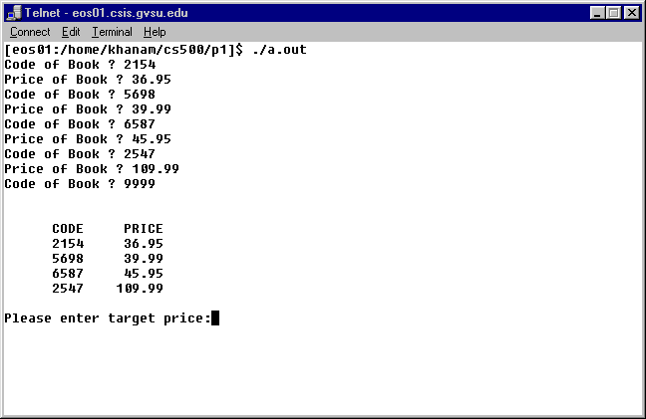

Finding target books and then sorting the list.
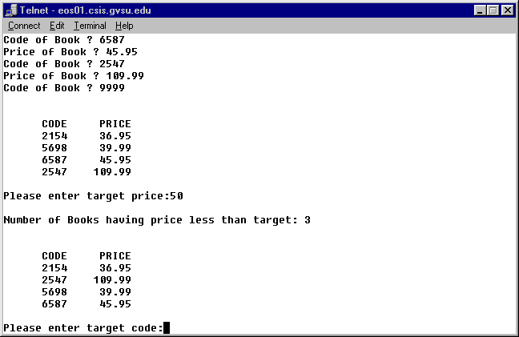

Finding target price.
