Project 2
CS 500

Prepared by
Ahmed M Khan

Part One: Using Big-Oh notation to analyze the time efficiency for each of the code segments below:
1.
if (n%2 == 1)
{
x = 0;
for (i = 0; i < n; i++)
for (j = 0; j < n/2; j++)
x += 2;
}
else for (k = 0; k < n; k++)
{
x += 1; y -= 2; z *= 3;
p = x + y + z;
printf ("%d", p);
}
Using Big-Oh notation :
Let the above function be T(n)
T(n) =1+n(n/2+1)+1 + +3n+ 1
=3+(n² + n)/2 +3n
= (n²+6n +6)/2
ignore constants and lower order values
O(T(n))= O(n²)
which is quadratic

2.
for (i = 0; i < n; i++)
for (j = 0; j < n; j++)
for (k = 0; k < j; k++)
z = i + j + k ;
T(n)=n(n(n+1)/2)
= (n³+n²)/2
= n³
O(T(n))= O(n³)
which is cubic

Part Three

/***************************************************************/
/* Author: Ahmed M Khan
/* Course No/Section: CS 500
/* Date: 05/29/2002
/* File Name: p2.c
/* Project No: 2
/* Description: C program 'Binary Search Tree Operations'
/****************************************************************/

#include <stdio.h>
#include <stdlib.h>
#include <time.h>

#define TRUE 1
#define FALSE 0

typedef int BOOLEAN;
typedef int ETYPE;
typedef int SIZE;

/*Tree node structure*/
typedef struct NODE *TREE;
struct NODE {
ETYPE element;
TREE leftChild, rightChild;
SIZE size; // size of each node
};

/* insert function */
TREE insert(ETYPE x, TREE T)
{
if (T == NULL) {
T = (TREE) malloc(sizeof(struct NODE));
T->element = x;
T->size++;
T->leftChild = NULL;
T->rightChild = NULL;
}
else if (x < T->element)
{
T->leftChild = insert(x, T->leftChild);
T->size++;
}
else if (x > T->element)
{
T->rightChild = insert(x, T->rightChild);
T->size++;
}
return T;
}

/* lookup function */
BOOLEAN lookup(ETYPE x, TREE T)
{
if (T == NULL)
return FALSE;
else if (x == T->element)
return TRUE;
else if (x < T->element)
return lookup(x, T->leftChild);
else /* x must be > T->element */
return lookup(x, T->rightChild);
}

/* adding nodes */
TREE addNodes( TREE T)
{

int i, elem;

for(i=0;i<10;i++)
{
elem = rand()%500;
if(!lookup(elem,T))
T=insert(elem,T);
else
{
i--;
continue;
}
}
return T;
}

/* print tree node values in inorder fashion*/
void print ( TREE T)
{
if(T!=NULL)
{
print(T->leftChild);
printf("%d\n",T->element);
print(T->rightChild);
}
}

/* get tree number of nodes */
int count ( TREE T)
{
if(T==NULL)
return 0;
else
return T->size;
}

/* main function*/
int main ()
{
TREE t = NULL;
int elem,i,size=0, option;
srand ( time(NULL) );

elem = rand() % 100;
if (!lookup(elem, t))
t = insert (elem, t);

printf("\nMain Menu\n\n\n");
printf("(1) Add Nodes\n");
printf("(2) Count nodes\n");
printf("(3) Print tree\n");
printf("(4) Quit\n");

do{
printf("Enter Choice:");
scanf("%d",&option);

if(option==1)
t=addNodes(t);
else if(option==2)
printf("Size is : %d\n",count(t));
else if(option==3)
print(t);
else if(option==4)
return 0;
} while(option>0 && option <4);
}

Screen Outputs

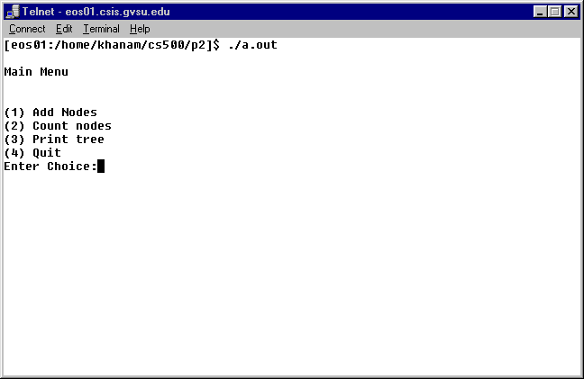
Adding nodes

Showing number of nodes
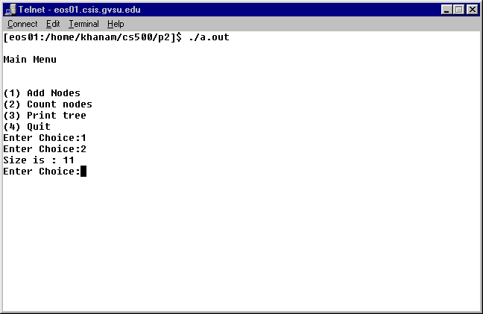
Showing node elements in in-order way

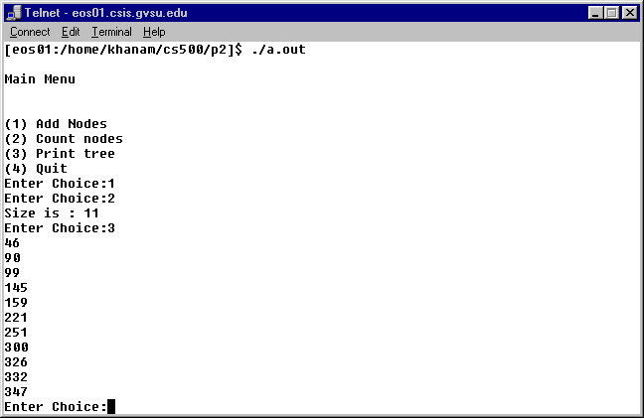

Adding ten more elements and showing number of nodes
