Project 3

CS 500

Prepared by

Ahmed M Khan

Part One

Sequence of elements

Pre-order

ABEFGHICDJLK

In-order

EBGFHIACLJDK

Post Order

EGHIFBCLJKDA

Part Two

/***************************************************************/
/* Author: Ahmed M Khan
/* Course No/Section: CS 500
/* Date: 06/05/2002
/* File Name: p3.c
/* Project No: 3
/* Description: C program 'List implementation'
/****************************************************************/
#include<stdlib.h>
#include<stdio.h>

#define MAX 50
#define TRUE 1
#define FALSE 0

typedef int BOOLEAN;
typedef struct {
int A[MAX];
int length;
} LIST;

/*Prototypes*/
void insert (int x, LIST *pL);
void delete (int x, LIST *pL);
void print (LIST *pL);
int retrieve(int x, LIST *pL);
int empty(LIST *pL);
int full(LIST *pL);
int length(LIST *pL);

/*main function*/
int main()
{
/* variable and pointer declarations*/
FILE *fptr;
int ch, value, pos=0, found, index;
char opt, numString[3];
LIST list;
LIST *listptr;
listptr=&list;
listptr->length=0;

/*open file for reading*/
fptr=fopen("pj3.dat","r");

/*manipulating file*/
while((ch=getc(fptr))!=EOF)
{
if(ch!='\n')
{
if( ch>=65 && ch<=90)
opt=ch;
else
numString[pos++]=ch;
}
else if(ch=='\n')
{
pos=0;
value=atoi(numString);
bzero(numString, 3);
if(opt=='I')
insert(value,listptr);
else if(opt=='D')
{
found=lookup(value, listptr);
if (found==1)
delete(value, listptr);
else
printf("\nValue not found, can not be deleted\n");

}
else if(opt=='P')
print(listptr);
else if(opt=='R')
{
index=value;
value=retrieve(index, listptr);
printf("Value at %d is %d\n",
index, value);
}
else if(opt=='E')
{
if(empty(listptr))
printf("List is not empty.\n");
else
printf("List is empty.\n");
}
else if(opt=='F')
{
if(full(listptr))
printf("List is full.\n");
else
printf("List is not full.\n");
}
else if(opt=='L')
printf("List length=%d\n",length(listptr));
value=0;

}
}
/*close file*/
fclose(fptr);

return 0;

}

/*lookup function*/
BOOLEAN lookup (int x, LIST *pL)
{
int i = 0;

while (i < pL->length && x > pL->A[i])
i++;

return (i < pL->length && pL->A[i] == x);

}

/*insert value in the list*/
void insert (int x, LIST *pL)
{
int i=0, j;
while (i < pL->length && x > pL->A[i])
i++;

for(j=pL->length-1; j>=i; j--)
pL->A[j+1]=pL->A[j];

pL->A[i]=x;
(pL->length)++;

printf("Inserting Value %d\n",pL->A[i]);

}

/*print list values*/
void print( LIST *pL)
{
int i=0;
printf("\nPrinting List\n");
while(i<pL->length)
printf("%d\n",pL->A[i++]);
}

/*delete value from the list*/
void delete( int x, LIST *pL)
{
int i=0,j;

while(i<pL->length && x > pL->A[i])
i++;

if(x==pL->A[i])
{
printf("Deleteing value %d\n",x);

for(j=i;j<=pL->length-2;j++)
pL->A[j]=pL->A[j+1];
}
(pL->length)--;

}

/*retrieve value from index*/
int retrieve( int i, LIST * pL)
{
return pL->A[i];
}

/* Is empty function*/
int empty(LIST *pL)
{
if(pL->length==0)
return 0;
else
return 1;
}

/* Is full function */
int full(LIST *pL)
{
if (pL->length==MAX)
return 1;
else
return 0;
}

/* return list length*/
int length(LIST *pL)
{
return pL->length;
}

Data File

P
I 4
I 9
I 14
I 2
I 10
I 7
I 18
R 0
R 2
R 4
R 6
P
D 2
I 3
I 15
D 18
D 10
D 7
P
I 5
I 1
I 9
I 10
I 11
I 12
I 21
I 22
P
R 3
R 4
R 5
E
F
L
D 11
P

Output from file:

Printing List
Inserting Value 4
Inserting Value 9
Inserting Value 14
Inserting Value 2
Inserting Value 10
Inserting Value 7
Inserting Value 18
Value at 0 is 2
Value at 2 is 7
Value at 4 is 10
Value at 6 is 18

Printing List
2
4
7
9
10
14
18
Deleteing value 2
Inserting Value 3
Inserting Value 15
Deleteing value 18
Deleteing value 10
Deleteing value 7

Printing List
3
4
9
14
15
Inserting Value 5
Inserting Value 1
Inserting Value 9
Inserting Value 10
Inserting Value 11
Inserting Value 12
Inserting Value 21
Inserting Value 22

Printing List
1
3
4
5
9
9
10
11
12
14
15
21
22
Value at 3 is 5
Value at 4 is 9
Value at 5 is 9
List is not empty.
List is not full.
List length=13
Deleteing value 11

Printing List
1
3
4
5
9
9
10
12
14
15
21
22

Screen Outputs

First Screen

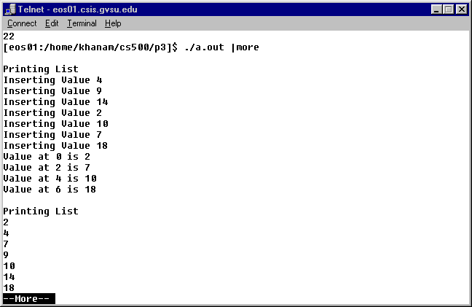

last screen

