Project 4

CS 500

Prepared by
Ahmed M Khan

Part One: Let R be the relation defined by aRb, bRc, cRd, aRc, and bRd.
- Draw the graph of R (draw a small circle for a letter and draw a line between two circles if they are related with respect to R).

- Is R a function? Justify your answer.
From the definition of the function, i.e., a relation with the property that for every member of a of A, there is at most one member b in B such that aRb, the above relation is a function. Because for every element from each set has only one possible range in the other set.
- Identify a possible domain and a possible range of R.
Domain = { a, b, c}
Range = { b, c, d}

/***************************************************************/
/* Author: Ahmed M Khan
/* Course No/Section: CS 500
/* Date: 06/12/2002
/* File Name: p4.c
/* Project No: 4
/* Description: C program 'Event-Driven Simulation'
/****************************************************************/
#include <iostream.h>
#include <math.h>
#include <time.h>
#include <stdlib.h>
#include "queue.h"

double expdist(double mean);

double expdist (double mean)
{
double r = rand();
r /= RAND_MAX;
return -mean*log(r);
}

int main ()
{
int i, id=1, did=0;
double t=0; /* starting time */
double clock, next, avail=0, dclock=0;
QUEUE pQueue;

next=expdist(1);
clock=next;

srand(time(0));

InitQueue(&pQueue);

while(clock < 480 || IsEmpty(&pQueue)==FALSE)
{
if(clock <480)
{
if (clock==next)
Enqueue(id, clock, &pQueue);
id++;
next=clock+expdist(1);
}

if(clock>=avail)
if(IsEmpty(&pQueue)==FALSE)
{
dclock=clock;
Dequeue(&did, &dclock, &pQueue);
}
ShowQueue(&pQueue);

avail=clock+expdist(5);
if(next<480)
{
if(next<avail)
clock=next;
else
clock=avail;
}
else
clock=avail;

}

return 0;

}

/***************************************************************/
/* Author: Ahmed M Khan
/* Course No/Section: CS 500
/* Date: 06/12/2002
/* File Name: queue.c
/* Project No: 4
/* Description: C program 'Event-Driven Simulation'
/****************************************************************/
#include <stdlib.h>
#include <stdio.h>
#include <iostream.h>
#include "queue.h"

void InitQueue(QUEUE *pQ)
{
pQ->front=NULL;
pQ->rear=NULL;
}

BOOLEAN IsEmpty (QUEUE *pQ)
{
return (pQ->front==NULL);
}

BOOLEAN Dequeue (int *pId, double *pt, QUEUE *pQ)
{
if(IsEmpty(pQ))
return FALSE;
else
{
//(*pId)=pQ->front->id;
//(*pt)=pQ->front->arrival;
cout<<"Customer :"<<pQ->front->id<<" Leaves at"<<*pt<<endl;
pQ->front=pQ->front->next;
return TRUE;
}
}

BOOLEAN Enqueue (int id, double t, QUEUE *pQ)
{
if(IsEmpty(pQ))
{
pQ->front=(struct NODE *) malloc(sizeof(struct NODE));
pQ->rear=pQ->front;
}
else
{
pQ->rear->next=(struct NODE *) malloc(sizeof(struct
NODE));
pQ->rear=pQ->rear->next;
}

pQ->rear->id=id;
pQ->rear->arrival=t;
pQ->rear->next=NULL;

cout<<"Customer "<<id <<" arrives at"<<t<<endl;
return TRUE;
}

void ShowQueue (QUEUE *pQ)
{
struct NODE *temp=NULL;

if(IsEmpty(pQ))
cout<<"List is Empty"<<endl;
else
{
temp=pQ->front;
while(temp!=NULL)
{
cout<<"Customer id:"<<temp->id<<"Arrival Time"
<<temp->arrival<<endl;
temp=temp->next;
}

}
}

/***************************************************************/
/* Author: Ahmed M Khan
/* Course No/Section: CS 500
/* Date: 06/12/2002
/* File Name: queue.h
/* Project No: 4
/* Description: C program Header File for 'Event-Driven Simulation'
/****************************************************************/

#define TRUE 1
#define FALSE 0

typedef int BOOLEAN;

struct NODE { /* a struct type for queue nodes */
int id; /* a customer's id */
double arrival; /* the time at which a customer arrives */
struct NODE* next; /* pointer to the next node if any */
};

typedef struct { /* a struct type for queues */

struct NODE *front, *rear; /* pointers to the front and rear nodes */
} QUEUE;

void InitQueue (QUEUE *pQ); /* initialize a queue */

BOOLEAN IsEmpty (QUEUE *pQ);

BOOLEAN Dequeue (int *pId, double *pt, QUEUE *pQ);

BOOLEAN Enqueue (int id, double t, QUEUE * pQ);

void ShowQueue (QUEUE *pQ); /* display all elements in a queue */

Screen Outputs
First Screen
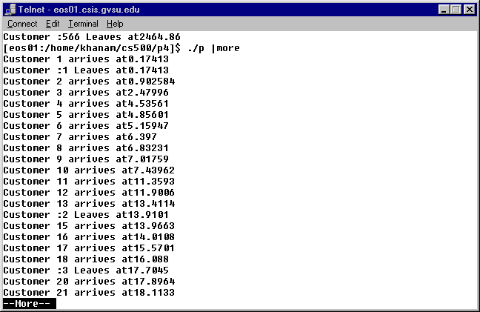
Last Screen

