CS 656

Project 2

Process Management Concept

Prepared by Ahmed M Khan

//server.c
#include <signal.h>
#include <sys/wait.h>
#include <unistd.h>
#include <sys/types.h>
#include <sys/socket.h>
#include <string.h>
#include <netinet/in.h>
#include <errno.h>
#include <stdio.h>
#include <sys/stat.h>
#include "readn.h"

int main(int argc, char* argv[])
{
const EXIT_FAILURE = 1;
const int BUF_SIZE = 1;
int sock; /* the socket we will use */
struct sockaddr_in client, // socket address information data
server; // structures
int newSock,childPid;
char file_buf[1],recv_buf[BUF_SIZE], send_buf[BUF_SIZE]; /*
Buffer for data read
from socket */
int structlength=0; /* length of sockaddr structure */
int port,numChars, LQ=1024; /* the port we will use */
FILE *fptr;

int fd,ch;
int str_len,umBytes, i=0,k, pid, status;

if (argc < 2) {
fprintf(stderr,"Usage: tcpserver port\n");
fprintf(stderr,"where port is a port number.\n");
exit(EXIT_FAILURE);
}

port = atoi(argv[1]);
port = htons(port); /* Convert argv[1] to network ordered integer */
printf("Port is %d %d \n", port, ntohs(port));

sock = socket(AF_INET, SOCK_STREAM, 0);
if (sock < 0) {
perror("socket");
exit(EXIT_FAILURE);
}
printf("\nSock:%d\n",sock);
memset((char *) &server, 0, sizeof(server));
server.sin_family = AF_INET;
server.sin_addr.s_addr = htonl(INADDR_ANY);
server.sin_port = port;

printf("Binding\n");

structlength = sizeof(server);

if (bind(sock, (struct sockaddr *) &server, structlength) < 0) {
perror("bind");
exit(EXIT_FAILURE);
}

if ( getsockname( sock, (struct sockaddr *)&server, &structlength ) )
{
perror(" error getting socket name");
exit(1);
}

listen(sock, LQ);

newSock=accept(sock,(struct sockaddr *) &client, &structlength);

if(newSock == -1){
perror(" Server:Error on accept\n");
exit(1);
}

//child is created
childPid=fork();

if(childPid<0){
perror(" Server:Error on fork.\n");
exit(1);
}

{ //child opens file file1.txt
if(childPid == 0){

fptr=fopen("file1.txt","r");
bzero(send_buf, BUF_SIZE);
bzero(file_buf,BUF_SIZE);
while((ch=getc(fptr))!=EOF)
{
if(ch !='\n')
{
file_buf[0]=ch;
strcpy(send_buf,file_buf);
numChars=strlen(send_buf);
printf("\nProcess 1 is sending: %s\n",send_buf);
if(write(newSock,send_buf,numChars)<0)
{
perror("write not ok ");
exit(1);
}
}
}
fclose(fptr);
exit(0);
}

else
{ //parent opens file file2.txt

fptr=fopen("file2.txt","r");
bzero(send_buf, BUF_SIZE);
bzero(file_buf,BUF_SIZE);
while((ch=getc(fptr))!=EOF)
{
if(ch!='\n')
{
file_buf[0]=ch;
file_buf[1]='\0';
strcpy(send_buf,file_buf);
str_len=strlen(send_buf);
printf("\nProcess 2 is sending: %s\n",send_buf);
if(write(newSock,send_buf,str_len)<0)
{
perror("write not ok ");
exit(1);
}
}

}

//releasing resources
fclose(fptr);

}

}

close(newSock);
exit(0);
}

//Client.c
#include <sys/types.h>
#include <sys/socket.h>
#include <netdb.h>
#include <string.h>
#include <netinet/in.h>
#include <stdio.h>
#include <errno.h>
#include <stdlib.h>
#include <time.h>
#include "readn.h"

int main(int argc, char *argv[])
{
const int BUF_SIZE =1;
struct hostent *host; /* Pointer to server host information struct */
int sock; /* the socket that we will use to the server */
struct sockaddr_in client, server; /* client and server address info */
int recvd; /* number of bytes recieved */
char recv_buf1[BUF_SIZE];
char recv_buf2[BUF_SIZE];
char send_buf[BUF_SIZE];
int structlength; /* length of sockaddr structure */
int port, numChars; /* port we talk to server on */
struct in_addr *addr; /* Internet address of server */
char more[2];
FILE *fptr;
int ch,i=0,j=0,str_len;
char string[161];
char send_str[BUF_SIZE];
static char flush[3]={"abc"};
struct timeval tv;
int time;
long num1, num2;
long time1,time2;
int merge[10][2];

if (argc < 3) {
fprintf(stderr,"Usage: tcpclient host port\n");
fprintf(stderr,"where host is a host name, and\n");
fprintf(stderr,"port is a port number.\n");
exit(EXIT_FAILURE);
}
port = atoi(argv[2]);
port = htons(atoi(argv[2])); /* Convert argv[2] to network ordered
short integer */

host = gethostbyname(argv[1]);
if (host == 0) {
fprintf(stderr,"Invalid network address: %s\n",argv[1]);
exit(EXIT_FAILURE);
}

/* Request socket */
sock = socket(AF_INET, SOCK_STREAM, 0);
if (sock < 0) {
perror("socket");
exit(EXIT_FAILURE);
}

/* Set up the server address struct */
memset((char *) &server, 0, sizeof(server));
server.sin_family = AF_INET;
memcpy(&server.sin_addr, host->h_addr, host->h_length);
server.sin_port = port;

memset((char *) &client, 0, sizeof(client));
client.sin_family = AF_INET;
client.sin_addr.s_addr = htonl(INADDR_ANY);
client.sin_port = htons(0);

if(connect(sock,(struct sockaddr *)&server, sizeof(server))<0)
{
perror("connect not ok?\n");
exit(1);
}
//opens file for sorted records
fptr=fopen("timesortfile.txt","w");

for(i=0;i<5;i++)
{
bzero(recv_buf1,BUF_SIZE);
numChars=readn(sock,recv_buf1,BUF_SIZE);
recv_buf1[numChars] = '\0';
num1=atol(recv_buf1);
printf("\nReceiving ... %s\t", recv_buf1);
time= gettimeofday(&tv,(struct timezone *) 0); //getting time
time1=tv.tv_usec;
printf("\tTime : %ld\n",time1);

bzero(recv_buf2,BUF_SIZE);
numChars=readn(sock,recv_buf2,BUF_SIZE);
recv_buf2[numChars] = '\0';
num2=atol(recv_buf2);
printf("\nReceiving ... %s\t", recv_buf2);
time= gettimeofday(&tv,(struct timezone *) 0); //getting time
time2=tv.tv_usec;
printf("\tTime : %ld\n",time2);

/*Since in each loop two data items are being received , therefore in each loop two data item are put in an array and sorted file as well.*/
//use of array is just for ease to display records alongwith the time of arrival

if(time1<time2)
{
merge[j][0]=num1;
merge[j][1]=time1;
putc(recv_buf1[0],fptr);
merge[++j][0]=num2;
merge[j][1]=time2;
putc(recv_buf2[0],fptr);
}
else
{
merge[j][0]=num2;
merge[j][1]=time2;
putc(recv_buf2,fptr);
merge[++j][0]=num1;
merge[j][1]=time1;
putc(recv_buf1,fptr);
}

j++;

}
//releasing resources
close(fptr);
close(sock);

for(i=0;i<10;i++)
{
printf("Arrival Time: %ld \t Value: %ld\n",
merge[i][1],merge[i][0]);
}

}

Contents of file1.txt
1
3
5
7
9

Contents of file2.txt
0
2
4
6
8

Output Server is started and running…
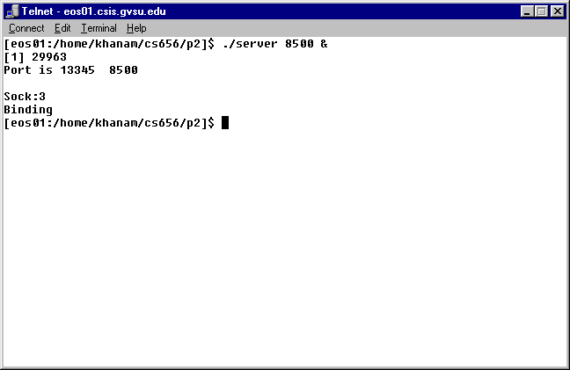

Client is started and running…
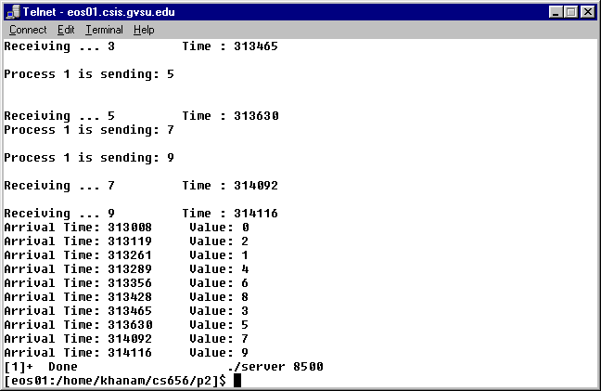

Output of Client/Server from telnet log file

[eos01:/home/khanam/cs656/p2]$ ./client eos01 8500

Process 2 is sending: 0

Receiving ... 0 Time : 313008

Process 2 is sending: 2
Process 1 is sending: 1

Receiving ... 2 Time : 313119

Process 2 is sending: 4

Receiving ... 1 Time : 313261

Receiving ... 4 Time : 313289
Process 2 is sending: 6
Process 1 is sending: 3

Receiving ... 6 Time : 313356

Process 2 is sending: 8

Receiving ... 8 Time : 313428

Receiving ... 3 Time : 313465

Process 1 is sending: 5

Receiving ... 5 Time : 313630
Process 1 is sending: 7

Process 1 is sending: 9

Receiving ... 7 Time : 314092

Receiving ... 9 Time : 314116
Arrival Time: 313008 Value: 0
Arrival Time: 313119 Value: 2
Arrival Time: 313261 Value: 1
Arrival Time: 313289 Value: 4
Arrival Time: 313356 Value: 6
Arrival Time: 313428 Value: 8
Arrival Time: 313465 Value: 3
Arrival Time: 313630 Value: 5
Arrival Time: 314092 Value: 7
Arrival Time: 314116 Value: 9
[1]+ Done ./server 8500

Output of Server with processes sending data
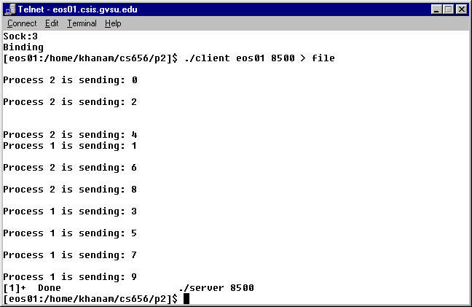

Output of Client , receiving data ( from log file)

Receiving ... 0 Time : 266785

Receiving ... 2 Time : 266857

Receiving ... 4 Time : 266947

Receiving ... 6 Time : 267004

Receiving ... 1 Time : 267090

Receiving ... 8 Time : 267099

Receiving ... 3 Time : 267191

Receiving ... 5 Time : 267302

Receiving ... 7 Time : 267372

Receiving ... 9 Time : 267681
Arrival Time: 266785 Value: 0
Arrival Time: 266857 Value: 2
Arrival Time: 266947 Value: 4
Arrival Time: 267004 Value: 6
Arrival Time: 267090 Value: 1
Arrival Time: 267099 Value: 8
Arrival Time: 267191 Value: 3
Arrival Time: 267302 Value: 5
Arrival Time: 267372 Value: 7
Arrival Time: 267681 Value: 9

