CS 656

Project 2

Process Management Concept
Pipe Version

Prepared by
Ahmed M Khan

/*
* CS 656 Project 2
* Process Management Concept
* Pipe Version
* Prepared by
* Ahmed M Khan
* mainprog.c
* Cleint (parent process) uses pipes for reading
* Server (child) uses pipes for writing
*/
#include<stdio.h>
#include<stdlib.h>
main()
{
int childpid, pipe1[2], pipe2[2];

if (pipe(pipe1) < 0 || pipe(pipe2) < 0)
printf("can't create pipes");

if ( (childpid = fork()) < 0) {
printf("can't fork");

} else if (childpid > 0) { /* parent */
/*closes write descriptors*/
close(pipe1[1]);
close(pipe2[1]);
client(pipe1[0], pipe2[0]);
while (wait((int *) 0) != childpid) /* wait for child */
;
/*closes read descriptors*/
close(pipe1[0]);
close(pipe2[0]);
exit(0);
} else { /* child */
/*closes read descriptors*/
close(pipe1[0]);
close(pipe2[0]);
server(pipe1[1], pipe2[1]);
/*closes write descriptors*/
close(pipe1[1]);
close(pipe2[1]);
exit(0);
}
}

/*
* CS 656 Project 2
* Process Management Concept
* Pipe Version
* Prepared by
* Ahmed M Khan
* server.c
*/
#include <stdio.h>
#include <stdlib.h>

#define BUF_SIZE 1
#define MAXBUFF 1024

server(writefd1, writefd2)
int writefd1;
int writefd2;
{
char file_buf[BUF_SIZE],
send_buf[BUF_SIZE],
buff[MAXBUFF];
int n, fd, numChars, ch, str_len;
int childPid2;
FILE *fptr;

/*
* Two processes read two files simultaneously
* and send data to respective pipes
*/
childPid2=fork();

if(childPid2<0){
perror(" Server:Error on fork.\n");
exit(1);
}

/*
* Read the data from the file and write to
* the IPC descriptor.
*/

/*server child is reading file1.txt sending data to client*/

if(childPid2 == 0)
{

fptr=fopen("file1.txt","r");
bzero(send_buf,BUF_SIZE);
bzero(file_buf,BUF_SIZE);

while((ch=getc(fptr))!=EOF)
{
if(ch !='\n')
{
file_buf[0]=ch;
strcpy(send_buf,file_buf);
numChars=strlen(send_buf);
printf("\nProcess 1 is sending: %s\n",send_buf);
/*writing data to pipe1*/
if(write(writefd1,send_buf,numChars)<0)
{
perror("write not ok ");
exit(1);
}
}

}
/*close file1 and exit*/
fclose(fptr);
exit(0);
}

/*server parent is reading file2.txt */
else
{

fptr=fopen("file2.txt","r");
bzero(send_buf, BUF_SIZE);
bzero(file_buf,BUF_SIZE);

while((ch=getc(fptr))!=EOF)
{
if(ch!='\n')
{
file_buf[0]=ch;
strcpy(send_buf,file_buf);
str_len=strlen(send_buf);
printf("\nProcess 2 is sending: %s\n",send_buf);
/*writing data to pipe2*/
if(write(writefd2,send_buf,str_len)<0)
{
perror("write not ok ");
exit(1);
}
}

}
while (wait((int *) 0) != childPid2) /* wait for child */
;
/*close file2 and exit*/
fclose(fptr);
exit(0);
}

}

/*
* CS 656 Project 2
* Process Management Concept
* Pipe Version
* Prepared by
* Ahmed M Khan
* client.c
*/
#include <stdio.h>
#include <time.h>
#include <stdlib.h>
#include <stdio.h>
#include <string.h>
#include <sys/types.h>

#define MAXBUFF 1024
#define BUF_SIZE 1
#define LOOP 5

client(readfd1, readfd2)
int readfd1;
int readfd2;
{
char buff[BUF_SIZE],
recv_buf1[BUF_SIZE],
recv_buf2[BUF_SIZE];
int n,i=0,j=0;
FILE *fptr;
struct timeval tv;
int time=0;
long time1=0,
time2=0;
int num1=0,
num2=0;
long merge[10][2];

fptr=fopen("timesortfile.txt","w");

/*
* Read the data from the IPC descriptor and write
* to standard output as well as to file timesortfile.txt
*/

for(i=0;i<LOOP;i++)
{
bzero(recv_buf1,BUF_SIZE);
/*reading from pipe1*/
n = read(readfd1, recv_buf1, BUF_SIZE);
recv_buf1[n] = '\0';
num1=atol(recv_buf1);
printf("\nReceiving ... %s\t", recv_buf1);
time= gettimeofday(&tv,(struct timezone *) 0);
time1=tv.tv_usec;
printf("\tTime : %ld\n",time1);

bzero(recv_buf2,BUF_SIZE);
/*reading from pipe2*/
n = read(readfd2, recv_buf2, BUF_SIZE);
recv_buf2[n] = '\0';
num2=atol(recv_buf2);
printf("\nReceiving ... %s\t", recv_buf2);
time= gettimeofday(&tv,(struct timezone *) 0);
time2=tv.tv_usec;
printf("\tTime : %ld\n",time2);

/*
*Since in each loop two data items are being received , therefore
*in each loop two data item are put in an array and sorted file
*as well.
*/
/*use of array is just for ease to display records
*alongwith the time of arrival
*/

if(time1<time2)
{
merge[j][0]=(long)num1;
merge[j][1]=time1;
putc(recv_buf1[0],fptr);
j++;
merge[j][0]=(long)num2;
merge[j][1]=time2;
putc(recv_buf2[0],fptr);
}

else
{
merge[j][0]=num2;
merge[j][1]=time2;
putc(recv_buf2[0],fptr);
merge[++j][0]=num1;
merge[j][1]=time1;
putc(recv_buf1[0],fptr);
}

j++;

}

close(fptr);

for(i=0;i<LOOP*2;i++)
{
printf("Arrival Time: %ld \t Value: %ld\n",
merge[i][1],merge[i][0]);
}

}

Screen Outputs
Server is reading files and writing data to IPC descriptors

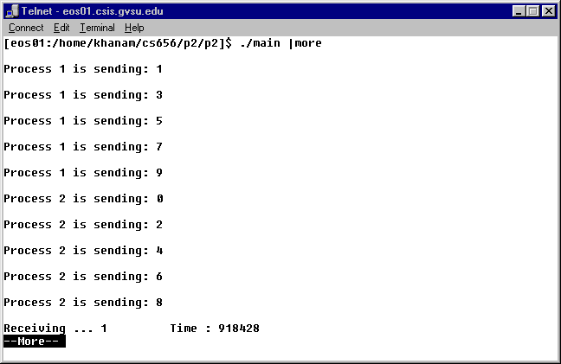

Client is receiving data by reading from respective descriptors
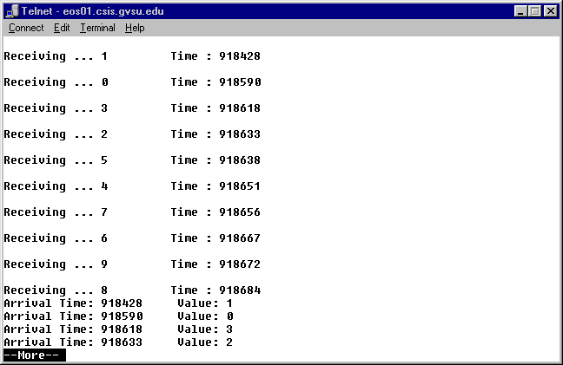

All data is sorted with the values of their arrival times.

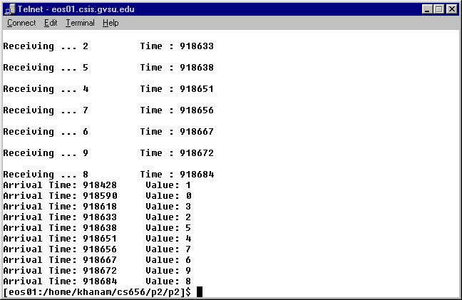

Output from telnet log file

[eos01:/home/khanam/cs656/p2/main clear
[eos01:/home/khanam/cs656/p2/p2]$ ./main |more

Process 1 is sending: 1

Process 1 is sending: 3

Process 1 is sending: 5

Process 1 is sending: 7

Process 1 is sending: 9

Process 2 is sending: 0

Process 2 is sending: 2

Process 2 is sending: 4

Process 2 is sending: 6

Process 2 is sending: 8

Receiving ... 1 Time : 382974

Receiving ... 0 Time : 382996

Receiving ... 3 Time : 383033

Receiving ... 2 Time : 383038

Receiving ... 5 Time : 383043

Receiving ... 4 Time : 383047

Receiving ... 7 Time : 383052

Receiving ... 6 Time : 383057

Receiving ... 9 Time : 383061

Receiving ... 8 Time : 383066
Arrival Time: 382974 Value: 1
Arrival Time: 382996 Value: 0
Arrival Time: 383033 Value: 3
Arrival Time: 383038 Value: 2
Arrival Time: 383043 Value: 5
Arrival Time: 383047 Value: 4
Arrival Time: 383052 Value: 7
Arrival Time: 383057 Value: 6
Arrival Time: 383061 Value: 9
Arrival Time: 383066 Value: 8

