CS 656
Project 4

Concurrency control

Prepared by
Ahmed M Khan

/********************************************************
* CS 656
* Project 4
* Concurrency Control
* Prepared by
* Ahmed M Khan
* tqueue.h
*/

typedef struct tqueue_work {
void (*routine)();
int argnum;
struct tqueue_work *next;
} tqueue_work_t;

typedef struct tqueue {
/* queue characteristics */
int num_threads;
int max_queue_size;
int do_not_block_when_full;
/* queue state */
pthread_t *threads;
int cur_queue_size;
tqueue_work_t *queue_head;
tqueue_work_t *queue_tail;
int queue_closed;
int shutdown;
/* queue synchronization */
pthread_mutex_t queue_lock;
pthread_cond_t queue_not_empty;
pthread_cond_t queue_not_full;
pthread_cond_t queue_empty;
} *tqueue_t;

void tqueue_init(
tqueue_t *tqueuep,
int num_threads,
int max_queue_size,
int do_not_block_when_full);

int tqueue_add_work(
tqueue_t tqueue,
void (*routine)(),
int argnum);
int tqueue_destroy(
tqueue_t tqueue,
int finish);
/********************************************************
* CS 656
* Project 4
* Concurrency Control
* Prepared by
* Ahmed M Khan
* tqueue.c
*/

#include <stdlib.h>
#include <stdio.h>
#include <unistd.h>
#include <sys/types.h>
#include <string.h>

#include <pthread.h>
#include "tqueue.h"

void *tqueue_thread(void *);

void tqueue_init(tqueue_t *tqueuep,
int num_worker_threads,
int max_queue_size,
int do_not_block_when_full)
{
int i, rtn,j;
tqueue_t tqueue;

/* allocate a queue data structure */
if ((tqueue = (tqueue_t )malloc(sizeof(struct tqueue))) == NULL)
perror("malloc"), exit(1);

/* initialize th fields */
tqueue->num_threads = num_worker_threads;
tqueue->max_queue_size = max_queue_size;
tqueue->do_not_block_when_full = do_not_block_when_full;
if ((tqueue->threads =
(pthread_t *)malloc(sizeof(pthread_t)*num_worker_threads))
== NULL)
perror("malloc"), exit(1);
tqueue->cur_queue_size = 0;
tqueue->queue_head = NULL;
tqueue->queue_tail = NULL;
tqueue->queue_closed = 0;
tqueue->shutdown = 0;
if ((rtn = pthread_mutex_init(&(tqueue->queue_lock), NULL)) != 0)
fprintf(stderr,"pthread_mutex_init %s",strerror(rtn)), exit(1);
if ((rtn = pthread_cond_init(&(tqueue->queue_not_empty), NULL)) != 0)
fprintf(stderr,"pthread_cond_init %s",strerror(rtn)), exit(1);
if ((rtn = pthread_cond_init(&(tqueue->queue_not_full), NULL)) != 0)
fprintf(stderr,"pthread_cond_init %s",strerror(rtn)), exit(1);
if ((rtn = pthread_cond_init(&(tqueue->queue_empty), NULL)) != 0)
fprintf(stderr,"pthread_cond_init %s",strerror(rtn)), exit(1);

/* Print idle and line*/
printf("\nRunning : Idle\n");
printf("\nQueue : \n");
printf("\n");
for(j=0;j<78;j++)
printf("_");

/* create threads */
for (i = 0; i != num_worker_threads; i++) {
if ((rtn = pthread_create( &(tqueue->threads[i]),
NULL,
tqueue_thread,
(void *)tqueue)) != 0)
fprintf(stderr,"pthread_create %d",rtn), exit(1);
}

*tqueuep = tqueue;
}

int tqueue_add_work(
tqueue_t tqueue,
void (*routine)(),
int argnum)
{
int rtn;
tqueue_work_t *workp;

if ((rtn = pthread_mutex_lock(&(tqueue->queue_lock))) != 0)
fprintf(stderr,"pthread_mutex_lock %d",rtn), exit(1);

/* no space and this caller doesn't want to wait */
if ((tqueue->cur_queue_size == tqueue->max_queue_size) &&
tqueue->do_not_block_when_full) {
if ((rtn = pthread_mutex_unlock(&(tqueue->queue_lock))) != 0)
fprintf(stderr,"pthread_mutex_unlock %d",rtn), exit(1);

return -1;
}

while( (tqueue->cur_queue_size == tqueue->max_queue_size) &&
(!(tqueue->shutdown || tqueue->queue_closed)) ) {

if ((rtn = pthread_cond_wait(&(tqueue->queue_not_full),
&(tqueue->queue_lock))) != 0)
fprintf(stderr,"pthread_cond_wait %d",rtn), exit(1);

}

/* the queue is in the process of being destroyed */
if (tqueue->shutdown || tqueue->queue_closed) {
if ((rtn = pthread_mutex_unlock(&(tqueue->queue_lock))) != 0)
fprintf(stderr,"pthread_mutex_unlock %d",rtn), exit(1);

return -1;
}

/* allocate work structure */
if ((workp = (tqueue_work_t *)malloc(sizeof(tqueue_work_t))) == NULL)
perror("malloc"), exit(1);
workp->routine = routine;
workp->argnum= argnum;
workp->next = NULL;

if (tqueue->cur_queue_size == 0) {
tqueue->queue_tail = tqueue->queue_head = workp;

if ((rtn = pthread_cond_broadcast(&(tqueue->queue_not_empty))) != 0)
fprintf(stderr,"pthread_cond_signal %d",rtn), exit(1);;
} else {
tqueue->queue_tail->next = workp;
tqueue->queue_tail = workp;
}

tqueue->cur_queue_size++;
if ((rtn = pthread_mutex_unlock(&(tqueue->queue_lock))) != 0)
fprintf(stderr,"pthread_mutex_unlock %d",rtn), exit(1);
return 1;
}

int tqueue_destroy(tqueue_t tqueue,
int finish)
{
int i,rtn;
tqueue_work_t *cur_nodep;

if ((rtn = pthread_mutex_lock(&(tqueue->queue_lock))) != 0)
fprintf(stderr,"pthread_mutex_lock %d",rtn), exit(1);

/* Is a shutdown already in progress? */
if (tqueue->queue_closed || tqueue->shutdown) {
if ((rtn = pthread_mutex_unlock(&(tqueue->queue_lock))) != 0)
fprintf(stderr,"pthread_mutex_unlock %d",rtn), exit(1);
return 0;
}

tqueue->queue_closed = 1;

/* If the finish flag is set, wait for workers to
drain queue */
if (finish == 1) {
while (tqueue->cur_queue_size != 0) {
if ((rtn = pthread_cond_wait(&(tqueue->queue_empty),
&(tqueue->queue_lock))) != 0)
fprintf(stderr,"pthread_cond_wait %d",rtn), exit(1);
}
}

tqueue->shutdown = 1;

if ((rtn = pthread_mutex_unlock(&(tqueue->queue_lock))) != 0)
fprintf(stderr,"pthread_mutex_unlock %d",rtn), exit(1);

/* Wake up any workers so they recheck shutdown flag */
if ((rtn = pthread_cond_broadcast(&(tqueue->queue_not_empty))) != 0)
fprintf(stderr,"pthread_cond_broadcast %d",rtn), exit(1);
if ((rtn = pthread_cond_broadcast(&(tqueue->queue_not_full))) != 0)
fprintf(stderr,"pthread_cond_broadcast %d",rtn), exit(1);
/* Destroy Mutex */
if ((rtn = pthread_mutex_destroy(&(tqueue->queue_lock))) != 0)
fprintf(stderr,"pthread_mutex_destroy %s",strerror(rtn)), exit(1);

/* Wait for workers to exit */
for(i=0; i < tqueue->num_threads; i++) {
if ((rtn = pthread_join(tqueue->threads[i],NULL)) != 0)
fprintf(stderr,"pthread_join %d",rtn), exit(1);
}

/* Now free queue */
free(tqueue->threads);
while(tqueue->queue_head != NULL) {
cur_nodep = tqueue->queue_head->next;
tqueue->queue_head = tqueue->queue_head->next;
free(cur_nodep);
}
free(tqueue);

printf("\n\nRunning : Idle\n");
printf("\nQueue : \n");

}

void *tqueue_thread(void *arg)
{
tqueue_t tqueue = (tqueue_t)arg;
int rtn;
tqueue_work_t *my_workp;
tqueue_work_t *temp_workp;
int i,j;
for(i=0;i<100;i++) {

/* Check queue for work */
if ((rtn = pthread_mutex_lock(&(tqueue->queue_lock))) != 0)
fprintf(stderr,"pthread_mutex_lock %d",rtn), exit(1);

while ((tqueue->cur_queue_size == 0) && (!tqueue->shutdown)) {

if ((rtn = pthread_cond_wait(&(tqueue->queue_not_empty),
&(tqueue->queue_lock))) != 0)
fprintf(stderr,"pthread_cond_wait %d",rtn), exit(1);

}

if (tqueue->shutdown == 1) {
if ((rtn = pthread_mutex_unlock(&(tqueue->queue_lock))) != 0)
fprintf(stderr,"pthread_mutex_unlock %d",rtn), exit(1);
pthread_exit(NULL);
}

/* Get to work, dequeue the next item */

my_workp = tqueue->queue_head;
tqueue->cur_queue_size--;
if (tqueue->cur_queue_size == 0)
tqueue->queue_head = tqueue->queue_tail = NULL;
else
tqueue->queue_head = my_workp->next;
/* Print running item and items in Queue*/
printf("\n\nRunning:\t %d",my_workp->argnum);
printf("\nQueue:\t");
temp_workp=my_workp;
for(j=0 ;j<tqueue->cur_queue_size;j++)
{
my_workp=my_workp->next;
printf("%d \t",my_workp->argnum);
}

my_workp=temp_workp;

/* Do work */
(*(my_workp->routine))(my_workp->argnum);
sleep(1);

/* Re-enqueue every forth item in the queue*/
if(i%4==0)
{
printf("\nre-enqueueing");
pthread_mutex_unlock(&(tqueue->queue_lock));
tqueue_add_work(tqueue,my_workp->routine,my_workp->argnum);
}

/* Print line*/
printf("\n");
for(j=0;j<78;j++)
printf("_");

/* Handle waiting add_work threads */
if ((!tqueue->do_not_block_when_full) &&
(tqueue->cur_queue_size == (tqueue->max_queue_size - 1)))

if ((rtn = pthread_cond_broadcast(&(tqueue->queue_not_full))) != 0)
fprintf(stderr,"pthread_cond_broadcast %d",rtn), exit(1);

/* Handle waiting destroyer threads */
if (tqueue->cur_queue_size == 0)

if ((rtn = pthread_cond_signal(&(tqueue->queue_empty))) != 0)
fprintf(stderr,"pthread_cond_signal %d",rtn), exit(1);
if(i%4!=0)
if ((rtn = pthread_mutex_unlock(&(tqueue->queue_lock))) != 0)
fprintf(stderr,"pthread_mutex_unlock %d",rtn), exit(1);

free(my_workp);
}
return(NULL);
}

/********************************************************
* CS 656
* Project 4
* Concurreny Control
* Prepared by
* Ahmed M Khan
* tqueuetest.c
*/
#include <stdio.h>
#include <pthread.h>
#include "tqueue.h"

void r1(int num)
{
int i, x;
for (i = 0; i < 1000000; i++) {
x = x +i;
}
}

extern int
main(void)
{

int i;
tqueue_t test_queue;

/* With 1 thread and queue size 20*/
tqueue_init(&test_queue,1, 20, 0);

sleep(5);

for ( i = 0; i < 20; i++) {
tqueue_add_work(test_queue, r1, i);
if((i%5)==0 && i!=0)
{
sleep(1);
}
}

sleep(30);
tqueue_destroy(test_queue, 1);

return 0;

}

Output using one thread – Start Screen
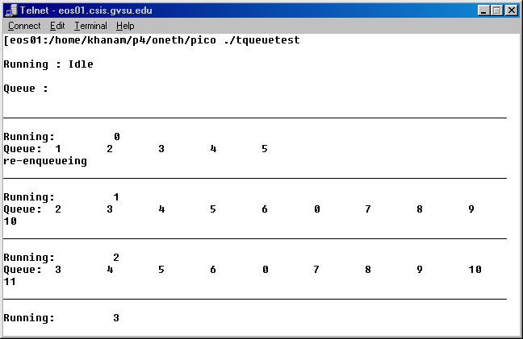

End Screen
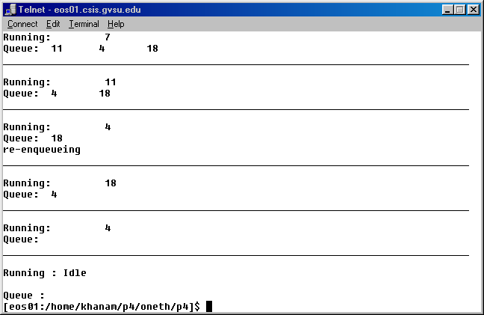

Detailed Output using one thread:

Running : Idle

Queue :

______________________________________________________________________________

Running: 0
Queue: 1 2 3 4 5
re-enqueueing
______________________________________________________________________________

Running: 1
Queue: 2 3 4 5 6 0 7 8 9
10
______________________________________________________________________________

Running: 2
Queue: 3 4 5 6 0 7 8 9 10
11
______________________________________________________________________________

Running: 3
Queue: 4 5 6 0 7 8 9 10 11
12
______________________________________________________________________________

Running: 4
Queue: 5 6 0 7 8 9 10 11 12
13
re-enqueueing
______________________________________________________________________________

Running: 5
Queue: 6 0 7 8 9 10 11 12 13
14 4 15
______________________________________________________________________________

Running: 6
Queue: 0 7 8 9 10 11 12 13 14
4 15 16
______________________________________________________________________________

Running: 0
Queue: 7 8 9 10 11 12 13 14 4
15 16 17
______________________________________________________________________________

Running: 7
Queue: 8 9 10 11 12 13 14 4 15
16 17 18
re-enqueueing
______________________________________________________________________________

Running: 8
Queue: 9 10 11 12 13 14 4 15 16
17 18 19 7
______________________________________________________________________________

Running: 9
Queue: 10 11 12 13 14 4 15 16 17
18 19 7
______________________________________________________________________________

Running: 10
Queue: 11 12 13 14 4 15 16 17 18
19 7
______________________________________________________________________________

Running: 11
Queue: 12 13 14 4 15 16 17 18 19
7
re-enqueueing
______________________________________________________________________________

Running: 12
Queue: 13 14 4 15 16 17 18 19 7
11
______________________________________________________________________________

Running: 13
Queue: 14 4 15 16 17 18 19 7 11

______________________________________________________________________________

Running: 14
Queue: 4 15 16 17 18 19 7 11
______________________________________________________________________________

Running: 4
Queue: 15 16 17 18 19 7 11
re-enqueueing
______________________________________________________________________________

Running: 15
Queue: 16 17 18 19 7 11 4
______________________________________________________________________________

Running: 16
Queue: 17 18 19 7 11 4
______________________________________________________________________________

Running: 17
Queue: 18 19 7 11 4
______________________________________________________________________________

Running: 18
Queue: 19 7 11 4
re-enqueueing
______________________________________________________________________________

Running: 19
Queue: 7 11 4 18
______________________________________________________________________________

Running: 7
Queue: 11 4 18
______________________________________________________________________________

Running: 11
Queue: 4 18
______________________________________________________________________________

Running: 4
Queue: 18
re-enqueueing
______________________________________________________________________________

Running: 18
Queue: 4
______________________________________________________________________________

Running: 4
Queue:
______________________________________________________________________________

Running : Idle

Queue :

Detailed Output using ten threads:

Running : Idle

Queue :

______________________________________________________________________________

Running: 0
Queue:
re-enqueueing

Running: 1
Queue:
re-enqueueing
______________________________________________________________________________

Running: 0
Queue: 2
re-enqueueing

Running: 2
Queue: 1
______________________________________________________________________________
re-enqueueing

Running: 1
Queue: 3
______________________________________________________________________________

Running: 3
Queue:
re-enqueueing

Running: 0
Queue:
______________________________________________________________________________

Running: 4
Queue: 2 ______________________________________________________________________________

Running: 2
Queue: 3
re-enqueueing

Running: 3
Queue:
re-enqueueing

Running: 5
Queue:
______________________________________________________________________________

Running: 2
Queue: 3 ______________________________________________________________________________

Running: 3
Queue:
re-enqueueing

Running: 6
Queue:
______________________________________________________________________________

Running: 3
Queue: 7 ______________________________________________________________________________

Running: 7
Queue:
re-enqueueing

Running: 8
Queue:
______________________________________________________________________________

Running: 7
Queue:
______________________________________________________________________________

Running: 9
Queue:
______________________________________________________________________________

Running: 10
Queue:
______________________________________________________________________________

Running: 11
Queue:
______________________________________________________________________________

Running: 12
Queue:
______________________________________________________________________________

Running: 13
Queue:
______________________________________________________________________________

Running: 14
Queue:
______________________________________________________________________________

Running: 15
Queue:
______________________________________________________________________________

Running: 16
Queue:
re-enqueueing

Running: 17
Queue:
re-enqueueing
_________________________________________________________________

Running: 16
Queue: 18 ______________________________________________________________________________

Running: 18
Queue: 17
______________________________________________________________________________

Running: 17
Queue:
re-enqueueing

Running: 19
Queue:
______________________________________________________________________________

Running: 17
Queue:

Reference

Pthreads Programming,
Bradford, N.
Orielly1998.

