CS 656

Project 5

Distributed IPC : Remote Procedure Call

Prepared by

Ahmed M Khan

/*
* sys.x - Specification of remote uptime and storage space service.
*/

/*
* Define 2 procedures:
* sys_uptime_1() returns the uptime.
* sys_space_1() returns the free and the user blocks
*/

/* structure definition */
struct values{
long free_blocks;
long user_blocks;
};

program SYS_PROG {
version SYS_VERS {
long SYS_UPTIME(int) = 1; /* procedure number = 1 */
values SYS_SPACE(int) = 2; /* procedure number = 2 */
} = 1; /* version number = 1 */
} = 0x30000001; /* program number = 0x30000001 */

/*
* Please do not edit this file.
* It was generated using rpcgen.
* sys.h
*/

#ifndef _SYS_H_RPCGEN
#define _SYS_H_RPCGEN

#include <rpc/rpc.h>

#ifdef __cplusplus
extern "C" {
#endif

struct values {
long free_blocks;
long user_blocks;
};
typedef struct values values;

#define SYS_PROG 0x30000001
#define SYS_VERS 1

#if defined(__STDC__) || defined(__cplusplus)
#define SYS_UPTIME 1
extern long * sys_uptime_1(int *, CLIENT *);
extern long * sys_uptime_1_svc(int *, struct svc_req *);
#define SYS_SPACE 2
extern values * sys_space_1(int *, CLIENT *);
extern values * sys_space_1_svc(int *, struct svc_req *);
extern int sys_prog_1_freeresult (SVCXPRT *, xdrproc_t, caddr_t);

#else /* K&R C */
#define SYS_UPTIME 1
extern long * sys_uptime_1();
extern long * sys_uptime_1_svc();
#define SYS_SPACE 2
extern values * sys_space_1();
extern values * sys_space_1_svc();
extern int sys_prog_1_freeresult ();
#endif /* K&R C */

/* the xdr functions */

#if defined(__STDC__) || defined(__cplusplus)
extern bool_t xdr_values (XDR *, values*);

#else /* K&R C */
extern bool_t xdr_values ();

#endif /* K&R C */

#ifdef __cplusplus
}
#endif

#endif /* !_SYS_H_RPCGEN */

/******************************************************************
* CS 656
* Project 5
* RPC Version of Reliability and Capacity service program
* to compare with Client/Server
* Socket based program of the same functionality
*
* Prepared by
* Ahmed M Khan
* rsys.c - client program for remote service.
*/

#include <stdio.h>
#include <rpc/rpc.h> /* standard RPC include file */
#include "sys.h" /* this file is generated by rpcgen */
#include <ctype.h>

main(argc, argv)
int argc;
char *argv[];
{
CLIENT *cl; /* RPC handle */
char *server;
long *lresult; /* return value from sys_uptime_1() */
struct values *sresult;
/* return value from sys_space_1() */

/* variables and structure to get time */
long beginTime, endTime;
struct timeval tv;
int time;

/* dummy int - just for sending it to server */
/**************************************************
* Note: functions with no arguments in .x file
* i.e., void values give error
* while compile time.
* To avoid that, a single int variable is sent
* to the function
*************************************************/
int x=0;

if (argc != 2) {
fprintf(stderr, "usage: %s hostname\n", argv[0]);
exit(1);
}
server = argv[1];

/*
* Create the client "handle" and using udp for communication
*/

if ( (cl = clnt_create(server, SYS_PROG, SYS_VERS, "udp")) == NULL) {
/*
* Couldn't establish connection with server.
*/

clnt_pcreateerror(server);
exit(2);
}

for( ; ; )
{
/* options */
printf("\nStatus: (1:Reliability 2:Capacity 3:Quit)?");
scanf("%d",&x);

/* Checking for correct option selected */
if (x!=1 && x!=2 && x!=3)
{
printf("\nPlease enter correct Selection\n");
continue;
}

/* get begin time of the process */
time=gettimeofday(&tv,(struct timezone *)0);
beginTime=tv.tv_usec;

/*
* First call the remote procedure "sys_uptime".
*/
if(x==1)
{
if ( (lresult = sys_uptime_1(&x, cl)) == NULL) {
clnt_perror(cl, server);
exit(3);
}
/* print uptime */
printf("On host %s Uptime = %ld seconds\n",
server, *lresult);
}

/*
* Now call the remote procedure "sys_space".
*/

if(x==2)
{
sresult=(struct values *)malloc(sizeof(struct values));
if ( (sresult = sys_space_1(&x, cl)) == NULL) {
clnt_perror(cl, server);
exit(4);
}
/* print free and user blocks */
printf("On host %s Free blocks= %ld User blocks=%ld\n ",
server, sresult->free_blocks,
sresult->user_blocks);
}
if(x==1 || x==2)
{
/* get end time of the process */
time=gettimeofday(&tv,(struct timezone *)0);
endTime=tv.tv_usec;
/* show time consumed during single call */
printf("Call took: %ld microsecs\n",endTime-beginTime);
}

if(x==3)
{
clnt_destroy(cl);
/* done with the handle */
printf("\nShutting Down......\n");

/*exit*/
printf("exit\n");
exit(0);
}

}

}

/******************************************************************
* CS 656
* Project 5
* RPC Version of Reliability and Capacity service program
* to compare with Client/Server
* Socket based program of the same functionality
*
* Prepared by
* Ahmed M Khan
*
* sys_server.c
* Note:
* The procedures defined in sys_proc.c are copied here
* and compile and link using command
* gcc -o sys_svc sys_server.c sys_svc.c sys_xdr.c -lrpcsvc
*
* This is sample code generated by rpcgen.
* These are only templates and you can use them
* as a guideline for developing your own functions.
*/
#include <stdlib.h>
#include <stdio.h>
#include "sys.h"
#include <sys/sysinfo.h>
#include <linux/sys.h>
#include <linux/kernel.h>
#include <sys/types.h>
#include <sys/statfs.h>
#include <sys/statvfs.h>
#include <sys/vfs.h>

long *
sys_uptime_1_svc(int *argp, struct svc_req *rqstp)
{
/* structure to get system info like uptime, memroy usage stats */
struct sysinfo info;

/* to hold uptime return to the caller , must be static */
static long uptime;

/* getting sys info */
sysinfo((struct sysinfo *)&info);
uptime=info.uptime;

/* return uptime */
return(&uptime);

}

values *
sys_space_1_svc(int *argp, struct svc_req *rqstp)
{
/* storage media hardcoded here */
char *argv="/dev/hda1";

/* for block sizes */
float div2k;

/* hold values of the storage in a structure values */
static values *pR = NULL;

/* structure for getting storage stats */
struct statfs stats;

/* getting and checking stats */
if(statfs(argv, &stats) != 0)
{
fprintf(stderr, "error getting stats for %s\n", argv[1]);
exit(1);
}

/* Finding free and user blocks sizes */
div2k = stats.f_bsize/1024;
pR= (values *)malloc(sizeof(values));
pR->free_blocks=stats.f_bfree*(long int)div2k;
pR->user_blocks=stats.f_bavail*(long int)div2k;

/* return structure values */
return((values *) pR);

}

/*
* Please do not edit this file.
* It was generated using rpcgen.
* sys_svc.c
*/

#include "sys.h"
#include <stdio.h>
#include <stdlib.h>
#include <rpc/pmap_clnt.h>
#include <string.h>
#include <memory.h>
#include <sys/socket.h>
#include <netinet/in.h>

#ifndef SIG_PF
#define SIG_PF void(*)(int)
#endif

static void
sys_prog_1(struct svc_req *rqstp, register SVCXPRT *transp)
{
union {
int sys_uptime_1_arg;
int sys_space_1_arg;
} argument;
char *result;
xdrproc_t _xdr_argument, _xdr_result;
char *(*local)(char *, struct svc_req *);

switch (rqstp->rq_proc) {
case NULLPROC:
(void) svc_sendreply (transp, (xdrproc_t) xdr_void, (char *)NULL);
return;

case SYS_UPTIME:
_xdr_argument = (xdrproc_t) xdr_int;
_xdr_result = (xdrproc_t) xdr_long;
local = (char *(*)(char *, struct svc_req *)) sys_uptime_1_svc;
break;

case SYS_SPACE:
_xdr_argument = (xdrproc_t) xdr_int;
_xdr_result = (xdrproc_t) xdr_values;
local = (char *(*)(char *, struct svc_req *)) sys_space_1_svc;
break;

default:
svcerr_noproc (transp);
return;
}
memset ((char *)&argument, 0, sizeof (argument));
if (!svc_getargs (transp, _xdr_argument, (caddr_t) &argument)) {
svcerr_decode (transp);
return;
}
result = (*local)((char *)&argument, rqstp);
if (result != NULL && !svc_sendreply(transp, _xdr_result, result)) {
svcerr_systemerr (transp);
}
if (!svc_freeargs (transp, _xdr_argument, (caddr_t) &argument)) {
fprintf (stderr, "%s", "unable to free arguments");
exit (1);
}
return;
}

int
main (int argc, char **argv)
{
register SVCXPRT *transp;

pmap_unset (SYS_PROG, SYS_VERS);

transp = svcudp_create(RPC_ANYSOCK);
if (transp == NULL) {
fprintf (stderr, "%s", "cannot create udp service.");
exit(1);
}
if (!svc_register(transp, SYS_PROG, SYS_VERS, sys_prog_1, IPPROTO_UDP)) {
fprintf (stderr, "%s", "unable to register (SYS_PROG, SYS_VERS, udp).");
exit(1);
}

transp = svctcp_create(RPC_ANYSOCK, 0, 0);
if (transp == NULL) {
fprintf (stderr, "%s", "cannot create tcp service.");
exit(1);
}
if (!svc_register(transp, SYS_PROG, SYS_VERS, sys_prog_1, IPPROTO_TCP)) {
fprintf (stderr, "%s", "unable to register (SYS_PROG, SYS_VERS, tcp).");
exit(1);
}

svc_run ();
fprintf (stderr, "%s", "svc_run returned");
exit (1);
/* NOTREACHED */
}

/*
* Please do not edit this file.
* It was generated using rpcgen.
* sys_xdr.c
*/

#include "sys.h"

bool_t
xdr_values (XDR *xdrs, values *objp)
{
register int32_t *buf;

if (!xdr_long (xdrs, &objp->free_blocks))
return FALSE;
if (!xdr_long (xdrs, &objp->user_blocks))
return FALSE;
return TRUE;
}

/*
* This is sample code generated by rpcgen.
* These are only templates and you can use them
* as a guideline for developing your own functions.
* sys_client.c
*/

#include "sys.h"

void
sys_prog_1(char *host)
{
CLIENT *clnt;
long *result_1;
int sys_uptime_1_arg;
values *result_2;
int sys_space_1_arg;

#ifndef DEBUG
clnt = clnt_create (host, SYS_PROG, SYS_VERS, "udp");
if (clnt == NULL) {
clnt_pcreateerror (host);
exit (1);
}
#endif /* DEBUG */

result_1 = sys_uptime_1(&sys_uptime_1_arg, clnt);
if (result_1 == (long *) NULL) {
clnt_perror (clnt, "call failed");
}
result_2 = sys_space_1(&sys_space_1_arg, clnt);
if (result_2 == (values *) NULL) {
clnt_perror (clnt, "call failed");
}
#ifndef DEBUG
clnt_destroy (clnt);
#endif /* DEBUG */
}

int
main (int argc, char *argv[])
{
char *host;

if (argc < 2) {
printf ("usage: %s server_host\n", argv[0]);
exit (1);
}
host = argv[1];
sys_prog_1 (host);
exit (0);
}

/*
* Please do not edit this file.
* It was generated using rpcgen.
* Sys_clnt.c
*/

#include <memory.h> /* for memset */
#include "sys.h"

/* Default timeout can be changed using clnt_control() */
static struct timeval TIMEOUT = { 25, 0 };

long *
sys_uptime_1(int *argp, CLIENT *clnt)
{
static long clnt_res;

memset((char *)&clnt_res, 0, sizeof(clnt_res));
if (clnt_call (clnt, SYS_UPTIME,
(xdrproc_t) xdr_int, (caddr_t) argp,
(xdrproc_t) xdr_long, (caddr_t) &clnt_res,
TIMEOUT) != RPC_SUCCESS) {
return (NULL);
}
return (&clnt_res);
}

values *
sys_space_1(int *argp, CLIENT *clnt)
{
static values clnt_res;

memset((char *)&clnt_res, 0, sizeof(clnt_res));
if (clnt_call (clnt, SYS_SPACE,
(xdrproc_t) xdr_int, (caddr_t) argp,
(xdrproc_t) xdr_values, (caddr_t) &clnt_res,
TIMEOUT) != RPC_SUCCESS) {
return (NULL);
}
return (&clnt_res);
}

Screen Output:
RPC server is started and running………
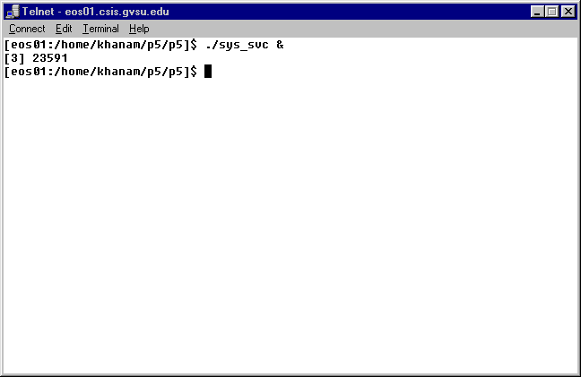

Client is started on the same server ( eos01 ).
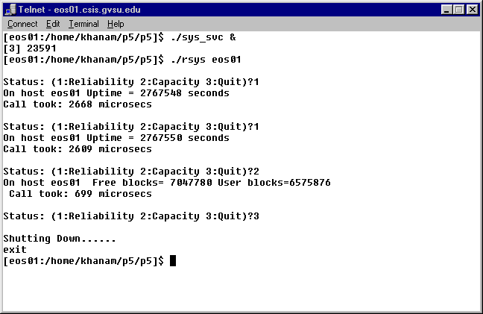

Client is started on different server (eos12).
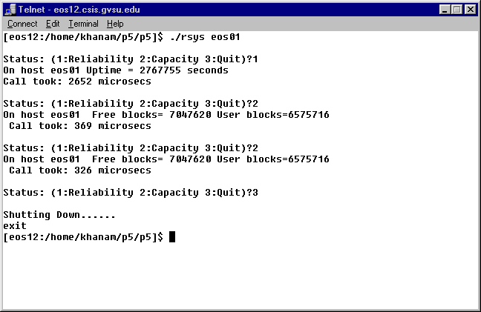
Client on Okami server
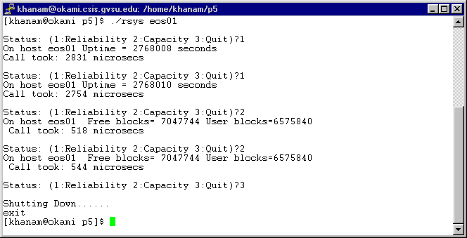

The capacity values in all outputs are different because of usage of the storage area of the system eos01.

Verification of Uptime using uptime command:
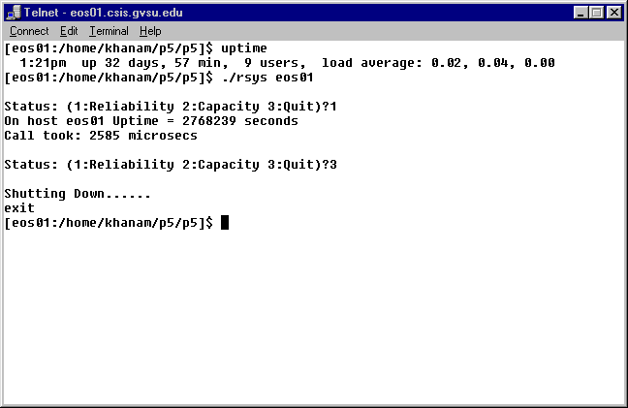
In the above diagram, uptime is 2768239 seconds which is almost equal to 32 hours and 57 minutes.
Verification of storage area using df command:
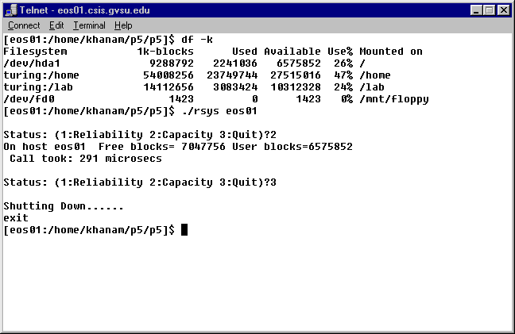
In the above screen output, available storage using df –k command and user blocks of the program are same.

/******************************************************************
* CS 656
* Project 5
* Socket Version of Reliability and Capacity service program
* to compare with RPC program of the same functionality
*
* Prepared by
* Ahmed M Khan
* client.c
*/
#include <sys/types.h>
#include <sys/socket.h>
#include <netdb.h>
#include <string.h>
#include <netinet/in.h>
#include <stdio.h>
#include <errno.h>
#include <stdlib.h>
#include <time.h>
#include "readn.h"

int main(int argc, char *argv[])
{
const int BUF_SEND =1; /* biffer size for sending data */
const int BUF_RECV =64;/* buffer size for receiving data */
struct hostent *host; /* Pointer to server host information struct */
int sock; /* the socket that we will use to the server */
struct sockaddr_in client, server; /* client and server address info */
int numChars; /* number of bytes recieved */
char recv_buf[BUF_RECV];
char send_buf[BUF_SEND];
int structlength; /* length of sockaddr structure */
int port; /* port we talk to server on */
struct in_addr *addr; /* Internet address of server */
char x[8];
int ch,y=0;

/* structure for time */
struct timeval tv;
/* variables for getting time */
int time;
long beginTime,endTime;

if (argc < 3) {
fprintf(stderr,"Usage: tcpclient host port\n");
fprintf(stderr,"where host is a host name, and\n");
fprintf(stderr,"port is a port number.\n");
exit(EXIT_FAILURE);
}
port = atoi(argv[2]);
port = htons(atoi(argv[2])); /* Convert argv[2] to network ordered
short integer */

host = gethostbyname(argv[1]);
if (host == 0) {
fprintf(stderr,"Invalid network address: %s\n",argv[1]);
exit(EXIT_FAILURE);
}

/* Request socket */
sock = socket(AF_INET, SOCK_STREAM, 0);
if (sock < 0) {
perror("socket");
exit(EXIT_FAILURE);
}

/* Set up the server address struct */
memset((char *) &server, 0, sizeof(server));
server.sin_family = AF_INET;
memcpy(&server.sin_addr, host->h_addr, host->h_length);
server.sin_port = port;

memset((char *) &client, 0, sizeof(client));
client.sin_family = AF_INET;
client.sin_addr.s_addr = htonl(INADDR_ANY);
client.sin_port = htons(0);

/* Connecting to server */
if(connect(sock,(struct sockaddr *)&server, sizeof(server))<0)
{
perror("connect not ok?\n");
exit(1);
}

while(y!=3)
{
/* options */
printf("\nStatus: (1:Reliability 2:Capacity 3:Quit)?");
fgets(x,8,stdin);
/* convert selection into int */
y=atoi(x);

/* put selection string into sending buffer */
bzero(send_buf,BUF_SEND);
strcpy(send_buf,x);
numChars=strlen(send_buf);

/* getting the begin time of the process */
time=gettimeofday(&tv,(struct timezone *)0);
beginTime=tv.tv_usec;

/* send data to server */
if(write(sock,send_buf,numChars)<0)
{
perror("write not ok ");
exit(1);
}

/* receive data from the server - read the socket */
bzero(recv_buf,BUF_RECV);
numChars=readn(sock,recv_buf,BUF_RECV);
recv_buf[numChars] = '\0';

/* getting end time of a single operation*/
time= gettimeofday(&tv,(struct timezone *) 0);
endTime=tv.tv_usec;

/* print the string received as it is */
printf("\n%s \n",recv_buf);

/*Show how much time is consumed during getting stats */
printf("Call took: %ld microsecs\n",endTime-beginTime);
}

/*close the socket and exit */
close(sock);
exit(0);

}

/******************************************************************
* CS 656
* Project 5
* Socket Version of Reliability and Capacity service program
* to compare with RPC program of the same functionality
*
* Prepared by
* Ahmed M Khan
* server.c
*/
#include <signal.h>
#include <sys/wait.h>
#include <unistd.h>
#include <sys/types.h>
#include <sys/socket.h>
#include <string.h>
#include <netinet/in.h>
#include <errno.h>
#include <stdio.h>
#include <stdlib.h>
#include <ctype.h>
#include <sys/stat.h>
#include <sys/sysinfo.h>
#include <linux/sys.h>
#include <linux/kernel.h>
#include <sys/types.h>
#include <sys/statfs.h>
#include <sys/statvfs.h>
#include <sys/vfs.h>
#include "readn.h"

int main(int argc, char* argv[])
{
/* buffer size for sending and receiving string */
const int BUF_SIZE = 128;
int sock; /* the socket we will use */
struct sockaddr_in client, // socket address information data
server; // structures
int newSock;
char recv_buf[BUF_SIZE], send_buf[BUF_SIZE]; /*
Buffer for data read from socket */

int structlength=0; /* length of sockaddr structure */
int port,numChars, LQ=1024; /* the port we will use */

/* to hold uptime from sysinfo */
long uptime=0;

/* hard disk name is hard coded here */
char *disk="/dev/hda1";

/* for block size */
float div2k;

/* Structure for storage info */
struct statfs stats;

/* Structure for system info */
struct sysinfo info;

int y=0;

if (argc < 2) {
fprintf(stderr,"Usage: tcpserver port\n");
fprintf(stderr,"where port is a port number.\n");
exit(EXIT_FAILURE);
}

port = atoi(argv[1]);
port = htons(port); /* Convert argv[1] to network ordered integer */
printf("Port is %d %d \n", port, ntohs(port));

sock = socket(AF_INET, SOCK_STREAM, 0);
if (sock < 0) {
perror("socket");
exit(EXIT_FAILURE);
}
printf("\nSock:%d\n",sock);
memset((char *) &server, 0, sizeof(server));
server.sin_family = AF_INET;
server.sin_addr.s_addr = htonl(INADDR_ANY);
server.sin_port = port;

printf("Binding\n");

structlength = sizeof(server);

/* Binding */
if (bind(sock, (struct sockaddr *) &server, structlength) < 0) {
perror("bind");
exit(EXIT_FAILURE);
}

if ( getsockname( sock, (struct sockaddr *)&server, &structlength ) )
{
perror(" error getting socket name");
exit(1);
}

/* listening */
listen(sock, LQ);

newSock=accept(sock,(struct sockaddr *) &client, &structlength);

if(newSock == -1){
perror(" Server:Error on accept\n");
exit(1);
}

while(1){
bzero(recv_buf,BUF_SIZE);

/* reading the socket for incoming values from the client */
numChars=readn(newSock,recv_buf,BUF_SIZE);

/* convert ascii to int */
y=atoi(recv_buf);

if(y==1)
{
/* getting system info into structure info */
sysinfo((struct sysinfo *)&info);

/*assigning uptime value from sysinfo to uptime variable */
uptime=info.uptime;

sprintf(send_buf,"\nUptime : %ld seconds",uptime);
numChars=strlen(send_buf);
}

else if(y==2)
{
/* getting and checking storage status */
if(statfs(disk, &stats) != 0)
{
fprintf(stderr, "error getting stats for server\n");
exit(1);
}

/*Free blocks and avaiable user blocks */
div2k = stats.f_bsize/1024;
sprintf(send_buf,"\nFree blocks: %ld User blocks: %ld",
stats.f_bfree*(long int)div2k,
stats.f_bavail*(long int)div2k);
numChars=strlen(send_buf);
}
else if(y==3)
{
/* close socket and exit */
printf("\nShutting down......\nexit\n");
close(newSock);
exit(0);
}

else
{
/* wrong query from the client */
strcpy(send_buf,"\nPlease enter correct Selection\n");
numChars=strlen(send_buf);
}

/* sending data to cleint */
if(write(newSock,send_buf,numChars)<0)
{
perror("write not ok ");
exit(1);
}
}

}
Screen Output:
Socket based Server is started and running……………
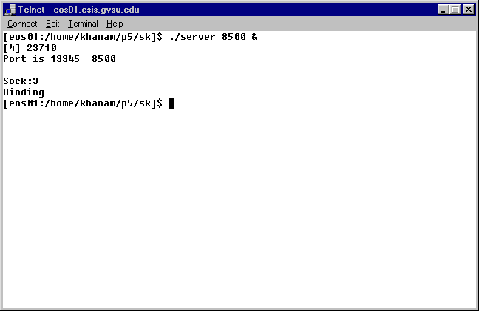

Client is started………
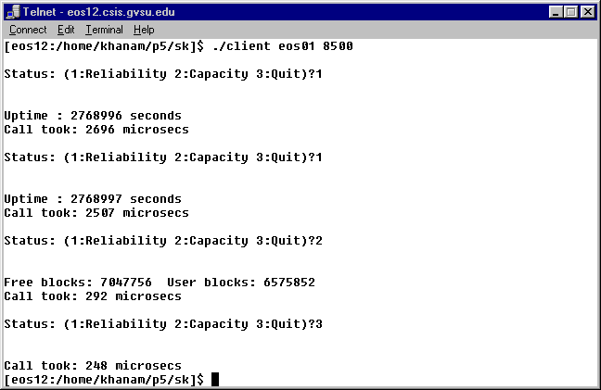

Comparison between RPC version and Socket based program

RPC client program is retrieving uptime from the remote server
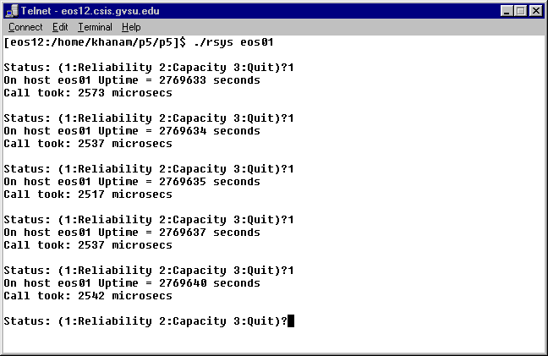
Processing time is around 2500 micro seconds.
Now Socket based client is obtaining uptime information from its remote server………
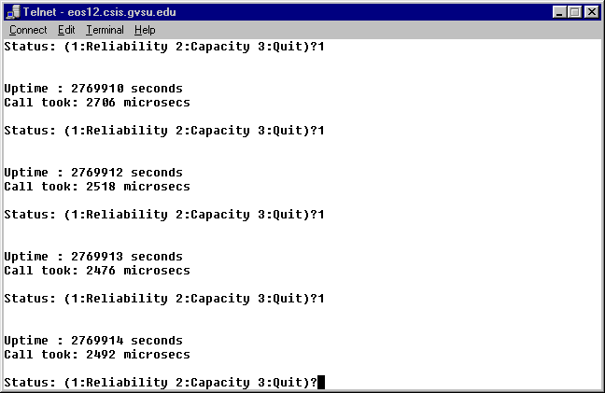

This version also shows the same ( 2500 micro seconds ) average processing time which include communication times in both cases.

RPC client is getting information about storage space of the media
( hard disk ).
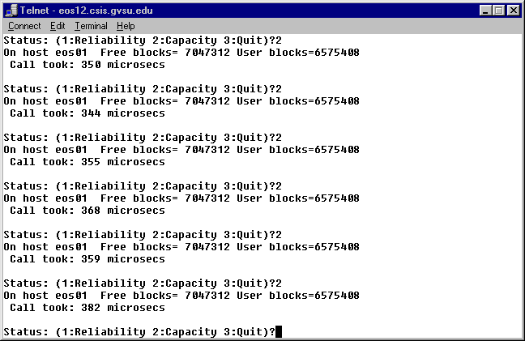
From the above screen output, average estimate processing time is between 340 and 400 microseconds.
Socket based Client is now getting the same information,
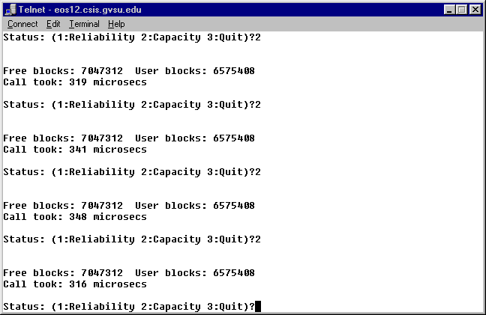
Average processing time is between 310 and 350 microseconds. So the processing time plus communication time does not differ very much for the both ( rpc & socket ) systems.

In the all above rpc execution sequence rpc client is using udp protocol. If the protocol is changed to tcp ( just change client handle’s last argument in rsys.c i.e., client program ) there will be negligible change in the performance.

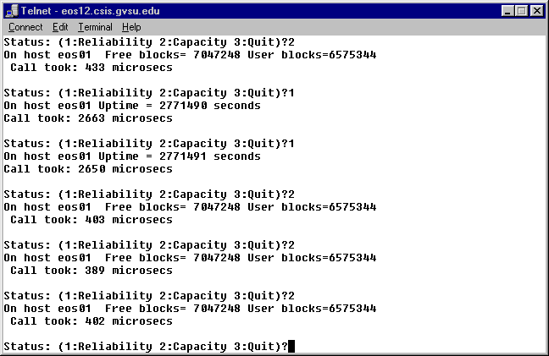

The above screen shows that tcp socket based program is even slower than rpc one though only one way communication is going on between client and server of the socket version.

References

Unix Network Programming
Stevens, W. Richard.
Prentice Hall 1990

Power Programming using RPC
Bloomer, John.
Oreilly 1992

