Project 6

CS 656

Distributed Shared Memory Programming

Prepared by

Ahmed M Khan

/***************************************************************
* Project 6
* Distributed Shared Memory Programming
* Prepared by
* Ahmed M Khan
*This master program generates the matrix values and then write them *on and then wait till worker claculate the result and write them *back to master
*/
// master.java

import java.util.*;
import java.lang.*;
import java.text.*;
import java.io.*;
import com.ibm.tspaces.*;

public class master {
public static void main( String argv[] ) {

String host = "localhost";
int n=1,x=0;
//variable for matrix dimension
int dim=0;

// user specified a server host & Dimension
if (argv.length ==2)
{
host = argv[0];
dim= Integer.parseInt(argv[1]);
}
else
{
System.out.println("Usage: command hostname ArrayDimension");
System.exit(1);
}

try {

TupleSpace ts = new TupleSpace("Sample1", host);
Tuple tup = null;

//instantiating dimension tuple
Tuple d = new Tuple("Dim", new Integer(dim));

//writing so that workers can read
ts.write(d);

//tuple for multiple values
Tuple multi = new Tuple();

//matrix formation routine
for(int k=1;k<=2;k++)
{
for(int i=1; i<=dim; i++)
{
for(int j=1; j<=dim; j++)
{
//assigning each value ( random numbers )
Tuple t1 = new Tuple("Matrix"+k+i+j, new Integer((int)
(Math.random()*9)));
//adding for multiple writing
multi.add(new Field(t1));
}
}
}
//writing all values in one go
TupleID[] ids = ts.multiWrite(multi);

//printing calculated matrix while receiving valies from worker
System.out.println("Matrix C");
for(int i=1; i<=dim; i++)
{
for(int j=1; j<=dim; j++)
{
// wait and take the calculated value
SuperTuple answer = ts.waitToTake("MatrixC"+i+j, new
Field(Integer.class));
Integer data =(Integer) answer.getField(1).getValue();
System.out.print("\t"+data.intValue());
}
System.out.println(" ");
}

} catch(TupleSpaceException tse) {
System.out.println(tse);
}
}
}

/**********************************************************
* Project 6
* Distributed Shared Memory Programming
* Prepared by
* Ahmed M Khan
* This is the worker program which reads the shared data and calculate
* the result. It receives the array dimension and all array values * from
* the master. This program uses countN, scan and wait funtionalities
*
*/
// worker.java

import java.util.*;
import java.lang.*;
import java.text.*;
import java.io.*;
import com.ibm.tspaces.*;

public class worker {

public static void main( String argv[] ) {

String host = "localhost";
int n=1,x=0, sum=0, count=0, dimen=0;

// user specified a server host
if (argv.length > 0)
host = argv[0];

try {
TupleSpace ts = new TupleSpace("Sample1", host);
//tuple for array dimension
Tuple dimTemplate = new Tuple("Dim", new Field(Integer.class));
SuperTuple tuple = (Tuple) ts.waitToTake(dimTemplate);
Integer dim = (Integer) tuple.getField(1).getValue();
dimen = dim.intValue();
//array declerations
int matrixA[][];
matrixA = new int[dimen][dimen];
int matrixB[][];
matrixB = new int[dimen][dimen];

//reading and assigning tuple values to arrays
for(int i=1; i<=dimen;i++)
{
for(int j=1; j<=dimen;j++)
{
{
Tuple template1 = new Tuple("Matrix"+1+i+j, new
Field(Integer.class));
Tuple template2 = new Tuple("Matrix"+2+i+j, new
Field(Integer.class));

SuperTuple wait1 = ts.waitToRead("Matrix"+1+i+j,
new
Field(Integer.class));
SuperTuple wait2 = ts.waitToRead("Matrix"+2+i+j,
new
Field(Integer.class));

int count1 = ts.countN(template1);
int count2 = ts.countN(template2);
if(count1 >0 && count2>0)
{
Tuple tupleSet1 = ts.scan(template1);
Tuple tupleSet2 = ts.scan(template2);
if( tupleSet1 != null && tupleSet2 != null)
{
for (Enumeration e1 = tupleSet1.fields();e1.hasMoreElements();)
for( Enumeration e2 = tupleSet2.fields();e2.hasMoreElements();)

{
Field f1 = (Field)e1.nextElement();
Field f2 = (Field)e2.nextElement();
Tuple tuple1 = (Tuple)f1.getValue();
Tuple tuple2 = (Tuple)f2.getValue();
Integer data1 = (Integer) tuple1.getField(1).getValue();
Integer data2 = (Integer) tuple2.getField(1).getValue();
ts.take(template1);
ts.take(template2);
matrixA[i-1][j-1]=data1.intValue();
matrixB[i-1][j-1]=data2.intValue();

break;

}
}
}
}

}
}
//printing matrix A
System.out.println("Matrix A");
for(int i=0; i<dimen; i++)
{
for(int j=0; j<dimen; j++)
{
System.out.print("\t "+matrixA[i][j]);
}
System.out.println(" ");
}
//printing matrix B
System.out.println("Matrix B");
for(int i=0; i<dimen; i++)
{
for(int j=0; j<dimen; j++)
{
System.out.print("\t "+matrixB[i][j]);
}
System.out.println(" ");
}

//calculating and sending values back to master
for(int i=0; i<dimen;i++)
{
for(int j=0; j<dimen;j++)
{
for(int k=0;k<dimen;k++)
{
sum=(matrixA[i][k]*matrixB[k][j])+sum;
}
int col=j+1; int row=i+1;
ts.write("MatrixC"+row+col, new Integer(sum));
sum=0;
}
}

//exit program
System.exit(1);

} catch(TupleSpaceException tse) {
System.out.println(tse);
}

}

}

Screen Outputs
First of all worker is started and it waits for data … as soon as master writes it graps (reads) the values from the tuplespace does its calculations
Worker is started and Ready……….
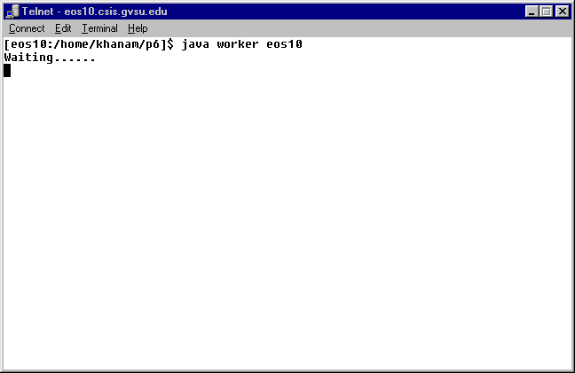

Now master is started…
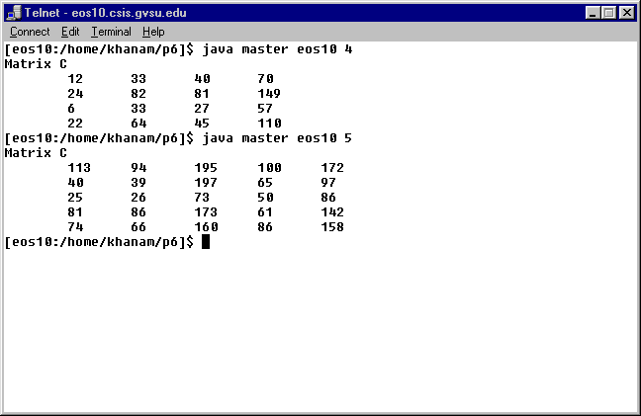
As soon as it starts .. it writes on tuplespace and worker ready fetch the values and writes new calculated values. The last argument is the array dimension required at command line.

Worker receiving array values and printing them…
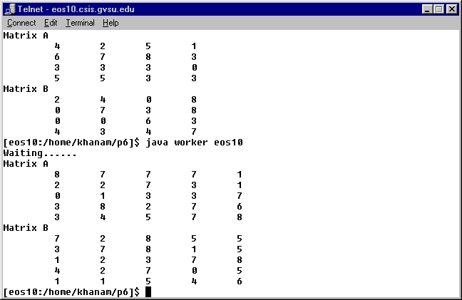

It can process array of 2x2 of small arrays as well as larger arrays as shown below.
Worker:
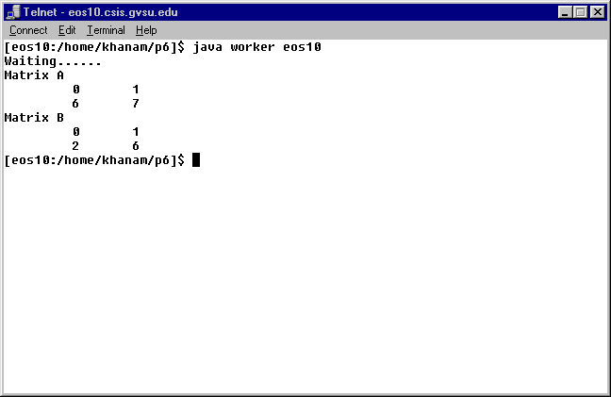

Master:
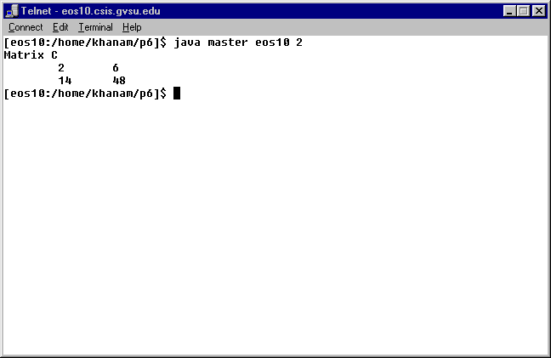

Larger arrays..
Worker:
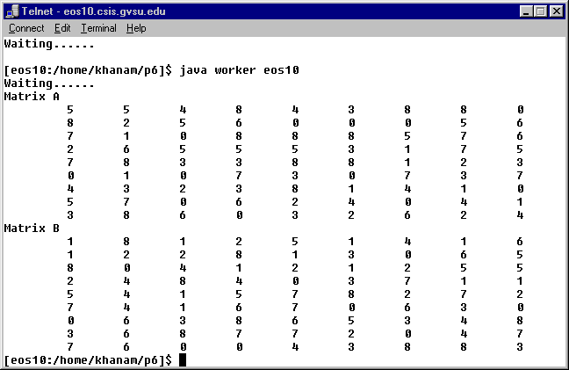
Master:
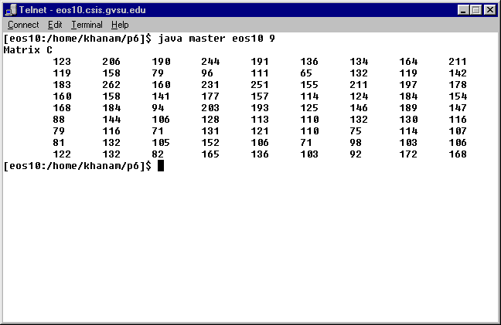

Verification of calculation:
Hard code the every single value to 1, then every value of the resultant matrix should be equal to array dimension.
Worker…
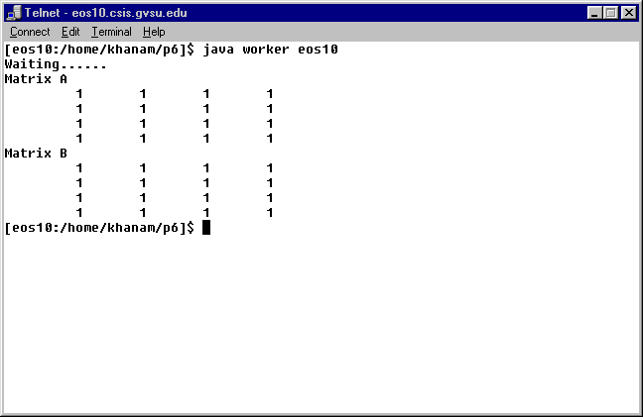
Master:
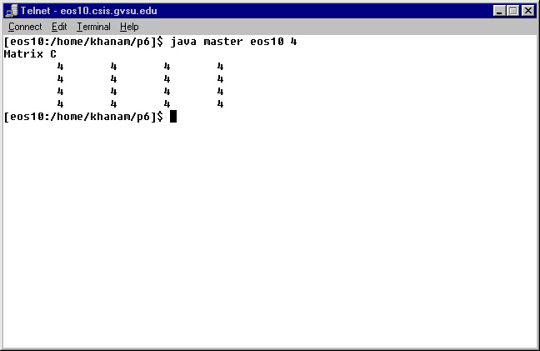

Outputs on different server…
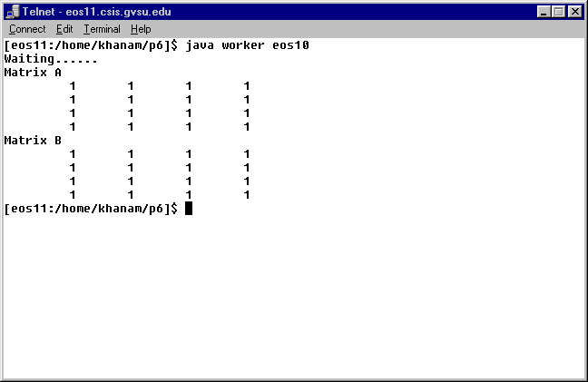
Master:

