LAB ASSIGNMENT 1

Q—1)WAP to design simple calculator with basic operation (add, sub, mul, div) using decision control statements.

a=float(input("Enter the first number:"))
b=float(input("Enter the second number"))
action=input("enter add for addition, sub for subtraction, div for division, mul for multiplication and exp for power:")
if action=="add":
print("the addition is", (a+b))
elif action=="sub":
print("the subtraction is",(a-b))
elif action=="div":
print("the division is",(a/b))
elif action=="mul":
print("the multiplication is",(a*b))
elif action=="exp":
print("the exponent is",(a**b))

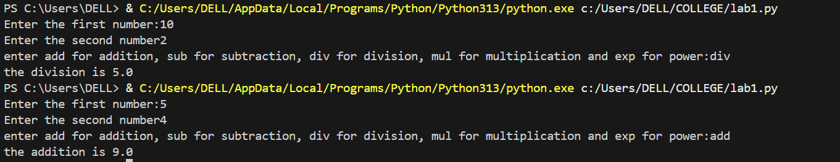
Q2--WAP TO PRINT EVEN NUMBERS WITHIN RANGE OF 1 and 20
for i in range(2,21,2):
print(i)

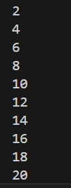
Q—3) WAP to calculate the a^b
a=int(input("ENTER BASE:"))
b=int(input("ENTER POWER:"))
print(a,"^",b, "is", a**b)
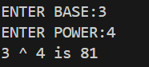
Q—4) WAP to calculate factorial of a number.
x=int(input("enter the number:"))
if x==0 or x==1:
print("factorial is 1")
else:
fact=1
for i in range(1,x+1):
fact*=i
print("factorial is", fact)

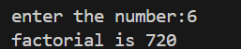
Q—5) WAP to check whether a number is prime or not.
n=int(input("Enter the number:"))
for i in range(2,n):
if n%i==0:
print("Number is not prime.")
break
else:
print("Number is prime.")

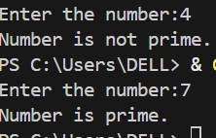
Q—6) WAP to check a number is Armstrong number (It is a number equal to the sum of its own digits, each raised to the power of the total number of digits. For example, 153 is an Armstrong number because it has three digits, and 1³ + 5³ + 3³ = 1 + 125 + 27 = 153.)

num=int(input("Enter a number:"))
power=len(str(num))
sum=0
for digit in str(num):
sum+=int(digit)**power
if sum==num:
print(num,"is an Armstrong number")
else:
print(num,"is not an Armstrong number")

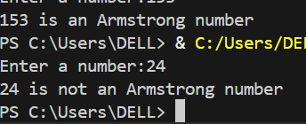
Q—7) WAP to check number is Palindrome or not.
um = int(input("Enter a number: "))
num_str=str(num)
rev=""
for el in num_str:
rev=el+rev
print("reversed number is", rev)
if rev==num_str:
print("The given number is a pallindrome")
else:
print("The given number is not a pallindrome.")

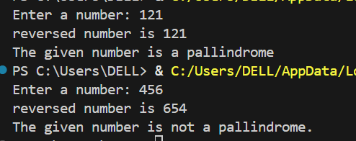
Q—8) Find the maximum number among the user defined list items.
n=int(input("Enter the number of items you want in the list:"))
list=[]
for i in range(n):
num=int(input("Enter numbers"))
list.append(num)
max=list[0]
for number in list:
if number>max:
max=number
print("The maximum number is",max)

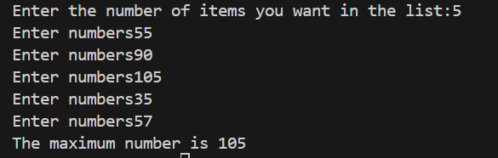
Q—9) WAP to print Fibonacci series upto nth terms.
n=int(input("the number of terms is:"))
a=0
b=1
print(a)
print(b)
for i in range(n):
c=a+b
print(c)
a=b
b=c

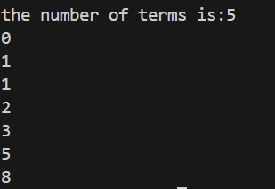
Q—10) Swap two numbers with and without help of third variables.
#Using a third variable
n1=int(input("Enter the first number:"))
n2=int(input("Enter the second number:"))
var=0
var=n1
n1=n2
n2=var
print(n1)
print(n2)

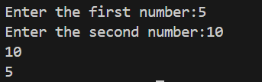
#WITHOUT THE HELP OF THE THIRD VARIABLE
a=int(input("Enter the first number"))
b=int(input("Enter the second number"))
a,b=b,a
print("the swapped numbers are",a, "and",b)

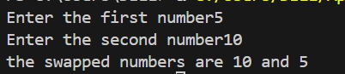
Q—11)
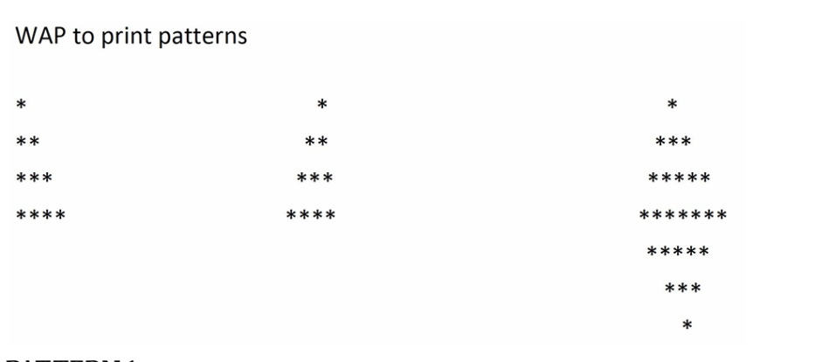
PATTERN 1
for i in range(1,5):
for j in range(i):
print("*",end="")
print()

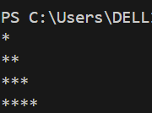
PATTERN 2
for i in range(1,5):
for j in range(1,4-i+1):
print(" ",end="")
for k in range(1,i+1):
print("*",end="")
print()

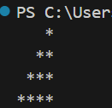
PATTERN 3
n=int(input("Enter the number of rows:"))
for i in range(1,n+1):
for j in range(1,n-i+1):
print(" ", end="")
for k in range(1,2*i):
print("*",end="")
print()

for i in range(n-1,0,-1):
for j in range(1,n-i+1):
print(" ",end="")
for k in range(1,2*i):
print("*",end="")
print()

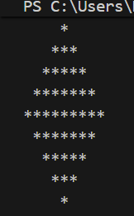
LAB ASSIGNMENT 2
Q—1) Print the tables from 2 to 5.
for i in range(1,11):
print(i*2," ", i*3," ",i*4," ",i*5)

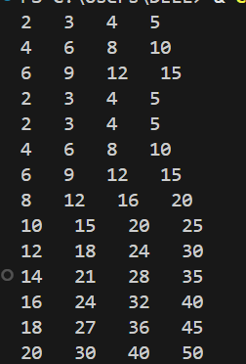
Q—2)Find the maximum and minimum number in a user defined list.
n=int(input("Enter the number of items you want in the list"))
l=[]
for i in range(n):
num=int(input("Enter numbers"))
l.append(num)
max=l[0]
for number in l:
if number>max:
max=number
print("maximum number is",max)

min=l[0]
for number in l:
if number<min:
min=number
print("minimum number is", min)

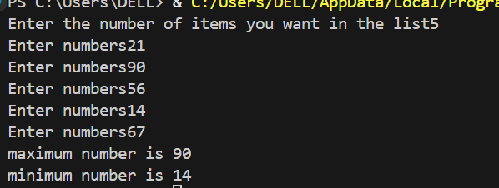
Q—3) Write a program to search an element with and without predefined library function.
#WITHOUT PREDEFINED LIBRARY FUNCTION
n=int(input("Enter the number of items you want in the list"))
l=[]
for i in range(n):
num=int(input("Enter numbers"))
l.append(num)
print(l)
number=int(input("Number to be searched is:"))
for el in l:
if el==number:
print("the number is present at",l.index(el))
break
else:
print("the number is not present in the list")

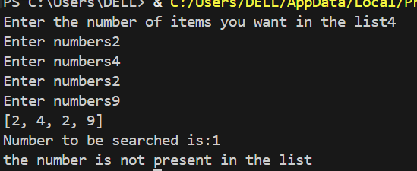
#WITH PREDEFINED LIBRARY FUNCTION
n=int(input("Enter the number of items you want in the list"))
l=[]
for i in range(n):
num=int(input("Enter numbers"))
l.append(num)
print("Your list is",l)
number=int(input("The number to be searched"))
if number in l:
print("The number is found at", l.index(number))
else:
print("The number is not found.")

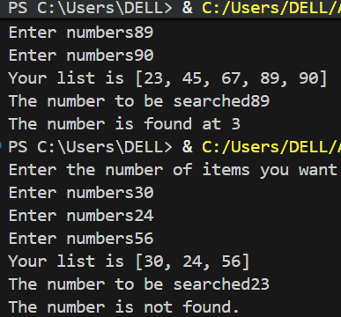
Q—4) Write a program to find a peak element in the given array. An element is considered peak element if its value is greater than or equal to the values of adjacent elements (if existed) Input: arr[]={10,15,25, 20}
arr=[10,15,25,20]
n=len(arr)
for i in range(len(arr)-1):
if arr[i]>arr[i-1] and arr[i]>arr[i+1]:
peak_val=arr[i]
print("The peak value is",arr[i])

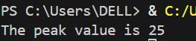
Q—5) Write a program to modify the given list by reducing each element by its next smaller element.
lst = [8, 4, 6, 2, 3]
modified = []

for i in range(len(lst)):
next_smaller = 0
for j in range(i+1, len(lst)):
if lst[j] < lst[i]:
next_smaller = lst[j]
break
modified.append(lst[i] - next_smaller)

print("Original List:", lst)
print("Modified List:", modified)

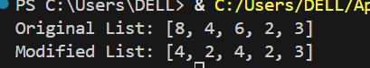

Q—6) Write a program to count the frequency of a given number in the array with and without predefined library function.
#WITHOUT PREDEFINED LIBRARY FUNCTION
=int(input("Enter the number of items you want in the list"))
l=[]
for i in range(n):
num=int(input("Enter numbers"))
l.append(num)
number=int(input("Enter the number whose frequency is to be counted"))
c=0
for el in l:
if el==number:
c+=1
else:
continue

print("the frequency of", number, "is",c)

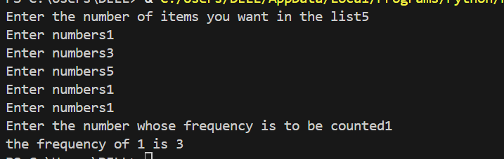
#WITH PREDEFINED LIBRARY FUNCTION
n=int(input("Enter the number of items you want in the list"))
l=[]
for i in range(n):
num=int(input("Enter numbers"))
l.append(num)
number=int(input("Enter the number whose frequency is to be counted"))
c=l.count(number)
print("The frequency",number,"is",c)

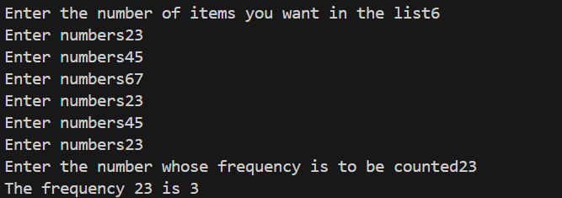
Q—7) The user is asked to enter the five numbers in an array at the time of initialization. After inputting the array items, the user updates the array by entering five more integer number one at a time at the end of the array. After that it remove most recently added 3 numbers. Write a program to implement this concept.
arr=[]
print("Enter the 5 numbers to be added in the array")
for i in range(5):
num=int(input("Enter the numbers"))
arr.append(num)

for i in range(5):
num=int(input("Enter next five numbers"))
arr.append(num)

for i in range(3):
arr.pop()

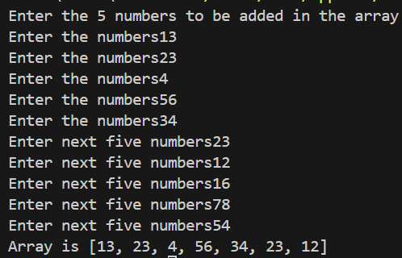
Q—8) Write a program to sort the 10 numbers given in the List.
arr=[]
print("Enter the 10 numbers to be added in the array")
for i in range(10):
num=int(input("Enter the numbers"))
arr.append(num)
arr.sort()
print("The sorted list is",arr)

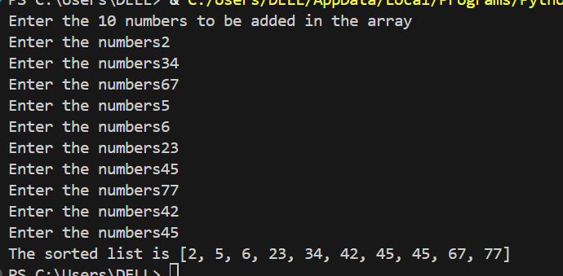

LAB ASSIGNMENT 3
Q—1) Write a program that takes two lists and returns True if they have at least one common member.
1=int(input("Enter the number of elements you want in the list 1"))
l1=[]
for i in range(n1):
num1=int(input("Enter numbers"))
l1.append(num1)
print("List 1 is:",l1)
n2=int(input("Enter the number of elements you want in list 2"))
l2=[]
for i in range(n2):
num2=int(input("Enter numbers"))
l2.append(num2)
print("List 2:",l2)

for el in l1:
if el in l2:
print(True)
break
else:
print(False)

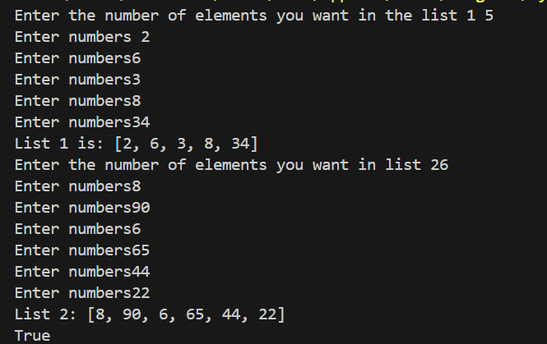
Q—2) A user adds three items in an e-cart of worth Rs. 5000, 1000 and 7000. He then realize that his monthly budget is exceeding from rupees ten thousand and removes the last item. Implement a program to process the above information and find out his total billing cost.
n=int(input("Enter the number of items you want"))
cart=[]
for i in range(n):
item=int(input("Enter the price of item"))
cart.append(item)
print(cart)
if sum(cart)>10000:
cart.pop()
print("Final cart after removal", cart)
print("Sum if cart is",sum(cart))

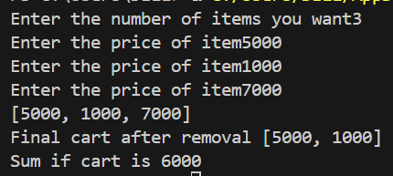
Q—3) Write a Python program to get a substring from a given string starting from the 3rd character to the 5th character.
s="I am xyz."
print(s[2:5])

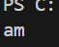
Q—4) Python program that accepts a string and calculates the number of digits, Letters and special characters.
s=input("Enter the string")
digit=0
letters=0
schar=0
for char in s:
if char.isalpha():
letters+=1
elif char.isnumeric():
digit+=1
else:
schar+=1
print("The number of letters is", letters, ".", "The number of digits is", digit, ".", "The number of special characters are",schar,".")

Q—5) Write a Python program to remove spaces from a string s =”This is a statement.”
s="This is a statement."
s_new=s.replace(" ","")
print("Output string is",s_new)

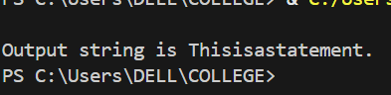
Q—6) Write a Python program to find duplicate values in a list using sets.
n=int(input("Enter the number of items you want in the list"))
l=[]
for i in range(n):
num=int(input("Enter numbers"))
l.append(num)
s=set()
dup=[]
for item in l:
if item in s:
dup.append(item)
else:
s.add(item)
print("The duplicates are", dup)

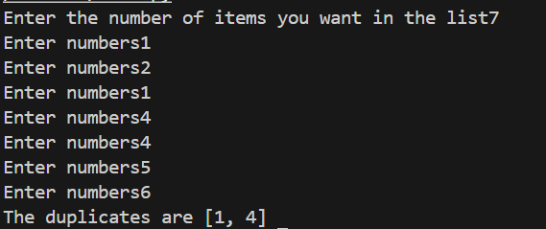

Q—7) Implement the program for adding two matrix of size 3x3 and store it into third matrix mat_sum.

a=[[1,2,3],[2,3,4],[4,5,6]]
b=[[2,3,4],[4,5,6],[8,6,7]]
mat_sum=[[0,0,0],[0,0,0],[0,0,0]]
for i in range(len(a)):
for j in range(len(a[0])):
mat_sum[i][j]=a[i][j]+b[i][j]
print(mat_sum)

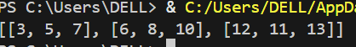
Q—8) Implement a program for multiplying two matrix of size 3x3 and store it into third matrix mat_prod.
mat1 = [
[1, 2, 3],
[4, 5, 6],
[7, 8, 9]
]

mat2 = [
[9, 8, 7],
[6, 5, 4],
[3, 2, 1]
]

mat_prod = [
[0, 0, 0],
[0, 0, 0],
[0, 0, 0]
]

for i in range(3):
for j in range(3):
for k in range(3):
mat_prod[i][j] += mat1[i][k] * mat2[k][j]

print("Product matrix:")
for row in mat_prod:
print(row)

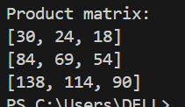

Q—9) Write a Python script to sort (ascending and descending) a dictionary by value.
d = {'a': 30, 'b': 10, 'c': 50}
asc = dict(sorted(d.items(), key=lambda x: x[1]))
desc = dict(sorted(d.items(), key=lambda x: x[1], reverse=True))
print("Ascending:", asc)
print("Descending:", desc)

try:
del my_dict["d"]
except KeyError as e:
print(f"Error: {e}")

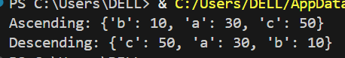
Q—10) Write a Python program to remove a key-value pair from a dictionary.
d = {'a': 10, 'b': 20, 'c': 30}
key = 'b'
if key in d:
del d[key]

print(d)

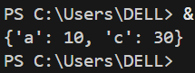
LAB ASSIGNMENT - 4
Q—1) 1.Write a program to create a dictionary of countries and their capitals.
2. Access and print the capital of a given country.
3. Add a new country–capital pair.
4. Update the capital of an existing country.
5. Print the final dictionary.
dict={
"India":"New Delhi",
"USA":"Washington DC",
"UK":"London",
"Canada":"Ottawa",
"Mexico":"Mexico City",
}
print(dict["India"])
dict["Sri lanka"]="Radio"
print(dict)
dict.update({"Sri Lanka":"Columbo"})
print("New dictionary is", dict)

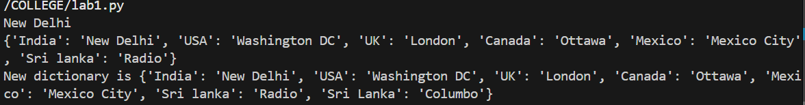
Q—2) Write a program to take a country name from the user and print its capital (use get() to avoid errors).
dict={
"India":"New Delhi",
"USA":"Washington DC",
"UK":"London",
"Canada":"Ottawa",
"Mexico":"Mexico City",
}

c=input("Enter country name:")
print(dict.get(c))

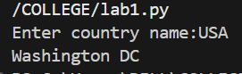
Q—3) You are asked to maintain a dictionary of programming languages and their release years.
(a) Create a dictionary with the following data:
a. Python → 1991
b. Java → 1995
c. C → 1972
(b) Add two more entries:
d. Go → 2009
e. Rust → 2010
(c) Remove the language with the earliest release year.
(d)Display only those languages released after the year 2000.
d={
"a.Python":1991,
"b.Java":1995,
"c.C":1992,
}
d.update({"d.Go":2009})
d.update({"e.Rust":2010})
print("New dictionary", d)

min_value=d["a.Python"]
req_key=""
for key in d:
if d[key]<min_value:
min_value=d[key]
req_key=key
else:
req_key="a.Python"

d.pop(req_key)
print(d)

keys=[]
for key in d:
if d[key]<2000:
keys.append(key)
for key in keys:
d.pop(key)

print(d)

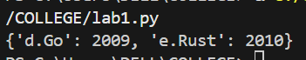
Q—4) A fruit seller maintains the prices of fruits using a dictionary in Python, where the keys are fruit names and the values are their prices. Here is the details of steps
a. Create a dictionary with at least 4 fruits and their prices.
b. Update the price of one fruit (e.g., change the price of "apple").
c. Add a new fruit with its price (e.g., "mango": 60).
d. Delete the most recently added fruit details from the dictionary.
Your task is to:
1. Write a Python program to perform the above steps.
2. Print the dictionary after each step to show the changes.
# Create a dictionary with at least 4 fruits and their prices.
dict={
"Apple":45,
"Pear":56,
"Banana":70,
"Dragon fruit":90,
}

dict["Apple"]=50
print(dict)

dict.update({"Orange":95})
print(dict)

dict.popitem()
print(dict)

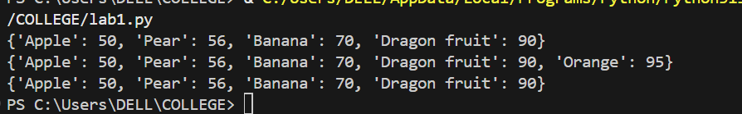
LAB ASSIGNMENT 5
Q—1) Create a program that uses functions to simulate a simple calculator, capable of addition, subtraction, multiplication, and division of two numbers taken as input parameter of different function calls.
def add(a,b):
return a+b
def sub(a,b):
return a-b
def mul(a,b):
return a*b
def div(a,b):
if b==0:
print("cannot divide by zero.")
else:
return a/b
x=float(input("enter the first number"))
y=float(input("enter the second number"))
print("addition is", add(x,y))
print("subtraction is",sub(x,y))
print("multiplication is", mul(x,y))
print("division is",div(x,y))

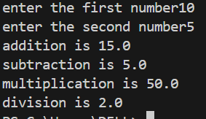
Q—2) Implement the series 1/1! +3/3! +5/5!....upto nth term using function.
def fact(n):
if n==0 or n==1:
return 1
else:
return n*fact(n-1)

def func(n):
x=0
for i in range(1,n+1,2):
y=i/fact(i)
x=x+y
return x

print(func(5))
print(func(3))

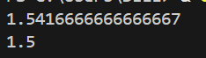
Q—3) Write a Python function to check whether a number falls within a given range.
def check_range(n,n1,n2):
if n<n2 and n>n1:
return True
else:
return False
n=float(input("Enter the number to be checked"))
n1=float(input("Enter the lower limit"))
n2=float(input("Enter the upper limit"))
print(check_range(n,n1,n2)

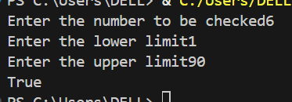
Q—4) Write a Python program to reverse a string. Sample: String : "1234abcd", Expected Output : "dcba4321"
def rev_str(x):
return x[ : :-1]
print(rev_str("1234abcd"))

def rev_str(x):
rev=" "
for char in x:
rev=char+rev
return rev

print(rev_str("1234abcd"))

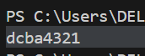

Q—5) Write a Python function to check whether a number is "Perfect" or not. In number theory, a perfect number is a positive integer that is equal to the sum of its proper positive divisors, that is, the sum of its positive divisors excluding the number itself (also known as its aliquot sum). Equivalently, a perfect number is a number that is half the sum of all of its positive divisors (including itself). Example : The first perfect number is 6, because 1, 2, and 3 are its proper positive divisors, and 1 + 2 + 3 = 6. Equivalently, the number 6 is equal to half the sum of all its positive divisors: ( 1 + 2 + 3 + 6 ) / 2 = 6. The next perfect number is 28 = 1 + 2 + 4 + 7 + 14. This is followed by the perfect numbers 496 and 8128.
def perfect_no(x):
sum1=0
for i in range(1,x):
if x%i==0:
sum1+=i

sum2=0
for i in range(1,x+1):
if x%i==0:
sum2+=i

if sum1==x and sum2/2==x:
print("number is perfect")
return True
else:
print("number is not perfect")
return False

print(perfect_no(6))
print(perfect_no(8))

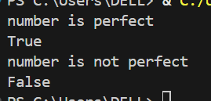
Q—6) Write a recursive function factorial(n) to calculate the factorial of a given integer n. The function should return 1 if n is 0 or 1 (base case) and recursively multiply n by factorial(n-1) otherwise. Test your function with different values of n.
def fact(n):
if n==0 or n==1:
return 1
else:
return n*fact(n-1)

print(fact(5))
print(fact(0))
print(fact(6))
print(fact(1))

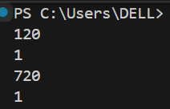
Q—7) Create a recursive function fibonacci(n) that returns the nth Fibonacci number. The base cases should return 0 for n=0 and 1 for n=1. Write test cases to verify the results for different values of n.
def fibonacci(n):
if n==0:
return 0
elif n==1:
return 1
else:
fib=fibonacci(n-1)+fibonacci(n-2)
return fib

print("the 4th fibonacci number is", fibonacci(4))
print("the 5th fibonacci number is", fibonacci(5))

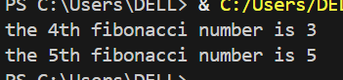
Q—8) Write a recursive function to calculate a**b.
def power(a,b):
if b==0:
return 1
else:
return (a*power(a,b-1))

print(power(2,2))

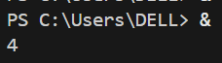
LAB ASSIGNMENT – 6
Q—1) Create a text file named notes.txt and write the following lines into it: Python is easy to learn. File handling is important concept in python. Do practice as practice makes it perfect !!!
with open("notes.txt","w") as f:
f.write("Python is easy to learn.\n")
f.write("File handling is important concept in python.\n")
f.write("Do practice as practice makes it perfect !!!.")
with open("notes.txt","r") as f:
data=f.read()
print(data)

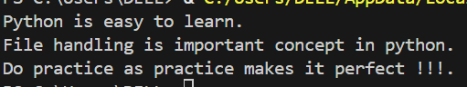
Q—2) Open notes.txt and display its contents line by line on the screen.
with open("notes.txt","r") as f:
for line in f:
print(line, end="")

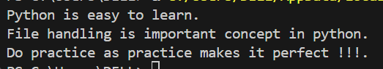
Q—3) Append a new line — "Keep learning Python!" — at the end of notes.txt.
with open("notes.txt","a") as f:
f.write("Keep learning Python!")
with open("notes.txt","r") as f:
data=f.read()
print(data)

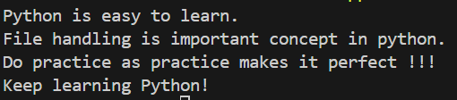
#included \n after last line of previous text. Could also add \n before staring this line
with open("notes.txt","w") as f:
f.write("Python is easy to learn.\n")
f.write("File handling is important concept in python.\n")
f.write("Do practice as practice makes it perfect !!!\n")

Q—4) Count the number of lines, words, and characters in a given text file.
#for words special character
with open("notes.txt","r") as f:
c1=0
for line in f:
c1+=1
print("number of lines is",c1)
with open("notes.txt","r") as f:
data=f.read()
c2=0
for char in data:
c2+=1
print("number of characters in file is",c2)
with open("notes.txt","r") as f:
c3=0
for line in f:
words=line.split()
for el in words:
if el.isalpha():
c3+=1

print("Number of words in file is",c3)

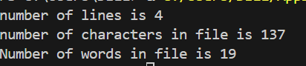
#for counting words with special characters like (!,. etc)
with open("notes.txt","r") as f:
c1=0
for line in f:
c1+=1
print("number of lines is",c1)
with open("notes.txt","r") as f:
data=f.read()
c2=0
for char in data:
c2+=1
print("number of characters in file is",c2)
with open("notes.txt","r") as f:
c3=0
for line in f:
words=line.split()
c3+=len(words)
print("Number of words in file is",c3)

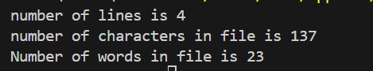

Q—5) Reads a file and prints all lines containing the word "Python" (case-insensitive).
with open("notes.txt","r") as f:
for line in f:
words=line.split()
for word in words:
if word.lower().strip(",!?.")=="python":
print(line)

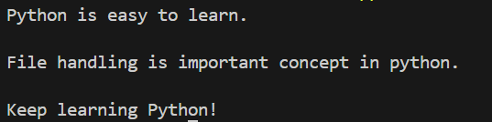
Q—6) Close the file notes.txt
with open ("notes.txt","r") as f:
f.close()

LAB ASSIGNMENT-5
(Recursion)
Q—1) Write a recursive function sum_of_digits(n) that returns the sum of the digits of a positive integer n. For example, sum_of_digits(123) should return 6 (1 + 2 + 3). The function should reduce n by dividing by 10 in each recursive call.
def sum_of_digits(num):
if num==0:
return num
else:
return((num%10)+sum_of_digits(num//10))

print("the result is",sum_of_digits(123))
print("the result is",sum_of_digits(12345))

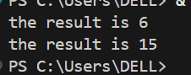

Q—2) Write a Python function that checks whether a passed string is a palindrome or not.
Note: A palindrome is a word, phrase, or sequence that reads the same backward as forward, e.g., madam or nurses run.

def is_palindrome(text):
cleaned = text.replace(" ", "").lower()
if cleaned == cleaned[::-1]:
return True
else:
return False
word = "madam"
if is_palindrome(word):
print("Palindrome")
else:
print("Not a palindrome")

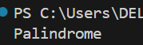
LAB ASSIGNMENT-8
- Generate a NumPy array of random integers between 10 and 100 of size 10.
Convert it into a Pandas Series and find:
- The maximum and minimum values
- The mean value
- Display all elements greater than the mean

import numpy as np
import pandas as pd
arr = np.random.randint(10, 100, 10)
s = pd.Series(arr)
max_val = s.max()
min_val = s.min()
mean_val = s.mean()
greater_than_mean = s[s > mean_val]

print("Array:\n", s)
print("\nMaximum:", max_val)
print("Minimum:", min_val)
print("Mean:", mean_val)
print("\nElements greater than mean:\n", greater_than_mean)

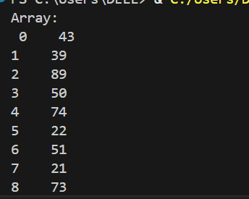
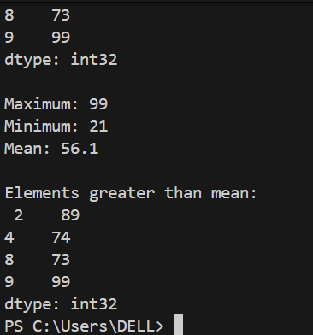
- Q—2) Create a Pandas DataFrame named students with the following data:
Name | Age | Marks
Riya | 20 | 85
Aman | 19 | 92
Neha | 21 | 76
Raj | 20 | 89
Perform the following tasks:
- Display only the names of students who scored more than 80.
- Add a new column Grade based on marks (A for >=85, B for >=75, else C).
Display the DataFrame after adding the new column.
import pandas as pd
students = pd.DataFrame({
"Name": ["Riya", "Aman", "Neha", "Raj"],
"Age": [20, 19, 21, 20],
"Marks": [85, 92, 76, 89]
})
print("Students scoring more than 80:")
print(students[students["Marks"] > 80]["Name"])
students["Grade"] = students["Marks"].apply(
lambda m: "A" if m >= 85 else ("B" if m >= 75 else "C")
)
print("\nDataFrame after adding Grade column:")
print(students)

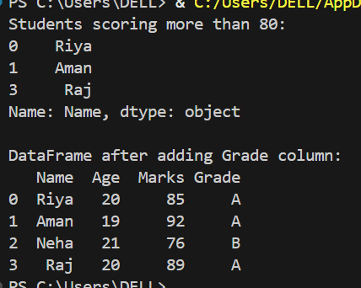
Q—3) Write a Python program to create a base class Person with attributes name and age.
Create a derived class Employee that inherits from Person and adds a new attribute salary. Both classes should have constructors (__init__ methods) to initialize their attributes. In Employee, use the super() function to call the parent class constructor.
Add a method display_details() in Employee to display all information.
class Person:
def __init__(self, name, age):
self.name = name
self.age = age
class Employee(Person):
def __init__(self, name, age, salary):
super().__init__(name, age)
self.salary = salary

def display_details(self):
print("Name:", self.name)
print("Age:", self.age)
print("Salary:", self.salary)
emp = Employee("Riya", 25, 50000)
emp.display_details()

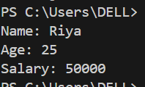
Q—4) Extract All Digits from a given text using regular expression.
text = " The Available Room numbers are: 123, 456, and 789."
import re

text = "The Available Room numbers are: 123, 456, and 789."
digits = re.findall(r'\d+', text)
print(digits)

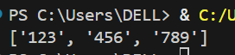

Q—5) Write a Python program using the re (regular expression) module to perform the following tasks on the given text: "Contact us at support@example.com or call 123-456-7890."
  - Extract and print the email address from the text.
  - Extract and print the phone number in the format 123-456-7890.
  - Replace all digits in the text with the character 'X' and print the masked output
- import re

- text = "Contact us at support@example.com or call 123-456-7890."
- email = re.findall(r'[A-Za-z0-9._%+-]+@[A-Za-z0-9.-]+\.[A-Za-z]{2,}', text)
- print("Email Address:", email)
- phone = re.findall(r'\d{3}-\d{3}-\d{4}', text)
- print("Phone Number:", phone)
- masked_text = re.sub(r'\d', 'X', text)
- print("Masked Text:", masked_text)



