SOFTWARE ENGINEERING ASSIGNMENT

MODULE – 1

SE – OVERVIEW OF IT

1. What is software? What is software engineering?

* Software is a language of computer. It is a collection of computer programs and data that provide the instructions for telling a computer what to do and how to do.

Software engineering is the art of developing quality software on time and within budget.

1. Explain types of software?

* 1)) System software or OS
* Provides basic functions for compute usage and helps to run the computer hardware and system.
* Is the s/w used by computer to translate the inputs from various sources into a language which a machine can understand.
* Basically OS coordinates the different hardware components of a computer. Ex – window, IOS.

2)) Application s/w :

- is the general designation of computer programs for performing user tasks.

- Types of application s/w

1) Mobile app: - Application that run on mobile Ex. Instagram, facebook, etc

2) Desktop app: - That run stand-alone in a desktop or laptop computer.

Ex. Microsoft office suite which includes Word, Excel etc.

-Ex. Outlook for email, and firefox, Google Chrome, Mozilla are the web browser.

- Anti-virus is an application and so is the media player.

3) Web app: - That run on a web browser - ex. google.com, facebook.com, etc.

3)) Programming s/w :

- is the process of designing, writing, testing, debugging, and maintaining the source code of computer programs.

- This s/w is pawritten in a programming language. - The purpose of programming is to create a program that exhibits a certaindesired behavior.

1. What is SDLC? Explain each phase of SDLC

* The software developing process (SDLC) a step by step process that helps development teams efficiently build the highest quality at the lowest cost. Teams follow SDLC to help them requirement gathering, analysis, design, deploy, test and maintain the software.

Phases of SDLC :

1. Requirement gathering : Establish customer needs.
2. Analysis : Model and specify the requirements.
3. Design : Model and specify a solution.
4. Implementation : construct a solution in software.
5. Testing : validate the solutions against requirements.
6. Maintenance : repair defects and adapt the solution to the new requirements.

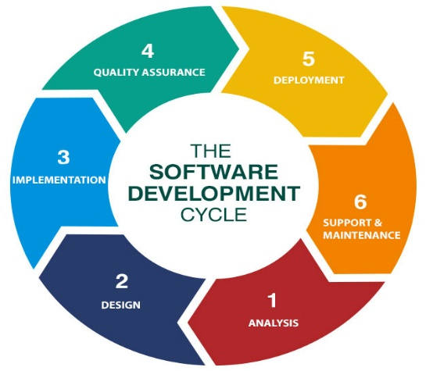

1. What Is DFD? Create a DFD diagram of Flipkart.

* A Data flow diagram (DFD) is a traditional way to visualize the information flows within a system.

It shows how information enters and leaves the system, what changes the information and where the information is stored. It may be used as a communication tool between a system analyst and any person who pays a part in the system that acts at the starting point for redesigning a system.

he information is stored. It may be used as a communication tool between a system analyst and any person who pays a part in the system that acts at the starting point for redesigning a system.

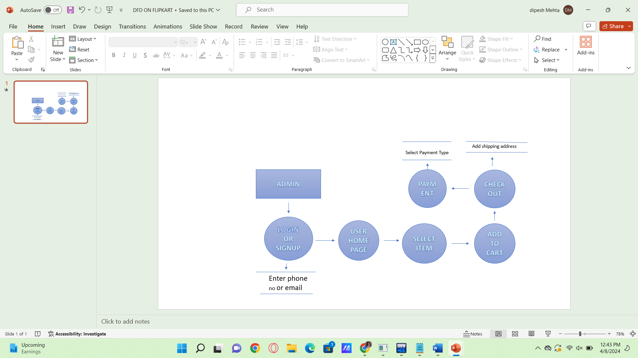

1. What is flowchart? Create a flowchart to make addition of two numbers.

* A flowchart is a graphical representation of the operations involved in a data processing.

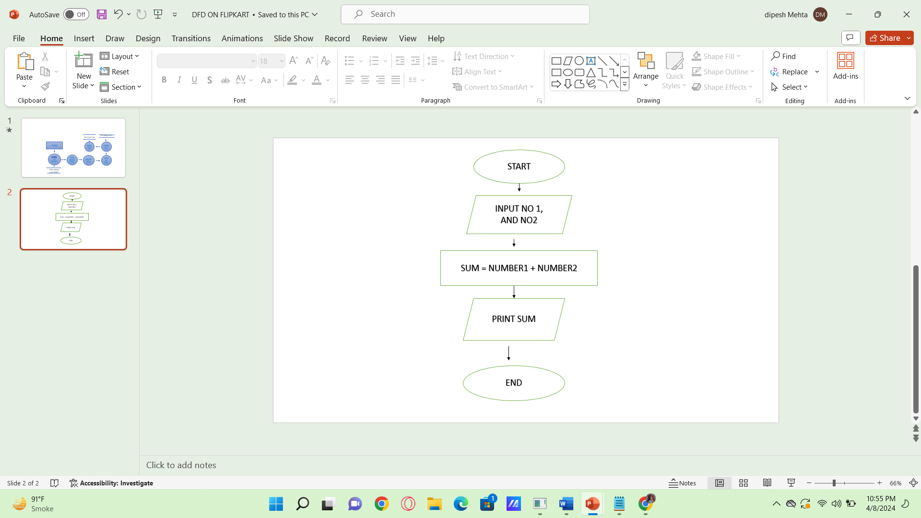

15

SUM = 5 + 10

A=5

B=10

1. What is a use case diagram? Create a use-case diagram on bill payment on Paytm.

* use case diagram describe the high level functions and scope of a system. These diagrams also identify the interactions between the system and the actors. The use cases and actors in use-case diagram describe what the system does and and how the actors use it, but not how the system operated internally.

