

**Module Code & Module Title**

**CS6P05NI Final Year Project**

**Assessment Weightage & Type**

**25% FYP Interim Report**

**Semester**

**2022 Autumn/Spring**

**Project Title: Final Year Project Interim Report**

**Student Name: Shirish Maharjan**

**London Met ID: 20049038**

**College ID: NP01CP4S210150**

**Internal Supervisor: Kshetrapal Bohora**

**External Supervisor: Ashutosh Chauhan**

**Assignment Due Date: 28th December 2022**

**Assignment Submission Date: 28th December 2022**

**Word Count (Where Required): 3963**

*I confirm that I understand my coursework needs to be submitted online via Google Classroom under the relevant module page before the deadline in order for my assignment to be accepted and marked. I am fully aware that late submissions will be treated as non-submission and a mark of zero will be awarded.*

Table of Contents

Abstract 1

Introduction 2

Problem Scenario 3

Project as a Solution 4

Aims and Objectives 5

Academic/Personal Objectives 5

Project Objectives 5

Structure of the Report 6

Background / Literature Review 7

Technologies Used 7

Methodology 9

Methodology to be used 9

Similar Projects: 10

ECN (Election Commission) App 10

Right2Vote 11

Opinio 12

Comparison Table 13

Progress Till Date 14

Survey Results 14

Use Case Diagram: 17

High Level Description 18

Sequence Diagram 20

Sequence diagram for Login 20

Sequence diagram for Cast Vote 20

Sequence diagram to Verify Voter 21

Entity – Relationship Diagram 22

Wireframes 23

Future Work 25

Development 25

Testing and bug fixing 26

Documentation (Report) 26

References 27

Appendix 28

Research on reports of similar projects 28

Kenyan Online Voting System 28

Internet Voting Project (Survey) 28

Design and Implementation of an Online Voting System 29

Considered Methodologies 29

Components of Sequence Diagrams 30

Remaining Wireframes 32

**Table of Figures**

Figure 1: Voting Line in Sindhupalchowk District 3

Figure 2: MERN Stack Architecture 8

Figure 3: Kanban Methodology 9

Figure 4: ECN App UI 10

Figure 5: Right2Vote UI 11

Figure 6: Opinio UI 12

Figure 7: Survey Question 1 14

Figure 8: Survey Question 2 14

Figure 9: Survey Question 3 15

Figure 10: Survey Question 4 15

Figure 11: Survey Question 5 15

Figure 12: Survey Question 6 16

Figure 13: Survey Question 7 16

Figure 14: Use Case Diagram 17

Figure 15: Actor 30

Figure 16: Lifeline 30

Figure 17: Messages 31

Figure 18: Activation Bar 31

Figure 19: Sequence diagram 1 20

Figure 20: Sequence Diagram 2 20

Figure 21: Sequence Diagram 3 21

Figure 22: Entity and Attributes 22

Figure 23: Relationship 22

Figure 24: Cardinality 22

Figure 25: Entity - Relationship diagram 23

Figure 26: Wireframe 1 - Login 24

Figure 27: Wireframe 2 - Voter Registration 24

Figure 28:Wireframe 3 - Admin Dashboard 32

Figure 29: Wireframe 4 - Pending Requests 32

Figure 30: Wireframe 5 - Admin Dashboard 33

Figure 31: Wireframe 6 - View Positions 33

Figure 32: Wireframe 7 - View Candidates 34

Figure 33: Wireframe 8 - View Results 34

Figure 34: Wireframe 9 - Insights 1 35

Figure 35: Wireframe 10 - Insights 2 35

Figure 36: Wireframe 12 - Insights 3 36

Figure 37: Wireframe 13 - Insights 4 36

**Table of Tables**

Table 1: Comparison Table 13

Table 2: Development Progress 26

# Abstract

The following report provides an overview on the progress till date of the project “e-vote” which is an online voting system that will be developed to mitigate the challenges faced by manual voting systems. This report provides detailed information on the problem domain – it underlines the problems faced by citizens and the authorities while carrying out manual elections. It also describes the plan on how the system will be developed, the features of the system and the technologies used. Finally, it highlights the future work to be done and the plan for completion of the project.

# Introduction

The process of voting to choose someone to be their political leader or representative in the government is called an election. Elections are the primary way for citizens to choose how the country is governed. Citizens vote when the government carries out an election. Usually, it is carried out every 5 years.

Till now, in developing countries like Nepal and India, the voting process is carried out manually. Citizens must go to government offices to fill forms and wait for their voter IDs to be issued. They cast their votes by marking a ballot paper and putting it into a ballot box. After the election ends, the boxes are opened, and the votes are counted and recorded by volunteers. This process is time consuming and costly with high chances of errors in the counting process.

‘eVote’, the online voting system will be developed to mitigate the challenges and obstacles faced by the current manual voting system. As its name suggests, it is a system that enables elections to be carried out online. It includes functionalities to carry out all the processes involved - creating Voter IDs, hosting elections, and counting the votes. It is not expected that the government implements the system as it is just a project developed by a student but, it is hoped that this system will act as an example of a digitalized election system and its advantages over the current election process.

## Problem Scenario

There are several problems with the manual voting system. The voting process itself can be broken down into three major stages. Each stage has several flaws that are described below:

**Stage 1: Creating the voter ID**

* Time Consuming: Citizens must go to their respective ward offices to create their voter IDs. They fill forms and must wait for several days for their IDs to be made.
* Management: The ward offices have difficulties managing and keeping up with the huge number of people who come to create their IDs in time.

**Stage 2: The Voting Process**

* Cost: Manual voting systems can be expensive to implement and maintain, particularly in large elections with many polling places and voters.
* Accessibility: Manual voting systems may not be accessible to all voters, particularly those with disabilities. For example, a voter who is on a wheelchair may have difficulty going to the polling station and casting vote.
* Security: Manual voting systems are vulnerable to fraud and tampering. It is difficult to ensure the integrity of paper ballots and there is a risk of vote tampering or ballot box stuffing.

**Stage 3: The Counting Process**

* Efficiency: Manual voting systems can be time-consuming and labour-intensive to administer. It can take a long time to count the votes by hand and there is a risk of mistakes being made during the tallying process.
* Accuracy: Manual voting systems can be prone to errors, such as mistakes in ballot design or tallying votes. This can lead to inaccurate results and disputes over the outcome of an election.

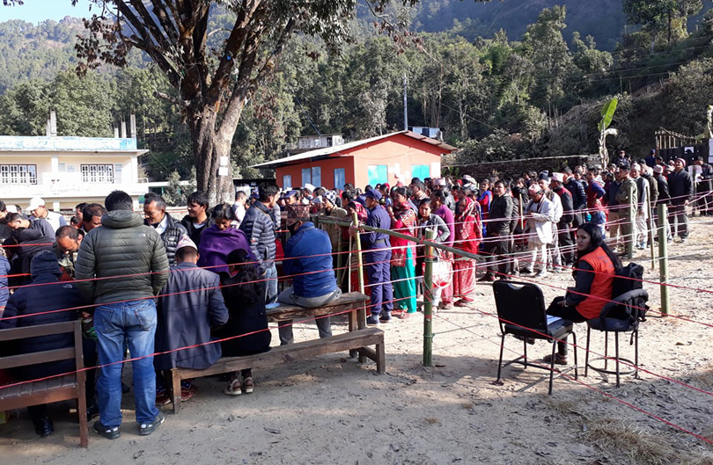

Figure : Voting Line in Sindhupalchowk District

## Project as a Solution

Online voting, also known as electronic voting, has several potential advantages over manual voting systems:

* Convenience: Online voting allows voters to cast their ballots from any location with an internet connection, rather than having to physically go to a polling place. This can make it more convenient for voters, particularly those who are physically unable to go to a polling place or who live far from one.
* Accessibility: Online voting systems can be designed to be more accessible for voters with disabilities. For example, an online voting system can provide audio instructions or allow voters to use assistive devices such as screen readers.
* Speed: Online voting systems can tally votes more quickly than manual systems, which can reduce the time it takes to announce election results.
* Security: Online voting systems can be designed with security measures in place to prevent fraud and tampering. For example, they may use encryption and authentication protocols to protect the confidentiality and integrity of the votes.
* Cost: Online voting systems may be more cost-effective than manual systems, particularly in large elections with many polling places and voters.

However, it is important to note that online voting systems also have their own set of challenges and potential drawbacks. For example, they may be vulnerable to technical issues such as server outages or hacking and may not be accessible to voters who do not have internet access or the necessary technology.

## Aims and Objectives

### Academic/Personal Objectives

* To learn how to use programming languages along with different frameworks for backend development.
* To learn about the new tools and technologies available currently for frontend development.
* To learn about the development and implementation of APIs.
* To gain experience on project planning and full-stack development.
* To learn about data visualization and data presentation.

### Project Objectives

The following are some of the primary objectives of this webapp:

* The main objective: To make elections efficient, fast, inexpensive, and transparent all while keeping it as simple as possible.
* To create a user-friendly website so that elderly voters who have little to no knowledge with computers can navigate through the website and cast their votes.
* To make the vote counting process fully automatic and reliable; humans may make many mistakes while counting votes, but computers don’t.
* To provide useful information about voting in Nepal so that news outlets can publish the reports and concerned authorities can act. Example: If the % of younger people who vote are very little, concerned authorities can advertise accordingly

# Structure of the Report

**Introduction**

The introduction briefly introduces the project and the report. It gives the reader an idea about the project topic, the problem domain and some of the features of the program. The aims and objectives of the project is also demonstrated in the introduction.

**Background Study**

Here, research and explanation on similar problems in different parts of the world and attempts to mitigate those problems are explained. Similar projects are explored, and they are compared to the project being developed. The background can serve as references and examples as well.

**Progress**

The development process that has been completed till now is shown here. This section contains the Use-case diagram, feature description, Entity – relationship, the project methodologies, diagrams and survey results for the program. Furthermore, it also contains the SRS which explains the program in a detailed manner.

**Future Work**

The remaining work to be done is outlined and a brief plan is devised on how to complete the work on time, the possible problems that could arise and the solutions to those problems.

**References**

This section contains the name of authors, the name of the article / webpages and the links for all the sections that were taken as references in the project.

**Appendix**

The appendix contains materials that is not considered essential for the report itself but is helpful for readers who want a more detailed description on various topics in the report.

# Background / Literature Review

## Technologies Used

The Project proposal stated that the project will be carried out using the following technologies: React and .NET but with the initiation of the development, the following change of technologies will be made:

Instead of ASP.NET for the back end, the MERN stack will be used:

MERN is a full-stack JavaScript software stack that consists of four open-source components: MongoDB, Express.js, React, and Node.js.

* MongoDB is a NoSQL database that stores data in a flexible, JSON-like format called BSON.
* Express.js is a web application framework for Node.js that provides a set of features for building web applications.
* React is a JavaScript library for building user interfaces.
* Node.js is a runtime environment for executing JavaScript code outside of a web browser.

The MERN stack is used to build web applications that can store, retrieve, and manipulate data using MongoDB as the database, Express.js as the server-side framework, React as the client-side framework, and Node.js as the runtime environment. The MERN stack allows developers to create full-stack web applications using a single programming language (JavaScript) and a single runtime environment (Node.js).

There are several advantages that MERN may have over ASP.NET, depending on the specific needs and preferences of the development team and the project. Some potential advantages of MERN over ASP.NET are:

* Full-stack JavaScript: MERN uses JavaScript for both the front-end and back-end of the web application, which may be more familiar and easier to work with for developers who are already proficient in JavaScript.
* Single language and runtime: MERN use a single programming language (JavaScript) and a single runtime environment (Node.js) for the entire stack, which can simplify the development process and reduce the need for developers to work with multiple languages and frameworks.
* Flexible database: MongoDB is a NoSQL database that stores data in a flexible, JSON-like format called BSON, which may be easier to work with than traditional relational databases.
* High performance: Node.js is designed for high-performance applications and is able to handle a large number of concurrent connections efficiently, which may make it a good choice for applications that require fast response times and high scalability.
* Active community: Both React and Node.js have large and active communities, which can provide a wealth of resources and support for developers working with the MERN stack.

Therefore, with in-depth research and approval from supervisors, it has been decided that the project will be developed using the MERN stack.

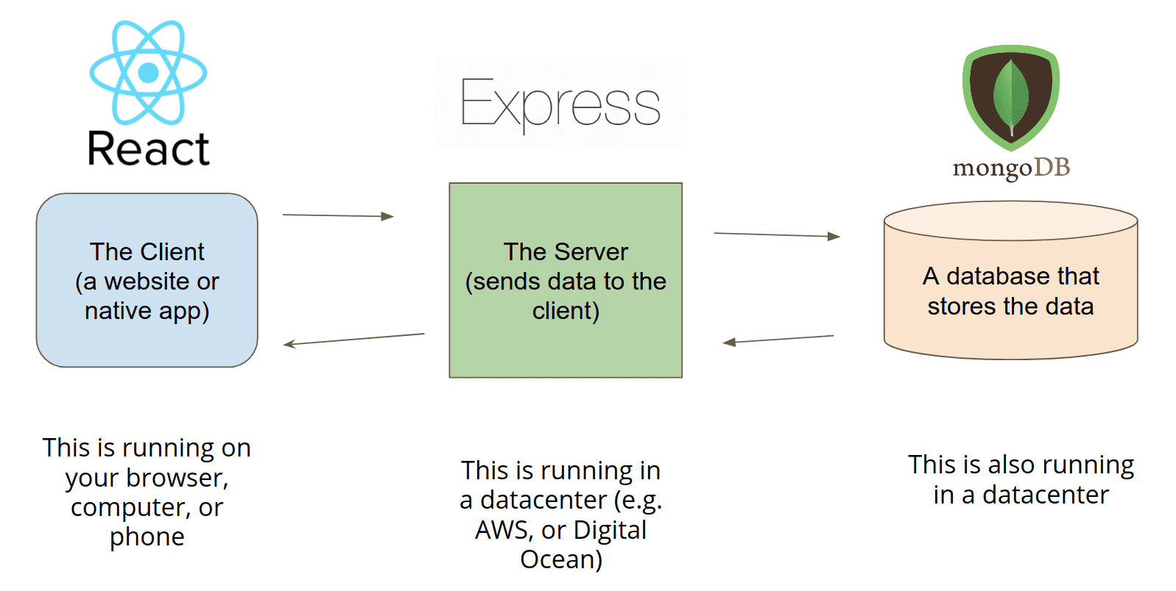

Figure : MERN Stack Architecture

## Methodology

A project methodology is a set of principles and practices that a is followed to achieve the goals of a project. It outlines the steps that a team / individual will take to plan, execute, and deliver the project, as well as the tools and techniques that will be used.

There are many different project methodologies to choose from, each with its own set of strengths and weaknesses. Some common examples include agile, lean, and waterfall.

### Methodology to be used

The Kanban Methodology is one of the simpler software development methodologies. It aims for continual improvement, task management flexibility, and improved workflow. The progress of the entire project may be quickly and simply comprehended using this illustrative technique. Basically, it divides the project into several tasks and categorizes them in the following way:

* Tasks to be done in the future.
* Tasks that are currently being done.
* Tasks that are done.

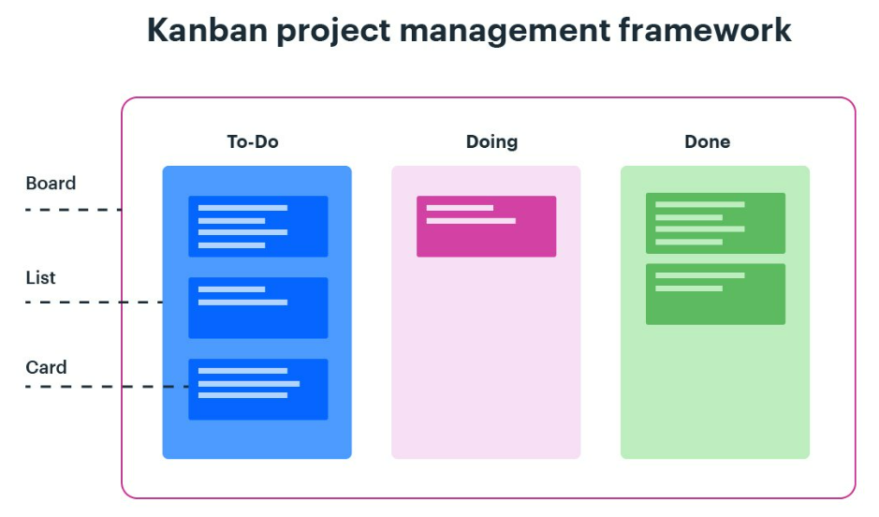

Figure : Kanban Methodology

In this way, the project can be divided into tasks and then move back and forth through the Kanban Table. Example: The login page can be a single task and it can be moved from to-do, doing, and done. The most notable quality of the methodology is its versatility and simplicity. (Kissflow, 2022)

## Similar Projects:

A brief summarization of similar systems that were created previously:

### ECN (Election Commission) App

Free social networking app ECN App is accessible on Android and iPhone mobile devices. The ECN App makes use of the internet connectivity on phones to deliver important information to members of the public and other stakeholders, such as ECN personnel and voters.

With relation to the Local Level Election and future elections in Nepal, this app makes it simple to track voters' polling places, election programs, voter counts, voter information, candidate information, election results, voter education, and media. Additionally, it offers SMS-based event tracking for both election officials and voters to view their polling place. (Nepal, 2017)

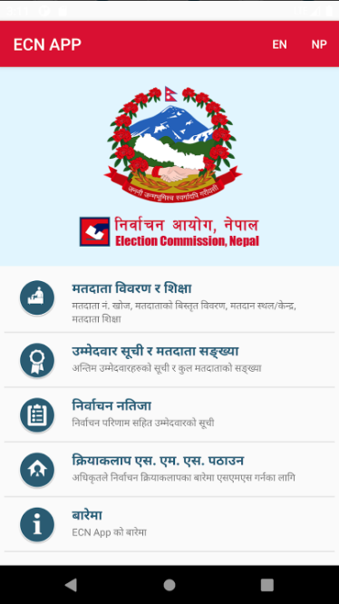

Figure : ECN App UI

### Right2Vote

This voting platform allows user to design their own poll, survey, election, choice, vote, contest, quiz, questionnaire, feedback form, test, exam, debate, and resolution.

The application can be used for a variety of purposes, including elections, choosing a candidate or representative, corporate AGM polls and corporate resolutions, market research, opinion polls, TV game shows, reality shows, news channel polls, NGO & social support groups, group decision making, awards, contests, quizzes, teaching, etc.

It is also a useful tool for social decision-making among friends and family on social networks. The live voting application contains capabilities including data analytics, real-time results presentation, public and restricted group polls, secret ballots, Aadhaar-based verification, and other ways. (Right2Vote, 2022)

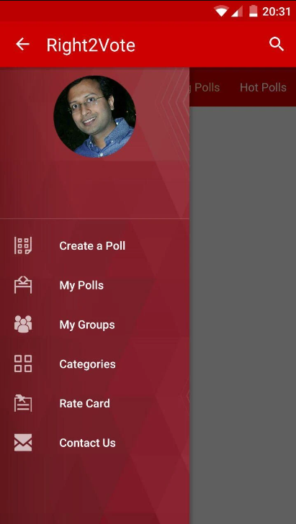

Figure : Right2Vote UI

### Opinio

Opino is a social networking platform for quick opinion gathering and sharing where users may interact and share thoughts in a simple and enjoyable manner.

On today's social media sites, like Facebook, Twitter, and Instagram, it takes a lot of work for someone to make a remark and share their perspective in response to someone else's request for their opinion. People can easily share their thoughts and join the conversation by participating in polls. Voters are curious about what the broader public thinks so they may determine whether their opinions coincide with those of the rest of the globe.

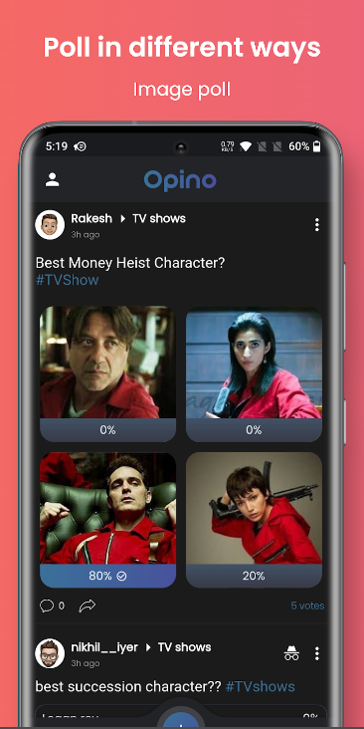

Figure : Opinio UI

### Comparison Table

The comparison table below lists down some of the features online voting apps and systems have and compares the to each other’s and to eVote as well.

|  |  |  |  |  |
| --- | --- | --- | --- | --- |
| Feature | ECN App | Right2Vote | Opinio | eVote |
| User Information | Checkmark with solid fill | Checkmark with solid fill | Checkmark with solid fill | Checkmark with solid fill |
| Announcements and Notices | Checkmark with solid fill | Close with solid fill | Checkmark with solid fill | Checkmark with solid fill |
| Insert Images | Close with solid fill | Checkmark with solid fill | Checkmark with solid fill | Close with solid fill |
| Admin authenticates new voters | Close with solid fill | Close with solid fill | Close with solid fill | Checkmark with solid fill |
| Interfaces for two actors (admin and voter) | Close with solid fill | Close with solid fill | Close with solid fill | Checkmark with solid fill |
| Create Polls | Close with solid fill | Checkmark with solid fill | Checkmark with solid fill | Checkmark with solid fill |
| Candidate Information | Checkmark with solid fill | Checkmark with solid fill | Close with solid fill | Checkmark with solid fill |
| Data Visualization | Close with solid fill | Checkmark with solid fill | Close with solid fill | Checkmark with solid fill |
| Add Comments | Close with solid fill | Close with solid fill | Checkmark with solid fill | Close with solid fill |
| Dual Language Support | Checkmark with solid fill | Close with solid fill | Close with solid fill | Close with solid fill |

Table : Comparison Table

# Progress Till Date

## Survey Results

An online survey was carried out inquiring voters on different questions so that feasibility and the requirements for the system could be specified. The survey further clears up the features voters would want for the system. The questions and the responses are presented below:

Figure : Survey Question 1

Figure : Survey Question 2

Figure : Survey Question 3

Figure : Survey Question 4

Figure : Survey Question 5

Figure : Survey Question 6

Figure : Survey Question 7

It can be concluded from the above results that majority of respondents have had a neutral or unpleasant experience from physical voting and would prefer to cast their votes online. They believe that it would be better if elections were held online. The main concern for the voters were security issues and usability for the elderly. Therefore, the system must be made secure and user friendly.

## Use Case Diagram:

The use case diagram illustrates the functionality of the whole system. These use cases represent the main actions that a voter and an admin would perform when using the online voting system. Depending on the specific requirements of the system, there may be additional use cases or variations on these use cases.

This use-case diagram provides a high-level overview of the functionality of the online voting system and the interactions between the actors and the system. It can be used to understand the requirements and capabilities of the system, and to identify any potential issues or gaps in the system's functionality.

Figure : Use Case Diagram

## High Level Description

**Action: Login**

Actors: Admin and Voter

Preconditions: Admin or Voter must be registered in the system.

Description: The user enters their ID number and password and can login to the system. The admin is shown the admin interface and the voter is shown the voter interface.

**Action: Register**

Actors: Voter

Preconditions: The voter is not registered in the system.

Description: The citizen can enter their personal details and their Citizenship details to send registration request to the admins.

**Action: View Ballot**

Actors: Voter

Precondition: The Voter is logged in to the system and the admin has created a ballot and has host the election.

Description: The Voter can click on view ballot on their navigation panel to view ballot. The ballot contains positions and the candidates in each position.

**Action: Cast Vote**

Actors: Voter

Preconditions: The voter has clicked on “View ballot” and has chosen a position to view candidates.

Description: The Voter can click on the logo of the candidate they want to cast their vote to and click on “cast vote”. The respective candidate will gain a vote.

**Action: Verify Voter**

Actors: Admin

Preconditions: A citizen has filled their details and sent a registration request.

Description: The admin can view details of the citizens who have filled the registration form and sent registration request.

**Action: Post Notice**

Actors: Admin

Preconditions: The admin has clicked on “Post notice” on their navigation bar and written a notice on the text box.

Description: The admin can post notices which will be visible on the dashboard of the voters.

**Action: Add Admin**

Actors: Admin

Preconditions: A new Admin needs to be added in the system

Description: The admin enters the details of the new admin to be added. The new admin is assigned an ID and password.

**Action: Create Ballot**

Actors: Admin

Preconditions: Admin is logged in to the system

Description: The actor clicks on “create ballot” on their navigation bar. They set the name and the duration for the ballot.

**Action: Add or Remove Candidates**

Actors: Admin

Preconditions: The admin has created a Ballot and clicked on the position they want to add / remove candidates to / from.

Description: The Admin can add candidates to a specific position or remove previously added candidates.

**Action: Host Election**

Actors: Admin

Preconditions: The admin has created the ballot, added candidates in all the positions and then made sure everything is correct.

Description: The admin clicks on “Host Election” which starts the election process.

**Action: View Results**

Actors: Admin and Voter

Preconditions: The voting duration has ended, and voters have cast their respective votes.

Description: The admin and voters can view the results of the election. The results contain the different chart insights as well.

Note: The Voters can view results only after the admin posts them.

**Action: Post Results**

Actors: Admin

Preconditions: The voting duration has ended, and voters have cast their respective votes.

Description: The admin can view the results first and then click on “post results” through which the results will be available for Voters as well.

**Action: Logout**

Actors: Admin and Voter

Preconditions: The admin or voter is logged in to the system.

Description: The admin or voter can log out from the system by clicking on the “logout” button.

## Sequence Diagram

A sequence diagram illustrates the interactions between a group of items and the order in which they occur. It is a form of an interaction diagram. Software engineers and business experts use these diagrams to comprehend the specifications for a new system or to describe an existing procedure. Event diagrams and event scenarios are other names for sequence diagrams. (Chart, 2022)

The following sequence diagrams have been developed for the functionalities of the system.

### Sequence diagram for Login

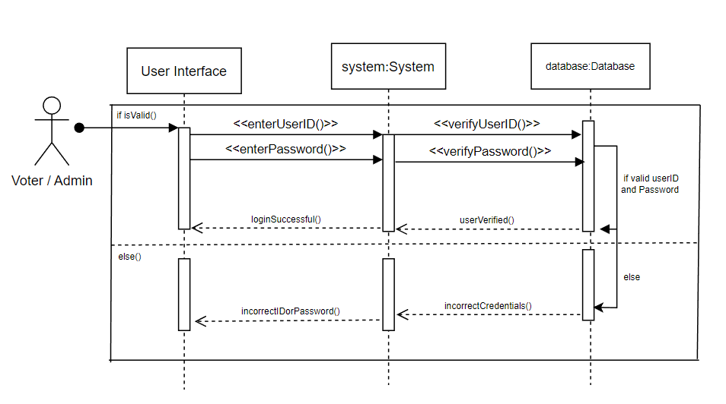

Figure : Sequence diagram 1

### Sequence diagram for Cast Vote

Figure : Sequence Diagram

### Sequence diagram to Verify Voter

Figure : Sequence Diagram 3

## Entity – Relationship Diagram

An Entity Relationship Diagram (ERD) is a visual representation of the relationships between entities in a database. It is used to model the structure of a database and can be used to design and document databases.

An ERD typically consists of four elements, including:

* Entities: An entity is a person, place, thing, or concept about which data is stored. In an ERD, entities are represented as boxes.
* Attributes: An attribute is a piece of information about an entity. In an ERD, attributes are represented in lists under the entity.

Figure : Entity and Attributes

* Relationships: A relationship is a connection between two or more entities. In an ERD, relationships are represented in diamond shape connecting entities.

Figure : Relationship

* Cardinality: Cardinality refers to the number of instances of one entity that can be associated with a single instance of another entity. In an ERD, cardinality is represented using symbols such as a crow's foot or a single line at the end of the relationship line.

Figure : Cardinality

Here, the Entity-Relationship diagram of the database of the voting system is created. This is one possible way to design the online voting system. The ERD can be used as a starting point for designing the database and developing the system.

Figure : Entity - Relationship diagram

## Wireframes

The wireframe of the UI of the website has been created using the Balsamiq Wireframes tool. Here, these wireframes are used as reference to create the UI of the webapp. There are two UIs: one for the admin and one for the voters. There are some similar webpages for these two actors but mostly, it is different. A few of the wireframes are included and the remaining are included in the Appendix section.

Here, the login page and the registration (voter) page are shown. The wireframe for the rest of the webpages is available in the Appendix.

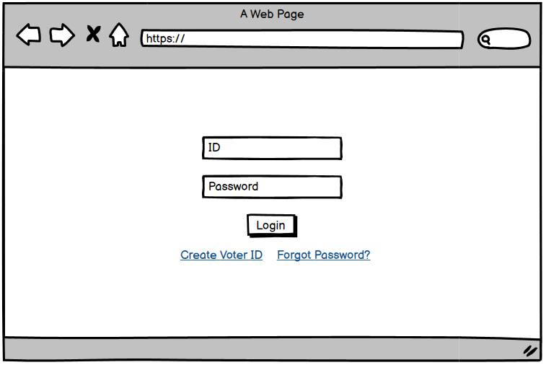

Figure : Wireframe 1 - Login

Figure : Wireframe 2 - Voter Registration

# Future Work

Till now, the planning phase has been completed. The methodology and the technologies have been finalised, and the necessary diagrams and wireframes have been completed. Now the major phases remaining are development, testing and documentation.

## Development

Development refers to the development of the frontend, databases and APIs. The majority of the development phase is coding the program. The deadline for completing the development phase according to the Gantt chart is by March. The development phase is further divided into smaller steps:

* Database design
* Front end development (UX / UI design)
* Functionalities development
* Backend development

The Gantt chart illustrated that UX / UI designs will be completed by January 2023, but the project is running slightly behind due to the need for various wireframes and diagrams to be designed. The preparation of Interim report further added extra work that led to a slight delay in the development process.

The following table lists down each step of the development phase according to the Kanban methodology:

|  |  |  |
| --- | --- | --- |
| To be done | Doing | Completed |
|  |  | Survey Conduction |
|  |  | Use case diagram |
|  |  | High level description |
|  |  | Entity-Relationship Diagram |
|  |  | Wireframes for UX / UI |
|  | Login Functionality |  |
|  | Voter’s front end |  |
|  | Database design |  |
| Admin’s front end |  |  |
| Voter’s functionalities |  |  |
| Admin’s functionalities |  |  |
| Vote counting functionality |  |  |
| Chart generation functionality |  |  |
| Logout functionality |  |  |
| Black box testing |  |  |
| White box testing |  |  |

Table : Development Progress

## Testing and bug fixing

Testing refers to checking if all the functionalities of the system work correctly or if any problems arise. The use of manual and automated tools to execute all the system components is involved. Both black box and white box testing must be carried out in this phase. The main purpose of testing are as follows:

* To identify errors, gaps, or missing requirements.
* To ensure there are no bugs in the code of the program.
* To ensure sure all the requirements of the users are met.
* To ensure if databases are being updated correctly.

Software testing is crucial because it allows any faults or errors in the software to be found early and fixed before the software product is delivered. Reliability, security, and high performance are all ensured by thoroughly tested software, which also leads to time savings, cost effectiveness, and customer pleasure. (Hamilton, 2022)

## Documentation (Report)

The documentation provides all the necessary information about the system. It guides all the parties involved in the software’s development, deployment, and use. Documentation is also necessary for record purposes. Project documentation helps with basic tasks such as installation and troubleshooting.

Till now, two documentation (including this one) reports have been completed: The Project proposal and the Interim report. The preparation of the final report will start after substantial development has been completed and will be finalized after the testing has been completed.

# References

Chart, L., 2022. *What is a sequence diagram in UML?.* [Online]   
Available at: https://www.lucidchart.com/pages/uml-sequence-diagram  
[Accessed December 2022].

Creately, 2022. *Sequence Diagram Tutorial.* [Online]   
Available at: https://creately.com/blog/diagrams/sequence-diagram-tutorial/  
[Accessed December 2022].

Goodman, D. N., 2016. *Internet Voting Project,* Toronto: The Centre for e-Democracy.

Hamilton, T., 2022. *What is Software Testing?.* [Online]   
Available at: https://www.guru99.com/software-testing-introduction-importance.html  
[Accessed December 2022].

Kissflow, 2022. *Kanban Methodology: The Simplest Agile Framework.* [Online]   
Available at: https://kissflow.com/project/agile/kanban-methodology/  
[Accessed December 2022].

Nepal, E. C., 2017. *ECN App.* [Online]   
Available at: https://play.google.com/store/apps/details?id=com.pcs.election2017  
[Accessed December 2022].

News, N., 2022. *17.73 million plus voters for Nepal's local level polls.* [Online]   
Available at: https://nepalnews.com/s/nation/17-73-million-plus-voters-for-nepal-s-local-level-polls  
[Accessed December 2022].

Right2Vote, 2022. *Right2Vote.* [Online]   
Available at: http://right2vote.in/  
[Accessed December 2022].

Wilson, N., 2012. *ONLINE VOTING SYSTEM,* s.l.: s.n.

# Appendix

## Research on reports of similar projects

### Kenyan Online Voting System

The “Kenyan Online Voting System” enables people who hold Kenyan citizenship to cast their votes online without going to any physical polling station. The database is maintained by the Independent Electoral and Boundaries Commission of Kenya (IEBC). Here, all the information of the voters with complete information is stored.

The main aim of this system is to let Kenyan Citizens practice their right of voting without problems. Here, a citizen must register themselves first to vote. The registration can be done only by the admin for security reasons. The System Administration must fill a registration form with details provided by citizen who are looking to register. The admin checks the validity of the details by comparing them to existing databases such as the Registrar of Persons and then they are registered as a voter. The citizens are provided with a unique and confidential USERNAME and PASSWORD through which they can log in to the system and use it. (Wilson, 2012)

This is a great system which also addresses the problems of manual voting in developing countries. The features are similar to those in this project. The major difference is the registration process. Even though the registration by admin is a secure way, the process will be time consuming.

### Internet Voting Project (Survey)

This report contains the results of surveys conducted as part of the Internet Voting Project in the 2014 Ontario municipal elections of candidates, paper voters, and election officials. The survey included 47 localities in all, offering sizable samples from all stakeholder groups. Internet voters in a small number of Canadian municipalities were the subject of earlier surveys. This study gives fresh information about municipal use of Internet voting in Canada by including a broader group of Internet voters and the perspectives of other election stakeholders. The paper finishes with lessons learned for future Internet voting development at the municipal level in Canada and worldwide. It begins with a detailed analysis of the general findings from each survey group.

Most stakeholders, according to the report, are in favour of online voting in local elections. Voters and election administrators want to see Internet voting employed in elections at higher levels of government since the groups that were surveyed find it to be satisfactory. Internet voting is Ontario voters' preferred method for municipal elections when it is given with other voting methods, and a sizable majority of users indicate they would advise others to use it as well.

There is support for Internet voting among paper voters as well. Many people who filled out paper ballots say they would vote online in future elections, especially in cases where their circumstances could preclude them from going to a real polling place. (Goodman, 2016)

### Design and Implementation of an Online Voting System

The following report discusses the problems Nigeria faces while carrying out elections. Its expresses that one of the primary metrics used to assess a state's level of democracy is the conduct of regular, competitive, participatory, credible, and nonviolent elections. Since Nigeria began to practice democracy in 1999, elections have been held utilizing the manual form of voting; nevertheless, these manual elections have been characterized by numerous electoral irregularities and problems. These include physical attacks on voters, tampering with election results, buying votes, remoteness of voting places, etc. These are sufficient grounds for designing and constructing an electronic voting system, which effectively addresses many of these issues.

The manual voting system's bottlenecks, such as the drawn-out registration process, pointless travel, election-related violence, and eventually the improbability of the results, are intended to be removed by the electronic voting system.

The project featured a fast registration technology that instantly registers a voter and issues them a voter card. The voter also has the option of casting their ballot in the closest, most convenient polling place, and their vote will be counted appropriately.

In comparison to the manual system, the results of the subsequent testing were highly impressive in terms of speed, security, and accuracy. The issues with the current manual voting system in the Nigerian electoral process will be significantly lessened by a system with all these features.

## Considered Methodologies

Initially, the Scrum Methodology was considered. Scrum methodology helps in breaking down the whole project into several smaller projects and then each of the broken-down project goes through a sprint cycle: Plan, Implement, Test and review. After careful consideration, it was concluded that this is a great methodology only if there are multiple people working on a single project, because each mini project can be done by different people. But since, e-Vote is an individual project, it is best that this methodology is avoided.

Another widely used software development Methodology is the Evolutionary Prototyping Methodology. A prototype of the webapp is constructed, tested, and then revised until a workable version of the webapp is reached. It creates a base to produce the final system of the software. In short, it is a trial-and-error method. This Methodology is also not quite effective for Individual Projects it is time consuming and lots of documentation is required. Since the FYP must be completed and submitted within the given timeframe, this methodology is best to be avoided as well.

## Components of Sequence Diagrams

The sequence diagram consists of the following components:

**Actors**: In a UML diagram, an actor represents a particular kind of role in which it communicates with the system's objects. eVote has 2 types of actors: Admin and Voter.

Figure : Actor

**Lifeline**: A named element that shows a specific participant in a sequence diagram is called a lifeline. In essence, a lifeline represents each incident in a sequence diagram. The top of a sequence diagram is where the lifeline pieces are placed.

Figure : Lifeline

**Messages**: Messages are used to represent communication between objects. The messages are displayed on the lifeline in chronological sequence.  Messages are represented by arrows. A sequence diagram's main components are lifelines and messages.

Figure : Messages

**Activation Bar**: The box that has been attached to the lifeline is the activation bar. It is applied to show that an object is active (or instantiated) during a two-object interaction. The rectangle's size tells us how long the objects will be active. (Creately, 2022)

Figure : Activation Bar

## Remaining Wireframes

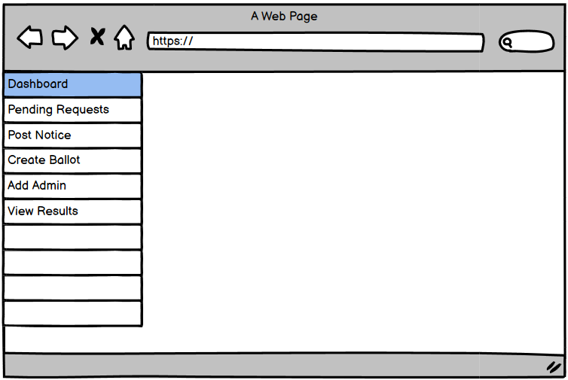

Figure :Wireframe 3 - Admin Dashboard

Figure : Wireframe 4 - Pending Requests

Figure : Wireframe 5 - Admin Dashboard

Figure : Wireframe 6 - View Positions

Figure : Wireframe 7 - View Candidates

Figure : Wireframe 8 - View Results

Figure : Wireframe 9 - Insights 1

Figure : Wireframe 10 - Insights 2

Figure : Wireframe 12 - Insights 3

Figure : Wireframe 13 - Insights 4