POKHARA UNIVERSITY
Faculty of Management Studies — BBA / BBA (Finance)
READING NOTES
Unit V: Introduction to Derivatives
(8 Teaching Hours) — Financial Management
Contents Covered
5.1 Introduction to Derivatives
5.2 Overview of Derivative Markets
5.3 Types of Derivatives (Futures, Options, Swaps, Forwards)
5.4 Overview of Futures Contracts
5.5 Overview of Options Contracts
5.6 Overview of Swaps
5.7 Application of Derivatives in the Nepalese Market
Practical Questions & Answers (Worked Numericals)
Quick-Revision Glossary

5.1 Introduction to Derivatives

What is a Derivative?
A derivative is a financial contract whose value is derived from the value of an underlying asset, index, or reference rate — rather than having independent value of its own. The underlying can be a stock, bond, commodity, currency, interest rate, or a market index.
Definition to remember
"A derivative is a contract between two or more parties whose value is based on an agreed-upon underlying financial asset, index, or security."

Key Features of Derivative Contracts
- Value derived from an underlying asset — the derivative itself has no independent existence.
- Involves two parties (a buyer/long and a seller/short) with a specified future settlement date.
- Contract terms are either standardized (exchange-traded) or customized (over-the-counter).
- Requires little or no initial investment relative to the value of the underlying — a source of leverage.
- Settlement can occur through physical delivery of the asset or cash settlement of the price difference.

Why Derivatives Exist — Core Functions
1. Hedging (Risk Management): Used to protect against adverse price movements in the underlying asset. A wheat farmer, for example, can lock in a selling price using a futures contract to remove uncertainty about the harvest-time price.
2. Speculation: Traders take a view on the future direction of prices and use derivatives to profit from anticipated movements, accepting higher risk for higher potential return.
3. Arbitrage: Exploits temporary price differences for the same asset in two different markets (e.g., spot vs. futures) to earn a risk-free profit, which in turn keeps markets efficient.
4. Price Discovery: Futures and options prices reflect the market's collective expectation of future prices, helping producers and investors plan ahead.
Exam tip
If a question asks "why do derivatives markets exist / what functions do they serve" — write the 4 points above as Hedging, Speculation, Arbitrage, Price Discovery (easy to remember as H-S-A-P).

5.2 Overview of Derivative Markets

Two Broad Market Structures
Basis | Exchange-Traded Derivatives | Over-the-Counter (OTC) Derivatives
Contract terms | Standardized (fixed size, expiry, tick size) | Customized/negotiated between parties
Counterparty risk | Minimal — clearing house guarantees performance | Present — depends on the other party's solvency
Liquidity | Generally high, transparent pricing | Lower, prices less transparent
Regulation | Regulated by exchange & securities regulator | Lightly regulated / self-regulated
Examples | Futures, exchange-traded options | Forwards, swaps, most exotic options

Market Participants
- Hedgers — reduce existing risk (e.g., an exporter hedging currency risk).
- Speculators — take on risk in pursuit of profit based on price expectations.
- Arbitrageurs — lock in riskless profit from price discrepancies across markets.
- Clearing house / clearing corporation — the intermediary that guarantees performance of exchange-traded contracts (in futures markets).

Global vs Nepalese Context
Globally, well-known derivative exchanges include the Chicago Mercantile Exchange (CME), National Stock Exchange (NSE, India), and CBOE (Chicago Board Options Exchange). In Nepal, a formal, regulated market for equity derivatives (index/stock futures & options) does not yet exist on NEPSE; derivative-type activity is presently limited mainly to commodity and currency instruments, discussed further in Section 5.7.

5.3 Types of Derivatives
The four principal categories of derivative instruments are forwards, futures, options, and swaps. Each differs in standardization, exchange listing, and the nature of the obligation created.
Feature | Forward | Futures | Option | Swap
Traded on | OTC (private) | Organized exchange | Exchange or OTC | OTC (private)
Standardization | Customized | Standardized | Standardized (exchange) / customized (OTC) | Customized
Obligation | Binding on both parties | Binding on both parties | Right for buyer; obligation for writer | Binding on both parties
Upfront cost | Usually none | Margin deposit | Premium paid by buyer | Usually none
Counterparty risk | High | Low (clearing house) | Low (exchange) / variable (OTC) | High
Settlement | At maturity | Daily mark-to-market + maturity | At/before expiry, if exercised | Periodic payment exchanges

Quick contrast
Forward vs Futures: a futures contract is essentially a standardized, exchange-traded, daily-settled version of a forward contract.
Option vs the other three: an option gives the buyer a RIGHT (not an obligation) — this is what makes its payoff asymmetric (Section 5.5).

5.4 Overview of Futures Contracts

Definition
A futures contract is a standardized, legally binding agreement to buy or sell a specified quantity of an underlying asset at a predetermined price on a specified future date, traded on an organized exchange.

Key Features
- Standardization — contract size, quality, and expiry dates are fixed by the exchange.
- Margin requirement — both parties deposit an initial margin as security, adjusted daily (maintenance margin).
- Marking-to-market — gains and losses are settled in cash at the end of every trading day, based on the day's settlement price.
- Clearing house guarantee — the clearing house becomes the counterparty to both sides, virtually eliminating default risk.
- High liquidity — easy to enter or exit a position before expiry by taking an offsetting position.

Payoff Diagrams
The payoff to a futures position is linear and symmetric — for every rupee the spot price moves, the position gains or loses proportionally, in the opposite direction for the buyer versus the seller.
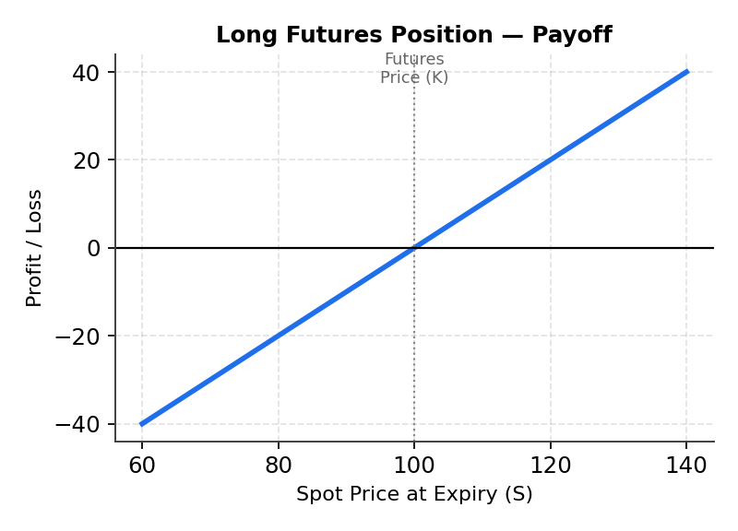
Fig. 5.1 — Long (buy) futures position: profit rises one-for-one as spot price (S) rises above the futures price (K).
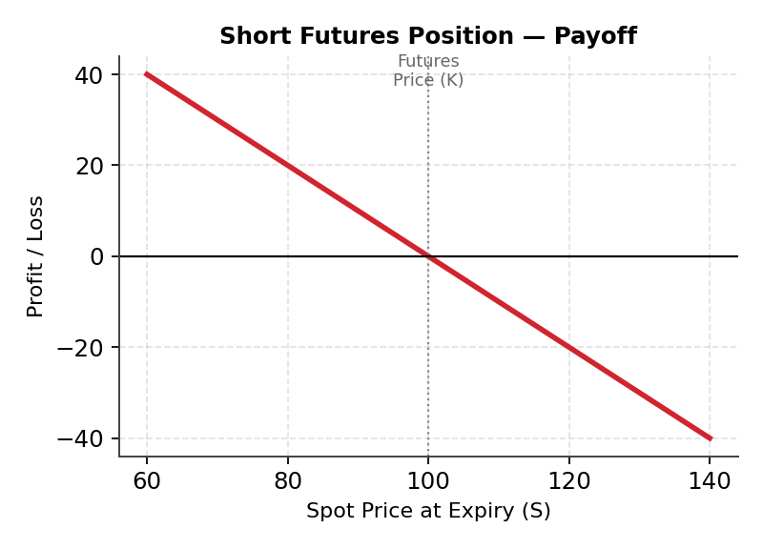
Fig. 5.2 — Short (sell) futures position: profit rises one-for-one as spot price (S) falls below the futures price (K).

Worked Numerical Example
A trader takes a long position in a gold futures contract at a futures price of Rs. 100,000 per 10 grams (contract size = 10 grams). At expiry, the spot price of gold is Rs. 106,000 per 10 grams.
- Payoff to long futures = Spot price at expiry − Futures price
- Payoff = 106,000 − 100,000 = Rs. 6,000 gain (per contract)
If instead the trader had gone short (sold futures) at Rs. 100,000 and the spot price fell to Rs. 96,000, the payoff to the short position = Futures price − Spot price = 100,000 − 96,000 = Rs. 4,000 gain.

5.5 Overview of Options Contracts

Definition and Key Terms
An option is a contract that gives its buyer the right, but not the obligation, to buy (call option) or sell (put option) an underlying asset at a predetermined price (the strike or exercise price) on or before a specified expiry date, in exchange for an upfront payment called the premium.
Term | Meaning
Call option | Gives the buyer the right to BUY the underlying at the strike price
Put option | Gives the buyer the right to SELL the underlying at the strike price
Strike / exercise price (K) | The pre-agreed price at which the underlying can be bought/sold
Premium | The non-refundable price paid by the buyer to the writer (seller) for the option
In-the-money (ITM) | Exercising the option would be profitable ignoring the premium
Out-of-the-money (OTM) | Exercising would not be profitable — option is left to lapse
At-the-money (ATM) | Spot price equals the strike price
American vs European option | American: exercisable any time up to expiry. European: exercisable only on expiry date

Payoff Diagrams (Four Basic Positions)
Assume strike price K = Rs. 100 and option premium = Rs. 8 in all four diagrams below.
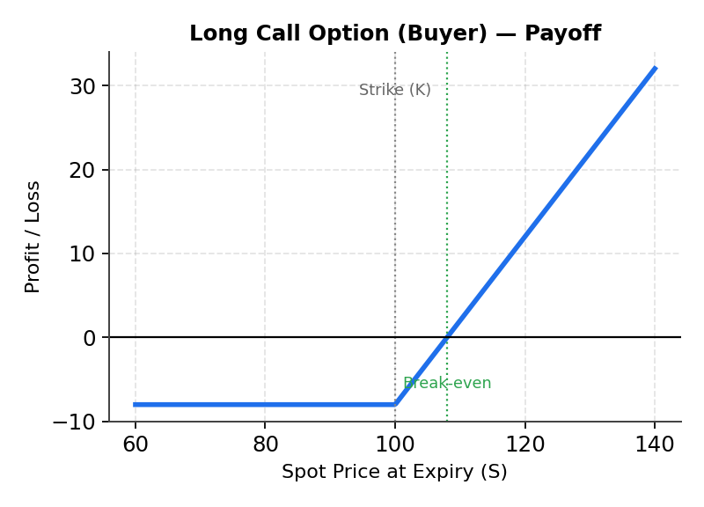
Fig. 5.3 — Long Call: loss limited to the premium paid (Rs. 8); unlimited upside above the break-even (K + premium = Rs. 108).
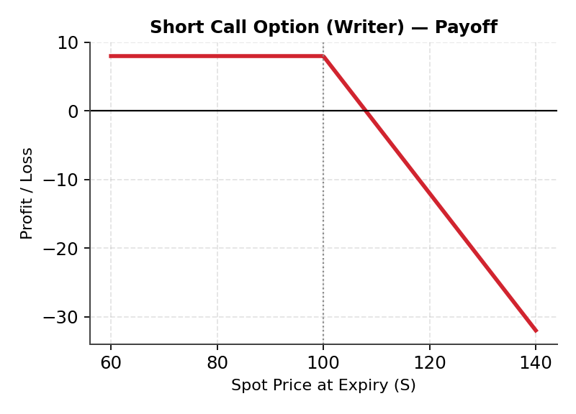
Fig. 5.4 — Short Call (writer): gain limited to premium received; theoretically unlimited loss if price rises sharply.
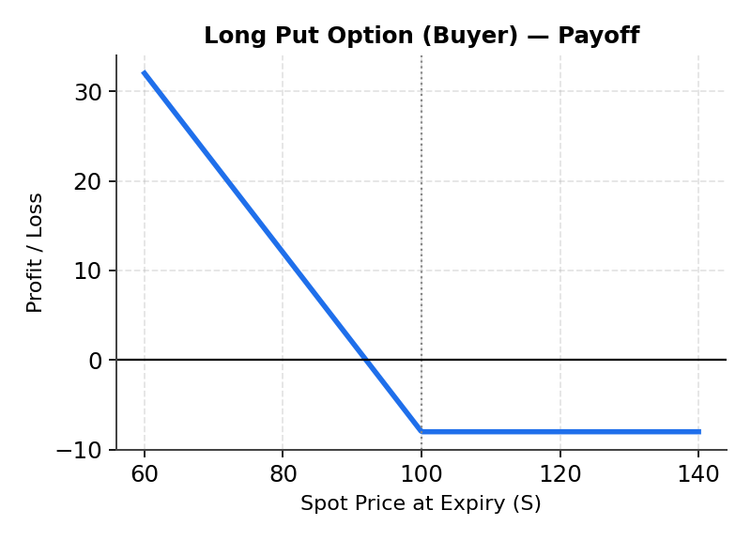
Fig. 5.5 — Long Put: loss limited to premium paid; profit rises as the spot price falls below the break-even (K − premium = Rs. 92).
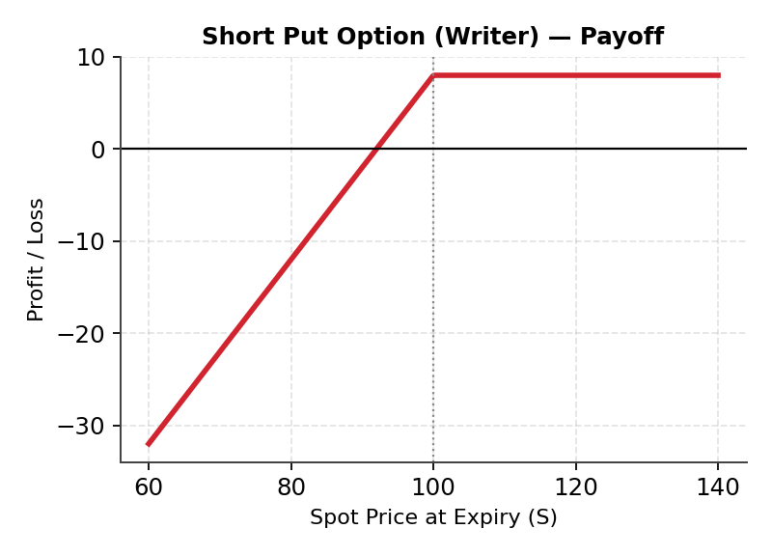
Fig. 5.6 — Short Put (writer): gain limited to premium received; large loss possible if the price falls sharply (bounded by zero).

Worked Numerical Examples
Example 1 — Call option: An investor buys a call option on a stock with strike price K = Rs. 500 by paying a premium of Rs. 20. At expiry, the stock price is Rs. 560.
- Payoff to buyer = Max(S − K, 0) = Max(560 − 500, 0) = Rs. 60
- Net profit = Payoff − Premium = 60 − 20 = Rs. 40 profit
- Break-even price = K + Premium = 500 + 20 = Rs. 520
- If the stock price at expiry had instead been Rs. 480, payoff = Max(480−500,0) = 0, so the option lapses and the buyer's loss = Rs. 20 (the premium).
Example 2 — Put option: An investor buys a put option with strike K = Rs. 300, paying a premium of Rs. 15. At expiry, the stock price is Rs. 270.
- Payoff to buyer = Max(K − S, 0) = Max(300 − 270, 0) = Rs. 30
- Net profit = Payoff − Premium = 30 − 15 = Rs. 15 profit
- Break-even price = K − Premium = 300 − 15 = Rs. 285

5.6 Overview of Swaps

Definition
A swap is an OTC agreement between two parties to exchange a series of cash flows over a specified period, based on a notional principal amount. Unlike futures/options, swaps are generally not exchange-traded and are tailored to the specific needs of the counterparties.

Common Types of Swaps
Interest Rate Swap (IRS): the most common type — one party exchanges fixed-rate interest payments for floating-rate payments (e.g., linked to a benchmark rate), computed on the same notional principal. The notional itself is never exchanged.
Currency Swap: exchange of principal and/or interest payments in one currency for those in another currency — used to manage foreign-exchange and cross-border funding risk.
Commodity Swap: exchange of a fixed price for a floating (market) price of a commodity, used by producers/consumers to stabilize cash flows.
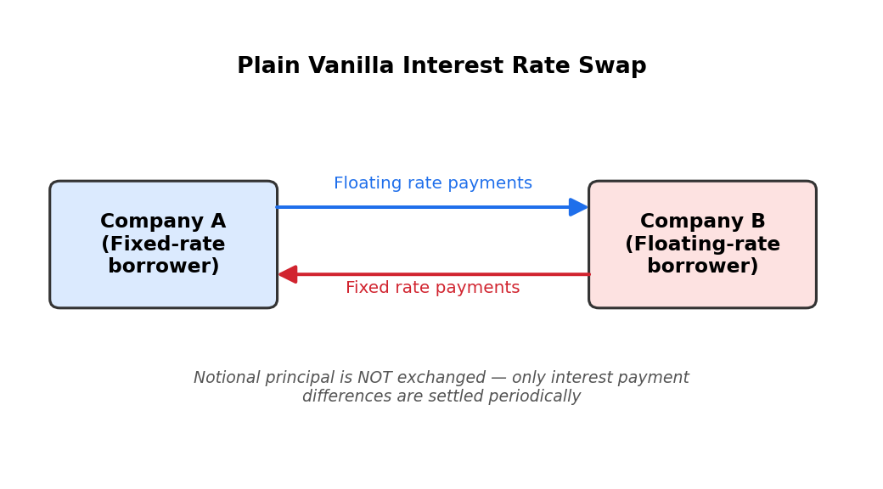
Fig. 5.7 — Structure of a plain-vanilla interest rate swap between two companies.

Worked Numerical Example — Interest Rate Swap
Company A and Company B enter a swap with a notional principal of Rs. 10,000,000. Company A agrees to pay a fixed rate of 8% p.a. and receive a floating rate; Company B pays floating and receives fixed. At the payment date, the floating rate resets to 8.5%.
- Fixed payment (A pays) = 10,000,000 × 8% = Rs. 800,000
- Floating payment (B pays) = 10,000,000 × 8.5% = Rs. 850,000
- Net settlement: B pays A the difference = 850,000 − 800,000 = Rs. 50,000 (only the net amount changes hands)

5.7 Application of Derivatives in the Nepalese Market

Current State
Nepal does not yet have a fully developed, exchange-regulated market for financial derivatives such as stock or index futures/options on NEPSE. However, derivative-like instruments are used in specific segments of the Nepalese economy:
1. Commodity derivatives: Commodity exchanges such as the Commodities and Metal Exchange Nepal (COMEN) and MEX Nepal facilitate futures-style trading in gold, silver, and select agricultural/base-metal commodities, allowing producers and traders to hedge price risk domestically.
2. Currency forward contracts: Commercial banks, under Nepal Rastra Bank (NRB) guidelines, offer forward foreign-exchange contracts mainly to importers and exporters to hedge against exchange-rate fluctuations on trade payments.
3. Interest rate risk management: Limited use of interest-rate-linked instruments exists mainly at the interbank/institutional level rather than as a retail derivative product.

Challenges to Development
- Regulatory and legal framework for exchange-traded equity derivatives is still evolving.
- Low market depth, liquidity, and awareness among retail investors.
- Limited technological and clearing infrastructure needed for daily mark-to-market settlement.
- Capital and foreign-exchange controls restrict some cross-border derivative activity.

Way Forward
- SEBON (Securities Board of Nepal) and NEPSE have periodically discussed introducing index futures as capital markets mature.
- Growth of commodity exchanges is viewed as a stepping stone toward a broader derivatives ecosystem.
- Investor education and a strengthened clearing/settlement system are seen as prerequisites for safe expansion.

Practical Questions & Answers
Worked numerical problems for exam practice, covering futures, options, and swaps.
Q1. An investor buys one futures contract on wheat at Rs. 2,500 per quintal (contract size 100 quintals). At expiry, the spot price of wheat is Rs. 2,610 per quintal. Calculate the investor's total gain/loss.
Answer:
- Payoff per quintal = Spot − Futures price = 2,610 − 2,500 = Rs. 110
- Total gain = 110 × 100 quintals = Rs. 11,000 gain
Q2. A company sells (goes short) a futures contract on crude oil at USD 80/barrel for 1,000 barrels. At expiry, spot price is USD 75/barrel. Find the profit or loss.
Answer:
- Payoff to short = Futures price − Spot price = 80 − 75 = USD 5/barrel
- Total profit = 5 × 1,000 = USD 5,000 profit
Q3. A trader buys a call option on ABC Ltd. shares with strike price Rs. 250 by paying a premium of Rs. 12. Determine the trader's profit/loss if the share price at expiry is (a) Rs. 280, and (b) Rs. 230.
Answer:
- (a) S = 280: Payoff = Max(280−250,0) = 30; Net profit = 30 − 12 = Rs. 18 profit
- (b) S = 230: Payoff = Max(230−250,0) = 0; the option lapses. Net loss = Rs. 12 (premium only)
- Break-even price = 250 + 12 = Rs. 262
Q4. An investor buys a put option on XYZ Ltd. with strike price Rs. 400, paying a premium of Rs. 18. If the spot price at expiry is Rs. 350, calculate the net profit. Also find the break-even price.
Answer:
- Payoff = Max(K−S,0) = Max(400−350,0) = Rs. 50
- Net profit = 50 − 18 = Rs. 32 profit
- Break-even price = K − Premium = 400 − 18 = Rs. 382
Q5. A call option writer sells a call at strike Rs. 600 for a premium of Rs. 25. What is the writer's maximum possible profit, and what happens if the share price rises to Rs. 700 at expiry?
Answer:
- Maximum profit for the writer = premium received = Rs. 25 (occurs whenever S ≤ K at expiry)
- If S = 700: Buyer's payoff = Max(700−600,0) = 100, so the writer must pay out Rs. 100 and nets a loss of 100 − 25 = Rs. 75 loss
- This illustrates that a call writer's loss is theoretically unlimited as the underlying price rises.
Q6. Two firms enter an interest rate swap on a notional of Rs. 5,000,000. Firm P pays fixed at 9% p.a. and receives floating; Firm Q pays floating and receives fixed. If the floating rate resets at 9.8%, who pays whom, and how much (net settlement)?
Answer:
- Fixed leg (P owes) = 5,000,000 × 9% = Rs. 450,000
- Floating leg (Q owes) = 5,000,000 × 9.8% = Rs. 490,000
- Since the floating amount exceeds the fixed amount, Q pays P the net difference = 490,000 − 450,000 = Rs. 40,000
Q7. Distinguish between hedging and speculation using derivatives, with one example each.
Answer:
- Hedging reduces existing risk exposure — e.g., an exporter buying a currency forward to lock in the exchange rate for an expected receivable, protecting against currency depreciation.
- Speculation takes on new risk to profit from an expected price move — e.g., a trader buying a call option purely because they expect the stock price to rise, with no underlying exposure to hedge.
Q8. Why is the maximum loss for a futures contract holder theoretically unlimited, while the maximum loss for an option buyer is limited to the premium?
Answer:
A futures contract obligates both parties to transact at the agreed price regardless of how far the market moves against them — there is no built-in floor or cap, so losses can grow without limit as the adverse price movement continues. An option, by contrast, gives the buyer a right, not an obligation: if exercising would be unprofitable, the buyer simply lets it lapse. The worst outcome for the buyer is therefore forfeiting the premium already paid — a fixed, known amount decided at the outset.

Quick-Revision Glossary
Term | One-line meaning
Underlying asset | The asset from which a derivative's value is derived
Notional principal | The reference amount used to calculate swap/derivative payments; not usually exchanged
Margin | Collateral deposited to cover potential losses on a futures position
Mark-to-market | Daily revaluation of a futures position to the day's settlement price
Premium | Price paid by an option buyer to the option writer
Strike price | Pre-agreed exercise price in an option contract
Hedger | Market participant reducing existing price risk
Speculator | Market participant accepting risk in pursuit of profit
Arbitrageur | Participant exploiting price differences for riskless profit
Clearing house | Exchange body that guarantees performance of futures contracts

