Name : Mubeena khanam B

E-mail id : [mubeenakhanam816@gmail.com](mailto:mubeenakhanam816@gmail.com)

**1.Task1**

**1.1 Task title :**

Responsive Company Member Team page.

**1.2 Task description:**

Create a webpage using HTML and CSS to show company team. The webpage must include the comapnay name and short description, and sections for different team categories (Founders, Developers, Sales and Management) with details about individual team member.

**1.3Steps taken:**

1.instalization

* Downloading software [visual studio ]
* Set up the software installing necessary requirements

2.project title:

* Using title tag and setting up the web page name as - company team page

3. Header and description:

* using the **<h1>** tag to add the company name
* including <p> tag within it to give the short description of company

4. Team section :

* The **<div>** tag is used to group together related elements, such as sections of a webpage
* using the **<h2>** tag to add the header of the team section
* Divided the team into three categories: Founders, Developers, Sales and Management
* For each category, added a subsection with a header and individual team member cards

5.Team member card:

* Each team member card includes an image and a name
* Styled the cards for consistent appearance with padding, margins, background color, and box shadow effects

6.styling:

* Ensured responsive design using flexbox properties to handle different screen sizes
  1. **Challenges faced:**
     1. Image sizing: Maintaining consistent image sizes and aspect ratios for the team member cards required careful styling
     2. Alignment and spacing : Achieving a uniform layout with proper alignment and spacing between different sections and elements
  2. **Solution implemented:**
     1. Image sizing : Set a fixed width for images and used CSS properties like **border-radius** to ensure all images have a consistent appearance
     2. Alignment and spacing : Applied CSS margins and paddings uniformly to create a balanced look .Used container elements with defined maximum widths to maintain content alignment within the pag.

**1.6 CODE:**

The complete code used for the project:

1.index.hmtl

<!DOCTYPE html>

<html lang="en">

<head>

<meta charset="UTF-8">

<meta name="viewport" content="width=device-width, initial-scale=1.0">

<title>Company Team Page</title>

<link rel="stylesheet" href="intert1.css">

</head>

<body>

<div class="container">

    <h1>Company Name</h1>

    <p>Welcome to VeriTech where a dedicated team ofprofessional works

        together to bring innovation, creativity and expertise to Software industry get to know t

        he individuals who makes our company thrive. .</p>

    <p>------------------------------------------------------------------</p>

    <h2>Meet Our Team</h2>

    <div class="team-section">

        <div class="team-category">

            <h3>Leadership/Management Team</h3>

            <div class="team-member">

                <div class="person">

                    <img src="C:\Users\Dell\Downloads\employee.png" alt="Founder 1">

                    <h4>Founder/CEO</h4>

                </div>

                <div class="person">

                    <img src="C:\Users\Dell\Downloads\employee.png" alt="Founder 2">

                    <h4>Founder 2/CEO</h4>

                </div>

                <div class="person">

                    <img src="C:\Users\Dell\Downloads\employee.png" alt="Founder 2">

                    <h4> vp,Development & growth</h4>

                </div>

                <div class="person">

                    <img src="C:\Users\Dell\Downloads\employee.png" alt="Founder 2">

                    <h4>VP,Sales and Marketing</h4>

                </div>

                <div class="person">

                    <img src="C:\Users\Dell\Downloads\employee.png" alt="Founder 2">

                    <h4>VP,Finance & operation</h4>

                </div>

                <!-- Add more founders as needed -->

            </div>

        </div>

        <div class="team-category">

            <h3>Developers</h3>

            <div class="team-member">

                <div class="person">

                    <img src="C:\Users\Dell\Downloads\employee.png" alt="Developer 1">

                    <h4>Developer 1</h4>

                    <p> Team lead,SE</p>

                </div>

                <div class="person">

                    <img src="C:\Users\Dell\Downloads\employee.png" alt="Developer 2">

                    <h4>Developer 2</h4>

                    <p>Software Engineer</p>

                </div>

                  <div class="person">

                    <img src="C:\Users\Dell\Downloads\employee.png" alt="Developer 2">

                    <h4>Developer 2</h4>

                    <p>Software Engineer</p>

                </div>

                <div class="person">

                    <img src="C:\Users\Dell\Downloads\employee.png" alt="Developer 2">

                    <h4>Developer 2</h4>

                    <p>Software Engineer</p>

                </div>

                <div class="person">

                    <img src="C:\Users\Dell\Downloads\employee.png" alt="Developer 2">

                    <h4>Developer 2</h4>

                    <p>Software Engineer</p>

                </div>

                <!-- Add more developers as needed -->

            </div>

        </div>

        <div class="team-category">

            <h3>Sales and Management</h3>

            <div class="team-member">

                <div class="person">

                    <img src="C:\Users\Dell\Downloads\employee.png" alt="Sales 1">

                    <h4>Sales 1</h4>

                    <p>Team lead</p>

                </div>

                <div class="person">

                    <img src="C:\Users\Dell\Downloads\employee.png" alt="Management 1">

                    <h4>Management 1</h4>

                      <p>Sales Officer</p>

                </div>

                <div class="person">

                    <img src="C:\Users\Dell\Downloads\employee.png" alt="Management 1">

                    <h4>Management 1</h4>

                      <p>Sales Officer</p>

                </div>

                <div class="person">

                    <img src="C:\Users\Dell\Downloads\employee.png" alt="Management 1">

                    <h4>Management 1</h4>

                      <p>Marketing Officer</p>

                </div>

                <div class="person">

                    <img src="C:\Users\Dell\Downloads\employee.png" alt="Management 1">

                     <h4>Management 1</h4>

                      <p>Management Officer</p>

                </div>

                <!-- Add more sales and management as needed -->

            </div>

        </div>

    </div>

</div>

</body>

</html>

2.intern1.css

body {

    font-family: Arial, sans-serif;

    margin: 0;

    padding: 0;

    background-color: #f0f0f0;

}

.container {

    max-width: 800px;

    margin: 20px auto;

    padding: 20px;

    background-color: #fff;

    border-radius: 10px;

    box-shadow: 0 0 10px rgba(0, 0, 0, 0.1);

}

h1, h2 {

    text-align: center;

}

h1 {

    color: #cc1a6a;

    text-align: center; /* Add your desired color here */

}

p

{

    color: #cc1a6a;

    text-align: center;

    justify-self: center;

}

.team-section {

    margin-top: 30px;

}

h3{

    background: #cc1a6a;

    text-align: center;

}

.team-category {

    margin-top: 20px;

}

.team-category h3 {

    margin-bottom: 10px;

}

.team-member {

    display: flex;

    justify-content: space-around;

    flex-wrap: wrap;

}

.team-member .person {

    width: calc(33.33% - 20px);

    margin: 10px;

    padding: 20px;

    background-color: #f9f9f9;

    border-radius: 5px;

    box-shadow: 0 0 5px rgba(0, 0, 0, 0.1);

}

.personimg{

    width: 100px;

   aspect-ratio: 2/1;

}

.team-member .person img {

    width: 100%;

    border-radius:2px;

}

.team-member .person h4 {

    margin-bottom: 10px;

    text-align: center;

}

Output :

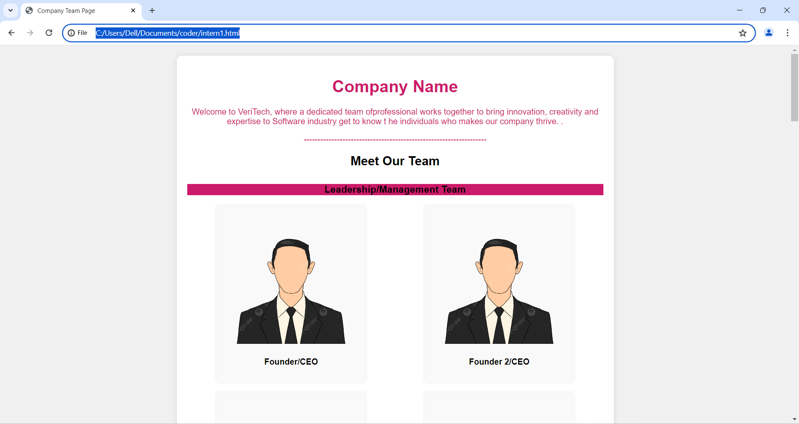 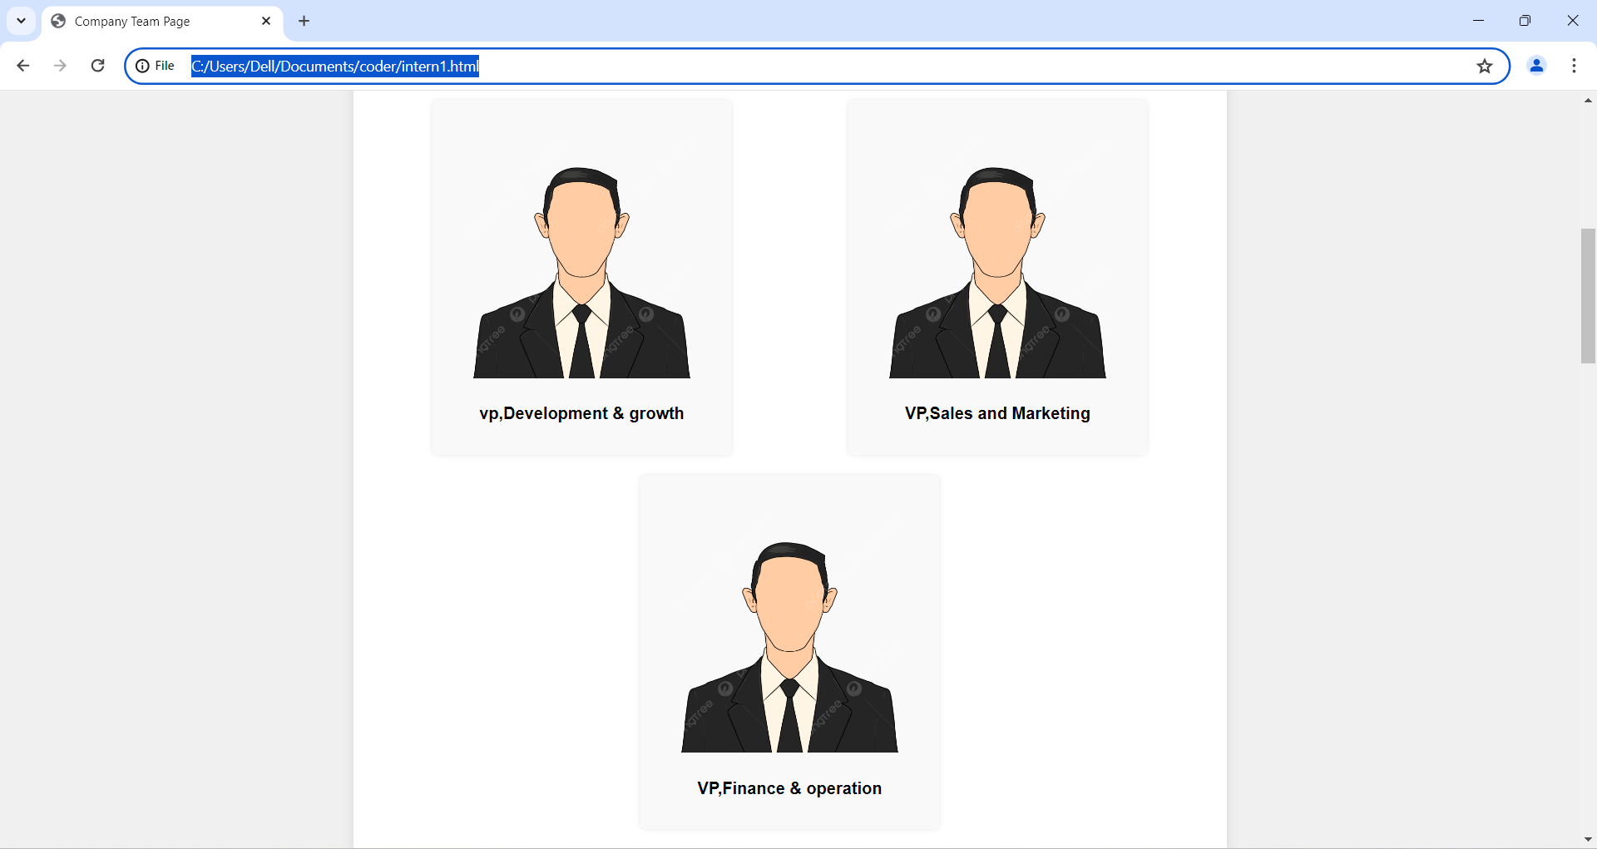 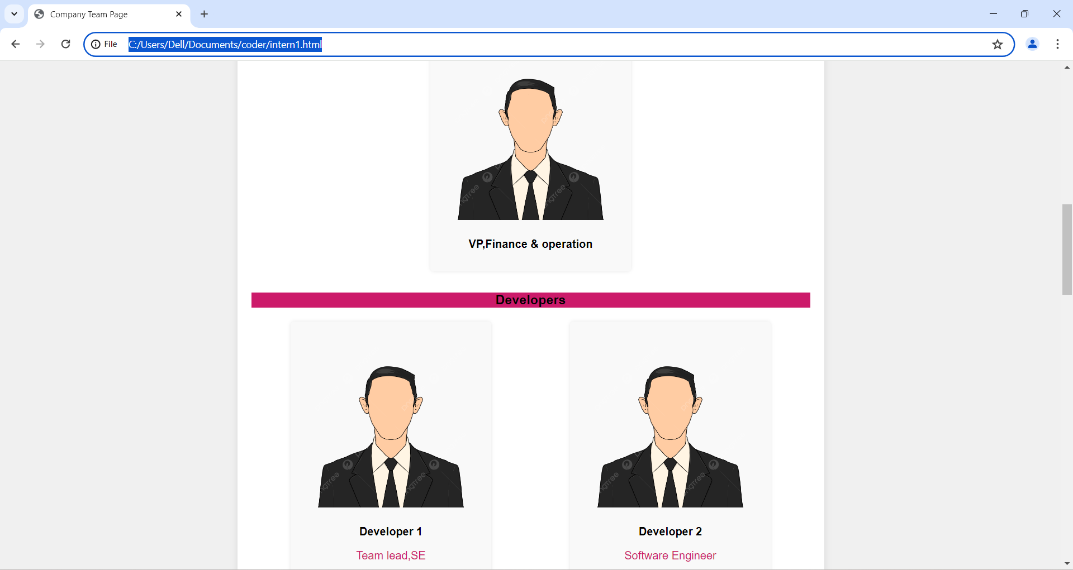 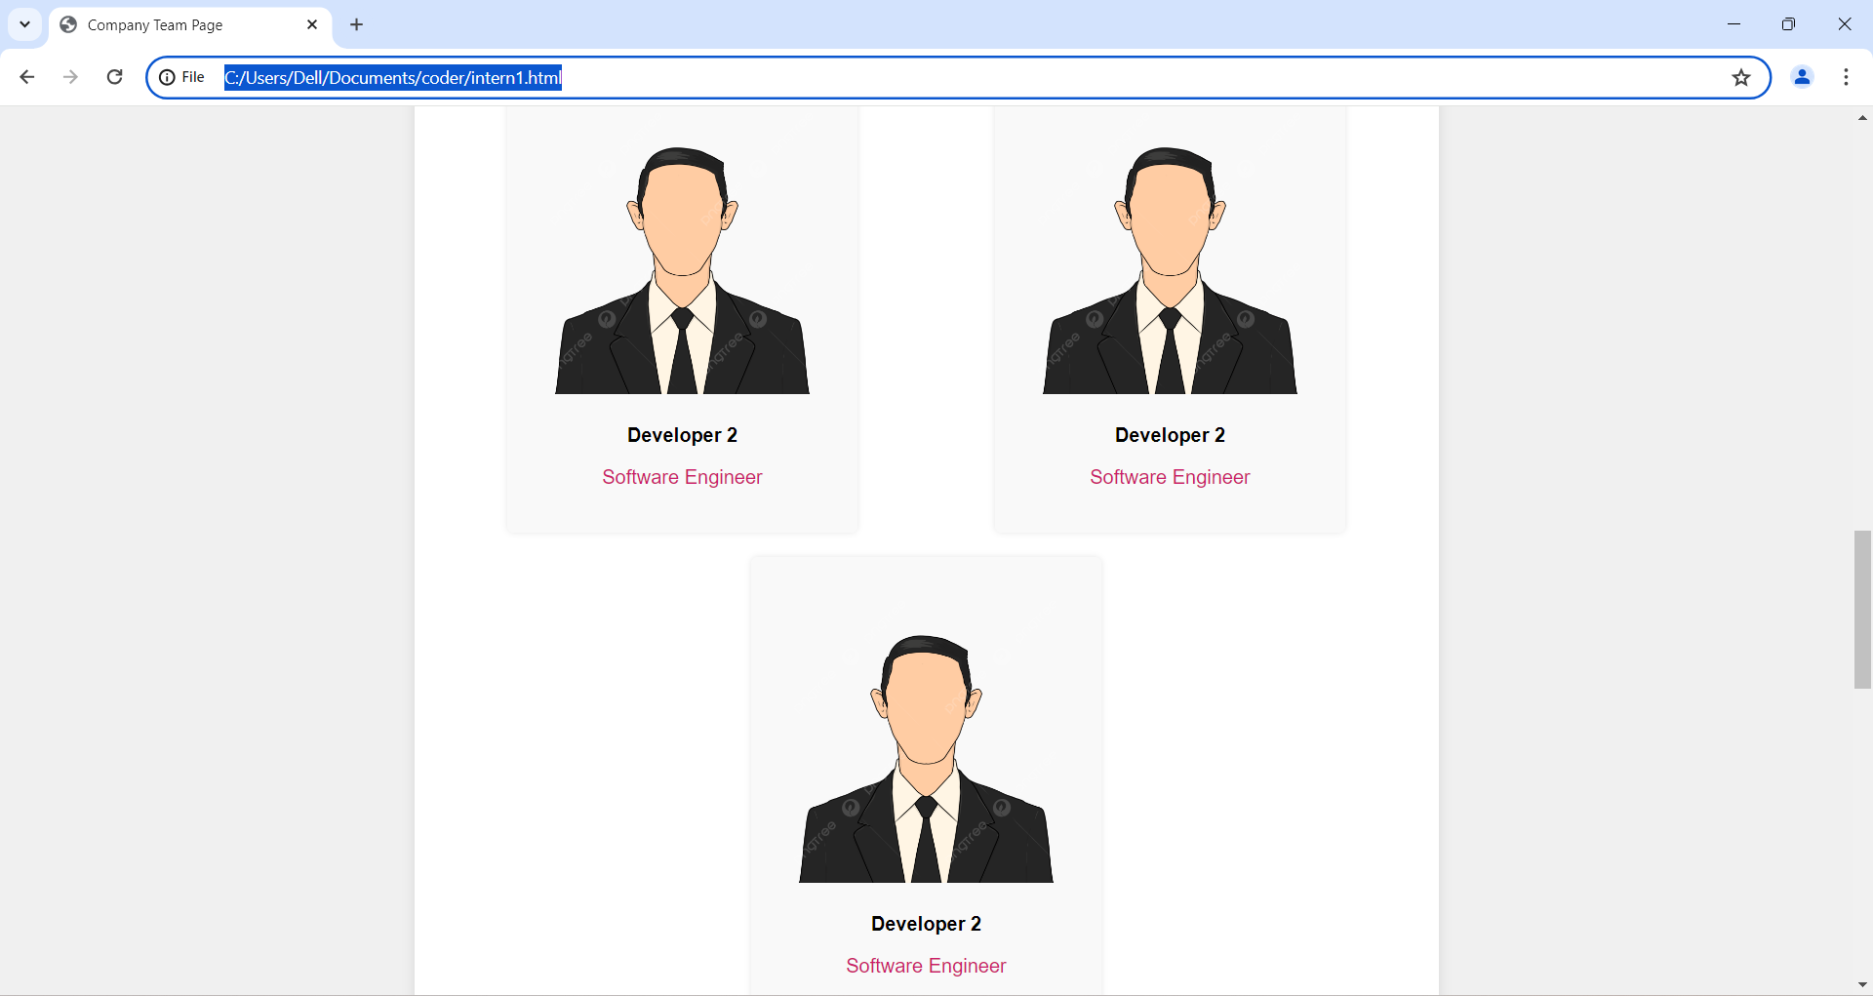 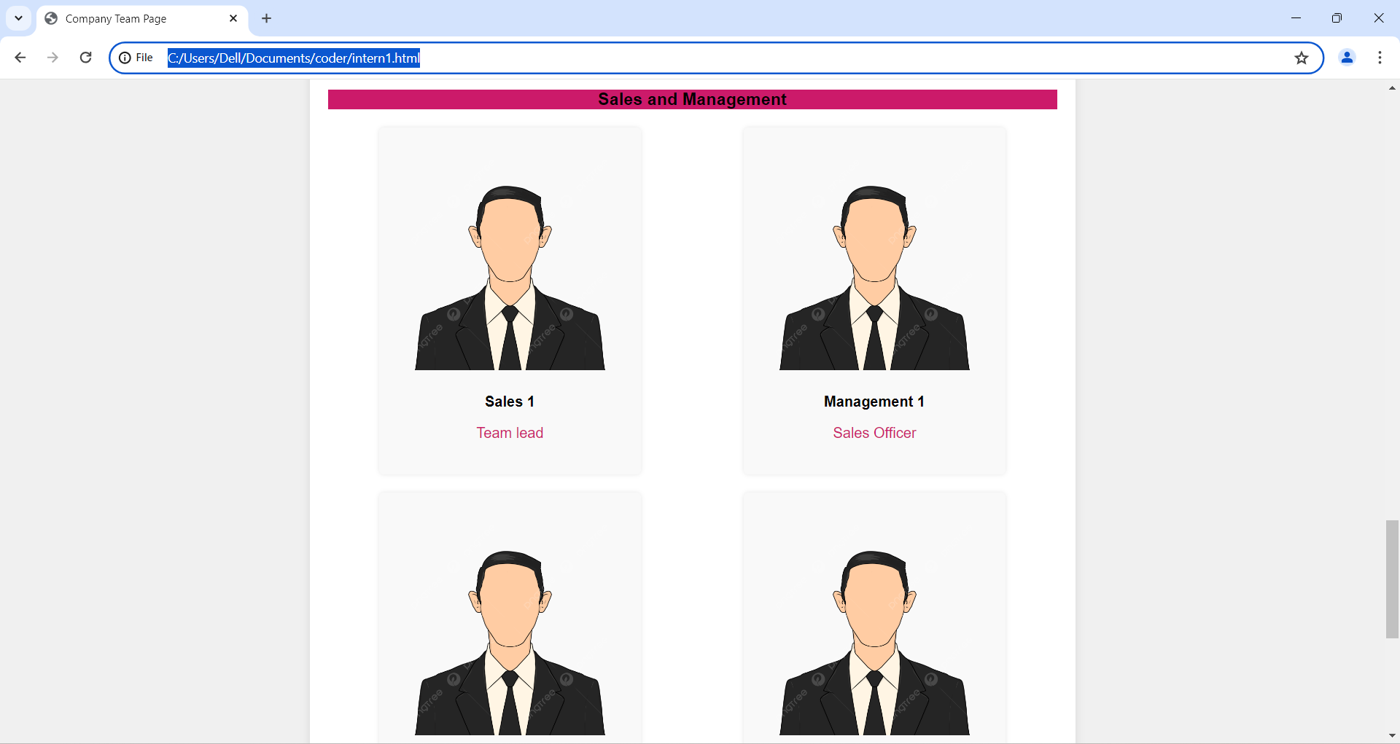 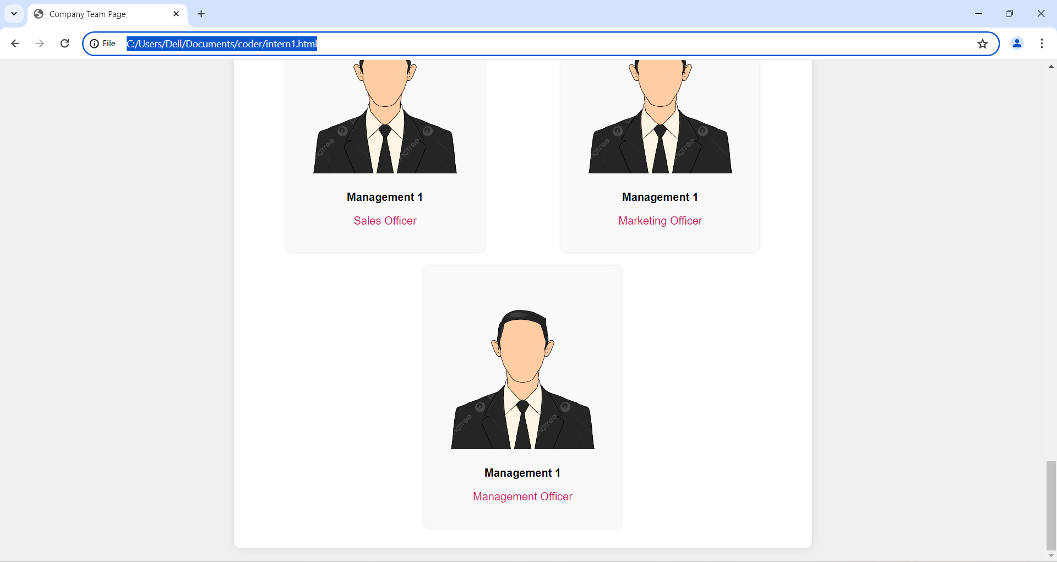

Create a webpage using HTML and CSS to showcase a company's team. The webpage should include the company name, a short description, and sections for different team categories (Founders, Developers, Sales and Management) with details about individual team members