Name : Mubeena khanam B

E-mail id : [mubeenakhanam816@gmail.com](mailto:mubeenakhanam816@gmail.com)

**1.Task1**

**1.1 Task title :**

Responsive event page for new car launch.

**1.2 Task description:**

Create a webpage using HTML and CSS to show company team. The webpage must include the title say welcome new launch page and hyperlink to nextpage different team categories (video,image) with details about individual page

**1.3Steps taken:**

1.instalization

* Downloading software [visual studio ]
* Set up the software installing necessary requirements

2.project title:

* Using title tag and setting up the web page name as - company team page

3. Header and description:

* using the **<h1>** tag to add the message

4. Team section :

* The **<div>** tag is used to group together related elements, such as sections of a webpage
* using the **<h2>** tag to add the header of the team section
* including <p> tag within it to give the short description of new car details
* For each category, added a subsection with a header nd individual team member cards

6.styling:

* Ensured responsive design using flexbox properties to handle different screen sizes
* Styled the cards for consistent appearance with padding, margins, background color, and box shadow effects
  1. **Challenges faced:**
     1. Image sizing: Maintaining consistent image sizes and aspect required careful styling
     2. video sizing: Maintaining consistent video sizes and aspect ratios for the team Alignment and spacing Achieving a uniform layout with proper alignment and spacing between different sections and elements
  2. **Solution implemented:**
     1. Image sizing : Set a fixed width for images and used CSS properties like **border-radius** to ensure all images have a consistent appearance
     2. Alignment and spacing : Applied CSS margins and paddings uniformly to create a balanced look .Used container elements with defined maximum widths to maintain content alignment within the page.

**1.6 CODE:**

The complete code used for the project:

1.inlayout.hmtl

<html>

    <head>

        <title> launch event</title>

        <meta name="viewport" content="width=device-width, initial-scale=1.0">

        <title>Company Team Page</title>

        <link rel="stylesheet" href="inlayout.css">

    </head>

    <body>

       <div class="container">

          <video autoplay loop muted >

              <source src="vv.mp4"  type="video/mp4">

          </video>

          </div>

       <div class="text-box">

        <h2>Welcome TO THE</h2>

   -> <h2>launch Of New Car</h2>

       </div>

      </video>

      </div>

      <div class="banner-text">

      <a href="nextpage.html" target="_blank">Visit Page to explore the details of new car</a>"

      </div>

</html>

2.inlayout.css

body {

    font-family: Arial, sans-serif;

    margin: 0;

    padding: 0;

    box-sizing: border-box;

}

.container{

    max-width: 100%;

    height: 100vh;

    position: relative;

}

.container video{

    max-width: 100%;

    height: 75%;

}

h1, h2 {

    text-align: left;

    color: aquamarine;

}

.text-box{

    position: absolute;

    top: 0;

    left: 0;

    background: #000;

    height: 100%;

    width: 100%;

    color: #fff;

    display:flex;

    align-items: center;

    font-size: 100px;

     font-weight: 800;

     mix-blend-mode: multiply;

}

.banner-text{

    position:absolute;

    top:35%;

  color:purple;

  padding: 20%;

  right: 45%;

}

3.nextpage.html

<html>

    <head>

        <title> launch event</title>

        <meta name="viewport" content="width=device-width, initial-scale=1.0">

        <title>Company Team Page</title>

<link rel="stylesheet" href="nextpage.css">

    </head>

    <body>

        <div class="container">

            <h1>BRAND NEW MODEL</h1>

            <p>Mahindra XUV 3XO price in India starts from ₹ 7.49 Lakh. XUV 3XO 2024 is available in 16 colours - Citrine Yellow, Deep Forest, Dune Beige, Everest White,

                Galaxy Grey, Nebula Blue, Stealth Black, Tango Red, Citrine Yellow with Stealth Black, Deep Forest with Galvono Grey, Dune Beige with Stealth Black, Everest White with Stealth Black, Galvono Grey with Stealth Black, Nebula Blue with Galvano Grey, Stealth Black with Galvono Grey, and Tango Red with Stealth Black. XUV 3XO seating capacity is 5 People.

                 XUV 3XO mileage is 17.96 - 21.2 km/l. XUV 3XO 2024 has received Not Tested safety rating.</p>

        <img src="download.jpeg"  width="=500px">

        <div class="text-box"></div>

        <h2>Mahindra XUV 3XO - XUV 3XO Price, Specs, Images, Colours</h2>

        <table border="3px">

            <tr>

            <th>

                XUV 3XO Model   </th>

                <th>Price</th>

                <th>Key Specs</th>

                </tr>

               <tr>

                <td>1.2 L TCMPFi</td>

                    <td>₹ 7.49 Lakh </td>

                        <td>Petrol, 1197 cc, Manual</td>

                        </tr>

        <tr>

            <td> MX2 Pro 1.2 L TCMPFi   </td>

            <td>₹ 8.99 Lakh </td>

            <td>Petrol, 1197 cc, Manual</td>

        </tr>

<tr>

    <td>

    TCMPFi</td>

        <td>>₹ 9.49 Lakh</td>

            <td>Petrol, 1197 cc, Manual</td>

            <tr>

              <td  >MX2 1.5 Turbo Diesel</td>

              <td>  ₹ 9.99 Lakh</td>

                <td>    Diesel, 1497 cc, Manual</td>

                </tr><tr>

               <td> MX2 Pro 1.2 L TCMPFi AT </td>

                <td>₹ 9.99 Lakh</td><td>    Petrol, 1197 cc, Automatic (TC)</td>

                </tr>

              <td>  MX3 Pro 1.2 L TCMPFi</td>   <td></td>₹ 9.99 Lakh    </td></td>Petrol, 1197 cc, Manual</td>

         <tr>     <td>  MX2 Pro 1.5 Turbo Diesel    <td>₹ 10.39 Lakh<td>    Diesel, 1497 cc, Manual</td></tr>

        </table>

        <ul>

            <li> Engine options

<p>

                    Mechanically, the compact SUV continues with the same powertrain options as its predecessor the XUV300.

                     So there's a 1.2-litre petrol engine and a 1.5-litre diesel engine.

                     The standard 1.2-litre petrol produces 109bhp/200Nm and can be had with a six-speed MT/six-speed AT.

                </p>

            </li>

            <li> Modern features

<p>

                Even the most basic version of the car gets features like projector headlamps, LED DRLs, 16-inch steel wheels, power windows,

                front armrest, rear AC vents, 12V socket and reverse parking sensors. At the other end of the scale, you get features level-2 ADAS, panoramic sunroof, Harman Kardon Music system, fully digital instrument cluster,

                 Adrenox connected car technology and dual-zone climate control with rear AC vents.</li>

</p>

</li>  </ul>

    </div>

</body>

</html>

4.nextpage.css

body {

    font-family: Arial, sans-serif;

    margin: 0;

    padding: 0;

    box-sizing: border-box;

}

.text-box{

display: flex;

justify-content: space-around;

flex-wrap: wrap;

}

Output:

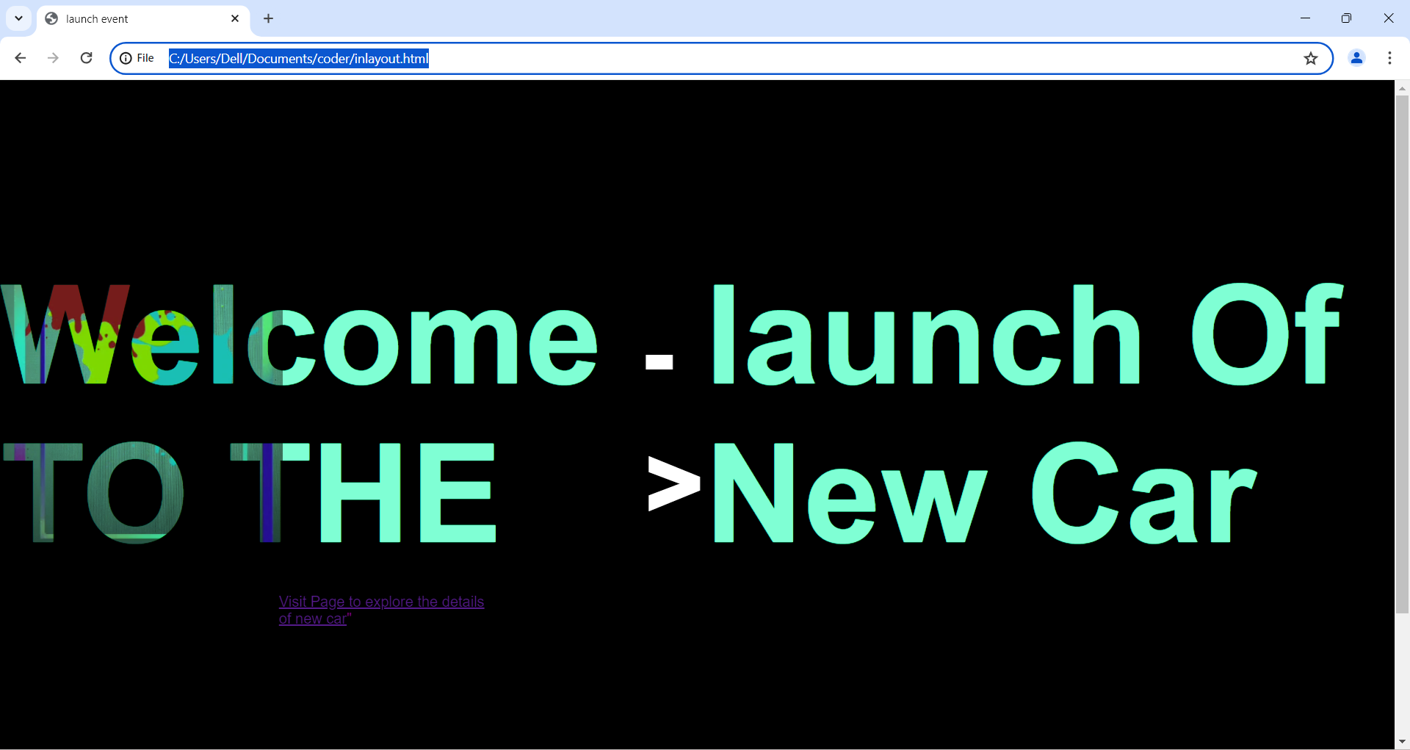

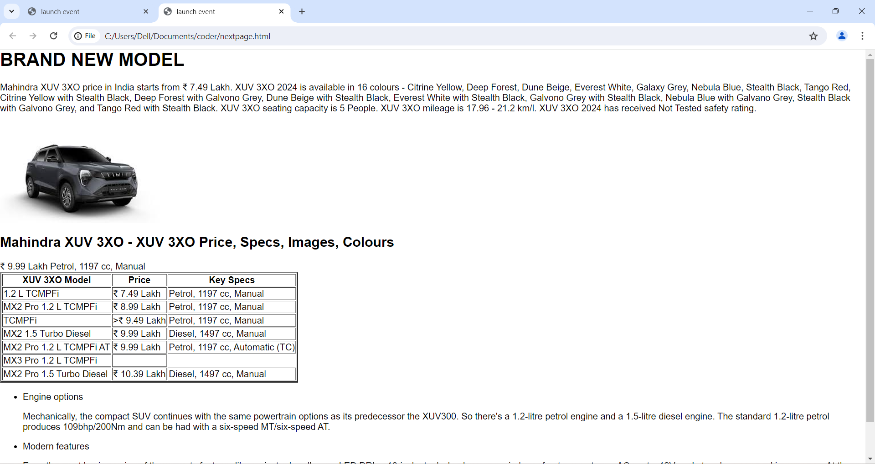

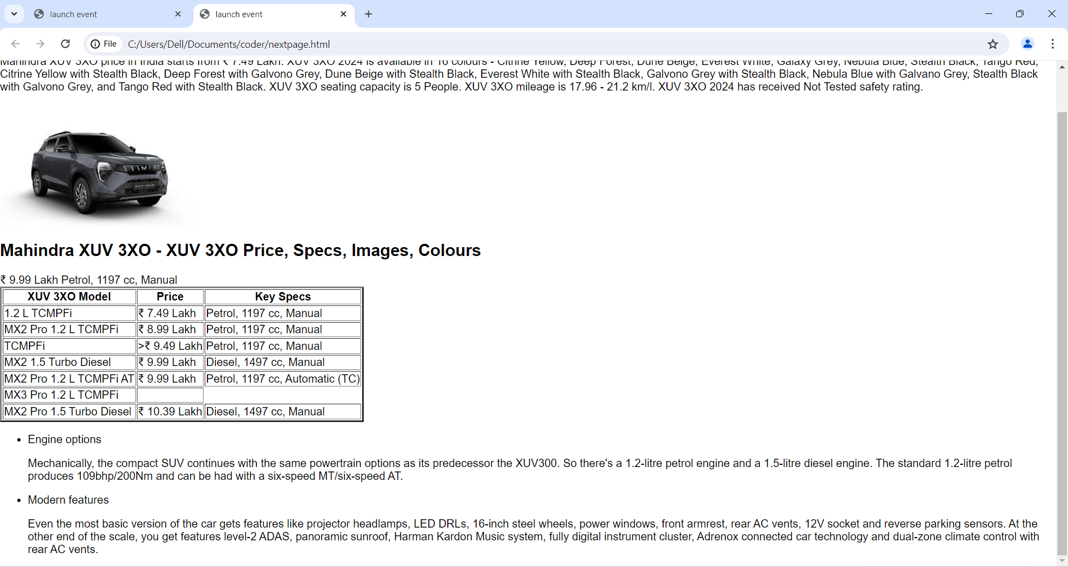

Create a webpage using HTML and CSS to showcase a company's team. The webpage should include the company name, a short description, and sections for different team categories (Founders, Developers, Sales and Management) with details about individual team members