TalentLense AI
AI-Powered Recruitment Platform
Final Project Report

Abstract
TalentLense AI is an intelligent recruitment platform designed to automate the hiring process using artificial intelligence. It integrates CV screening, AI-based interviews, candidate evaluation, and proctoring into a single system. The platform helps organizations reduce hiring time, improve decision accuracy, and ensure unbiased evaluations.

Objectives
• Automate resume screening using AI
• Conduct AI-based video interviews
• Provide accurate candidate evaluation
• Detect cheating using proctoring
• Simplify hiring workflow for HR teams

Introduction
TalentLense AI is a smart hiring platform that helps companies automate the recruitment process using AI.
It can:
• Read and analyze resumes (CV screening)
• Schedule interviews automatically
• Conduct AI-based video interviews
• Evaluate candidates and give scores

System Architecture
The system consists of frontend, backend, and database layers working together.
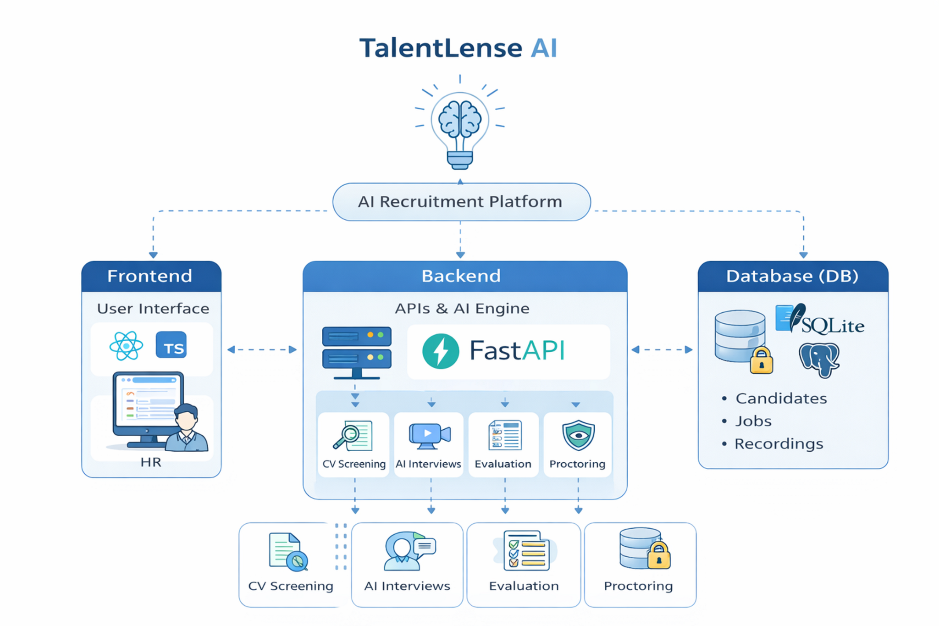

Technologies Used
Frontend: React, TypeScript, Vite, Axios, Zustand
Backend: Python, FastAPI, Uvicorn, Pydantic
Database: SQLite, SQLAlchemy, Alembic
AI: MediaPipe, OpenCV, NumPy
Video/Audio: MediaRecorder, Web Speech API
Security: JWT, bcrypt, Fernet
Infrastructure: Docker, docker-compose

System Features
1. CV Screening – Extracts and matches candidate data
2. AI Interview – Automated interview system
3. Evaluation – Scores candidate performance
4. Dashboard – Manage candidates and results

System Working Flow
1. Candidate uploads CV
2. AI extracts and analyzes data
3. Interview is scheduled
4. Candidate gives interview (video + audio recorded)
5. AI evaluates answers
6. HR reviews results

Video Recording & Proctoring
Video is recorded using MediaRecorder API.
Audio is captured via microphone.
AI detects cheating using face detection and gaze tracking.
Proctoring alerts are generated for suspicious behavior.

Challenges & Issues
• Audio echo during recording
• Video lag/freezing
• Incorrect scoring (always 100/100)
• Need for better proctoring accuracy

Future Improvements
• Fix audio/video issues
• Improve scoring algorithm
• Enhance cheating detection
• Add real-time analytics dashboard

How to Run on Another System
- Copy the TalentLense-AI-Export folder
- Rename .env.example to .env and fill credentials
- Run pip install -r backend/requirements.txt
- Run python -m db.setup
- Run python -m backend.run
- In frontend: npm install then npm run dev

Conclusion
TalentLense AI provides a complete automated hiring solution using modern technologies and AI systems. It simplifies recruitment and helps organizations make better hiring decisions.

