Document Title: “Day-3 Api Integration Report- [Basma khan]

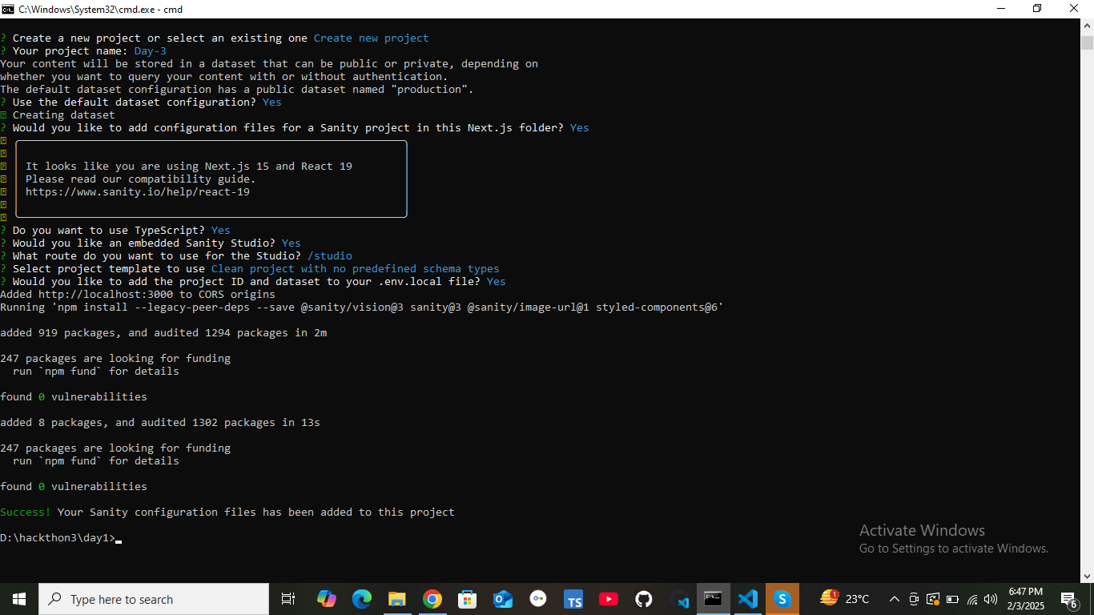

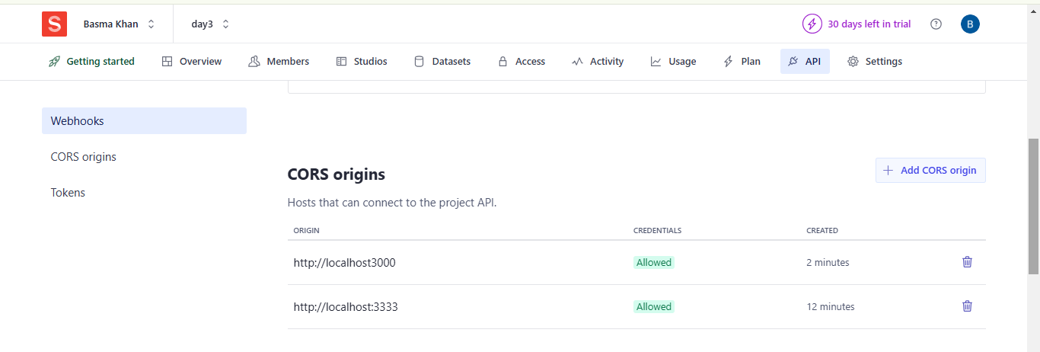

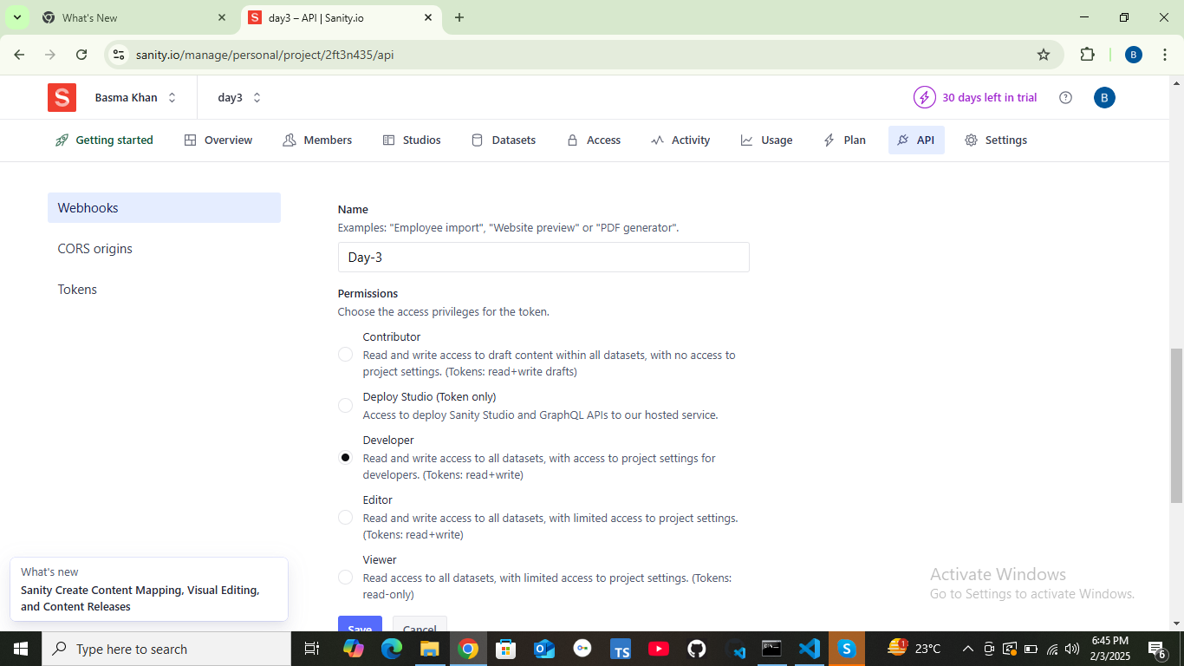

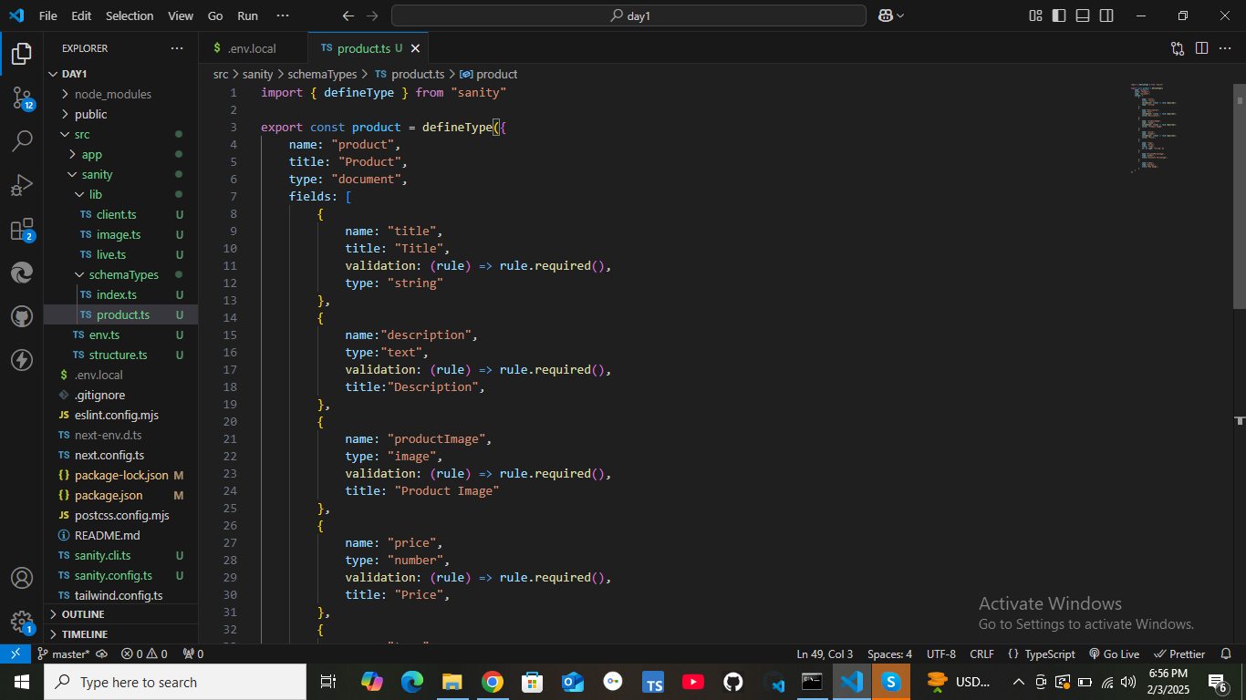

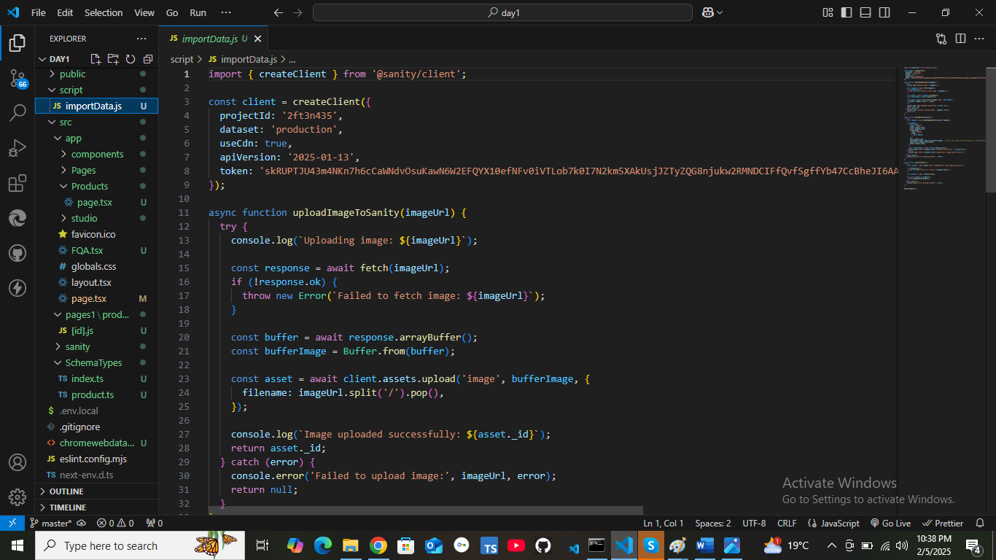

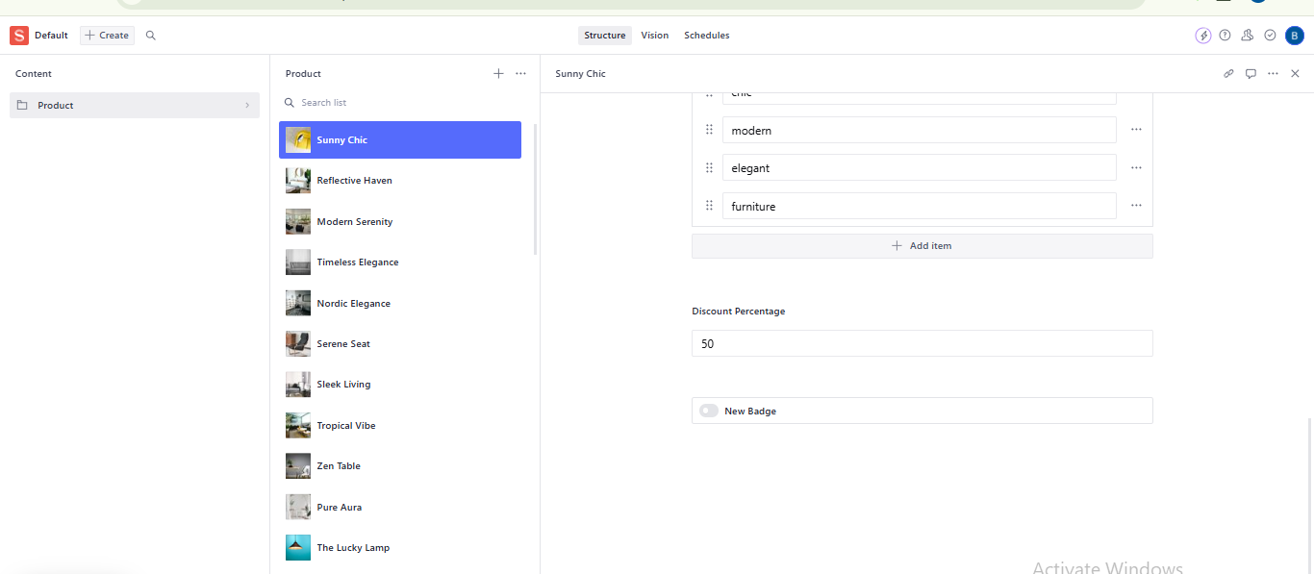

**Day-4 IMPLEMENTATION Report**

**Introduction to the E-commerce Website**

**This e-commerce website is designed to facilitate online shopping by allowing users to browse, select, and purchase products easily. The main purpose of the website is to provide a seamless shopping experience, whether for furniture, home décor, or other lifestyle products. Users can explore different categories, read product descriptions, check prices, and add items to their cart for a hassle-free checkout process.**

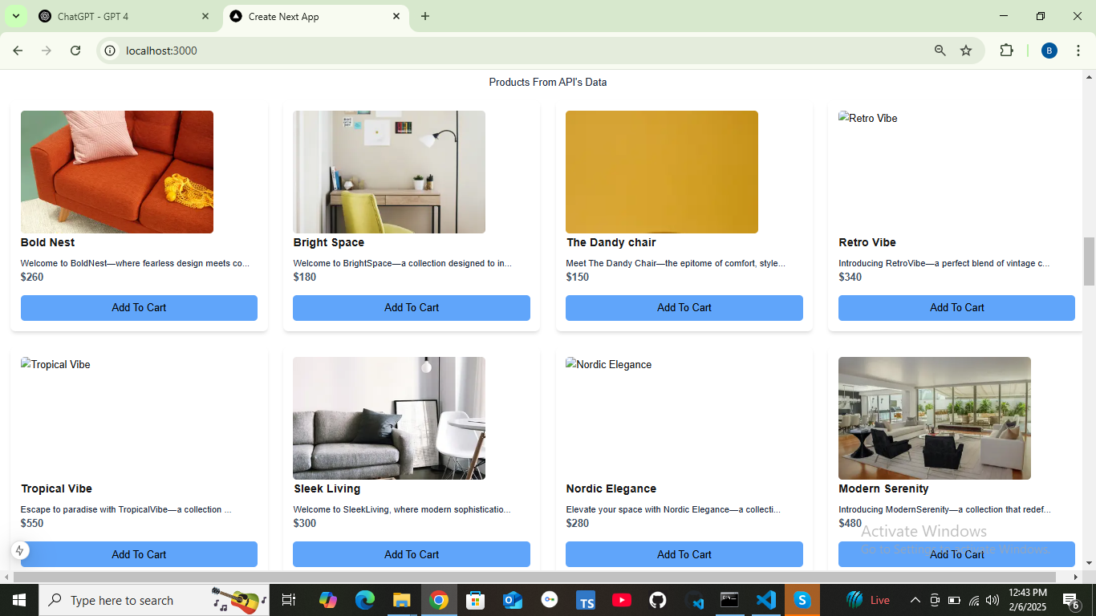

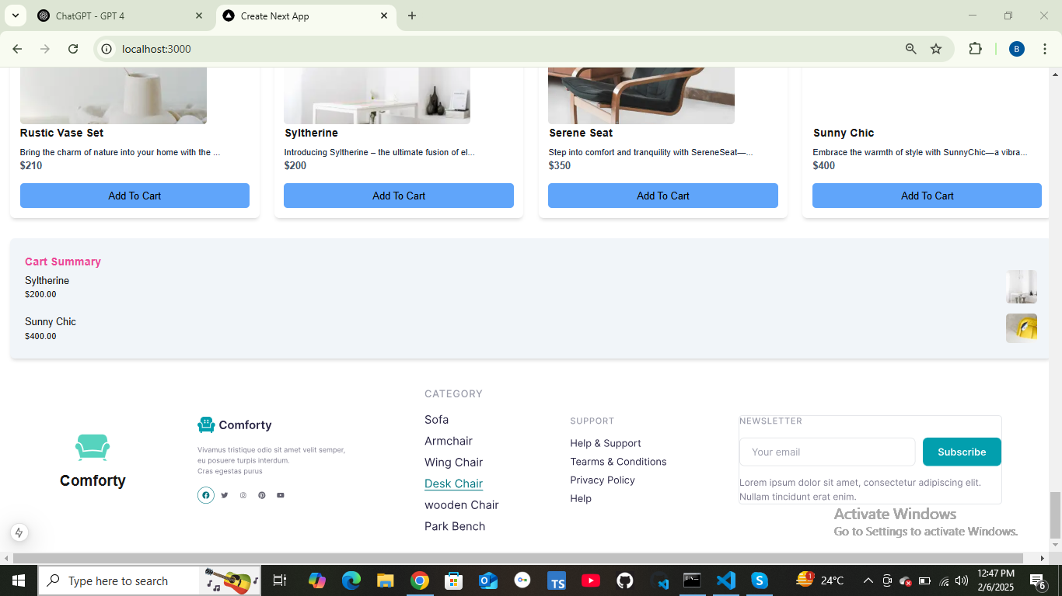

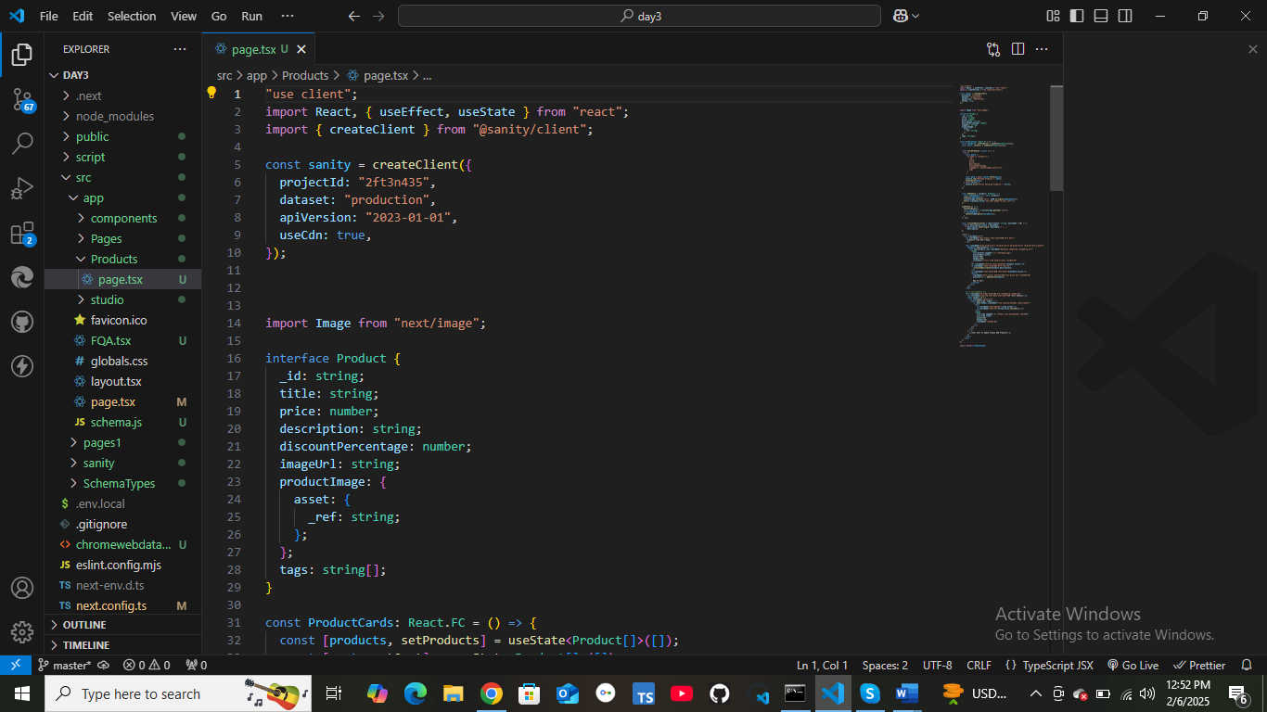

**Tags**

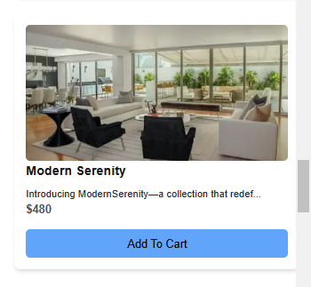

**Backend Development**

User Authentication & Authorization: JWT token will be used for user authentication and authorization to ensure security.

Payment Gateway Integration

A payment gateway (e.g., Stripe, PayPal) will be integrated so that users can easily make secure transactions.

Component Integration

The cart system, user profile, wishlist, and checkout process will be integrated smoothly to enhance user experience.

Conclusion

The final version of the website will be user-friendly and scalable, ensuring ease of use and future growth.

Future improvement plans include AI-based product recommendations and advanced search filters to enhance functionality.

**Day-5 Testing, Error Handling, And Backend Integration Refinement**

Step 1 : Functional Testing

Step 2 : Error Handling

Step 3 : Postman API

Step 1:My Website is responsive

Step 2: no error handling

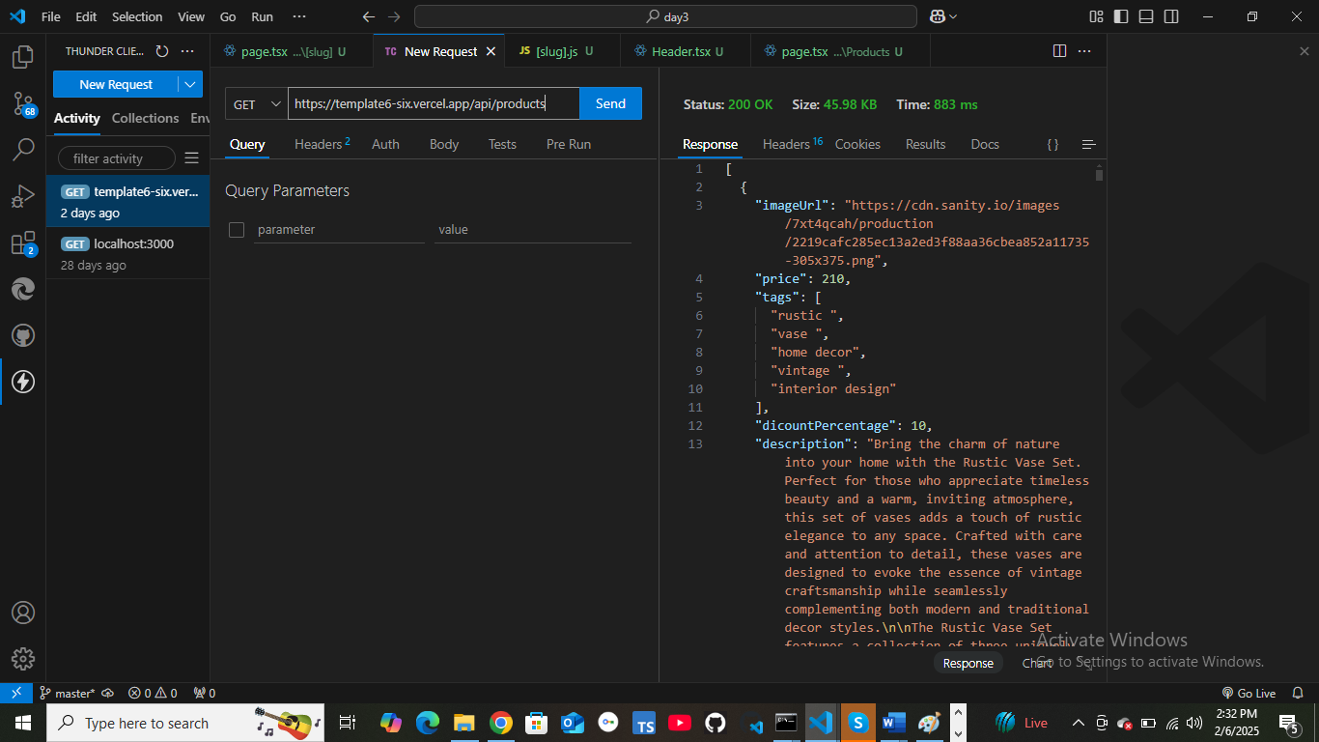

|  |  |
| --- | --- |
|  |  |
| | **Test Case ID** | **Test Case Description** | **Test Steps** | **Expected Result** | **Actual Result** | **Status** | **Severity Level** | **Assigned To** | **Remarks** | | --- | --- | --- | --- | --- | --- | --- | --- | --- | | 2 | TC001 | Validate product listing page | Open product page > Verify products | Products displayed correctly | Products displayed correctly | Passed | Low | - | No issues found | | 3 | TC002 | Test API error handling | Disconnect API > Refresh page | Show fallback UI with error message | Error message shown | Passed | Medium | - | Handled gracefully | | 4 | TC003 | Check cart functionality | Add product to cart > Verify cart contents | Cart updates with added product | Cart updates as expected | Passed | High | - | Works as expected | | 5 | TC004 | Ensure responsiveness on mobile | Resize browser window > Check layout | Layout adjusts properly to screen size | Responsive layout working as intended | Passed | Medium | - | Test successful | |  |

Step 4 : Performance Optimization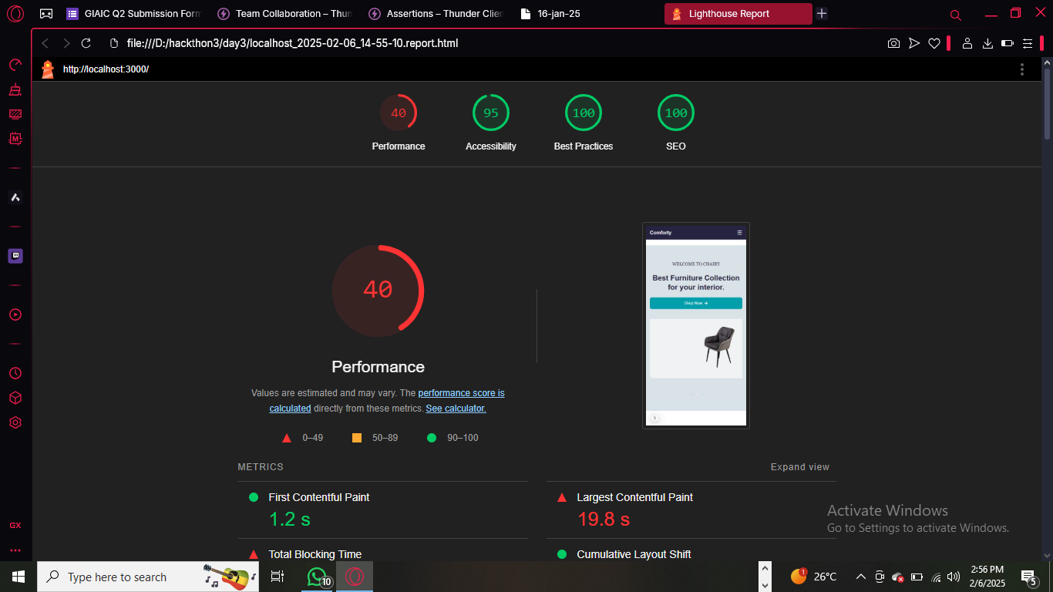

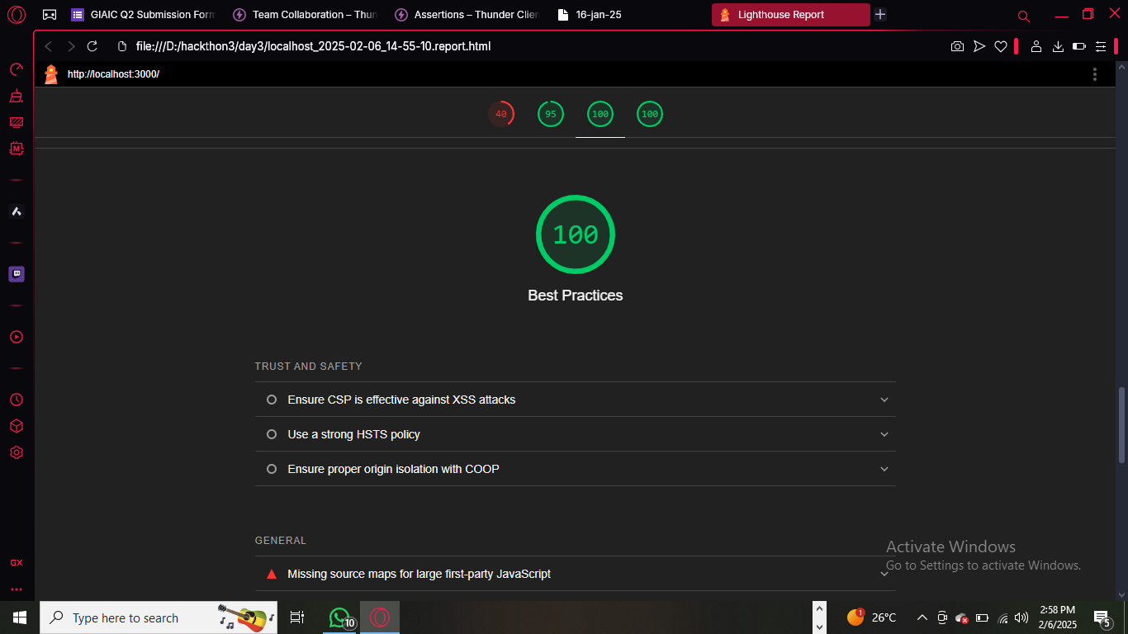

Trust and Safety

* Ensure CSP is effective against XSS attacks

|  |  |  |
| --- | --- | --- |
|  |  |  |

* Use a strong HSTS policy

|  |  |  |
| --- | --- | --- |
|  |  |  |

* Ensure proper origin isolation with COOP

|  |  |  |  |
| --- | --- | --- | --- |
|  |  |  |  |

* General
* Missing source maps for large first-party JavaScript

**Developer Resources**

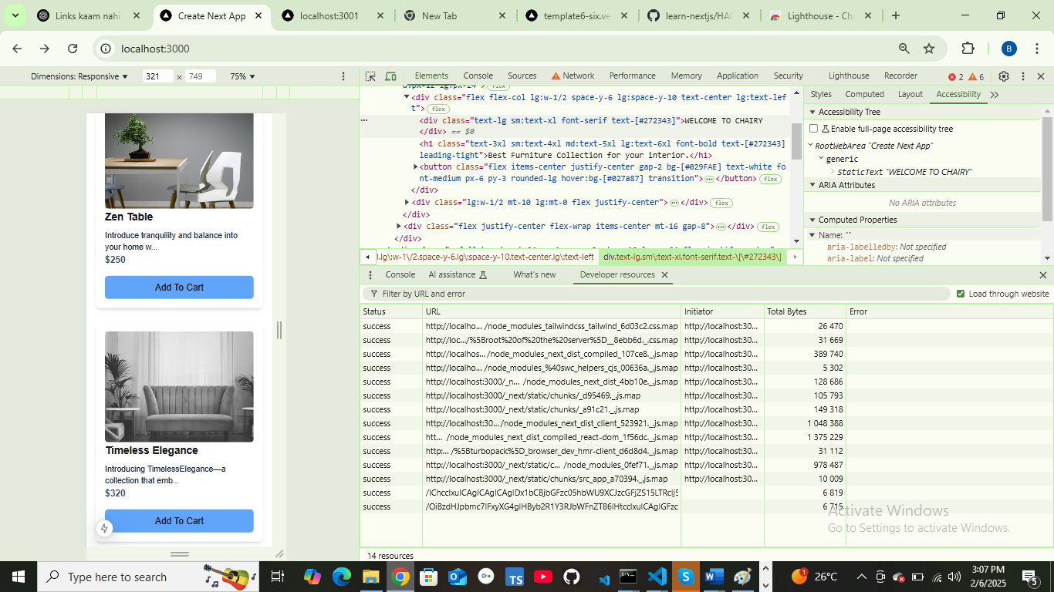

**Performance Monitor**

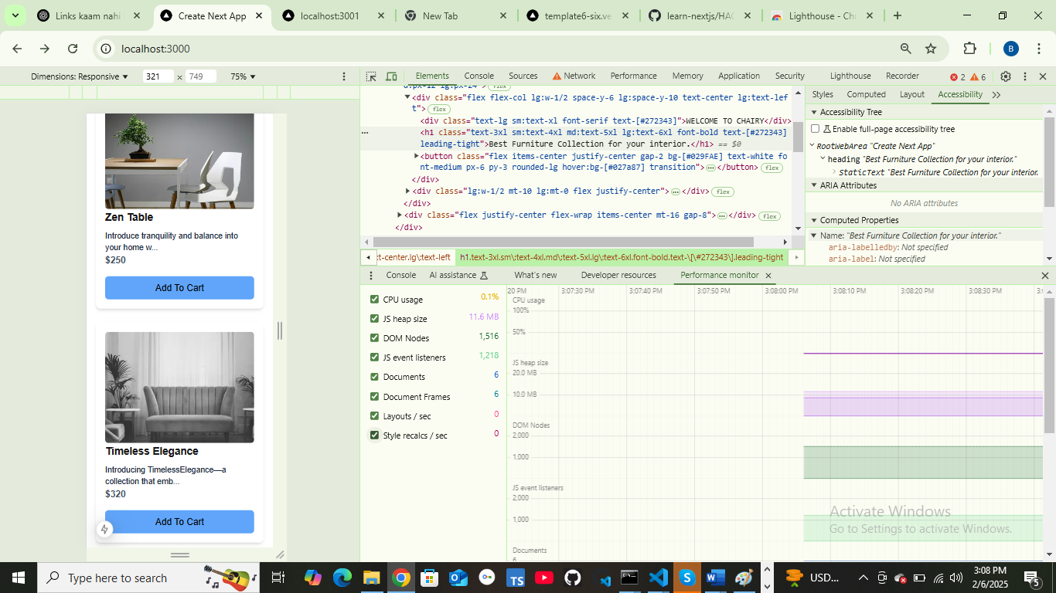

**Security**



    
    
    
    
    
    
    
    
    
    
    
    
    
    
    
    
    
    
    
    
    
    
    
    
    
    