Results for back propagation with neural network using python:

With Iteration 10 and learning rate 0.05 –

With Iteration 1000 and learning rate 0.0005 –

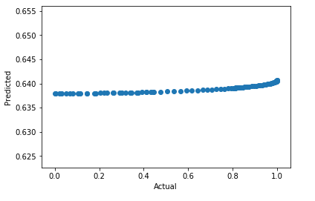

With Iteration 10000 and learning rate 0.00005 –

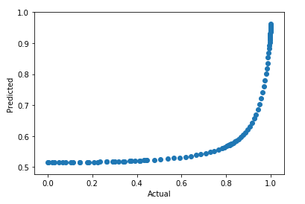

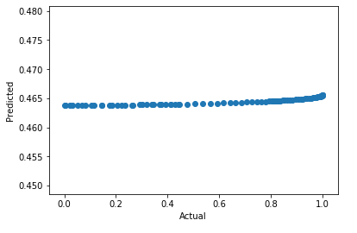

The performance of the neural network training model depends on the number of iterations and the size of learning rate. As the diagrams clearly show, performance improves greatly with higher number of iterations and smaller learning step value. The error value for each setting is printed on the console when the code runs and can be observed to reduce as the number of iterations go up.