13:AIM:-Performing linear regression analysis using lm() (R).
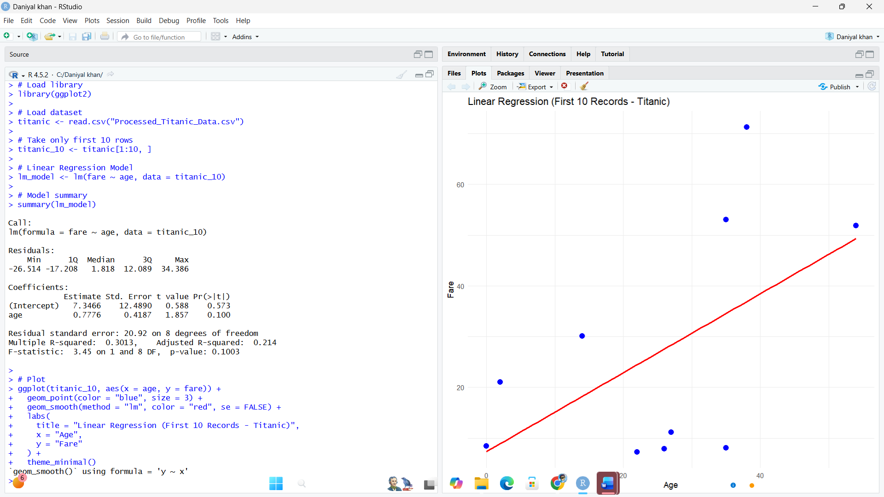

14:AIM:-Performing logistic regression using glm() (R).

