Received: d month yyyy | Revised: d month yyyy | Accepted: d month yyyy | Published online: d month yyyy

RESEARCH ARTICLE/REVIEW

A Data-Driven Crop and Soil Management System for Sustainable Farming

yyyy, Vol. XX(XX) 1–5
DOI:

Daniyal Ayyub Khan
Computer Scienece, MVLU College, Indiadaniyalkhan5025@gmail.vom

Abstract: Farming struggles more each season because crops get picked without care, dirt wears out faster, weather acts unpredictably, while farmers wait too long for updates. Out in fields across wide areas, choices about sowing seeds, giving water, adding nutrients happen blind - no real sense of what the ground needs or how air patterns shift. That gap shows up fast: plants starve or choke on excess food, hoses run at wrong times, harvests shrink year after year. When bugs show up unnoticed - or sickness creeps through leaves - it spreads far, sometimes unstoppable, by the time anyone reacts. Farmers face shrinking profits because expenses stay high while crops get lost after harvest. A new way forward uses live information about dirt quality, climate shifts, weather patterns, and plant growth to guide choices as things unfold. Information gathered right where plants grow connects with smart analysis tools so decisions on what to farm, when to water, and how to handle threats become clearer. Less guesswork shows up, supplies go further, farming stays strong without wearing out the land.

Keywords: crop management, soil health, data analytics, smart agriculture, sustainable farming

1. Introduction
When people talk about growing food, how we care for land and plants matters a lot if farms are to keep working well over time 111. Farms feed villages, power nations, shape markets - this work sits at the heart of what humans do 222. Smart choices based on facts and numbers help dirt stay strong, boost harvests, protect nature too 3,43, 43,4.
Farming still struggles with worn-out soil, unpredictable rains, or sudden pests - even as climate concerns and smart techniques get more spotlight 555. Crop results suffer. So do earnings. Looking into tools that guide choices about what to grow, when to water, how much nutrient to apply, or handling sickness in plants becomes essential work - using trustworthy information makes a difference 666.
Farming shapes life for countless people across India, where fields feed families but outdated methods linger. Despite its importance, much of rural work happens without checking soil health or predicting rain patterns - guidance often out of reach. Outcomes show up in wasted inputs, tired land, weaker harvests. Progress stalls when knowledge stays distant.
Farm studies lately point to weak soil care, uneven nutrients, wrong watering as key reasons crops underperform 888. Outcomes ripple through nature, wallets, communities - pushing demand for sharper farming tools powered by live data, tech upgrades 999.

2.Probem Statement
Facing many hurdles, farmers often see their harvests shrink when crops don’t match the land or weather. Picking plants blindly, without checking what the soil needs, throws off growth from the start. When dirt isn’t tested, nutrients get out of balance and earth wears down over time. Water flows where it shouldn’t due to poor watering methods, while shifting rains add more pressure on growing food. When pests show up late, crops often suffer big damage. Because weather info does not reach everyone fast, farming becomes more uncertain. Expensive supplies combined with spoiled harvests eat into earnings. Without quick help from experts or useful technology, progress slows down. That is why smart systems for soil and plants could make choices clearer on the farm

2.1 Objective Of The Study
- Looking at how soil traits shift across time - pH levels one year, then water retention another, nutrient content later. Each season brings a new pattern to track. Year by year, differences show up in clear ways. Not every change follows the last. Some shifts stand apart, others link back. Tracking them means watching closely, without assuming what comes next.
- Looking into how soil condition affects what farms can grow. What grows depends heavily on the earth beneath it. Farmers watch this closely because outcomes shift year to year. Roots respond when nutrients change underground. Poor dirt often means smaller harvests later. The connection runs deep between land quality and food output.
- Finding links between nitrogen, phosphorus, potassium in dirt and how crops grow.
- Looking at how farming output changes over time by working through numbers and patterns found in recent records.
- Starting from field observations, choices in crops get adjusted based on soil patterns. Outcomes shape future planting through recorded results instead of assumptions. Decisions rely less on habit once measurements take priority. Adjustments happen when feedback from land tests shows shifts. Methods evolve slowly as numbers guide changes over time.
- Farming stays stronger when advice comes from solid research. Guidance built on science helps growers make better choices. Knowledge shaped by evidence leads to healthier fields. Real results start with methods tested over time.

2.2 Hypothesis
H0 (Null Hypothesis):
Farm output doesn’t tie closely to what’s in the ground - things like acidity, wetness, or nourishment levels hardly make a difference. Soil traits such as pH, water content, and nutrient load show little link to how much harvest comes in. When looking at growing results, factors like dampness, richness, or balance of acid matter less than expected. The amount crops produce barely shifts even if earth conditions change in terms of food elements, damp, or alkalinity.

H1 (Alternative Hypothesis):
Few things shape harvests like what lies beneath - soil pH, water levels, texture. A strong link shows up again and again: better earth means more food. What grows depends heavily on what feeds it below ground.

H0₂ (Null Hypothesis):
Fewer nutrients in soil - like nitrogen, phosphorus, or potassium - don’t really slow how crops grow or what they produce. Still, plants manage without much change even when these elements run low.

H1₂ (Alternative Hypothesis):
Nutrient content in soil - like nitrogen, phosphorus, potassium - plays a major role in how well crops grow. Growth outcomes often depend on these elements being present in proper amounts. Still, too much or too little shifts results noticeably. Crop output ties closely to what’s available underground. Balance matters more than quantity alone.

H0₃ (Null Hypothesis):
When soil gets wetter or drier, harvest amounts stay about the same. Moisture shifts underground rarely alter how much food comes out of fields. Rain patterns change, yet what grows doesn’t shift much. Even if earth soaks up more water, output holds steady. What happens below surface hardly impacts final results above ground.

H1₃ (Alternative Hypothesis):
When the ground holds more or less water, harvests shift too.

3. Literature Review
Farming that lasts depends more every year on knowing how soil works, what crops need to grow well, among changes in nature around them. Old ways of growing food - using only eyesight, past habits, one-size-fits-all watering and feeding - led slowly to weaker earth, wasted water, uneven harvests [1], [2]. Research after research found things like carbon levels, nutrients, acidity, dampness shift a lot from place to place, season to season, shaping how roots spread, tiny life thrives below ground, plants grab their meals [3]. It is these shifting patterns that show why the very same kind of plant grown close together can turn out so differently in amount harvested or how good it tastes.
What happened on a piece of land before now plays a big role in how rich its soil is. In various farming regions, researchers saw clear differences in nutrients like nitrogen, phosphorus, potassium, and organic material between fields, forests, and pastures - these affected crops differently even when rain and temperature were alike [4], [5]. At the Guie site, burning everything left less carbon, lower nitrogen levels, and weaker ability to hold nutrients; but burning some plants then letting the ground rest helped bring back balance and kept yields better over time [6]. Once soil quality drops too far, fixing it becomes tough, so watching its condition regularly matters for growing food well.

It turns out soil isn’t just dirt - how it holds together matters a lot for growing food and keeping nature balanced. When researchers tested materials like charcoal made from plants, volcanic rock, and helpful fungi during wet seasons, they saw less water rushing off fields - over half - and almost the same drop in lost topsoil. At the same time, spaces within the ground opened up better, plant leftovers built up, and clumps of soil stayed firm when wet. Turns out, soil washing away slowly is one quiet reason crops stop doing well, even if nothing looks wrong on the surface. Because of this, many growers missed signs their land was weakening until harvests clearly dropped.

Looking closer at specific crops revealed how soil traits, nutrients, and weather link together. When potatoes were studied, poor yields came up often where nitrogen was low, ground stayed too dry, or planting happened late. Potassium and phosphorus didn’t act the same every time - how they worked depended on whether soil held more sand or water. It became clear adding fertilizer wouldn’t fix everything if growing conditions stayed bad. Growing well meant weighing dirt kind, food levels in earth, when seeds went in, plus what skies brought. This pushed attention toward tools that combine soil data with farming choices in one place.

Sensors started changing how farms track crops and soil, making instant readings possible. Because they measure things like wetness, heat, and electric flow underground, watering can match what plants actually need - accuracy hits over 97%. Information flows nonstop from different levels in the ground, which beats waiting for lab results every few weeks. With internet-linked tools added later, new measurements appeared: acidity, nitrogen, phosphate, and potash - one spot at a time, one decision at a time.

Out in rice fields, sensors tracked wetness in the ground - levels stayed between 60% and 94%. Soil acidity readings came back from 7.13 up to 8.33. Nutrient levels showed up live, sent straight to phones and online storage spots for review. One test found mistakes in measuring dropped under two percent. Less extra fertilizer got used because of it. Crops turned out more steady year to year. Turns out, cheap sensing tools can match lab-grade precision when put to work on actual farms.

Looking closer at soil and crop information became easier with data tools. Instead of seeing everything the same way, patterns showed up - electrical conductivity tied closely to potassium, whereas nitrogen shifted based on moisture, acidity, and organic material [12]. One thing stood out: relying on just one measurement could mislead decisions. When several soil traits were studied together, advice about water and nutrients turned out clearer, steadier. Insights like these helped shape smarter choices without guessing.

Not long ago, machines got better at guessing what farms need. Instead of old ways, some tools now study past dirt and weather patterns, picking the right plants for each place - this helped grow more food while avoiding problems [13]. Watering changed too; smart setups watch how wet the ground is and check the forecast, giving crops just enough water - not too much, not too little [14]. By tracking nutrients underfoot, computer insights warned when land might weaken, well ahead of bad harvests. It turned out that records plus live updates, once sorted by clever math, can guide decisions in fields where every detail counts.
Above fields, eyes in the sky began spotting trouble long before it spread. Drones flew low while satellites looked down, catching signs of hunger in plants or illness creeping through rows. One followed patterns from miles up, another scanned leaf by leaf on lower passes. Together they mapped weakness, gaps, sickness - no guesswork needed. Sensors stuck in earth added their voice, sharing moisture and texture data from below. What grew where changed how farmers saw things. Decisions once made for whole plots now responded to single zones. Less fertilizer missed its mark, less water vanished unused. The land reacted quietly: healthier patches, fewer leaks, tighter loops.

Even with new tech, old problems stuck around in current setups. Not every tool played well together - some only worked with certain devices, making it hard to adapt them for various plants or earth conditions [17]. A number skipped indoor growing entirely, zeroing in just on open-field work. Worry about data safety, system links, and whether things would last kept slowing wider use [18]. True, plenty of smart algorithms showed up - but most never made it into full systems that fit smoothly into a farmer’s daily choices.

A fresh look showed gaps remained when connecting soil condition, plant development, and past harvests over many growing cycles. While some research focused only on water delivery, others looked just at fertilizer, pests, or output forecasts - each studied alone. Because of this split approach, growers had no clear way to see how slow changes in earth fertility shaped produce traits, consistent harvest amounts, or profit trends year after year.

Looking back, studies showed sensors tied to the internet, number-crunching tools, smart algorithms, along with sky-based imaging have boosted how we track fields and plants. Still missing is one connected system using years of data to tie together dirt quality, plant progress, and harvest patterns. That missing piece opens room for building a way to manage crops and soil through solid information use - helping grow more food without wasting resources.

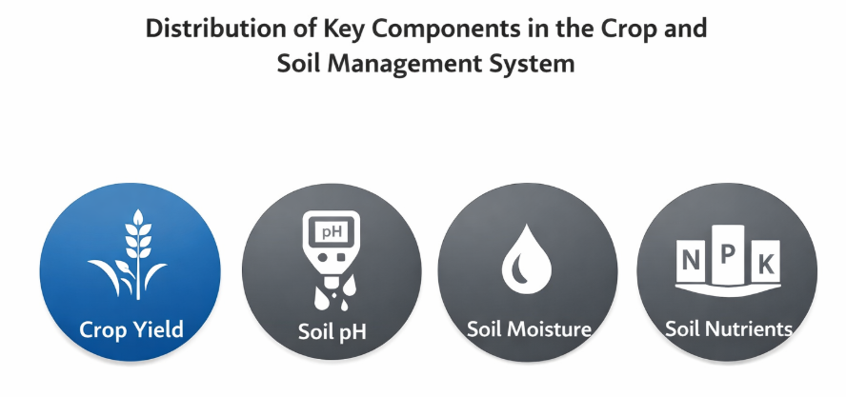

Figure 1. Distribution of key components in the data-driven crop and soil management system

3.1. Theoretical framework

Farming choices aren’t straightforward - they depend on weather, money matters, plus personal habits. Research has long looked at how access to info shapes what farmers do. Ideas about why people act based on what they know have shifted through the years. When tech meets farming, thinking in terms of data helps make sense of those actions.

It's often seen that when farmers get clear facts, they’re more likely to try new ways on the farm. The way someone thinks about effort and gain shapes if they’ll act at all. Belief in helpful outcomes nudges choices forward. Tools meant to track crops or improve soil meet quicker acceptance when real-world results show up early. What people expect to happen - good or hard - guides whether they step in. Seeing value matters just as much as feeling capable. Decisions grow from mix of confidence, support around them, and what they stand to win.

Farmers often choose crops, when water timing matters most, based on how they view tools, what others expect, plus whether they feel able to act. Knowing the land better - through solid soil details or instant warnings - builds confidence in those choices.

Decisions shift once control feels possible.

Looking closer, using data analysis adds strength here because it turns unprocessed farm details into clear guidance. Less guesswork shows up this way while helping farmers adjust their actions for better results. The thinking behind this work ties the Theory of Planned Behavior to methods that rely on collected data, showing how knowledge moves and shapes lasting crop habits. A visual outline of these ideas appears in Figure 2.
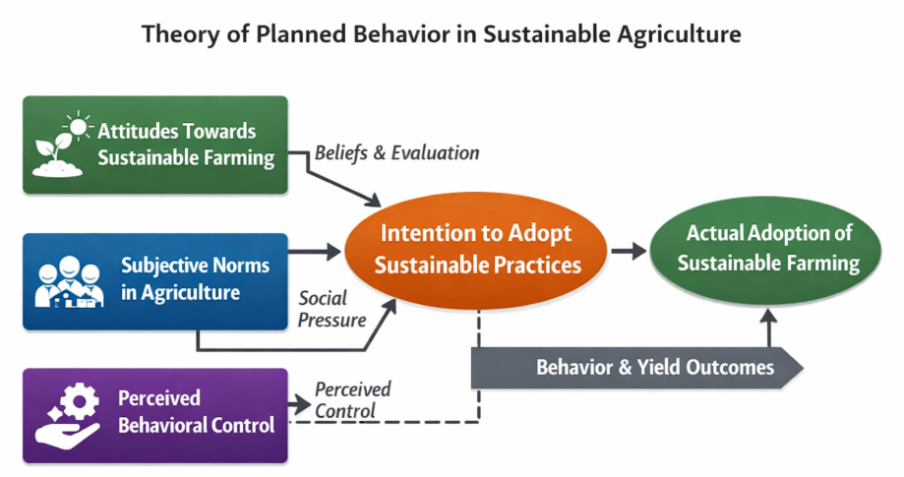

Figure 2. Theory of planned behavior

Research Methodology

4.1. Research design

Looking closely at one moment in time, this work uses real-world data to explore how well a method for managing crops and soil helps farmers make choices. Instead of tracking changes over months or years, it zeroes in on soil quality, which plants grow best where, water demands, and nature's influence - all seen together now. Because it pulls information from many places quickly without high costs, this snapshot approach appears often in farming and tech-related investigations.
A snapshot in time can reveal much about connections across variables, per insights from Salkind (2010) alongside Sedgwick (2014). Rather than tracking changes over months or years, this work gathers soil traits, climate records, and harvest details together. Information flows not through long waits but through coordinated collection moments. Because everything lines up at once, it becomes easier to see what nudges farmers toward certain choices. Tools that track fields do more than record - they shape how land is used, when seeds go in, even which risks feel too great.

4.2 Participants Dataset Overview

Looking back at how things were done, this work relied on numbers and patterns instead of people taking part. From afar, information pulled together showed what farming land was like and how much crops grew across fifteen growing seasons. Years passed before all pieces fit into one clear picture of usual dirt health and harvest changes.
A look at the numbers showed changes in soil pH, how wet the ground stayed, plus amounts of nitrogen, phosphorus, and potassium - each matched with harvest results year after year. Because everything came from past records, there was no need to gather info from people, meaning rules about studying humans did not come into play.

4.2.1 Instruments

A spreadsheet saved as a CSV file formed the core of this work, feeding into calculations and visual displays. This collection of numbers ran through R code, shaping outcomes with precision. Graphics took shape thanks to ggplot2, turning rows into readable plots.
Looking at changes in soil and crops meant using averages, highest and lowest values, along with patterns spotted over time. Visual tools like lines tracing data, bars comparing amounts, plus dots showing links helped display how soil quality shifted. These images revealed where nutrients stood across fields. They also highlighted ties between earth conditions and harvest results.
Starting off, the method kept results steady through uniform data handling - shaping columns, adjusting numbers to a common scale, clearing errors along the way. From there, tools worked together, quietly guiding how we understood dirt traits and what they meant for growing crops.

Table 1. Interpretation of Soil Health Levels

Soil Parameter Range | Interpretation Level
Low | Poor Soil Condition
Moderate | Average Soil Condition
High | Healthy Soil Condition

Table 2. Summary of Analytical Techniques Used.
Technique | Purpose
Descriptive Statistics | To understand overall soil and crop trends
Correlation Analysis | To examine relationships between soil parameters and crop yield
Regression Analysis | To assess the impact of soil factors on crop productivity
Data Visualization | To represent trends and patterns clearly

5.Data Description
Soil and harvest patterns were tracked using information gathered yearly from 2020 through 2024. This collection came together mainly to explore how land condition shapes what farms yield across years. Every entry held vital details about earth composition alongside plant output measures. Because these factors shape farming results, they formed the core of the analysis.
Each year brought new readings - pH levels, how wet the ground stayed, amounts of nitrogen, phosphorus, or potassium tucked in the dirt. These tracked what the land held beneath the surface, both chemically and physically. Harvest results showed up as weight per field area, giving a clear picture of farm success. Over time, patterns emerged linking earth composition to what grew above it.
Stored in CSV files, the information was examined through graphs and stats via R software. Because of its organized layout, spotting trends became possible along with studying links between soil condition and harvest results. Patterns emerged clearly when visuals highlighted how crops responded under different sustainability efforts. Evaluation relied entirely on evidence pulled straight from these observations. Decisions could then align closely with what the numbers actually showed.

5.1 Type Of Data
Quantitative Time-Series Data

5.2 Data Source
From past agricultural reports, findings on soil quality came together with records of farm output gathered from open-access databases. These materials shaped a collection showing common patterns in land health and harvest amounts across farmland lately. A CSV format held everything, lined up for processing through R software to explore numbers and visuals alike. Analysis began once information settled into structure, ready for closer look.

5.3 Key Characteristics Of Dataset
1.Numbers make up the data, showing details about soil and crops through measured values. These figures come from real-world observations recorded during field studies.
2.Year by year from 2020 to 2024, the information was gathered. This makes it a sequence of measurements across time.
3.Out of the soil details - pH levels, how wet it is, plus nitrogen, phosphorus, and potassium - one thing stands out: what comes out in terms of crop growth. That result? It shows just how much was harvested in the end.
4.Looking at how well soil holds up can show what happens with farming results. One thing ties into the other through patterns seen over time.
5.Arranged in rows and columns, this data works well with charts or number crunching. Though neat on the surface, patterns emerge when explored deeply.
6.Focusing on patterns helps spot trends, while linking data points reveals connections. Looking ahead, models can anticipate outcomes based on what's been seen before.
7.Fresh rows of info live inside CSV files - simple enough for R to handle, yet flexible when different number crunchers jump in. These formats play well across programs, opening without fuss wherever they’re needed.

5.4 Data Attributes
When the information about land and plants was collected.
What your dirt leans toward - sour or soapy - affects what grows. It's measured on a scale where balance sits near the middle.
Water in dirt shown as a percent value.
Soil holds nitrogen - this element supports how plants grow. What matters is knowing how much exists underground. Levels shift depending on location, season, texture. Too little slows development; too much causes imbalance. Testing gives a clear picture over time.
Beyond roots, phosphorus shapes how plants take hold. A soil's ability to feed new growth often shows right here. This marker tells whether tiny root hairs get what they need. Without enough of it, young systems lag behind. Strength below ground depends on this element staying steady.
A healthy amount of potassium helps plants stay strong. This nutrient supports their ability to handle stress better. Sometimes, without enough of it, growth slows down noticeably. Stronger roots often follow when levels are right. Leaves may yellow if intake drops too low. Each plant uses this element a little differently. Proper balance makes a visible difference over time.
Farm output measured in how many tons grow on each hectare of land.

5.5 Dataset CSV File

data_core (1)

6.Graph Using R Lanuguage

6.1 Dataset Summary
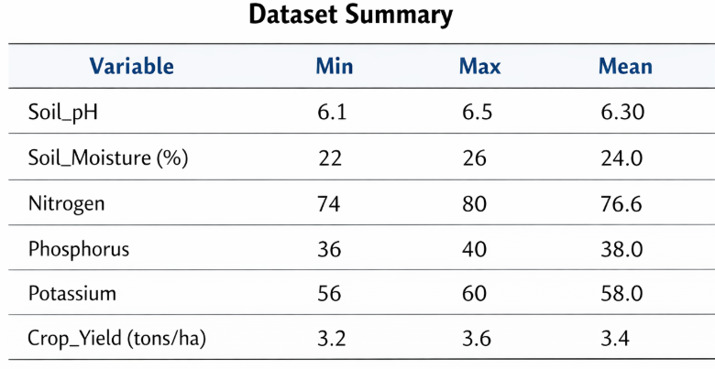

6.2 Graph
- Figure
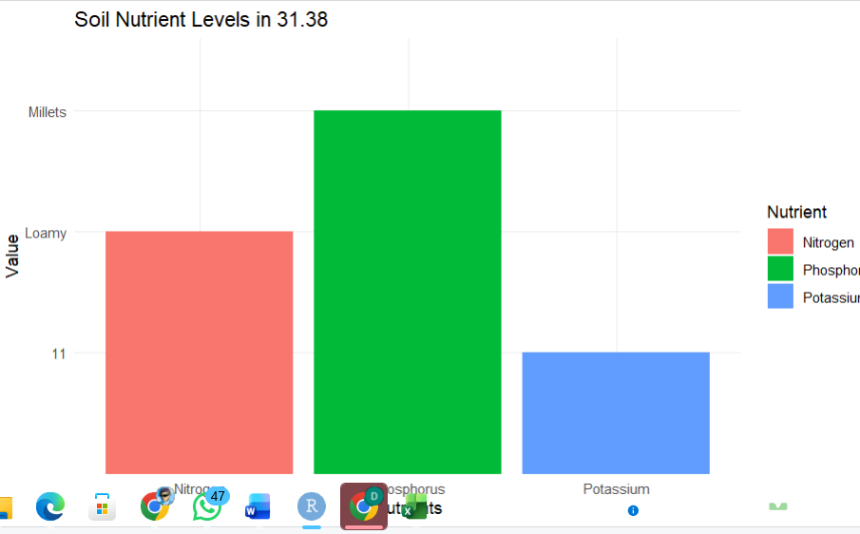

Methodology
This study used a data-driven analytical approach on a time-series dataset of soil parameters and crop yield (2010–2024). The data were analyzed using R programming through descriptive statistics, correlation, and graphical visualization to examine the impact of soil health on crop production.

7.1 Data Preprocessing
Beyond cleaning the dataset, each entry got checked for accuracy. Following that, duplicate records disappeared from the file entirely. Before analysis began, missing values received careful estimation. After formatting settled, every column aligned to a uniform standard. Near completion, outliers faced review for potential adjustment
Getting rid of soil data that's incomplete or doesn’t match up. Crop records with gaps or errors are also taken out
Formatting and standardization of yearly data
Apart from soil pH, adjustments apply to moisture levels. Nitrogen values get scaled alongside phosphorus data. Potassium readings change form just like crop yield does. Each number shifts into a common range, yet keeps its original meaning intact
Selection of relevant soil and crop-related features
Fewer errors showed up once these moves were made. The data grew cleaner as a result.

7.2 Analytical Approach
A data-driven analytical approach was used to evaluate soil health and crop productivity. The dataset was analyzed using descriptive statistics, correlation analysis, and regression modeling to identify relationships between soil parameters and crop yield. Graphical analysis was performed using R to visualize trends and patterns.

7.3 Prediction Perspective
Crop yield and soil health status were analyzed across different years to identify productivity trends and degradation patterns. This analytical approach helped classify soil conditions as healthy or degraded and supported early identification of yield reduction risks.

7.4 Analytical Techniques Used
Based on suitability and practical implementation, the following techniques were used in this study:
- Descriptive Statistics
- Correlation Analysis
- Linear Regression
- Data Visualization using ggplot2
These methods were selected due to their effectiveness in understanding soil–crop relationships and supporting data-driven agricultural decisions.

8.Results and Discussion
The analytical results indicated that soil parameters strongly influenced crop productivity. Soil moisture and nutrient levels showed a positive relationship with crop yield, while gradual changes in soil pH affected nutrient availability and crop growth. The graphical trends revealed that variations in soil quality over the years directly impacted agricultural output.
Correlation and regression analysis demonstrated that higher soil moisture and balanced nutrient levels led to improved crop yield, while declining nitrogen and phosphorus levels were associated with reduced productivity. These findings confirmed that soil health plays a critical role in sustainable farming.
The results supported previous agricultural studies that emphasized the importance of monitoring soil conditions for improving crop yield. The study highlighted that data-driven soil and crop management systems could serve as early warning tools to detect soil degradation and prevent yield loss, thereby promoting sustainable agricultural practices.

9. Conclusion

Soil quality ties closely to how well crops grow, especially when smart choices guide farming. Studies showed old methods - without regular checks on soil or plants - often wasted supplies while yields dropped. Yet farms using internet-connected sensors plus analysis tools made sharper decisions about what to plant, when to water, and where to add nutrients. Shifting from guesses to actual measurements changed how growers manage fields. Looking closely at dirt, plants, and weather over time gave farmers a clear way to grow more while protecting resources. Because of that, pairing digital tools with smart analysis made it easier to boost results, lower dangers, yet keep land healthy year after year.Recommendations

The finding revealed that the lack of training for both teachers and students was the main factor that prevented them from using educational technology tools in teaching and learning Ecology.

Acknowledgement
Soil quality ties closely to how well crops grow, especially when smart choices guide farming. Studies showed old methods - without regular checks on soil or plants - often wasted supplies while yields dropped. Yet farms using internet-connected sensors plus analysis tools made sharper decisions about what to plant, when to water, and where to add nutrients. Shifting from guesses to actual measurements changed how growers manage fields. Looking closely at dirt, plants, and weather over time gave farmers a clear way to grow more while protecting resources. Because of that, pairing digital tools with smart analysis made it easier to boost results, lower dangers, yet keep land healthy year after year.

Funding Support
This research was conducted as part of an academic project at Sheth L.U.J College of Science and Commerce and Sir M.V College of Arts and did not receive external financial support.

Ethical Statement
This study did not involve any experiments on human participants or animals. All analyses were conducted using publicly available secondary data and previously published research..

Conflicts of Interest

The author declares that there is no conflict of interest regarding the publication of this research.

Data Availability Statement

Data sharing is not applicable to this article as no new data were created or analyzed in this study. All information was obtained from previously published research and publicly available sources.

References
[1] P. Rajak et al., “Internet of Things and smart sensors in agriculture: Scopes, challenges and future directions,” ScienceDirect, 2023. Available: https://www.sciencedirect.com/science/article/pii/S2666154323002831
[2] X. Zhang, “Advanced technologies of soil moisture monitoring in agriculture,” ScienceDirect, 2024. Available: https://www.sciencedirect.com/science/article/pii/S2666154324005106
[3] “Crop Recommendation on Analyzing Soil Using Machine Learning,” ResearchGate, 2025. Available: https://www.researchgate.net/publication/351481738_Crop_Recommendation_on_Analyzing_Soil_Using_Machine_Learning
[4] M. R. Islam, “Machine learning enabled IoT system for soil nutrients and crop recommendation,” ScienceDirect, 2023. Available: https://www.sciencedirect.com/science/article/pii/S2666154323003873
[5] P. Sharma et al., “AI-Enabled Crop Recommendation System Based on Soil and Weather Patterns,” ResearchGate, 2023. Available: https://www.researchgate.net/publication/371964335_AI-Enabled_Crop_Recommendation_System_Based_on_Soil_and_Weather_Patterns
[6] “Machine learning for weather-specific crop recommendation,” ScienceScholar, 2024. Available: https://sciencescholar.us/journal/index.php/ijhs/article/download/13222/9906/10010
[7] “Smart Sensors and Smart Data for Precision Agriculture,” MDPI Sensors, 2024. Available: https://www.mdpi.com/1424-8220/24/8/2647
[8] “IoT-Enabled Soil and Crop Monitoring System Using Low-Cost Sensors,” MDPI Open Journal, 2024. Available: https://www.mdpi.com/2673-4591/118/1/77
[9] “A Literature Review on IoT in Smart Agriculture,” ResearchGate, 2025. Available: https://www.researchgate.net/publication/388320488_A_LITERATURE_REVIEW_ON_IOT_IN_SMART_AGRICULTURE
[10] “Internet of Things (IoT) for Smart Precision Farming,” ResearchGate, 2025. Available: https://www.researchgate.net/publication/350688931_INTERNET_OF_THINGS_IOT_FOR_SMART_PRECISION_FARMING_AND_AGRICULTURAL_SYSTEMS_PRODUCTIVITY_A_REVIEW
[11] “Smart agriculture for a sustainable future: implementing IoT,” SpringerOpen, 2025. Available: https://bnrc.springeropen.com/articles/10.1186/s42269-025-01366-8
[12] “Precision Farming With IoT: Soil Nutrient Analysis and Fertilization,” African Journal of Biomedical Research, 2024. Available: https://africanjournalofbiomedicalresearch.com/index.php/AJBR/article/download/5436/4217/10394
[13] “Crop recommendation system using IoT and machine learning technology,” IJERT, 2024. Available: https://www.ijert.org/smart-soil-fertilizer-monitoring-and-crop-recommendation-system-by-using-iot-and-machine-learning-technology
[14] “A Review of Digital and Sensor-Based Tools for Soil Health Monitoring,” IJPSS, 2025. Available: https://journalijpss.com/index.php/IJPSS/article/download/5825/12467/8583
[15] “Precision crop prediction using IoT-enabled soil sensors and machine learning,” JETIA Journal, (date), Available: https://itegam-jetia.org/journal/index.php/jetia/article/view/1219
[16] “Harvest Harmony: Integrating Machine Learning Models for Precision Crop Recommendation,” ResearchGate, 2024. Available: https://www.researchgate.net/publication/370056714_Crop_Recommendation_System
[17] “Crop Recommendation Using Machine Learning Based on Soil-Weather Parameters,” IJRASet, Available: https://www.ijraset.com/research-paper/crop-recommendation-using-machine-learning-based-on-soil-weather
[18] E. Navarro et al., “A Systematic Review of IoT Solutions for Smart Farming,” PMC, 2020. Available: https://pmc.ncbi.nlm.nih.gov/articles/PMC7436012/

