Received: d month yyyy | Revised: d month yyyy | Accepted: d month yyyy | Published online: d month yyyy

RESEARCH ARTICLE/REVIEW

A Data-Driven Crop and Soil Management System for Sustainable Farming

yyyy, Vol. XX(XX) 1–5
DOI:

Daniyal Ayyub Khan
Computer Scienece, MVLU College, Indiadaniyalkhan5025@gmail.vom

Abstract: Farming struggles more each season because crops get picked without care, dirt wears out faster, weather acts unpredictably, while farmers wait too long for updates. Out in fields across wide areas, choices about sowing seeds, giving water, adding nutrients happen blind - no real sense of what the ground needs or how air patterns shift. That gap shows up fast: plants starve or choke on excess food, hoses run at wrong times, harvests shrink year after year. When bugs show up unnoticed - or sickness creeps through leaves - it spreads far, sometimes unstoppable, by the time anyone reacts. Farmers face shrinking profits because expenses stay high while crops get lost after harvest. A new way forward uses live information about dirt quality, climate shifts, weather patterns, and plant growth to guide choices as things unfold. Information gathered right where plants grow connects with smart analysis tools so decisions on what to farm, when to water, and how to handle threats become clearer. Less guesswork shows up, supplies go further, farming stays strong without wearing out the land.

Keywords: crop management, soil health, data analytics, smart agriculture, sustainable farming

1. Introduction
When people talk about growing food, how we care for land and plants matters a lot if farms are to keep working well over time 111. Farms feed villages, power nations, shape markets - this work sits at the heart of what humans do 222. Smart choices based on facts and numbers help dirt stay strong, boost harvests, protect nature too 3,43, 43,4.
Farming still struggles with worn-out soil, unpredictable rains, or sudden pests - even as climate concerns and smart techniques get more spotlight 555. Crop results suffer. So do earnings. Looking into tools that guide choices about what to grow, when to water, how much nutrient to apply, or handling sickness in plants becomes essential work - using trustworthy information makes a difference 666.
Farming shapes life for countless people across India, where fields feed families but outdated methods linger. Despite its importance, much of rural work happens without checking soil health or predicting rain patterns - guidance often out of reach. Outcomes show up in wasted inputs, tired land, weaker harvests. Progress stalls when knowledge stays distant.
Farm studies lately point to weak soil care, uneven nutrients, wrong watering as key reasons crops underperform 888. Outcomes ripple through nature, wallets, communities - pushing demand for sharper farming tools powered by live data, tech upgrades 999.

2. Literature Review

Farming that lasts depends more every year on knowing how soil works, what crops need to grow well, among changes in nature around them. Old ways of growing food - using only eyesight, past habits, one-size-fits-all watering and feeding - led slowly to weaker earth, wasted water, uneven harvests [1], [2]. Research after research found things like carbon levels, nutrients, acidity, dampness shift a lot from place to place, season to season, shaping how roots spread, tiny life thrives below ground, plants grab their meals [3]. It is these shifting patterns that show why the very same kind of plant grown close together can turn out so differently in amount harvested or how good it tastes.
What happened on a piece of land before now plays a big role in how rich its soil is. In various farming regions, researchers saw clear differences in nutrients like nitrogen, phosphorus, potassium, and organic material between fields, forests, and pastures - these affected crops differently even when rain and temperature were alike [4], [5]. At the Guie site, burning everything left less carbon, lower nitrogen levels, and weaker ability to hold nutrients; but burning some plants then letting the ground rest helped bring back balance and kept yields better over time [6]. Once soil quality drops too far, fixing it becomes tough, so watching its condition regularly matters for growing food well.

It turns out soil isn’t just dirt - how it holds together matters a lot for growing food and keeping nature balanced. When researchers tested materials like charcoal made from plants, volcanic rock, and helpful fungi during wet seasons, they saw less water rushing off fields - over half - and almost the same drop in lost topsoil. At the same time, spaces within the ground opened up better, plant leftovers built up, and clumps of soil stayed firm when wet. Turns out, soil washing away slowly is one quiet reason crops stop doing well, even if nothing looks wrong on the surface. Because of this, many growers missed signs their land was weakening until harvests clearly dropped.

Looking closer at specific crops revealed how soil traits, nutrients, and weather link together. When potatoes were studied, poor yields came up often where nitrogen was low, ground stayed too dry, or planting happened late. Potassium and phosphorus didn’t act the same every time - how they worked depended on whether soil held more sand or water. It became clear adding fertilizer wouldn’t fix everything if growing conditions stayed bad. Growing well meant weighing dirt kind, food levels in earth, when seeds went in, plus what skies brought. This pushed attention toward tools that combine soil data with farming choices in one place.

Sensors started changing how farms track crops and soil, making instant readings possible. Because they measure things like wetness, heat, and electric flow underground, watering can match what plants actually need - accuracy hits over 97%. Information flows nonstop from different levels in the ground, which beats waiting for lab results every few weeks. With internet-linked tools added later, new measurements appeared: acidity, nitrogen, phosphate, and potash - one spot at a time, one decision at a time.

Out in rice fields, sensors tracked wetness in the ground - levels stayed between 60% and 94%. Soil acidity readings came back from 7.13 up to 8.33. Nutrient levels showed up live, sent straight to phones and online storage spots for review. One test found mistakes in measuring dropped under two percent. Less extra fertilizer got used because of it. Crops turned out more steady year to year. Turns out, cheap sensing tools can match lab-grade precision when put to work on actual farms.

Looking closer at soil and crop information became easier with data tools. Instead of seeing everything the same way, patterns showed up - electrical conductivity tied closely to potassium, whereas nitrogen shifted based on moisture, acidity, and organic material [12]. One thing stood out: relying on just one measurement could mislead decisions. When several soil traits were studied together, advice about water and nutrients turned out clearer, steadier. Insights like these helped shape smarter choices without guessing.

Not long ago, machines got better at guessing what farms need. Instead of old ways, some tools now study past dirt and weather patterns, picking the right plants for each place - this helped grow more food while avoiding problems [13]. Watering changed too; smart setups watch how wet the ground is and check the forecast, giving crops just enough water - not too much, not too little [14]. By tracking nutrients underfoot, computer insights warned when land might weaken, well ahead of bad harvests. It turned out that records plus live updates, once sorted by clever math, can guide decisions in fields where every detail counts.
Above fields, eyes in the sky began spotting trouble long before it spread. Drones flew low while satellites looked down, catching signs of hunger in plants or illness creeping through rows. One followed patterns from miles up, another scanned leaf by leaf on lower passes. Together they mapped weakness, gaps, sickness - no guesswork needed. Sensors stuck in earth added their voice, sharing moisture and texture data from below. What grew where changed how farmers saw things. Decisions once made for whole plots now responded to single zones. Less fertilizer missed its mark, less water vanished unused. The land reacted quietly: healthier patches, fewer leaks, tighter loops.

Even with new tech, old problems stuck around in current setups. Not every tool played well together - some only worked with certain devices, making it hard to adapt them for various plants or earth conditions [17]. A number skipped indoor growing entirely, zeroing in just on open-field work. Worry about data safety, system links, and whether things would last kept slowing wider use [18]. True, plenty of smart algorithms showed up - but most never made it into full systems that fit smoothly into a farmer’s daily choices.

A fresh look showed gaps remained when connecting soil condition, plant development, and past harvests over many growing cycles. While some research focused only on water delivery, others looked just at fertilizer, pests, or output forecasts - each studied alone. Because of this split approach, growers had no clear way to see how slow changes in earth fertility shaped produce traits, consistent harvest amounts, or profit trends year after year.

Looking back, studies showed sensors tied to the internet, number-crunching tools, smart algorithms, along with sky-based imaging have boosted how we track fields and plants. Still missing is one connected system using years of data to tie together dirt quality, plant progress, and harvest patterns. That missing piece opens room for building a way to manage crops and soil through solid information use - helping grow more food without wasting resources.

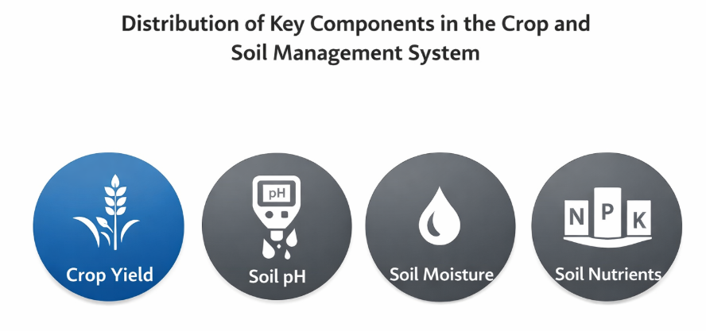

Figure 1. Distribution of key components in the data-driven crop and soil management system

2.1. Theoretical framework

Farming choices aren’t straightforward - they depend on weather, money matters, plus personal habits. Research has long looked at how access to info shapes what farmers do. Ideas about why people act based on what they know have shifted through the years. When tech meets farming, thinking in terms of data helps make sense of those actions.

It's often seen that when farmers get clear facts, they’re more likely to try new ways on the farm. The way someone thinks about effort and gain shapes if they’ll act at all. Belief in helpful outcomes nudges choices forward. Tools meant to track crops or improve soil meet quicker acceptance when real-world results show up early. What people expect to happen - good or hard - guides whether they step in. Seeing value matters just as much as feeling capable. Decisions grow from mix of confidence, support around them, and what they stand to win.

Farmers often choose crops, when water timing matters most, based on how they view tools, what others expect, plus whether they feel able to act. Knowing the land better - through solid soil details or instant warnings - builds confidence in those choices.

Decisions shift once control feels possible.

Looking closer, using data analysis adds strength here because it turns unprocessed farm details into clear guidance. Less guesswork shows up this way while helping farmers adjust their actions for better results. The thinking behind this work ties the Theory of Planned Behavior to methods that rely on collected data, showing how knowledge moves and shapes lasting crop habits. A visual outline of these ideas appears in Figure 2.
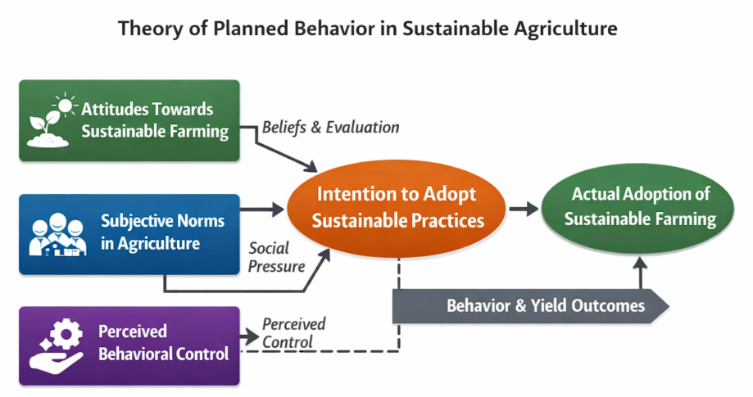

Figure 2. Theory of planned behavior

Research Methodology

3.1. Research design

Looking closely at one moment in time, this work uses real-world data to explore how well a method for managing crops and soil helps farmers make choices. Instead of tracking changes over months or years, it zeroes in on soil quality, which plants grow best where, water demands, and nature's influence - all seen together now. Because it pulls information from many places quickly without high costs, this snapshot approach appears often in farming and tech-related investigations.
A snapshot in time can reveal much about connections across variables, per insights from Salkind (2010) alongside Sedgwick (2014). Rather than tracking changes over months or years, this work gathers soil traits, climate records, and harvest details together. Information flows not through long waits but through coordinated collection moments. Because everything lines up at once, it becomes easier to see what nudges farmers toward certain choices. Tools that track fields do more than record - they shape how land is used, when seeds go in, even which risks feel too great.

3.2 Participants Dataset Overview

Looking back at how things were done, this work relied on numbers and patterns instead of people taking part. From afar, information pulled together showed what farming land was like and how much crops grew across fifteen growing seasons. Years passed before all pieces fit into one clear picture of usual dirt health and harvest changes.
A look at the numbers showed changes in soil pH, how wet the ground stayed, plus amounts of nitrogen, phosphorus, and potassium - each matched with harvest results year after year. Because everything came from past records, there was no need to gather info from people, meaning rules about studying humans did not come into play.

3.2.1 Instruments

A spreadsheet saved as a CSV file formed the core of this work, feeding into calculations and visual displays. This collection of numbers ran through R code, shaping outcomes with precision. Graphics took shape thanks to ggplot2, turning rows into readable plots.
Looking at changes in soil and crops meant using averages, highest and lowest values, along with patterns spotted over time. Visual tools like lines tracing data, bars comparing amounts, plus dots showing links helped display how soil quality shifted. These images revealed where nutrients stood across fields. They also highlighted ties between earth conditions and harvest results.
Starting off, the method kept results steady through uniform data handling - shaping columns, adjusting numbers to a common scale, clearing errors along the way. From there, tools worked together, quietly guiding how we understood dirt traits and what they meant for growing crops.

Table 1. Interpretation of Soil Health Levels
Soil Parameter Range | Interpretation Level
Low | Poor Soil Condition
Moderate | Average Soil Condition
High | Healthy Soil Condition

Table 2. Summary of Analytical Techniques Used.

Technique | Purpose
Descriptive Statistics | To understand overall soil and crop trends
Correlation Analysis | To examine relationships between soil parameters and crop yield
Regression Analysis | To assess the impact of soil factors on crop productivity
Data Visualization | To represent trends and patterns clearly

4. Conclusion

Soil quality ties closely to how well crops grow, especially when smart choices guide farming. Studies showed old methods - without regular checks on soil or plants - often wasted supplies while yields dropped. Yet farms using internet-connected sensors plus analysis tools made sharper decisions about what to plant, when to water, and where to add nutrients. Shifting from guesses to actual measurements changed how growers manage fields. Looking closely at dirt, plants, and weather over time gave farmers a clear way to grow more while protecting resources. Because of that, pairing digital tools with smart analysis made it easier to boost results, lower dangers, yet keep land healthy year after year.Recommendations

The finding revealed that the lack of training for both teachers and students was the main factor that prevented them from using educational technology tools in teaching and learning Ecology.

Acknowledgement
Soil quality ties closely to how well crops grow, especially when smart choices guide farming. Studies showed old methods - without regular checks on soil or plants - often wasted supplies while yields dropped. Yet farms using internet-connected sensors plus analysis tools made sharper decisions about what to plant, when to water, and where to add nutrients. Shifting from guesses to actual measurements changed how growers manage fields. Looking closely at dirt, plants, and weather over time gave farmers a clear way to grow more while protecting resources. Because of that, pairing digital tools with smart analysis made it easier to boost results, lower dangers, yet keep land healthy year after year.

Funding Support
This research was conducted as part of an academic project at Sheth L.U.J College of Science and Commerce and Sir M.V College of Arts and did not receive external financial support.

Ethical Statement
This study did not involve any experiments on human participants or animals. All analyses were conducted using publicly available secondary data and previously published research..

Conflicts of Interest

The author declares that there is no conflict of interest regarding the publication of this research.

Data Availability Statement

Data sharing is not applicable to this article as no new data were created or analyzed in this study. All information was obtained from previously published research and publicly available sources.

References
[1] P. Rajak et al., “Internet of Things and smart sensors in agriculture: Scopes, challenges and future directions,” ScienceDirect, 2023. Available: https://www.sciencedirect.com/science/article/pii/S2666154323002831
[2] X. Zhang, “Advanced technologies of soil moisture monitoring in agriculture,” ScienceDirect, 2024. Available: https://www.sciencedirect.com/science/article/pii/S2666154324005106
[3] “Crop Recommendation on Analyzing Soil Using Machine Learning,” ResearchGate, 2025. Available: https://www.researchgate.net/publication/351481738_Crop_Recommendation_on_Analyzing_Soil_Using_Machine_Learning
[4] M. R. Islam, “Machine learning enabled IoT system for soil nutrients and crop recommendation,” ScienceDirect, 2023. Available: https://www.sciencedirect.com/science/article/pii/S2666154323003873
[5] P. Sharma et al., “AI-Enabled Crop Recommendation System Based on Soil and Weather Patterns,” ResearchGate, 2023. Available: https://www.researchgate.net/publication/371964335_AI-Enabled_Crop_Recommendation_System_Based_on_Soil_and_Weather_Patterns
[6] “Machine learning for weather-specific crop recommendation,” ScienceScholar, 2024. Available: https://sciencescholar.us/journal/index.php/ijhs/article/download/13222/9906/10010
[7] “Smart Sensors and Smart Data for Precision Agriculture,” MDPI Sensors, 2024. Available: https://www.mdpi.com/1424-8220/24/8/2647
[8] “IoT-Enabled Soil and Crop Monitoring System Using Low-Cost Sensors,” MDPI Open Journal, 2024. Available: https://www.mdpi.com/2673-4591/118/1/77
[9] “A Literature Review on IoT in Smart Agriculture,” ResearchGate, 2025. Available: https://www.researchgate.net/publication/388320488_A_LITERATURE_REVIEW_ON_IOT_IN_SMART_AGRICULTURE
[10] “Internet of Things (IoT) for Smart Precision Farming,” ResearchGate, 2025. Available: https://www.researchgate.net/publication/350688931_INTERNET_OF_THINGS_IOT_FOR_SMART_PRECISION_FARMING_AND_AGRICULTURAL_SYSTEMS_PRODUCTIVITY_A_REVIEW
[11] “Smart agriculture for a sustainable future: implementing IoT,” SpringerOpen, 2025. Available: https://bnrc.springeropen.com/articles/10.1186/s42269-025-01366-8
[12] “Precision Farming With IoT: Soil Nutrient Analysis and Fertilization,” African Journal of Biomedical Research, 2024. Available: https://africanjournalofbiomedicalresearch.com/index.php/AJBR/article/download/5436/4217/10394
[13] “Crop recommendation system using IoT and machine learning technology,” IJERT, 2024. Available: https://www.ijert.org/smart-soil-fertilizer-monitoring-and-crop-recommendation-system-by-using-iot-and-machine-learning-technology
[14] “A Review of Digital and Sensor-Based Tools for Soil Health Monitoring,” IJPSS, 2025. Available: https://journalijpss.com/index.php/IJPSS/article/download/5825/12467/8583
[15] “Precision crop prediction using IoT-enabled soil sensors and machine learning,” JETIA Journal, (date), Available: https://itegam-jetia.org/journal/index.php/jetia/article/view/1219
[16] “Harvest Harmony: Integrating Machine Learning Models for Precision Crop Recommendation,” ResearchGate, 2024. Available: https://www.researchgate.net/publication/370056714_Crop_Recommendation_System
[17] “Crop Recommendation Using Machine Learning Based on Soil-Weather Parameters,” IJRASet, Available: https://www.ijraset.com/research-paper/crop-recommendation-using-machine-learning-based-on-soil-weather
[18] E. Navarro et al., “A Systematic Review of IoT Solutions for Smart Farming,” PMC, 2020. Available: https://pmc.ncbi.nlm.nih.gov/articles/PMC7436012/

