**High-Level Design (HLD)**

**Travel Purchase Package Prediction**

|  |  |
| --- | --- |
| Written By | Ubaid Ahmad Khanday |
| Version | 1.0 |
| Date | 2-12-2024 |

|  |  |  |  |
| --- | --- | --- | --- |
| **Version** | **Date** | **Author** | **Comments** |
|  |  |  |  |
|  |  |  |  |
|  |  |  |  |
|  |  |  |  |
|  |  |  |  |
|  |  |  |  |
|  |  |  |  |
|  |  |  |  |
|  |  |  |  |
|  |  |  |  |
|  |  |  |  |
|  |  |  |  |
|  |  |  |  |
|  |  |  |  |
|  |  |  |  |

**Document Change Control Record**

Review

|  |  |  |  |
| --- | --- | --- | --- |
| **Version** | **Date** | **Reviewer** | **Comments** |
|  |  |  |  |

**Approval**

|  |  |  |  |  |
| --- | --- | --- | --- | --- |
| **Version** | **Review date** | **Reviewed By** | **Approved By** | **Comments** |
|  |  |  |  |  |

**Abstract**

This project addresses a classification problem focused on predicting travel package purchases. Leveraging historical data on customer interactions and purchase behaviors, the system aims to classify customers into categories based on their likelihood of purchasing specific travel packages. Through the analysis of past purchase records and customer attributes, the system employs various machine learning algorithms to discern patterns and relationships, enabling accurate classification of potential buyers. The primary objective is to develop a robust classification model capable of effectively categorizing customers, thereby empowering businesses to tailor marketing strategies and optimize sales efforts for improved customer engagement and revenue generation in the travel industry.

1. Introduction

**1.1 Why these High-Level Design Documents?**

The purpose of this High-Level Design(HLD) Documents is to add necessary details to the current project description to represent a suitable for coding. This document is also intended to help detect contradictions before coding. And can be used as a reference manual for how the modules interact at a high level.

The HLD will be :

* Present all of the design aspects and define them in detail.
* Describe the user interface being implemented.
* Describe the needed Python libraries for the coding.
* Describe the performance requirements.
* Include design features and the architecture of the project.
* List and describe the non-functional attributes like:
  + Security
  + Reliability
  + Maintainability
  + Portability
  + Reusability
  + Application Compatibility
  + Resource Utilization
  + Serviceability

**1.2 Scope**

The HLD documentation presents the structure of the system, such as the database architecture, application architecture(layers), application flow (Navigation), and technology architecture, The HLD uses non-technical and mildly-technical terms which should be understandable to the administrators of the system

**1.3 Definition**

|  |  |
| --- | --- |
| TERM | Description |
| DB | Database, the cloud platform where the data will be stored. Can be considered  cloud storage. |
| ML | Machine Learning |
| AWS | Amazon Web Services |
| API or APIs | Application Programming Interface can be considered a website link from there we can extract information. |

**2. General Description**

**2.1 Product Perspective**

The Travel Package Purchase Prediction system is an ML-based application aimed at forecasting customer decisions regarding travel package selection. By analyzing various features and historical data, the system predicts whether a customer is likely to opt for a travel package.

**2.2 Problem Statement**

The objective of this project is to develop a predictive system capable of forecasting the demand for travel packages based on various customer attributes and historical data. Specifically, the system should take input information about a travel package and predict whether customers are likely to opt for it in the future. The challenge lies in building an application that can accurately produce these predictions, enabling travel companies to make informed decisions regarding marketing strategies, inventory management, and resource allocation.

**2.3 Proposed Solution**

Our solution entails leveraging exploratory data analysis (EDA) to uncover key relationships between various attributes and travel package purchase likelihood. We'll employ machine learning algorithms, including hyperparameter tuning, to build a predictive model capable of forecasting future sales demand. The client will interact with a user-friendly web application, inputting relevant features, which will then undergo validation, preprocessing, and prediction generation in the backend. By deploying this integrated system, we aim to provide clients with actionable insights, enabling them to optimize marketing strategies, allocate resources efficiently, and maximize revenue generation in the dynamic travel industry landscape.

**2.4 Data Requirements**

The necessary data for the Travel Package Purchase Prediction project is readily available within the dashboard. The dataset contains essential information pertinent to customer behavior and travel package attributes. With 4888 rows, it includes columns such as 'CustomerID', 'ProdTaken', 'Age', 'CityTier', 'DurationOfPitch', 'NumberOfPersonVisiting', 'NumberOfFollowups', 'PreferredPropertyStar', etc. oThese attributes provide valuable insights into customer demographics, preferences, and interactions with travel packages.

**2.5 Tool Used**

The programming language is Python that is used here, also we will use some other python-based libraries like, for ml, we will use Scikit-Learn library, for data manipulation we will use pandas, for numerical computation Numpy, for custom APIs creation Flask web frameworks. Visual Studio Code is used as python IDE for all modular coding and custom APIs creation. And storing all code files for publically available we will use GitHub.





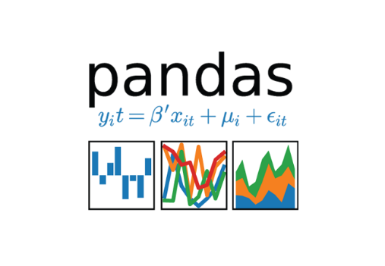





**2.6 Constraints**

The System should be user-friendly, the user should get all proper messages while using the web app. He/she also should get a proper error message if he/she has done something wrong On the web-app page. All the errors and results should be delivered in the easiest possible way and all the buttons are going to insert on the webpage should be labeled properly, so the user did not get confused to use the system.

**2.7 Assumptions**

The project assumes the reliability of historical data and the effectiveness of machine learning models in predicting future demand for travel packages. It also presumes stability in external factors influencing purchase decisions and consistency in customer behavior over time.

**3. Design Details**

**3.1 Process Flow**

We will be using following process flow for this project. The process will be based on modular coding i.e. use of oops concepts to build the entire project from start to end.

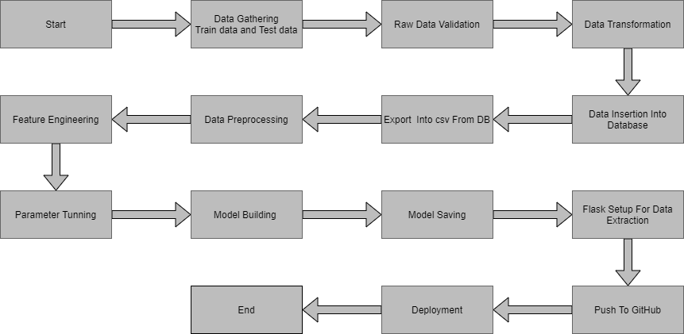

**3.2 Deployment Process**

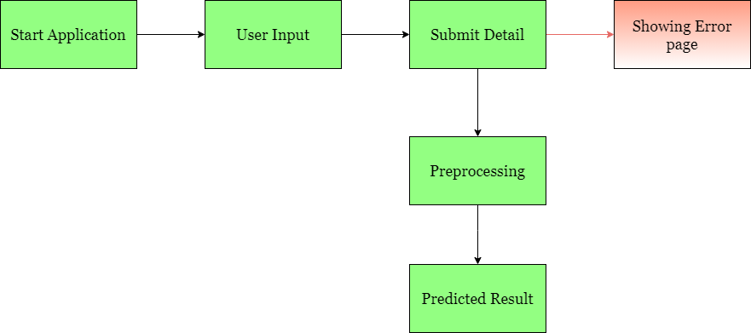

**3.3 Error Handling**

If any error occurred in the processing way then the error message should be shown to the user in a completely non-technical way that can be understandable by any person. And Meaningful error message should be shown, so the user can spot his mistake and rerun the process with improvement. All the errors that are will occur should be handled properly. And we have to log every error for our application and have to manage the same.

**4. Performance**

The Travel Package Purchse Prediction is dependent on machine-learning algorithms. We will train various ml algorithms and will find the best fitting algorithm for predicting the target. Our system performance will be based on the data we are going to feed to the algorithms. And the performance will depend on the finalized model. and the web application and the deployment server. With all of these components, our program should run properly.

**4.1 Reusability**

The code and the module are created during the time of building the project should maintain all coding guidelines and full project code is written in a Modular fashion. Our system should have the flexibility to work properly from any location. And it should handle any improper input value from the user and should give a meaningful error message so the user can correct his/her mistake and enter valid input to get the result. And the system should be reusable in every manner with different types of inputs values that are all are it has been trained.

**4.2 Application Compatibility**

The different libraries and python programming languages are used to build the system. Every library has its own functionality and it should work properly with our fluctuate system. Flask will be used for making the web APIs and HTML/CSS will be used to make the web application. All the components of the application should work properly and it should produce a result without any interpretation.

**4.3 Resource Utilization**

Our application should utilize the given resource properly and it should use a minimal amount of internet to work and call the APIs on the Web page. Our system should not use much amount of computational resources hence it will make the application slow. Our application will be deployed cloud platform and it should utilize the resource given on the cloud and work properly.

**5. Deployment**

For the deployment process, we will using AWS cloud platforms for hosting our application. The cloud platform will run the system and it will give the flexibility to use our application globally.



**6. Conclusion**

The Travel Package Purchase Prediction project aims to provide invaluable insights to travel companies, assisting them in optimizing marketing strategies, enhancing customer targeting, and maximizing revenue generation. By analyzing past customer behavior and travel package attributes, we endeavor to develop a robust machine learning model capable of accurately predicting future demand for travel packages. This predictive system will not only empower businesses to make informed decisions regarding product offerings and resource allocation but also streamline supply chain management processes. Leveraging historical data and advanced machine learning techniques, we aspire to drive growth and efficiency in the travel industry while delivering tangible value to stakeholders.

**7. Reference**

Google image for collection the logos and images.

Sketch diagram for drawing the diagrams.