Business Requirements Document: Multi-Currency Loan Support
Project ID: PRJ-2026-FIN-042
Status: Draft
Date: January 20, 2026

1. Functional Overview
This project aims to expand the bank’s lending capabilities by introducing support for three new currencies: Chinese Yuan (CNY), Offshore Chinese Yuan (CNH), and Egyptian Pound (EGP). The system must allow bankers to originate loans in these currencies and perform balance enquiries with real-time currency-specific data.

2. Process Analysis

As-Is Process
Currently, the Loan Management System (LMS) only supports major currencies (USD, EUR, GBP). When a banker attempts to create a loan for a client requiring CNY, CNH, or EGP, the system lacks these options in the dropdown, necessitating manual workarounds or preventing the transaction entirely.

To-Be Process
Bankers will select the specific currency (CNY, CNH, or EGP) at the point of loan inception. The system will validate the currency code, apply the relevant exchange rate, and store the record. Enquiries will display the outstanding balance and interest in the original currency of the loan.

3. Proposed Solution

Frontend Changes (Team: FRONTEND)
The frontend must be updated to include the new currency codes in the loan creation and enquiry modules.
A. Loan Creation Screen
- Modify the Currency dropdown menu to include:
  - CNY (Chinese Yuan)
  - CNH (Offshore Chinese Yuan)
  - EGP (Egyptian Pound)
- Ensure that selecting these currencies triggers the correct decimal formatting (e.g., 2 decimal places for these specific codes).
B. Enquiry Module
- Update the search filters to allow filtering by Currency.
- Update the Results Grid to display the currency symbol next to the principal amount.

Backend Changes
The backend must recognize and process the ISO codes for the new currencies and ensure they map correctly to the accounting ledger.
A. Database Schema Update
The Ref_Currency table must be appended with the following values:
Currency Code | Currency Name | Decimal Places | Country/Region
CNY | Chinese Yuan (Onshore) | 2 | China
CNH | Chinese Yuan (Offshore) | 2 | Hong Kong / Intl
EGP | Egyptian Pound | 2 | Egypt
B. Logic Implementation
- Update the Currency Validation Service to accept the new ISO codes.
- Update the Interest Calculation Engine to pull the specific benchmark rates associated with CNY/CNH (e.g., SHIBOR) and EGP (e.g., Corridor Rate).

4. System Sequence Diagram (SSD)
This diagram illustrates the logic for adding and validating a new currency during the loan creation process.
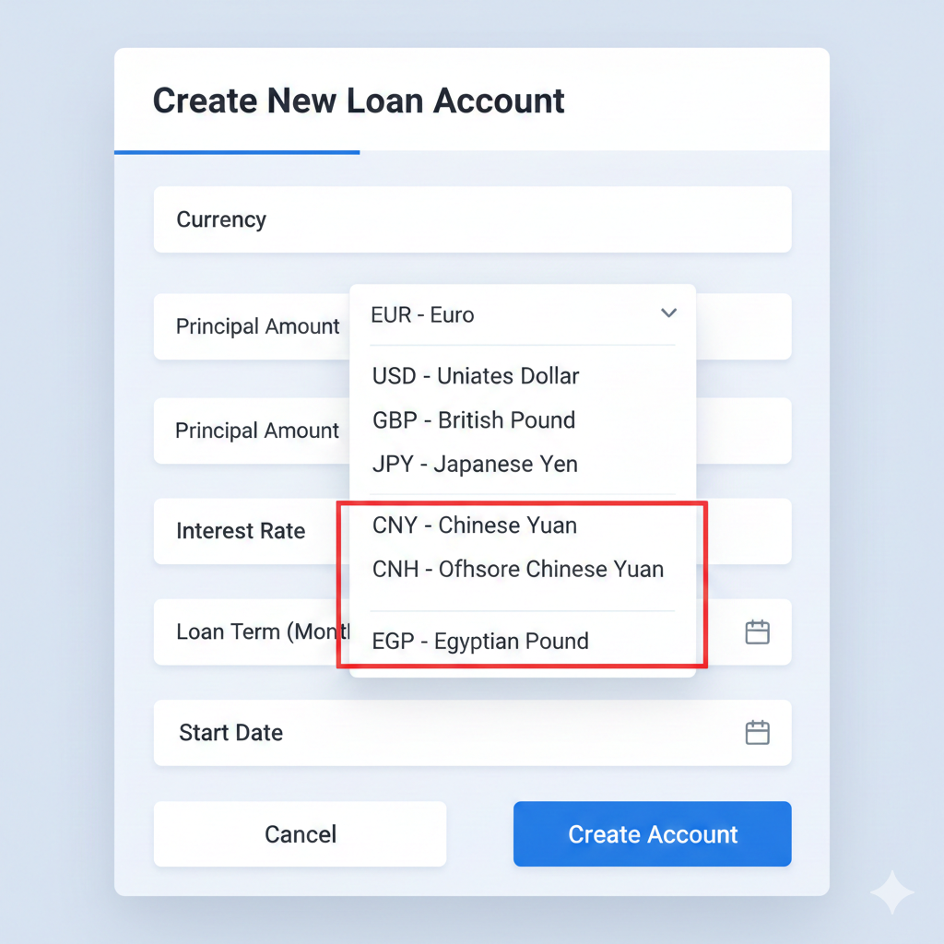

5. Impacted Systems
- Core Banking System (CBS): Must recognize new currency IDs for ledger entries.
- Treasury Module: To provide daily exchange rates for CNY/CNH/EGP.
- Reporting Engine: To generate monthly statements in the new currencies.

6. DWH (Data Warehouse) Changes
- ETL Jobs: Modify extraction scripts to include the new currency attributes.
- Fact Tables: Update FACT_LOAN_BALANCE to ensure no data truncation occurs when storing EGP values.
- Dimensions: Update DIM_CURRENCY to match the backend database table.
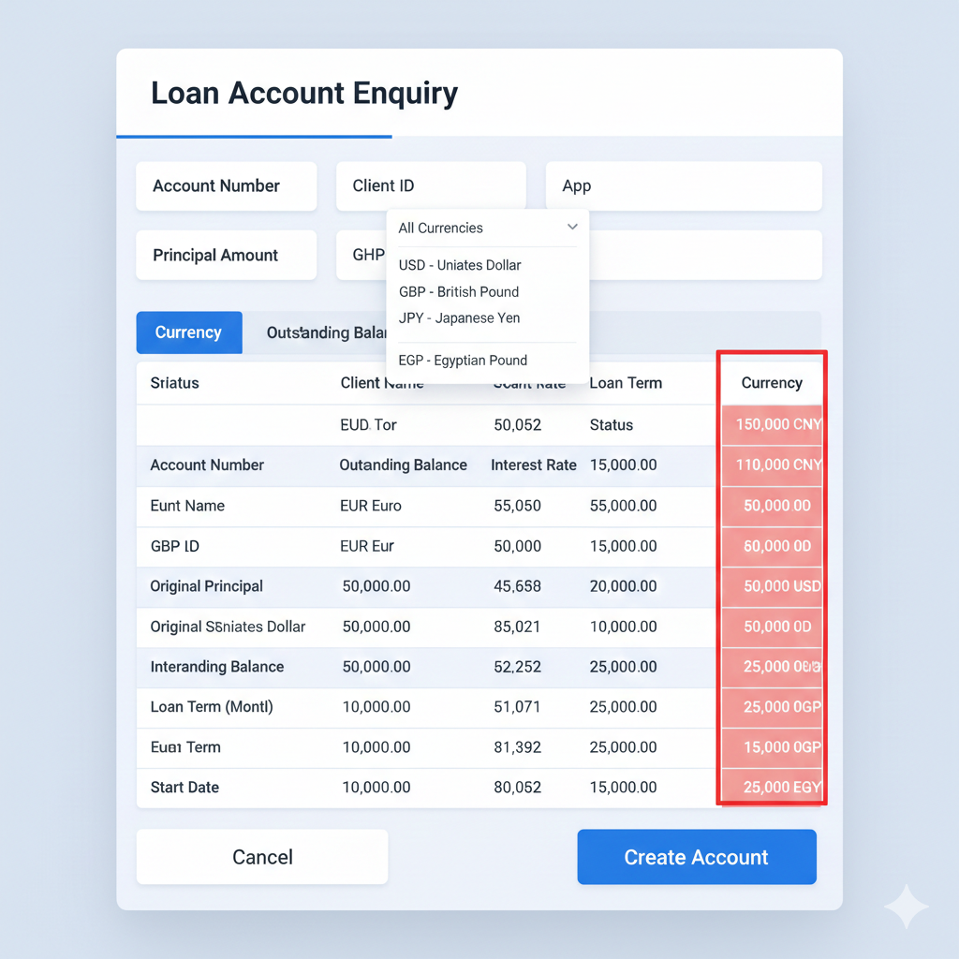

7. Exceptions
- Rate Volatility: If the exchange rate for EGP is unavailable from the Treasury feed, the system should block loan creation and alert the administrator.
- Regulatory Limits: Loans in CNY/CNH may be subject to specific cross-border regulatory caps; the system should trigger a warning if the loan amount exceeds the predefined threshold.

8. Appendix & Doc Approval

Doc Approval
Name | Role | Signature | Date
[Name] | Product Owner
[Name] | Tech Lead
[Name] | QA Manager

