**Assignment 1 - Quality Assurance**

**Requirements:**

Operating System - WINDOWS 10

Programming Language - JAVA

Version - 1.8.0_171

Libraries Used - JUNIT5, JAXB

IDE - ECLIPSE (Version: Oxygen.3a)

**Notes:**

* Main Entry Point for the Project **QAAssignment1** is **OrderValidationImpl.**
* To run the program, import the project in eclipse and select **OrderValidationImpl,** and right click and select **“Run As” -> “Run Configurations”**

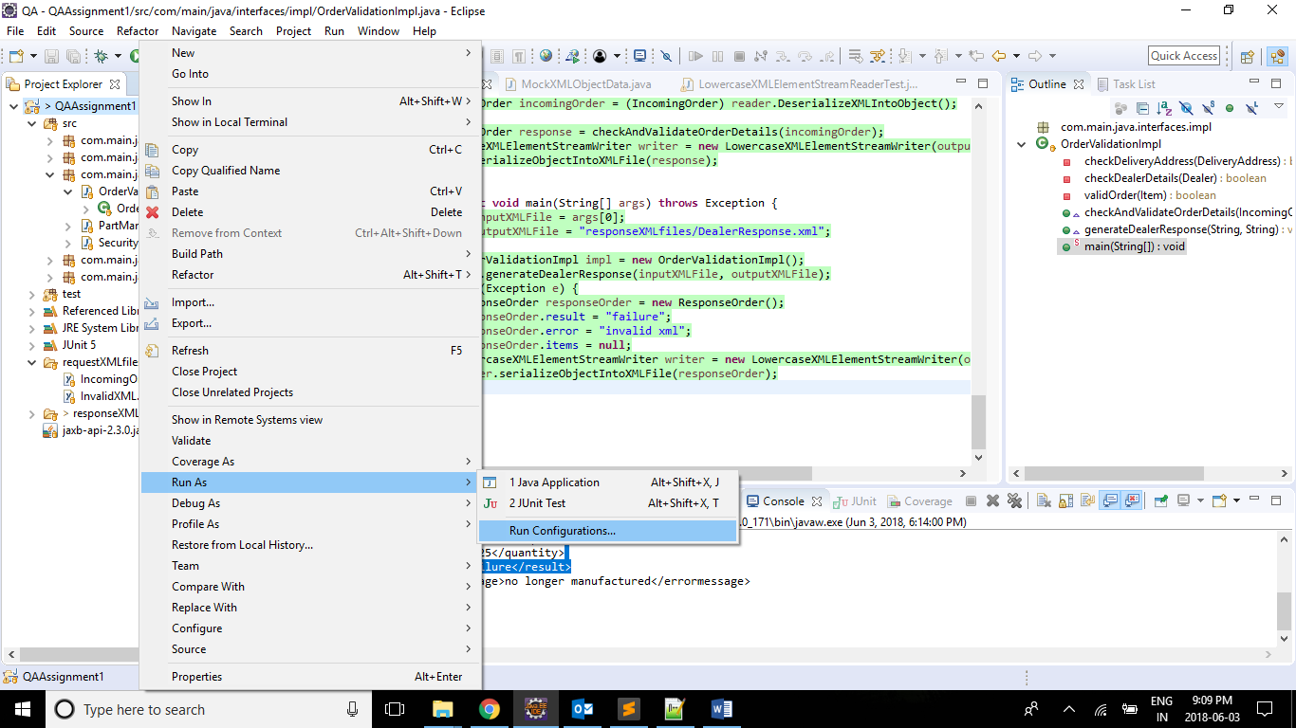

* After selecting, Run Configuration window appears, specify the path of the xml file in the

Program arguments in the arguments tab, as shown below.

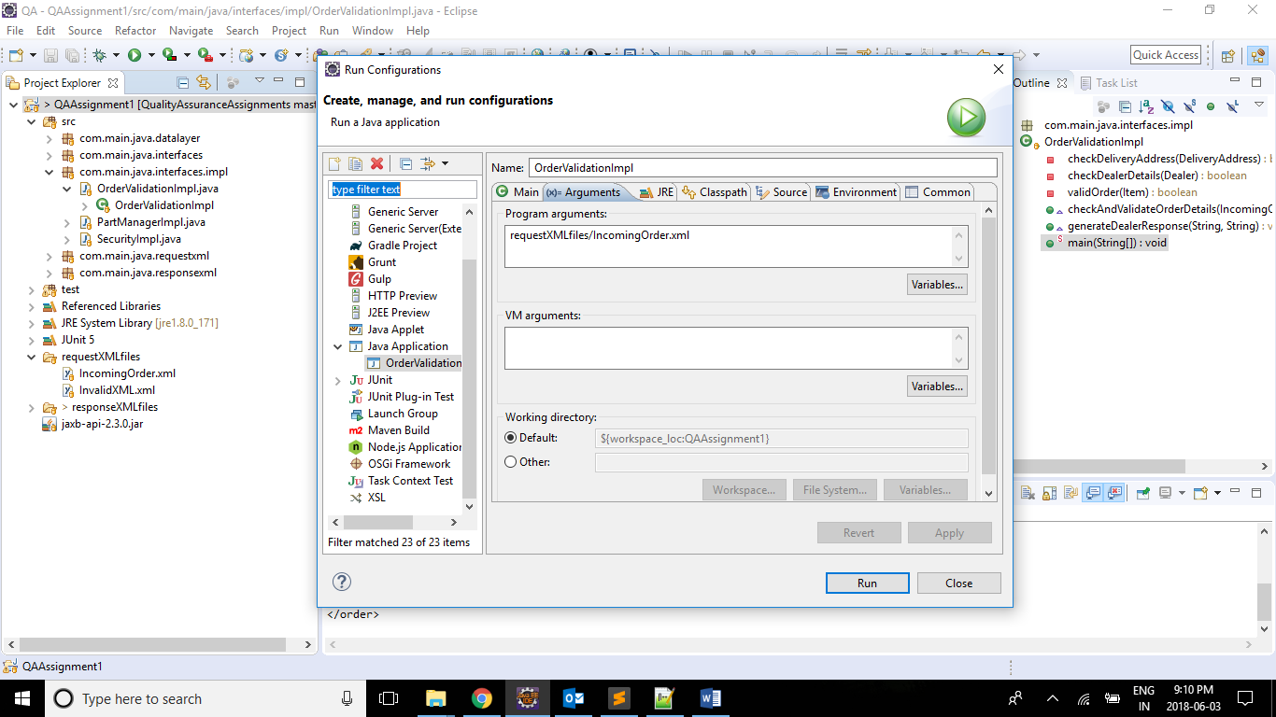

* Output response xml file will be generated under "responseXMLfiles/DealerResponse.xml" under the project **QAAssignment1.**
* To run the Junit Unit Test cases, right click on the project and select **Run As** and then select Junit Test, as shown below.

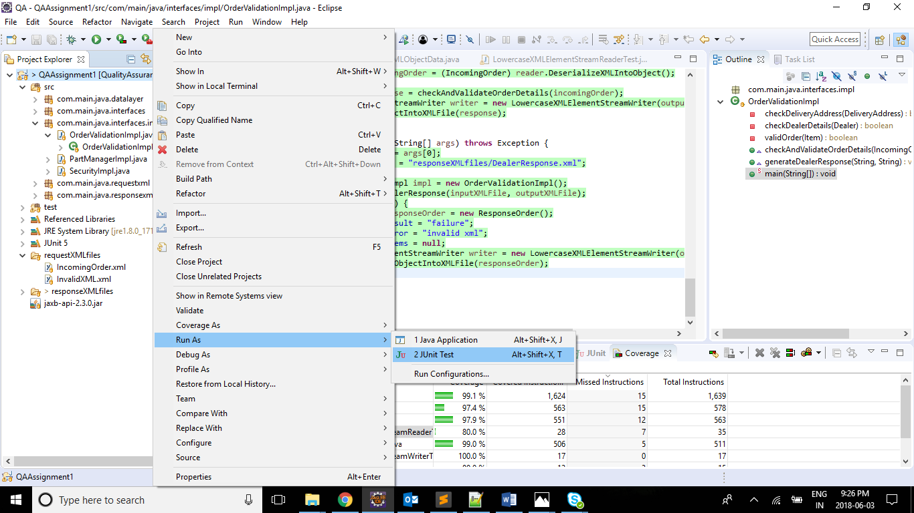

* To check the code coverage, right click on the project and select **Coverage As** and then select Junit Test, as shown below.

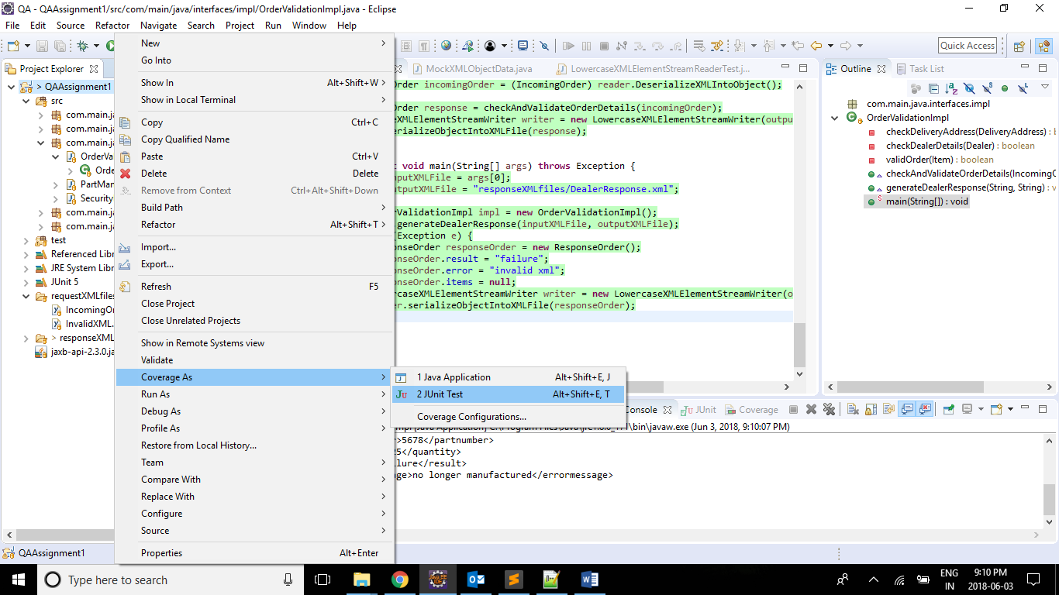

* The following is the Code Coverage, 100%.

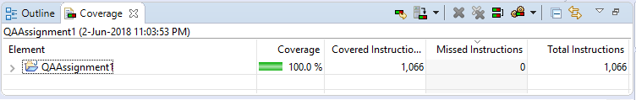

**Assumption for Data Layer:**

The following are the dealer ids and dealer access keys, which are mocked in the data layer. These Ids and Keys helps us in identifying whether the incoming order is authorized or not.

|  |  |
| --- | --- |
| Authorised Dealer Ids | Authorised Dealer Access Keys |
| "XXX-1234-ABCD-1231"  "XXX-1234-ABCD-1232"  "XXX-1234-ABCD-1233"  "XXX-1234-ABCD-1234"  "XXX-1234-ABCD-1235"  "XXX-1234-ABCD-1236"  "XXX-1234-ABCD-1237"  "XXX-1234-ABCD-1238"  "XXX-1234-ABCD-1239"  "XXX-1234-ABCD-1240" | "kkklas8882kk23nllfjj88290"  "kkklas8882kk23nllfjj88291"  "kkklas8882kk23nllfjj88292"  "kkklas8882kk23nllfjj88293"  "kkklas8882kk23nllfjj88294"  "kkklas8882kk23nllfjj88295"  "kkklas8882kk23nllfjj88296"  "kkklas8882kk23nllfjj88297"  "kkklas8882kk23nllfjj88298"  "kkklas8882kk23nllfjj88300" |

The following are the part numbers which are: available to sell / Out of Order / Non-Manufactured.

|  |  |  |
| --- | --- | --- |
| Available Part Numbers | Out of Order Part Numbers | Non-Manufactured Part Numbers |
| 1231  1232  1233  1234  1235  1236  1237  1238  1239  1240  1241  1242  1243  1244  1245  1246  1247  1248  1249  1250 | 1201  1202  1203  1204  1205  1206  1207  1208  1209  1210  1211  1212  1213  1214  1215  1216  1217  1218  1219  1220 | 1261  1262  1263  1264  1265  1266  1267  1268  1269  1270  1271  1272  1273  1274  1275  1276  1277  1278  1279  1280  5678 |