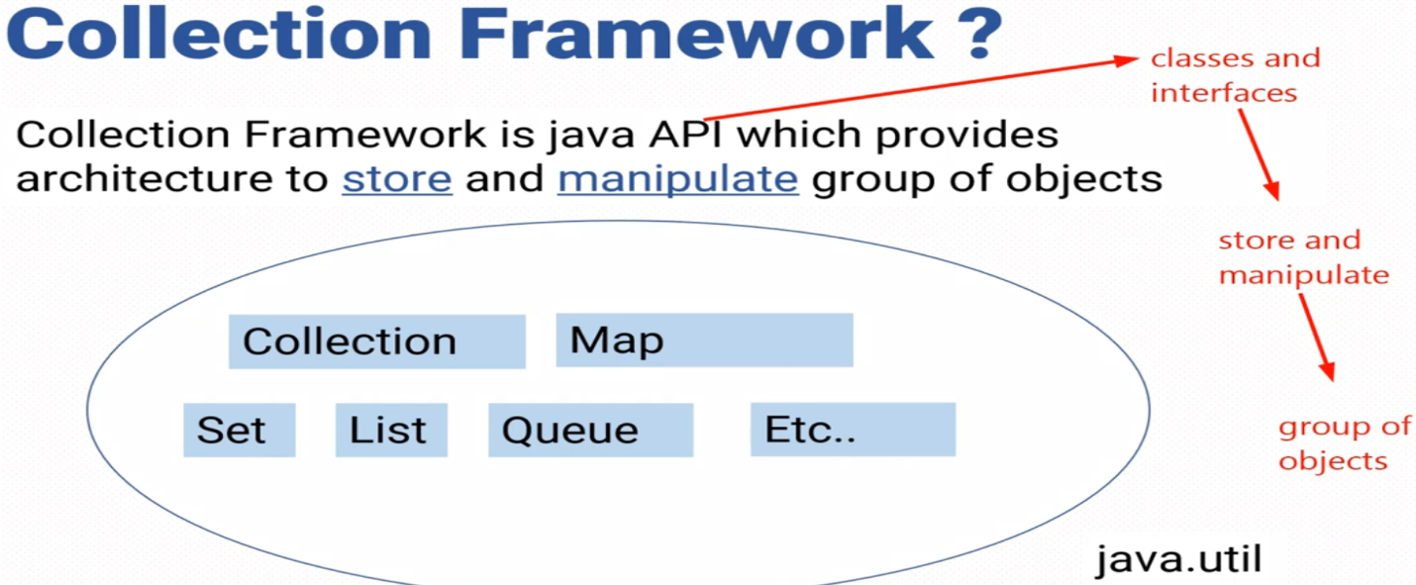

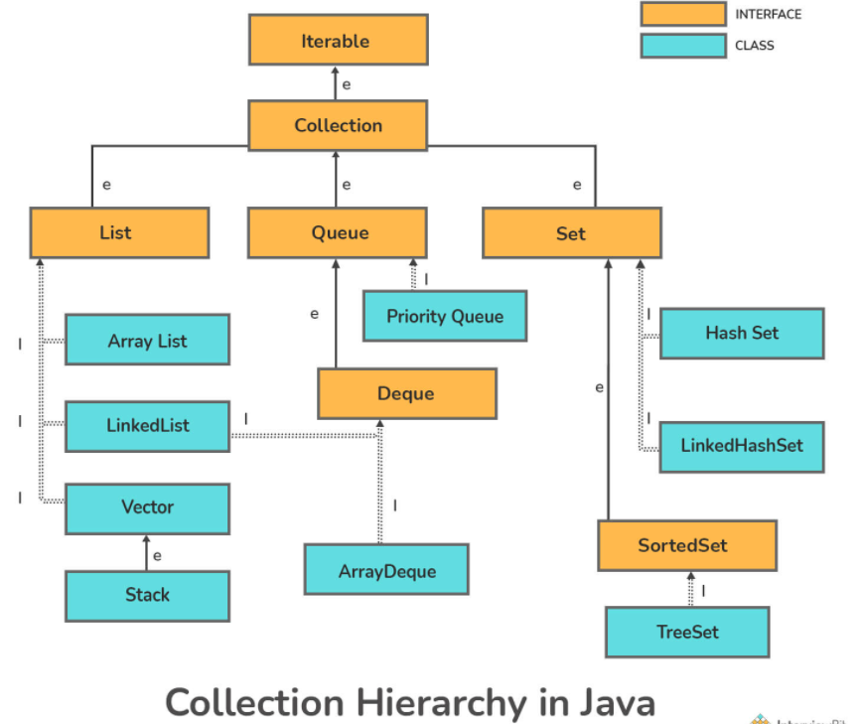

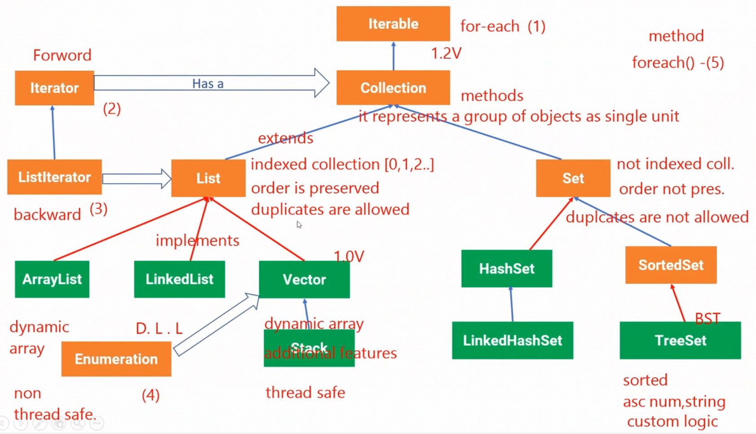

Green Boxes Represents Class.

Orange boxes represents Interface.

Blue lines represents extend relationship.

Red lines represents implements relationship.

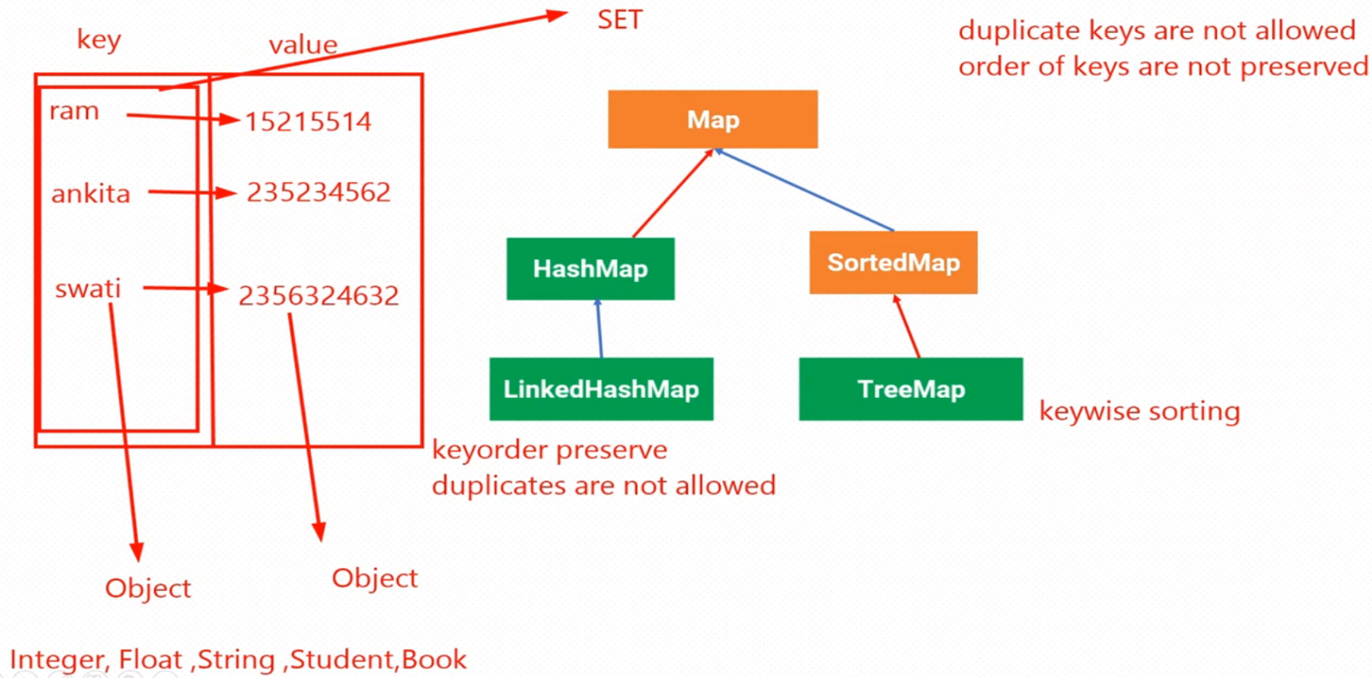

**List**

1. Adding element in List

List <String> list = new ArrayList<String>(); or new LinkedList<String>();

list.add(“element1”); -> add at element at the end

list.add(index, “element”); -> add at particular index

1. Removing element in list

We can use remove() method

remove(int index) -> remove from specific index.

remove(Obj obj) -> remove first occurrence of specific object

1. How to get element from List at particular index

get(int index) -> returns the object at provided index.

1. How to get index of specific element in List.

indexOf(Object obj) -> return the index of first occurrence of obj.

returns -1 if obj is not present in list.

1. Traversing a list

Use stream.forEach()

**Set**

1. Adding element to Set

set.add(“element”) -> return false if element is already present in set.

1. Removing element from Set

set.remove(Obj obj) -> returns true if obj is present into set.

1. Traversing a set

We have 3 methods

1. Using iterator
2. Using enhanced for loop -> for(String stock : setOfStocks){System.out.println(stock);}
3. Using forEach loop(in Stream API) -> setOfStock.forEach(i -> System.out.println(i))

**Map**

1. Adding element to Map.

put(key,value)

1. Removing element from Map.

remove(key) -> remove element having this particular key.

1. Traversing a map -> use map.forEach((k,v)->{//do anything with key & value})
2. Getting list of keys in Map ->

keySet() method returns a Set of keys contained in the map.

1. Getting List of values from Map ->

values() method returns a Collection view of the values.

1. Getting value corresponding to a key ->

get(Object key)

1. To check whether a key is present in Map

containsKey(key) -> returns true if key is present in Map otherwise returns false.