**What is Apache Kafka?**

It is a publish-subscribe based messaging system, used for exchanging data between processes, applications and servers.

**Components in Kafka**

1. Producer: It is a client application that publishes (writes) events to a Kafka cluster.
2. Consumer: It is a client application that subscribes to (reads and processes) events.
3. Broker: It is a server in the cluster this will receive and send the data. We can have multiple broker in one cluster. There will be only one leader broker, rest will be follower broker. Sometimes they are called as Kafka servers.
4. Cluster: It is a group of servers working together for three reasons: speed (low latency), durability, and scalability.
5. Topic: It specifies the category of message. Each topic has a name that is unique across the entire Kafka cluster. Messages are sent to and read from specific topics. In other words, producers write data to topics, and consumers read data from topics. Kafka topics are multi-subscriber.
6. Partitions: As a distributed system, Kafka runs in a cluster, and each cluster has a broker or group of brokers. Partitioning is what enables messages to be split in parallel across several brokers in the cluster. Using this method of parallelism, Kafka scales to support multiple consumers and producers simultaneously.
7. Offset: It is a unique ID assigned to the partitions, which contains messages.
8. Consumer Groups: It is a set of consumers which cooperate to consume data from some topics.
9. Zookeeper: It is used for metadata management in the Kafka world. For example: Zookeeper keeps track of which brokers are part of the Kafka cluster. Zookeeper is used by Kafka brokers to determine which broker is the leader of a given partition and topic. In Kafka 4, Zookeeper will be replaced with kRaft.
10. Kafka Connect: Kafka can not work alone, it has to integrate with multiple systems like splunk(to show the logs), so Kafka connect is the framework for integrating Kafka with external systems to help the development of connectors for ingesting the data to and from the kafka to various sources and sinks.

**1**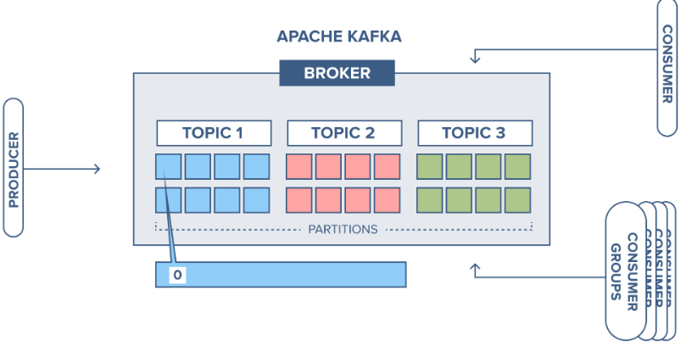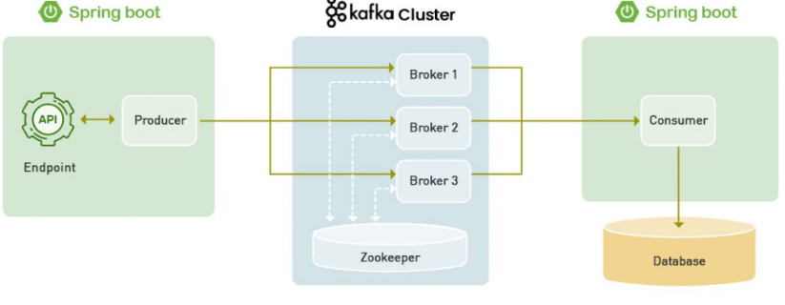

**What is difference between Cluster and Broker**

What is difference between RabbitMQ and Kafka.

**Architecture flow of Kafka**