Maven is built tool that helps in building and managing the project.

Build tool takes care of *generating source code, compiling source code and packaging compiled source code into JAR files*.

Maven is based on Project Object Model (POM). POM is an XML file which contains information about project such as what dependencies are used and other configuration details. While executing a task, Maven read POM gets needed information and then runs the code.

Maven is mostly used with java projects, but can also be used with C#, ruby and scala projects.

**Need For Maven**

Maven solves the problem of getting the JAR Files. In absence of Maven one need to manually download the required JAR files.

Maven helps in creating right project structure. It also helps in building and deploying the project.

**POM**

Introduction

POM Example

<project xmlns = "http://maven.apache.org/POM/4.0.0"

xmlns:xsi = "http://www.w3.org/2001/XMLSchema-instance"

xsi:schemaLocation = "http://maven.apache.org/POM/4.0.0

http://maven.apache.org/xsd/maven-4.0.0.xsd">

<modelVersion>4.0.0</modelVersion>

<groupId>com.companyname.project-group</groupId>

<artifactId>project</artifactId>

<version>1.0</version>

</project>

All POM files require **Project** element and 3 mandatory fields: **groupId**, **artifactId** and **Version**.

groupId – Used to uniquely identify the project. (Package of project)

artifactId – name of Project.

Version – Speifies version of Project.

**Build Profile**

A Build profile is a set of configuration values, which can be used to set or override default values of Maven build. Using a build profile, we can customize build for different environments such as Production v/s Development environments.

Build profiles are majorly of three types :-

1. Per Project : Defined in the project POM file, pom.xml
2. Per User : Defined in Maven settings xml file(%USER_HOME%/.m2/settings.xml)
3. Global : Defined in Maven global settings xml file (%M2_HOME%/conf/settings.xml)

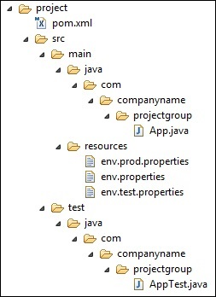

**env.properties** : default configuration used if no profile is mentioned.

**env.test.properties :** test configuration when test profile is used.

**env.prod.properties** : production configuration when prod profile is used.

**Maven Repository**

It is a directory where all the project jars, library jar, plugins or any other project specific artifacts are stored

Maven Repository is of 3 types.

1. Local
2. Central
3. Remote

**Maven Plugin**

Plugins are used for : -

1. Create JAR File.
2. Create War File.
3. Unit Testing
4. Creating Project Documentation, etc.

**Archetype**

Archetype is a plugin which is used to create a project structure.

**Different Tags used in POM.xml**

1. <artifactId>
2. <Dependencies> : Parent tag of <Dependency> tag. It contains bunch of dependency.
3. <Dependency>
4. <groupId>
5. <Parent>
6. <Plugins>
7. <Properties>

How To Create Maven Project

File🡪New🡪 Maven Project

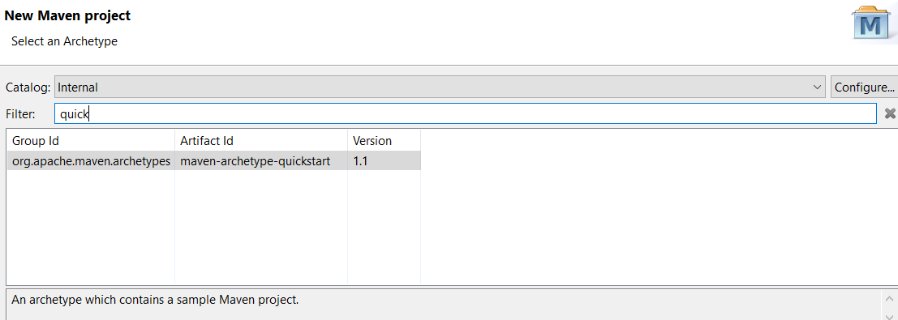

Click on Next.

Provide GroupId(PackageName)

ArttifactId(Project Name)

Click Finish.

**Changing Java Version**

File🡪Build Path🡪Configure Build Path 🡪Select Libraries Tab🡪Add Library 🡪 JRE System Library 🡪Select requisite java version.