BIRLA INSTITUTE OF TECHNOLOGY & SCIENCE, PILANI

Pilani Campus

EEE C434/EEE F434: Digital Signal Processing

**Lab 4: Circular Convolution, DCT and Window Functions**

**Note: Please write your MATLAB codes in this .doc file and save it. Capture and paste the snapshots of your plots, wherever required. Make sure you get it signed before leaving the lab.**

**Please make sure you add a title, axis labels, x-axis limit and y-axis limit, grid on, and legend (if required) to each of your figures.**

Kshitij Khandelwal | 2015A3PS0156P

**PART A: Circular Convolution**

The input sequence x[n] and the impulse response of a system h[n] are given as:

x[n] = {1, 6, 1, 4}

h[n] = {4, 5, 0, 6, 0, 9}

a) Compute the output response using linear convolution. Plot the output sequence.

xn = [1 6 1 4];

hn = [4 5 0 6 0 9];

yn = conv(xn,hn);

n = 0:1:8;

stem(yn);

xlabel('n');

ylabel('y[n]');

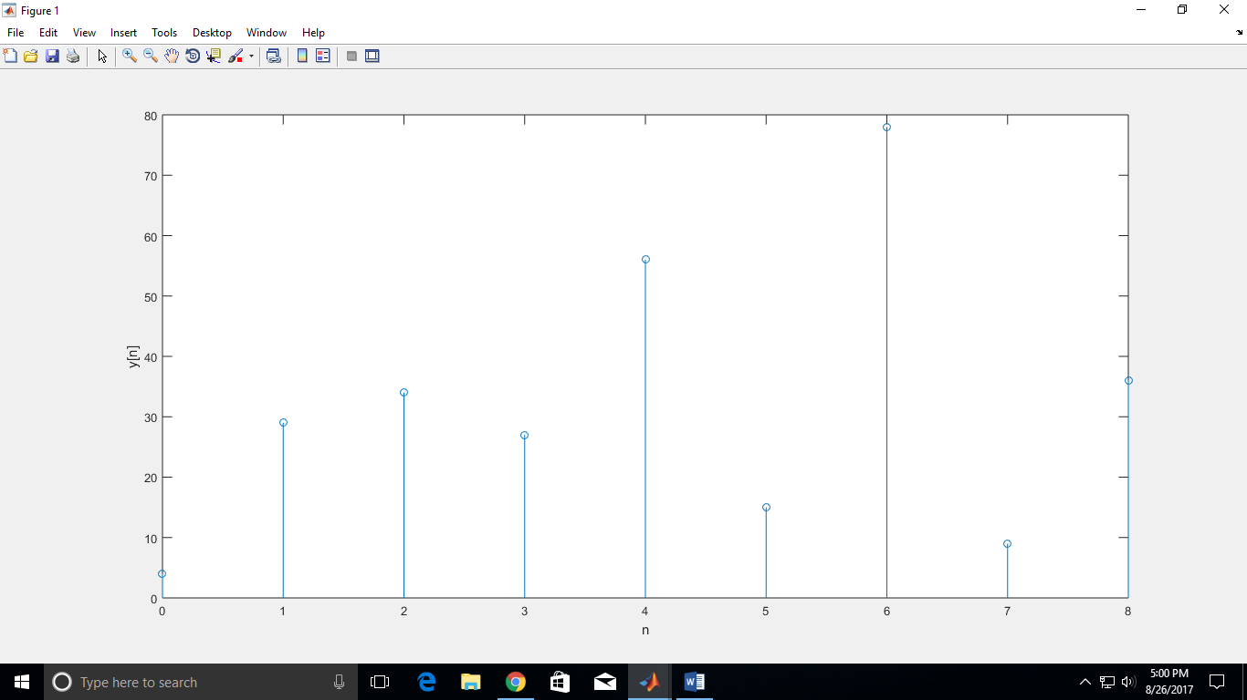

b) Obtain the N-point circular convolution between x[n] and h[n] such that the output sequence from circular convolution is similar to the linear convolution. Use subplots to show your findings.

xn = [1 6 1 4];

hn = [4 5 0 6 0 9];

yn = conv(xn,hn);

N = length(xn)+length(hn)-1;

ycn = cconv(xn,hn,N);

n = 0:1:N-1;

subplot(2,1,1);

stem(n,yn);

xlabel('n');

ylabel('y[n]');

title('Linear convolution');

subplot(2,1,2);

stem(n,ycn);

xlabel('n+1');

ylabel('yc[n]');

title('9-point Circular convolution');

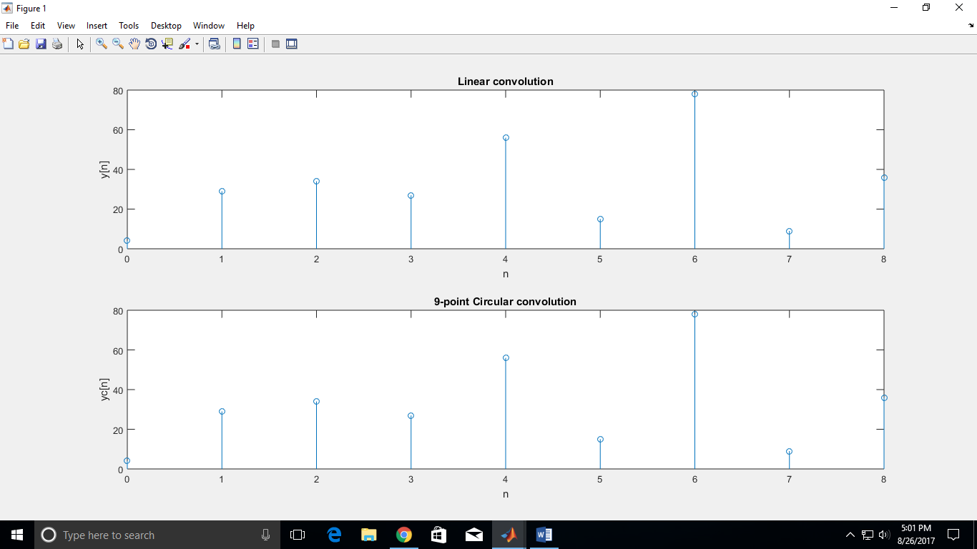

c) Set the length N of circular convolution as the length maximum between x[n] and h[n]. Compute the N-point circular convolution. Plot the output sequence.

xn = [1 6 1 4];

hn = [4 5 0 6 0 9];

N = max(length(xn),length(hn));

ycn = cconv(xn,hn,N);

n = 0:1:N-1;

stem(n,ycn);

xlabel('n');

ylabel('yc[n]');

title('6-point Circular convolution');

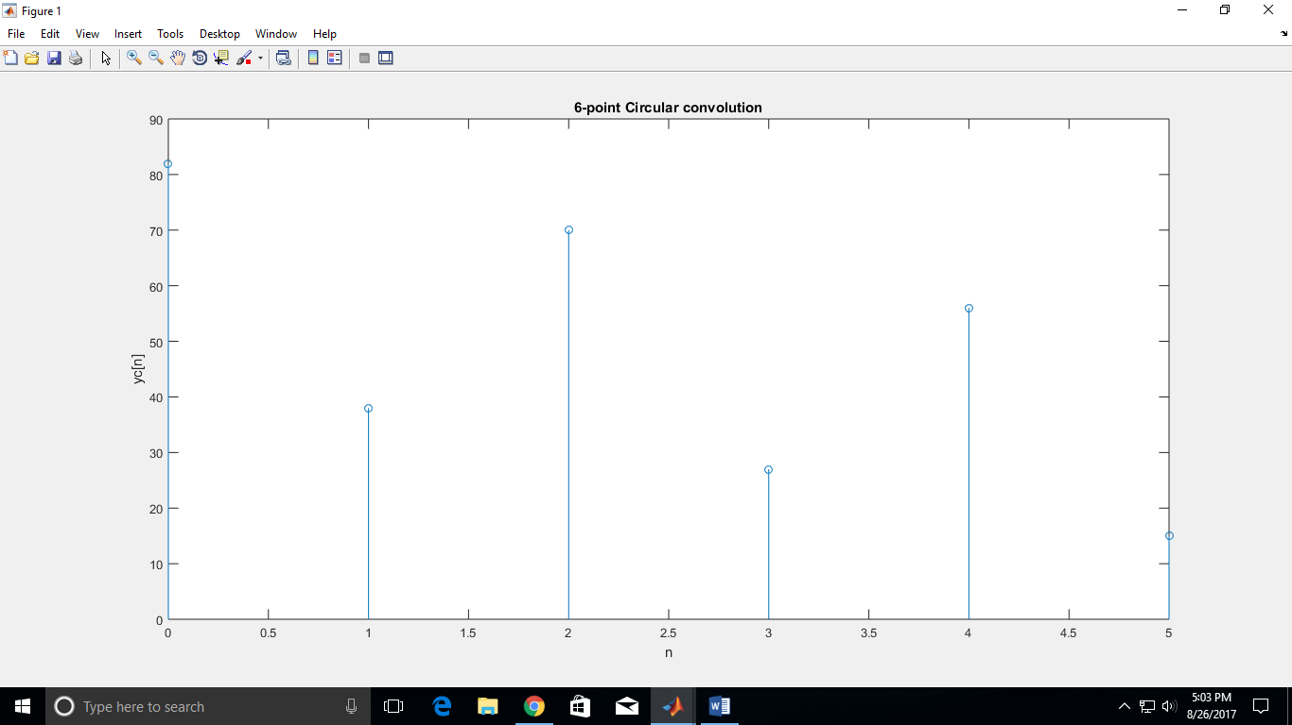

What are the observations with respect to the aliasing effect?

* As the value of N < L+P-1, and the first L+P-1-N elements of the sequence are convolved over the starting value thereby resulting in aliasing and rendering a part of the original signal unusable.

**PART B: Discrete Cosine Transform**

a) Read an audio file

To access the sound file (‘si1188.wav’):

<https://drive.google.com/file/d/0B7-qexRAlXuTUldYOUdPTXFYSW8/view?usp=sharing>

b) Compute and plot the Discrete Cosine transform of the signal.

c) Set the threshold at 10% of the maximum value of the DCT spectrum. Apply thresholding to the DCT spectrum; compute Inverse DCT of the thresholded spectrum. Plot the results.

d) Repeat part c) for threshold value of 25% of the maximum value of the DCT spectrum.

Plot the results b) to d) as a subplot with two columns and four rows. Column 1 should have the time domain signal with the corresponding DCT spectrum in column 2.

e) Calculate and plot the absolute errors in part c) and d), which is given by:

**Error = Original signal –Thresholded Signal**

The fourth row of the above subplot (i.e., from parts b, c, d) should plot the absolute error for 10% and 25% threshold value.

[y fs] = audioread('si1188.wav');

%10 percent threshold

z = dct(y);

thresh10 = 0.1*max(z);

i = 1;

while(i<length(z))

if z(i) < thresh10

z(i) = 0;

end

i = i+1;

end

y10 = idct(z);

e10 = y - y10;

%25 percent threshold

z = dct(y);

thresh25 = 0.25*max(z);

i = 1;

while(i<length(z))

if z(i) < thresh25

z(i) = 0;

end

i = i+1;

end

y25 = idct(z);

e25 = y - y25;

%plotting

%original

subplot(4,2,1);

stem(y,'.');

title('Original');

subplot(4,2,2);

stem(abs(dct(y)),'.');

title('Original');

%10 percent

subplot(4,2,3);

stem(y10,'.')

title('10% thresh');

subplot(4,2,4);

stem(abs(dct(y10)),'.');

title('10% thresh');

%25 percent

subplot(4,2,5);

stem(y25,'.');

title('25% thresh');

subplot(4,2,6);

stem(abs(dct(y25)),'.');

title('25% thresh');

%errors

subplot(4,2,7);

stem(abs(e10),'.');

title('absolute e10');

subplot(4,2,8);

stem(abs(e25),'.');

title('absolute e25');

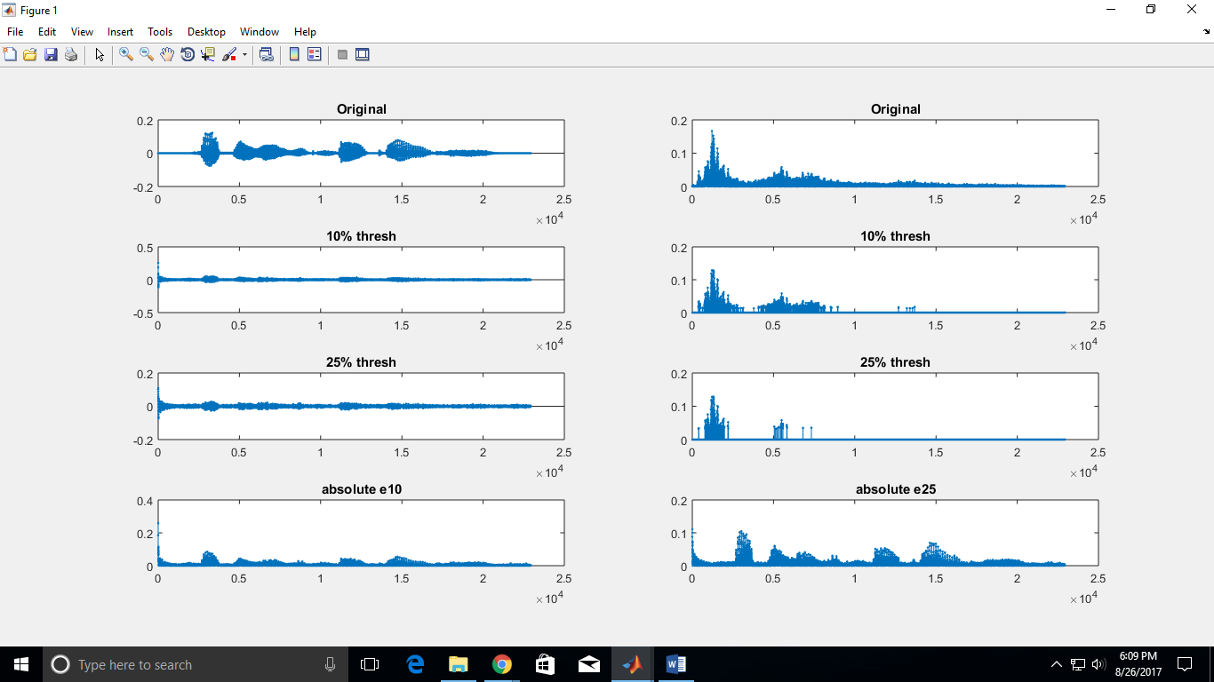

f) Calculate the energy loss in part c) and d), which is given by:

**Energy loss = $\frac{ \sum{{\left(x-x_{thr}\right)}^{2}}}{\sum{x^2}}$**

What are the observations with respect to the effect of thresholding on the absolute error and energy loss?

%energy loss

i = 1;

num10 = 0;

num25 = 0;

den = 0;

while(i<length(y));

newnum10 = (y(i)- y10(i))^2;

newnum25 = (y(i)- y25(i))^2;

newden = y(i)^2;

num10 = num10 + newnum10;

num25 = num25 + newnum25;

den = den + newden;

i = i+1;

end

eloss10 = num10/den

eloss25 = num25/den

eloss10 =

0.5738

eloss25 =

0.7092

More energy loss occurs at 25% threshold than at 10% threshold. Also, 25% threshold is more erroneous.

**PART C: Window Function**

Generate a time representation and magnitude spectrum (or frequency) of the following window functions: (1) Rectangular, (2) Hamming, (3) Hanning and (4) Blackman window function, with N =1000. Plot these as a subplot with four rows and two columns. Column 1 should have the time domain signal with the corresponding magnitude spectrum in column 2. Make sure the x-axis for the magnitude spectrum is in Hz and the y-axis is in dB scale. Assume Fs = 10 kHz. Comment your observations in terms of main-lobe width and relative side-lobe amplitude.