BIRLA INSTITUTE OF TECHNOLOGY & SCIENCE, PILANI

EEE C434/EEE F434: Digital Signal Processing

Lab 1: Introduction to MATLAB

Note: Write your answers in this .doc file only and save it. Capture and paste snapshots of graphs, wherever required.

Name: Kshitij Khandelwal.
ID: 2015A3PS0156P

1) Generating Array elements
a) Create an array of 3 elements having values 100 200 and 300. Name the array x.
Answer:
>> x = [100 200 300];
b) Append the same array with 3 other elements all having values 100.
Answer:
>> x = [x 100 100 100];
c) Pad the array with 4 zeros.
Answer:
>> x = [x 0 0 0 0];
d) Limit the number of elements in the array to 5 elements.
Answer:
>> y = x(1:5);
e) Display the 2nd and the 3rd element of the array at the command prompt.
Answer:
>> y(2:3)
f) Make a two dimensional array of size 3*3. Call it x3d.
Answer:
>> x3d = randi(100,3);
g) Display the 2nd row 3rd column element of the array at the command prompt.
Answer:
>> x3d(2,3)
h) Find the transpose of this matrix and display both the 3*3 matrices. Call it x3dc.
Answer:
>> x3dc = transpose(x3d)
>> x3d
i) Find the sum of the array elements in x (the one-dimensional array created in c).
Answer:
>> sum(x);
The sum is 900
j) What happens when I use the same command to the 3d array x3d.
Answer:
>> sum(x3d);
Values of each column are added and presented separately.
k) Make two arrays containing 100 elements from 1 to 100 in steps of 1 and 5, respectively.
Answer:
Answer:
>> array1 = [1:1:100];
>> array5 = [1:5:100];
l) Find the lengths of both the recently created arrays.
Answer:
>> length(array1)
The value returned is 100.
>> length(array5)
The value returned is 20.

2) Getting used to functions to abs, sqrt and exp
a) Find the square root of a positive number and store it in a variable called xsqrt. Obtain the positive number from the user using the input command.
Answer:
num1 = input(' \n Enter a positive number \n ');
xsqrt = sqrt(num1);

b) Find the square root of a negative number and store it in a variable called xsqrt1. Obtain the number again from the user.
Answer:
num1 = input(' \n Enter a negative number \n ');
xsqrt1 = sqrt(num1);

c) Note the difference in the values stored in xsqrt and xsqrt1.
Answer:
The value stored in xsqrt is a real number that is of class ‘double’ whereas that in xsqrt1 is a complex number that is of class ‘double(complex)’.
d) Find the abs value of xsqr1 and store that in the same variable.
Answer:
>> xsqrt1 = abs(xsqrt1);
e) Obtain 10 random elements using rand and randn functions. Observe the difference.
Answer:
>> rand(1,10)
>> randn(1,10)
The ‘rand’ function gives positive random real values between 0 and 1. The ‘randn’ function gives both positive and negative values between -2 and 2.

3) Create a simple sine function and Plot it
a) Create a sine wave with duration = 1sec (assume suitable fs) and assign it to a variable and plot it. Obtain the frequency of the sine wave for this question from the user.
Answer:
freq = input('\n Enter frequency (<5000)\n');
t = 0:0.02:1;
sin2pift = sin(2*3.14*freq*t);
plot(t,sin2pift);

b) Label your plot and label the axes. Sketch the result obtained on screen here.
Answer:
title('SineWave');
xlabel('time');
ylabel('magnitude');

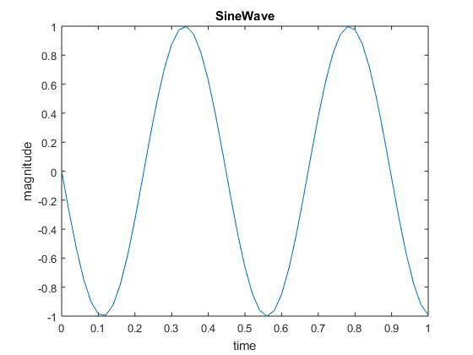
c) Obtain grids on your plot.
Answer:
grid;
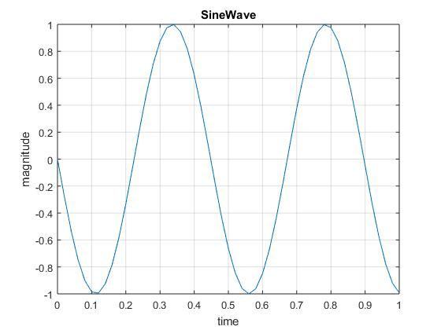

d) Obtain multiple sine plots of different frequency on the same plot.
Answer:
t = 0:0.02:1;
freq1 = input('\n Enter frequency 1 (<5000)\n');
sin2pift1 = sin(2*3.14*freq1*t);
plot(t,sin2pift1);
hold on;
freq2 = input('\n Enter frequency 2 (<5000)\n');
sin2pift2 = sin(2*3.14*freq2*t);
plot(t,sin2pift2);
title('SineWave');
xlabel('time');
ylabel('magnitude');
grid;

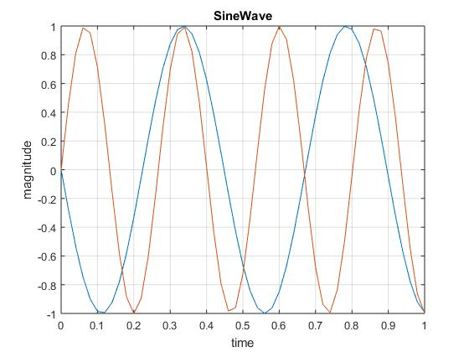

e) Obtain these multiple plots on different subplots in the same figure.
Answer:
t = 0:0.02:1;
freq1 = input('\n Enter frequency 1 (<5000)\n');
sin2pift1 = sin(2*3.14*freq1*t);
freq2 = input('\n Enter frequency 2 (<5000)\n');
sin2pift2 = sin(2*3.14*freq2*t);
subplot(2,1,1);
plot(t,sin2pift1);
title('SineWave1');
xlabel('time');
ylabel('magnitude');
grid;
subplot(2,1,2);
plot(t,sin2pift2);
title('SineWave2');
xlabel('time');
ylabel('magnitude');
grid;

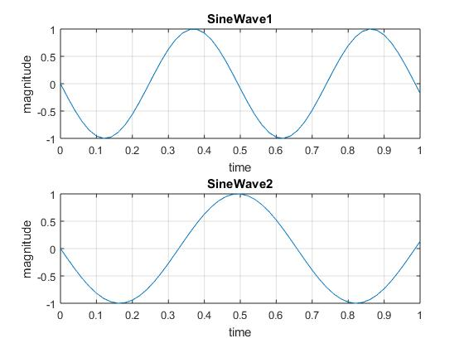

4) To get used to control functions
a) Generate a random array of 100 elements between 0 and 10. Call it x. Also generate another 100-element array containing values from 1 to 100 in steps of 1 and call it x1.
Answer:
>> x = randi([0 10], 1, 100);
>> x1 = 1:1:100;
b) Set a counter that counts the number of odd elements in x and x1.
Answer:
count = 0;
for i = 1:100
y = x(i)/2;
if (round(y)~= y);
count = count + 1;
end;
end;
count

Use x1 instead of x for the second operation. Values of count are 42 and 50 respectively.
c) Use rand function to generate a random sequence and then apply 0.5 as a threshold to obtain the binary digits. Display the binary digits.
Answer:
for i = 1:10
if x(i)<0.5
x(i) = 0;
else x(i) = 1;
end;
end;
x

x =

1 0 0 1 1 1 1 0 0 0

5) To Create functions and call and execute them
a) Create a function that counts the number of multiples of 3 in an array. Call it mult3.
Answer:
function mult3(x)
len = length(x);
count = 0;
for i = 1:len
y = x(i)/3;
if (round(y)== y);
count = count + 1;
end;
end;
count
b) Run this function from a main command using some of the test examples.
