Front End Filter Design

Part of our practicum project involves the front end design for the CubeSat transceiver. This includes the signal filter(s), external signal amplification, and system antenna.

*Antenna and Filter(s)*

There are two possible modes of operation for the transciever:

1) Single bidirectional port

a) This requires a single antenna, a single filter, and an optional power amplifier (to boost the signal).

Note: The MKW01Z128 has a low power built in PA, but we may need to boost the amplification beyond this, especially for the Capstone version.

b) The low pass filter provided in the documentation seems to work great as a bidirectional filter.

2) Dual port

a) Here, we will construct two separate RF paths to the antenna; one path will act as the TX and the other as the RX.

b) An external switch is required to switch the antenna between the receiver and transmitter.

C) An optional external power amplifier can be included to boost the signal. However it's been highly suggested we include a PA for our final product.

*LTSpice simluations Rev.1*

Starting with the high pass filter that is included in the data sheet (KW01DHRM Rev 1/2014):

1) Modified the two inductor values from 12nH to 14nH.

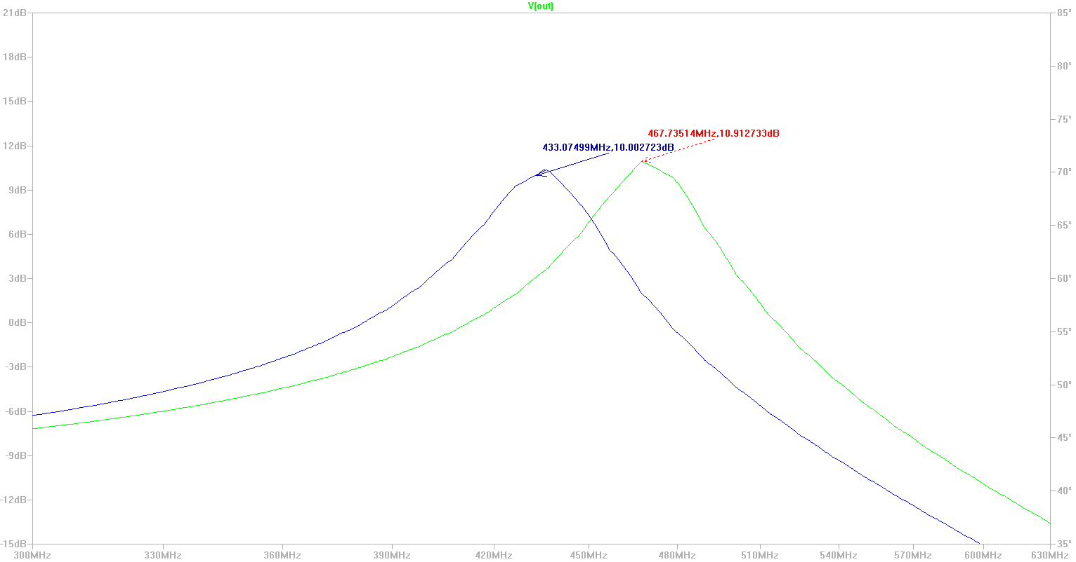

The green plot shows the frequencies that are passed using the original inductance of 12nH and the blue plot shows the result of using 14nH.

2) As noted above, this filter works fine for the bidirectional design.

Note the input and output of the filter can be switched without much loss in gain. A 50 load is used since the system expects a 50 connection to the antenna.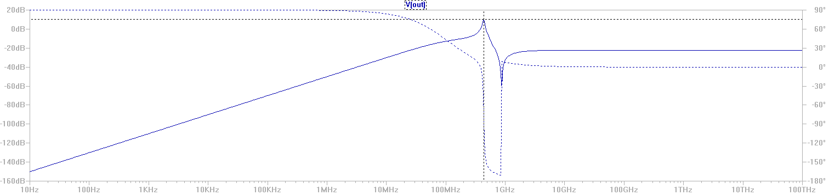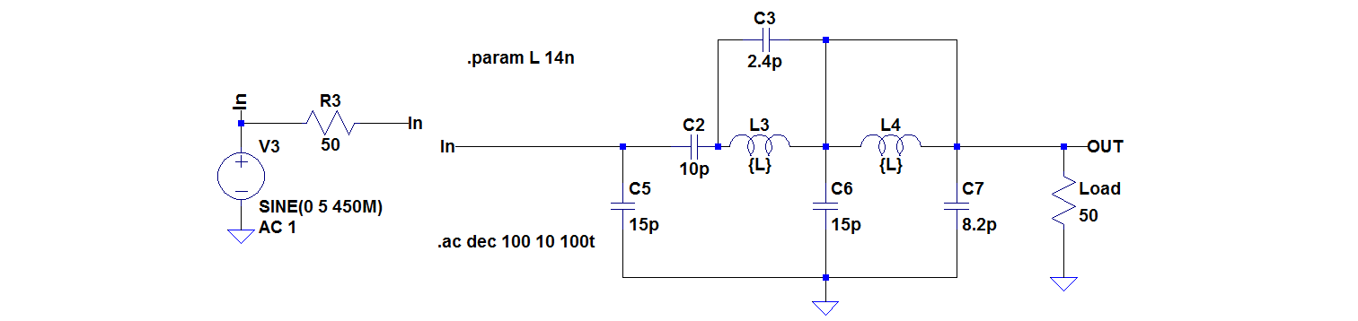

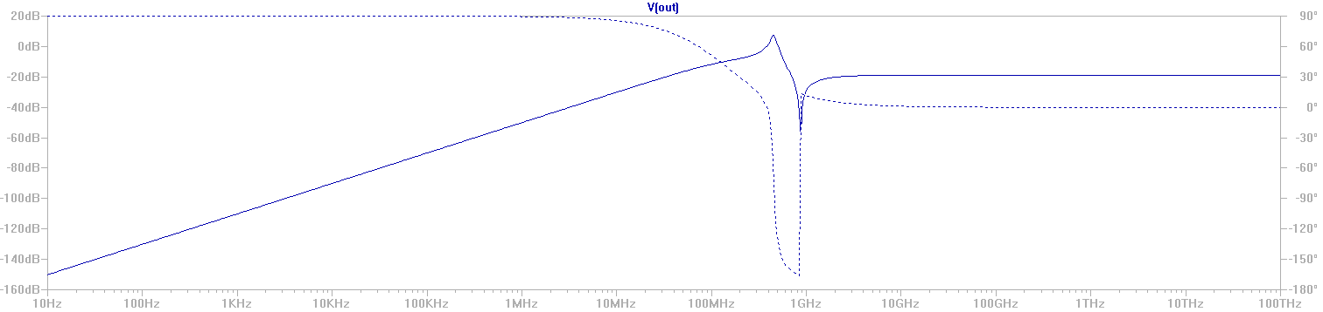

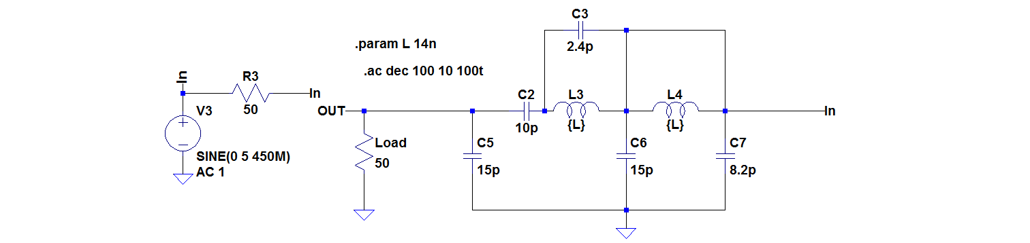

3) To improve the filter, I decided to cascade an additional low pass filter to the filter shown above. This will help remove any potentially unwanted harmonics. Below is a simulation to demonstrate the higher frequency attenuation.

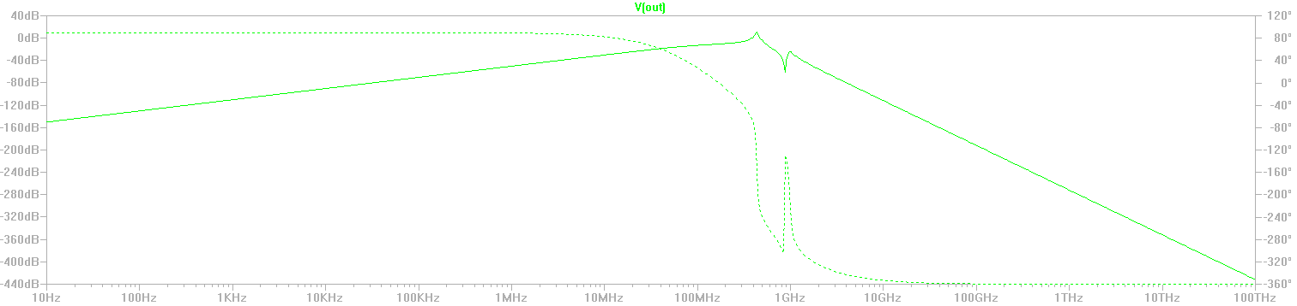

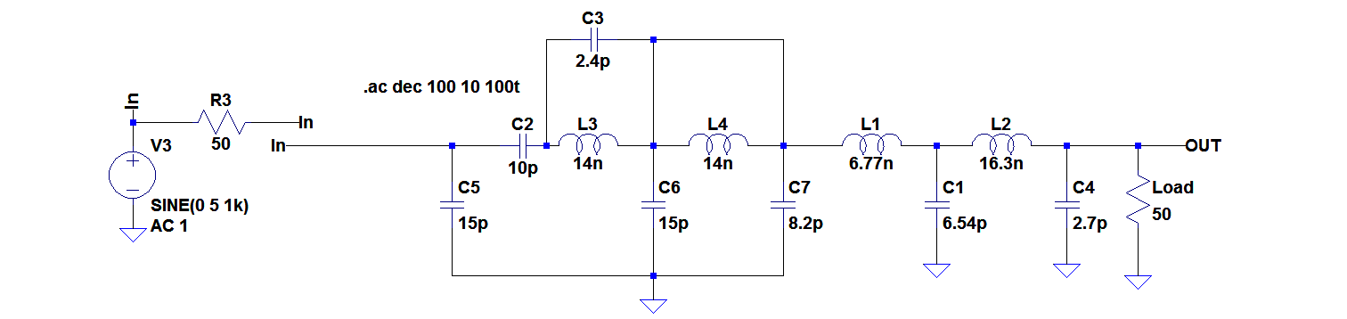

Here, the gain of the filter is virtually unaffected when used in the intended direction; however, as seen below, the filter does not behave well as a bidirectional filter.

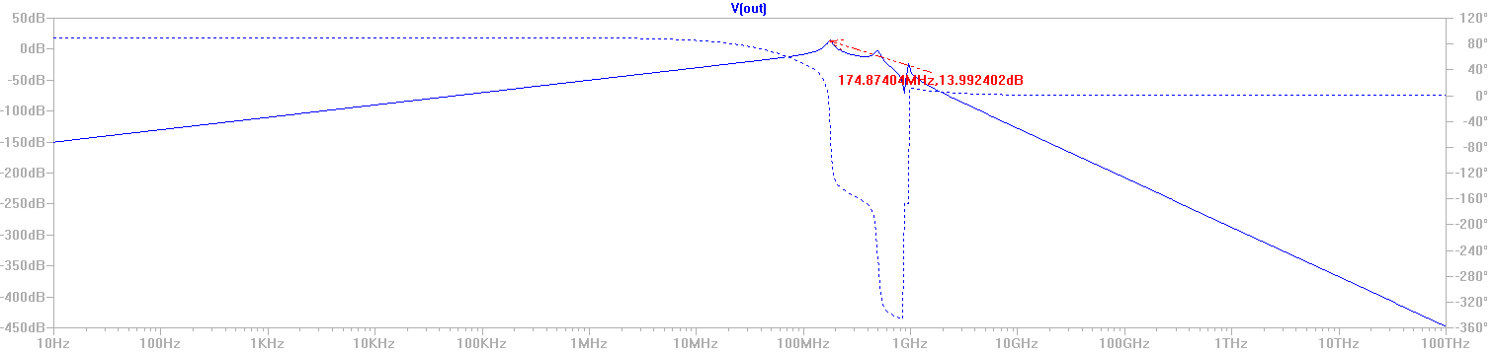

This filter would still be an improvement if we use the dual port design

4) To improve the attenuation of the lower frequencies, I included another 2nd order high pass filter. This filter is shown below.

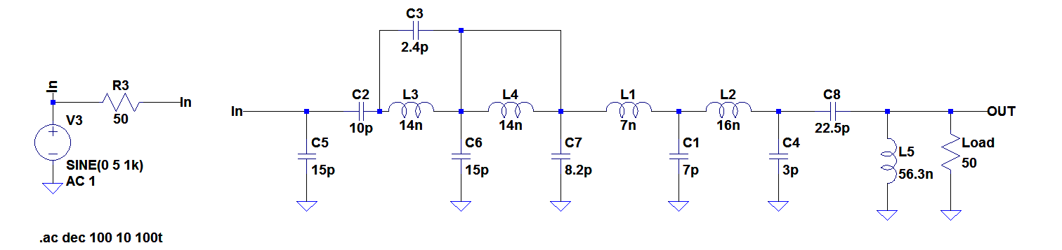

And the results are shown on the following page.

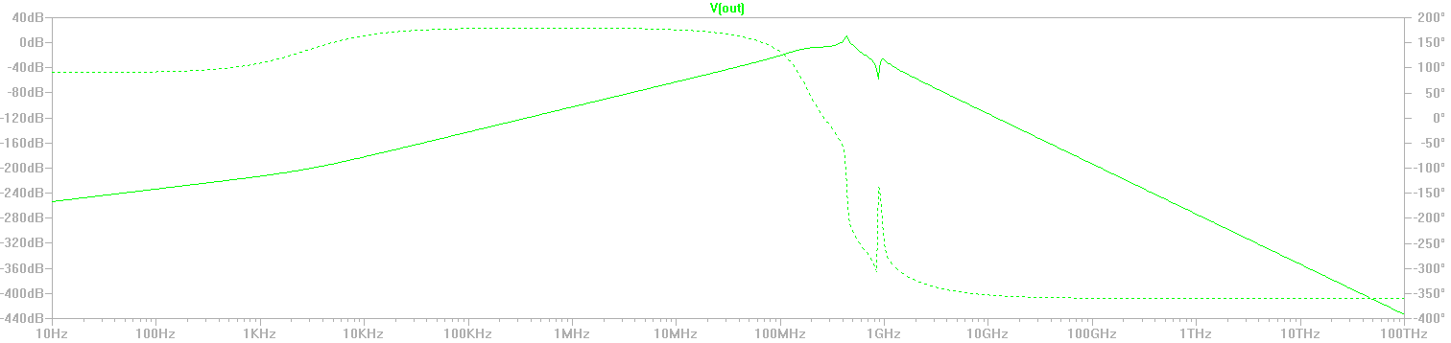

As can be seen below, the filter is still doing a great job passing the 433MHz signal

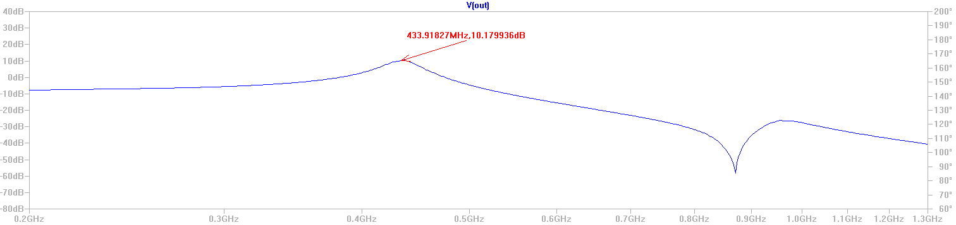

Again, this filter is only going to function as a directional filter. So, should only be used if we decide on the dual port design.

*Notes*:

1) We still need to determine whether we want to use the single port or dual port design. I am fairly sure that Andrew requested the dual port design, but if we are going to half-duplex the system it may not be necessary.

2) For either design, a PA filter is most likely needed. There is an internal PA that can be programmed. This will need further documentation.

3) The antenna design still needs attention. We need to discuss and decide on a type of antenna. Also, I like the idea of making and testing several prototypes before getting too deep into any single design. We should look at what other CubeSat antenna designs are like.

4) The above filter design included an error that omitted the appropriate input impedance of the source. This fix is included in the rev. 2 design and will be documented below.

*Rev. 1 Eagle schematic and board layout*

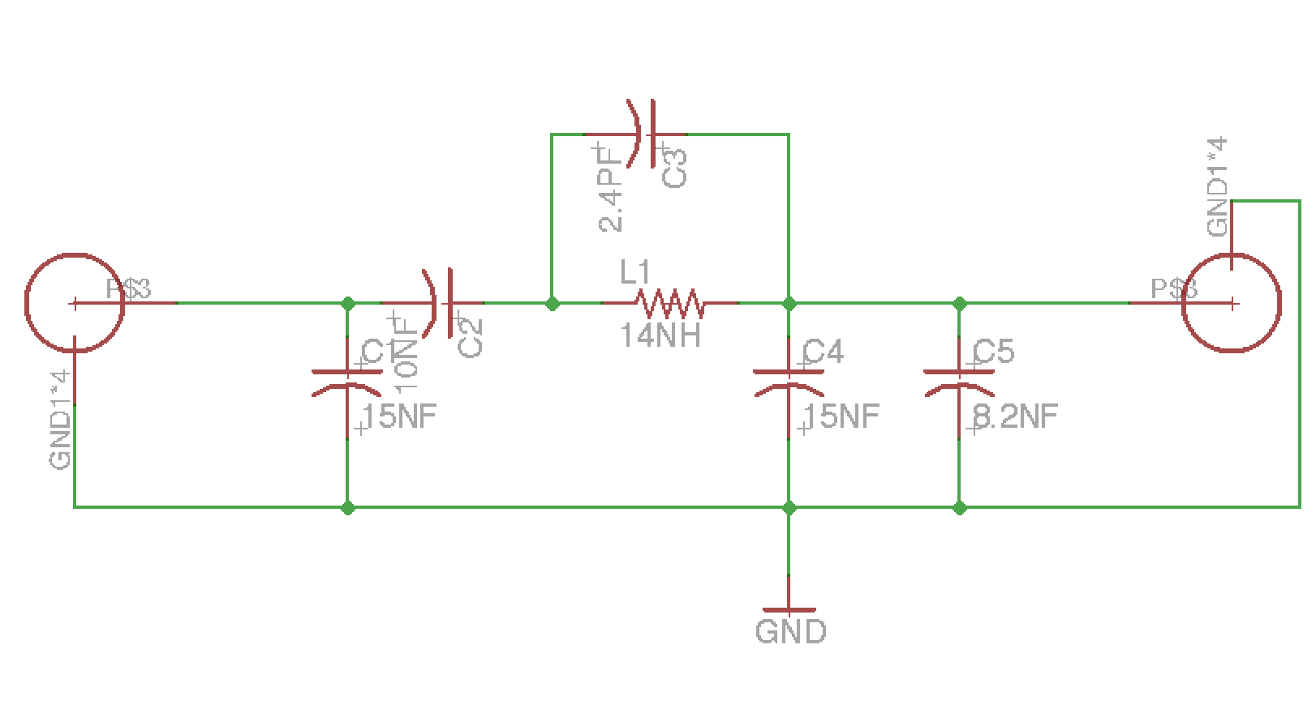

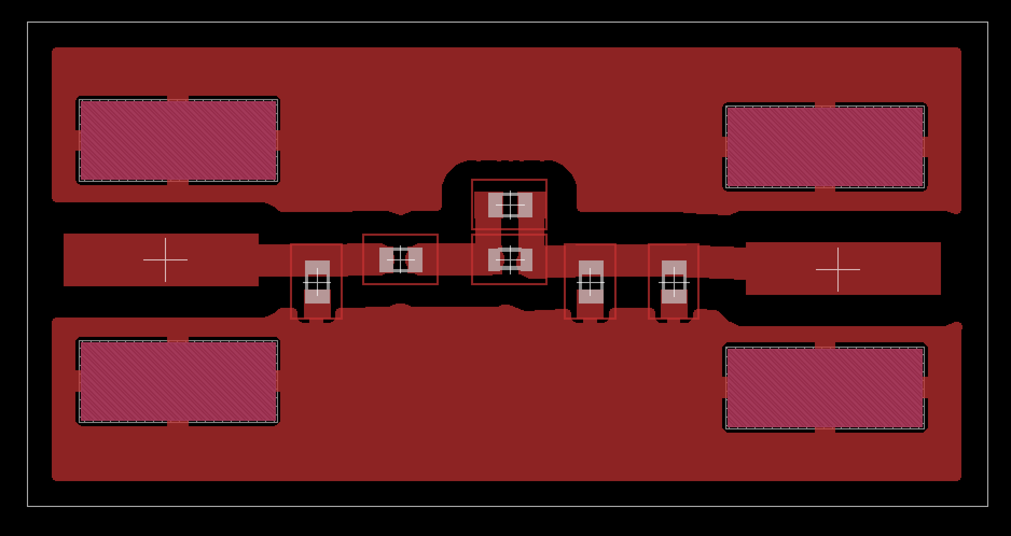

Note: The SMA connector part footprint was custom designed, as it was not found in the included parts library. On the rev.2 version, the pads are made smaller and slightly closer together to fit the part better.

*LTSpice simluations Rev.2*



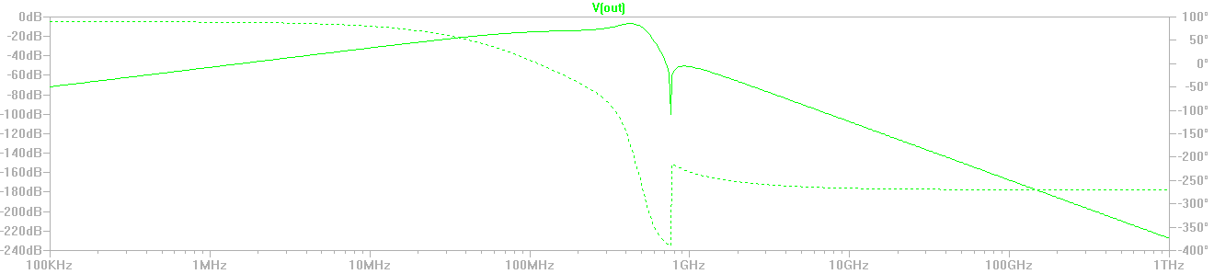

This filter design does not have the high gain in the pass band of the rev 1 design, but the high gain was due to improper impedance matching of the filter to the source. I believe this filter response is closer to what the designers of the dev board filter intended. It still has a good bidirectional response and is capable of attenuating the second harmonic of the input signal by greater than 40dB.

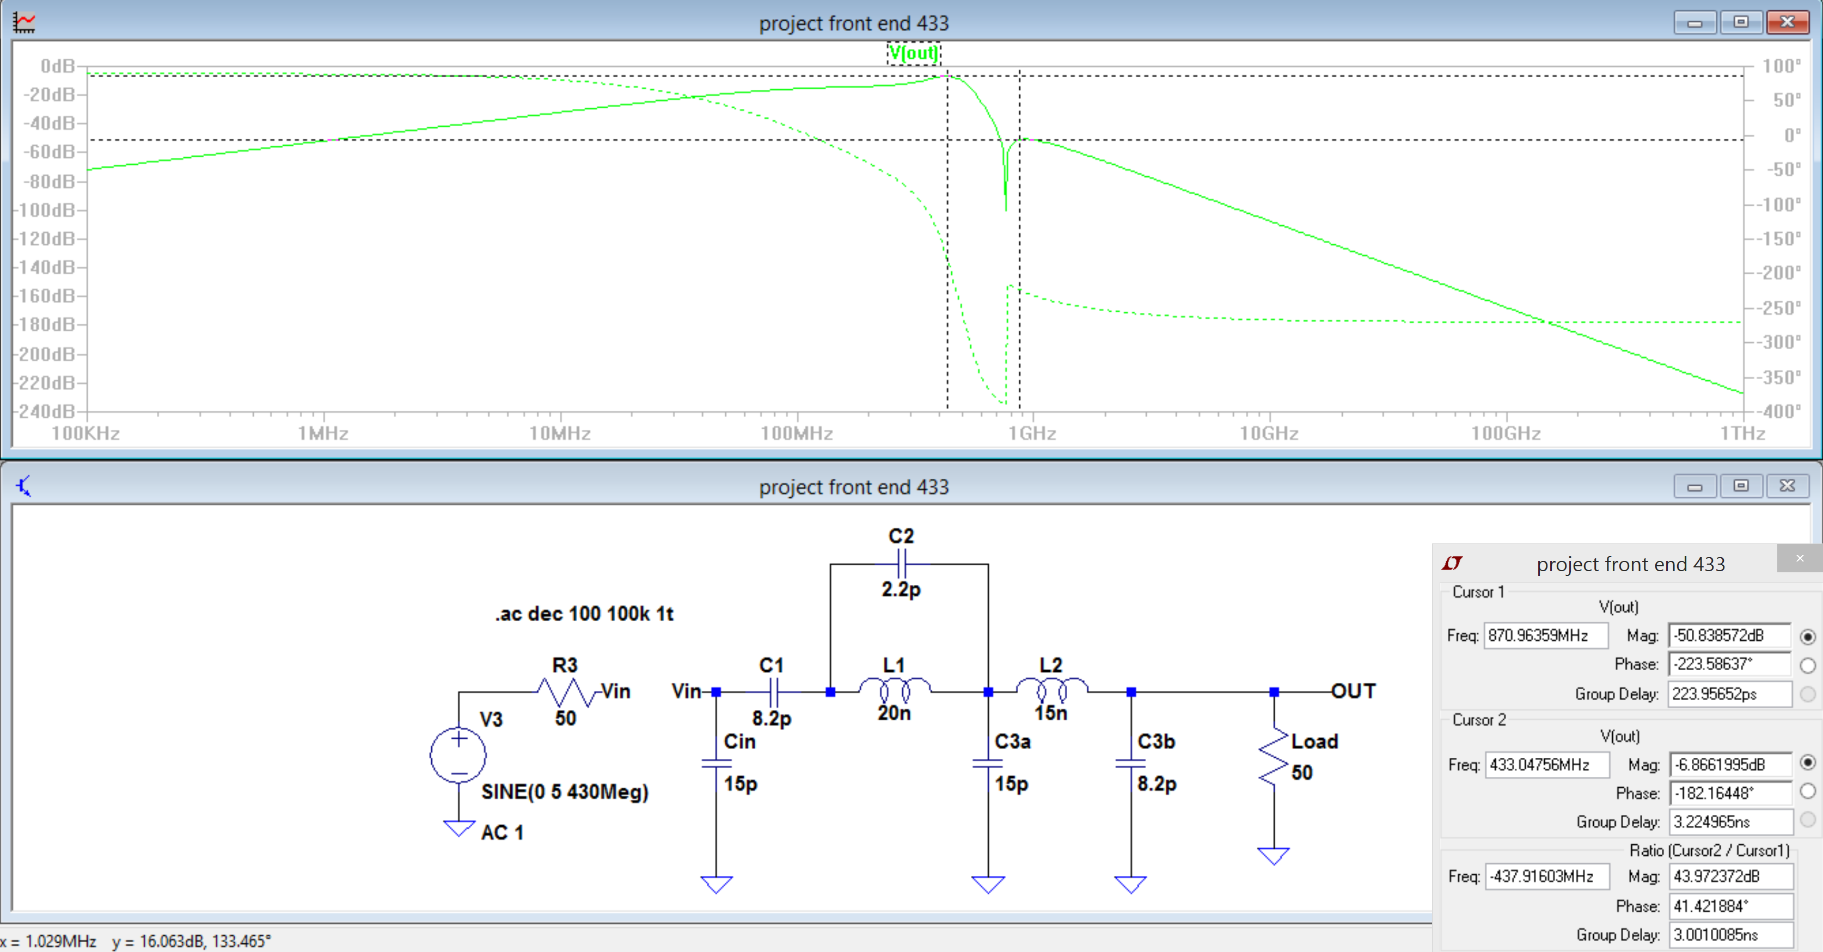

Note: I have been playing around with some different filter topographies and I am finding a theme where the band pass frequencies are less than unity. This is where the amplification stage is necessary for the design to work.

*Rev. 2 Eagle schematic and board layout*

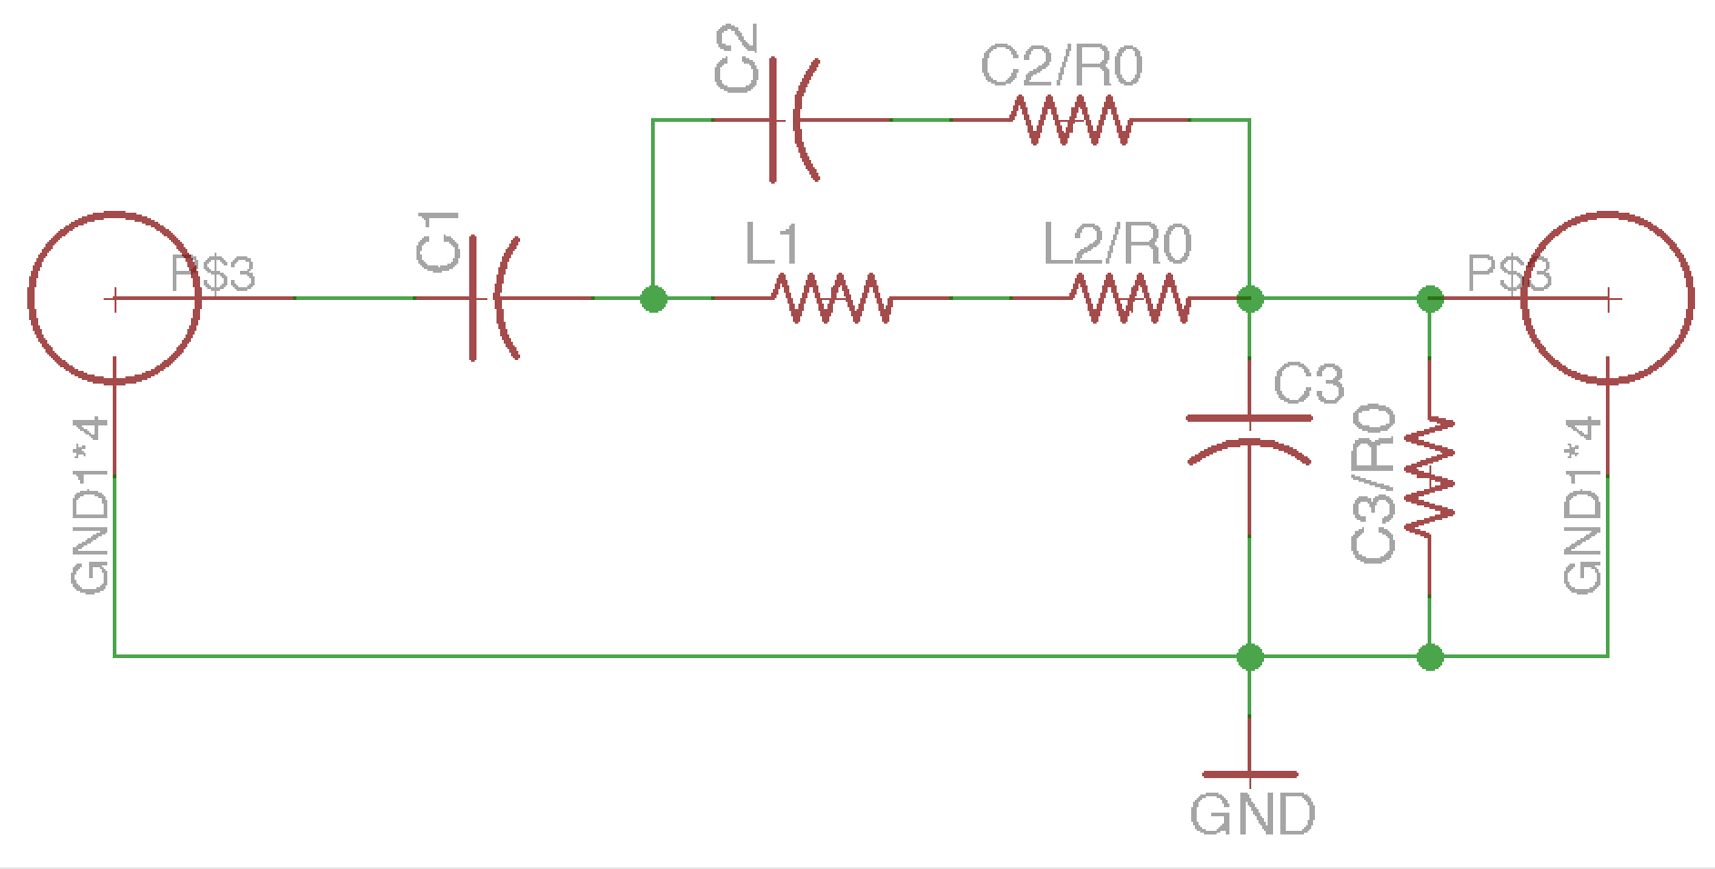

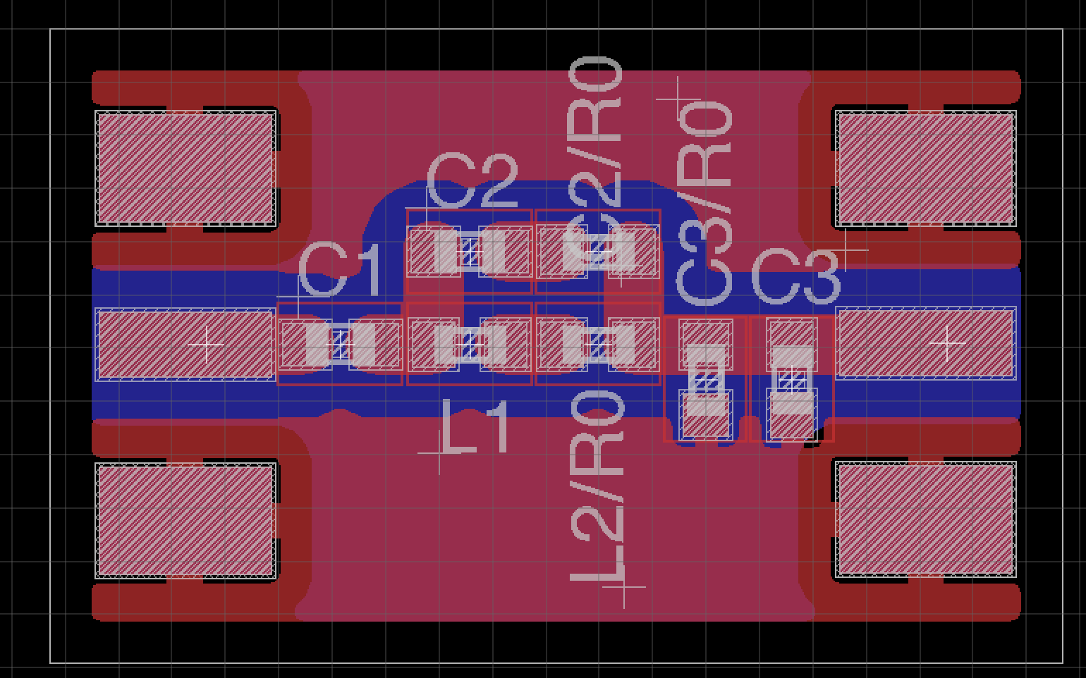

Here, I am using a much tighter construction with components laid out almost next to each other so that the transmission lines are as short as possible. We are still using transmission lines that are not ideal. The ideal lines require a width that is about twice as wide and therefore are harder to work with in Eagle. A future plan will be to figure out how to make the wider transmission lines work with the pad size for the 0603 component parts.

*LTSpice simluations Cauer Filter Design*

I have just started working on a new design using a Cauer (elliptic) filter. I am using Elsie filter design software for this filter and am impressed with its frequency response. The schematic, below, shows the response of the design after changing component values to those that should be available in the IEEE store.

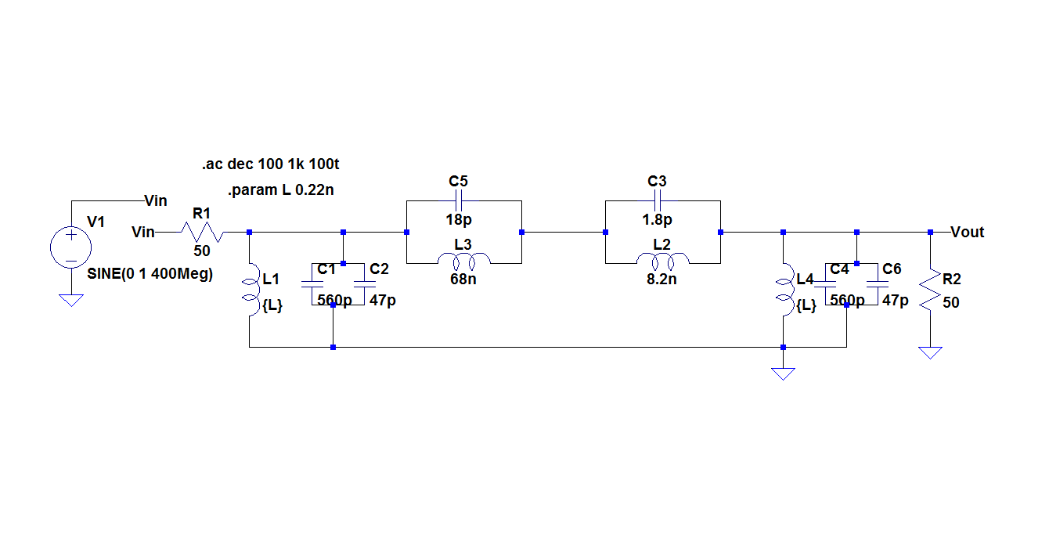

This is a 4 stage LC filter, so it will require more parts than the rev 2 design shown earlier. The response is great at attenuating most of the unwanted frequencies around our 433 MHz pass frequency. The second order harmonic is about -80dB.

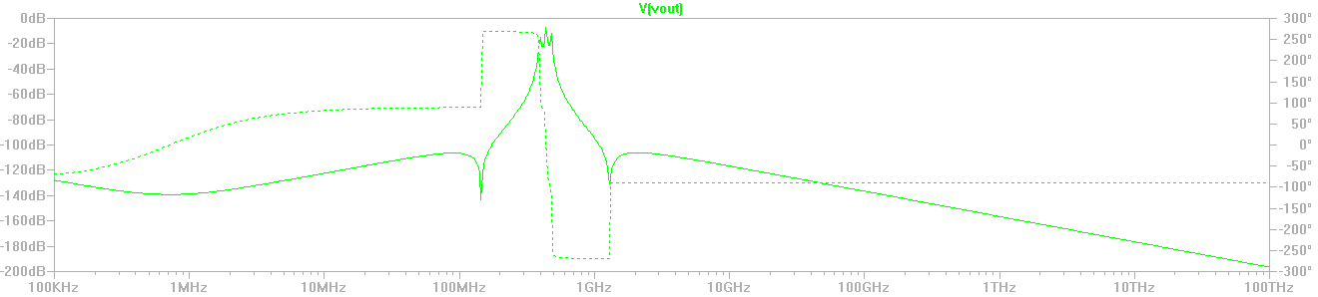

For a closer look at the pass band…

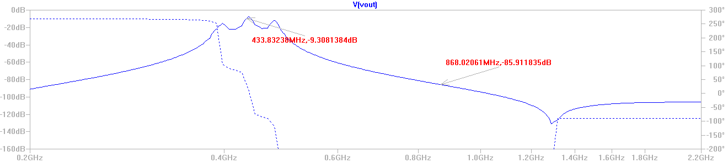

And, of course, this filter has a great bidirectional response…

