Front End Filter Design

Part of our practicum project involves the front-end design for the CubeSat transceiver. This includes the RF filter(s), external signal amplification, and system antenna. Here, we are looking at the filter topography that is recommended by freescale, the maker of the transceiver we use.

There are two possible modes of operation for the transceiver:

1) Single bidirectional port

a) This requires a single antenna, a single filter, and an optional power amplifier. The MKW01Z128 is fabricated with an internal PA that is capable of outputting up to 17dBm.

b) The low pass filter provided in the documentation appears to operate fine as a bidirectional filter.

2) Dual port

a) Both the receiver and the transmitter will have an independent path to the antenna. This leaves the option to include an external PA for the transmitter and a LNA for the receiver.

b) An external switch is required to switch the antenna between the receiver and transmitter.

*LTSPICE simulations, build, and test Rev.1*

**

Figure 1: LTSPICE schematic of initial filter design

*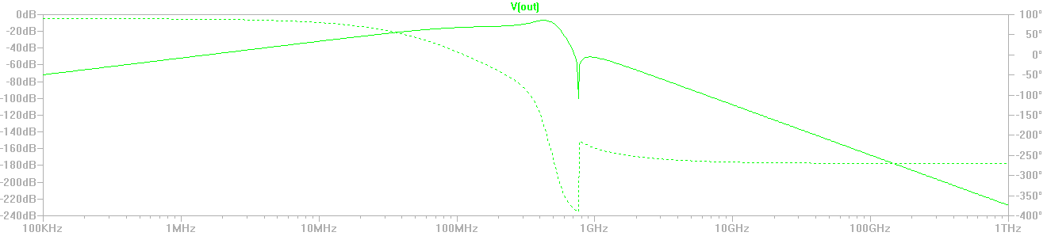*

Figure 2: LTSPICE S21 response of filter of broad frequency range.

*Rev. 1 Eagle schematic and board layout*

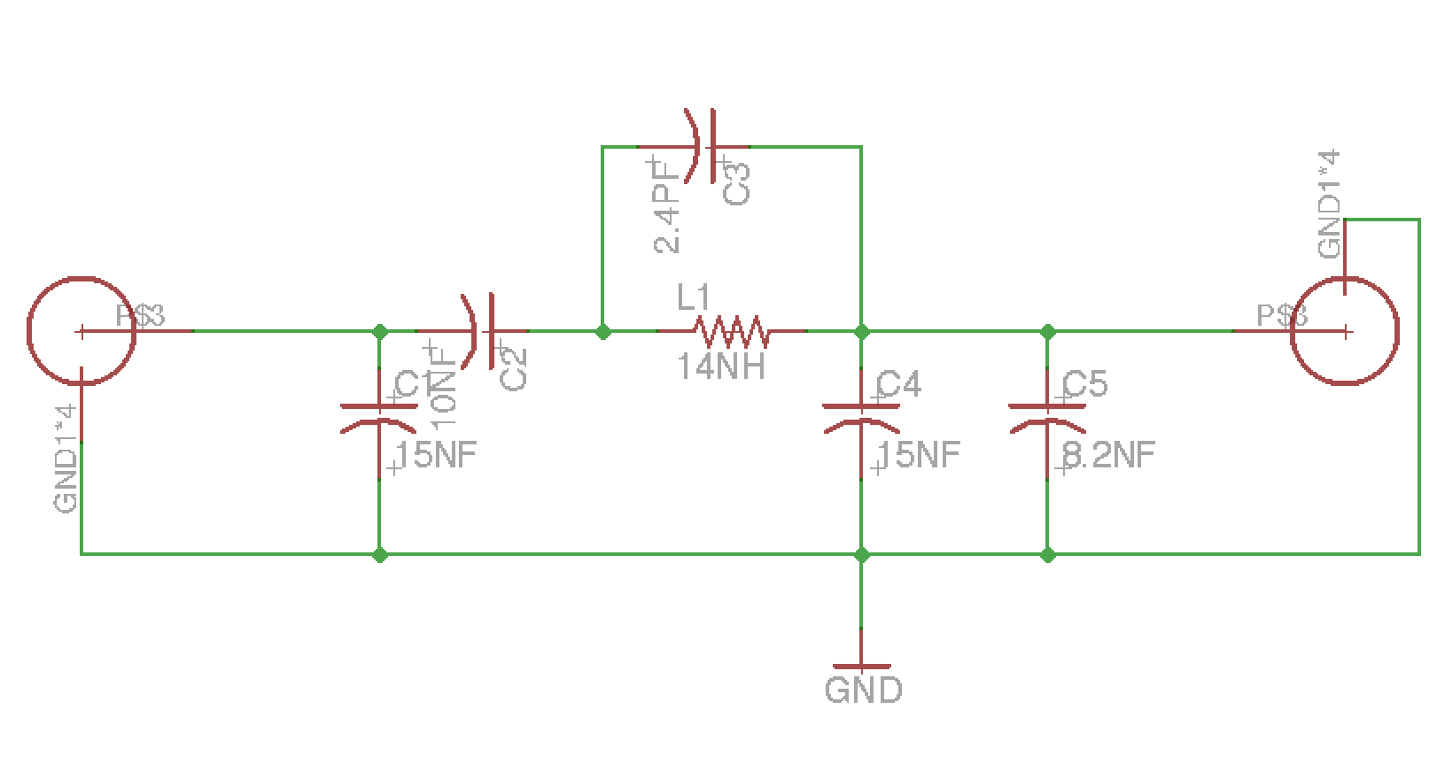

Figure 3: Rev.1 Eagle Schematic

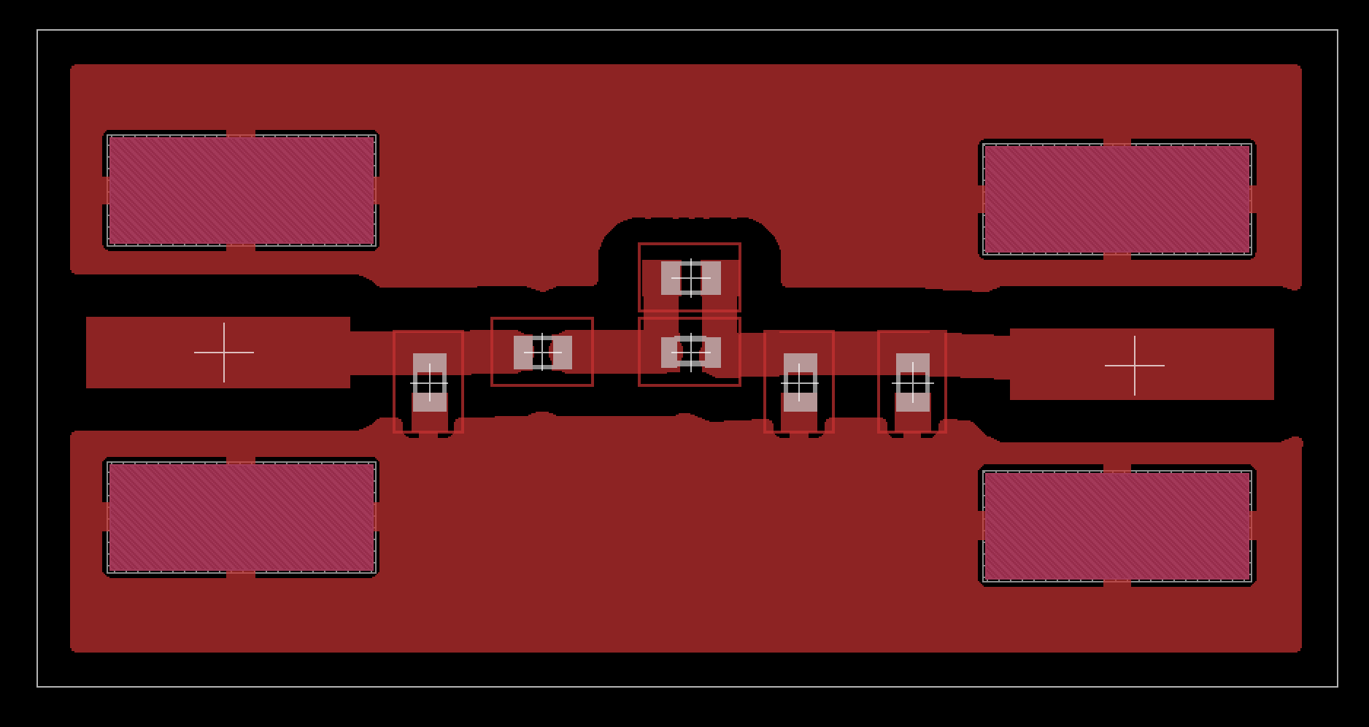

Figure 4: Rev.1 Eagle Board Layout

*LTSPICE simulations Rev.2*

This filter design does not have the high gain in the pass band of the rev 1 design, but the high gain was due to improper impedance matching of the filter to the source. It is believed that this filter response is closer to what the designers of the dev board filter intended. It still has a good bidirectional response and is capable of attenuating the second harmonic of the input signal by greater than 40dB.

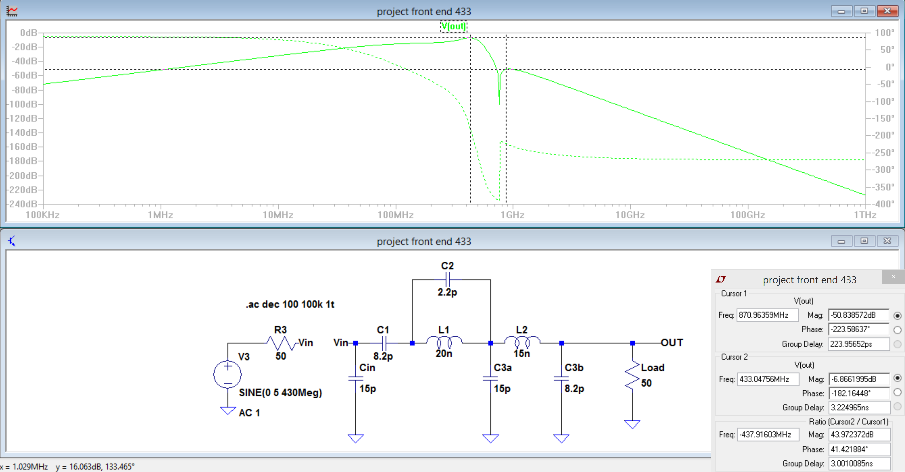

Figure 5: Rev.2 LTSPICE simulations

*Rev. 2 Eagle schematic and board layout*

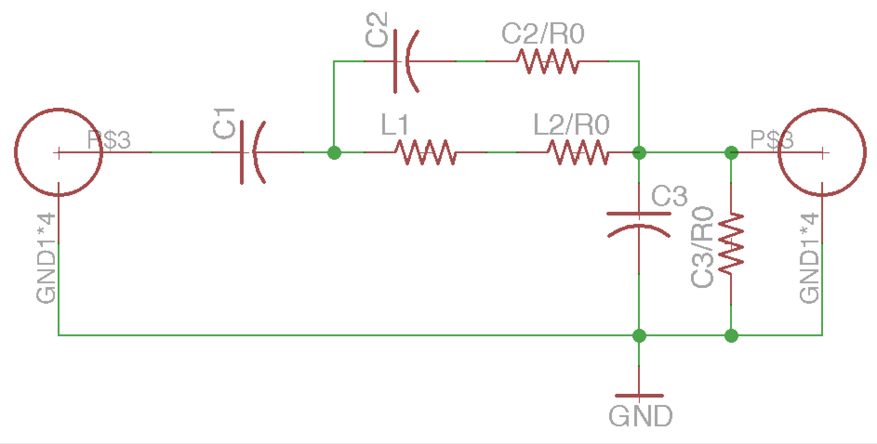

Figure 6: Rev.2 Eagle Schematic

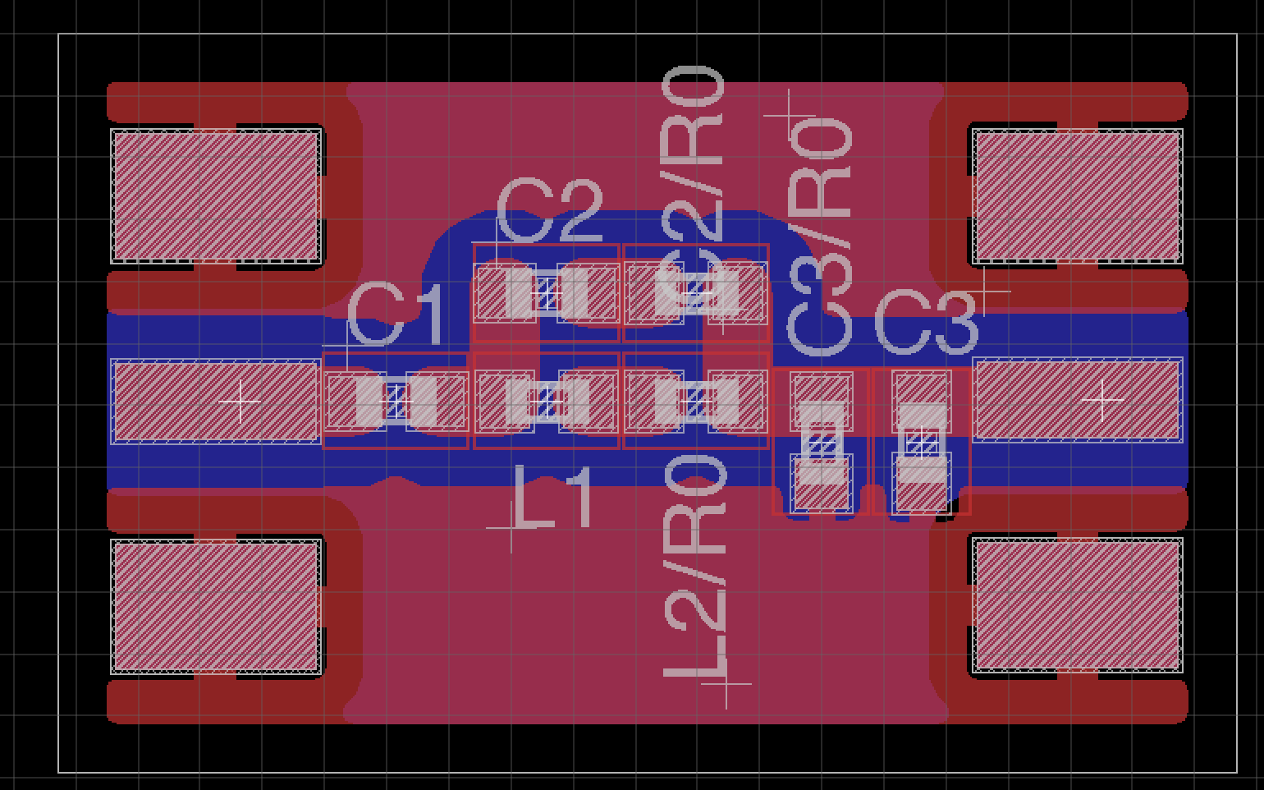

Figure 7: Rev.2 Board Layout

*Alternative Filter Topographies*

Simulation has begun on a new design using a Cauer (elliptic) filter. This design is created using Elsie filter design software and the initial results show a good frequency response. The schematic, below, shows the filter and it’s response as designed with normal component values.

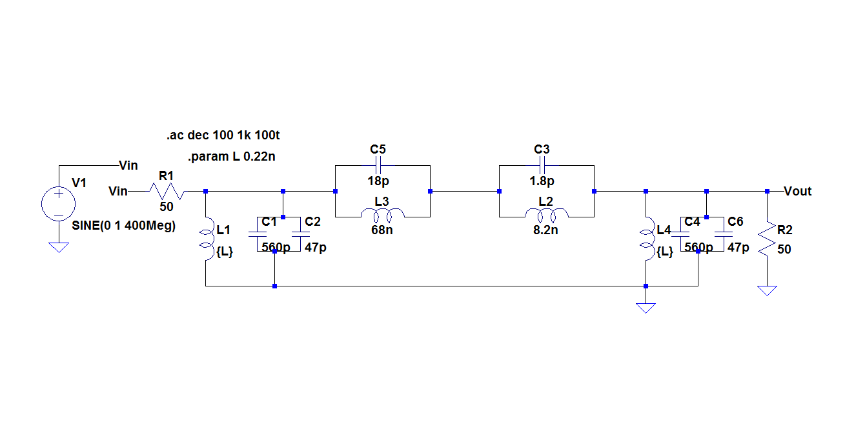

Figure 8: LTSPICE schematic of elliptical filter designed using Elsie filter design tool.

This is a 4-stage LC filter, so it will require more parts than the Rev.2 design discussed earlier. The response is great at attenuating most of the unwanted frequencies around the desired 436.5 MHz frequency.

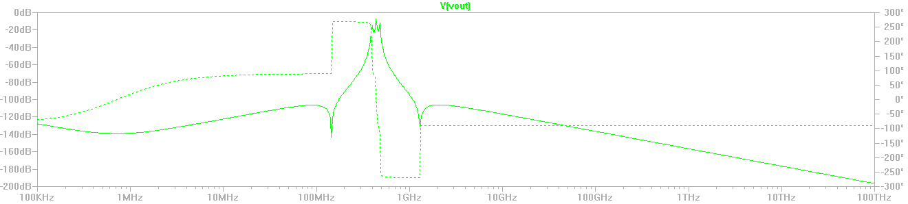

Figure 9: LTSPICE simulation of the elliptical filter

Note that one trade off in this filter design is the amount of ripple in the pass band. The second harmonic is attenuated by more than 85dB, which is pretty incredible considering that -40dB is all that is required.

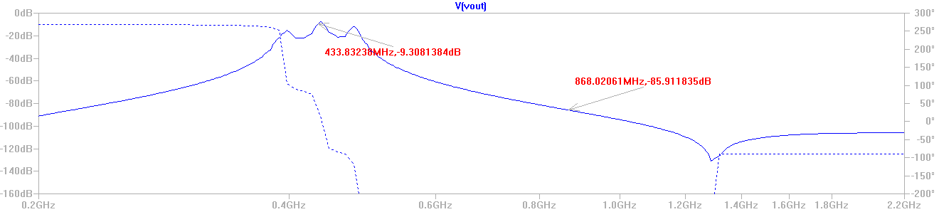

Figure 10: LTSPICE simulation of the elliptical filter showing detail of pass band and 2nd harmonic response