The purpose of this document is to determine the appropriate components that will improve the response of the front-end filter used on the current C3 breakout board. By systematically altering the value of the capacitors and inductors, one at a time, and observing the effects this change has on the filter in simulation, the hope is that a blueprint can be made that will assist in future tuning. ADS is a simulation tool that is created specifically for RF, microwave, and high speed digital designers. Since this software is required learning for the microwave IC design classes at PSU, it seemed logical to revisit the previous simulations done in LTSPICE for the design of the front-end filter. Below is an image of the final LTSPICE schematic design for the bidirectional filter. For comparison, this is followed by an image of the same design used in ADS.

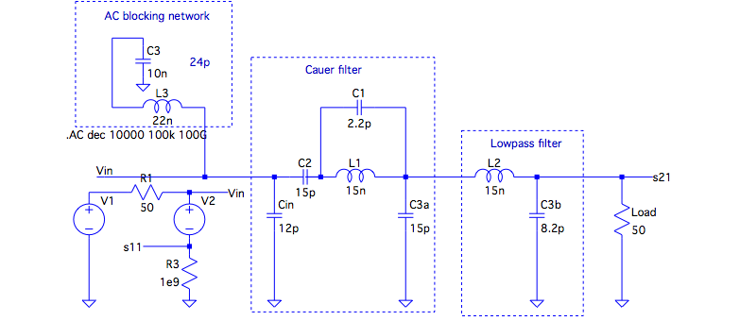

Figure 1. LTSPICE schematic for front end filter

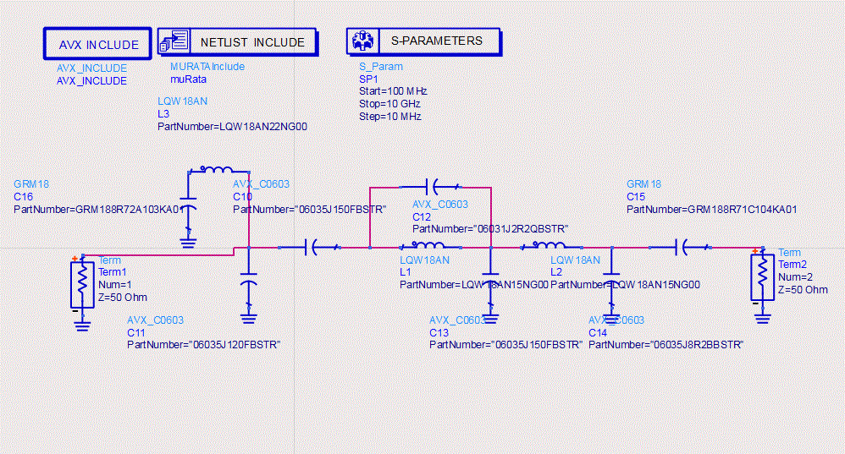

Figure 2. ADS schematic for front end filter

The schematic generated in Eagle for the front-end filter is shown below. This schematic represents the final layout on the original breakout board. All components will be referenced from this image in the remainder of the document.

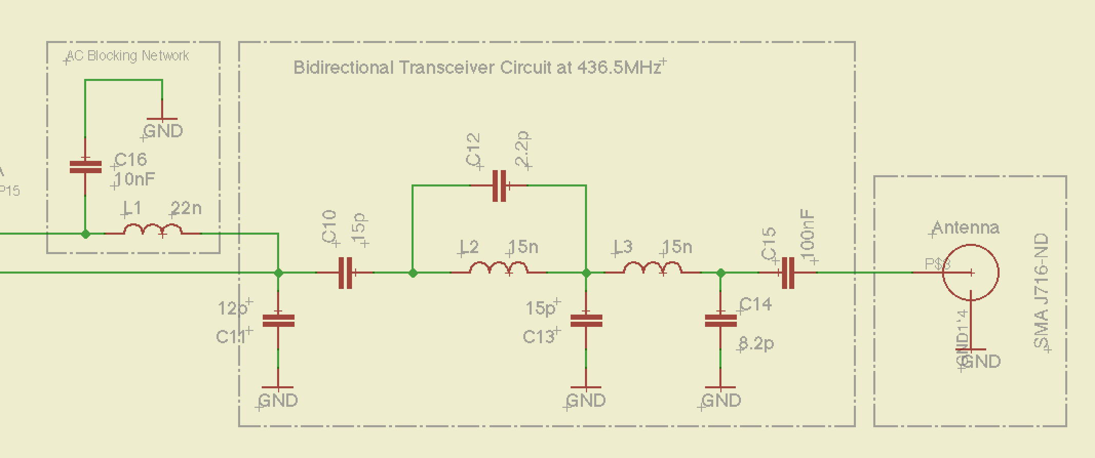

Figure 3. Eagle schematic showing front end filter

Figures 4 and 5 show the response of the filter as simulated in ADS, which is based on the final design on the breakout board. It is easy to see that the center frequency of this filter is not at the desired frequency of 436.5 MHz. This is due to testing the response of the filter prior to build where it was determined an approximate difference between simulation and measurement. This difference was calculated into the filter design with the hopes of achieving a better response.

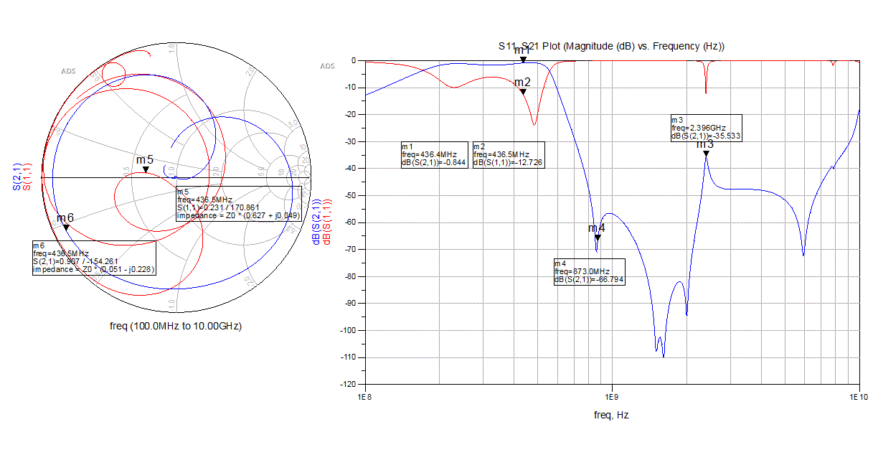

Figure 4: S11 and S21 response of front end filter as designed on rev0 breakout board

As noted previously, the idea is to test each of the main capacitors and inductors one at a time and report their individual effects on the filter as a whole system. Each component will be analyzed with a plus or minus 33% change in value followed by a brief discussion of the findings. This will all be done using the simulation tool ADS.

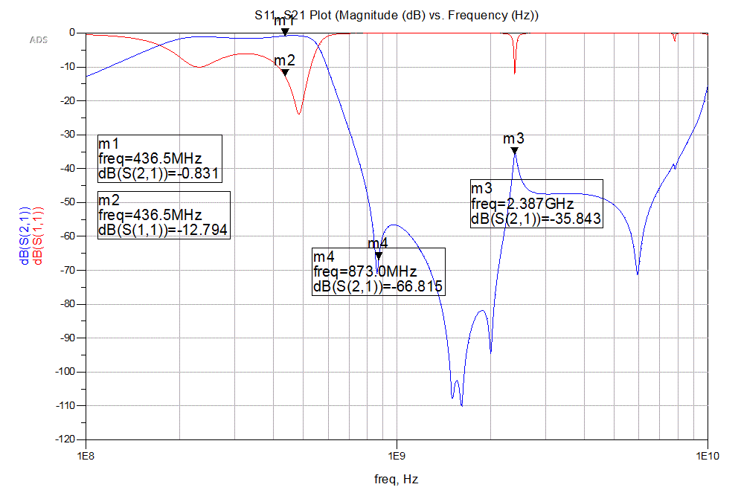

Figure 5. S11 and S21 response of filter before tuning

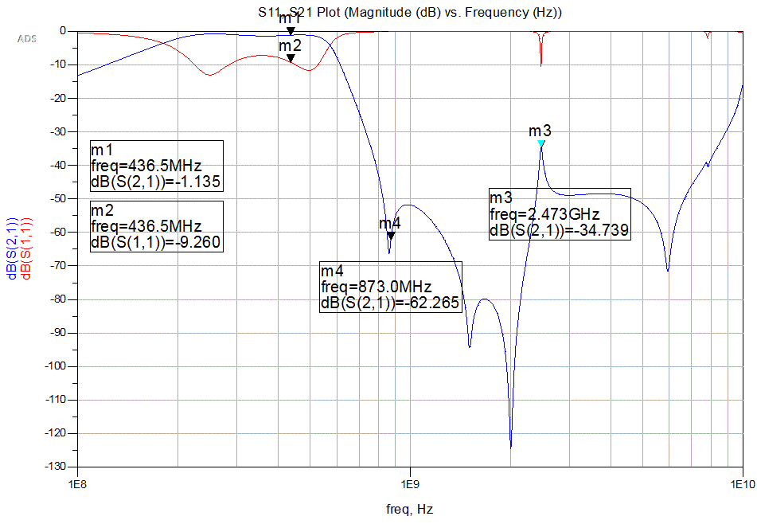

Figure 6. C11 tuned from 12pF down to 8.2pF

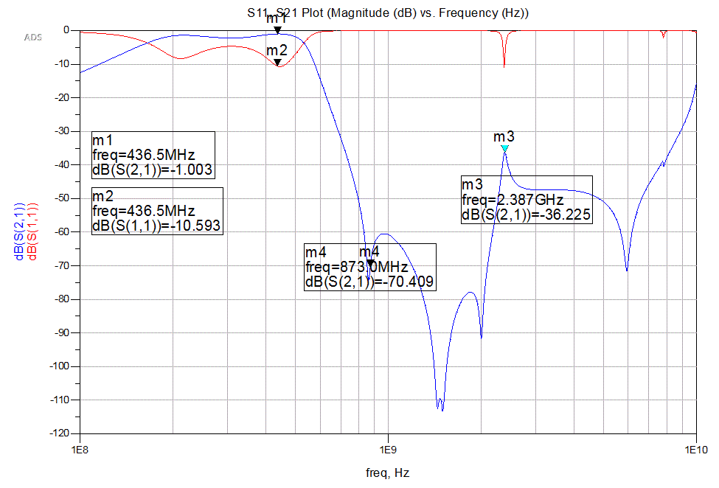

Figure 7. C11 tuned from 12pF to 16pF

Tuning C11 moves the center frequency of the pass band up and down. However, the S11 response at the center frequency is made worse. The 2nd harmonic attenuation is barely changed during the tuning. Interestingly, the shape of the elliptical filter seems to change between the 2nd harmonic and the marker m3. However, the frequency at m3 is only slightly affected. Overall, this capacitor could be used to tune the frequency of interest closer to the center of the pass band.

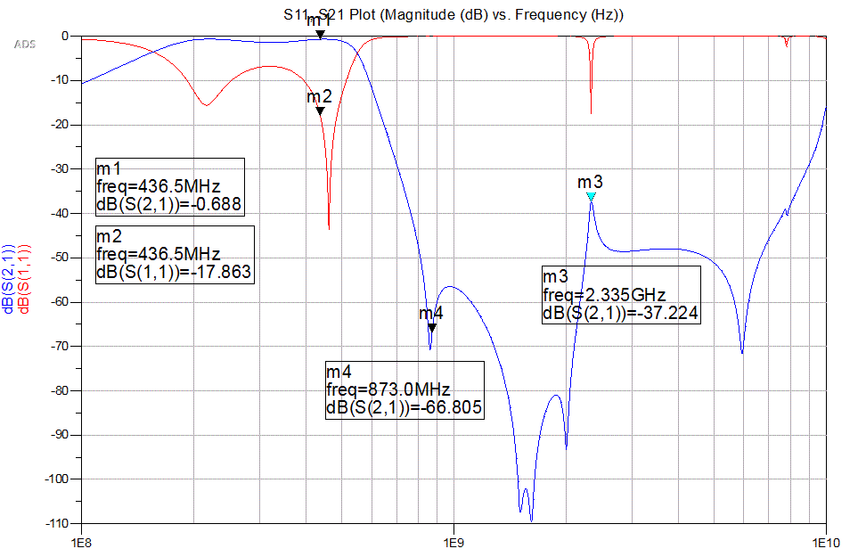

Figure 8: C10 Tuned from 15pF up to 20pF

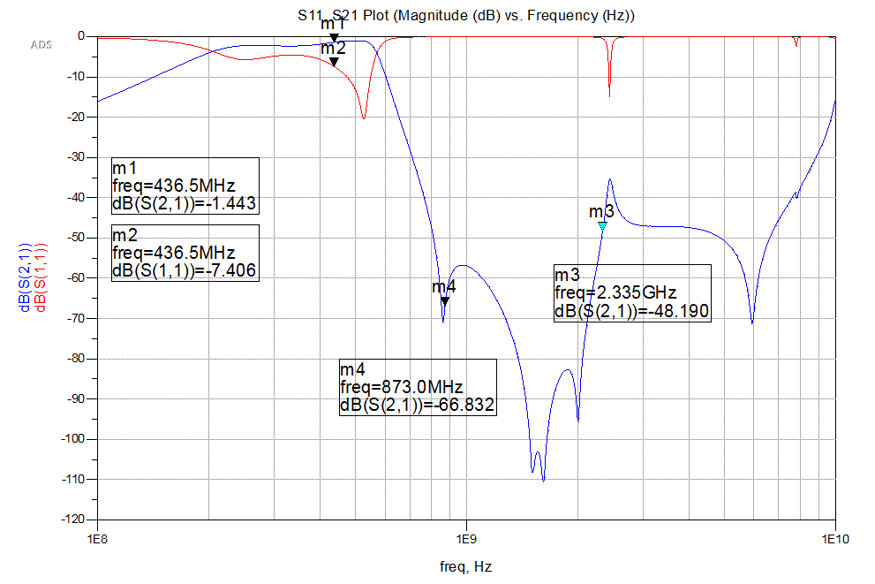

Figure 9: C10 Tuned from 15pF down to 10pF

Tuning C10 has a slight effect on moving the center frequency of the pass band. More interestingly, the S11 response seems to improve drastically as the capacitance is increased. A slight improvement in the S21 response is also made when the capacitance is increased. The change in the value of C11 does not seem to alter the attenuation of the 2nd harmonic and higher frequencies seem mostly unaffected. Overall, this capacitor could be used to improve the S11 and S21 response of the filter.

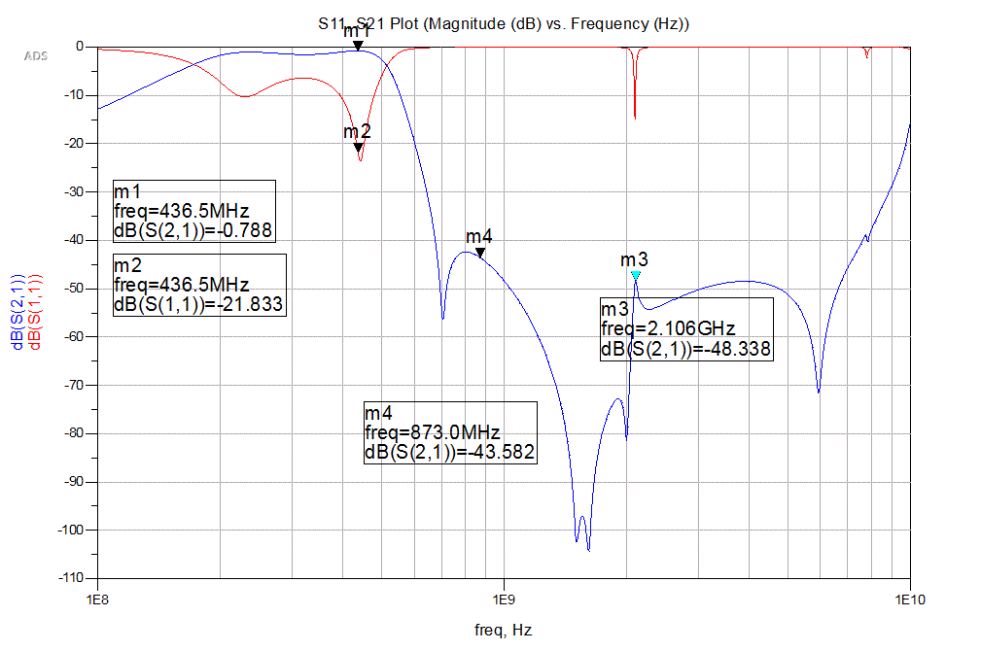

Figure 10: C12 Tuned from 2.2pF down to 3.3pF

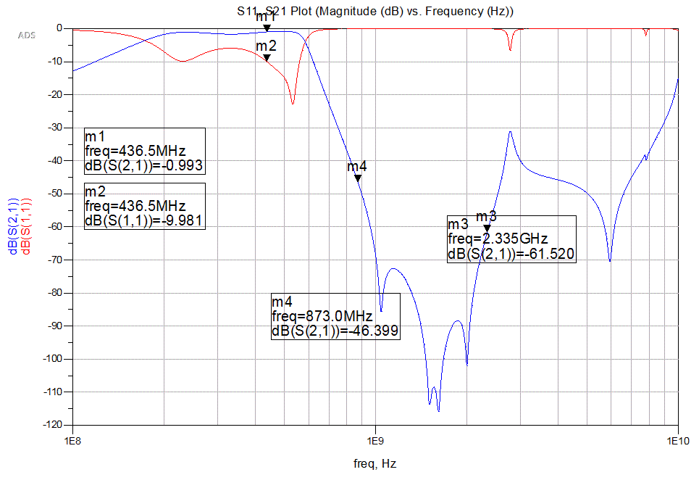

Figure 11: C12 Tuned from 2.2pF down to 1.5pF

Tuning C12 has a dramatic effect on the 2nd harmonic attenuation. Also, the higher frequencies are greatly affected. Notice how much the marker m3 changes between figure 10 and figure 11. The center frequency is tunable with this capacitor and Figure 10 does show an improved S11 response at the frequency of interest. This capacitor should most likely not be considered tunable due to the adverse affects of the response in the higher frequencies.

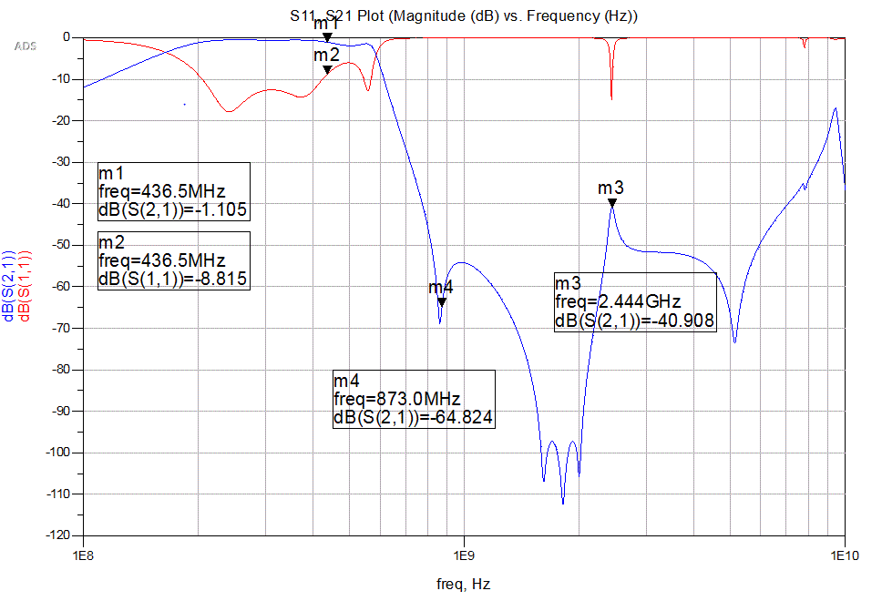

Figure 12: C13 Tuned from 15pF down to 20pF

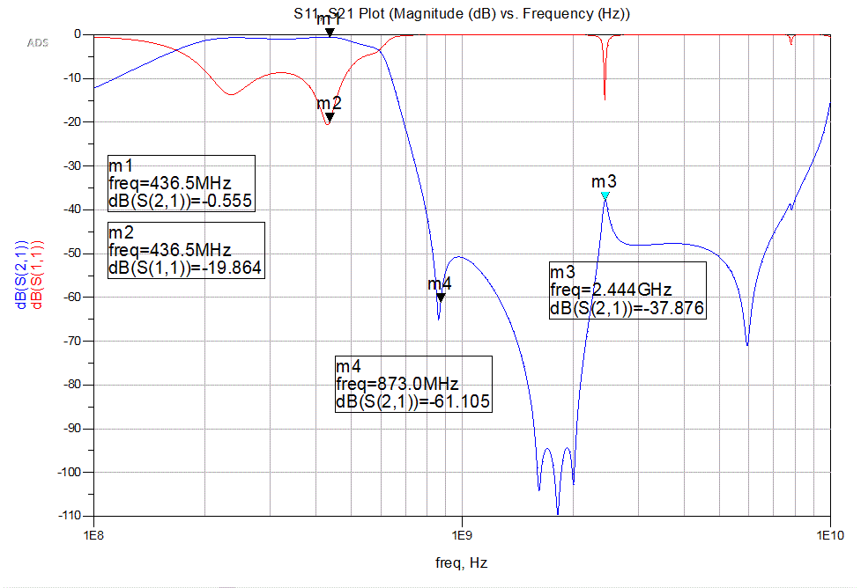

Figure 13: C13 Tuned from 15pF down to 10pF

Tuning C13 has the effect of moving the center of the pass band. Also, the S11 and S21 parameters are improved when the capacitance is reduced. The higher frequencies are less affected by the change in capacitance; the 2nd harmonic attenuation seems to hold position across the change. Overall, the capacitor can be used to tune the center frequency of the filter and improve the s-parameter response.

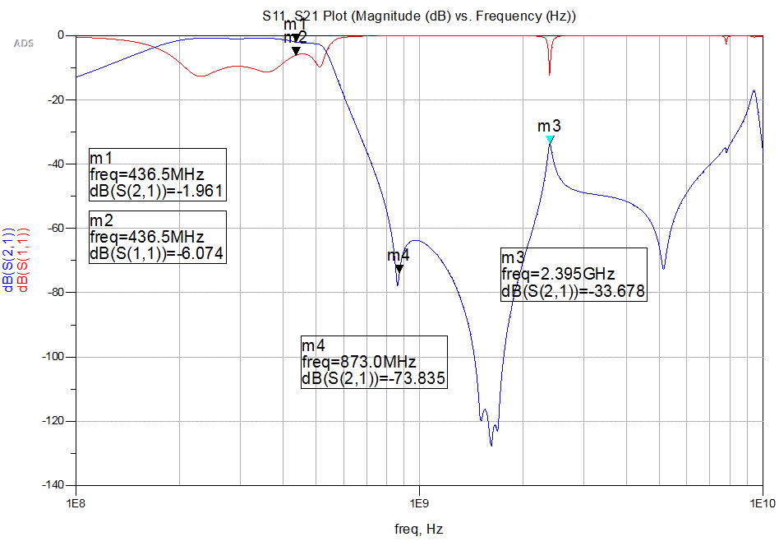

Figure 14: C14 Tuned from 8.2pF up to 11pF

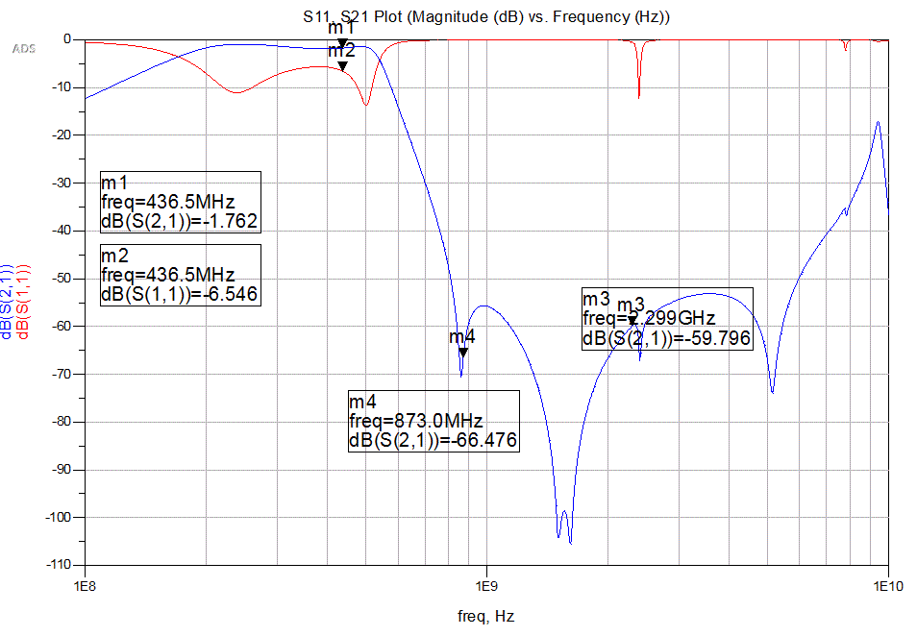

Figure 15: C14 Tuned from 8.2pF up to 5.6pF

Tuning C14 makes no improvement on the pass band and shows only mild changes at he 2nd harmonic attenuation. However, the filter response at higher frequencies has been improved. This capacitor is a good candidate for smoothing out some of the higher frequency spikes (especially the one centered around 2.4 GHz).

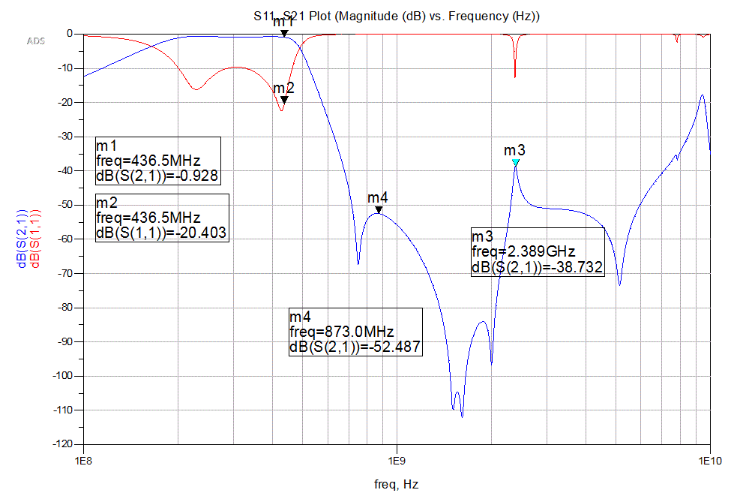

Figure 16: L1 Tuned from 15nH up to 20nF

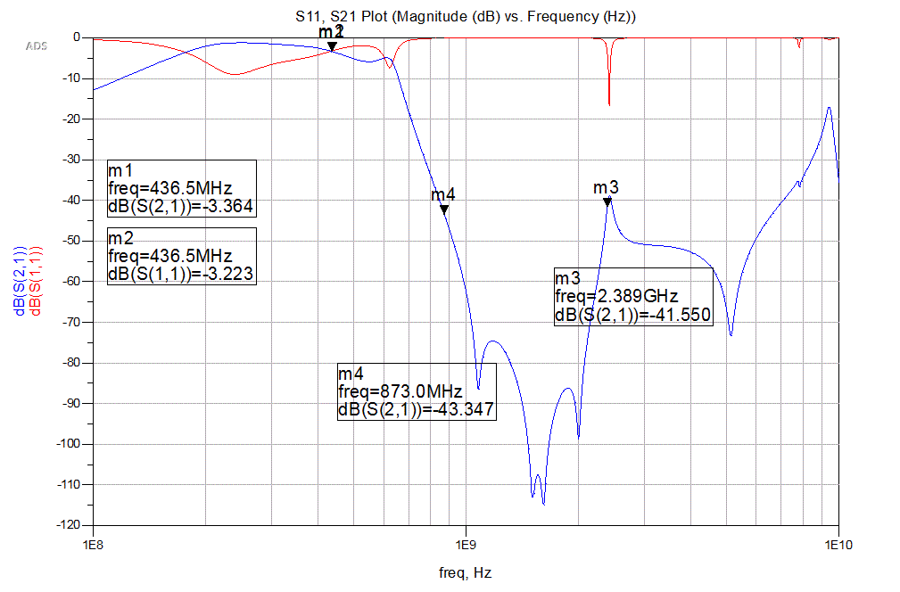

Figure 17: L1 Tuned from 15nH up to 10nF

Tuning L1 has some negative consequences on the pass band when the inductor is tuned down. However, the response is slightly improved when the inductance is increased. Also, the 2nd harmonic response is drastically changed across the tuning range. Overall, this inductor should most likely not be changed.

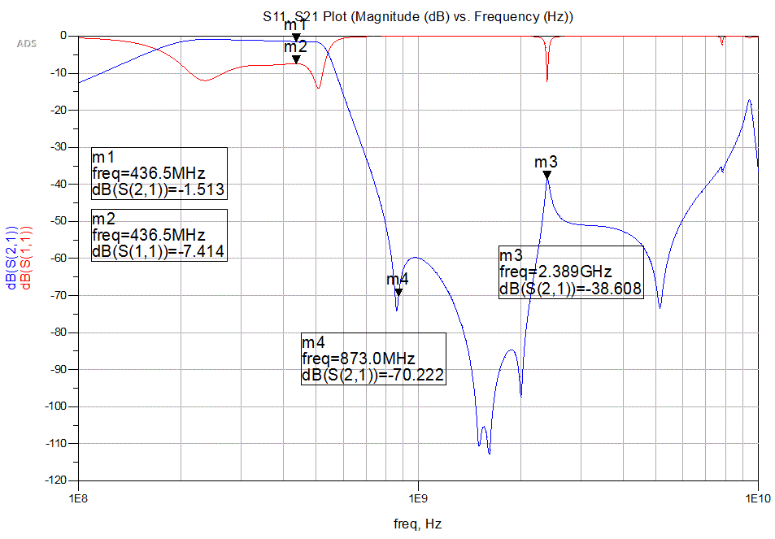

Figure 18: L2 Tuned from 15nH up to 20nF

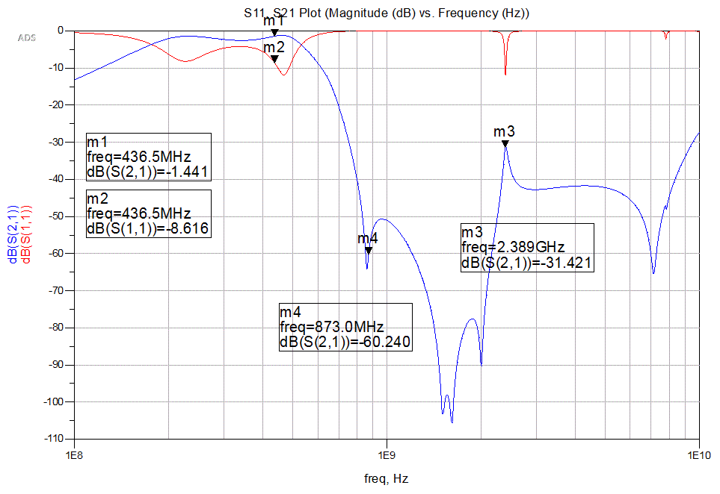

Figure 19: L2 Tuned from 15nH up to 10nF

Tuning L2 seems to move the center frequency of the pass band slightly; however, the S11 and S21 response does not improve noticeably. Also, there is no real enhancement to the filter at the higher frequencies. Overall, this inductor has little obvious benefit as a tunable component.

Overview of observations from simulation:

C11: Overall, this capacitor could be used to tune the frequency of interest closer to the center of the pass band. The center frequency moves up when the capacitance is increased and moves down when the capacitance is decreased.

C10: Overall, this capacitor could be used to improve the S11 and S21 response of the filter. This improvement was made when the capacitance was tuned higher.

C12: This capacitor should most likely not be considered tunable due to the adverse affects of the response in the higher frequencies.

C13: Overall, the capacitor can be used to tune the center frequency of the filter and improve the s-parameter response. This improvement was made when the capacitance was tuned down.

C14: This capacitor is a good candidate for smoothing out some of the higher frequency spikes (especially the one centered around 2.4 GHz). This improvement was made when the capacitance was tuned down.

L1: Overall, this inductor should most likely not be changed.

L2: Overall, this inductor should most likely not be changed.

An example of the tuned filter is shown in the next figure. Here, the lessons learned from the above simulations were applied. C11 is tuned from 12 pF to 15pF. C10 is tuned from 15pF to 22pF. C14 is tuned from 8.2pF to 6.2pF.

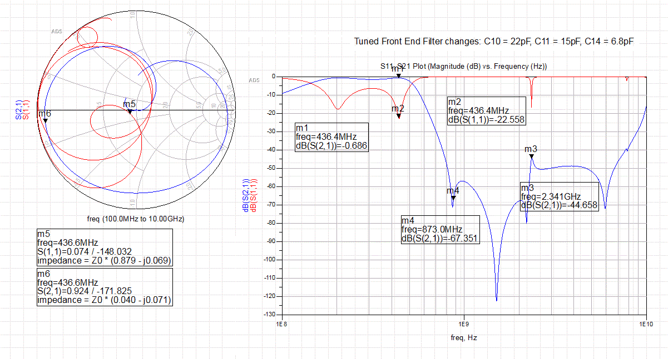

Figure 20: L2 Tuned filter with improved center frequency response, S21 response, and S11 response.

As a note, tuning this circuit is not trivial. This exercise was supposed to help single out the components that could be used to make quick and easy enhancements to the filter to improve the response. However, it became apparent during tuning that although a single component can have an impact on the response of the filter, it generally requires several components to be tuned to achieve any real benefit. This is further complicated by the fact that as the order of the tuned components increases, the complexity of the tuning increases, where each change has an additive effect on the system as a whole. Obviously, a more quantitative evaluation of the filter is required in order to effectively make real, intelligent design changes.