# ACCIDENT DETECTION AND ALERT SYSTEM

Submitted by

**Darakhshan Naheed**

### 21040445011

Under the guidance of

### Mrs. Sunidhi Priyadarshini

(Asst. Prof., Department of Computer Science & Engineering)

**Polytechnic Compound Road, Dumka, Jharkhand 814101**

SRS Report submitted to

Dumka Engineering College

in

partial fulfilment for

the award of the degree of

### BACHELOR OF TECHNOLOGY

In the department of

## Computer Science & Engineering July 2024



**Jharkhand University of Technology, Ranchi**

# Table of Contents

Requirements Version Control **1.** **Introduction**

* 1. Purpose
  2. Document Conventions
  3. Intended Audience
  4. Product Scope
  5. Overview

### Overall Description

* 1. Product Perspective
  2. Product Functions
  3. User Classes and Characteristics
  4. User Interests
  5. Operating Environment
  6. Design and Implementation Constraints
  7. User Documentation
  8. Assumptions and Dependencies

### Requirements Modelling

* 1. Requirements Modelling
     1. Scope
     2. Detecting an accident and alert system

### Booking a Flight Specific Requirements

* 1. External Interface Requirements
  2. Functional Requirements

4.3. Software System Attributes

* 1. Non-functional Requirements
  2. System Features
  3. Requirements prioritization

### Appendix A: Glossary

1. **Reference**

# Introduction

## Purpose

Nowadays, the rate of accidents has increased rapidly. Due to employment, the usage of vehicles like cars, bikes have increased, because of this reason the accidents can happen due to over speed. People are going under risk because of their over speed, due to unavailability of advanced techniques, the rate of accidents can’t be decreased. To reduce the accident rate in the country this paper introduces a solution. Automatic accident detection and alert systems are introduced. The main objective is to control the accidents by sending a message to the registered mobile, hospital and police station using wireless communications techniques.

## Intended Audience

The intended audience for this document consists of Drivers and Vehicle owners, pedestrians and cyclists, Commercial Fleet Managers, Logistics Companies, Ambulance services etc.

## Product Scope

* Accident Detection: Implement machine learning algorithms to analyze sensor data and confirm accidents.
* Real-time Notification: Provide precise GPS coordinates of the accident location to responders.
* User Interface: Create a mobile application and web-based interface for emergency services and authorities to monitor and manage alerts.
* Emergency Response Integration: Store users' emergency contacts and medical information for responders.
* Data storage and Analytics: Analyze accident data to identify patterns, improve system accuracy, and suggest preventive measures.
* Technical specifications: Hardware, Software, and Infrastructure

## Overview

The Accident Alert System is designed to enhance safety and response times in the event of vehicle and pedestrian accidents through real-time detection and notification mechanisms. This comprehensive system leverages advanced sensors, machine learning algorithms, and communication technologies to detect accidents, alert emergency services and designated contacts, and provide precise location information to facilitate prompt assistance.

# Overall Description

## Product Perspective

The Accident Alert System is designed to revolutionize transportation safety and emergency response by providing a comprehensive, real-time solution for accident detection and alerting. This system integrates advanced sensors, including accelerometers, gyroscopes, and GPS modules, within vehicles to continuously monitor and analyze movement, detecting sudden changes indicative of accidents. Once an accident is detected, the system uses sophisticated machine learning algorithms to confirm the event and immediately sends alerts to emergency services, pre-designated contacts, and nearby users, ensuring that help is dispatched quickly and accurately. The user interface, comprising an intuitive mobile application and a web portal, allows users to receive real-time alerts, manually report accidents, and access critical data, while emergency services and fleet managers can monitor and manage alerts through a comprehensive dashboard. Despite potential challenges such as hardware limitations, regulatory compliance, and user adoption, the system's design ensures data privacy and security through encryption and access controls. It assumes widespread technology adoption and effective collaboration with authorities to ensure its success. By leveraging the latest advancements in technology and fostering collaboration with various stakeholders, the Accident Alert System aims to significantly reduce accident impacts, save lives, and enhance overall road safety, making it an indispensable tool for modern transportation and emergency response frameworks.

## Product Functions

These functions use state-of-the-art technologies to provide a comprehensive and intelligent safety solution:

### Accident Detection and Prevention

* Predictive Analytics: Utilize AI to analyze driving patterns, environmental conditions, and historical data to predict potential accidents and provide early warnings to drivers.
* Collision Avoidance: Implement advanced algorithms to detect approaching collisions and automatically trigger vehicle safety mechanisms (e.g., automatic braking).

### Notification and Alerts

* **Automatic Alerts**: Instantly notify emergency services, pre-designated contacts, and nearby users when an accident is detected, providing detailed information about the incident.
* **Location Tracking**: Provide precise GPS coordinates and real-time updates on the accident location to responders and emergency services.
* **Multi-channel Notifications**: Send alerts via multiple channels, including SMS, email, in-app notifications, and voice calls, ensuring timely dissemination of information. the help of this function customer selects the number of passengers and their category, either adult, child or infant.

### User Interfaces

* **Mobile Application:** Both Android and iOS platforms, offering real-time alerts, manual accident reporting, emergency contact management, and access to driving.
* **Web Portal**: Comprehensive dashboard for emergency services and fleet managers to monitor accidents, manage alerts, and coordinate response efforts.
* **Augmented Reality (AR) Integration**: Provide real-time visual guidance for first responders and users through AR features in the mobile app.

### Data Management and Security

* **Cloud Storage**: Securely store historical data on cloud servers, facilitating detailed analysis, reporting, and system improvement.
* **Decentralized Storage**: Utilize decentralized data storage solutions to enhance data security and privacy.
* **Encryption**: Ensure end-to-end encryption of all data transmissions and storage, protecting user data from unauthorized access.

### Emergency Response Integration

* **Emergency Protocol Automation:** Automatically initiate emergency protocols, including contacting emergency services and notifying designated contacts**.**
* **Medical Data Transmission:** Enable real-time transmission of critical medical information to healthcare providers to ensure tailored medical care for accident victims.
* **Traffic Management Integration:** Communicate with traffic management systems to adjust traffic signals and ease congestion around the accident site, facilitating quicker emergency response

### Global Scalability

* **Regional Customization**: Adapt the system to comply with varying regulations and needs across different regions, including multi-language support.
* **International Partnerships**: Establish partnerships with international emergency services and public safety agencies to ensure seamless global operation.
* **Regulatory Compliance**: Ensure compliance with the latest data protection regulations globally, providing users with greater control over their personal information.

## Data flow diagram

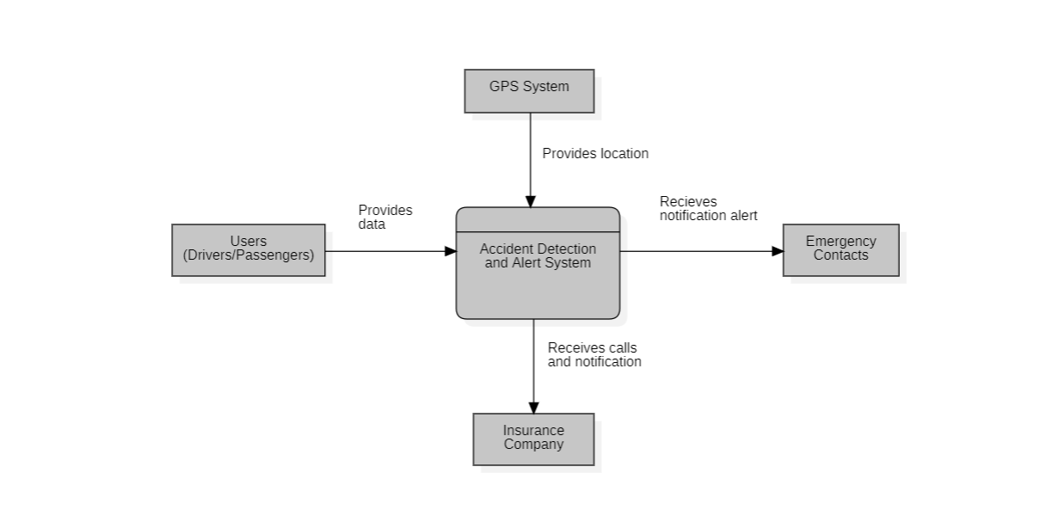

0 Level DFD

**Components of the 0-Level DFD**

1. **External Entities**
   * **Vehicle Sensors**: Provide data on vehicle status, such as acceleration, deceleration, and impact forces.
   * **GPS System**: Provides location data.
   * **Emergency Contacts**: Receives notifications and alerts.
   * **Emergency Services**: Receives emergency calls and notifications.
2. **Processes**
   * **Accident Detection and Alert System**: Central process that receives data from sensors and GPS, detects accidents, and sends alert

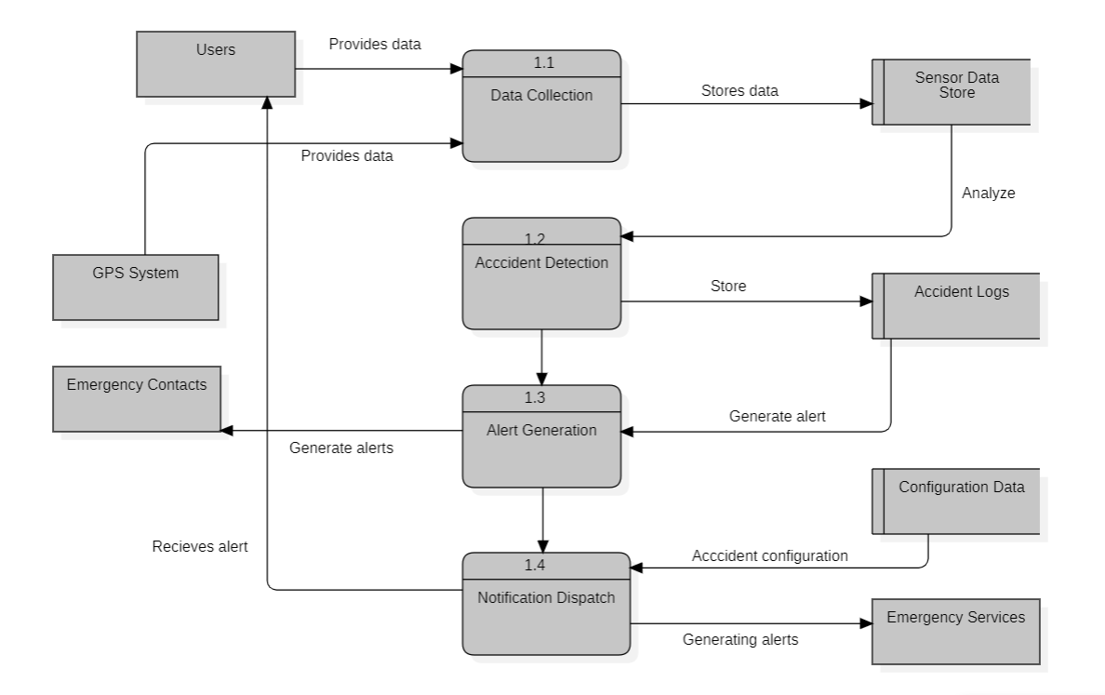

1 Level DFD

A 1-level Data Flow Diagram (DFD) provides a more detailed view of the system by breaking down the main process into sub-processes. Here’s the 1-level DFD for an accident detection and alert system, showing its internal processes and data flows.

**Components of the 1-Level DFD**

1. **External Entities**
   * Vehicle Sensors
   * GPS System
   * Emergency Contacts
   * Emergency Services
2. **Processes**
   * 1.1 Data Collection
   * 1.2 Accident Detection
   * 1.3 Alert Generation
   * 1.4 Notification Dispatch
3. **Data Stores**
   * D1 Sensor Data Store
   * D2 Accident Logs
   * D3 Configuration Data

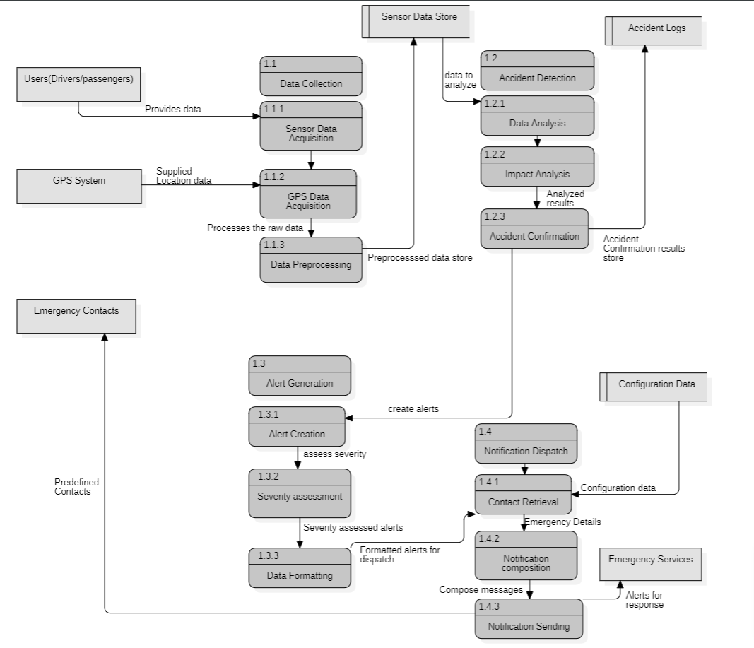

2 Level DFD

A 2-level Data Flow Diagram (DFD) further decomposes the processes defined in the 1-level DFD, providing even more detail about the system's internal workings. Here’s the 2-level DFD for an accident detection and alert system, breaking down the processes identified at the 1-level.

**Components of the 2-Level DFD**

**Process 1.1: Data Collection**

1. 1.1.1 Sensor Data Acquisition
2. 1.1.2 GPS Data Acquisition
3. 1.1.3 Data Preprocessing

**Process 1.2: Accident Detection**

1. 1.2.1 Data Analysis
2. 1.2.2 Impact Analysis
3. 1.2.3 Accident Confirmation

**Process 1.3: Alert Generation**

1. 1.3.1 Alert Creation
2. 1.3.2 Severity Assessment
3. 1.3.3 Data Formatting

**Process 1.4: Notification Dispatch**

1. 1.4.1 Contact Retrieval
2. 1.4.2 Notification Composition
3. 1.4.3 Notification Sending

## User Classes and Characteristics

The system divides users into different categories:

* **Vehicle Owners/Driver:** Non-technical, safety-conscious, need easy configuration, clear notifications, minimal false positives.
* **Family Members/Emergency Contacts:** Concerned about driver safety, concerned about driver safety.
* **Emergency Services:** Professional responders, need detailed accident data, system integration, reliable communication.
* **Fleet Managers:** Manage multiple vehicles, require fleet monitoring dashboard, reports, multi-vehicle management.
* **Insurance Companies:** Risk assessment, claims processing, need detailed accident reports, historical data analysis, secure data access.
* **System Administrators/Technicians:** Technical maintenance, require diagnostic tools, secure access, remote updates, and troubleshooting.

## User Interests

Vehicle owners and drivers prioritize safety assurance, ease of use, and accurate detection, ensuring they and their loved ones are promptly notified in case of an accident. Family members and emergency contacts value timely notifications, detailed accident information, and real-time tracking through multiple channels. Emergency services are interested in prompt response enabled by accurate and detailed accident data, seamless integration with their systems, and reliable communication. Fleet managers focus on fleet safety, efficient monitoring and reporting, compliance with safety regulations, and effective management of multiple vehicles and drivers.

## Operating Environment

The system operates with vehicle sensors, GPS modules, and communication hardware, running on a real-time operating system. It utilizes cellular or satellite networks for alert transmission and integrates with cloud services for data storage and analytics, and with emergency response systems for prompt action.

## Design and Implementation

The system is designed with integrated vehicle sensors, GPS modules, and communication hardware, all managed by an onboard processing unit running real-time detection algorithms. A user-friendly mobile app facilitates configuration, real-time tracking, and alert notifications via SMS, email, and push notifications. Cloud services provide data storage and analytics for detailed accident reports and insights. The implementation involves seamless integration between onboard systems, mobile applications, and cloud services, followed by rigorous testing to ensure accuracy and reliability. Deployment includes equipping vehicles with the necessary hardware, user training, and regular software updates for continuous improvement.

## User Documentation

The instructions on how to register for accident detection, send and track the alert areas where accidents occurred on the available website.

## Assumptions and Dependencies

The project assumes vehicles have compatible sensors and network coverage for notifications, and it depends on reliable sensor data and regulatory compliance.

# Requirements Modelling

## Requirements Modelling

### Scope

The project scope involves developing a system for accurate real-time vehicular accident detection, alert generation, and data logging with a user-friendly interface for configuration and monitoring.

### Detecting an accident and alert system

Description: The accident detection and alert system employs a network of sensors to continuously monitor vehicle conditions, including accelerometers for impact detection and GPS for location tracking. When an unusual event is detected, such as a significant collision or rapid deceleration, the system immediately analyzes the data to confirm an accident. If confirmed, it generates an automated alert with detailed information about the accident's severity, location, and time, and sends it to emergency services and predefined contacts via reliable communication channels like GSM, LTE, or Bluetooth. Drivers can also manually initiate alerts to ensure faster response if they are conscious and able to do so. Emergency responders use the real-time information provided by the system to quickly reach the accident site, assess the situation, and deliver timely assistance. The system also records and stores accident data for further analysis, helping to improve safety features and refine emergency response protocols.

# Specific Requirements

## External Interface Requirements

### User Interfaces

* **Dashboard**: Displays real-time system status, sensor data, and alert notifications.
* **Configuration Panel**: Allows users to set up and adjust system parameters, such as alert thresholds, contact details, and notification preferences.
* **Alert Management**: Provides a view of recent alerts, including details about detected accidents and response status.
* **Manual Alert Trigger**: Offers a button or control for drivers to manually activate alerts if needed.
* **Data Access**: Enables users to view and analyze logged accident data and historical reports.
* **System Health Monitoring**: Displays system diagnostics, battery status, and sensor health indicators.
* **Feedback and Notifications**: Shows feedback messages and notifications about system status, updates, or errors.

### Hardware Interfaces

* **Accelerometers**: High sensitivity, wide measurement range.
* **Gyroscopes**: High precision, low noise.
* **GPS Module**: High accuracy, reliable signal.
* **Microcontroller/Processor**: Sufficient processing power and memory.
* **Data Fusion Module**: Efficient integration of sensor data.
* **GSM/LTE**: Reliable network connectivity for sending alerts.
* **Bluetooth/Wi-Fi**: Local communication, if needed
* **Battery**: Long-lasting, stable voltage.
* **Power Management**: Efficient power distribution.
* **Physical Button**: Durable, easy to access.
* **Touchscreen/Control Panel**: Optional, for configuration and monitoring.
* **Storage Module**: For logging accident data

### Hardware Interfaces

* **Sensor Data Interface**: Collects and processes data from accelerometers, gyroscopes, and GPS
* **Detection Algorithms**: Identifies and confirms collision events.
* **Alert Generation and Transmission**: Creates and sends alerts via GSM/LTE and optionally Bluetooth/Wi-Fi.
* **User Interface**: Provides configuration settings and real-time monitoring.
* **Data Management**: Logs, stores, and retrieves accident data.

## 4.1 Functional Requirements

1. **Description**: Detects sudden deceleration indicative of a collision.

* **Input**: Accelerometer data
* **Processing**: Analyzes acceleration patterns to identify sudden drops.
* **Output**: Collision detected alert

2. **Description**: Determines vehicle rollover by detecting changes in orientation.

* **Input**: Gyroscope data
* **Processing**: Monitors and analyzes changes in the vehicle's orientation.
* **Output**: Rollover detected alert

3. **Description**: Provides the exact location of the accident for quick response.

* **Input**: GPS data
* **Processing**: Retrieves and confirms the vehicle's coordinates.
* **Output**: Accident location coordinates

4. **Description**: Detects airbag deployment to confirm the severity of the accident.

* **Input**: Airbag sensor data
* **Processing**: Monitors airbag status to detect deployment.
* **Output**: Airbag deployed alert

5. **Description**: Monitors vehicle speed for sudden stops indicating a possible accident.

* **Input**: Speedometer data
* **Processing**: Analyzes speed data to detect abrupt stops.
* **Output**: Sudden stop detected alert

6. **Description**: Sends emergency alerts to predefined contacts for immediate assistance.

* **Input**: Emergency contact list
* **Processing**: Triggers alert messages to be sent automatically.
* **Output**: Notification sent to emergency contacts

7. **Description**: Alerts the nearest emergency services to ensure a rapid response.

* **Input**: Emergency service contact information
* **Processing**: Identifies and contacts the closest emergency services.
* **Output**: Notification sent to emergency services

8. **Description**: Triggers an audio alarm within the vehicle to alert passengers and nearby people.

* **Input**: Impact detection from sensors
* **Processing**: Activates the audio alarm system.
* **Output**: Audio alarm activation

9. **Description**: Records accident event data for post-accident analysis and insurance purposes.

* **Input**: Event data from all sensors
* **Processing**: Compiles and stores data in a secure log.
* **Output**: Stored accident event log

10. **Description**: Activates an in-car display message to inform passengers of the emergency situation.

* **Input**: Accident detection confirmation
* **Processing**: Generates and displays an emergency message on the in-car screen.
* **Output**: Display emergency message in-car

## 4.2 Non-functional Requirements

1. **Performance**
   * The system shall detect and respond to an accident within 5 seconds.
   * The system shall send alerts and notifications within 10 seconds of detecting an accident.
   * The system shall handle at least 100 alerts per hour without performance degradation.
2. **Reliability**
   * The system shall have an uptime of 99.9%, ensuring it is almost always available.
   * The system shall have a mean time between failures (MTBF) of at least 1 year.
   * The system shall be capable of self-diagnosing and recovering from minor faults without human intervention.
3. **Scalability**
   * The system shall be able to handle an increase in the number of vehicles without performance degradation.
   * The system shall support at least 10,000 simultaneous users.
4. **Usability**
   * The system shall have an intuitive and user-friendly interface.
   * The system shall provide clear and concise notifications to users.
   * The system shall be easy to configure and maintain by non-technical users.
5. **Security**
   * The system shall encrypt all data transmissions to protect against unauthorized access.
   * The system shall implement authentication and authorization mechanisms to restrict access to authorized users only.
   * The system shall comply with industry standards for cybersecurity to protect against attacks.
6. **Maintainability**
   * The system shall be modular to facilitate easy updates and maintenance.
   * The system shall provide comprehensive logging and diagnostics for troubleshooting.
   * The system shall support remote updates to minimize downtime and maintenance efforts.
7. **Availability**
   * The system shall be available 24/7 without interruption.
   * The system shall have backup mechanisms in place to ensure continuous operation in case of hardware or software failures.
8. **Compatibility**
   * The system shall be compatible with various vehicle makes and models.
   * The system shall support integration with different sensor types and communication protocols.
9. **Data Integrity**
   * The system shall ensure the accuracy and consistency of all stored and transmitted data.
   * The system shall implement error-checking mechanisms to prevent data corruption.
10. **Efficiency**
    * The system shall optimize resource usage, including CPU, memory, and network bandwidth.
    * The system shall minimize power consumption to avoid draining the vehicle's battery.
11. **Compliance**
    * The system shall comply with relevant industry standards and regulations, such as automotive safety standards and data privacy laws.
    * The system shall be certified by appropriate regulatory bodies to ensure adherence to safety and quality standards.
12. **User Experience**
    * The system shall provide timely and relevant feedback to users.
    * The system shall minimize false positives to avoid unnecessary alerts and notifications.
    * The system shall offer customization options for users to tailor alerts and notifications to their preferences.
13. **Localization**
    * The system shall support multiple languages and regional settings to cater to a global user base.
    * The system shall adapt to local emergency services and protocols for effective communication and assistance.

## System Features

(Contains functional, non-functional and solution-oriented requirements) Features of the system are the followings:

* + - * **Real-Time Accident Detection**: Monitors sensor data to identify collisions or impacts.
      * **Automatic Alerts**: Sends alerts to emergency services and contacts upon detecting an accident.
      * **Manual Alert Trigger**: Allows users to manually initiate alerts for immediate assistance.
      * **GPS Location Tracking**: Provides precise location information for emergency responders.
      * **Data Logging**: Records and stores accident-related data for analysis.
      * **User-Friendly Interface**: Dashboard for real-time monitoring and configuration.
      * **Communication Modules**: Integrates with GSM/LTE and optionally Bluetooth/Wi-Fi.
      * **Security Features**: Encrypts data and manages access controls.
      * **System Health Monitoring**: Tracks the health and performance of the system.
      * **Firmware Updates**: Supports remote updates and maintenance.

## Requirements Prioritization

### MUST

### - Accurate Detection

### - Immediate Alert

### - Real-Time Monitoring

### - Robust Communication

### - User Interface

### - Data Privacy and Security

**SHOULD**

* **- Automatic Response**
* **- Battery Backup**
* **- Integration with Other Systems**
* **- User Notifications**
* **- Self-Testing and Diagnostics**
* **- Voice Alerts**

### COULD

### - Predictive Analytics

### - Customizable Alerts

### - Historical Data Analysis

### - Third-Party Integration

### - User Training

### - Multilingual Support

### - Cost-Effective

**WON’T**

* **- Manual Detection**
* **- Delayed Alerts**
* **- Single Communication Channel**
* **- Complex User Interface**
* **- Lack of Data Security**

# Appendix A: Glossary

* **Accelerometer**: A sensor that measures changes in velocity or acceleration to detect sudden movements or impacts.
* **Alert**: A notification sent by the system to inform emergency services, predefined contacts, or users about an accident.
* **Collision Detection**: The process of identifying whether an impact or sudden change in motion qualifies as an accident.
* **Data Fusion**: The integration of data from multiple sensors to improve the accuracy of accident detection.
* **Firmware**: Software embedded in hardware devices that controls their operations and can be updated to enhance functionality or fix issues.
* **GPS (Global Positioning System)**: A satellite-based system that provides location and time information anywhere on Earth.
* **GSM (Global System for Mobile Communications)**: A standard for mobile communication used for sending text messages and making calls.
* **LTE (Long-Term Evolution)**: A standard for high-speed wireless communication used for data transmission.
* **Manual Alert Trigger**: A feature allowing users to manually send an alert to emergency contacts or services.
* **Power Management Circuit**: Electronic components responsible for regulating and distributing power within the system.
* **Sensor Fusion**: The process of combining data from various sensors to improve the accuracy and reliability of the system.
* **System Dashboard**: The main user interface that displays real-time information, alerts, and system status.
* **Touchscreen/Control Panel**: A user interface element that allows users to interact with the system through touch or physical controls.
* **User Interface (UI)**: The means by which users interact with the system, including graphical elements and controls for configuration and monitoring.

# References

# https://www.reqview.com/doc/iso-iec-ieee-29148-srs-example/

# <https://www.python.org/>

# <https://www.researchgate.net/publication/360620242_ACCIDENT_DETECTION_AND_ALERT_SYSTEM>

# <https://nevonprojects.com/accident-identification-alert-system/>

# <https://jespublication.com/uploads/2023-V14I6041.pdf>

# <https://www.researchgate.net/publication/362264272_Accident_Detection_and_Alerting_Systems_A_Study>

