|  |  |
| --- | --- |
|  | Approved: Coordinator: АЙДАРХАНОВ АЛИХАН Dean: АЙДАРХАНОВ АЛИХАН 25.04.2022 |

**Syllabus**for the course  
**«Coding Lab»**Academic Year 2022-2023

|  |  |
| --- | --- |
| **1. General information** | |
| Major code and title | Coding Lab |
| Subject category | Basic |
| Number of Credits | 5 |
| Language of delivery | Английский |
| Prerequisites |  |
| Postrequisites | Educational practice |
| Instructors | АЙДАРХАНОВ АЛИХАН, ЕЛЬВИРА АЙТМУХАНБЕТОВА |
| **2. Goals, objectives and learning outcomes of the course** | |
| **Course goal(s):**  цель | |
| **Course objectives:**  задача | |
| **Learning outcomes:**  результат | |
| **3. Course description:**  описание | |
| **4. Course policy:**  политика | |
| **5. Literature:**  литература | |

**6. Course calendar**

**6.1 Lecture, practical/seminar/laboratory session plans**

|  |  |  |
| --- | --- | --- |
| № | Abbreviation | Meaning |
| 1 | TSIS | Teacher-supervised independent work (СРСП) |
| 2 | SIS | Students’ independent work (СРС) |
| 3 | IP/GP | Individual or group project |
| 4 | LW | Laboratory Work |
| 5 | Q | Quiz |

|  |  |  |  |  |  |  |  |
| --- | --- | --- | --- | --- | --- | --- | --- |
| W № | Topic | References | L | P | LAB | SIS | TSIS |
| 1 | 1 |  | 0.0 | 5.0 | 0 | 9.0 | 1.0 |
| 2 | 2 |  | 0.0 | 5.0 | 0 | 9.0 | 1.0 |
| 3 | 3 |  | 0.0 | 5.0 | 0 | 9.0 | 1.0 |
| 4 | 4 |  | 0.0 | 5.0 | 0 | 9.0 | 1.0 |
| 5 | 5 |  | 0.0 | 5.0 | 0 | 9.0 | 1.0 |
| 6 | 6 |  | 0.0 | 5.0 | 0 | 9.0 | 1.0 |
| 7 | 7 |  | 0.0 | 5.0 | 0 | 9.0 | 1.0 |
| 8 | 8 |  | 0.0 | 5.0 | 0 | 9.0 | 1.0 |
| 9 | 9 |  | 0.0 | 5.0 | 0 | 9.0 | 1.0 |
| 10 | 10 |  | 0.0 | 5.0 | 0 | 9.0 | 1.0 |
|  | Total hours: | 150 | 0 | 50 | 0 | 90 | 10 |

**7. Student performance evaluation system for the course**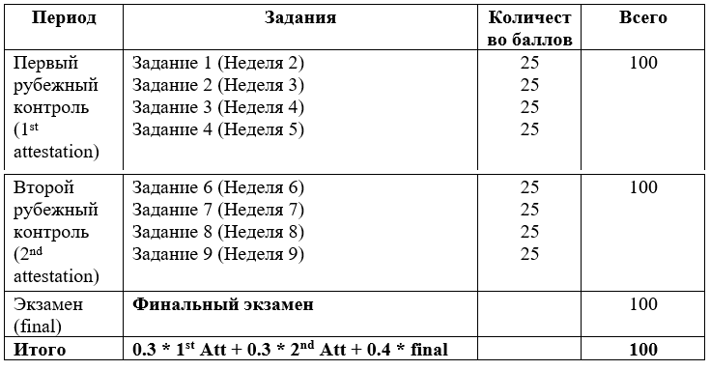

|  |  |  |  |
| --- | --- | --- | --- |
| Letter | Numerical | Percentage | Traditional |
| A | 4.0 | 95-100 | Excellent |
| A- | 3.67 | 90-94 | Excellent |
| B+ | 3.33 | 85-89 | Good |
| B | 3.0 | 80-84 | Good |
| B- | 2.67 | 75-79 | Good |
| C+ | 2.33 | 70-74 | Satisfactory |
| C | 2.0 | 65-69 | Satisfactory |
| C- | 1.67 | 60-64 | Satisfactory |
| D+ | 1.33 | 55-59 | Satisfactory |
| D | 1.0 | 50-54 | Satisfactory |
| F | 0 | 0-49 | Fail |

**8. Methodological Guidelines**

методы