EMA

Deprivation Connections to Key Stage 4 Achievement

Summary
The link between poor attainment in education and other factors of deprivation is acknowledged in its inclusion in measures of overall deprivation. However, data linking specific stages of educational achievement to wider deprivation can be absent or obscured behind data processing in deprivation focused reports. This report examines links between attainment at Key Stage 4 (GCSE or equivalent) and overall deprivation as measured by the Index of Multiple Deprivation (IMD), with a focus on attainment in English and Maths. Five broad types of deprived area at the upper local authority level have been identified using k-means clustering on IMD subdomain data. The Key Stage 4 (KS4) data focused on three areas: overall high attainment, overall pass attainment, and high attainment in Maths and English. This data was then combined with overall deprivation and the identified deprivation types to answer the following questions:

- Does attainment at KS4 in an area correlate to the area's overall deprivation?
- If so, is this affected by level of attainment?
- Does attainment in English and Maths have a disproportionate effect on these correlations?
- Which geographical areas would benefit from a focus on helping educational attainment at KS4?
- Would these areas benefit from a push to high attainment, a focus on basic pass level attainment, and/or from focus on English and Maths specifically?

In short, the answers to these questions are:

- Yes. Wider attainment at KS4 reasonably correlates to lower levels of deprivation.
- No. Where effects are apparent, it is at the level of passing GCSEs or equivalent.
- There is a small but clear effect of English and Maths attainment on correlations to IMD.
- Only the most overall deprived areas. Areas with medium deprivation are comparable in KS4 attainment to the least deprived areas.
- The focus should be on students achieving passes, particularly in Maths and English.

A limitation of the results is in the date of the data used which is over five years old. Another is that the results summarise higher level geographic areas, and cannot focus in on very specific target areas for improvement. Repeating the study with current data and attempting to identify statistics and targets within smaller geographic areas are reasonable next steps in terms of data analysis.
The report does not require any specialist knowledge.

Data Sources

Key Stage 4 Data
The Key Stage 4 data was obtained from gov.uk (UK Government, 2015d), imported into a pandas dataframe, and cleaned. It covers KS4 attainment percentages for 151 upper tier local authorities, taken from the file SFR01_2016_LA_Tables.xlsx. This excludes the City of London, for which there was no data. The attainment percentages represent what have been grouped as “high attainment” (percentage of pupils achieving 5+ A*-C GCSEs or equivalent), “pass attainment” (% achieving 5+ A*-G GCSEs or equivalent), percentages entered for both Maths and English, and percentages achieving an A*-C in both English and Maths. The data is aggregated so that no personal or identifying data was included.

IMD Data
The IMD data was obtained from gov.uk (UK Government, 2015a), imported into a pandas dataframe, and cleaned. The data used covers the average scores for IMD and all subdomains (excluding age related subdomains) for all 152 upper tier local authorities, taken from the file File_11_ID_2015_Upper-tier_Local_Authority_Summaries.xlsx. The averages represent the average score in each domain over all of the Lower Layer Super Output Areas (LSOAs) within the local authority. It must be noted that these scores are relative and not an absolute measure of deprivation (UK Government, 2015c), and that the data given at this level represents a summary of smaller areas (UK Government, 2015b). This means that scores should not be measured against each other in anything more than a relative (higher or lower) manner, and it should be understood that there may be variance within the LSOAs of a local authority that is obscured at the summary level. The data is aggregated so that no personal or identifying data was included.

Border Geographic Data
Data for visualising the borders of the local authorities was obtained from geoportal.statistics.gov.uk (UK Government, 2018a and UK Government, 2018b). This data is used purely for visualising the local authority areas in illustration 1, and has no other bearing on the investigation. No personal or identifying data was included.

Data Licencing
All of the above data sources are available under the Open Government Licence Version 3, available at https://www.nationalarchives.gov.uk/doc/open-government-licence/version/3/. This license allows the data to be freely accessed, copied, stored, adapted, combined with other data, published, and exploited in commercial and non-commercial contexts.

Data Combination
Because both datasets used were limited and in the form of aggregate statistics over a local authority, without personally identifying data, there was no possibility of the combination of datasets being used to de-anonymise each other to identify individuals. Note that this may not be the case for the full source datasets which cover more information, including potentially personally identifying information such as age, sex, and race.

Once cleaned, the KS4 and IMD data was easy to combine along the included Government Statistical Service (GSS) codes for each area. There were only two mismatches in GSS codes between the two datasets, both relating to the same area.

Area Name | KS4 GSS Code | IMD GSS Code
Northumberland | E06000048 | E06000057
Gateshead | E08000020 | E08000037
Table 1: Data mismatches
It turned out that E06000057 is a region that contains now inactive predecessors E06000048 and most of E08000020, with E08000037 containing the remainder of E08000020. The deprivation data is slightly more up to date on these codes, but the redistribution of territory made it difficult to match them up. It was decided to replace the KS4 code with the equivalent code from the IMD data, with the caveat that the data may not have been collected over the exact same region in these cases.

Analysis Pipeline

Deprivation Clustering
The deprivation data was analysed using k-means clustering, a method of dividing data points into groups based on similarity. These groups were then analysed in an attempt to identify subtypes of deprived area. After experimenting with various k values, 5 clusters appeared to be the most appropriate balance of detail and relevance. These groupings were:
- Cluster 1: Overall low deprivation (low scores on all fronts)
- Cluster 2: Overall high deprivation (high scores on all fronts)
- Cluster 3: Overall medium deprivation (medium scores on all fronts).
- Cluster 4: Medium, with high scores in living environment, barriers to housing and services, and crime, but low scores in education, employment, and health and disability deprivation.
- Cluster 5: Medium, with low scores in living environment deprivation, barriers to housing and services, and crime, but high scores in education, employment, and health and disability deprivation.
Lowering the number of clusters to 3, instead of reducing distinctions to a simple low, high and medium deprivation, emphasises the split in the final two types and is a good indication that this split is significant. Raising the number of clusters revealed no extra significant information.
The exact assignment of local authority to a cluster is not precisely repeatable, but in multiple tests the same five categories appear each time, with broadly the same proportions of members per cluster and repeatedly assigning key authorities and broader regions to the same groups. The final choice of exact assignment to go forward with was an arbitrary run of the clustering algorithm. Obviously, this is suboptimal and more work could be done on refining these groupings.
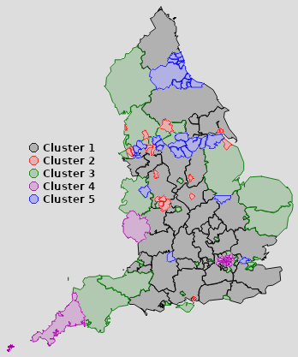Illustration 1: Local authorities coloured by deprivation type
Cluster 1, overall low deprivation, has the greatest proportion of local authorities at 53 members. They are overwhelmingly large rural areas in the south and midlands. The presence of a large amount of undifferentiated low deprivation is to be expected from the IMD data, as it looks to detail areas with high deprivation not provide a broader relative measure of affluence.

Cluster 2, overall high deprivation, has the smallest proportion of local authorities at 17 members. Local authorities are small, urban, and all but Portsmouth in a single if broad Northern area. Note the absence of London authorities in this category.

Cluster 3, general medium deprivation, has 34 members. There is a wide variety in geographic nature of these local authorities, but the west and east are emphasised.

Cluster 4 contains 20 areas which are overwhelmingly London authorities. Crime is relatively high, as is deprivation in living environment and access to housing and services, but deprivation in education, employment and health areas is lower. The persistent inclusion of Cornwall in this cluster is interesting, and may point to a theme of high income disparity, but this has not been tested and remains speculation.

Cluster 5 inverts cluster 4, with low crime and low living environment deprivation and barriers to housing and services, but high deprivation in the areas of education, health and employment. It contains 27 members, and like cluster 2 is predominantly urban and northern. Its primary presence is in two very specific geographical areas, one in the region of Durham and Newcastle, and the other along the M62.

Relation of Deprivation Data to KS4 Data
The KS4 data was plotted against both IMD average score and the identified deprivation groupings. Correlation coefficients (Pearson's r) measuring the strength of correlation were calculated for various data series versus corresponding average IMD score, and ranges and overlaps in the graphs of scores from the deprivation groupings were observed.
Coefficient of correlation
to IMD average score
KS4 data series | All data | Without outliers
% 5+ A*-C | -0.6 | -0.58
% 5+ A*-C including both English & Maths | -0.64 | -0.63
% 5+ A*-C excluding both English & Maths | 0.15 | 0.18
% 5+ A*-G | -0.58 | -0.56
% 5+ A*-G including both English & Maths | -0.63 | -0.65
% 5+ A*-G excluding both English & Maths | 0.43 | 0.55
GCSE or equivalent Maths & English % entered | -0.44 | -0.43
GCSE or equivalent Maths & English A*-C % achieved | -0.66 | -0.64
Table 2: Correlation Coefficients

There was a significant, though not enough to be called “very strong”, negative correlation between achievement of 5+ GCSE or equivalent passes and IMD, i.e. a higher percentage of passes correlated to a lower average IMD score. The strength of this correlation was not greatly effected by the difference between 5+ A*-C grades and 5+ A*-G. Where the passes included Maths and English, the correlation was slightly strengthened.

An interesting observation was the moderate positive correlation between achieving 5+ passes without both English and Maths and IMD average score: IMD increased with absence of both English and Maths passes despite 5+ passes being achieved in other subjects. This suggests that lack of basic English and Maths skills, even with basic attainment in other subjects, has a link to deprivation. It cannot be said from the data if this is causative in either direction, or if it is linked by an external factor. One possible avenue of investigation into this is to check the areas for populations of recent immigrants, who may have skills in all other areas but do not have the standard of English required for a pass, though again this is purely speculative as to possible cause. It is also interesting that this correlation exists solely at the passing level of achievement. The same data for A*-C without both English and Maths had no significant correlation to any of the data tested against it.

Achievement of A*-C grades in both English and Maths had the strongest negative correlation to IMD score at -0.66. This is very close to correlation with 5+ pass and 5+ A-C* when those include both English and Maths; too close to be considered significant on its own. It does however point to the significance of English and Maths achievement when taken alongside other KS4 data including English and Maths attainment.
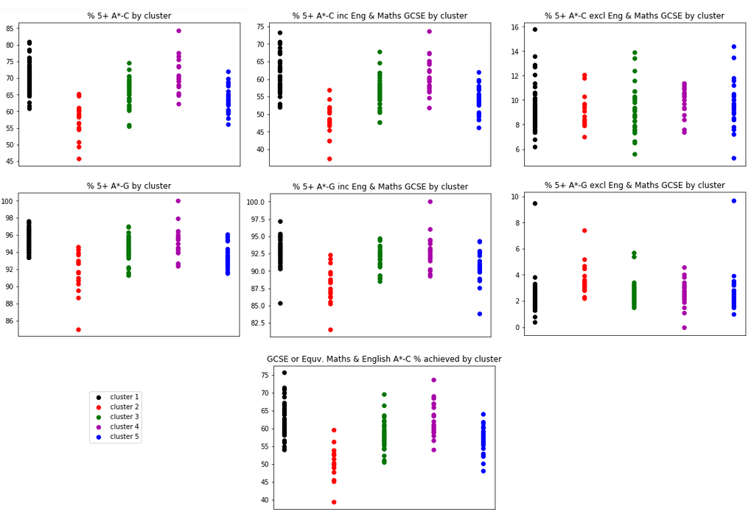Illustration 2 Results spread by cluster. One dot represents one local authority.
Displaying KS4 data by deprivation groupings (Illustration 2 above) almost universally showed a clear and limited range of values, with occasional outliers. This provides some indication that the clusters themselves are of some value outside the data that generated them. 5+ A*-Cs without both English and Maths, in the top right of the illustration, shows what is to be expected if the clusters have little to no correlation to the data series values: cluster ranges span most of the full data range, and they appear to be on about the same vertical level. Contrast this with the clear patterning in the other data: clusters take a specific and continuous subset of the full range of values (with some outliers), and they have their median (approximately the middle of the vertical line) at different values and therefore different heights in the graph.

These graphs demonstrate a marked difference in median between cluster 1 (low deprivation) and cluster 2 (high deprivation), with cluster 1 showing consistently higher achievement and cluster 2 consistently lowest. They also show that medium deprivation areas, clusters 3, 4, and 5, fall in ranges closer to the least deprived areas in the area of KS4 achievement. Cluster 4's lower education and skills deprivation is reflected in its KS4 data ranges generally being closer that that of cluster 2, but cluster 5's higher education and skills deprivation does not appear to mark it significantly from cluster 3. This shows that it is the cluster of most deprived areas, cluster 2, where overall deprivation and low KS4 achievement is linked; it is less so in clusters 3 and 5, and does not have a significant effect at all in cluster 4. Targeting “more deprived” areas based on the IMD alone would miss this distinction.

Potential issues with these results

Outliers
A few repeated outliers from their cluster were identified:
Name | Under/Over  Expectations | Comments
The Isles of Scilly | Over | An obviously unique area, with very high attainment percentages. This is the output of a single school catering to a small population
Southend-on-Sea | Over | Both are slightly over-performing outliers from their cluster in high (A*-C) English and Maths achievement.
Slough | Over
Knowsley | Under | Significant educational underachievement in all examined areas, the lowest in the country.
Rochdale | Under | All are slightly under-performing outliers from their respective clusters.
Bexley | Under
Salford | Under
Table 3: Outliers

Removing these outliers and running correlation data again in most cases slightly weakened the correlation strengths (see table 2 above). This would indicate that they are outliers from their cluster, but not the overall KS4 achievement and IMD patterns. The only significant effect of removing them was a considerable strengthening of the correlation between 5+ passes without both English and Maths, again emphasising that particular data connection.

Non-independence of data
Despite the data having come from two different areas of investigation, it is likely that the IMD and KS4 attainment data are not fully independent. The IMD's domain of Education, Skills and Training Deprivation likely involved similar underlying data to that used for the KS4 attainment data. This in turn already links IMD and KS4 attainment through the way the two datasets are constructed and may cause false or strengthened correlations. In addition, as deprivation and education are both complex social topics with many factors acting upon them, there may be many confounding factors not present in either dataset. The impact of these factors is hard to determine without considerable further investigation.

Reflection
A pandas dataframe was used to store and manipulate the main data. This was appropriate due to the small scale, complete, tabular, and mostly numeric or short string form of the data. It did not contain any complex system of inter-referencing, which would have made a database format more appropriate to handle navigating these data links, and it did not have the properties of variable format or inconsistently typed data that would make a document database solution ideal.

The completeness and consistent format of the data made it easy to work with, once matching GSS codes had been found between datasets. My initial assumption of what would be the best matching IMD data file was incorrect, and I had to go back and check other files then load the correct one in and shape and clean it again. The KS4 data required quite a bit of cleaning as it was formatted for easy reading in a spreadsheet, not easy import into a pandas dataframe.

At first I was unsure if data mining for types of deprivation would produce anything of use to the investigation, and I was prepared to abandon it if it did not and note only the lack of results. However it turned out that it did produce clear and relevant results, if hindered by the lack of strict repeatability. Visualising this data on maps was immensely helpful in understanding the links between areas in the same clusters. This involved research into how to produce these maps, and the sourcing and using of the borders data (and issues with requesting the information for Dorset from the APIs automatically, which were eventually resolved with a manual import of the relevant GeoJSON data). I may have been able to use point markers at area centroids if I had been unable to achieve this, but the clearness and visual impact would have been lessened. Producing a full map of all borders was not possible on the OU remote server and inevitably caused a web browser crash, so illustration 1 had to be composited from two Folium map outputs in image editing software.

References

UK Government (2015) 'The English Index of Multiple Deprivation (IMD) 2015 –Guidance' [Online]. Available at https://assets.publishing.service.gov.uk/government/uploads/system/uploads/attachment_data/file/464430/English_Index_of_Multiple_Deprivation_2015_-_Guidance.pdf (Accessed 23rd May 2021)

UK Government (2015) 'English indices of deprivation 2015' [Online]. Available at https://www.gov.uk/government/statistics/english-indices-of-deprivation-2015 (Accessed 23rd May 2021)

UK Government (2015) 'Frequently asked questions' [Online]. Available at https://assets.publishing.service.gov.uk/government/uploads/system/uploads/attachment_data/file/579151/English_Indices_of_Deprivation_2015_-_Frequently_Asked_Questions_Dec_2016.pdf (Accessed 23rd May 2021)

UK Government (2015) 'Revised GCSE and equivalent results in England: 2014 to 2015' [Online].
Available at https://www.gov.uk/government/statistics/revised-gcse-and-equivalent-results-in-england-2014-to-2015 (Accessed 23rd May 2021)

UK Government (2018) 'Counties (December 2018) Boundaries EN BFC' [Online]. Available at https://geoportal.statistics.gov.uk/datasets/counties-december-2018-boundaries-en-bfc (Accessed 23rd May 2021)

UK Government (2018) 'Local Authority Districts (December 2018) Boundaries GB BFC' [Online]. Available at https://geoportal.statistics.gov.uk/datasets/local-authority-districts-december-2018-boundaries-gb-bfc (Accessed 23rd May 2021)

Appendix 1: Notebooks

Notebook | Contents
C8867951_project_diary | Full investigation process
Data Acquisition And Cleaning | A streamlined version of the data acquisition, loading and cleaning process found in the project diary.
Diagrams | Used to produce the diagrams in this report. Also includes renumbering of clusters to the labels given in this report.

