Emily Longman and Ehmar Khan

Group 14

1/13/17

CS 352

Homework 1

# Design Principles - Notepad

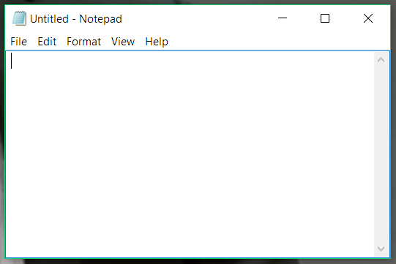

### Support of principles:

* Visibility
  + Notepad is a pretty light and barebones application to begin with, but the blinking cursor that is immediately present makes it fairly obvious that the user should just start typing. The drop-down menus to make any setting changes are also easily visible, and sorted into categories so that the menu bar isn’t overcrowded. Because it’s such a clean and simple program, the work that the user puts into it is also more visible since it isn’t cluttered with lots of menus or tools.
* Feedback
  + Once again, because this is such a lightweight program the feedback is pretty basic, but works well. When one types the letters, they immediately appear on the screen like any standard text editor should. The program has been around for nearly two decades so it has been refined to work smoothly on most systems.
* Constraints

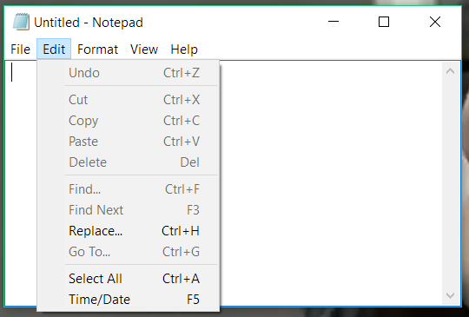

* + Notepad uses some classic constraint techniques such as greying out non-applicable menu options as seen in the screenshot above. It is also constrained to being only plaintext since one could not copy and paste an image into it. Similarly, when you go to save the file it will only suggest the .txt file extension since others would likely not work as the user intended.

* Consistency
  + One of the principles that notepad best represents is consistency. The menus and behavior are like that of almost all other standard text editors. The drop-down menus are arranged in a way that the user is used to and the text is displayed as expected. Standard keyboard shortcuts such as Ctrl+C also all work, allowing the user some immediate fluency with the program if they’ve used other text editors previously.
* Affordance
  + Some of the examples listed in the above principle are also forms of affordance. If the user has ever typed on a computer before they are likely to know how to use it. Even if they don’t, the keyboard physically has the affordance of buttons that look like they should be pressed, producing the character or action printed on them. The standard blinking cursor is also an affordance that tells the user the program is waiting for text input, so it’s obvious they should type in it. Even just the name of the program, notepad, suggest that is something like the digital equivalent of a sticky note; it’s not formatted, but can be filled with whatever text the user wishes.

### Violation of principles:

* Visibility

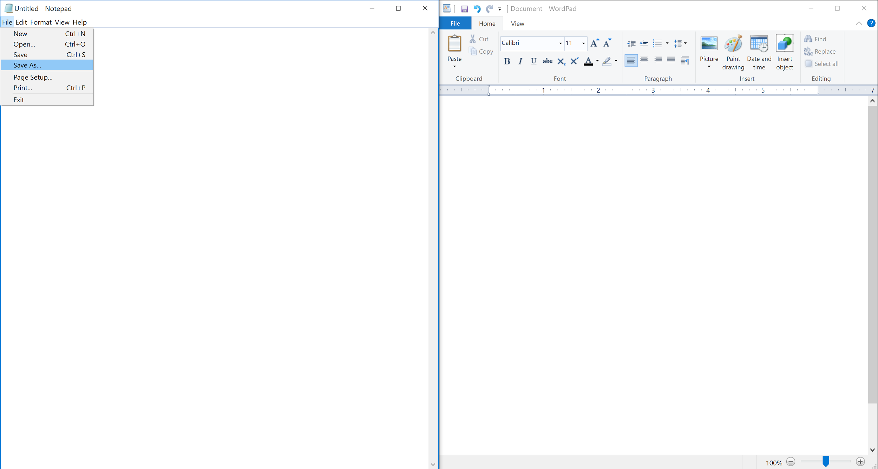

* + When we open a notepad document it looks like a big white page with just five tabs at the top which isn't really pretty and doesn't provide us with much options for interacting with the document. In contrast to some other application, eg. Microsoft Wordpad, the formatting options are not visible right away and if we need to change the font style or size we will first need to select the format option at the top. Also, it is not obvious what we are supposed to do with the document after we are finished with it, as there is no visible quick save button or any other option that makes the document available for future reference. Again, we'll need to select the files tab before we can access this option.
* Feedback
  + Although notepad is supposed to be a very simple program, its sole purpose is to help us document and so there should be more options for interacting with what we type other than a just a ‘word wrap’ or ‘font’ option in the ‘format’ tab. As mentioned earlier, the application looks dull and it’d certainly have more users today if it looked more colorful or be more attractive by any other means.
* Constraints
  + When we start typing into a notepad document we have to capitalize the very first letter manually, as it is a small letter by default, which shouldn’t be the case. It doesn’t highlight or auto-correct syntactically incorrect words. In some areas, the application has more constraints than it needs, which can be inconvenient for the user. For example, there is an undo option but there is no redo option, unlike the Wordpad. The ‘view’ tab only has a ‘status bar’ option which we can’t even select, as it is greyed out.
* Consistency
  + Although it provides the basic functionalities of a text editor that most users are used to, the application has some inconsistencies that can make a user’s work prone to errors. It’s possible that it was intended to look like a simple editor with a compact design. However, most text editors have many of the functionalities directly visible in the top, and so a new notepad user may initially assume that these options are not present in the application at all. Also, like mentioned earlier, the notepad doesn’t highlight misspelled words or let us ‘redo’ our work, unlike many other text editors.
* Affordance
  + The application provides affordance in terms of letting us document at a very basic level, but as mentioned above, it has very few editing/formatting options (relatively) which aren’t even directly visible. A list of options which can be activated by keyboard shortcuts are hidden in the ‘edit’ tab, which the user needs to look for if he/she is not already familiar with these shortcuts. Also, it only lets us save a document as a ‘.txt’ file.