Chess Course Notes
Basics se pro tak · 8 levels · 70 lessons
Har lesson ka saar, board diagrams, abhyaas positions aur sawal-jawab. Har sawal ke neeche jawab diya hai: padhne se pehle khud socho.
Fehrist (contents)
- Level 1: Shuruaat: board, pieces aur rules
  - 1.1 Chess ki soch: shuruaat se pehle
  - 1.2 Chessboard ko jaano
  - 1.3 Pieces kaise chalte hain
  - 1.4 Special moves
  - 1.5 Check, checkmate, stalemate
  - 1.6 Jeet aur draw ke tareeke
  - 1.7 Pieces ki keemat aur trades
  - 1.8 Notation: moves likhna aur padhna
  - 1.9 Tournament rules, clock aur ratings
- Level 2: Pehli jeet: mate, safety aur opening
  - 2.1 Queen se mate (K+Q vs K)
  - 2.2 Rook se mate (K+R vs K)
  - 2.3 Do rooks aur Queen+Rook se mate
  - 2.4 Hanging pieces aur safety
  - 2.5 Samajhdaari se capture
  - 2.6 Opening ke 10 principles
  - 2.7 Shuruaati traps aur pitfalls
  - 2.8 Sochne ka tareeka: forcing moves (CCT)
- Level 3: Middlegame 1: Tactics
  - 3.1 Middlegame mein sochne ki process
  - 3.2 Fork (do pe ek saath attack)
  - 3.3 Pin
  - 3.4 Skewer
  - 3.5 Discovered attack aur double check
  - 3.6 Defender hatao aur overloading
  - 3.7 Deflection aur decoy
  - 3.8 Interference, clearance, x-ray, zwischenzug
  - 3.9 Calculation ke 3 golden rules
  - 3.10 Calculation aur visualization
- Level 4: Middlegame 2: Checkmate patterns
  - 4.1 Mate patterns: shuruaat aur mate ki kala
  - 4.2 Back-rank mate
  - 4.3 Smothered mate aur Philidor's legacy
  - 4.4 Rook aur knight/bishop ke mate patterns
  - 4.5 Queen, bishop aur pawn ke mate patterns
- Level 5: Middlegame 3: Strategy aur plan
  - 5.1 Position ke elements aur exchanges
  - 5.2 Pawn structure
  - 5.3 Pawn structure: gehraai se
  - 5.4 Weak squares aur outposts
  - 5.5 Open files, 7th rank, piece activity
  - 5.6 Plan kaise banayein
  - 5.7 Prophylaxis aur restriction
  - 5.8 Positional sacrifices
- Level 6: Openings: shuruaat mazboot
  - 6.1 Opening ke ideas
  - 6.2 Opening systems
  - 6.3 Italian Game
  - 6.4 Ruy Lopez (Spanish)
  - 6.5 Sicilian Defense
  - 6.6 French aur Caro-Kann
  - 6.7 Queen's Gambit aur Slav
  - 6.8 Indian defenses aur English
  - 6.9 Gambits
  - 6.10 Advanced opening traps
  - 6.11 Apna repertoire banao
- Level 7: Endgames: jeet pakki karo
  - 7.1 Endgame ke bade themes
  - 7.2 Do bishops se mate
  - 7.3 King aur pawn: opposition
  - 7.4 Square rule aur triangulation
  - 7.5 Pawn endgame tricks
  - 7.6 Rook endgames: Lucena aur Philidor
  - 7.7 Minor pieces aur theory
- Level 8: Pro level: practical chess
  - 8.1 Deep calculation
  - 8.2 Time management
  - 8.3 Psychology aur practical play
  - 8.4 Apne games analyse karo
  - 8.5 Improve aur jeetne ke tips
  - 8.6 Master games aur chess ka itihaas
  - 8.7 World champions: Anderssen se Euwe tak
  - 8.8 World champions: Botvinnik se Kasparov tak
  - 8.9 The Queen's Gambit series se sabak (1)
  - 8.10 The Queen's Gambit series se sabak (2)
  - 8.11 Opening, middlegame aur endgame ke famous quotes
  - 8.12 Elo badhane ka training plan

Level 1: Shuruaat: board, pieces aur rules
Chess ki soch, board, pieces ki chaal, special moves, check-mate, jeet-draw, notation, tournament rules
- Yahan se chess ki neev banegi.
- Har cheez board par khud kar ke seekhoge.
- Jaldi mat karo: yeh basics pakke hue to aage sab aasaan lagega.

1.1 Chess ki soch: shuruaat se pehle
Quotes, growth mindset, game ke 3 hisse, seekhne ka model
Yaad rakho
- Har master kabhi beginner tha (Chernev). Haar se jeet se zyada seekhte ho (Capablanca).
- Achhi chaal dikhe to ruko, behtar chaal dhundo (Lasker).
- Game ke 3 hisse: opening, middlegame, endgame.
- Concentric circles model: pehle principles, phir processes aur patterns, phir details aur exceptions.
- Checkmate sab se upar: mate mil raha ho to queen bhi de sakte ho.

1.1.1 Chess ke famous quotes
- "Har chess master kabhi beginner tha." (Irving Chernev, "Logical Chess Move by Move" ke lekhak)
- "Chess, pyaar aur music ki tarah, insaan ko khush kar sakta hai." (Siegbert Tarrasch)
- "Chess dimaag ka gymnasium hai": roz khelna = roz dimaag ki kasrat.
- "Jeet se zyada haar se seekhte ho. Achha banne se pehle saikdon games haarne padenge." (Capablanca)
- "Achhi chaal dikhe to bahut khush mat ho. Ruko aur behtar chaal dhundo." (Emanuel Lasker)
- "Achha player hamesha lucky hota hai." (Capablanca): jitna strong, utna "luck".
- "Narm dil se chess nahi khel sakte." (French kahavat): jeetne ki zid chahiye, darr ke draw mat lo.
- "Blunders board par intezaar kar rahe hain." aur "Jeetta woh hai jo aakhri se pehli galti karta hai." (Tartakower)

1.1.2 Sawal 1: Lasker ki salah
Lasker ki salah: achhi chaal dikhe to kya karo?
Jawab:
✓ Ruko aur behtar chaal dhundo
- Pehli achhi chaal aksar best nahi hoti.
- Ek second aur socho.

1.1.3 Sawal 2: Tartakower ke hisaab se game kaun jeetta hai?
Tartakower ke hisaab se game kaun jeetta hai?
Jawab:
✓ Jo aakhri se pehli galti karta hai
- Dono galtiyan karte hain.
- Jo aakhri galti nahi karta, woh jeetta hai.
- Isliye haar maan ke mat baitho.

1.1.4 Growth mindset: haar = sabak
- Haar ko learning samjho, sharm nahi. Har haare game mein ek sabak chhupa hai.
- Har game ke baad pucho: kahan galti hui, kyun hui, agli baar kya karunga?
- Rating upar-neeche hoti rahegi. Lagaataar seekhte raho, result apne aap aayega.
- Netflix ki "The Queen's Gambit" (2020) series ke baad lakhon naye log chess khelne lage. Online chess (Lichess, Chess.com) se aaj seekhna bahut aasaan hai.

1.1.5 Sawal 3: Ek game haar gaye
Ek game haar gaye. Sabse achha kya hai?
Jawab:
✓ Analyse karo: galti kahan aur kyun hui
- Haar tab hi faydemand hai jab us se seekho.

1.1.6 Game ke 3 hisse
- Opening: pieces bahar laana (development), center, castling. Aksar pehli 10-15 chaal.
- Middlegame: dono taraf castle ho chuke, queens board par. Plans, attack, tactics. Creativity yahan sabse zyada.
- Endgame: bahut pieces trade ho chuke. King bahar aakar ladta hai (mate ka khatra kam), aur pawns (promotion) sabse important.
- Example: Uhlmann vs Fischer (1970): Modern Benoni opening, Fischer ne middlegame mein tactic se pawn jeeta, phir endgame mein king active karke jeeta.

1.1.7 Sawal 4: Queens trade ho gayi, kuch hi pieces bache, kings center ki taraf…
Queens trade ho gayi, kuch hi pieces bache, kings center ki taraf aa rahe hain. Kaunsa phase?
Jawab:
✓ Endgame
- Kam material + active kings = endgame.

1.1.8 Sawal 5: Endgame mein king ka role?
Endgame mein king ka role?
Jawab:
✓ Active hokar ladna
- Mate ka khatra kam ho jaata hai, isliye king ek taakatwar piece ban jaata hai.

1.1.9 Concentric circles: is course ka seekhne ka model
- Teen gol daayre socho, andar se bahar:
- 1.
- Andar: badi philosophies aur principles.
- Jaise "pehle khud ko haar se bachao, phir attack karo" (development, center, king safety).
- 2.
- Beech: processes (calculation, forcing moves: checks, captures, threats) aur patterns (fork, pin, mate patterns).
- 3.
- Bahar: specific details aur exceptions (opening names, variations, theoretical endgames).
- Opening, middlegame aur endgame teeno ke apne daayre hain.
- Course ke end tak yeh daayre bade karte jaana hai.

1.1.10 Sawal 6: Concentric circles mein sabse andar kya hai?
Concentric circles mein sabse andar kya hai?
Jawab:
✓ Badi philosophies aur principles
- Pehle principles.
- Details baad mein unhe bada karte hain.

1.1.11 Geometry ka jaadu: mate sab se upar
- Pieces ki keemat (queen 9, rook 5, bishop/knight 3) ek guide hai, kanoon nahi.
- Checkmate game khatam kar deta hai, isliye mate ke liye queen bhi de sakte ho.
- Famous "Fox ka masterpiece" game mein White ne pehle queen (Qxg6!!), phir knight (Nxg6) di, aur bishop + rook se mate kiya.
- Chalo ek chhota version khud karo.

1.1.12 Abhyaas: Queen sacrifice karke mate in 2!
Queen sacrifice karke mate in 2!
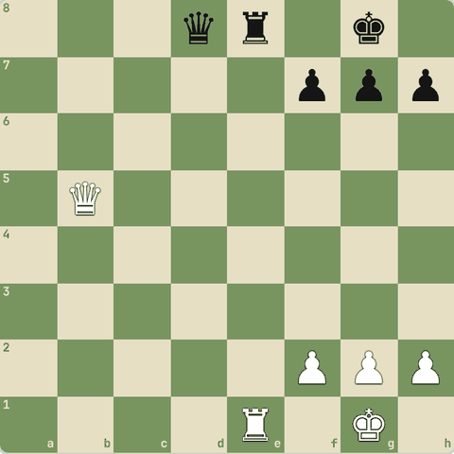
(White ki chaal)
Jawab:
1. Qxe8+ Qxe8 2. Rxe8#
- `1.Qxe8+!
- Qxe8 2.Rxe8#`.
- Queen (9 points) di, par game jeet liya.
- Black king apne hi pawns se band hai (back-rank mate).
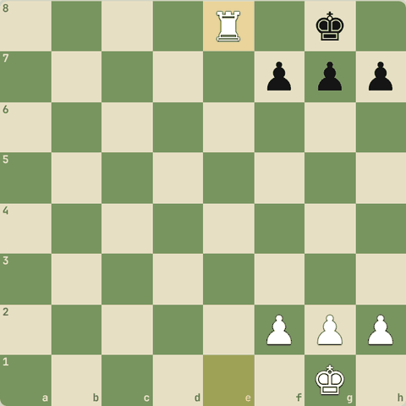
Line ke baad position

1.2 Chessboard ko jaano
Squares, files, ranks, center
Yaad rakho
- Board 8×8 = 64 squares. Light on right: neeche right corner (h1) hamesha light.
- Files = khadi lines a-h, ranks = aadi lines 1-8. Square ka naam = file + rank (e4).
- Center = d4 e4 d5 e5. Center ke pieces zyada squares control karte hain.
- White hamesha pehli chaal chalta hai.
- Pieces ke letters: K king, Q queen, R rook, B bishop, N knight. Pawn ka koi letter nahi.
- Setup: rooks corner, phir knights, bishops. Queen apne colour par (White queen d1, Black queen d8), king uske bagal mein.
- Square colour: a1 dark. (file number + rank) even = dark, odd = light.

1.2.1 Board: 64 squares
- Chessboard mein 8×8 = 64 squares hote hain: 32 light, 32 dark.
- Golden rule: board aise rakho ki right side ke neeche wala corner light square ho.
- ("Light on right")
- White ke pieces neeche (rank 1-2) aur Black ke upar (rank 7-8) se shuru hote hain.
- White hamesha pehli chaal chalta hai.
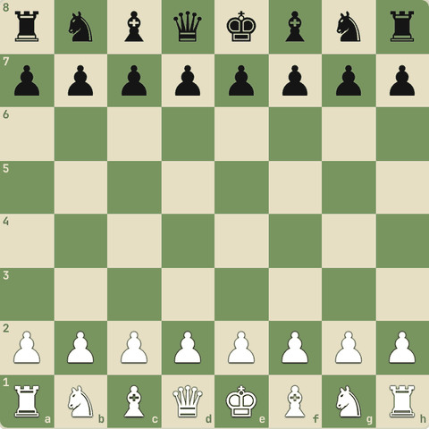

1.2.2 Files aur ranks
- Khadi lines (upar-neeche) ko files kehte hain: a se h tak.
- Aadi lines (left-right) ko ranks kehte hain: 1 se 8 tak.
- Har square ka naam = file + rank.
- Jaise peeli line e-file hai, aur us par ek square hai e4.
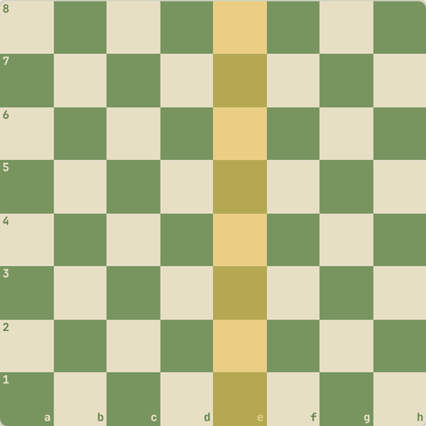

1.2.3 Center sabse important
- Beech ke 4 squares d4 e4 d5 e5 ko center kehte hain.
- Center mein baitha piece zyada squares control karta hai.
- Isliye opening mein sab center ke liye ladte hain.
- Diagonal = tirchhi line, jaise a1 se h8.
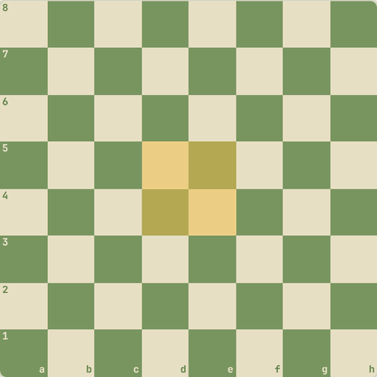

1.2.4 Sawal 1: Kaunsa square light hai?
Kaunsa square light hai?
Jawab:
✓ h1
- "Light on right": White ki taraf right corner h1 light hota hai.
- a1 dark hai.

1.2.5 Sawal 2: e4 mein e kya batata hai?
e4 mein e kya batata hai?
Jawab:
✓ File (khadi line)
- Pehle letter = file (a-h), phir number = rank (1-8).

1.2.6 Pieces ke naam aur setup
- K King, Q Queen, R Rook, B Bishop, N Knight (K pehle se king ke liye hai). Pawn ka koi letter nahi.
- Neeche se: rank 1 par R N B Q K B N R, rank 2 par 8 pawns.
- "Queen apne colour par": White queen light square d1, Black queen dark square d8.
- Dono kings ek hi file (e) par aamne-saamne.
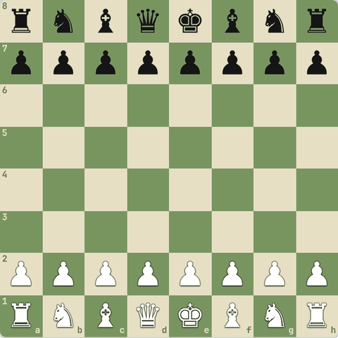

1.2.7 Sawal 3: Notation mein knight ka letter kya hai?
Notation mein knight ka letter kya hai?
Jawab:
✓ N
- K king ke liye hai, isliye knight = N.

1.2.8 Sawal 4: Is setup mein galti kya hai?
Is setup mein galti kya hai?
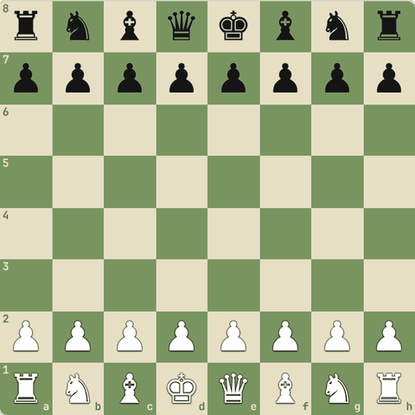
Jawab:
✓ White king aur queen ki jagah ulti hai
- Queen apne colour par: White queen d1 (light) par honi chahiye, king e1 par.

1.2.9 Diagonals
- Tirchhi lines ko diagonal kehte hain.
- Sabse lambi do: a1-h8 aur h1-a8 (8-8 squares).
- Bishop aur queen inhi par chalte hain.
- Ek diagonal ke saare squares ek hi colour ke hote hain.
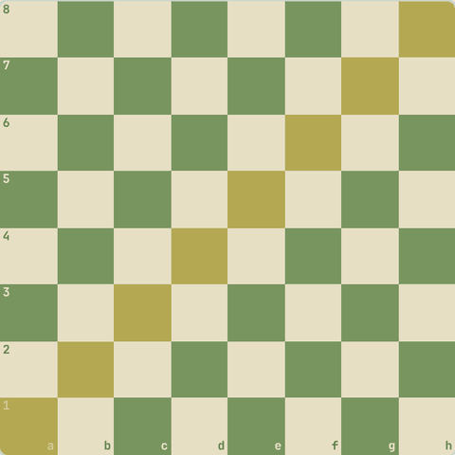

1.2.10 Sawal 5: d5 square kis colour ka hai?
d5 square kis colour ka hai?
Jawab:
✓ Light
- d = 4, rank 5: 4+5 = 9 (odd) = light.
- Yaad rakho: a1 (1+1=2, even) dark hai.

1.2.11 Sawal 6: g7 kis colour ka hai?
g7 kis colour ka hai?
Jawab:
✓ Dark
- g = 7, rank 7: 7+7 = 14 (even) = dark.

1.2.12 Diagram: Har square ka naam (White ki taraf se)
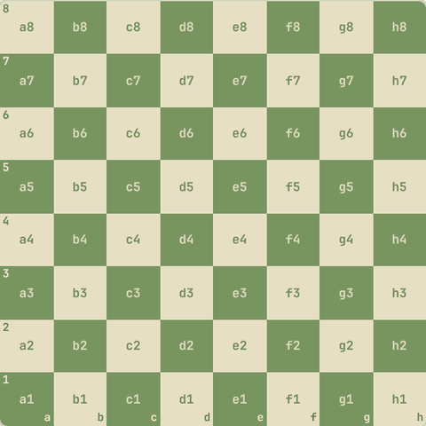
Har square ka naam (White ki taraf se)

1.3 Pieces kaise chalte hain
King, queen, rook, bishop, knight, pawn
Yaad rakho
- Rook seedha (5), bishop tirchha (3), queen dono (9), knight "L" shape (3), king 1 square, pawn aage 1 (pehli baar 2).
- Sirf knight pieces ke upar se kood sakta hai.
- Pawn seedha chalta hai par tirchha capture karta hai, aur kabhi peeche nahi jaata.
- King attack wale square par kabhi nahi ja sakta.
- Center mein pieces sabse taakatwar: knight center mein 8 squares, corner mein sirf 2.
- Pawn aage koi ho to ruk jaata hai (blocked), par tirchha capture kar sakta hai.
- Do kings kabhi bagal mein nahi aa sakte: beech mein kam se kam ek square.
- White hamesha pehli chaal chalta hai.

1.3.1 Rook ♜
- Rook seedha chalta hai: upar, neeche, left, right.
- Jitne marzi squares, jab tak koi raste mein na aaye.
- Value: 5 points.
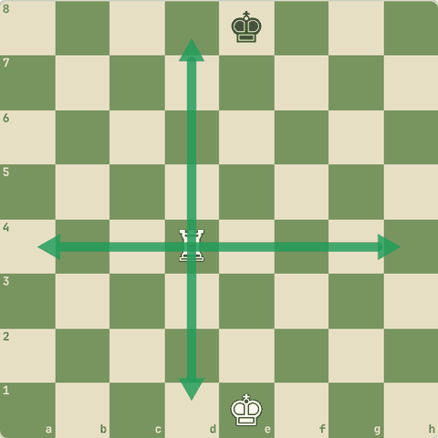

1.3.2 Board par dekho: Rook d4 kahan-kahan ja sakta hai?
Rook d4 kahan-kahan ja sakta hai?
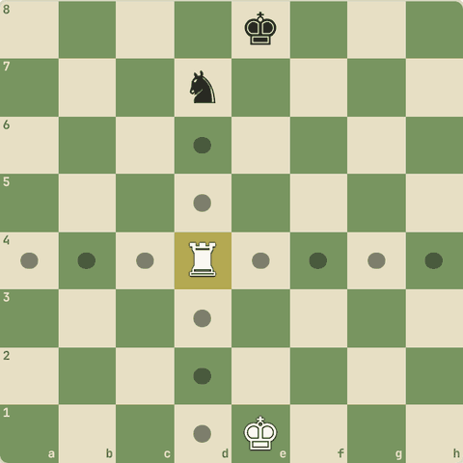
13 squares: a4, b4, c4, d1, d2, d3, d5, d6, d7, e4, f4, g4, h4
- Rook d7 ke knight ko capture kar sakta hai, par uske aage nahi ja sakta.
- Capture karne ke liye dushman ke square par jaate hain.

1.3.3 Bishop ♝
- Bishop sirf diagonal (tirchha) chalta hai.
- Light square wala bishop hamesha light squares par hi rahega.
- Value: 3 points.
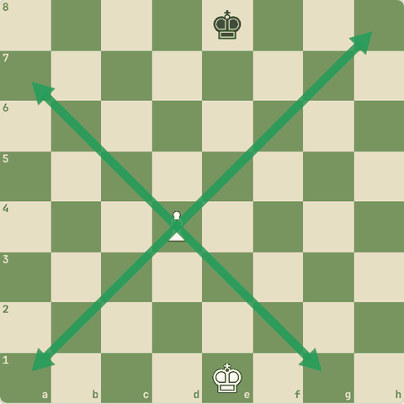

1.3.4 Board par dekho: Bishop c4 kahan ja sakta hai?
Bishop c4
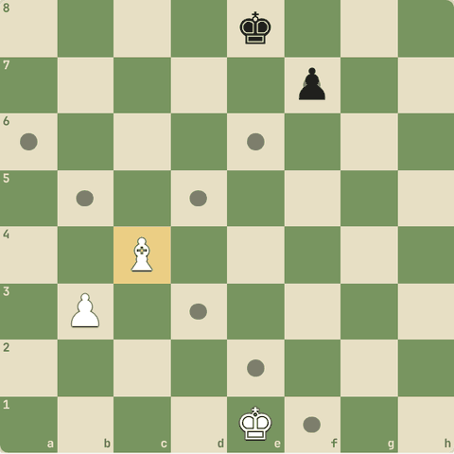
8 squares: a6, b5, d3, d5, e2, e6, f1, f7
- Apna pawn b3 raasta rok raha hai.
- f7 ka black pawn capture ho sakta hai.

1.3.5 Queen ♛
- Queen = rook + bishop.
- Seedha bhi, tirchha bhi.
- Sabse taakatwar piece.
- Value: 9 points.
- Isko faltu mein mat khona!
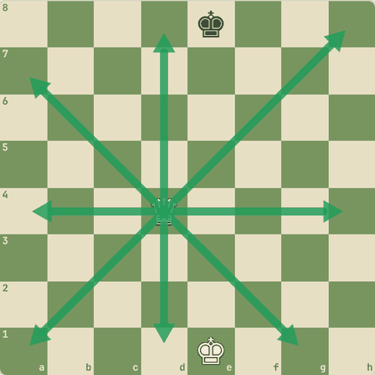

1.3.6 Board par dekho: Queen d4 kahan ja sakta hai?
Queen d4
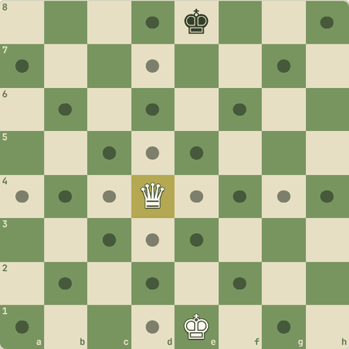
27 squares: a1, a4, a7, b2, b4, b6, c3, c4, c5, d1, d2, d3, d5, d6, d7, d8, e3, e4, e5, f2, f4, f6, g1, g4, g7, h4, h8
- Center mein queen 27 squares tak control karti hai!

1.3.7 Knight ♞
- Knight "L" shape mein chalta hai: 2 square ek taraf, phir 1 square side mein.
- Knight hi akela piece hai jo doosre pieces ke upar se kood sakta hai.
- Har chaal mein woh light se dark (ya dark se light) square par jaata hai.
- Value: 3 points.
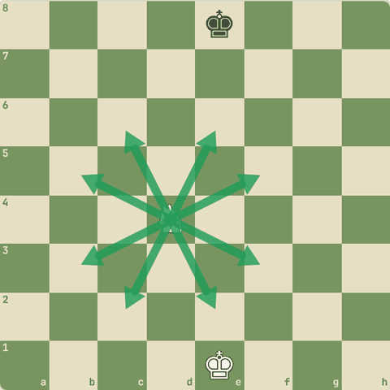

1.3.8 Board par dekho: Knight d4 kahan ja sakta hai?
Knight d4
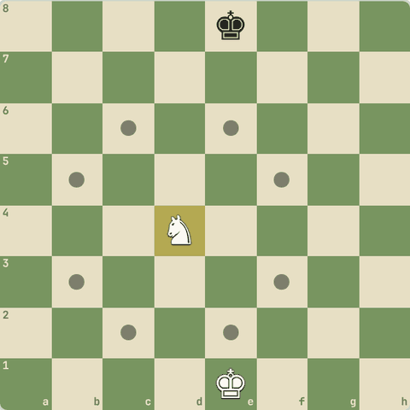
8 squares: b3, b5, c2, c6, e2, e6, f3, f5
- Center mein knight 8 squares, corner mein sirf 2.
- "Knight on the rim is dim": kinare par knight kamzor hota hai.

1.3.9 Board par dekho: Corner wala knight a1
Corner wala knight a1: kitne squares?
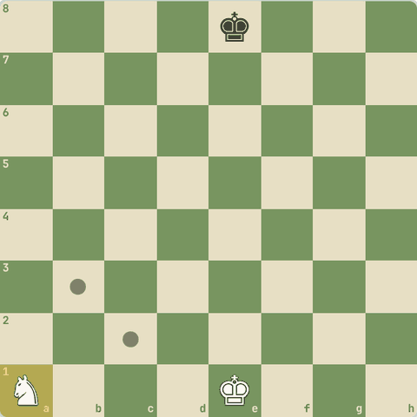
2 squares: b3, c2
- Sirf 2!
- Isliye knights ko center ki taraf lao.

1.3.10 Pawn ♟
- Pawn sirf aage chalta hai, ek square.
- Pehli chaal mein 2 square bhi ja sakta hai.
- Par capture tirchha karta hai (ek square aage diagonal).
- Seedha aage koi ho to pawn ruk jaata hai.
- Pawn kabhi peeche nahi jaata.
- Value: 1 point.
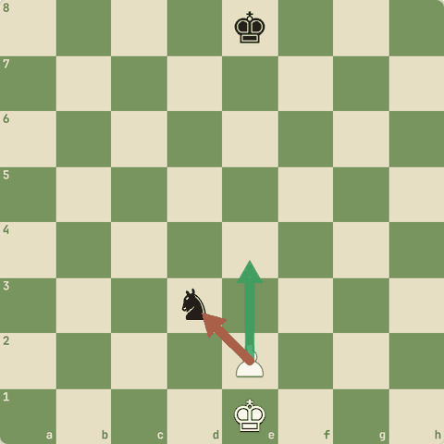

1.3.11 Board par dekho: Pawn e2 kahan ja sakta hai?
Pawn e2 kahan ja sakta hai?
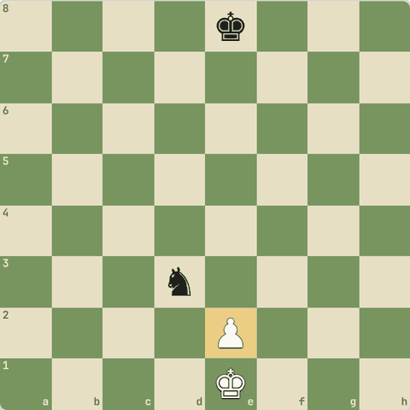
1 squares: d3
- e3, e4 (pehli chaal) aur d3 par knight ko capture.

1.3.12 King ♚
- King har taraf sirf 1 square chalta hai.
- King ko kabhi aise square par nahi le ja sakte jahan dushman attack kar raha ho.
- Yahan black rook poori 5th rank control kar raha hai.
- King ki value infinite hai: king gaya to game gaya.
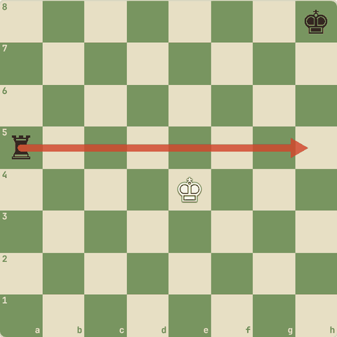

1.3.13 Board par dekho: King e4 kahan ja sakta hai?
King e4 kahan ja sakta hai?
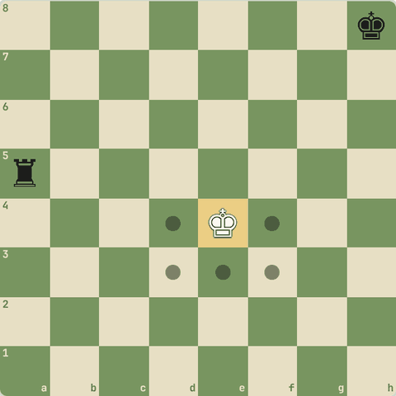
5 squares: d3, d4, e3, f3, f4
- d5, e5, f5 par rook ka attack hai, isliye king wahan nahi ja sakta.

1.3.14 Sawal 1: Kaunsa piece doosre pieces ke upar se kood sakta hai?
Kaunsa piece doosre pieces ke upar se kood sakta hai?
Jawab:
✓ Knight
- Sirf knight jump karta hai.

1.3.15 Sawal 2: Pawn capture kaise karta hai?
Pawn capture kaise karta hai?
Jawab:
✓ Tirchha aage (diagonal)
- Pawn seedha chalta hai par tirchha capture karta hai.

1.3.16 Board par dekho: Pawn e4 aage blocked hai
Pawn e4 aage blocked hai. Kahan ja sakta hai?
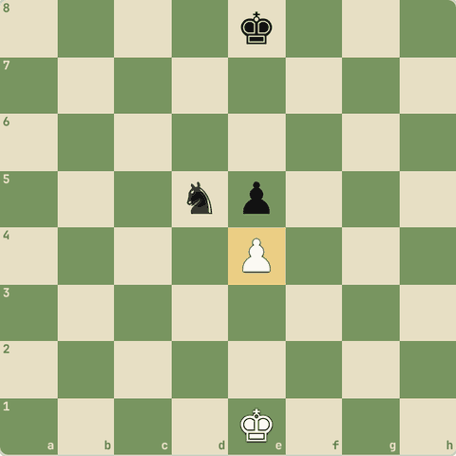
1 squares: d5
- Seedha e5 blocked hai, par tirchha d5 ka knight capture ho sakta hai.

1.3.17 Board par dekho: Shuru ki position
Shuru ki position: knight g1 kahan ja sakta hai?
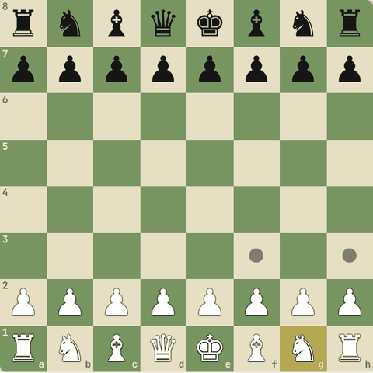
2 squares: f3, h3
- Knight pawns ke upar se kood ke f3 ya h3 ja sakta hai.
- Isliye pehli chaal mein bhi knight chal sakta hai.

1.3.18 Board par dekho: Knight d4 apne pawns ke upar se koodta hai
Knight d4 apne pawns ke upar se koodta hai.
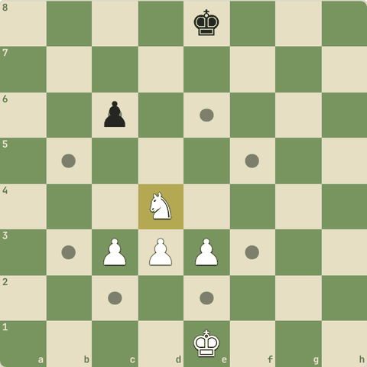
8 squares: b3, b5, c2, c6, e2, e6, f3, f5
- Apne pawns raasta nahi rokte, knight koodta hai.
- c6 ka pawn capture ho sakta hai.

1.3.19 Board par dekho: Bheed wale board par rook b4
Bheed wale board par rook b4: kahan-kahan?
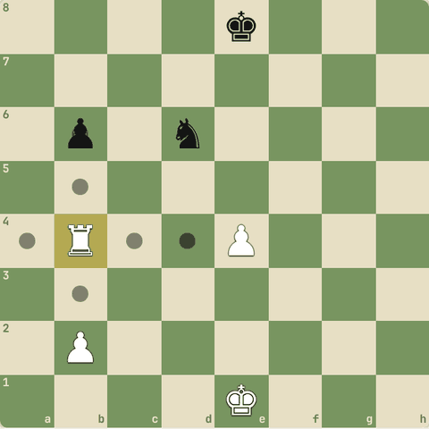
6 squares: a4, b3, b5, b6, c4, d4
- Apna pawn (b2, e4) raasta rokta hai.
- Dushman (b6) ko capture karke wahin rukna padta hai.

1.3.20 Board par dekho: Kings aamne-saamne
Kings aamne-saamne: King d3 kahan ja sakta hai?
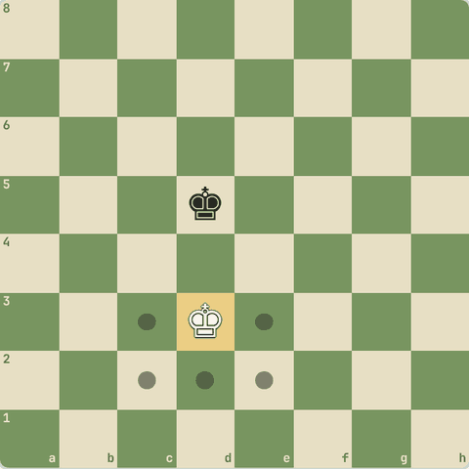
5 squares: c2, c3, d2, e2, e3
- c4, d4, e4 black king ke bagal mein hain.
- Do kings kabhi bagal mein nahi aa sakte.

1.3.21 Sawal 3: Kaunsa piece poore game mein ek hi colour ke squares par rehta hai?
Kaunsa piece poore game mein ek hi colour ke squares par rehta hai?
Jawab:
✓ Bishop
- Bishop sirf diagonal chalta hai, isliye colour kabhi nahi badalta.

1.3.22 Sawal 4: Kaunsa piece har chaal mein colour badalta hai?
Kaunsa piece har chaal mein colour badalta hai?
Jawab:
✓ Knight
- Knight ki L-shape chaal hamesha light se dark ya dark se light.

1.3.23 Sawal 5: Game mein pehli chaal kaun chalta hai?
Game mein pehli chaal kaun chalta hai?
Jawab:
✓ White
- Hamesha White.

1.4 Special moves
Castling, en passant, promotion
Yaad rakho
- Castling: king 2 square rook ki taraf, rook doosri taraf. O-O kingside, O-O-O queenside.
- Castling tab nahi: king/rook pehle chal chuke, beech mein piece, king check mein, ya king attacked square se guzre.
- En passant: dushman pawn 2 square chal kar bagal mein aaye to turant agli chaal mein capture.
- Promotion: aakhri rank par pawn queen/rook/bishop/knight banta hai. Kabhi knight (underpromotion) best hota hai.
- Castling ki philosophy: pehle king safe karo, phir attack ("put yourself beyond defeat").
- Queenside castling mein b1 (ya b8) attack mein ho tab bhi castle ho sakta hai: king us square se nahi guzarta.
- En passant Black bhi kar sakta hai, aur promotion capture karke bhi hota hai.

1.4.1 Castling: king ki suraksha
- Castling mein ek hi chaal mein king 2 square rook ki taraf jaata hai, aur rook king ke doosri taraf aa jaata hai.
- Kingside: O-O (king g1, rook f1)
- Queenside: O-O-O (king c1, rook d1)
- Shart: king aur rook pehle kabhi na chale hon, beech mein koi piece na ho, king check mein na ho, aur king jis square se guzre ya pahunche woh attack mein na ho.
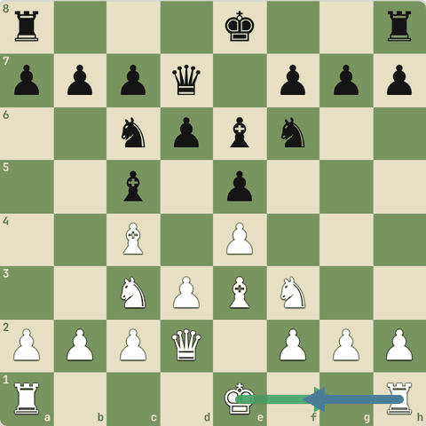

1.4.2 Abhyaas: Kingside castle karo (O-O)
Kingside castle karo (O-O). King ko g1 par tap karo.
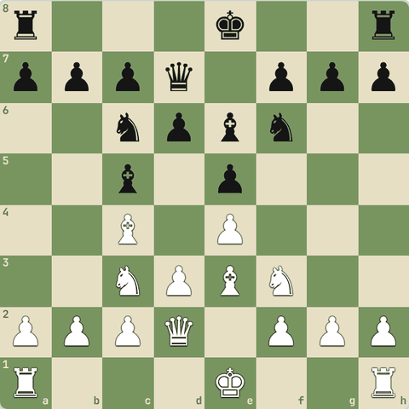
(White ki chaal)
Jawab:
1. O-O
- King ab safe corner mein hai aur rook center ki taraf aa gaya.
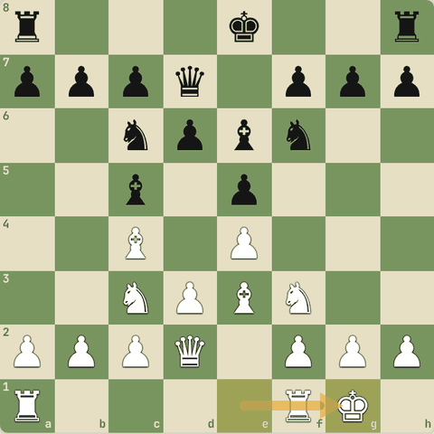
Chaal ke baad

1.4.3 Sawal 1: Kya White yahan kingside castle kar sakta hai?
Kya White yahan kingside castle kar sakta hai?
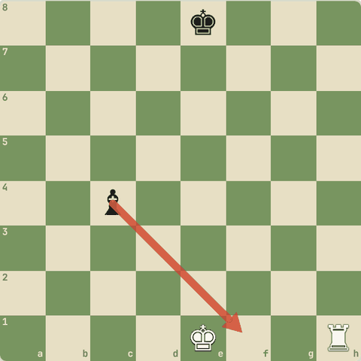
Jawab:
✓ Nahi: f1 attack mein hai
- King f1 se guzrega, aur c4 ka bishop f1 ko attack kar raha hai.
- Isliye castling allowed nahi.

1.4.4 En passant
- Agar dushman ka pawn 2 square chal kar tumhare pawn ke bilkul bagal mein aa jaaye, to tum use aise capture kar sakte ho jaise woh 1 hi square chala ho.
- Ise en passant kehte hain.
- Yeh sirf turant agli chaal mein hi ho sakta hai.
- Yahan Black ne abhi d7-d5 khela.
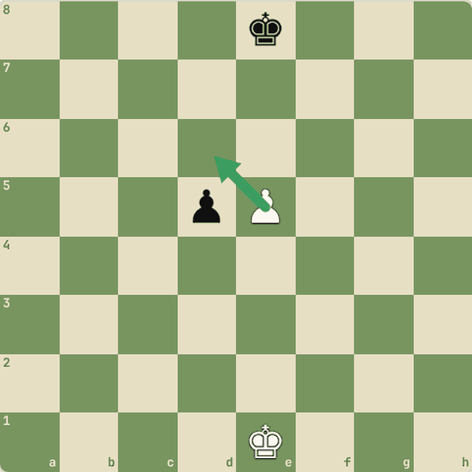

1.4.5 Abhyaas: En passant karo
En passant karo: e5 pawn se d6 par capture.
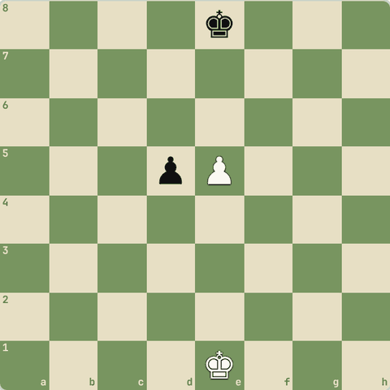
(White ki chaal)
Jawab:
1. exd6
- Pawn d6 par gaya aur d5 ka black pawn board se hat gaya.
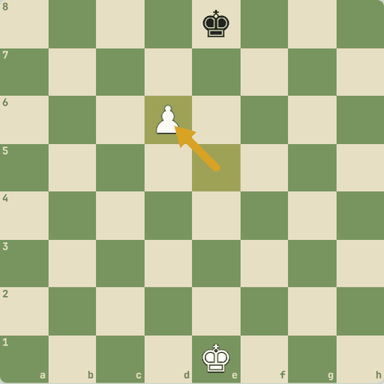
Chaal ke baad

1.4.6 Promotion
- Pawn jab aakhri rank (White ke liye 8th) par pahunchta hai, to woh queen, rook, bishop ya knight ban jaata hai.
- Zyadatar queen banate hain.
- Isliye endgame mein pawns bahut keemti ho jaate hain.
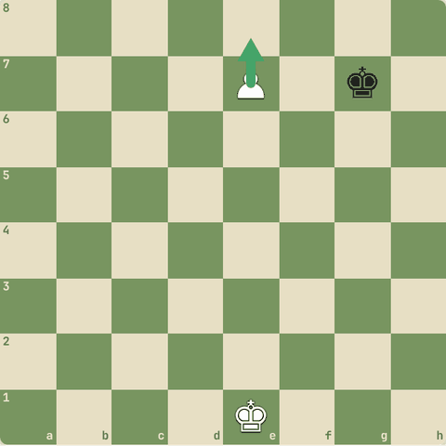

1.4.7 Abhyaas: Pawn ko queen banao
Pawn ko queen banao.
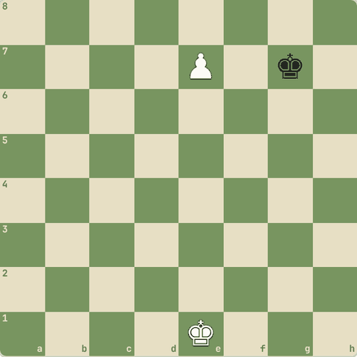
(White ki chaal)
Jawab:
1. e8=Q
Ye bhi sahi: e8=R
- Ab White ke paas queen hai, aur yeh jeetne wali position hai.
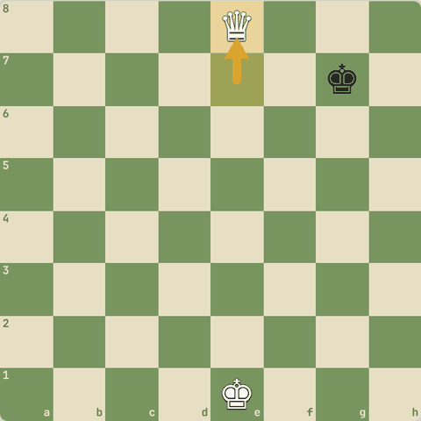
Chaal ke baad

1.4.8 Abhyaas: Kabhi queen nahi, knight banana better hota hai!
Kabhi queen nahi, knight banana better hota hai! Sabse achhi chaal dhundo.
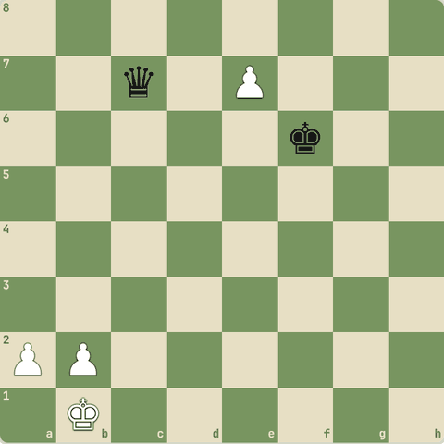
(White ki chaal)
Jawab:
1. e8=N+ Ke5 2. Nxc7
- e8=N+ check deta hai aur c7 ki queen par bhi attack karta hai (fork).
- King hatega, phir knight queen le lega.
- Ise underpromotion kehte hain.
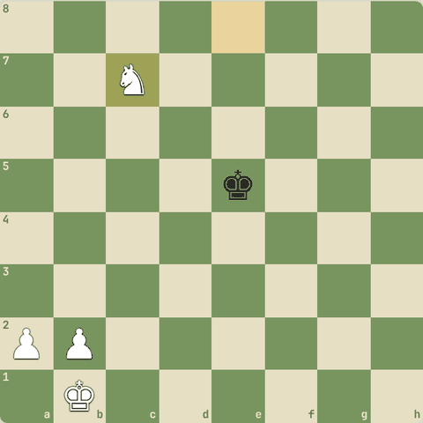
Line ke baad position

1.4.9 Castling kyun?
- Purani salah: "Pehle khud ko haar se bachao, phir attack karo." Castling se king center se hat kar pawns ke peeche safe ho jaata hai, aur rook game mein aa jaata hai.
- Isliye opening mein jaldi castle karo.

1.4.10 Abhyaas: Kya yahan queenside castle ho sakta hai?
Kya yahan queenside castle ho sakta hai? b1 attack mein hai! Agar ho sakta hai, to karo.
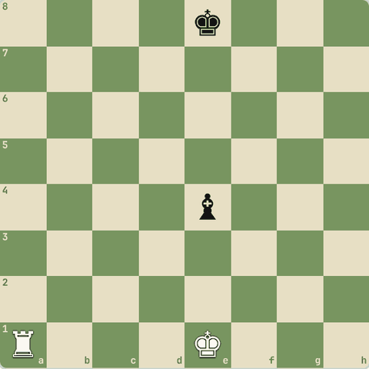
(White ki chaal)
Jawab:
1. O-O-O
- Haan!
- King e1, d1, c1 ko chhoota hai, b1 ko nahi.
- Sirf rook b1 se guzarta hai, aur rook ke liye attack se farak nahi padta.
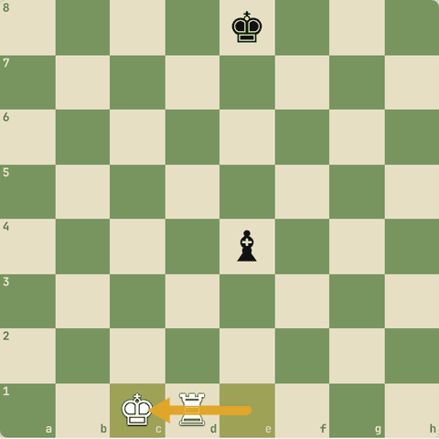
Chaal ke baad

1.4.11 Sawal 2: Kya White kingside castle kar sakta hai?
Kya White kingside castle kar sakta hai?
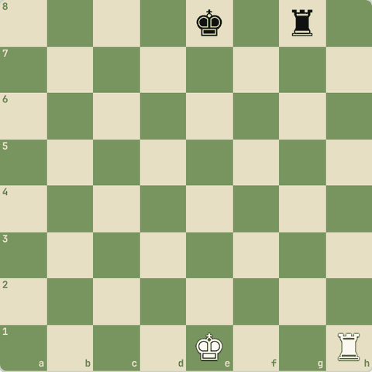
Jawab:
✓ Nahi: king g1 par check mein aa jaayega
- Black rook g8 poori g-file control karta hai.
- Castling se check mein jaana allowed nahi.

1.4.12 Sawal 3: Kya White kingside castle kar sakta hai?
Kya White kingside castle kar sakta hai?
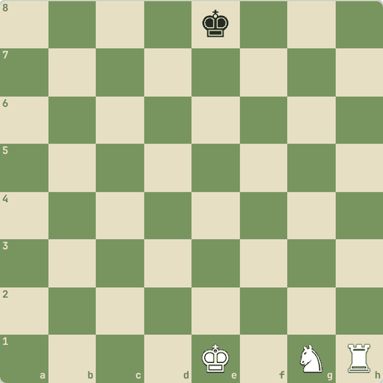
Jawab:
✓ Nahi: beech mein knight hai
- King aur rook ke beech saare squares khaali hone chahiye.
- Pehle Ng1 ko develop karo.

1.4.13 Sawal 4: White king check mein hai
White king check mein hai. Kya castle karke check se bach sakta hai?
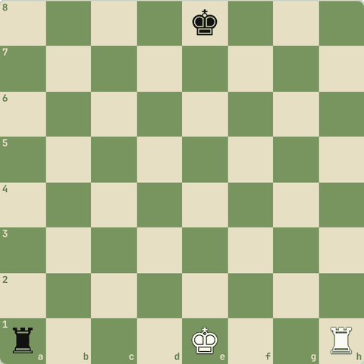
Jawab:
✓ Nahi, check mein castling allowed nahi
- Check se bachne ke liye castling nahi kar sakte.

1.4.14 Sawal 5: King ne pehle ek chaal chali, phir wapas e1 aa gaya
King ne pehle ek chaal chali, phir wapas e1 aa gaya. Ab castling?
Jawab:
✓ Kabhi nahi ho sakti
- King ya woh rook ek baar bhi chal gaya to us taraf castling hamesha ke liye khatam.

1.4.15 Abhyaas: Black ki chaal
Black ki chaal: en passant karo!
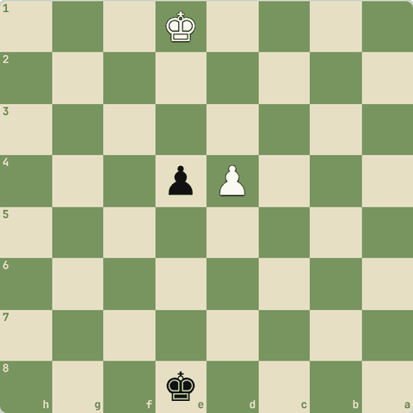
(Black ki chaal)
Jawab:
1… exd3
- White pawn d2-d4 do square chala aur e4 pawn ke bagal mein aaya.
- Black ne turant exd3 se capture kiya.
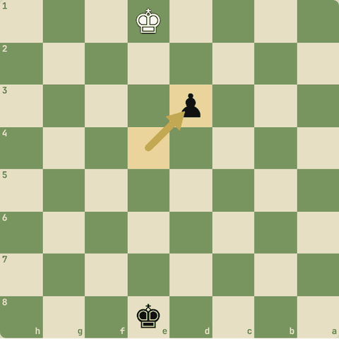
Chaal ke baad

1.4.16 Abhyaas: Capture karke promotion!
Capture karke promotion! Rook lo aur queen banao.
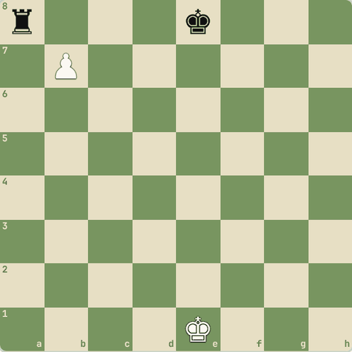
(White ki chaal)
Jawab:
1. bxa8=Q+
- Pawn ne tirchha a8 ka rook capture kiya aur saath mein queen ban gaya, check ke saath.
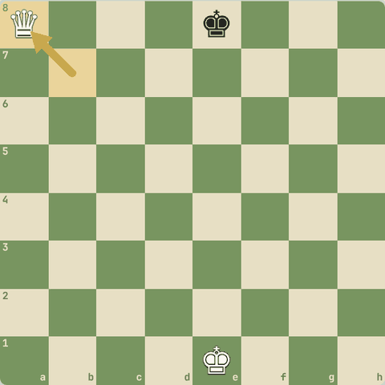
Chaal ke baad

1.5 Check, checkmate, stalemate
Game kaise jeette hain
Yaad rakho
- Check se bachne ke 3 tareeke: king hatao, block karo, attacker ko capture karo.
- Checkmate = check + bachne ka koi raasta nahi = jeet.
- Stalemate = check nahi par koi legal chaal nahi = draw. Jeette waqt iska dhyan rakho!
- Back-rank mate: king apne hi pawns ke peeche band.
- Check har piece de sakta hai: pawn tirchha, knight L se (block nahi ho sakta), rook/bishop/queen line se.
- Double check: sirf king hil kar bachta hai.
- Discovered check: ek piece hata, peeche wale piece ka check khul gaya.

1.5.1 Check
- Jab king par attack ho to use check kehte hain.
- Check se turant bachna zaroori hai. 3 tareeke:
  - King ko hatao safe square par
  - Beech mein piece rakho (block)
  - Attack karne wale piece ko capture karo
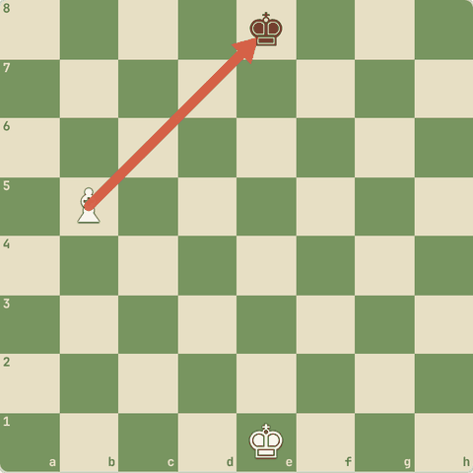

1.5.2 Checkmate = jeet
- Agar king check mein hai aur bachne ka koi tareeka nahi, to yeh checkmate hai.
- Game khatam, jisne mate diya woh jeeta.
- Yahan Black king ke apne pawns hi uska raasta rok rahe hain.
- Ise back-rank mate kehte hain.
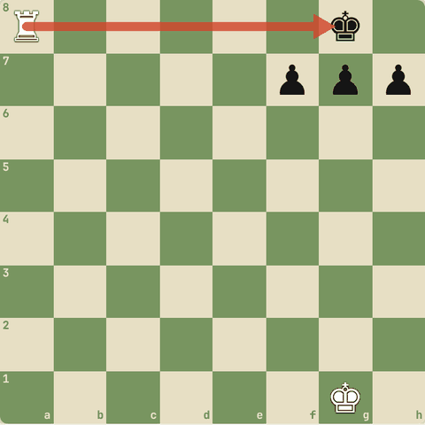

1.5.3 Abhyaas: Mate in 1
Mate in 1: ek chaal mein checkmate karo!
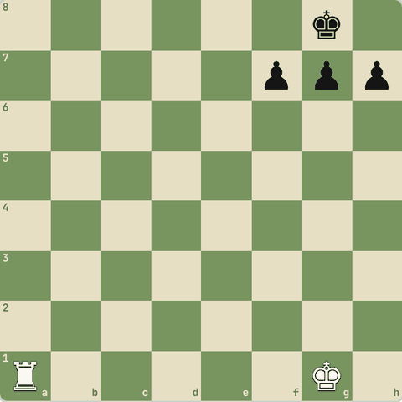
(White ki chaal)
Jawab:
1. Ra8#
- Ra8#: back-rank mate.
- King ke paas koi square nahi.
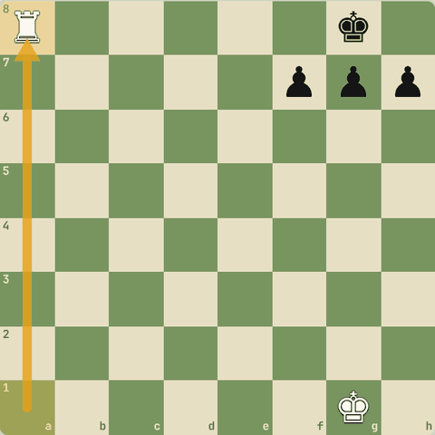
Chaal ke baad

1.5.4 Abhyaas: Mate in 1
Mate in 1: queen aur king ki team-work.
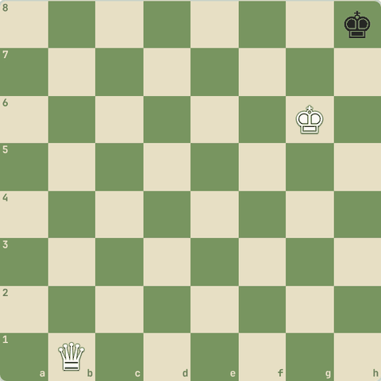
(White ki chaal)
Jawab:
1. Qb8#
- King escape squares band karta hai, queen 8th rank par check deti hai: Qb8#.
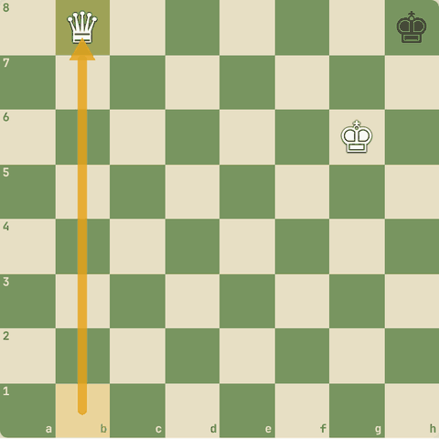
Chaal ke baad

1.5.5 Stalemate = draw!
- Agar jiski chaal hai uska king check mein nahi, par usse koi bhi legal chaal nahi hai, to yeh stalemate hai.
- Stalemate = draw.
- Yahan Black ki chaal hai: king h8 hilega to attack mein aayega, aur koi aur piece nahi.
- Jeeta hua game draw ho gaya!
- Jeetne wale ko is se bachna hai.
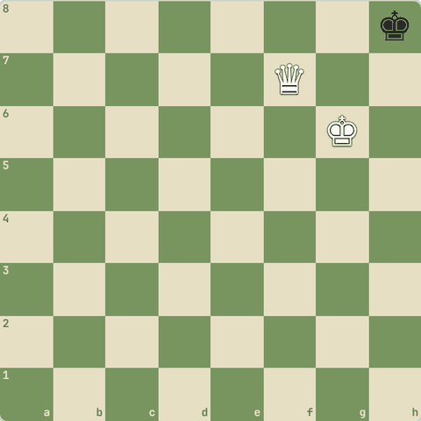

1.5.6 Sawal 1: Black ki chaal hai
Black ki chaal hai. Yeh kya hai?
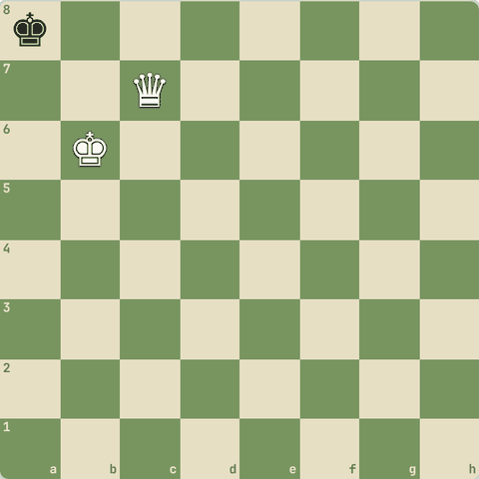
Jawab:
✓ Stalemate
- Black king check mein nahi hai par uski har chaal attack mein jaati hai.
- Koi aur piece nahi, to stalemate (draw).

1.5.7 Abhyaas: Mate karo, stalemate nahi!
Mate karo, stalemate nahi! Dhyan se.
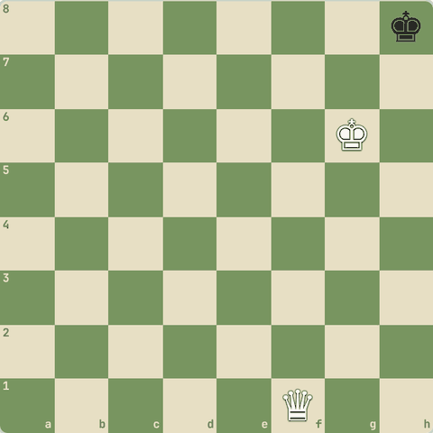
(White ki chaal)
Jawab:
1. Qf8#
- Qf8# check deta hai.
- Agar Qf7 khelte to Black ke paas koi chaal na hoti aur check bhi na hota: stalemate.
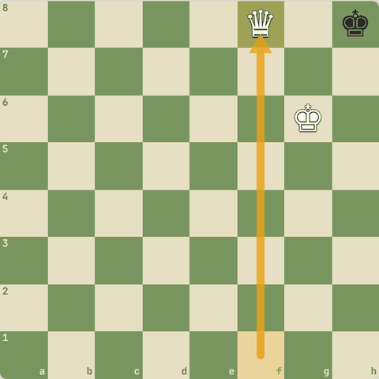
Chaal ke baad

1.5.8 Sawal 2: Check se bachne ka kaunsa tareeka galat hai?
Check se bachne ka kaunsa tareeka galat hai?
Jawab:
✓ Apni koi bhi doosri chaal chalna
- Check mein ho to sirf woh chaal chal sakte ho jo check hataye.

1.5.9 Sawal 3: Black king ko kaun check de raha hai?
Black king ko kaun check de raha hai?
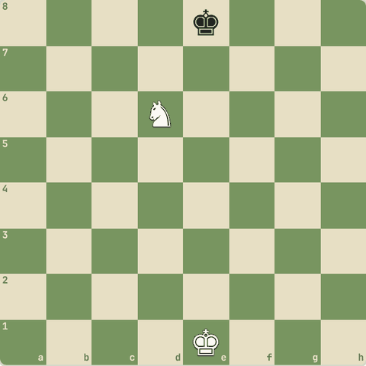
Jawab:
✓ Knight
- Knight d6 se e8 par L-shape.
- Knight ka check block nahi ho sakta: ya king hatao ya knight capture karo.

1.5.10 Abhyaas: Check se bacho
Check se bacho: checking piece ko capture karo.
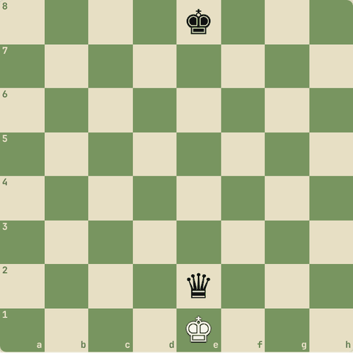
(White ki chaal)
Jawab:
1. Kxe2
- Queen protected nahi thi, isliye king ne khud capture kar liya.
- Protected hoti to king capture nahi kar sakta.
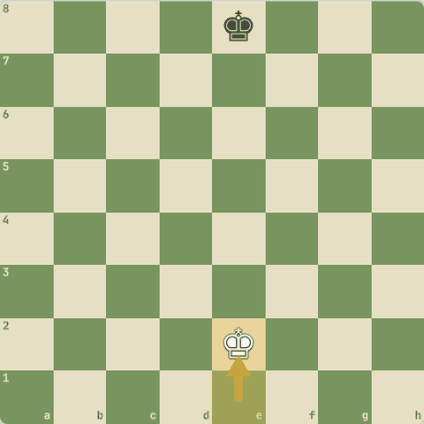
Chaal ke baad

1.5.11 Abhyaas: Rook ka check!
Rook ka check! Beech mein piece rakh kar (block) bachao.
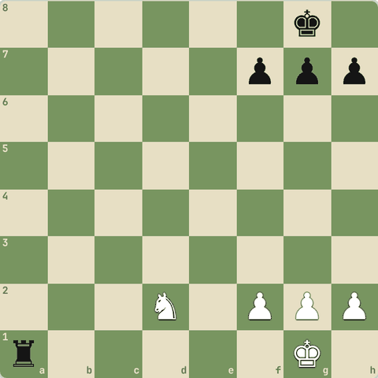
(White ki chaal)
Jawab:
1. Nf1
- Nf1 check block karta hai, aur king knight ko protect karta hai.
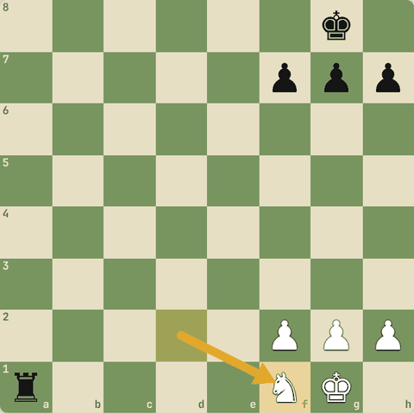
Chaal ke baad

1.5.12 Abhyaas: Check! Na capture, na block
Check! Na capture, na block. King ko safe square par le jao.
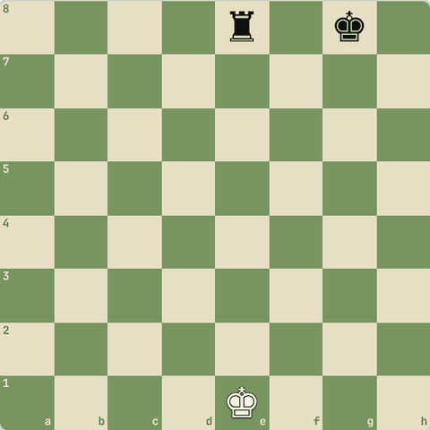
(White ki chaal)
Jawab:
1. Kd2
Ye bhi sahi: Kd1 Kf1 Kf2
- Rook ki e-file chhodo: d1, d2, f1, f2 sab safe hain.
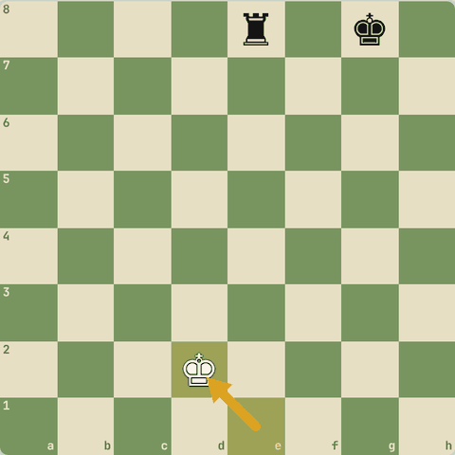
Chaal ke baad

1.5.13 Sawal 4: Double check (do pieces ek saath check) mein kya kar sakte ho?
Double check (do pieces ek saath check) mein kya kar sakte ho?
Jawab:
✓ Sirf king ko hilao
- Ek chaal se do checks block ya capture nahi ho sakte.
- King ko hilna hi padega.

1.5.14 Abhyaas: Discovered check
Discovered check: bishop hatao, rook ka check khulega. Saath mein queen jeeto!
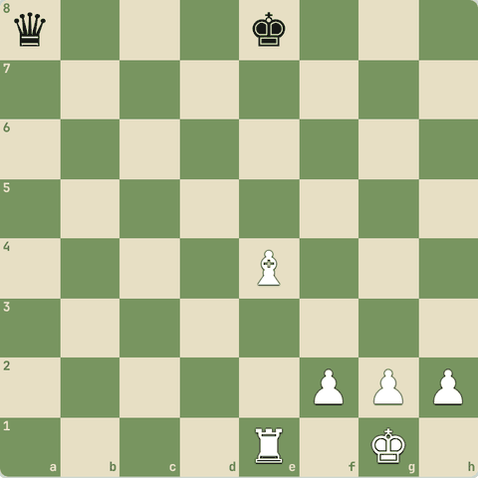
(White ki chaal)
Jawab:
1. Bxa8+
- Bishop ne queen li aur e1 rook ka check khul gaya.
- Black pehle check ka jawab dega, queen wapas nahi le sakta.
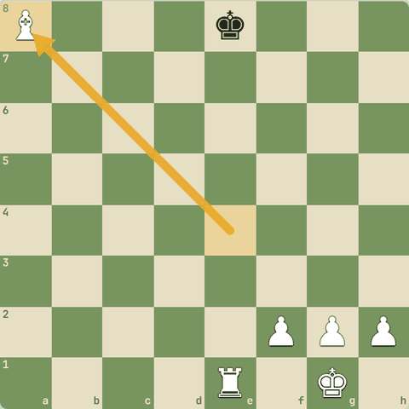
Chaal ke baad

1.5.15 Sawal 5: Kya do kings bagal-bagal (jaise e4 aur e5) aa sakte hain?
Kya do kings bagal-bagal (jaise e4 aur e5) aa sakte hain?
Jawab:
✓ Nahi, kabhi nahi
- King ek doosre ko check de rahe honge, jo illegal hai.

1.6 Jeet aur draw ke tareeke
Checkmate, resign, time; perpetual, stalemate, repetition, 50-move, agreement
Yaad rakho
- Draw ke 5 tareeke: stalemate, 3-fold repetition, 50-move rule, insufficient material, agreement.
- K+N vs K aur K+B vs K = draw (mate namumkin).
- K+R vs K aur K+Q vs K = jeet.
- Haarti position mein repetition / perpetual check se draw bacha sakte ho.
- Jeet: checkmate, opponent resign kare, ya opponent ka time khatam (agar tumhare paas mate ka material ho).
- Draw: stalemate, insufficient material, 3-fold repetition, 50-move rule, perpetual check, mutual agreement.
- Haar rahe ho to perpetual check ya stalemate se draw bachao.

1.6.1 Jeetne ke 3 tareeke
- Checkmate: game wahin khatam.
- Resign: opponent haar maan le (haari position mein aksar log resign karte hain).
- Time: clock wale game mein opponent ka time khatam ho jaaye to tum jeete. Par agar tumhare paas mate karne ka material hi nahi (jaise sirf king), to draw.

1.6.2 Draw ke 5 tareeke
- Stalemate: chaal hai, par koi legal move nahi aur check bhi nahi.
- 3-fold repetition: same position 3 baar aaye (same player ki chaal ke saath).
- 50-move rule: 50 chaalein (dono taraf) bina pawn move ya capture ke.
- Insufficient material: mate karna namumkin. Jaise King vs King, King+Bishop vs King, King+Knight vs King.
- Agreement: dono players draw maan lein.

1.6.3 Sawal 1: King + ek Knight vs akela King
King + ek Knight vs akela King: kya hoga?
Jawab:
✓ Draw: mate ke liye material kam hai
- Akele knight ya bishop se mate nahi diya ja sakta.

1.6.4 Sawal 2: King + Rook vs akela King?
King + Rook vs akela King?
Jawab:
✓ Jeet: rook se mate diya ja sakta hai
- Rook (ya queen) ke saath mate force kar sakte hain.
- Yeh technique Level 2 mein seekhoge.

1.6.5 Sawal 3: Dono players ek hi chaal baar-baar repeat karte hain aur position…
Dono players ek hi chaal baar-baar repeat karte hain aur position 3 baar same hoti hai. Kya hoga?
Jawab:
✓ Draw (3-fold repetition)
- 3 baar same position = draw claim kar sakte hain.
- Isko "perpetual check" mein bhi dekhoge.

1.6.6 Sawal 4: Opponent ka time khatam ho gaya, par tumhare paas sirf king hai
Opponent ka time khatam ho gaya, par tumhare paas sirf king hai. Result?
Jawab:
✓ Draw
- Akela king kabhi mate nahi kar sakta, isliye time par bhi draw.

1.6.7 Abhyaas: Tum Black ho aur bahut peeche ho
Tum Black ho aur bahut peeche ho. Perpetual check se draw bachao!
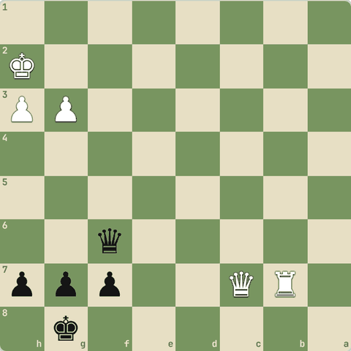
(Black ki chaal)
Jawab:
1… Qf2+ 2. Kh1 Qf1+ 3. Kh2 Qf2+
- Qf2+ Kh1 Qf1+ Kh2 Qf2+...
- White king bach nahi sakta, checks khatam nahi honge = draw.
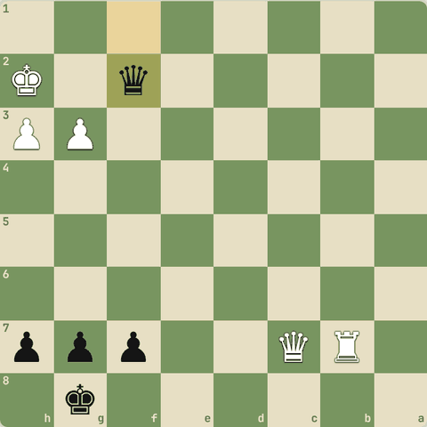
Line ke baad position

1.6.8 Sawal 5: King + Bishop vs King + Bishop (dono bishops same colour)
King + Bishop vs King + Bishop (dono bishops same colour). Result?
Jawab:
✓ Draw (insufficient material)
- Koi bhi mate force nahi kar sakta.

1.6.9 Sawal 6: 50 chaal (dono taraf) tak na koi pawn chala, na capture hua
50 chaal (dono taraf) tak na koi pawn chala, na capture hua. Kya hota hai?
Jawab:
✓ Player draw claim kar sakta hai
- Yeh 50-move rule hai.

1.6.10 Sawal 7: Dono players game ke beech draw par raazi ho gaye
Dono players game ke beech draw par raazi ho gaye. Allowed?
Jawab:
✓ Haan, mutual agreement se draw
- Draw offer apni chaal chalne ke baad karo, opponent maane to draw.

1.6.11 Sawal 8: Tum jeet rahe ho
Tum jeet rahe ho. Stalemate se kaise bacho?
Jawab:
✓ Har chaal par dekho ki opponent ke paas koi legal chaal bachi hai ya nahi
- Akele king ko hamesha kam se kam ek square ya chaal chhodo, jab tak mate na de sako.

1.6.12 Diagram: Stalemate
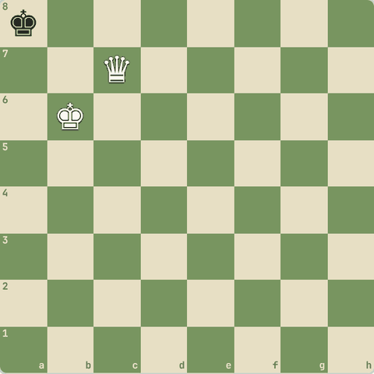
Stalemate: Black ki chaal, check nahi, par koi legal chaal nahi

1.6.13 Diagram: Insufficient material
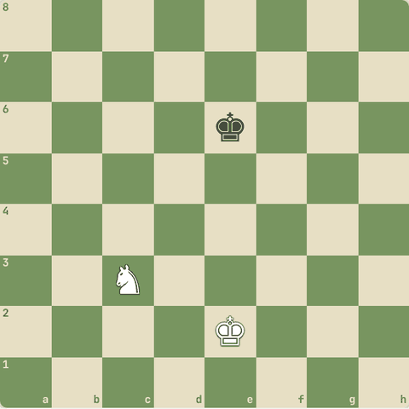
Insufficient material: K+N vs K, mate namumkin = draw

1.7 Pieces ki keemat aur trades
Kab lena hai, kab nahi
Yaad rakho
- Pawn 1, knight 3, bishop 3, rook 5, queen 9, king anmol.
- Trade se pehle points jodo: 3 dekar 5 mila = exchange jeeta.
- Har chaal mein dekho: koi piece hanging (bina protection) to nahi?
- Capture se pehle attackers aur defenders gino.
- Keemat ek guide hai: bishop aksar knight se thoda behtar (~3.25), khaas kar open board par.
- Algebraic symbols: K Q R B N; capture x, check +, mate #.

1.7.1 Point system
- Pawn = 1
- Knight = 3
- Bishop = 3 (thoda zyada jab dono bishops ho)
- Rook = 5
- Queen = 9
- King = anmol
- Trade karte waqt points jodo.
- Bishop (3) dekar rook (5) mila to tumne "exchange" jeeta.
- Yeh sirf guide hai: position zyada important hai, par shuru mein yeh bahut kaam aata hai.

1.7.2 Sawal 1: Tumhara knight dekar dushman ka rook mile
Tumhara knight dekar dushman ka rook mile. Achha trade?
Jawab:
✓ Haan: 3 dekar 5 mile
- +2 points ka fayda.

1.7.3 Sawal 2: Queen (9) ke badle do rooks (5+5)
Queen (9) ke badle do rooks (5+5). Points mein kaun aage?
Jawab:
✓ Do rooks wala
- 10 vs 9: do rooks thode zyada.
- Real game mein dono kaafi barabar hote hain.

1.7.4 Abhyaas: Koi piece free mein mil raha hai
Koi piece free mein mil raha hai. Lelo!
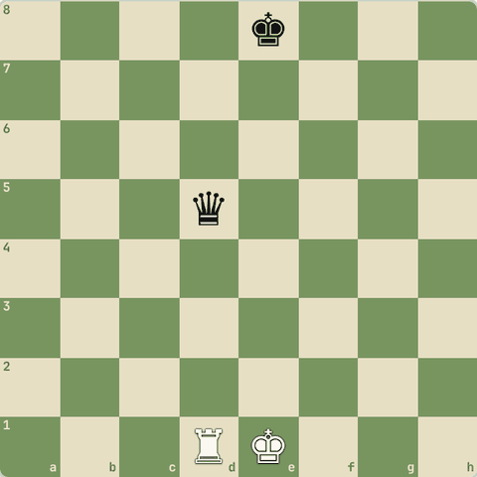
(White ki chaal)
Jawab:
1. Rxd5
- Queen ko kisi ne protect nahi kiya tha.
- Hamesha dekho: kya koi piece bina protection ke hai?
- ("hanging piece")
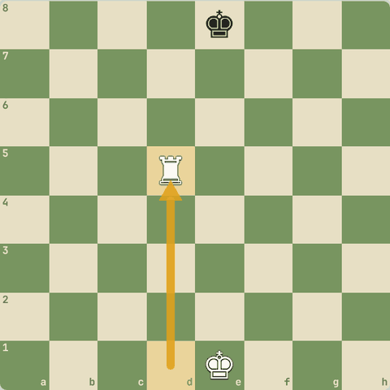
Chaal ke baad

1.7.5 Abhyaas: Black ki queen ne galti ki
Black ki queen ne galti ki. Saza do!
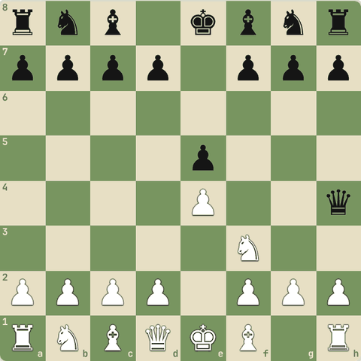
(White ki chaal)
Jawab:
1. Nxh4
- Nxh4: knight ne queen le li. 9 points free!
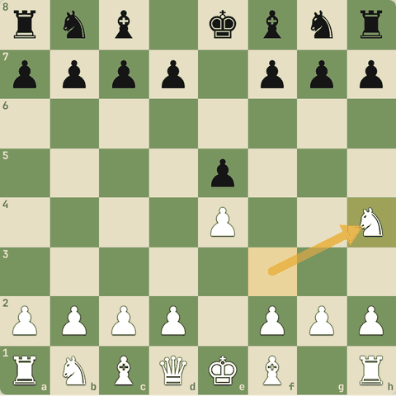
Chaal ke baad

1.7.6 Sawal 3: Yahan White Nxe5 khel sakta hai
Yahan White Nxe5 khel sakta hai. Kya yeh achha hai?
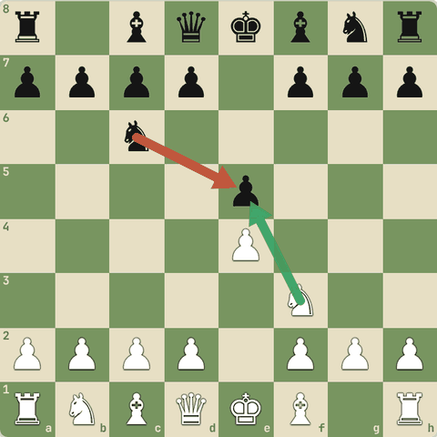
Jawab:
✓ Nahi: Nc6 pawn ko protect kar raha hai
- Nxe5 Nxe5 ke baad White ne knight (3) diya aur pawn (1) liya.
- Pehle attackers aur defenders gino.

1.7.7 Sawal 4: Bishop aur knight dono 3
Bishop aur knight dono 3. Open board (kam pawns) par aksar kaun behtar?
Jawab:
✓ Bishop
- Bishop door tak chalta hai.
- Band (closed) position mein knight behtar ho sakta hai.

1.7.8 Sawal 5: Do minor pieces (3+3) ke badle ek rook (5) aur ek pawn (1)
Do minor pieces (3+3) ke badle ek rook (5) aur ek pawn (1). Kaun aage?
Jawab:
✓ Pieces wala, aksar
- Points barabar (6 vs 6), par middlegame mein do pieces aksar zyada kaam karte hain.

1.7.9 Diagram: Exchange
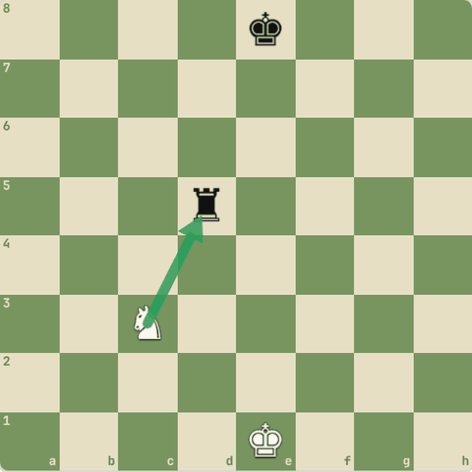
Exchange: knight (3) ke badle rook (5). Nxd5 ke baad White +2

1.8 Notation: moves likhna aur padhna
Chess ki bhasha
Yaad rakho
- Chaal = piece letter + square: Nf3, Bc4. Pawn ka letter nahi: e4.
- x capture, + check, # mate, O-O / O-O-O castling, e8=Q promotion.
- ! achhi, !! shandaar, ? galti, ?? blunder, !? interesting, ?! doubtful.
- Fool's mate seekh: opening mein f aur g pawns faltu mat chalao.
- Descriptive notation (purani): P-K4 = e4. Har square ke do naam (White aur Black ki taraf se).
- FEN: ek line mein poori position. Number = khaali squares, w/b = kiski chaal, KQkq = castling.

1.8.1 Algebraic notation
- Har chaal = piece ka letter + square.
- K = King, Q = Queen, R = Rook, B = Bishop, N = Knight
- Pawn ka koi letter nahi: e4 matlab pawn e4 par gaya
- x = capture: Nxe5 (knight ne e5 par capture kiya), exd5 (e-pawn ne d5 par)
- + = check, # = checkmate
- O-O = kingside castle, O-O-O = queenside
- e8=Q = promotion
- Annotation: ! achhi chaal, !! shandaar, ? galti, ?? blunder, !? interesting, ?! doubtful.

1.8.2 Sawal 1: Bxf7+ ka matlab?
Bxf7+ ka matlab?
Jawab:
✓ Bishop ne f7 par capture kiya aur check diya
- B = bishop, x = capture, + = check.

1.8.3 Sawal 2: O-O-O kya hai?
O-O-O kya hai?
Jawab:
✓ Queenside castle
- Teen O = lamba castle (queen ki taraf).

1.8.4 Sawal 3: exd5 mein kaunsa piece chala?
exd5 mein kaunsa piece chala?
Jawab:
✓ e-file ka pawn
- Pawn capture mein uski file likhte hain: e-pawn ne d5 par capture kiya.

1.8.5 Abhyaas: Notation se chaal chalo
Notation se chaal chalo: Nf3
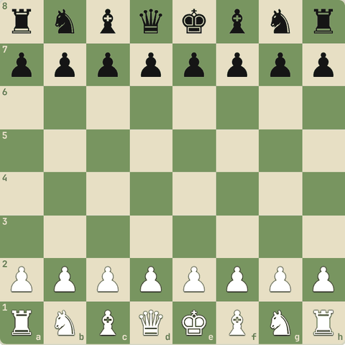
(White ki chaal)
Jawab:
1. Nf3
- Knight g1 se f3 par.
- Bahut achhi opening chaal hai.
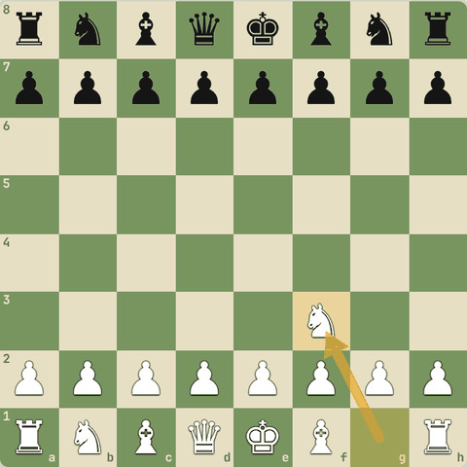
Chaal ke baad

1.8.6 Notation padho: Italian Game
- Har chaal ko notation se padho aur board par dekho.
1. e4 e5 2. Nf3 Nc6 3. Bc4 Bc5 4. O-O Nf6 5. d3 O-O
- 1.e4: pawn e2 se e4 (pawn ka letter nahi).
- 2.Nf3: knight f3 par.
- 3.Bc4: bishop c4 par.
- 4.O-O: kingside castling.
- 5...O-O: Black ne bhi castle kiya. Ab dono kings safe.
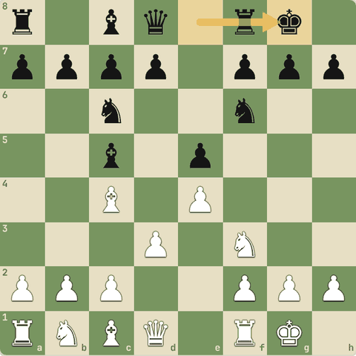
Final position (5…O-O)

1.8.7 Descriptive notation (purani)
- Purani kitabon aur "The Queen's Gambit" series mein yeh notation dikhti hai.
- Squares file ke piece ke naam se: e-file = K (king) file, f-file = KB (king bishop) file...
- P-K4 = pawn king file ke 4th square par = 1.e4
- N-KB3 = Nf3
- Rank apni taraf se ginte hain, isliye har square ke do naam (White ke liye K4, Black ke liye K5 = e4).
- Aaj sab algebraic use karte hain: chhota aur saaf.

1.8.8 Sawal 4: Descriptive N-KB3 (White) ka algebraic?
Descriptive N-KB3 (White) ka algebraic?
Jawab:
✓ Nf3
- KB file = f-file, White ki taraf se 3rd rank = f3.

1.8.9 FEN: position ki ek line
- FEN (Forsyth-Edwards Notation) ek line mein poori position likhta hai.
- Shuru ki position:
- rnbqkbnr/pppppppp/8/8/8/8/PPPPPPPP/RNBQKBNR w KQkq - 0 1
- Rank 8 se rank 1 tak, / se alag.
- Bade letters White, chhote Black. Number = itne khaali squares.
- w = White ki chaal. KQkq = castling ke haq. - = en passant square nahi. Last do numbers: 50-move counter aur chaal number.

1.8.10 Sawal 5: FEN mein 8 ka matlab?
FEN mein 8 ka matlab?
Jawab:
✓ Poori rank khaali (8 khaali squares)
- Number hamesha khaali squares ki ginti hai.

1.8.11 Sawal 6: FEN ke end mein ..
FEN ke end mein ... b KQkq - 0 1: b ka matlab?
Jawab:
✓ Black ki chaal
- w = White to move, b = Black to move.

1.9 Tournament rules, clock aur ratings
Touch-move, ek haath, clock, scoresheet, etiquette, ratings
Yaad rakho
- Touch-move: chhua piece chalana padega. Theek karna ho to "adjust" / "J'adoube".
- Clock usi haath se dabao jisse chaal chali. Phone bajna = aksar haar.
- Draw offer apni chaal ke baad, clock se pehle.
- Titles: CM 2200, FM 2300, IM 2400 + norms, GM 2500 + 3 norms.
- Ek haath se chaal, usi haath se clock. Castling mein pehle king 2 square, phir rook.
- Opponent ka piece chhua to (legal ho to) use capture karna padega.
- Pawn 8th rank par pahunche to promote karna zaroori (queen, rook, bishop ya knight).
- Mobile phone tournament hall mein nahi. Opponent ko disturb mat karo. Scoresheet saaf likho. FIDE Handbook mein saare rules.

1.9.1 Over-the-board rules
- Touch-move: jo piece chhua, wahi chalana padega. Apna piece theek karna ho to pehle "adjust" (ya "J'adoube") bolo.
- Piece chhod diya = chaal poori.
- Clock usi haath se dabao jisse chaal chali.
- Illegal move: rapid/blitz mein opponent ko extra time; doosri illegal move par haar (FIDE rules ke hisaab se).
- Classical mein notation likhna zaroori (scoresheet).
- Phone pass mein ho aur baj jaaye = aksar haar.
- Draw offer apni chaal chalne ke baad, clock dabane se pehle.
- Rating: Elo system.
- Jeet se rating badhti hai, haar se ghatti.
- Stronger player ko harane par zyada points.
- FIDE titles: CM (2200), FM (2300), IM (2400 + norms), GM (2500 + 3 GM norms).
- Women: WCM, WFM, WIM, WGM.

1.9.2 Sawal 1: Apna piece theek se rakhna hai bina chaal chale
Apna piece theek se rakhna hai bina chaal chale. Kya bolo?
Jawab:
✓ "Adjust" / "J'adoube"

1.9.3 Sawal 2: GM title ke liye kya chahiye?
GM title ke liye kya chahiye?
Jawab:
✓ 2500 rating aur 3 GM norms

1.9.4 Tournament ke 12 rules (FIDE)
- 1.
- Board aise ki light square right mein.
- 2.
- White pehle chalta hai.
- 3.
- Pawn last rank par promote karna hi padega (queen ya underpromotion: rook/bishop/knight).
- 4.
- Har chaal ek haath se.
- 5.
- Touch-move: apna piece chhua to wahi chalana padega.
- 6.
- Opponent ka piece chhua to, agar legal ho, use capture karna padega.
- 7.
- Piece theek karna ho to pehle "adjust" / "J'adoube" bolo.
- 8.
- Castling: pehle king ko 2 square chalo, phir rook.
- (Pehle rook chhua to sirf rook ki chaal maani ja sakti hai.)
- 9.
- Jis haath se chaal chali, usi haath se clock dabao.
- 10.
- Scoresheet saaf aur padhne layak likho.
- 11.
- Opponent ki izzat karo: baat karke, awaaz se, ya kisi tarah disturb mat karo.
- 12.
- Mobile phone hall mein mat le jao: bajne par aksar game haar jaate ho.
- Poore rules: FIDE Handbook (free PDF, fide.com).

1.9.5 Sawal 3: Castling karte waqt pehle kaunsa piece chhuna chahiye?
Castling karte waqt pehle kaunsa piece chhuna chahiye?
Jawab:
✓ King
- Pehle king 2 square, phir rook.
- Pehle rook chhua to arbiter use rook ki chaal maan sakta hai.

1.9.6 Sawal 4: Galti se opponent ka knight chhu liya aur use capture karna legal hai
Galti se opponent ka knight chhu liya aur use capture karna legal hai. Ab?
Jawab:
✓ Use capture karna padega
- Touch-move rule opponent ke pieces par bhi lagta hai.

1.9.7 Sawal 5: Chaal right haath se chali
Chaal right haath se chali. Clock kis haath se?
Jawab:
✓ Right (usi haath se)
- Rule: jis haath se chaal, usi se clock.

1.9.8 Sawal 6: Pawn 8th rank par pahuncha
Pawn 8th rank par pahuncha. Kya use pawn hi rehne de sakte ho?
Jawab:
✓ Nahi, promote karna zaroori hai
- Promotion zaroori hai: queen, rook, bishop ya knight.

1.9.9 Sawal 7: Tournament hall mein phone baj gaya
Tournament hall mein phone baj gaya. Aam taur par kya hota hai?
Jawab:
✓ Game haar sakte ho
- Isliye phone hall ke bahar rakho.

Level 2: Pehli jeet: mate, safety aur opening
Basic mates, hanging pieces, samajhdaari se capture, opening principles, shuruaati traps, sochne ka tareeka
- Ab pehle games jeetna seekhenge: akele king ko mate karna, apne pieces bachana, sahi capture chunna, aur opening mein galtiyon (traps) se bachna.

2.1 Queen se mate (K+Q vs K)
Box method
Yaad rakho
- Queen ko dushman king se knight ki doori par rakho: box chhota karte jao.
- King edge par aa jaaye to apna king paas lao.
- Mate queen + king ki team se hota hai.
- Har chaal ke baad check karo: Black ke paas chaal bachi hai? Warna stalemate.

2.1.1 Box method
- Queen + King se mate dene ke steps:
  - Queen ko knight ki doori par rakho dushman king se. Isse king ek "box" mein band hota hai.
  - Box ko chhota karte jao, jab tak king kinare (edge) par na aa jaaye.
  - Ab apne king ko paas lao.
  - Queen se mate do, king ki help se.
- Khatra: stalemate!
- Har chaal ke baad dekho ki Black ke paas koi chaal bachi hai.
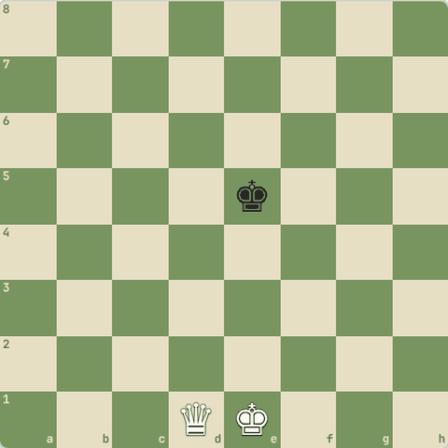

2.1.2 Final picture
- Aisi position mein mate hota hai: queen king ke saamne, aur apna king queen ko protect kar raha hai.
- Ya queen poori edge rank par check de jabki king saamne khada ho.
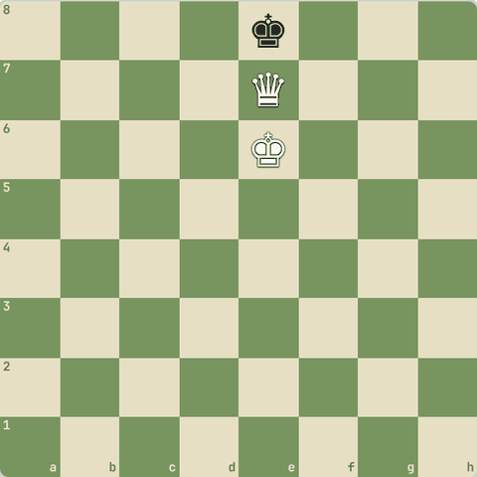

2.1.3 Khud khelo: Checkmate karo
Ab tum karo: Black king ko 20 chaal ke andar mate do.
- Queen ko king ke paas mat le jao jahan woh protect na ho!
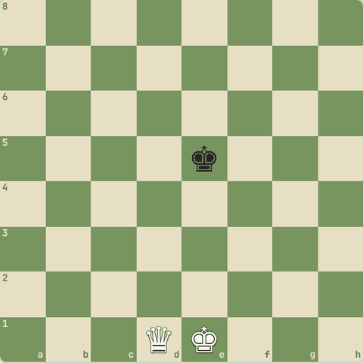
(White ki chaal)

2.2 Rook se mate (K+R vs K)
Opposition aur rook ki deewar
Yaad rakho
- Rook ek deewar banata hai: king ko ek taraf band karo.
- Apne king ko saamne lao (beech mein ek square) = opposition.
- Kings aamne-saamne hon tab rook se check: king peeche jaata hai.
- Rook ko dushman king se door rakho taaki woh capture na ho.

2.2.1 Rook ki deewar
- Rook ek deewar banata hai jo king ko ek taraf band rakhti hai.
- Rook se king ko ek rank/file mein band karo.
- Apne king ko dushman king ke saamne lao (beech mein ek square) = opposition.
- Jab kings aamne-saamne hon, rook se check do: king peeche jaayega.
- Aise edge tak dhakelo, phir edge par check = mate.
- Rook ko dushman king se door rakho taaki woh use pakad na le.
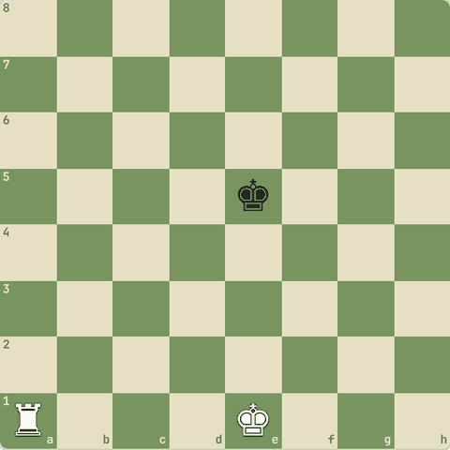

2.2.2 Mate ki picture
- Kings aamne-saamne.
- Ab Ra8#: rook poori 8th rank par check deta hai, aur apna king d7, e7, f7 band karta hai.
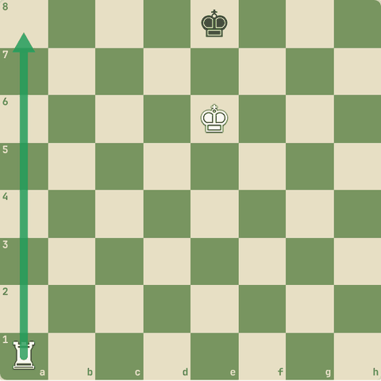

2.2.3 Abhyaas: Mate in 1
Mate in 1
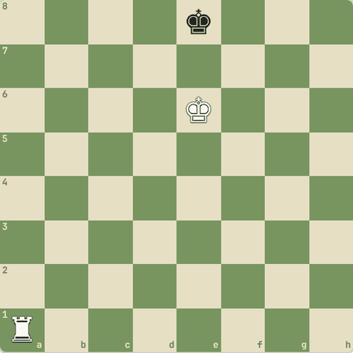
(White ki chaal)
Jawab:
1. Ra8#
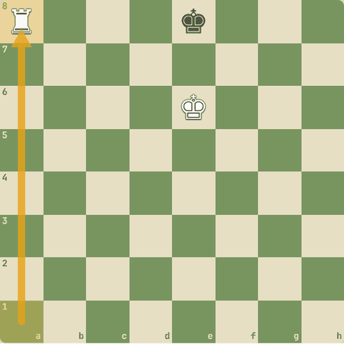
Chaal ke baad

2.2.4 Khud khelo: Checkmate karo
Ab poora karo: 30 chaal mein rook se mate.
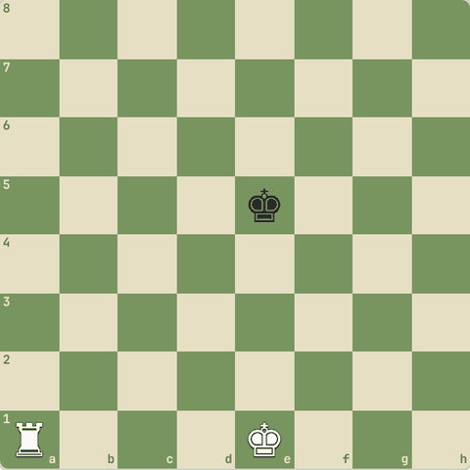
(White ki chaal)

2.3 Do rooks aur Queen+Rook se mate
Ladder (seedhi) mate
Yaad rakho
- Do rooks seedhi ki tarah: ek rank band, doosra agli rank par check.
- King ki zaroorat nahi.
- Dushman king rook ke paas aaye to rook ko doosre kinare le jao.
- King do rooks ke beech fansa ho to ghabrao mat: ek rook ko doosri taraf le jao, taaki dono rooks ek hi side se seedhi banaayein.
- Queen + rook bhi seedhi bana sakte hain: ek rank rokta hai, doosra check deta hai.

2.3.1 Ladder mate
- Do rooks seedhi ki tarah chalte hain: ek rook ek rank band karta hai, doosra agli rank par check deta hai.
- Phir pehla aage badhta hai.
- King ki zaroorat nahi!
- Bas dhyan rahe ki king rooks ke paas aa kar unhe capture na kar le: tab rook ko door (doosre kinare) le jao.
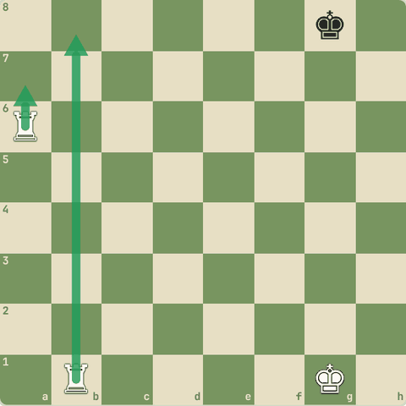

2.3.2 Abhyaas: Mate in 2
Mate in 2: seedhi chalo.
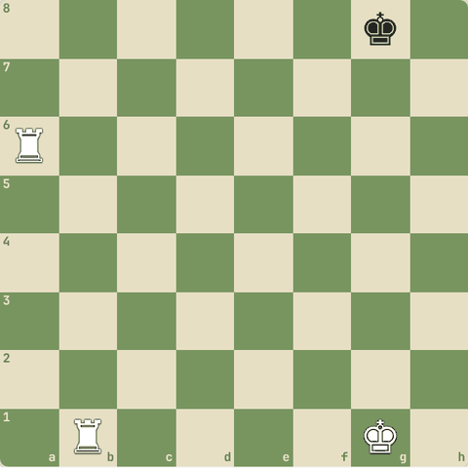
(White ki chaal)
Jawab:
1. Ra7 Kh8 2. Rb8#
- Ra7 se 7th rank band, phir Rb8#.
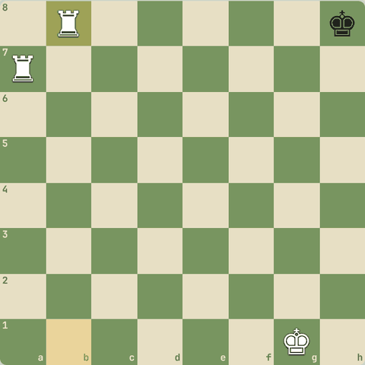
Line ke baad position

2.3.3 Khud khelo: Checkmate karo
Do rooks se 12 chaal mein mate karo.
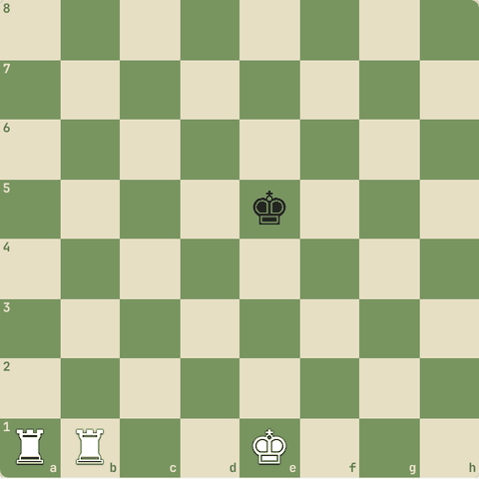
(White ki chaal)

2.3.4 King rooks ke beech ho to?
- Kabhi dushman king dono rooks ke beech hota hai (ek rook upar ki rank band karta hai, doosra neeche ki).
- Ghabrao mat:
  - Pehle socho king ko kis kinare dhakelna hai (jo zyada paas hai).
  - Jo rook galat taraf hai, use file ke bilkul kinare se ghuma kar doosri taraf lao, king se door rakhte hue.
  - Ab dono rooks ek hi side se seedhi (ladder) chalo: ek rank band, doosra agli rank par check.
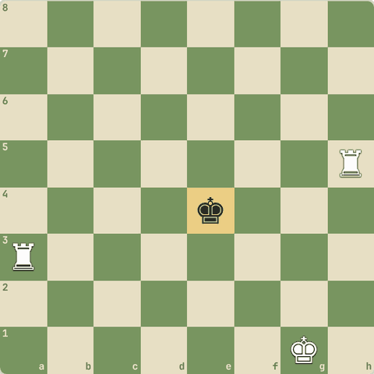

2.3.5 Khud khelo: Checkmate karo
King rooks ke beech hai. Do rooks se 12 chaal mein mate karo.
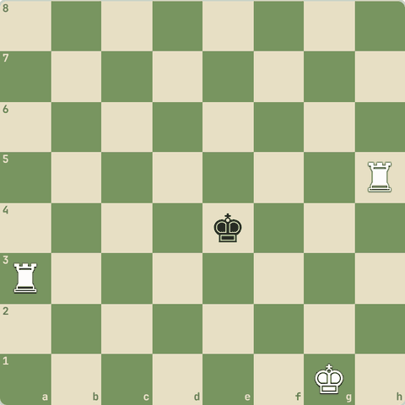
(White ki chaal)

2.3.6 Queen + Rook: aur bhi tez
- Queen aur rook bhi seedhi (ladder) banate hain: ek piece king ko ek rank par rokta hai, doosra agli rank par check deta hai.
- Bas dhyan rahe ki king tumhare piece ke bagal mein aakar use capture na kare: aise mein piece ko door wale side par le jao.

2.3.7 Abhyaas: Rook 7th rank rok raha hai
Rook 7th rank rok raha hai. Queen se mate in 1.
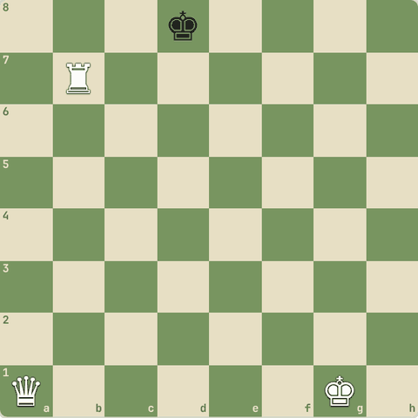
(White ki chaal)
Jawab:
1. Qa8#
- Rook ne 7th rank band ki, queen ne 8th rank par check diya.
- Yahi ladder ka idea hai.
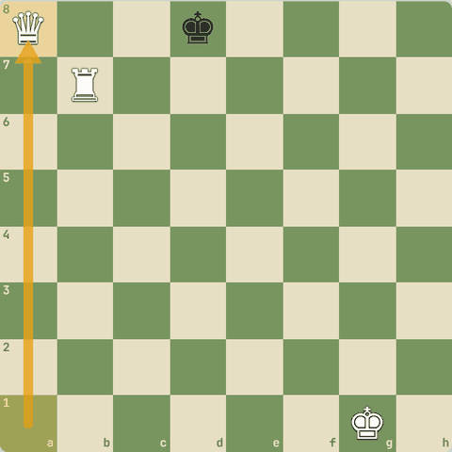
Chaal ke baad

2.3.8 Khud khelo: Checkmate karo
Queen + Rook se 10 chaal mein mate karo.
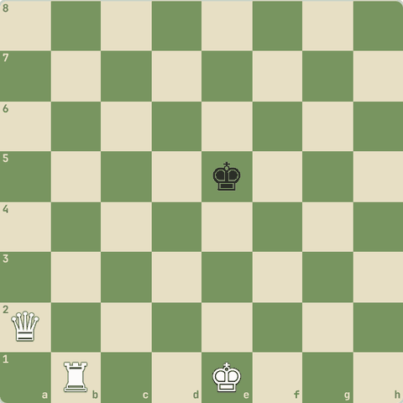
(White ki chaal)

2.4 Hanging pieces aur safety
Attackers vs defenders
Yaad rakho
- Beginners zyada games pieces free mein dene se haarte hain.
- Har chaal se pehle: koi piece bina protection? Opponent ki pichli chaal ne kya attack kiya?
- Attackers > defenders = piece khatre mein.
- Opponent ka hanging piece dikhe to turant saza do.
- "Loose pieces drop off": bina protection ke piece hi tactics ka nishaana bante hain.
- Opponent ke loose pieces dhundo, apne loose pieces bachao.

2.4.1 Blunder se bacho
- Beginners zyada games pieces free mein dene se haarte hain, galat plan se nahi.
- Har chaal se pehle:
  - Kya meri chaal ke baad koi piece bina protection ke reh jaayega?
  - Opponent ki pichli chaal ne kya attack kiya?
  - Kisi square par attackers gino aur defenders gino. Attackers zyada = piece khatre mein.

2.4.2 Sawal 1: Black ka knight c6 attack mein hai
Black ka knight c6 attack mein hai. Kitne White pieces use attack kar rahe hain aur kitne Black defend?
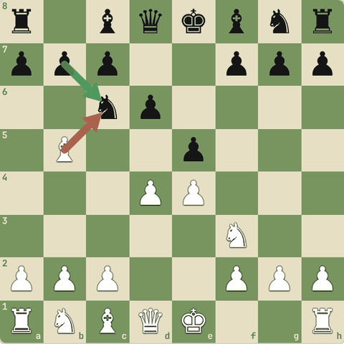
Jawab:
✓ 1 attacker, 1 defender
- Bb5 attack karta hai, b7 pawn defend karta hai.
- Barabar: abhi khatra nahi.
- Lekin bishop ne knight ko pin kiya hai (Level 3).

2.4.3 Abhyaas: Tum Black ho
Tum Black ho. White ne Nxe5 khel kar pawn liya, par knight ab hanging hai. Saza do!
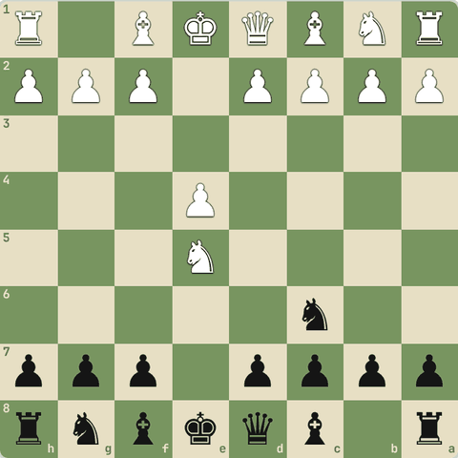
(Black ki chaal)
Jawab:
1… Nxe5
- Nxe5: knight (3) ke badle sirf pawn (1) mila White ko.
- Attackers aur defenders ginna kabhi mat bhoolo.
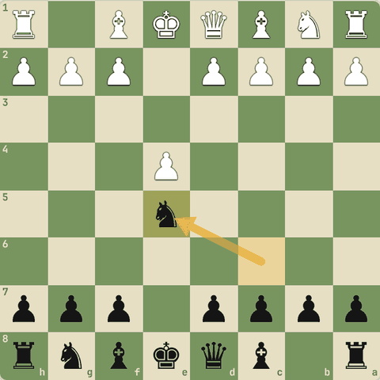
Chaal ke baad

2.4.4 Abhyaas: White ki chaal
White ki chaal. Black ne bishop g4 par rakha, par woh protected nahi hai.
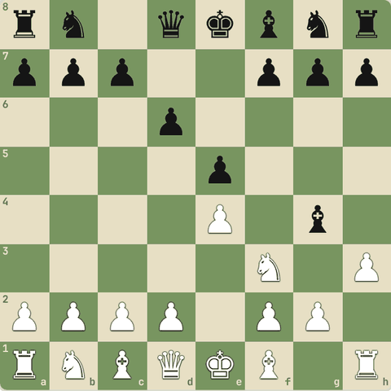
(White ki chaal)
Jawab:
1. hxg4
- hxg4: pawn (1) ne bishop (3) le liya.
- Black ne h3 pawn ka attack nahi dekha.
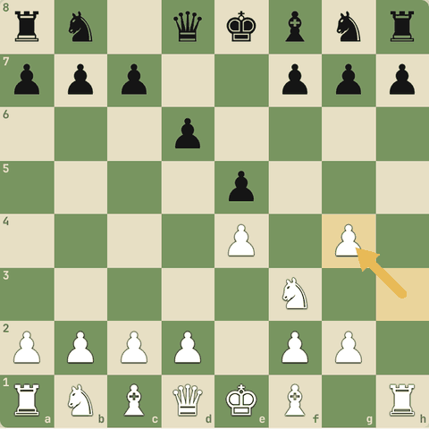
Chaal ke baad

2.4.5 Loose pieces drop off (LPDO)
- Opening principle: pieces ko bina protection ke mat chhodo.
- Bade players bhi isse haare: Christiansen vs Karpov (1993) mein world champion Karpov ka ek loose piece pakda gaya aur woh jaldi haar gaye.
- Ulta bhi socho: opponent ka unprotected piece ek "downside" hai.
- Tactics aksar wahin se shuru hoti hain.

2.4.6 Abhyaas: Koi piece bina protection ke hai (hanging)
Koi piece bina protection ke hai (hanging). Pakdo!
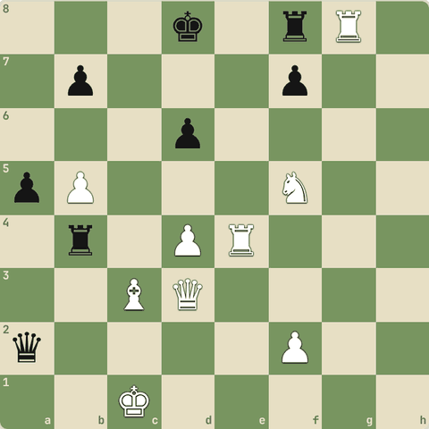
(White ki chaal)
Jawab:
1. Rxf8+
- Rxf8+: free material.
- Har chaal par dekho: kaun sa piece bina protection ke hai?
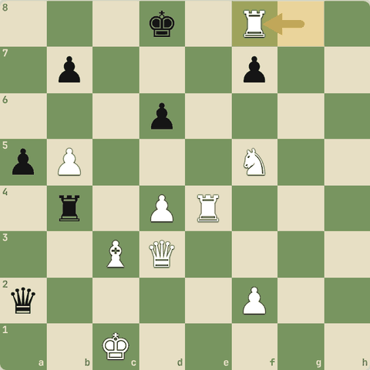
Chaal ke baad

2.4.7 Abhyaas: Koi piece bina protection ke hai (hanging)
Koi piece bina protection ke hai (hanging). Pakdo!
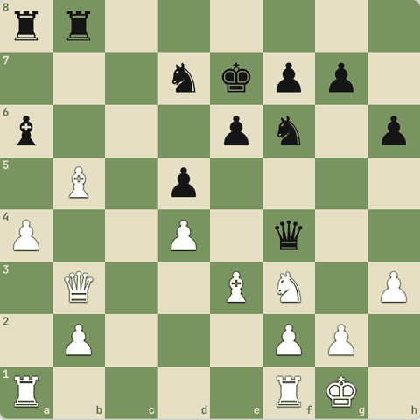
(White ki chaal)
Jawab:
1. Bxf4
- Bxf4: free material.
- Har chaal par dekho: kaun sa piece bina protection ke hai?
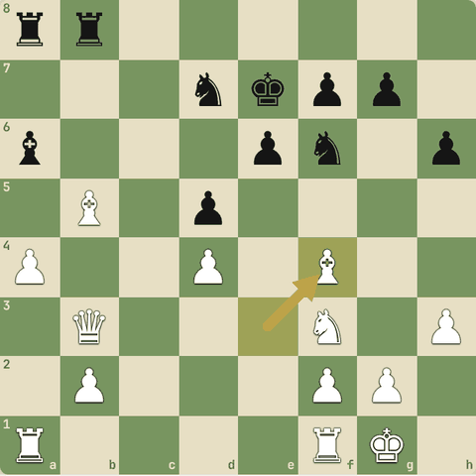
Chaal ke baad

2.4.8 Abhyaas: Koi piece bina protection ke hai (hanging)
Koi piece bina protection ke hai (hanging). Pakdo!
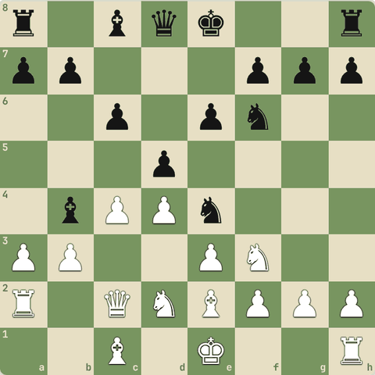
(White ki chaal)
Jawab:
1. axb4
- axb4: free material.
- Har chaal par dekho: kaun sa piece bina protection ke hai?
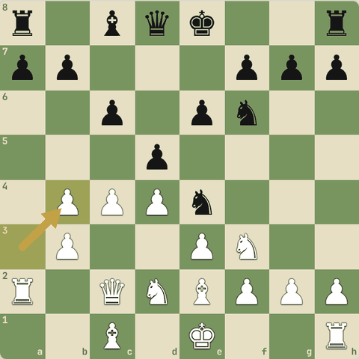
Chaal ke baad

2.4.9 Abhyaas: Koi piece bina protection ke hai (hanging)
Koi piece bina protection ke hai (hanging). Pakdo!
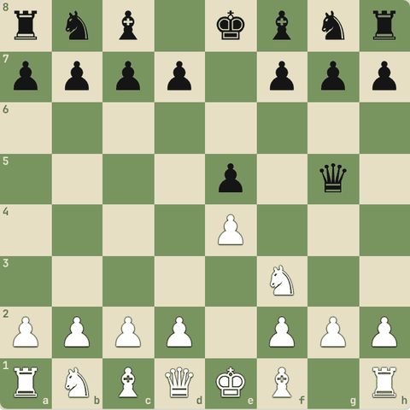
(White ki chaal)
Jawab:
1. Nxg5
- Nxg5: free material.
- Har chaal par dekho: kaun sa piece bina protection ke hai?
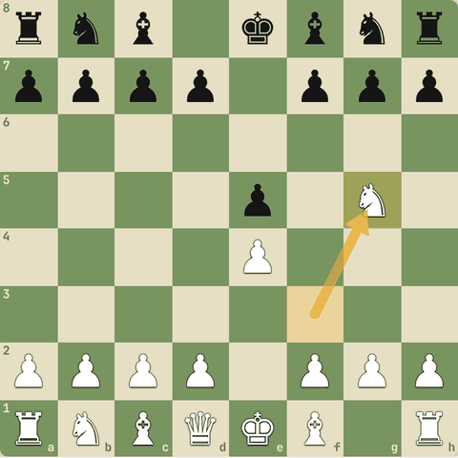
Chaal ke baad

2.4.10 Abhyaas: Koi piece bina protection ke hai (hanging)
Koi piece bina protection ke hai (hanging). Pakdo!
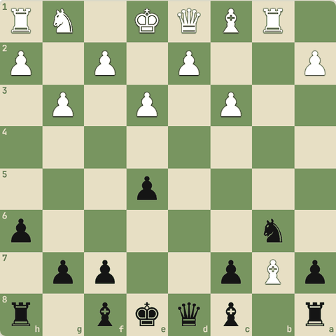
(Black ki chaal)
Jawab:
1… Bxb7
- Bxb7: free material.
- Har chaal par dekho: kaun sa piece bina protection ke hai?
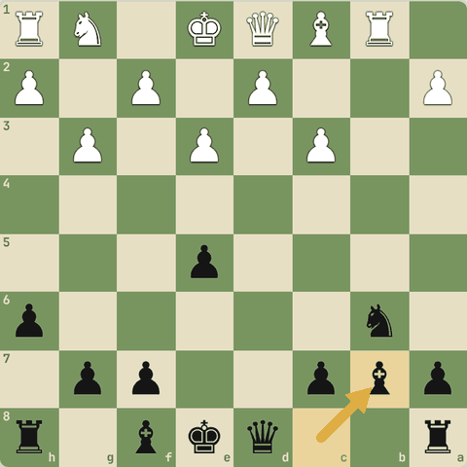
Chaal ke baad

2.4.11 Abhyaas: Koi piece bina protection ke hai (hanging)
Koi piece bina protection ke hai (hanging). Pakdo!
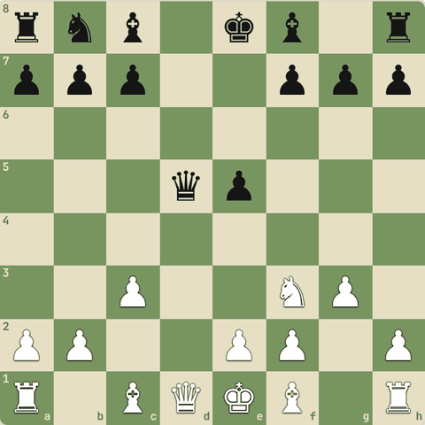
(White ki chaal)
Jawab:
1. Qxd5
- Qxd5: free material.
- Har chaal par dekho: kaun sa piece bina protection ke hai?
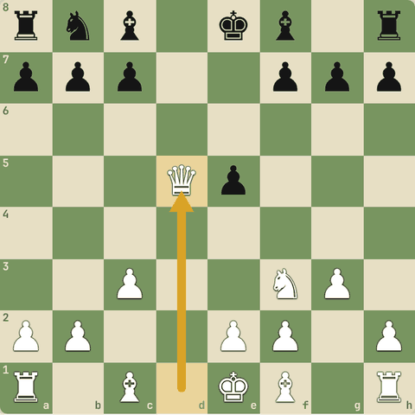
Chaal ke baad

2.4.12 Diagram: Attackers vs defenders
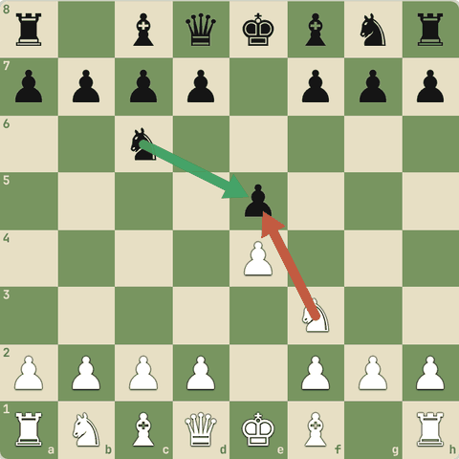
Attackers vs defenders: e5 par 1 white attacker (Nf3), 1 black defender (Nc6). Lena bekaar.

2.5 Samajhdaari se capture
Attackers vs defenders ginna, sahi piece se capture
Yaad rakho
- Capture se pehle gino: kitne attackers, kitne defenders.
- Attackers zyada = capture aksar sahi. Barabar ya kam = soch ke.
- Sabse sasta piece pehle capture kare (pawn se, queen se nahi).
- Defender ko hata do (capture ya bhaga do), phir piece jeeto.

2.5.1 Capture karne se pehle gino
- Har capture ke baad recapture hoga.
- Isliye:
- 1.
- Attackers gino (tumhare kitne pieces us square ko attack karte hain).
- 2.
- Defenders gino (opponent ke kitne pieces bachate hain).
- 3.
- Attackers zyada hon to aksar capture achha hai, par sasta piece pehle use karo.
- 4.
- Points jodo: pawn ke badle knight de diya to nuksaan.

2.5.2 Abhyaas: Black knight d5 par hai
Black knight d5 par hai. Kis piece se capture karoge?
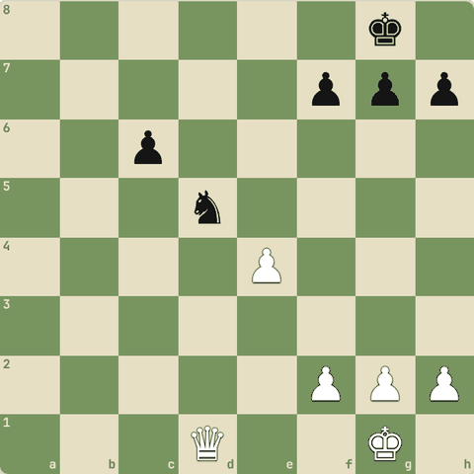
(White ki chaal)
Jawab:
1. exd5
- Pawn (1) se knight (3) lo.
- cxd5 se pawn wapas jaayega, phir bhi tum 2 point aage.
- Qxd5?? par cxd5 aur queen gayi!
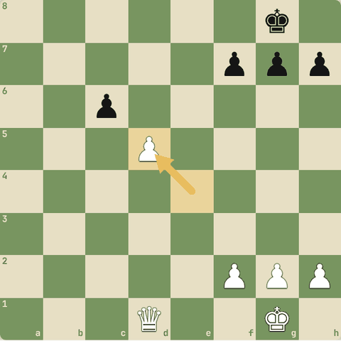
Chaal ke baad

2.5.3 Abhyaas: d5 pawn: 2 attackers vs 1 defender
d5 pawn: 2 attackers vs 1 defender. Pawn jeeto.
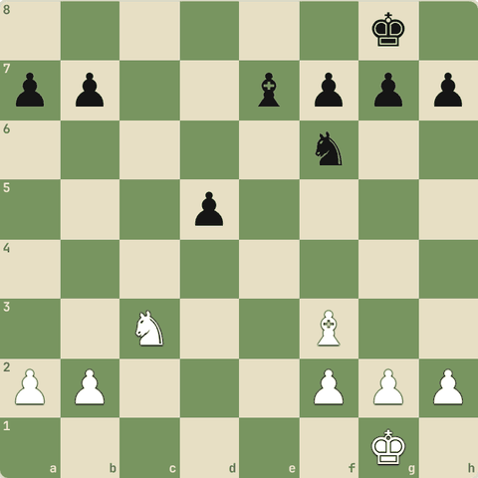
(White ki chaal)
Jawab:
1. Nxd5 Nxd5 2. Bxd5
- Nxd5 Nxd5 Bxd5: do attackers, ek defender, isliye aakhri capture tumhara.
- Ek pawn aage.
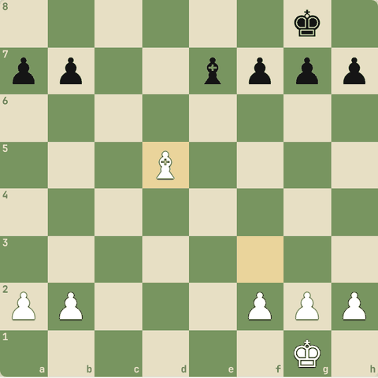
Line ke baad position

2.5.4 Sawal 1: Ek pawn par tumhare 2 attackers, opponent ke 3 defenders
Ek pawn par tumhare 2 attackers, opponent ke 3 defenders. Capture karoge?
Jawab:
✓ Aam taur par nahi
- Defenders zyada hain: aakhri capture opponent ka hoga, tum material khoge.

2.5.5 Defender hatao
- Kabhi piece protected hota hai, par uska defender khud kamzor hai.
- Pehle defender ko capture karo ya bhagao, phir piece free ho jaata hai.
- (Is idea ko aage tactics mein "removing the defender" kahenge.)

2.6 Opening ke 10 principles
Pehli 10-12 chaalein kaise khelein
Yaad rakho
- Center lo (e4/d4), knights aur bishops develop karo, jaldi castle.
- Ek piece baar-baar mat chalao, queen jaldi mat nikaalo.
- Rooks connect karke open files par lao.
- f7/f2 sabse kamzor square: Scholar's mate se bacho (...g6 ya ...Qe7).
- Philosophy: pehle khud ko haar se bachao (development, center, castle), phir attack.
- Opening mein lalach mat karo: pawn ke liye development aur king safety mat khoo.
- Morphy jaise masters ne tez development aur jaldi castling se hi jeeta.

2.6.1 Opening principles
- Center lo: e4, d4 (ya e5, d5) pawns se.
- Pieces develop karo: knights aur bishops ko pehle bahar lao. Knights pehle, bishops baad mein.
- Jaldi castle karo (pehli 10 chaal mein).
- Ek piece ko baar-baar mat chalao bina wajah.
- Queen ko jaldi mat nikaalo: chhote pieces use bhaga dete hain aur tum time khote ho.
- Rooks ko connect karo aur open files par lao.
- Faltu pawn moves (a4, h4) mat karo shuru mein.
- Pawn ke liye development mat chhodo.
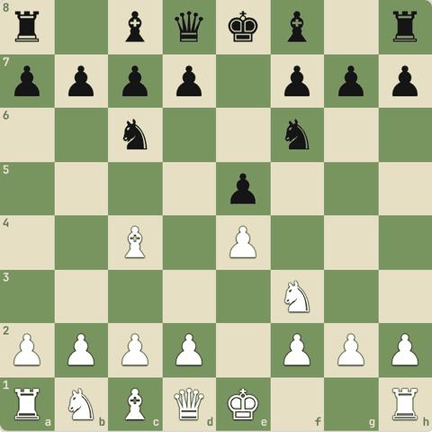

2.6.2 Sawal 1: Start position mein sabse achhi chaal kaunsi?
Start position mein sabse achhi chaal kaunsi?
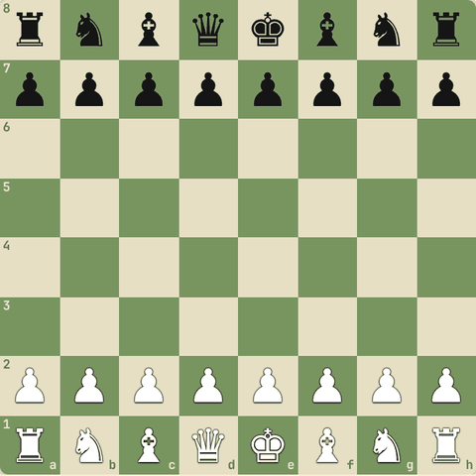
Jawab:
✓ Nf3
- Nf3 center (e5, d4) control karta hai aur castling ki taiyaari.

2.6.3 Abhyaas: White ki chaal
White ki chaal. Black ne galti ki: Scholar's mate do!
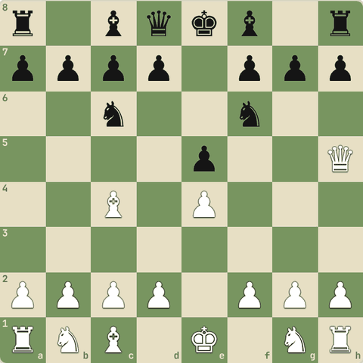
(White ki chaal)
Jawab:
1. Qxf7#
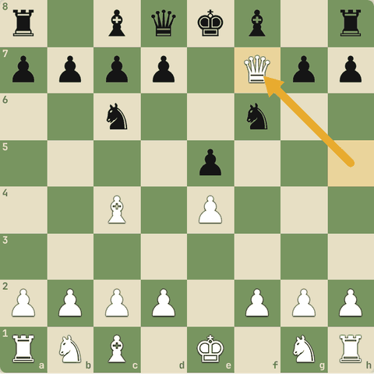
Chaal ke baad

2.6.4 Masters se sabak
- Development: Morphy vs Carpentier (1849): Morphy ne saare pieces jaldi bahar nikaale, opponent pieces ghar par baithe reh gaye.
- Center: Greco vs NN: center ke pawns aur pieces se attack ke raaste khulte hain.
- Jaldi castle: Morphy vs Schrufer: king center mein reh gaya to open files par mar gaya.
- Lalach mat karo: opening mein ek pawn ke liye development aur king safety khona aksar haar hai.
- Queen jaldi mat nikalo: chhote pieces se attack hokar woh time (tempo) khoti hai.

2.6.5 Sawal 2: Opening mein ek free pawn mil raha hai, par lene ke liye queen ko…
Opening mein ek free pawn mil raha hai, par lene ke liye queen ko 3 chaal chalni padegi aur king center mein rahega. Kya karoge?
Jawab:
✓ Development aur castling pehle
- Tempo aur king safety aksar ek pawn se zyada keemti.

2.6.6 Sawal 3: Kaunsa principle sahi nahi?
Kaunsa principle sahi nahi?
Jawab:
✓ Ek hi piece baar-baar chalao
- Opening mein har piece ek baar chalao, ek ko baar-baar nahi.

2.6.7 Abhyaas: White ki queen jaldi aa gayi
White ki queen jaldi aa gayi. Developing chaal se use bhagao (tempo jeeto).
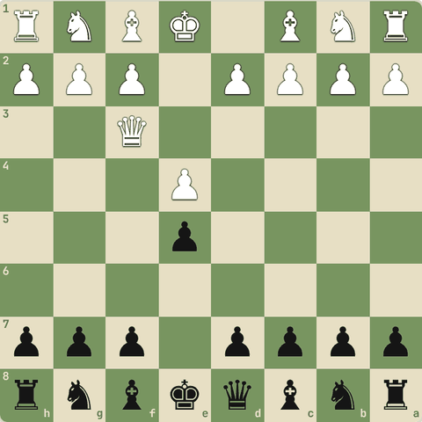
(Black ki chaal)
Jawab:
1… Nf6
- 2...Nf6: knight develop bhi hua, e4 par attack bhi.
- Queen ko phir hilna padega.
- (Nc6 bhi achha.)
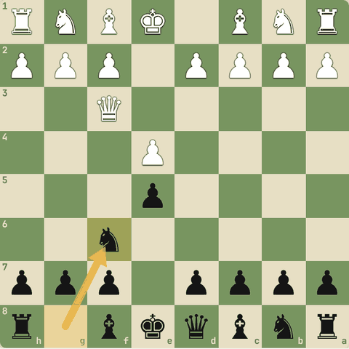
Chaal ke baad

2.7 Shuruaati traps aur pitfalls
Fool's mate, Scholar's mate, early queen, f6, Legal, Blackburne Shilling
Yaad rakho
- Traps jaano taaki unme na phanso, aur opponent phanse to saza do.
- Fool's mate: f-pawn aur g-pawn jaldi mat hilao (e1-h4 diagonal khulta hai).
- f7/f2 sabse kamzor square: sirf king bachata hai.
- e5 ko f6 se mat bachao (Damiano): king khul jaata hai.
- Lalach (Bxd1 ya Nxe5 jaisi free cheezein) se pehle socho: kahin trap to nahi?

2.7.1 Traps kyun seekhein?
- Trap = aisi chaal jo achhi dikhti hai par galat jawab par turant jeet deti hai.
- Traps seekhne ke 2 fayde:
  - Bachaav: tum un mein nahi phansoge.
  - Hamla: opponent phanse to tum saza doge.
- Par trap ke liye apni position kharab mat karo.
- Achhi chaalein khelo jo trap bhi set karein.

2.7.2 Sabse chhota game: Fool's mate
- Notation padh kar game samjho.
- Yeh duniya ka sabse chhota checkmate hai (sirf 2 chaal).
1. f3 e5 2. g4 Qh4#
- 1.f3? King ke saamne ka pawn kamzor kiya.
- 1...e5 Black ne center liya aur queen ka raasta khola.
- 2.g4?? Bahut badi galti! e1-h4 diagonal poora khul gaya.
- 2...Qh4# Checkmate! Seekh: opening mein f aur g pawns ko faltu mat chalao.
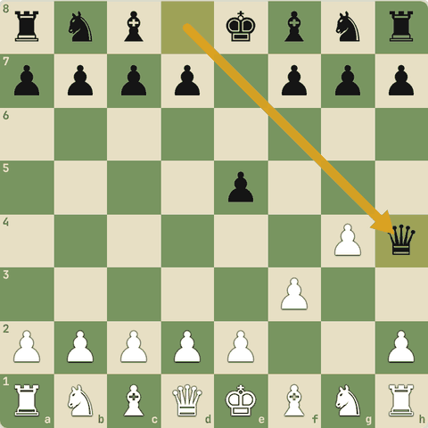
Final position (2…Qh4#)

2.7.3 Fool's mate pattern: Teed vs Delmar (1896)
- Same idea: Black ne f aur g pawns aage karke king ko khol diya.
1. d4 f5 2. Bg5 h6 3. Bh4 g5 4. Bg3 f4 5. e3 h5 6. Bd3 Rh6 7. Qxh5+ Rxh5 8. Bg6#
- 1...f5 Dutch: king ke paas ka pawn.
- 4...f4? pawns aur aage.
- 6...Rh6 rook bhi bahar, par king ka diagonal khula hai.
- 7.Qxh5+!! queen sacrifice.
- 8.Bg6# e8-h5 diagonal khula tha. Mate!
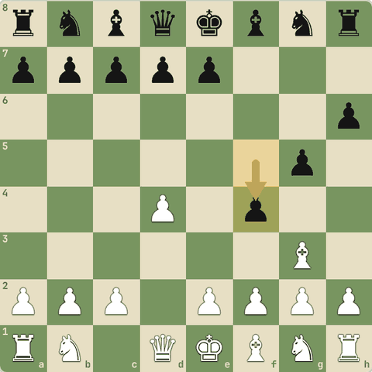
Position after 4…f4
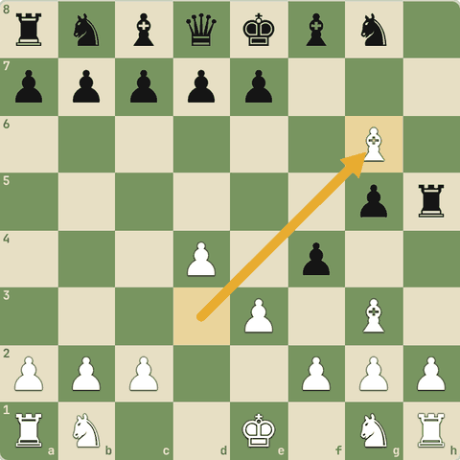
Final position (8.Bg6#)

2.7.4 Fool's mate pattern: Greco vs NN (1620)
- 400 saal purana game: f-pawn ki galti se wahi diagonal khula.
1. e4 b6 2. d4 Bb7 3. Bd3 f5 4. exf5 Bxg2 5. Qh5+ g6 6. fxg6 Nf6 7. gxh7+ Nxh5 8. Bg6#
- 3...f5? king ka diagonal khula.
- 5.Qh5+ check!
- 6.fxg6 ab gxh7+ ki threat.
- 6...Nf6 queen par attack.
- 7.gxh7+! discovered check: bishop d3 ka check!
- 8.Bg6# Mate!
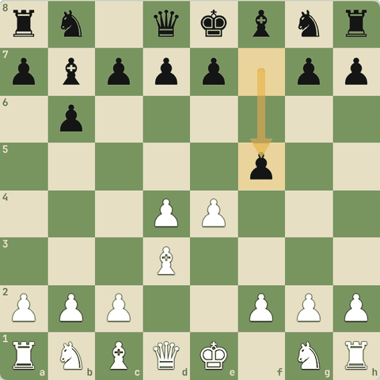
Position after 3…f5
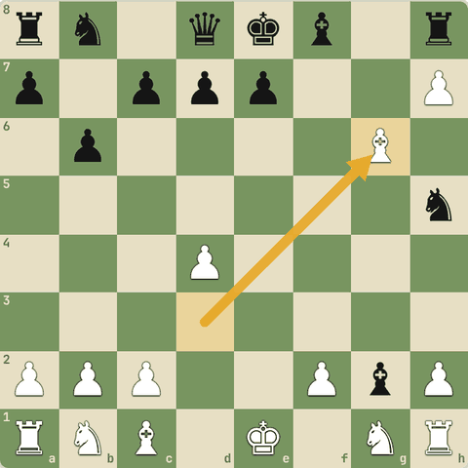
Final position (8.Bg6#)

2.7.5 Early queen trap: `2.Qh5` ke baad `g6??`
- 2.Qh5 ek kamzor opening hai, par 2...g6?? aur bhi badi galti.
1. e4 e5 2. Qh5 g6 3. Qxe5+ Qe7 4. Qxh8
- 2.Qh5 e5 aur f7 par nazar.
- 2...g6?? queen ko bhagaya par e5 bhool gaye.
- 3.Qxe5+ fork: king aur h8 rook!
- 4.Qxh8 rook gaya.
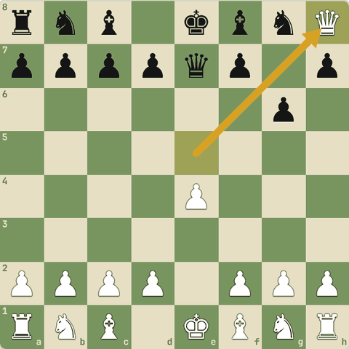
Final position (4.Qxh8)

2.7.6 Abhyaas: Tum Black ho
Tum Black ho. White ne 2.Qh5 khela. Sabse achha jawab: e5 bachao aur develop karo.
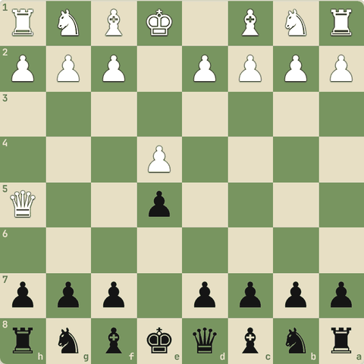
(Black ki chaal)
Jawab:
1… Nc6
Ye bhi sahi: Qe7 d6 Qf6
- 2...Nc6! e5 protect aur development.
- Phir 3.Bc4 g6! (ab safe) 4.Qf3 Nf6 aur White ki queen ka time barbaad.
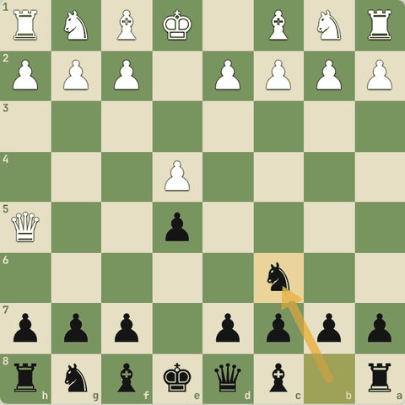
Chaal ke baad

2.7.7 Scholar's mate: trap aur bachaav
- Yeh beginner ka sabse common trap hai.
- Dekho aur phir bachna seekho.
1. e4 e5 2. Bc4 Nc6 3. Qh5 Nf6 4. Qxf7#
- 2.Bc4 bishop f7 ko dekh raha hai. f7 sirf king protect karta hai: kamzor square.
- 3.Qh5 queen + bishop dono f7 par. Saath mein e5 par bhi attack.
- 3...Nf6?? Knight ne queen ko attack kiya, par f7 bhool gaya.
- 4.Qxf7# Checkmate. Seekh: f7/f2 square ko dhyan se protect karo.
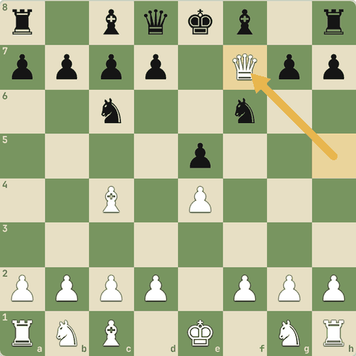
Final position (4.Qxf7#)

2.7.8 Abhyaas: Black ho
Black ho. White ne Qh5 khela. Mate se bachao aur e5 bhi bachao.
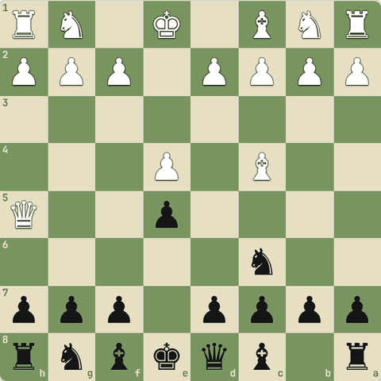
(Black ki chaal)
Jawab:
1… g6
Ye bhi sahi: Qe7 Qf6
- 3...g6! queen ko bhagata hai.
- 3...Qe7 bhi theek hai.
- Phir Nf6 aur development: White ki queen ka time waste hua.
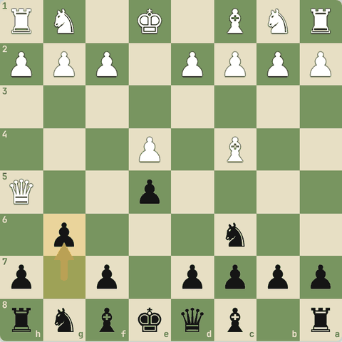
Chaal ke baad

2.7.9 Scholar's mate ka rook-fork version
- Opponent ki nakal mat karo.
- 2...Bc5 ke baad 3.Qh5: ab 3...g6?? phir fork.
1. e4 e5 2. Bc4 Bc5 3. Qh5 g6 4. Qxe5+ Qe7 5. Qxh8
- 2...Bc5 nakal. Behtar: 2...Nf6! (Tarrasch: "knights before bishops").
- 3.Qh5 f7 aur e5 dono par attack.
- 3...g6?? (sahi: 3...Qe7)
- 4.Qxe5+ fork: king, rook h8 (aur bishop c5).
- 5.Qxh8 Rook gaya.
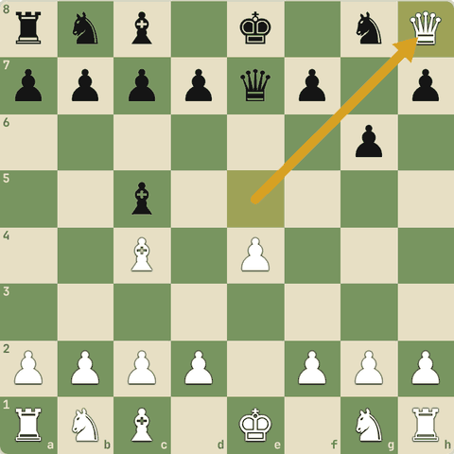
Final position (5.Qxh8)

2.7.10 f6 se e5 bachana: Damiano ki galti
- 2...f6? king ka pawn shield kamzor karta hai.
1. e4 e5 2. Nf3 f6 3. Nxe5 fxe5 4. Qh5+ g6 5. Qxe5+ Qe7 6. Qxh8
- 2...f6? behtar 2...Nc6.
- 3.Nxe5! knight sacrifice.
- 3...fxe5? (3...Qe7 behtar)
- 4.Qh5+ king khula hai.
- 4...g6 (4...Ke7 5.Qxe5+ Kf7 6.Bc4+ aur bhayankar attack)
- 5.Qxe5+ fork!
- 6.Qxh8 Rook gaya, White material mein aage.
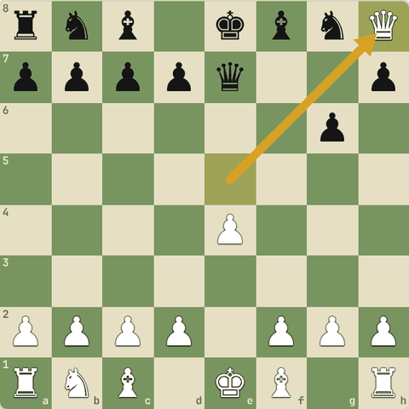
Final position (6.Qxh8)

2.7.11 King's Gambit: `fxe5` trap
- Black gambit lene ki jagah 2...Nc6 khelta hai.
- Agar White 3.fxe5??...
1. e4 e5 2. f4 Nc6 3. fxe5 Qh4+ 4. g3 Qxe4+ 5. Qe2 Qxh1
- 2...Nc6 simple development.
- 3.fxe5?? lalach.
- 3...Qh4+! king ka diagonal khula hai.
- 4.g3 (4.Ke2 Qxe4+ 5.Kf2 Bc5+ aur bhi bura)
- 4...Qxe4+ fork: king aur rook h1.
- 5…Qxh1 Rook gaya.
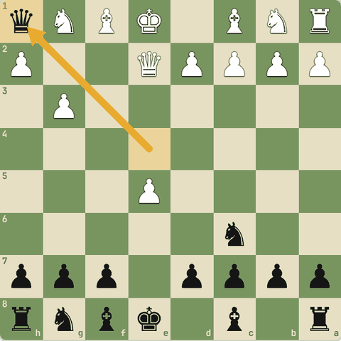
Final position (5…Qxh1)

2.7.12 Legal's mate (trap)
- Ek famous opening trap jahan White queen sacrifice karta hai.
1. e4 e5 2. Nf3 d6 3. Bc4 Bg4 4. Nc3 g6 5. Nxe5 Bxd1 6. Bxf7+ Ke7 7. Nd5#
- 3...Bg4 knight ko pin kiya (relative pin, peeche queen).
- 4...g6? slow chaal.
- 5.Nxe5! Pin tod diya! Queen de di.
- 5...Bxd1?? Lalach. 5...dxe5 behtar tha.
- 6.Bxf7+ King ko bahar kheencha.
- 7.Nd5# Teen minor pieces ka mate!
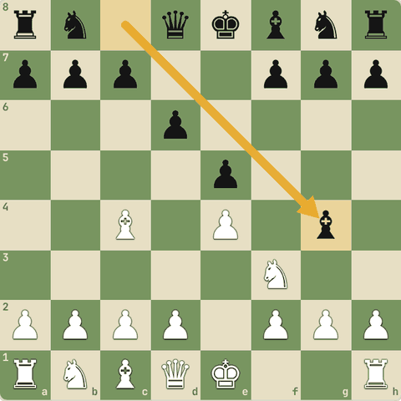
Position after 3…Bg4
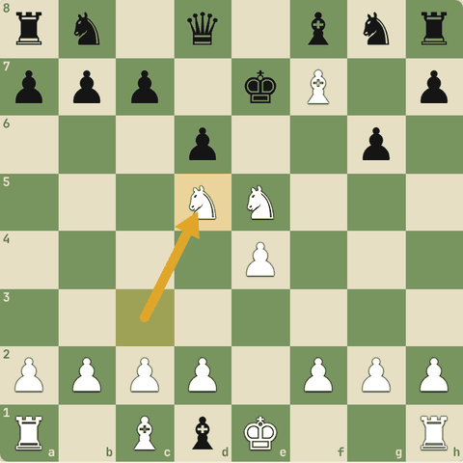
Final position (7.Nd5#)

2.7.13 Abhyaas: Legal trap ke baad
Legal trap ke baad: Black ne queen le li (5...Bxd1). Mate in 2!
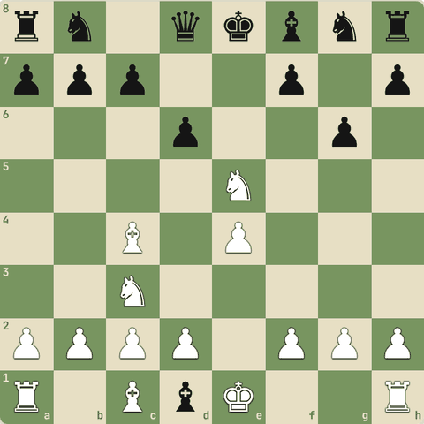
(White ki chaal)
Jawab:
1. Bxf7+ Ke7 2. Nd5#
- 6.Bxf7+ Ke7 7.Nd5#.
- Teen minor pieces ne mate kiya, queen ki zaroorat hi nahi.
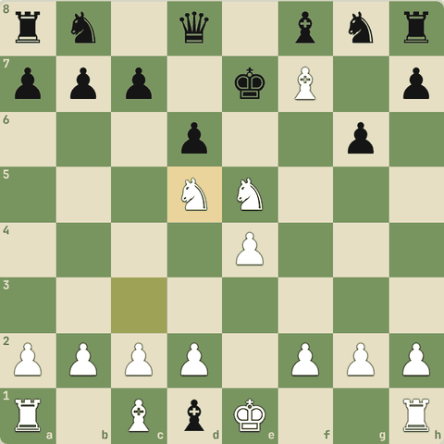
Line ke baad position

2.7.14 Blackburne Shilling trap
- 3...Nd4 ek trick hai.
- Agar White lalach kare to mate!
1. e4 e5 2. Nf3 Nc6 3. Bc4 Nd4 4. Nxe5 Qg5 5. Nxf7 Qxg2 6. Rf1 Qxe4+ 7. Be2 Nf3#
- 3...Nd4?! pawn e5 "free" lagta hai.
- 4.Nxe5? lalach. Behtar: 4.Nxd4 ya 4.O-O.
- 4...Qg5! g2 aur e5 par attack.
- 5.Nxf7?? aur lalach.
- 5...Qxg2
- 6.Rf1
- 6...Qxe4+
- 7.Be2
- 7...Nf3# Smothered mate! Seekh: opponent ki trick chaal par pehle socho "kyun?".
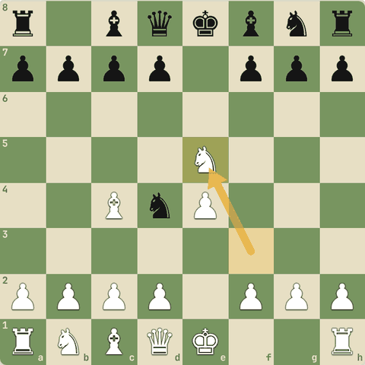
Position after 4.Nxe5
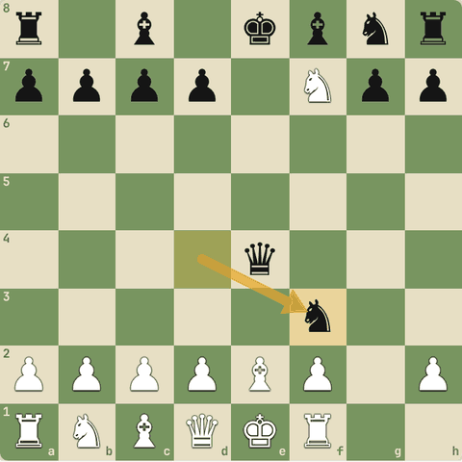
Final position (7…Nf3#)

2.7.15 Sawal 1: Trap se bachne ka sabse achha general tareeka?
Trap se bachne ka sabse achha general tareeka?
Jawab:
✓ "Free" material lene se pehle opponent ki threat (checks, captures, threats) dekho
- Aksar trap tab lagta hai jab hum lalach mein opponent ki agli chaal nahi dekhte.

2.8 Sochne ka tareeka: forcing moves (CCT)
Checks, Captures, Threats
Yaad rakho
- Har chaal se pehle CCT: Checks, Captures, Threats.
- Pehle apne liye, phir opponent ke liye socho.
- Aakhir mein blunder check: meri chaal se kuch hanging to nahi?
- Opponent ki har chaal par poocho: "Iski threat kya hai?"
- Hum computer nahi: isliye pehle forcing moves (checks, captures, threats) dekho. Yeh opponent ke jawab seemit karti hain.
- Sabse forcing: double check, phir check, phir capture, phir badi threat (mate in 1-2, queen par attack).
- Kabhi quiet (shaant) chaal forcing se behtar hoti hai: CCT jaagrukta ke liye hai, andhadhundh khelne ke liye nahi.

2.8.1 Har chaal se pehle CCT
- Grandmasters bhi har position mein pehle forcing moves dekhte hain:
  - Checks: kya main check de sakta hoon?
  - Captures: kya main kuch capture kar sakta hoon?
  - Threats: kya main koi bada attack bana sakta hoon (mate threat, queen par attack)?
- Phir yahi opponent ke liye socho: woh kya karna chahta hai?
- Aakhir mein blunder check: "Kya meri chaal se koi piece hanging hoga?"

2.8.2 Abhyaas: CCT use karo
CCT use karo: pehle saare checks dekho. Sabse achhi chaal?
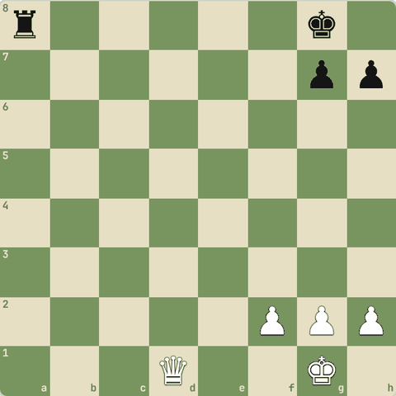
(White ki chaal)
Jawab:
1. Qd5+
- Qd5+ check deta hai aur a8 rook par bhi attack.
- King hatega, phir Qxa8+.
- Checks pehle dekhne se yeh turant milta hai.
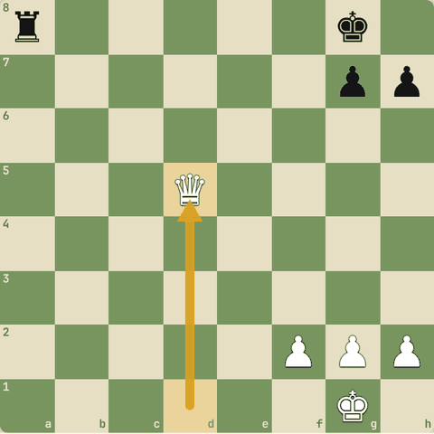
Chaal ke baad

2.8.3 Sawal 1: Opponent ne abhi apni queen tumhare king ke paas laayi
Opponent ne abhi apni queen tumhare king ke paas laayi. Sabse pehle kya socho?
Jawab:
✓ Woh kya threat bana raha hai (mate?)
- Opponent ki threat dekhna = aadhe blunders khatam.

2.8.4 Forcing moves pehle kyun?
- Computer har second laakhon positions dekhta hai, hum nahi.
- Hum is kami ko poora karte hain forcing moves ko pehle dekh kar: Checks, Captures, Threats (jaise mate in 1-2, queen par attack).
- Forcing chaal opponent ke jawab bahut kam kar deti hai, isliye aage tak calculate karna aasaan ho jaata hai.
- Sabse forcing: double check (king ko hilna hi padega).
- Par yaad rakho: CCT jaagrukta hai.
- Kabhi ek shaant (quiet) chaal best hoti hai.

2.8.5 Abhyaas: Pehle saare checks dekho
Pehle saare checks dekho. Mate in 1!
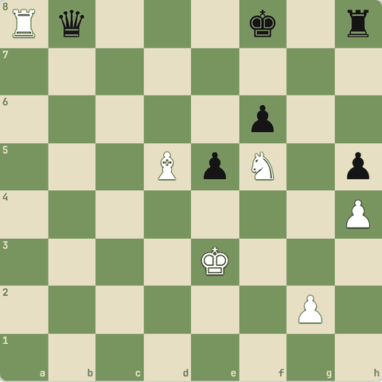
(White ki chaal)
Jawab:
1. Rxb8#
- Rxb8# checkmate.
- Checks pehle dekhne se aisi chaalein nahi chhoot-ti.
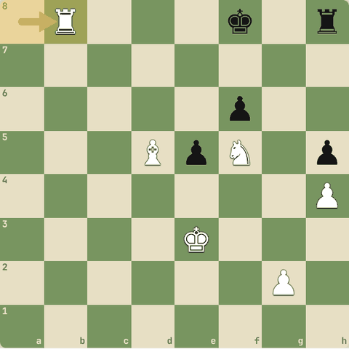
Chaal ke baad

2.8.6 Abhyaas: Pehle saare checks dekho
Pehle saare checks dekho. Mate in 1!
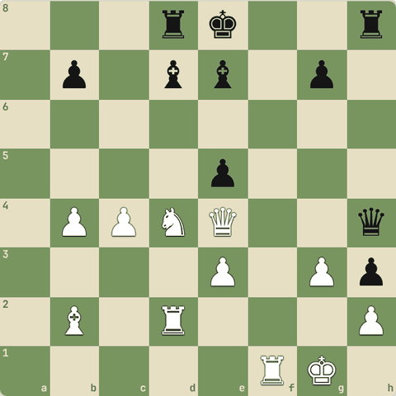
(White ki chaal)
Jawab:
1. Qg6#
- Qg6# checkmate.
- Checks pehle dekhne se aisi chaalein nahi chhoot-ti.
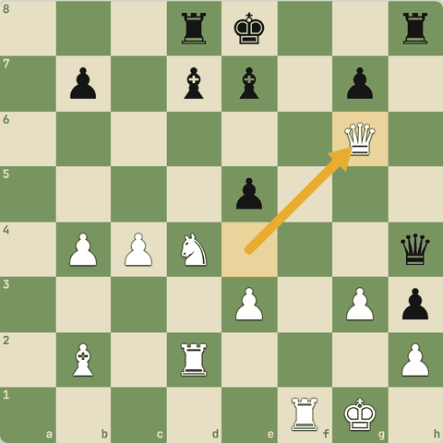
Chaal ke baad

2.8.7 Abhyaas: Pehle saare checks dekho
Pehle saare checks dekho. Mate in 1!
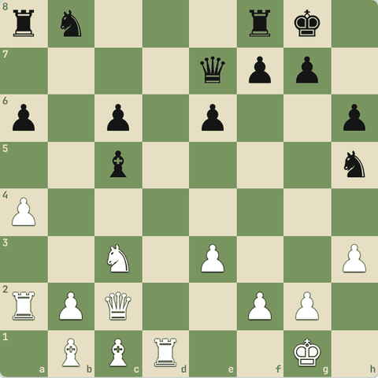
(White ki chaal)
Jawab:
1. Qh7#
- Qh7# checkmate.
- Checks pehle dekhne se aisi chaalein nahi chhoot-ti.
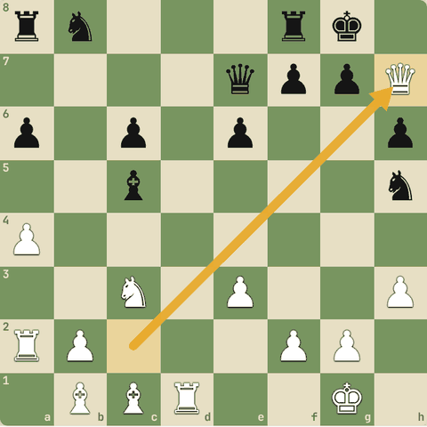
Chaal ke baad

2.8.8 Abhyaas: Pehle saare checks dekho
Pehle saare checks dekho. Mate in 1!
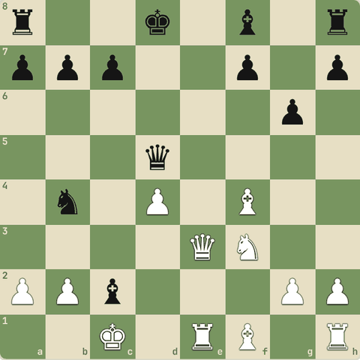
(White ki chaal)
Jawab:
1. Qe8#
- Qe8# checkmate.
- Checks pehle dekhne se aisi chaalein nahi chhoot-ti.
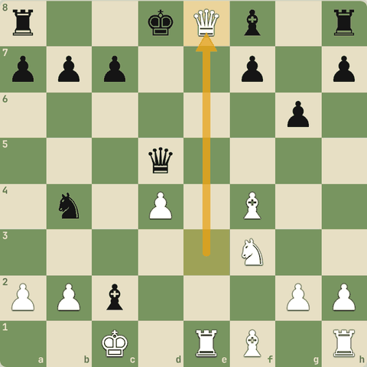
Chaal ke baad

Level 3: Middlegame 1: Tactics
Sochne ki process, fork, pin, skewer, discovered attack, defender hatao, deflection, decoy, interference, clearance, x-ray, calculation
- Middlegame section (Level 3-5) yahan se shuru.
- Middlegame woh hissa hai jab pieces bahar aa chuke hain aur asli ladaai hoti hai: tactics, mate attacks aur plans.
- Pehla hissa tactics: chhoti forcing chaalon se material ya mate jeetna.
- Pehle sochne ki process, phir har hathiyaar alag se, aur bahut saare puzzles.

3.1 Middlegame mein sochne ki process
Processes vs patterns, downsides, defensive hero, ek-chaal ka game
Yaad rakho
- Process (calculation, evaluation, visualization) aur pattern (fork, pin, mate patterns) alag cheezein hain. Dono chahiye.
- Chess "single-turn" game hai: ek chaal mein do threats = opponent ek hi bacha payega (double attack ka raaz).
- Evaluation mein opponent ke downsides dhundo: unprotected pieces, kamzor king.
- Calculation ek "draft story" hai: jo defensive hero tumhari story bigaadta hai, use hatao.
- Forcing moves dekho, par kabhi quiet chaal aur kabhi aur aage calculate karna behtar.

3.1.1 Processes aur patterns
- Process = sochne ka tareeka, kisi bhi position mein: forcing moves (checks, captures, threats) dekhna, calculation (aage ki chaalein sochna), visualization (dimaag mein board), evaluation (line ke end mein kaun behtar: material, king safety, pawn structure).
- Pattern = jaani-pehchaani shakal: fork, pin, deflection, mate patterns.
- Pattern pata na ho tab bhi process se jeet sakte ho.
- Aur patterns process ko tez karte hain.

3.1.2 Chess ek-chaal ka game hai
- Har chaal mein opponent sirf ek kaam kar sakta hai.
- Agar tum ek chaal se do threats banao, aur koi ek chaal dono ko na roke, to ek cheez jaayegi.
- Isliye double attack (fork) sabse important tactic hai.
- Kabhi double attack ek piece nahi karta: ek piece hatne se peeche wale ka attack khulta hai (discovered attack).

3.1.3 Sawal 1: Opponent ki do cheezon par ek saath threat hai, aur koi ek chaal…
Opponent ki do cheezon par ek saath threat hai, aur koi ek chaal dono nahi bachati. Kyun jeet hoti hai?
Jawab:
✓ Kyunki chess mein ek turn mein ek hi chaal hoti hai
- Single-turn game: ek chaal = ek bachaav.

3.1.4 Downsides ka jashn: unprotected pieces aur king
- Position dekh kar pehle opponent ki kamzoriyan (downsides) dhundo:
  - Unprotected pieces: sabse classic downside. Kabhi seedha nahi pakad sakte, use doosre downside (jaise check) mein badalna padta hai.
  - King safety: khula king, kamzor back rank, pawns aage badhe hue.
- Calculation in downsides ko ubhaarne ka tool hai.
- Pata ho ki kya dhundh rahe ho, to aur aage tak dekh paate ho.

3.1.5 Defensive hero ko hatao
- Calculation ek draft story jaisi hai.
- Aksar story mein ek defensive hero hota hai: woh ek piece jo tumhara plan bigaad deta hai (mate square bachata hai, piece ko protect karta hai).
- Story dobara likho: pehle hero ko capture karo, bhagao, ya bhatkao (removing the defender, deflection), phir plan chalao.

3.1.6 Sawal 2: Tumhari mate ki line mein ek black knight f6 square h7 ko bacha…
Tumhari mate ki line mein ek black knight f6 square h7 ko bacha raha hai. Pehle kya socho?
Jawab:
✓ Knight (defensive hero) ko kaise hatayein
- Defender hatao, phir mate.

3.1.7 Facts awareness
- Har forcing chaal khelni zaroori nahi: kabhi quiet chaal (jo badi threat banaye) zyada strong.
- Opponent ki threat aur trap se jaagruk raho, par darr ke ruk mat jao: kabhi aur aage calculate karo to dikhega ki "khatra" asli nahi.

3.2 Fork (do pe ek saath attack)
Knight, queen aur pawn forks
Yaad rakho
- Fork = ek piece se do ya zyada pieces par ek saath attack.
- Knight fork sabse khatarnaak: uska attack block nahi hota.
- Best fork = check + kuch aur: pehle king bachana padta hai.
- Pawn aur queen bhi fork karte hain. Royal fork = king + queen.
- Fork = double attack. King + kuch aur par fork sabse strong (check ka jawab dena padta hai).
- Pawn bhi fork karta hai. Fork se pawn ko promote karne ka raasta bhi ban sakta hai.
- Famous: Petrosian-Spassky, Petrosian-Simagin, Botvinnik-Kotov, Anand-Kasparov, Tal-Pliss (pawn fork).

3.2.1 Fork kya hai
- Fork = ek piece se do ya zyada dushman pieces par ek saath attack.
- Opponent ek hi bacha sakta hai.
- Knight fork sabse khatarnaak hota hai kyunki knight ka attack block nahi hota.
- Sabse best fork: king + kuch aur (check ke saath), kyunki check pehle bachana padta hai.
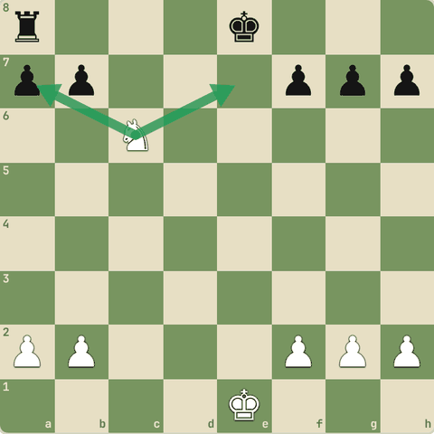

3.2.2 Abhyaas: Knight fork dhundo!
Knight fork dhundo!
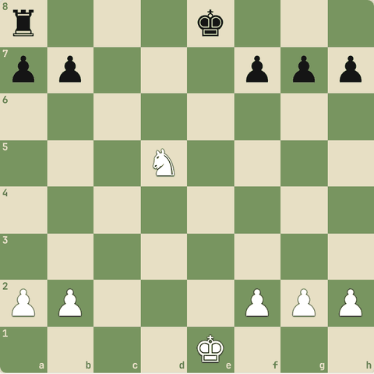
(White ki chaal)
Jawab:
1. Nc7+ Kd7 2. Nxa8
- Nc7+ king aur a8 rook ka fork.
- King hatega, phir Nxa8.
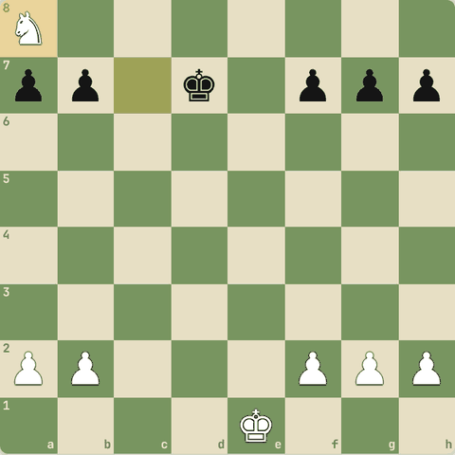
Line ke baad position

3.2.3 Abhyaas: Queen fork
Queen fork: check + rook.
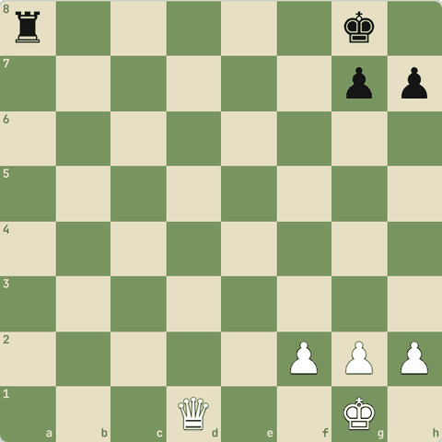
(White ki chaal)
Jawab:
1. Qd5+
- Qd5+ king ko check aur a8 rook ko attack.
- Phir Qxa8.
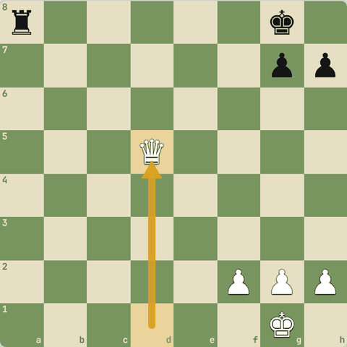
Chaal ke baad

3.2.4 Abhyaas: Pawn bhi fork karta hai!
Pawn bhi fork karta hai!
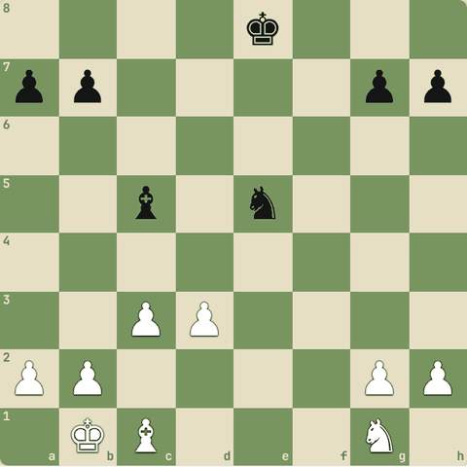
(White ki chaal)
Jawab:
1. d4
- d4 bishop aur knight dono par attack.
- c3 pawn d4 ko protect karta hai.
- Ek piece jaayega.
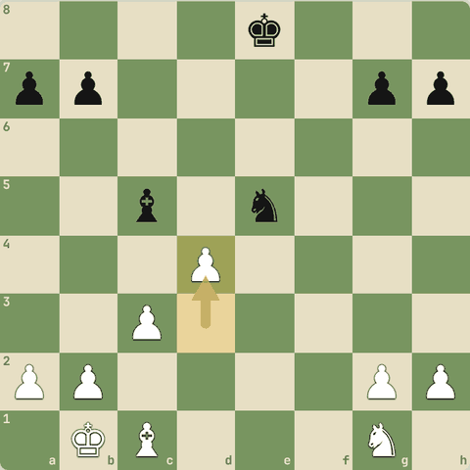
Chaal ke baad

3.2.5 Abhyaas: Royal fork
Royal fork: king aur queen.
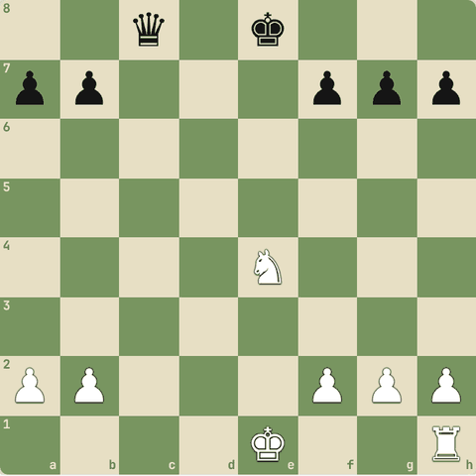
(White ki chaal)
Jawab:
1. Nd6+ Kd7 2. Nxc8
- Nd6+ king + queen fork.
- Queen jeet li.
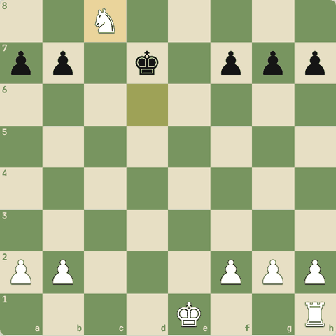
Line ke baad position

3.2.6 Masters ke forks
- Fork har level par aata hai:
  - Petrosian vs Spassky, Petrosian vs Simagin, Botvinnik vs Kotov: knight aur queen ke forks se material.
  - Avrukh vs Kamsky: fork se pawn ko queen banane ka raasta saaf.
  - Aronian vs Seel, Anand vs Kasparov, Keene vs Botvinnik.
  - Tal vs Pliss: "pawns bhi fork karte hain!"
- Ab khud karo: aur forks.

3.2.7 Abhyaas: Fork dhundo
Fork dhundo: ek chaal, do nishaane.
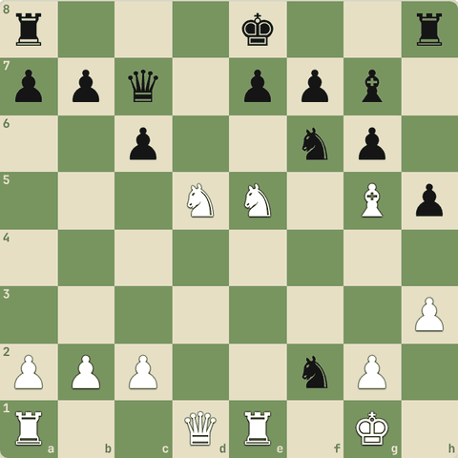
(White ki chaal)
Jawab:
1. Nxc7+
- Line: Nxc7+.
- Ek piece ne ek saath do cheezon par attack kiya.
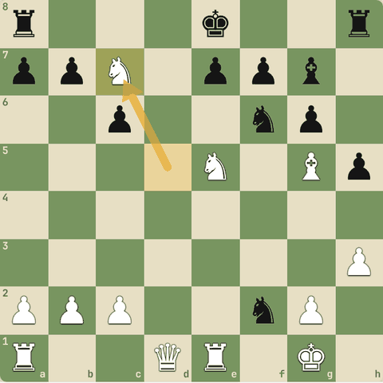
Chaal ke baad

3.2.8 Abhyaas: Fork dhundo
Fork dhundo: ek chaal, do nishaane.
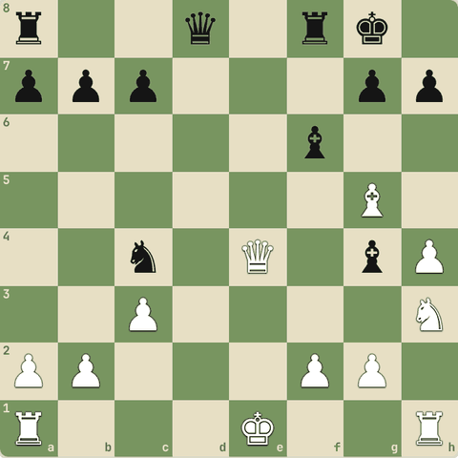
(White ki chaal)
Jawab:
1. Qxc4+
- Line: Qxc4+.
- Ek piece ne ek saath do cheezon par attack kiya.
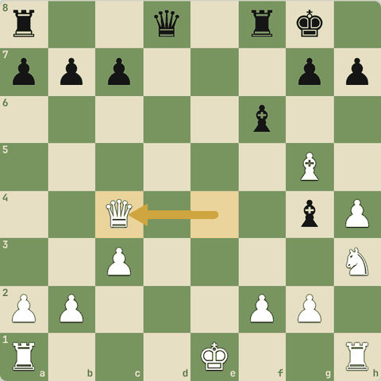
Chaal ke baad

3.2.9 Abhyaas: Fork dhundo
Fork dhundo: ek chaal, do nishaane.
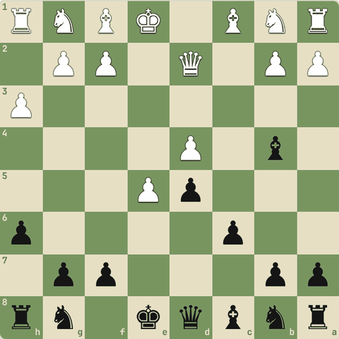
(Black ki chaal)
Jawab:
1… Bxd2+
- Line: Bxd2+.
- Ek piece ne ek saath do cheezon par attack kiya.
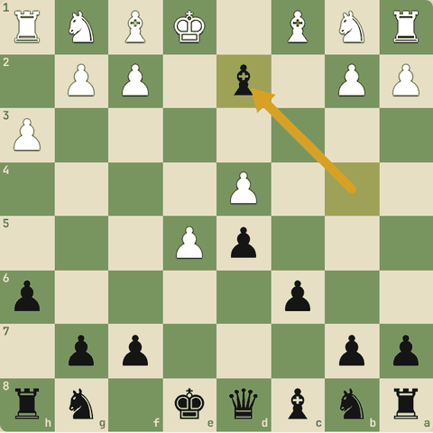
Chaal ke baad

3.2.10 Abhyaas: Fork dhundo
Fork dhundo: ek chaal, do nishaane.
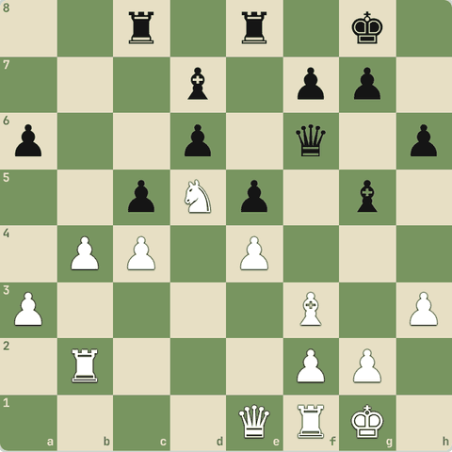
(White ki chaal)
Jawab:
1. Nxf6+
- Line: Nxf6+.
- Ek piece ne ek saath do cheezon par attack kiya.
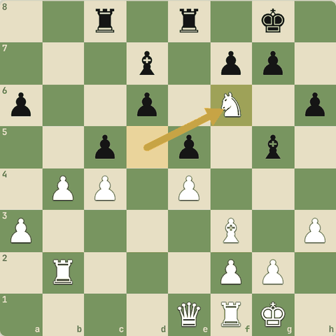
Chaal ke baad

3.2.11 Abhyaas: Fork dhundo
Fork dhundo: ek chaal, do nishaane.
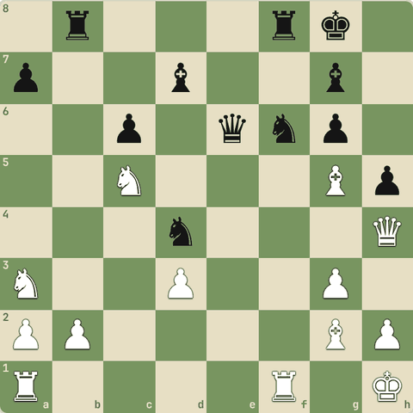
(White ki chaal)
Jawab:
1. Nxe6
- Line: Nxe6.
- Ek piece ne ek saath do cheezon par attack kiya.
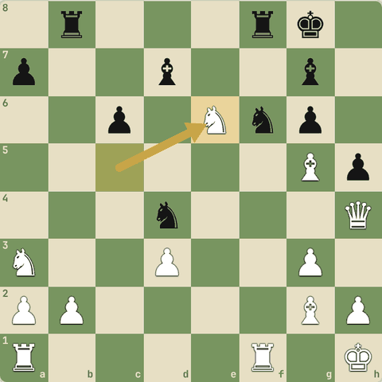
Chaal ke baad

3.2.12 Abhyaas: Fork dhundo
Fork dhundo: ek chaal, do nishaane.
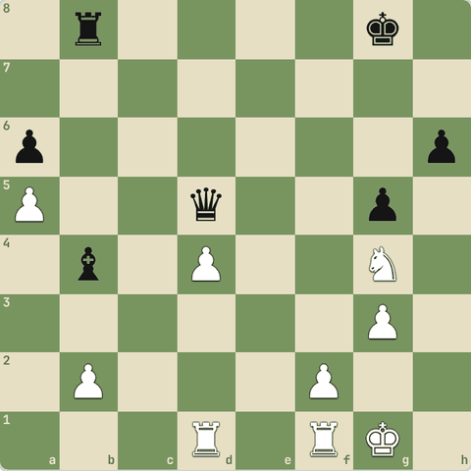
(White ki chaal)
Jawab:
1. Nf6+ Kf7 2. Nxd5
- Line: Nf6+ Kf7 Nxd5.
- Ek piece ne ek saath do cheezon par attack kiya.
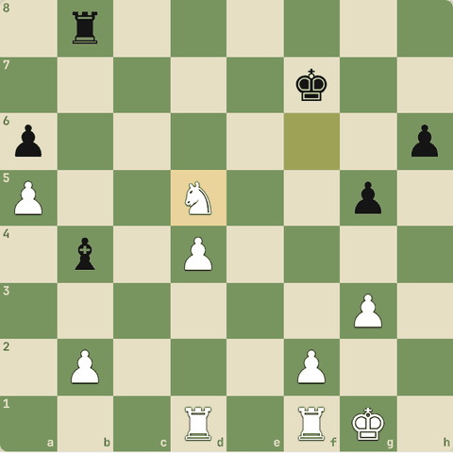
Line ke baad position

3.2.13 Abhyaas: Fork dhundo
Fork dhundo: ek chaal, do nishaane.
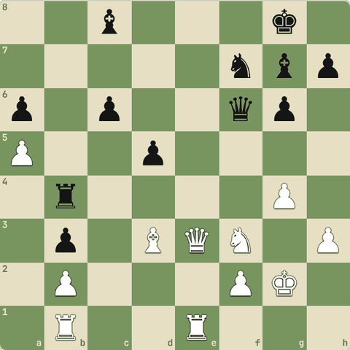
(White ki chaal)
Jawab:
1. Qe8+ Bf8 2. Qxc8
- Line: Qe8+ Bf8 Qxc8.
- Ek piece ne ek saath do cheezon par attack kiya.
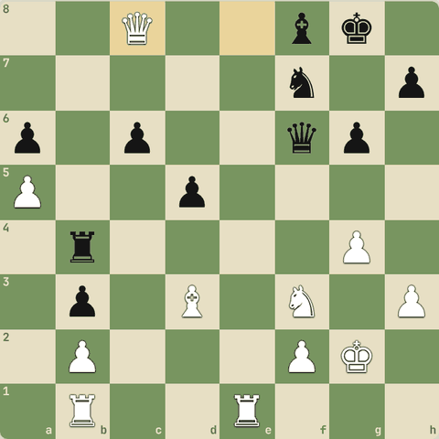
Line ke baad position

3.2.14 Abhyaas: Fork dhundo
Fork dhundo: ek chaal, do nishaane.
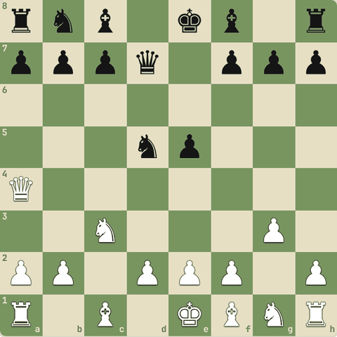
(White ki chaal)
Jawab:
1. Qxd7+ Bxd7 2. Nxd5
- Line: Qxd7+ Bxd7 Nxd5.
- Ek piece ne ek saath do cheezon par attack kiya.
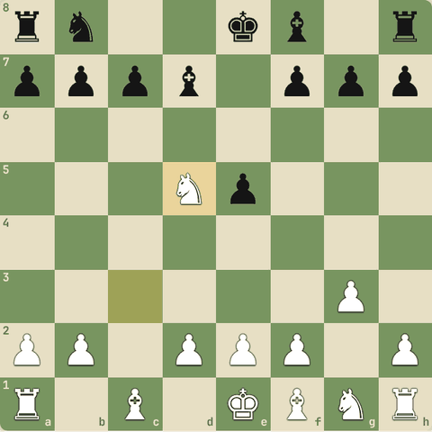
Line ke baad position

3.3 Pin
Piece hil nahi sakta
Yaad rakho
- Pin: aage wala piece hil nahi sakta kyunki peeche zyada keemti piece hai.
- Absolute pin (peeche king): kanoonan hil nahi sakta. Relative pin (peeche queen/rook): hilega to nuksaan.
- Pinned piece par aur attack karo (aksar pawn se).
- Bishop, rook, queen hi pin karte hain.
- Absolute pin: peeche king, pinned piece chal hi nahi sakta. Relative pin: peeche queen/rook, chal sakta hai par nuksaan.
- Relative pin kabhi tod sakte ho (rebel) agar badle mein bada fayda ho (Legal trap, Popov-Petkovski).
- Pinned piece defender nahi raha: pin se mate ya material jeeto (Nimzowitsch-Rubinstein).

3.3.1 Pin kya hai
- Pin = ek piece hil nahi sakta (ya hilna nahi chahiye) kyunki uske peeche zyada keemti piece hai.
- Absolute pin: peeche king hai. Pinned piece kanoonan hil hi nahi sakta.
- Relative pin: peeche queen/rook hai. Hil sakta hai par nuksaan hoga.
- Pin ka fayda: pinned piece par aur attack karo (jaise pawn se).
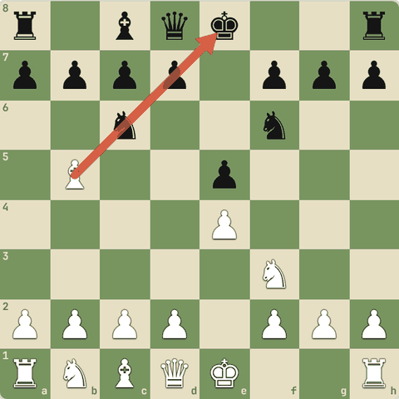

3.3.2 Abhyaas: Pin karke queen jeeto
Pin karke queen jeeto.
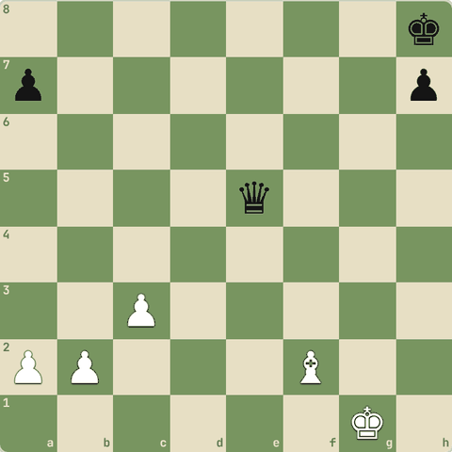
(White ki chaal)
Jawab:
1. Bd4
- Bd4! queen h8 king ke saath pin hai.
- Woh hat nahi sakti: Qxd4 cxd4 ke baad Black ne queen (9) dekar bishop (3) liya.
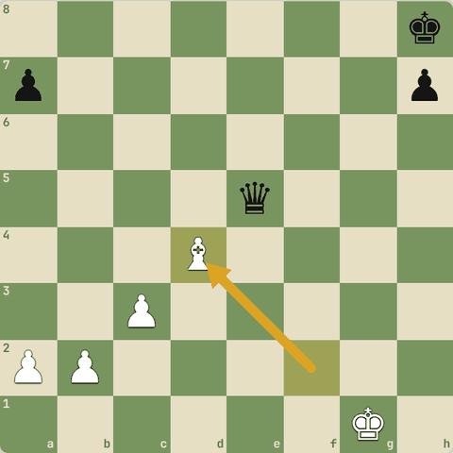
Chaal ke baad

3.3.3 Abhyaas: Pinned knight par attack karo!
Pinned knight par attack karo!
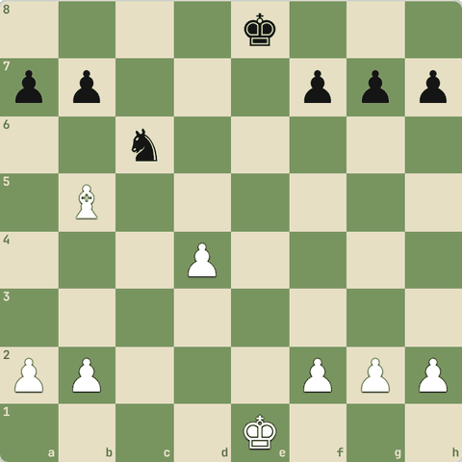
(White ki chaal)
Jawab:
1. d5
- d5! knight pinned hai (peeche king).
- Woh bhaag nahi sakta, agli chaal dxc6 se piece jeet.
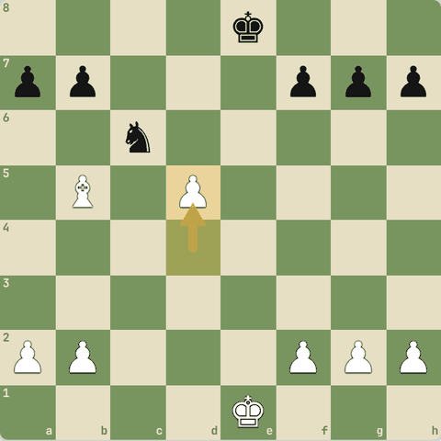
Chaal ke baad

3.3.4 Sawal 1: Yahan c6 ka knight kis type ke pin mein hai?
Yahan c6 ka knight kis type ke pin mein hai?
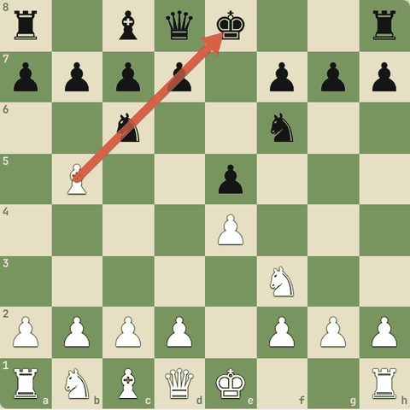
Jawab:
✓ Absolute pin (peeche king)
- Bb5 se e8 king tak diagonal: knight beech mein hai aur kanoonan hil nahi sakta.

3.3.5 Pin ke prakaar
- Absolute pin: peeche king. Pinned piece chal hi nahi sakta (illegal).
- Relative pin: peeche queen ya rook. Chal sakta hai, par peeche wala jaayega.
- Relative pin se bagawat: kabhi pinned piece chala do agar badle mein mate ya bada fayda ho (Legal trap mein Nxe5!, Popov vs Petkovski).
- Pin ka jashn: pinned piece "nakli defender" hai. Us par aur attackers lao (Nimzowitsch vs Rubinstein: pin se mate force).
- Examples: Nimzowitsch-Nielsen (defensive hero ko pin karke hataaya), Bronstein-Goldenov (pin se key square par kabza), Xie Jun-Yu Lefu.

3.3.6 Elephant trap (Queen's Gambit Declined): pin jo pin nahi tha
- White ko laga f6 knight pinned hai aur d5 pawn free hai.
- Par Black ka jawab tayyar tha.
1. d4 d5 2. c4 e6 3. Nc3 Nf6 4. Bg5 Nbd7 5. cxd5 exd5 6. Nxd5 Nxd5 7. Bxd8 Bb4+ 8. Qd2 Bxd2+ 9. Kxd2 Kxd8
- 4...Nbd7 trap set.
- 6.Nxd5?? "knight pinned hai" soch kar pawn liya.
- 6...Nxd5! relative pin todi! Queen de di.
- 7.Bxd8
- 7...Bb4+! check.
- 8.Qd2 sirf yahi.
- 8...Bxd2+
- 9...Kxd8 Black ek piece aage.
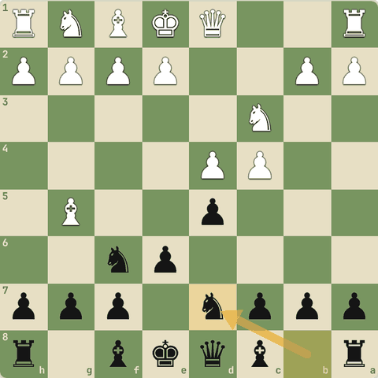
Position after 4…Nbd7
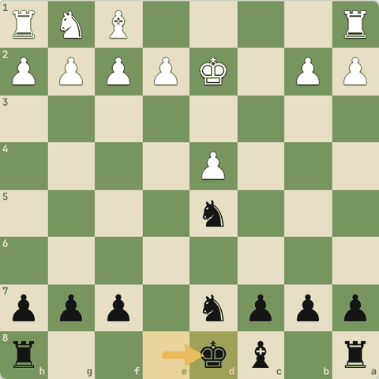
Final position (9…Kxd8)

3.3.7 Sawal 2: Pinned piece ke peeche king hai
Pinned piece ke peeche king hai. Kya woh chal sakta hai?
Jawab:
✓ Nahi, illegal hai
- Absolute pin.

3.3.8 Abhyaas: Pin se jeeto
Pin se jeeto.
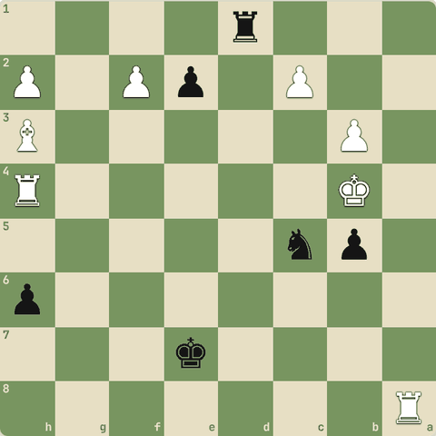
(Black ki chaal)
Jawab:
1… e1=Q+
- Line: e1=Q+.
- Pinned piece hil nahi sakta (ya hilne par bada nuksaan), isliye material jeeta.
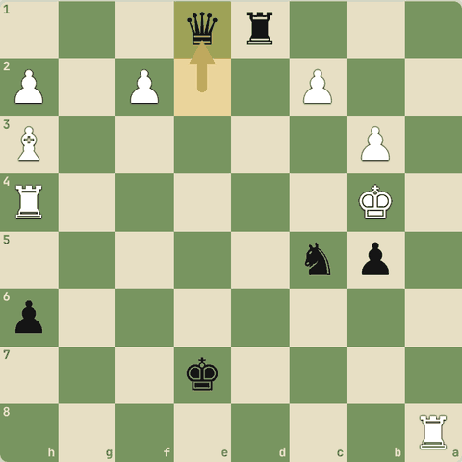
Chaal ke baad

3.3.9 Abhyaas: Pin se jeeto
Pin se jeeto.
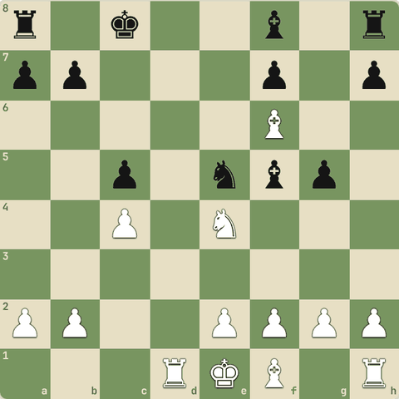
(White ki chaal)
Jawab:
1. Rd8+ Kc7 2. Rxa8
- Line: Rd8+ Kc7 Rxa8.
- Pinned piece hil nahi sakta (ya hilne par bada nuksaan), isliye material jeeta.
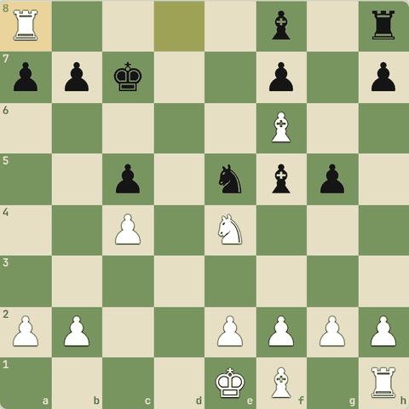
Line ke baad position

3.3.10 Abhyaas: Pin se jeeto
Pin se jeeto.
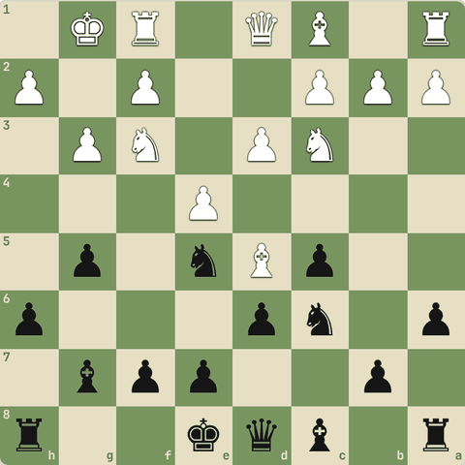
(Black ki chaal)
Jawab:
1… Bg4 2. Nxe5 Bxd1
- Line: Bg4 Nxe5 Bxd1.
- Pinned piece hil nahi sakta (ya hilne par bada nuksaan), isliye material jeeta.
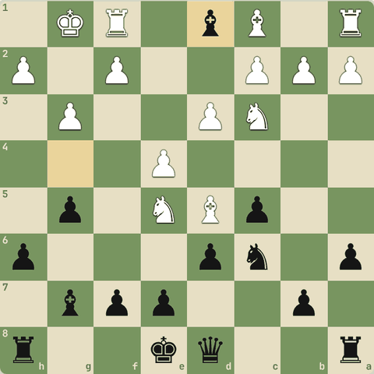
Line ke baad position

3.3.11 Abhyaas: Pin se jeeto
Pin se jeeto.
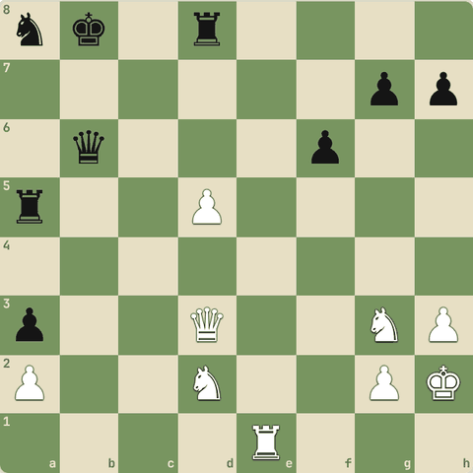
(White ki chaal)
Jawab:
1. Rb1 Rdxd5 2. Rxb6+
- Line: Rb1 Rdxd5 Rxb6+.
- Pinned piece hil nahi sakta (ya hilne par bada nuksaan), isliye material jeeta.
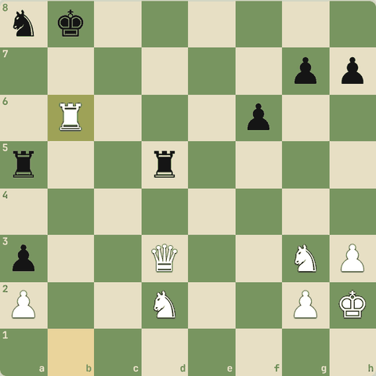
Line ke baad position

3.3.12 Abhyaas: Pin se jeeto
Pin se jeeto.
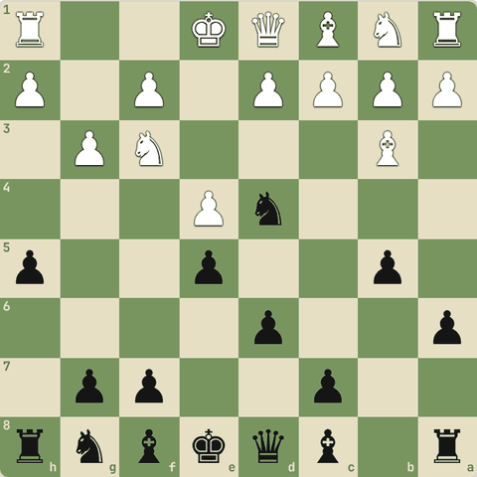
(Black ki chaal)
Jawab:
1… Bg4 2. Nxd4 Bxd1
- Line: Bg4 Nxd4 Bxd1.
- Pinned piece hil nahi sakta (ya hilne par bada nuksaan), isliye material jeeta.
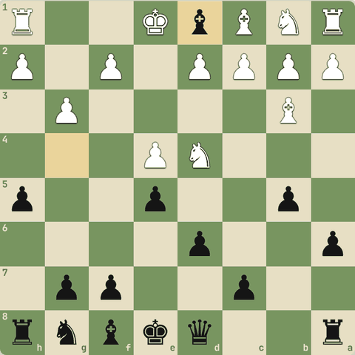
Line ke baad position

3.3.13 Abhyaas: Pin se jeeto
Pin se jeeto.
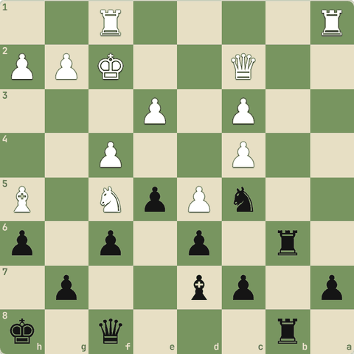
(Black ki chaal)
Jawab:
1… Rb2 2. Qxb2 Rxb2+
- Line: Rb2 Qxb2 Rxb2+.
- Pinned piece hil nahi sakta (ya hilne par bada nuksaan), isliye material jeeta.
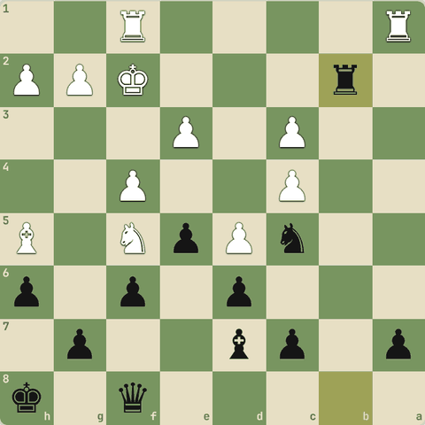
Line ke baad position

3.4 Skewer
Ulta pin
Yaad rakho
- Skewer = ulta pin: keemti piece aage (aksar king), kam keemti peeche.
- Aage wala hatega, peeche wala capture.
- Line pieces (rook, bishop, queen) hi skewer karte hain.
- Skewer = ulta pin: aage bada piece (king/queen), hatega to peeche wala jaayega.
- Famous: Short-Vaganian, Kasparov-Tatai, Fischer-Stepans, Carlsen-Anand, Kramnik-Nakamura.

3.4.1 Skewer
- Skewer pin ka ulta hai: keemti piece aage hai (aksar king), aur kam keemti peeche.
- Aage wala hatega, to peeche wala capture.
- Rooks, bishops aur queens skewer karte hain (seedhi line wale pieces).
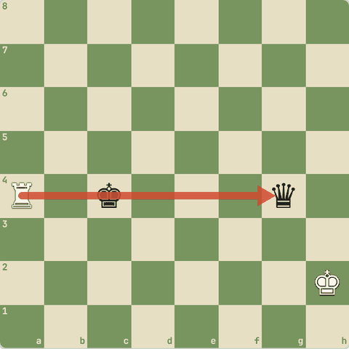

3.4.2 Abhyaas: Rook skewer!
Rook skewer!
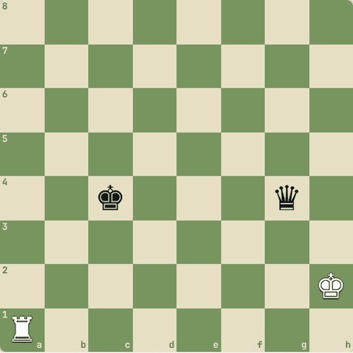
(White ki chaal)
Jawab:
1. Ra4+ Kd3 2. Rxg4
- Ra4+ king ko check, woh hatega, phir Rxg4.
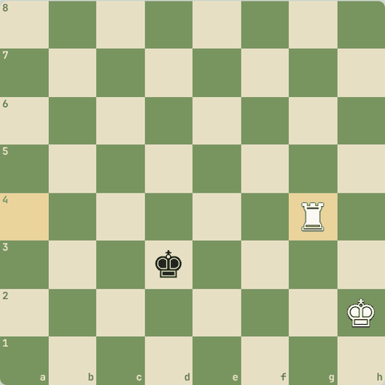
Line ke baad position

3.4.3 Abhyaas: Bishop skewer!
Bishop skewer!
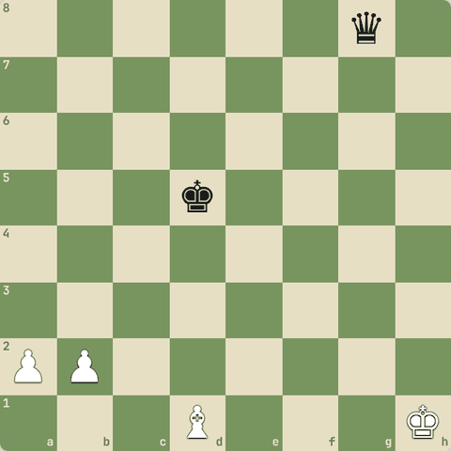
(White ki chaal)
Jawab:
1. Bb3+ Kd6 2. Bxg8
- Bb3+ king hatega, phir Bxg8.
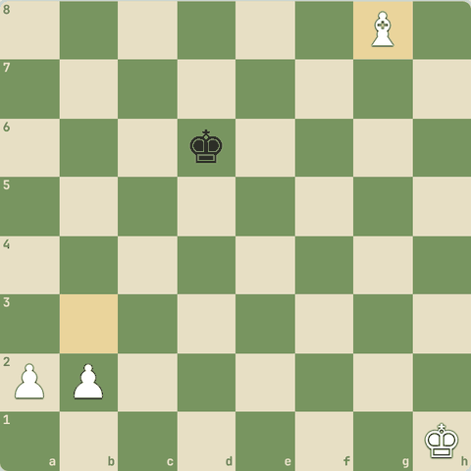
Line ke baad position

3.4.4 Masters ke skewers
- Skewer mein bada piece aage hota hai.
- Woh hatta hai, peeche wala jaata hai.
- Aksar check ke saath.
- Examples: Short-Vaganian, Kasparov-Tatai, Fischer-Stepans, Unzicker-Tal, Carlsen-Anand, Spassky-Korchnoi, Kramnik-Nakamura, Rivera-Fischer.

3.4.5 Abhyaas: Skewer dhundo
Skewer dhundo: bade piece par attack, peeche wala jeeto.
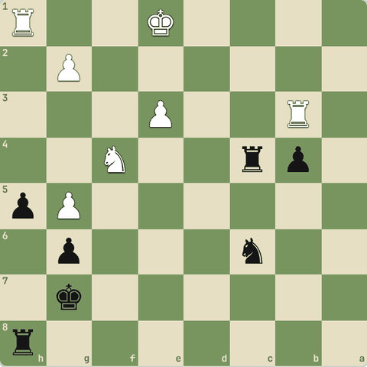
(Black ki chaal)
Jawab:
1… Rc1+ 2. Ke2 Rxh1
- Line: Rc1+ Ke2 Rxh1.
- Bada piece hata aur peeche wala piece gaya.
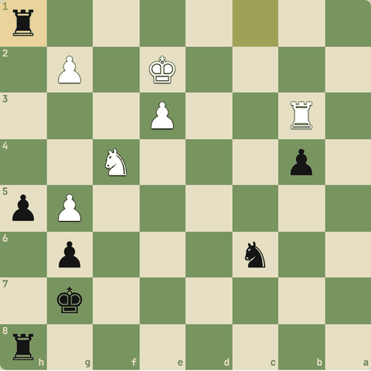
Line ke baad position

3.4.6 Abhyaas: Skewer dhundo
Skewer dhundo: bade piece par attack, peeche wala jeeto.
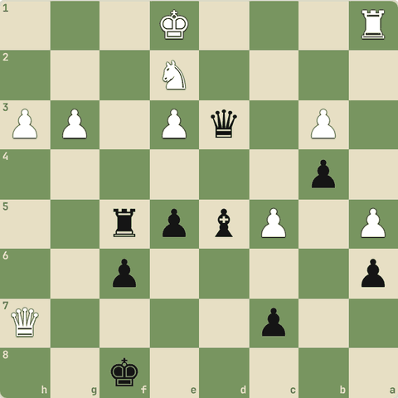
(Black ki chaal)
Jawab:
1… Rf1+ 2. Kxf1 Qxh7
- Line: Rf1+ Kxf1 Qxh7.
- Bada piece hata aur peeche wala piece gaya.
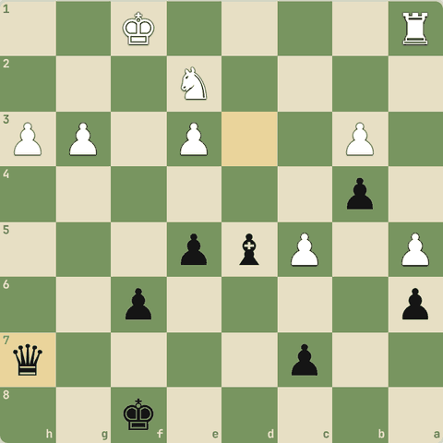
Line ke baad position

3.4.7 Abhyaas: Skewer dhundo
Skewer dhundo: bade piece par attack, peeche wala jeeto.
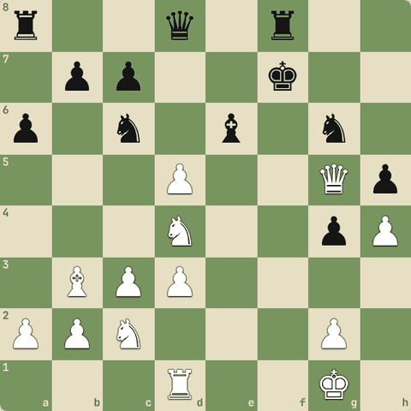
(White ki chaal)
Jawab:
1. Rf1+ Ke8 2. Qxg6+
- Line: Rf1+ Ke8 Qxg6+.
- Bada piece hata aur peeche wala piece gaya.
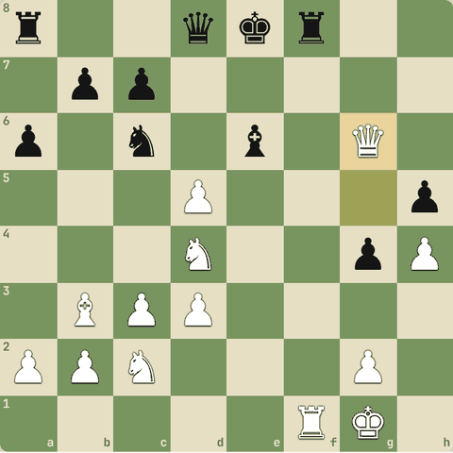
Line ke baad position

3.4.8 Abhyaas: Skewer dhundo
Skewer dhundo: bade piece par attack, peeche wala jeeto.
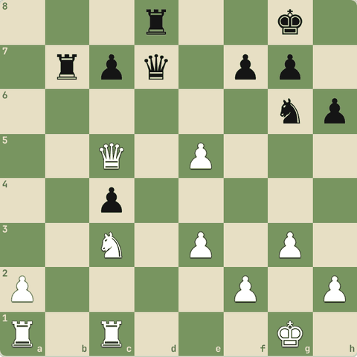
(White ki chaal)
Jawab:
1. Rd1 Qf5 2. Rxd8+
- Line: Rd1 Qf5 Rxd8+.
- Bada piece hata aur peeche wala piece gaya.
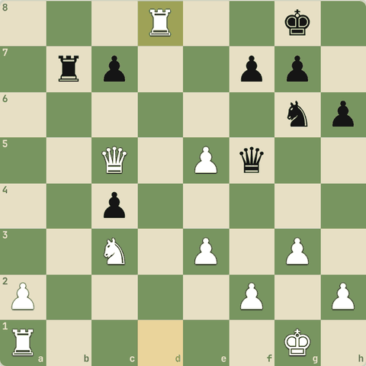
Line ke baad position

3.4.9 Abhyaas: Skewer dhundo
Skewer dhundo: bade piece par attack, peeche wala jeeto.
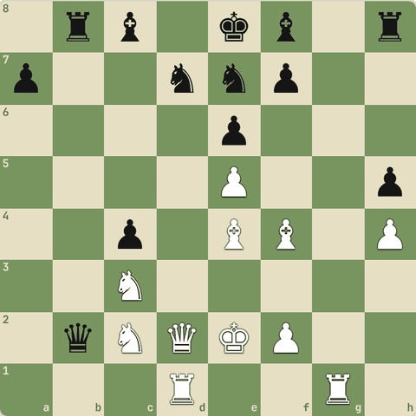
(White ki chaal)
Jawab:
1. Rb1 Rb3 2. Rxb2
- Line: Rb1 Rb3 Rxb2.
- Bada piece hata aur peeche wala piece gaya.
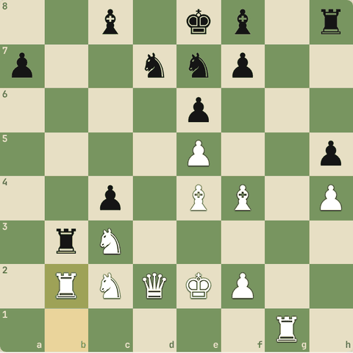
Line ke baad position

3.4.10 Abhyaas: Skewer dhundo
Skewer dhundo: bade piece par attack, peeche wala jeeto.
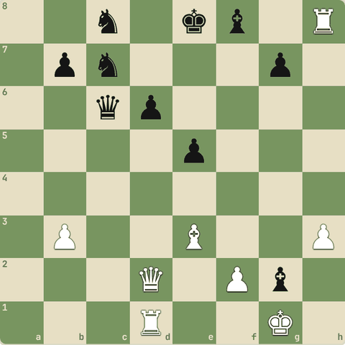
(White ki chaal)
Jawab:
1. Rc1 Qd7 2. Kxg2
- Line: Rc1 Qd7 Kxg2.
- Bada piece hata aur peeche wala piece gaya.
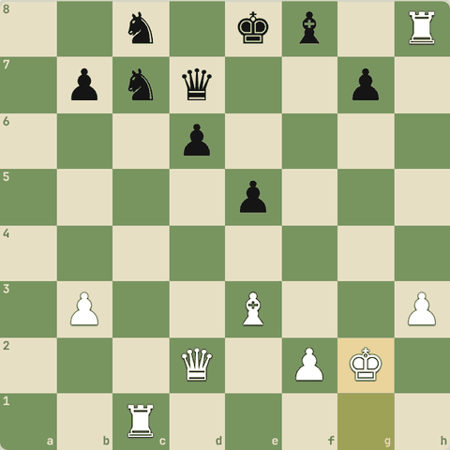
Line ke baad position

3.5 Discovered attack aur double check
Chhupa hua attack
Yaad rakho
- Discovered attack: aage wala piece hate to peeche wale ka attack khul jaata hai.
- Hatne wala piece bhi kuch attack kare = do threats ek saath.
- Double check ka jawab sirf king ko hatana hai: block ya capture nahi.
- Discovered attack: aage wala piece hat-ta hai aur khud bhi kuch attack karta hai = do threats.
- Discovered check sabse khatarnak: aage wala piece kuch bhi le sakta hai.
- Famous: Reti-Tartakower, Bronstein-Geller, Fischer-Spassky 1972 (game 8), Kasparov-Karpov.

3.5.1 Discovered attack
- Jab ek piece hatta hai aur uske peeche wale piece ka attack khul jaata hai, use discovered attack kehte hain.
- Agar khula attack king par ho to discovered check.
- Khatarnaak kyunki hatne wala piece bhi kuch attack kar sakta hai: do threats ek saath!
- Double check: dono pieces check dein.
- Iska jawab sirf king ko hatana hai.
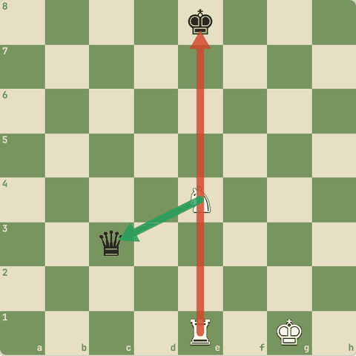

3.5.2 Abhyaas: Discovered check se queen jeeto
Discovered check se queen jeeto.
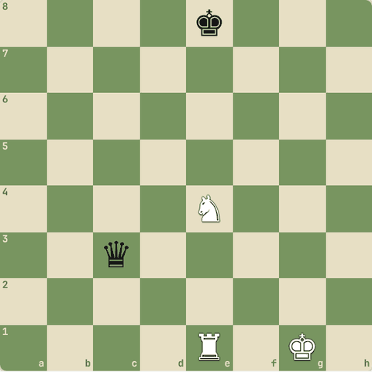
(White ki chaal)
Jawab:
1. Nxc3+
- Knight ne queen li aur rook ka check khul gaya.
- Black ko check bachana padega.
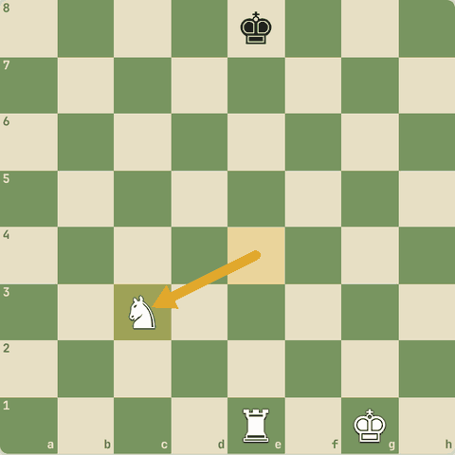
Chaal ke baad

3.5.3 Abhyaas: Double check se mate in 1!
Double check se mate in 1!
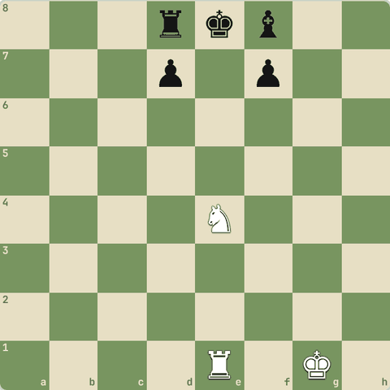
(White ki chaal)
Jawab:
1. Nd6#
- Nd6#: knight + rook ka double check.
- King ke saare squares band, aur double check block ya capture nahi hota.
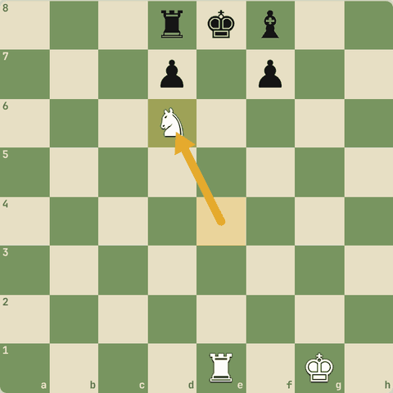
Chaal ke baad

3.5.4 Masters ke discovered attacks
- Examples: Reti-Tartakower (queen sacrifice ke baad discovered double check), Bronstein-Geller, Fischer-Spassky 1972 (game 8), Kasparov-Karpov, Reti-Bogoljubov, Petrosian-Matanovic.
- Yaad rakho: jo piece hat-ta hai, use bhi kaam do (capture, check ya threat).

3.5.5 Abhyaas: Discovered attack
Discovered attack: ek piece hatao, peeche wala attack karega.
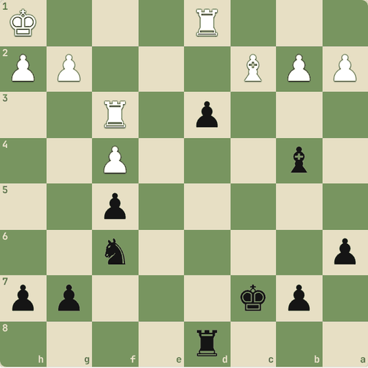
(Black ki chaal)
Jawab:
1… dxc2
- Line: dxc2.
- Aage wale piece ne raasta khola, do threats ek saath.
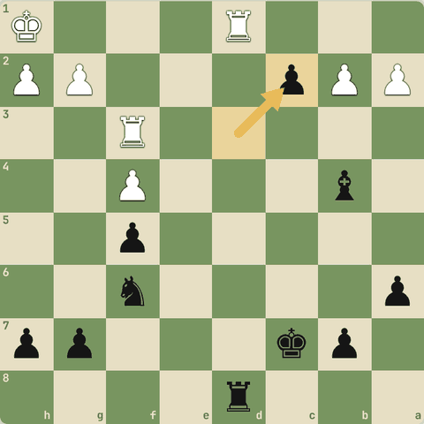
Chaal ke baad

3.5.6 Abhyaas: Discovered attack
Discovered attack: ek piece hatao, peeche wala attack karega.
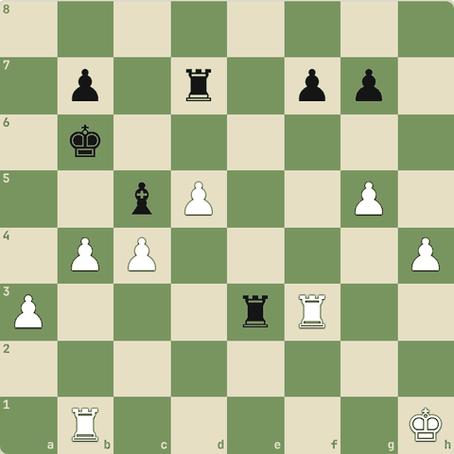
(White ki chaal)
Jawab:
1. bxc5+
- Line: bxc5+.
- Aage wale piece ne raasta khola, do threats ek saath.
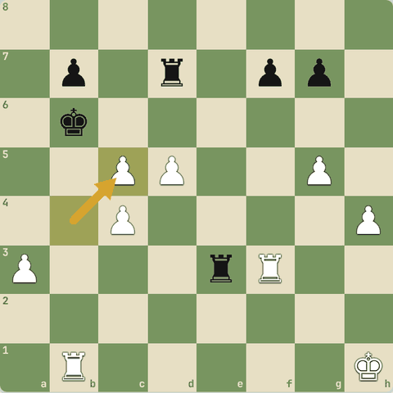
Chaal ke baad

3.5.7 Abhyaas: Discovered attack
Discovered attack: ek piece hatao, peeche wala attack karega.
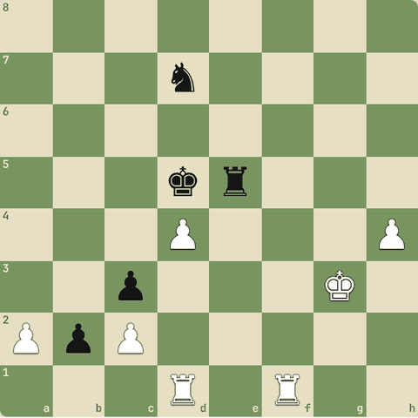
(White ki chaal)
Jawab:
1. dxe5+
- Line: dxe5+.
- Aage wale piece ne raasta khola, do threats ek saath.
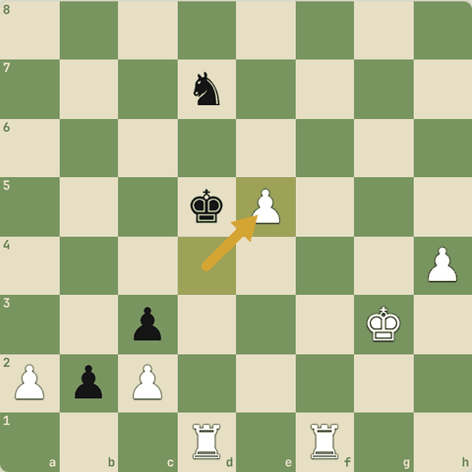
Chaal ke baad

3.5.8 Abhyaas: Discovered attack
Discovered attack: ek piece hatao, peeche wala attack karega.
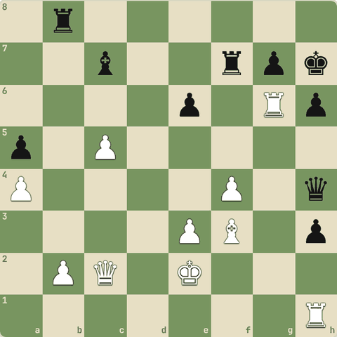
(White ki chaal)
Jawab:
1. Rg4+ Kg8 2. Rxh4
- Line: Rg4+ Kg8 Rxh4.
- Aage wale piece ne raasta khola, do threats ek saath.
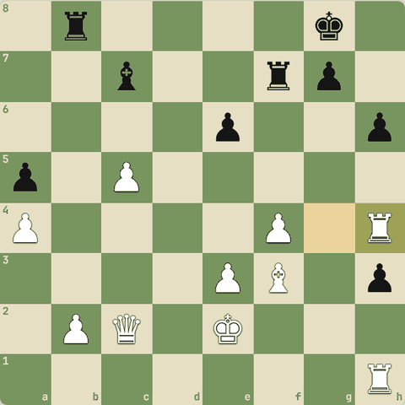
Line ke baad position

3.5.9 Abhyaas: Discovered attack
Discovered attack: ek piece hatao, peeche wala attack karega.
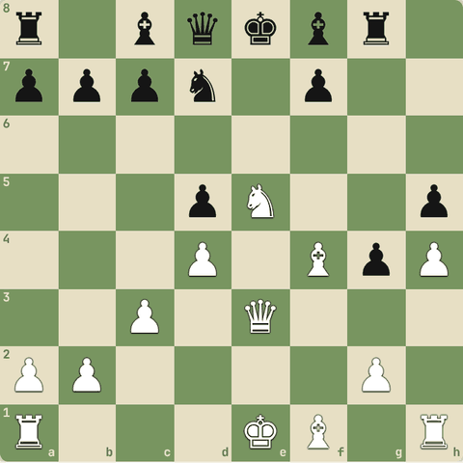
(White ki chaal)
Jawab:
1. Nc6+ Qe7 2. Nxe7
- Line: Nc6+ Qe7 Nxe7.
- Aage wale piece ne raasta khola, do threats ek saath.
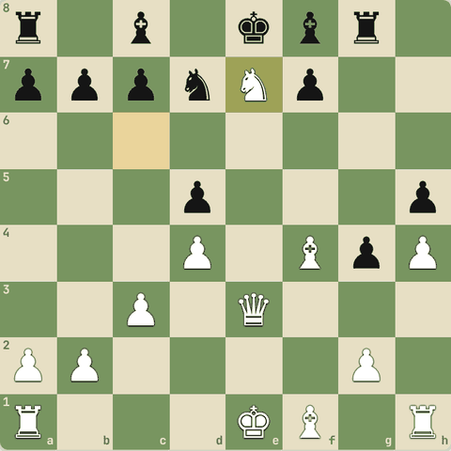
Line ke baad position

3.5.10 Abhyaas: Discovered attack
Discovered attack: ek piece hatao, peeche wala attack karega.
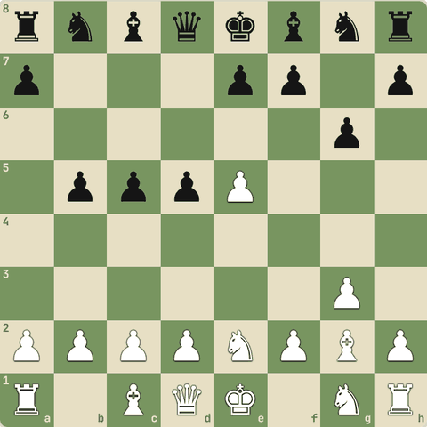
(White ki chaal)
Jawab:
1. exd6 Nc6 2. Bxc6+
- Line: exd6 Nc6 Bxc6+.
- Aage wale piece ne raasta khola, do threats ek saath.
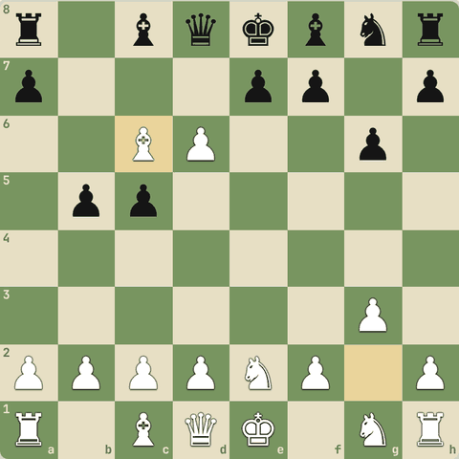
Line ke baad position

3.5.11 Abhyaas: Discovered check se jeeto!
Discovered check se jeeto!
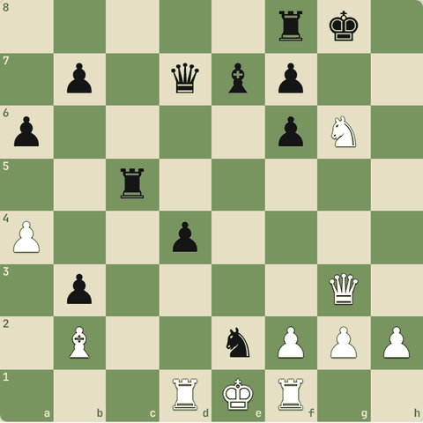
(White ki chaal)
Jawab:
1. Nxe7+
- Line: Nxe7+.
- Discovered check: opponent check ka jawab dega, tumhara doosra piece free mein kuch le lega.
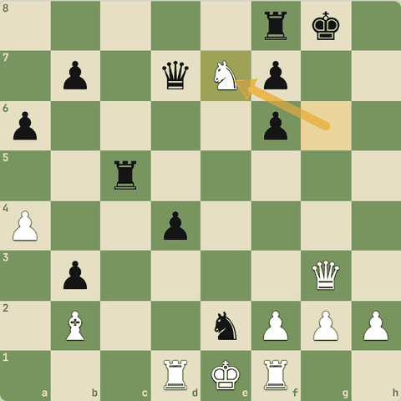
Chaal ke baad

3.5.12 Abhyaas: Discovered check se jeeto!
Discovered check se jeeto!
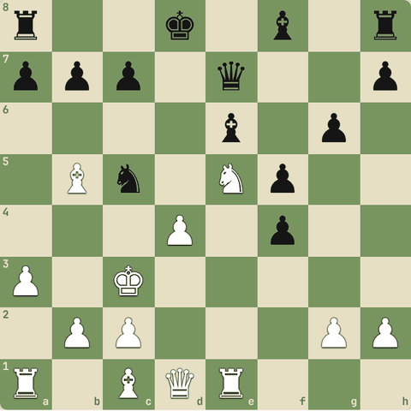
(White ki chaal)
Jawab:
1. dxc5+
- Line: dxc5+.
- Discovered check: opponent check ka jawab dega, tumhara doosra piece free mein kuch le lega.
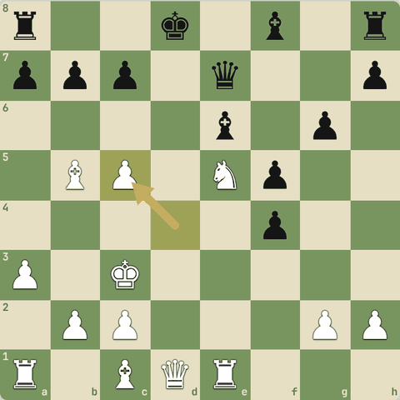
Chaal ke baad

3.5.13 Abhyaas: Discovered check se jeeto!
Discovered check se jeeto!
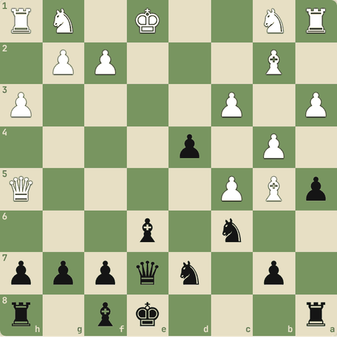
(Black ki chaal)
Jawab:
1… Bg4+ 2. Kf1 Bxh5
- Line: Bg4+ Kf1 Bxh5.
- Discovered check: opponent check ka jawab dega, tumhara doosra piece free mein kuch le lega.
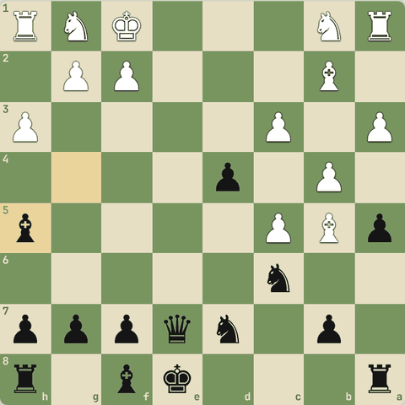
Line ke baad position

3.6 Defender hatao aur overloading
Removing the defender (undermining), overloaded piece
Yaad rakho
- Removing the defender: bachaane wale piece ko capture karo ya bhagao.
- Deflection: defender ko zabardasti door le jao.
- Overloading: ek defender ke do kaam, ek par vaar karo.
- Decoy: dushman piece ko kharab square par lalchao.
- Removing the defender (undermining / removing the guard): defender ko capture karo ya bhagao.
- Overloading: ek piece ke paas do kaam; ek kaam par hamla karo, doosra chhoot jaayega.
- Examples: Tseshkovsky-Kasparov, Karjakin-Short, Adams-Whiteley, Uhlmann-Schwartz.

3.6.1 Defender ko hatao
- Removing the defender: jo piece kisi square/piece ko bacha raha hai, use capture karo ya bhagao.
- Deflection: defender ko zabardasti door le jao (aksar sacrifice se).
- Overloading: ek defender ke paas do kaam hain. Ek kaam par attack karo, doosra khul jaayega.
- Decoy: dushman piece ko kharab square par lalchao (sacrifice se).

3.6.2 Abhyaas: Defender hatao, phir mate ki threat
Defender hatao, phir mate ki threat.
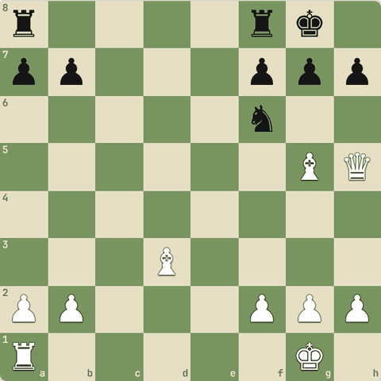
(White ki chaal)
Jawab:
1. Bxf6
- Nf6 hi h7 ko bacha raha tha.
- Bxf6 ke baad Qxh7# ki threat, isliye White piece jeet leta hai.
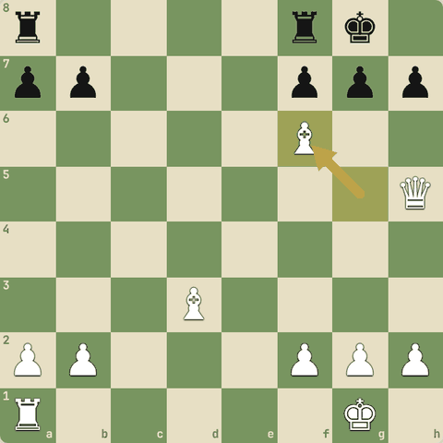
Chaal ke baad

3.6.3 Abhyaas: Deflection
Deflection: queen le lo! Socho: kya Black wapas le sakta hai?
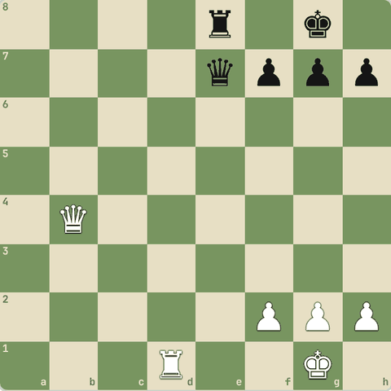
(White ki chaal)
Jawab:
1. Qxe7
- Qxe7! Agar ...Rxe7 to Rd8+ Re8 Rxe8#: rook ko back rank chhodni padi.
- Isliye Black wapas nahi le sakta aur queen gayi.
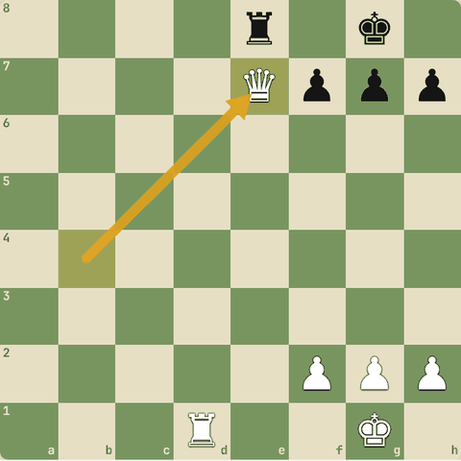
Chaal ke baad

3.6.4 Undermining ke examples
- Removing the defender ko undermining ya removing the guard bhi kehte hain.
- Examples: Tseshkovsky-Kasparov, Karjakin-Short, Uhlmann-Schwartz, Adams-Whiteley, Inkiov-Jovanic, Cukierman vs NN.

3.6.5 Abhyaas: Pehle defender ko hatao, phir jeeto
Pehle defender ko hatao, phir jeeto.
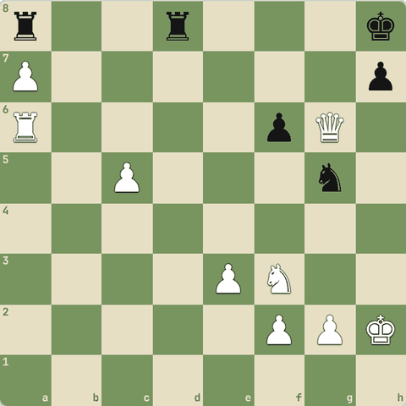
(White ki chaal)
Jawab:
1. Qxf6+ Kg8 2. Nxg5
- Line: Qxf6+ Kg8 Nxg5.
- Pehli chaal ne defender ko hata diya, doosri chaal ne bina bachaav wala piece le liya.
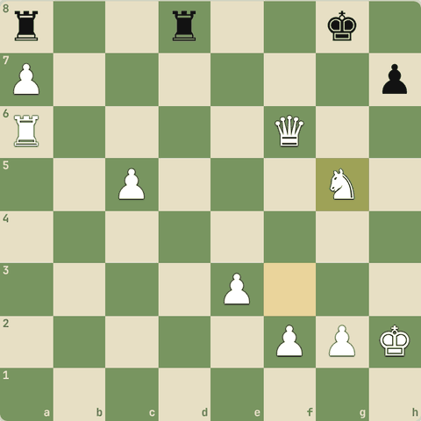
Line ke baad position

3.6.6 Abhyaas: Pehle defender ko hatao, phir jeeto
Pehle defender ko hatao, phir jeeto.
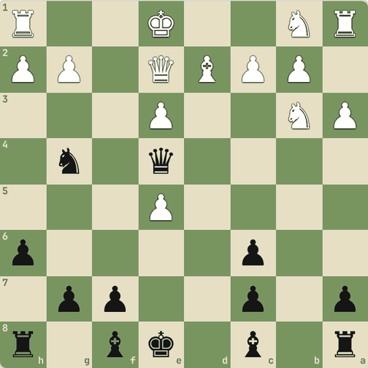
(Black ki chaal)
Jawab:
1… Qxc2 2. Bc3 Qxb3
- Line: Qxc2 Bc3 Qxb3.
- Pehli chaal ne defender ko hata diya, doosri chaal ne bina bachaav wala piece le liya.
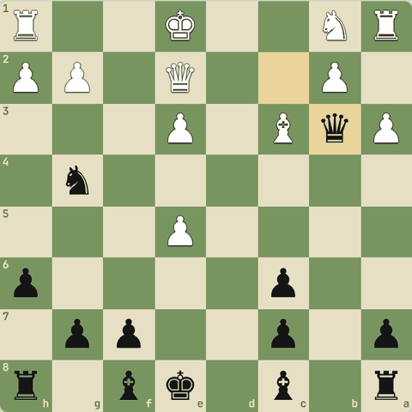
Line ke baad position

3.6.7 Abhyaas: Pehle defender ko hatao, phir jeeto
Pehle defender ko hatao, phir jeeto.
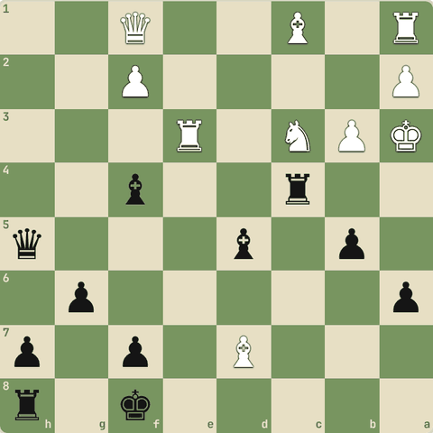
(Black ki chaal)
Jawab:
1… Bxe3 2. Bxe3 Rxc3
- Line: Bxe3 Bxe3 Rxc3.
- Pehli chaal ne defender ko hata diya, doosri chaal ne bina bachaav wala piece le liya.
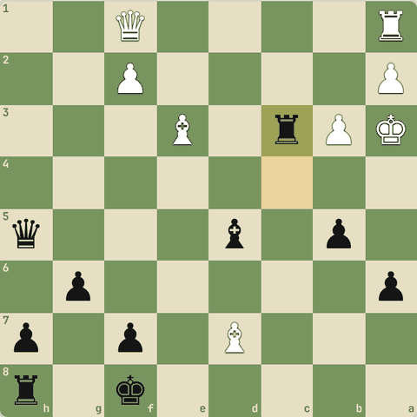
Line ke baad position

3.6.8 Abhyaas: Pehle defender ko hatao, phir jeeto
Pehle defender ko hatao, phir jeeto.
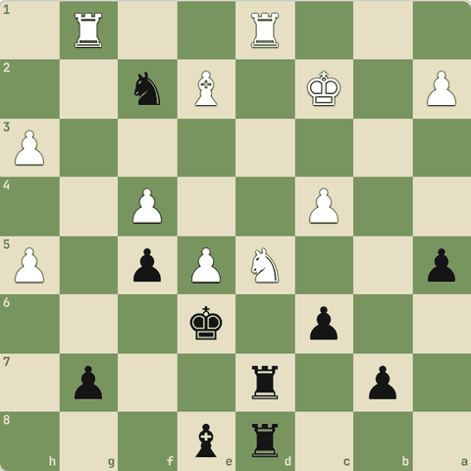
(Black ki chaal)
Jawab:
1… Nxd1 2. Rxd1 cxd5
- Line: Nxd1 Rxd1 cxd5.
- Pehli chaal ne defender ko hata diya, doosri chaal ne bina bachaav wala piece le liya.
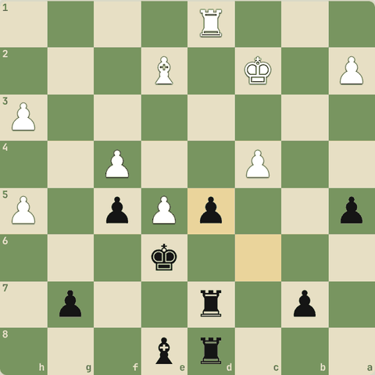
Line ke baad position

3.6.9 Abhyaas: Pehle defender ko hatao, phir jeeto
Pehle defender ko hatao, phir jeeto.
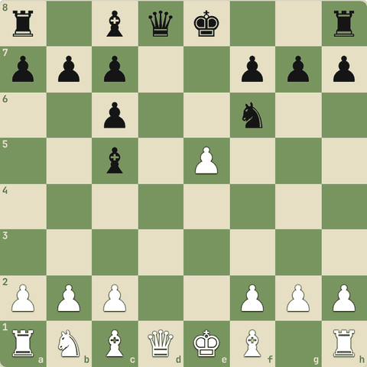
(White ki chaal)
Jawab:
1. Qxd8+ Kxd8 2. exf6
- Line: Qxd8+ Kxd8 exf6.
- Pehli chaal ne defender ko hata diya, doosri chaal ne bina bachaav wala piece le liya.
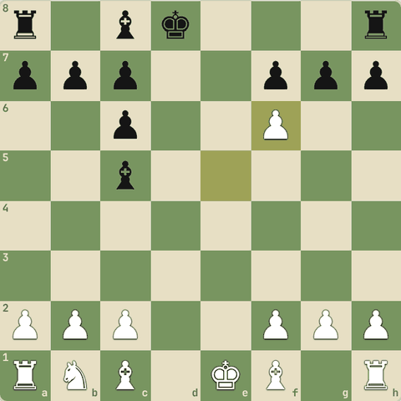
Line ke baad position

3.6.10 Abhyaas: Pehle defender ko hatao, phir jeeto
Pehle defender ko hatao, phir jeeto.
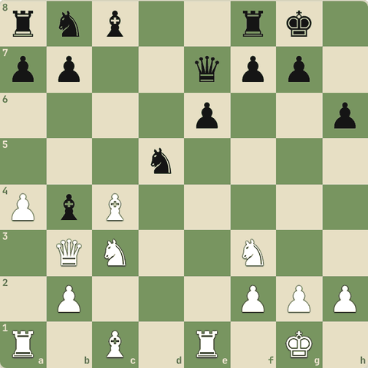
(White ki chaal)
Jawab:
1. Nxd5 exd5 2. Rxe7
- Line: Nxd5 exd5 Rxe7.
- Pehli chaal ne defender ko hata diya, doosri chaal ne bina bachaav wala piece le liya.
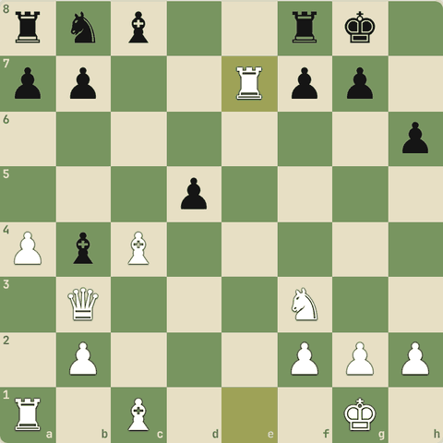
Line ke baad position

3.7 Deflection aur decoy
Defender ko door bhagao, ya dushman piece ko kharab square par kheencho
Yaad rakho
- Deflection: defender ko uski duty se door kheencho (aksar sacrifice se).
- Decoy: dushman piece (aksar king/queen) ko kisi kharab square par laao, phir fork/skewer/mate.
- Famous deflection: Timman-Yusupov, Zukertort-Blackburne, Velimirovic-Csom, Botvinnik-Keres, Tal-Averbakh.
- Famous decoy: Bjornsson-Tal, Nimzowitsch-Mieses, Seirawan-Polgar, Letelier-Fischer, Korchnoi-Tal, Polgar-Hansen.

3.7.1 Deflection
- Deflection = defender ko uske kaam se door le jao.
- Jaise ek rook back rank bacha raha hai: use kisi aur cheez par capture karne pe majboor karo, phir back rank par mate.
- Examples: Timman-Yusupov, Chandler-Gruenfeld, Zukertort-Blackburne, Velimirovic-Csom, Canal vs NN, Botvinnik-Keres, Chiburdanidze-Malaniuk, Tal-Averbakh, Lputian-Balashov.

3.7.2 Abhyaas: Deflection
Deflection: defender ko uski duty se hatao.
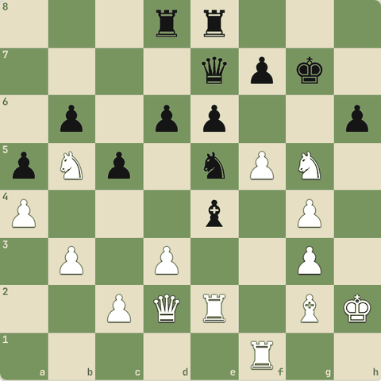
(White ki chaal)
Jawab:
1. f6+ Qxf6 2. Rxf6
- Line: f6+ Qxf6 Rxf6.
- Defender capture karne gaya aur apna asli kaam chhod diya.
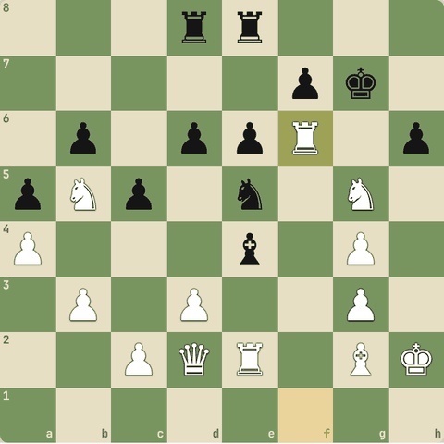
Line ke baad position

3.7.3 Abhyaas: Deflection
Deflection: defender ko uski duty se hatao.
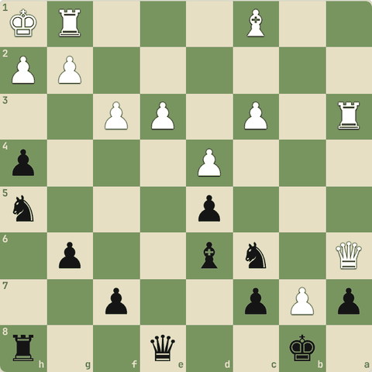
(Black ki chaal)
Jawab:
1… Ng3+ 2. hxg3 hxg3#
- Line: Ng3+ hxg3 hxg3#.
- Defender capture karne gaya aur apna asli kaam chhod diya.
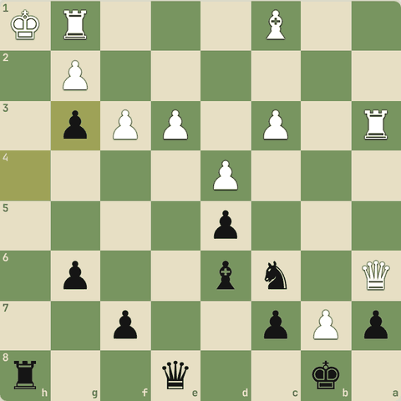
Line ke baad position

3.7.4 Abhyaas: Deflection
Deflection: defender ko uski duty se hatao.
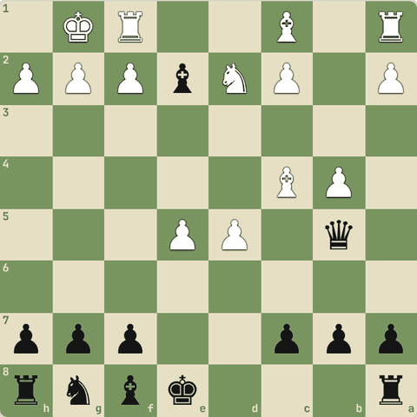
(Black ki chaal)
Jawab:
1… Bxc4 2. Nxc4 Qxc4
- Line: Bxc4 Nxc4 Qxc4.
- Defender capture karne gaya aur apna asli kaam chhod diya.
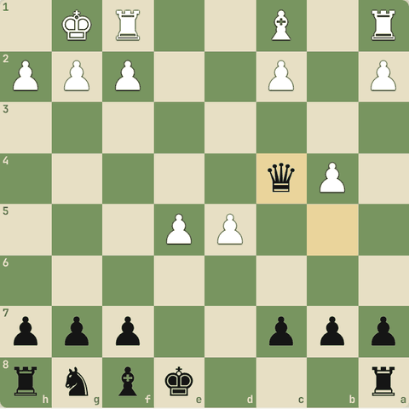
Line ke baad position

3.7.5 Abhyaas: Deflection
Deflection: defender ko uski duty se hatao.
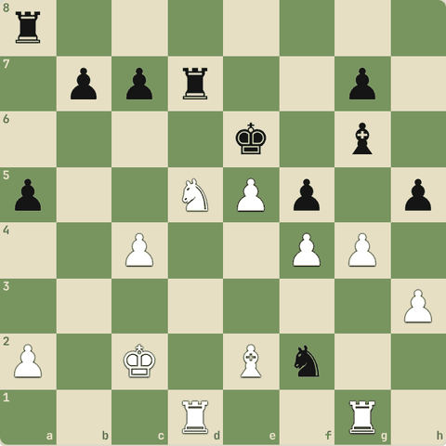
(White ki chaal)
Jawab:
1. gxh5 Bxh5 2. Bxh5
- Line: gxh5 Bxh5 Bxh5.
- Defender capture karne gaya aur apna asli kaam chhod diya.
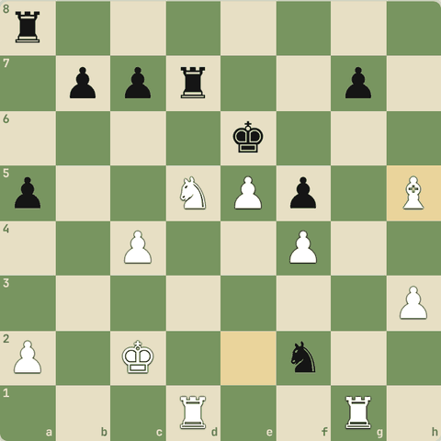
Line ke baad position

3.7.6 Abhyaas: Deflection
Deflection: defender ko uski duty se hatao.
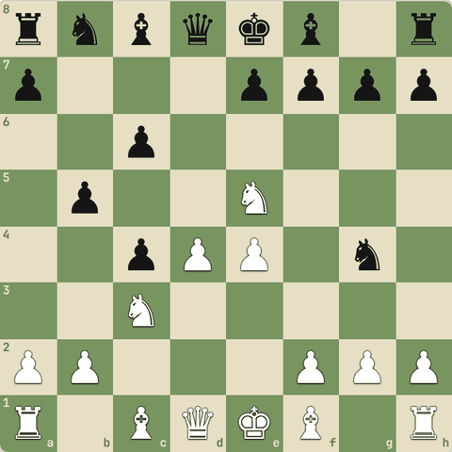
(White ki chaal)
Jawab:
1. Nxg4 Bxg4 2. Qxg4
- Line: Nxg4 Bxg4 Qxg4.
- Defender capture karne gaya aur apna asli kaam chhod diya.
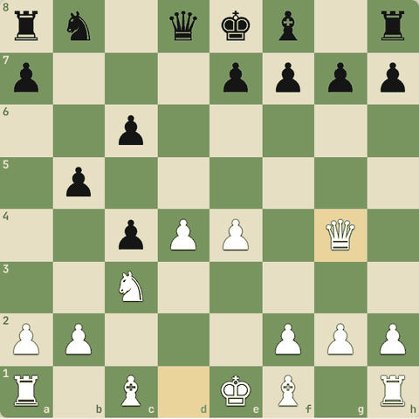
Line ke baad position

3.7.7 Abhyaas: Deflection
Deflection: defender ko uski duty se hatao.
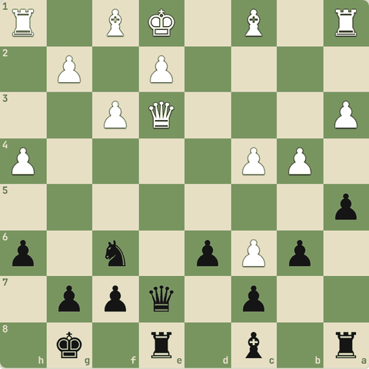
(Black ki chaal)
Jawab:
1… Qxe3 2. Bxe3 Rxe3
- Line: Qxe3 Bxe3 Rxe3.
- Defender capture karne gaya aur apna asli kaam chhod diya.
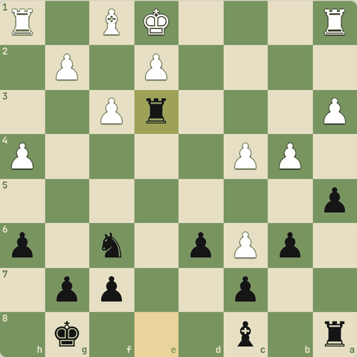
Line ke baad position

3.7.8 Decoy (attraction)
- Decoy = sacrifice se dushman ke piece (aksar king ya queen) ko ek kharab square par kheencho.
- Wahan fork, skewer, pin ya mate ho jaata hai.
- Examples: Bjornsson-Tal, Nimzowitsch-Mieses, Seirawan-Polgar, Letelier-Fischer, Nei-Petrosian, Spassky-Averkin, Korchnoi-Tal, Larsen-Spassky, Kosten-Chandler, Kotronias-Vallejo, Polgar-Hansen.

3.7.9 Sawal 1: Deflection aur decoy mein farak?
Deflection aur decoy mein farak?
Jawab:
✓ Deflection defender ko kisi jagah se hatata hai, decoy dushman piece ko kisi jagah par laata hai
- Deflection = "wahan se hatao", decoy = "yahan laao".

3.7.10 Abhyaas: Decoy: sacrifice se dushman piece ko kharab square par kheencho
Decoy: sacrifice se dushman piece ko kharab square par kheencho.
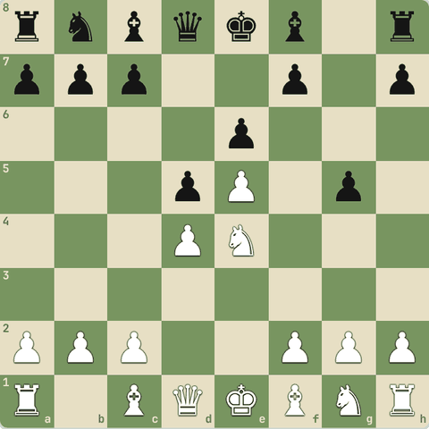
(White ki chaal)
Jawab:
1. Nf6+ Qxf6 2. exf6
- Line: Nf6+ Qxf6 exf6.
- Sacrifice ne piece ko aisi jagah kheencha jahan agla tactic kaam karta hai.
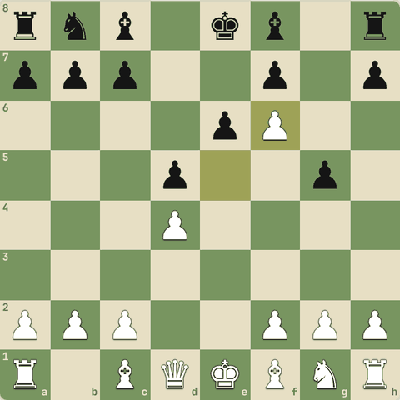
Line ke baad position

3.7.11 Abhyaas: Decoy: sacrifice se dushman piece ko kharab square par kheencho
Decoy: sacrifice se dushman piece ko kharab square par kheencho.
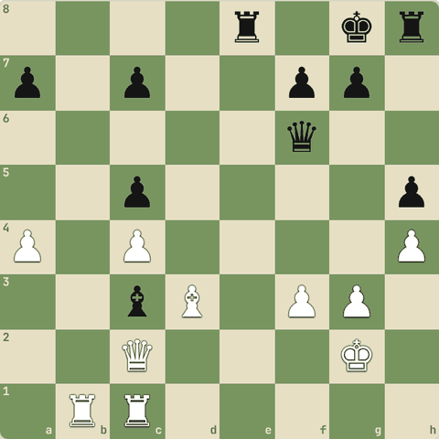
(White ki chaal)
Jawab:
1. Qxc3 Qxc3 2. Rxc3
- Line: Qxc3 Qxc3 Rxc3.
- Sacrifice ne piece ko aisi jagah kheencha jahan agla tactic kaam karta hai.
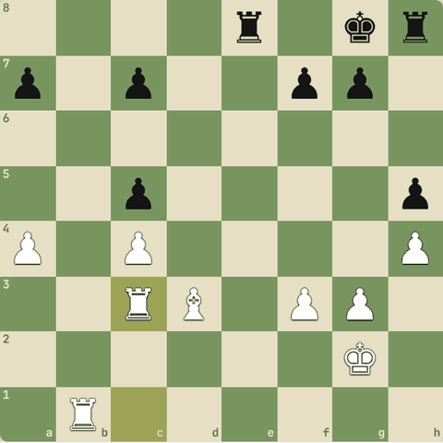
Line ke baad position

3.7.12 Abhyaas: Decoy: sacrifice se dushman piece ko kharab square par kheencho
Decoy: sacrifice se dushman piece ko kharab square par kheencho.
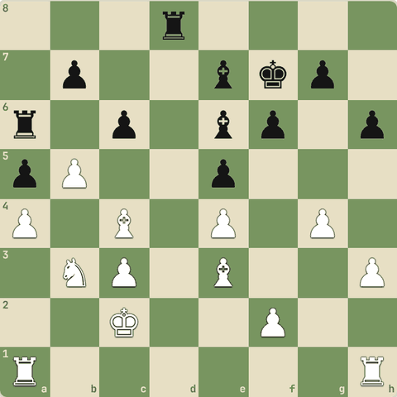
(White ki chaal)
Jawab:
1. Bxe6+ Kxe6 2. bxa6
- Line: Bxe6+ Kxe6 bxa6.
- Sacrifice ne piece ko aisi jagah kheencha jahan agla tactic kaam karta hai.
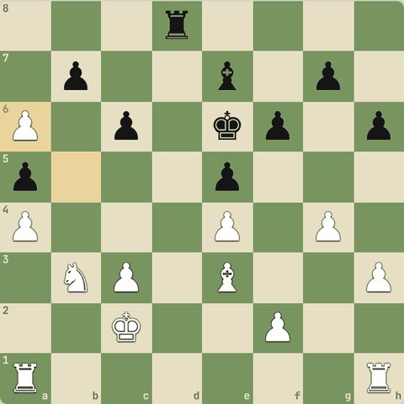
Line ke baad position

3.7.13 Abhyaas: Decoy: sacrifice se dushman piece ko kharab square par kheencho
Decoy: sacrifice se dushman piece ko kharab square par kheencho.
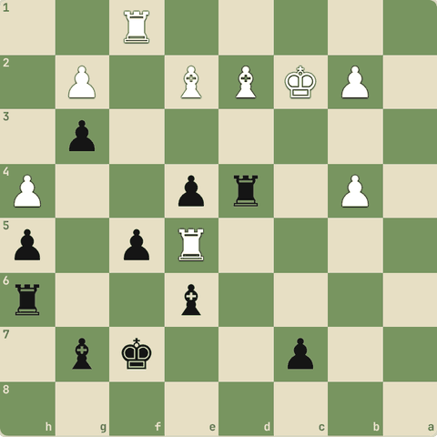
(Black ki chaal)
Jawab:
1… Rxd2+ 2. Kxd2 Bxe5
- Line: Rxd2+ Kxd2 Bxe5.
- Sacrifice ne piece ko aisi jagah kheencha jahan agla tactic kaam karta hai.
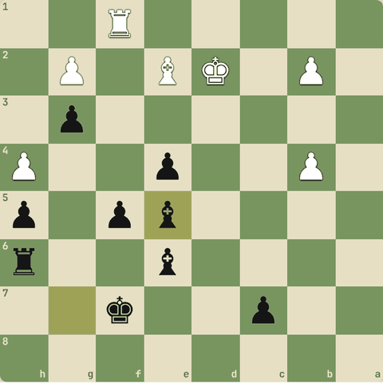
Line ke baad position

3.7.14 Abhyaas: Decoy: sacrifice se dushman piece ko kharab square par kheencho
Decoy: sacrifice se dushman piece ko kharab square par kheencho.
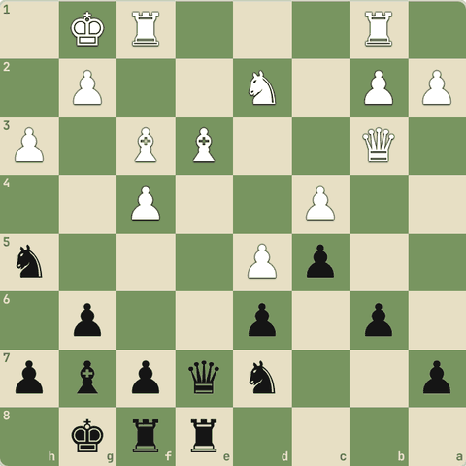
(Black ki chaal)
Jawab:
1… Qxe3+ 2. Qxe3 Rxe3
- Line: Qxe3+ Qxe3 Rxe3.
- Sacrifice ne piece ko aisi jagah kheencha jahan agla tactic kaam karta hai.
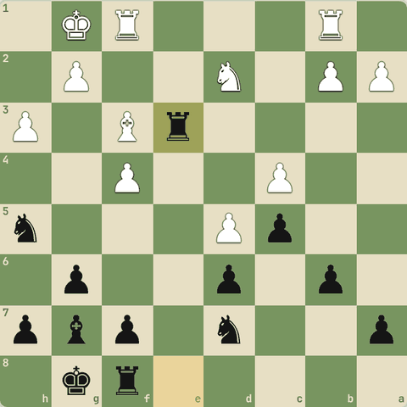
Line ke baad position

3.7.15 Abhyaas: Decoy: sacrifice se dushman piece ko kharab square par kheencho
Decoy: sacrifice se dushman piece ko kharab square par kheencho.
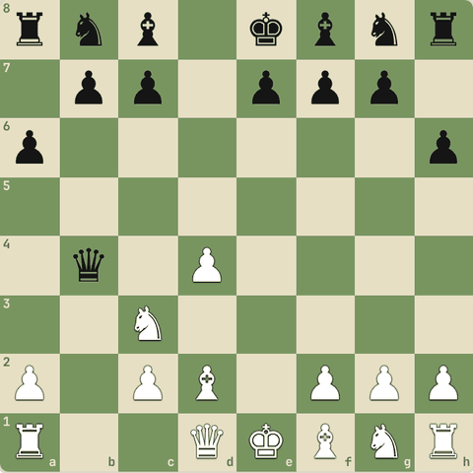
(White ki chaal)
Jawab:
1. Nb5 Qxb5 2. Bxb5+
- Line: Nb5 Qxb5 Bxb5+.
- Sacrifice ne piece ko aisi jagah kheencha jahan agla tactic kaam karta hai.
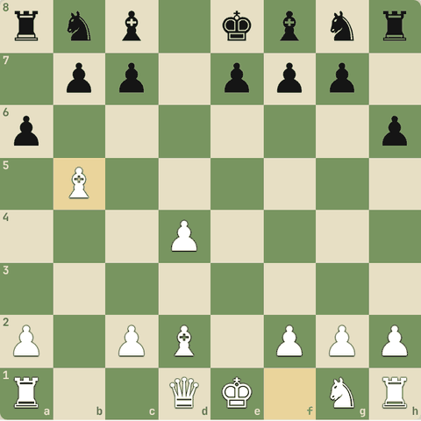
Line ke baad position

3.8 Interference, clearance, x-ray, zwischenzug
Lines kaatna aur kholna, aar-paar attack, beech ki chaal
Yaad rakho
- Zwischenzug: recapture se pehle ek zyada forcing chaal.
- X-ray: piece dushman piece ke aar-paar square control karta hai.
- Interference: do dushman pieces ke beech apna piece rakh kar connection kaato.
- Clearance, desperado, perpetual check: ye bhi yaad rakho.
- Interference (disconnection, "spanner"): do dushman pieces ke beech apna piece rakh kar unka connection kaato.
- Clearance (line clearance): apna hi piece raaste se hatao (aksar tempo ke saath) taaki doosre piece ki line khule.
- X-ray: piece doosre piece ke aar-paar square ko control/support karta hai.
- Zwischenzug: expected recapture se pehle ek zyada forcing chaal.

3.8.1 Advanced motifs
- Zwischenzug (in-between move): expected recapture ki jagah pehle ek zyada forcing chaal (check/threat) khelo.
- X-ray: piece dushman piece ke aar-paar ek square ko control karta hai.
- Interference: do dushman pieces ke beech mein apna piece rakh kar unka connection kaato.
- Clearance: apne hi piece ko hata kar line/square khaali karo.
- Desperado: jo piece waise bhi jaane wala hai, use jitna ho sake mehenga becho.
- Perpetual check: haarti position mein lagaataar check de kar draw.

3.8.2 Sawal 1: Opponent ne tumhara knight capture kiya
Opponent ne tumhara knight capture kiya. Recapture ki jagah tum pehle check dete ho jo queen ko bhi attack karta hai. Yeh kya kehlata hai?
Jawab:
✓ Zwischenzug
- In-between move: pehle bada threat, recapture baad mein.

3.8.3 Sawal 2: Tum haar rahe ho, par opponent ke king ko lagaataar check de sakte ho
Tum haar rahe ho, par opponent ke king ko lagaataar check de sakte ho. Kya milega?
Jawab:
✓ Draw (perpetual check / repetition)
- Lagaataar checks se same position repeat hoti hai = draw.

3.8.4 Interference (spanner in the works)
- Do dushman pieces ek doosre ko support kar rahe hain (jaise do rooks, ya rook jo mate square bachata hai).
- Unke beech mein apna piece rakho: ab line kat gayi.
- Use capture karne mein bhi line aksar band rehti hai.
- Examples: Miles-Pritchett, Piket-Kramnik, Kramnik-Topalov, Koskinen-Kasman, Karpov-Polgar.

3.8.5 Sawal 3: Black ka rook b8 aur queen g8 ek doosre ko back rank par bachate hain
Black ka rook b8 aur queen g8 ek doosre ko back rank par bachate hain. Tum e8 par piece rakh do jo dono line kaat de. Yeh kaunsa tactic?
Jawab:
✓ Interference
- Line ke beech piece rakhna = interference.

3.8.6 Clearance (line kholna)
- Kabhi apna hi piece raasta rok raha hota hai.
- Use tempo ke saath (check, capture ya threat se) hatao taaki queen/rook/bishop ki line khul jaaye, ya square khaali ho jaaye.
- Examples: Keene-Briant, Karjakin-Komiliakov, La Bourdonnais-McDonnell.

3.8.7 Sawal 4: Tumhari queen ki h-file par tumhara apna knight h5 baitha hai
Tumhari queen ki h-file par tumhara apna knight h5 baitha hai. Knight check dekar hatta hai aur queen h7 par mate karti hai. Yeh kya hai?
Jawab:
✓ Clearance
- Apna piece hata kar line kholna = clearance.

3.8.8 X-ray
- Piece doosre piece ke aar-paar dekhta hai.
- Jaise rook queen ke peeche ho (battery): queen trade hone par rook usi square ko support karta hai.
- Examples: Fischer-Bisguier, Euwe-Loman, Ivanchuk-Van Wely, Mamedyarov-Carlsen.

3.8.9 Abhyaas: X-ray: queens aamne-saamne, dono ke peeche rooks
X-ray: queens aamne-saamne, dono ke peeche rooks. Kaun jeetega? Chaal chalo.
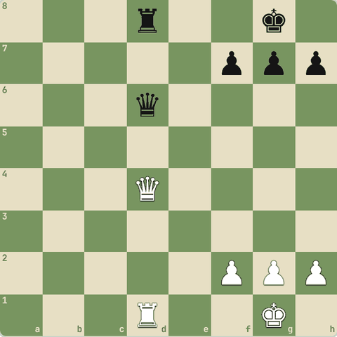
(White ki chaal)
Jawab:
1. Qxd6 Rxd6 2. Rxd6
- Qxd6 Rxd6 Rxd6.
- d1 rook ne queen ke aar-paar d6 ko support kiya.
- White ek rook aage.
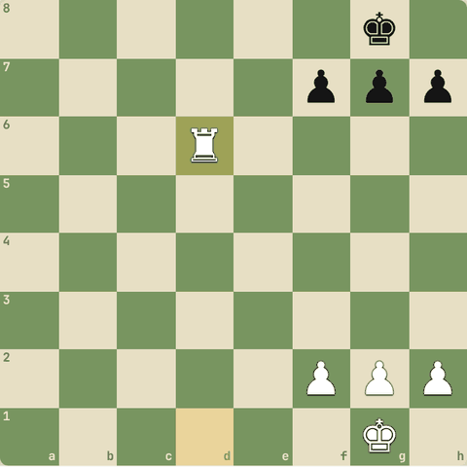
Line ke baad position

3.8.10 Abhyaas: Zwischenzug!
Zwischenzug! Black ne tumhari queen d2 par le li. Recapture se pehle ek zyada forcing chaal?
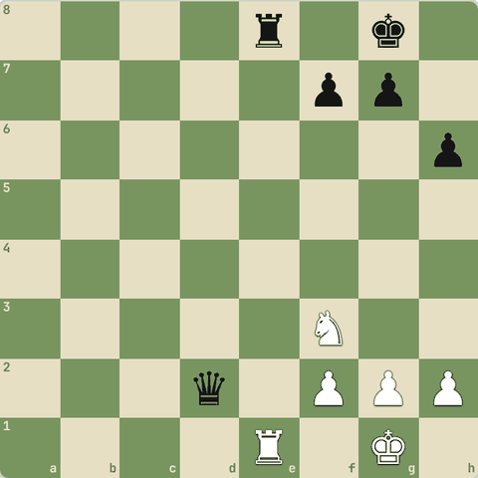
(White ki chaal)
Jawab:
1. Rxe8+ Kh7 2. Nxd2
- Pehle Rxe8+ (check ke saath rook), phir Nxd2 se queen wapas.
- Seedha Nxd2?? par Rxe1+ aur tum peeche.
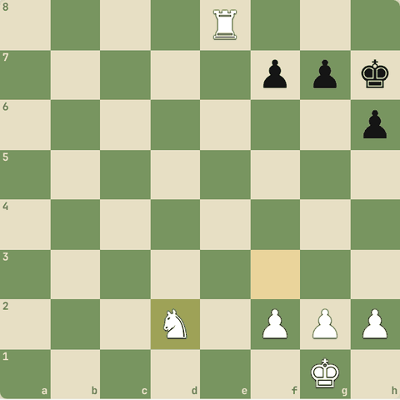
Line ke baad position

3.8.11 Diagram: X-ray: Rd1 ka attack apne Rd2 ke aar-paar d8 tak (doubling)
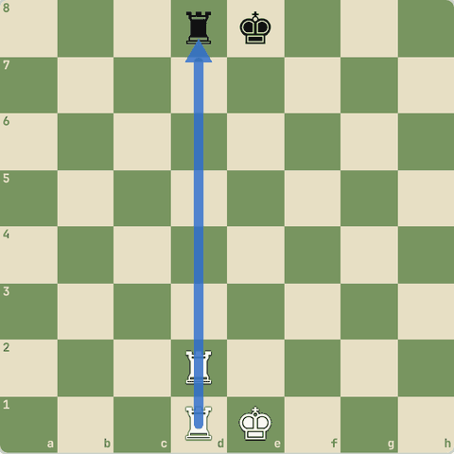
X-ray: Rd1 ka attack apne Rd2 ke aar-paar d8 tak (doubling)

3.9 Calculation ke 3 golden rules
Pichli chaal ki kamzori, killer common squares, in-effect clause, squares ka pyaar
Yaad rakho
- Rule 1: Opponent ki pichli chaal ne kya kamzor chhoda? (square, piece, line)
- Rule 2: Killer common squares: jahan tumhare do pieces mil kar attack karte hain, wahan sacrifice ya mate aksar kaam karta hai.
- Rule 3: In-effect clause: har chaal ka poore board par asar dekho (discovered lines, khule raaste, open/closed position).
- Teeno ka raaz ek: chess squares ka khel hai. Jeetne ke liye key squares tak pahuncho.

3.9.1 Calculation kya hai?
- Calculation = aage ki chaalein dimaag mein khelna: meri chaal, opponent ka sabse achha jawab, phir meri... aur end mein evaluate karna.
- Forcing moves se shuru karo kyunki unke jawab kam hote hain.
- Is course ke teen golden rules calculation ko asaan banate hain.

3.9.2 Rule 1: Pichli chaal ki kamzori
- Har chaal kuch naya kholti hai aur kuch chhodti hai.
- Opponent ke chalne ke baad pucho:
  - Is piece ne kaunsa square/piece bachana chhod diya?
  - Kaunsi line khul gayi?
  - Kya koi piece ab unprotected hai?

3.9.3 Rule 2: Killer common squares
- Woh squares jahan tumhare do (ya zyada) pieces ek saath pahunchte hain.
- Wahan:
  - sacrifice karke bhi recapture ho jaata hai,
  - ek piece doosre ko support karke mate deta hai (jaise queen + bishop h7 par).
- Kabhi common square shuru se hota hai, kabhi calculation ke beech banta hai.
- Dovetail aur Mayet jaise mate patterns isi par chalte hain.

3.9.4 Abhyaas: Common square dhundo jahan tumhare pieces mil kar mate karein
Common square dhundo jahan tumhare pieces mil kar mate karein.
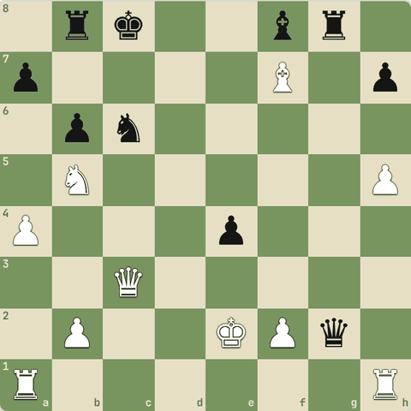
(White ki chaal)
Jawab:
1. Qxc6+ Kd8 2. Qc7#
- Line: Qxc6+ Kd8 Qc7#.
- Do pieces ek hi square/area par mile: wahi killer common square.
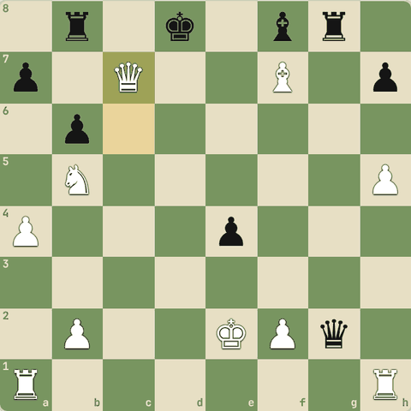
Line ke baad position

3.9.5 Abhyaas: Common square dhundo jahan tumhare pieces mil kar mate karein
Common square dhundo jahan tumhare pieces mil kar mate karein.
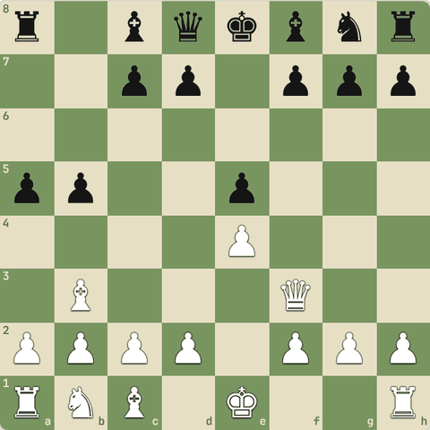
(White ki chaal)
Jawab:
1. Qxf7#
- Line: Qxf7#.
- Do pieces ek hi square/area par mile: wahi killer common square.
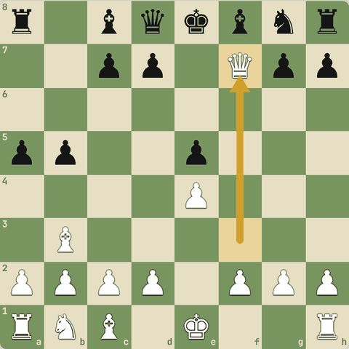
Chaal ke baad

3.9.6 Abhyaas: Common square dhundo jahan tumhare pieces mil kar mate karein
Common square dhundo jahan tumhare pieces mil kar mate karein.
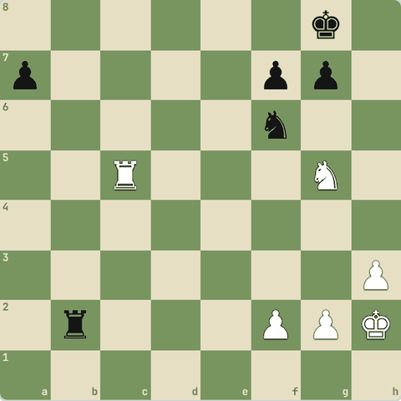
(White ki chaal)
Jawab:
1. Rc8+ Ne8 2. Rxe8#
- Line: Rc8+ Ne8 Rxe8#.
- Do pieces ek hi square/area par mile: wahi killer common square.
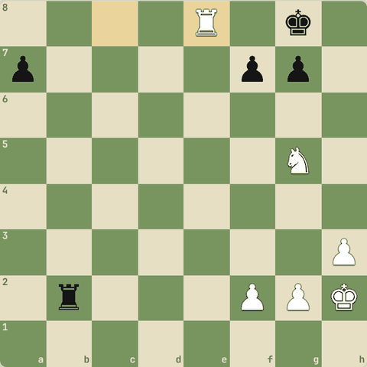
Line ke baad position

3.9.7 Abhyaas: Common square dhundo jahan tumhare pieces mil kar mate karein
Common square dhundo jahan tumhare pieces mil kar mate karein.
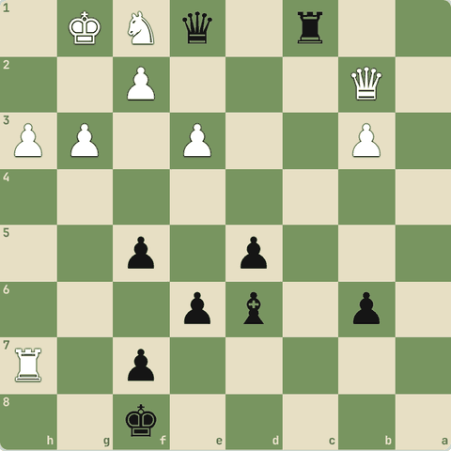
(Black ki chaal)
Jawab:
1… Qxf1+ 2. Kh2 Qh1#
- Line: Qxf1+ Kh2 Qh1#.
- Do pieces ek hi square/area par mile: wahi killer common square.
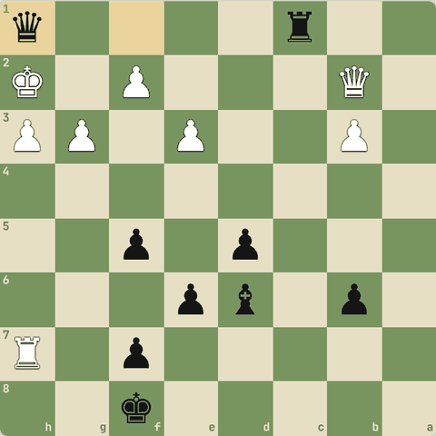
Line ke baad position

3.9.8 Rule 3: In-effect clause
- Sirf jo piece chala uske arrows mat dekho.
- Poore board par asar dekho:
  - Hatne se kaunsi line khuli (discovered effects)?
  - Kaunse doosre pieces azaad hue?
  - Pawns ka role: open position (khule raaste) mein tactics zyada, closed mein kam.

3.9.9 Abhyaas: In-effect clause
In-effect clause: chaal ka poore board par asar dekho.
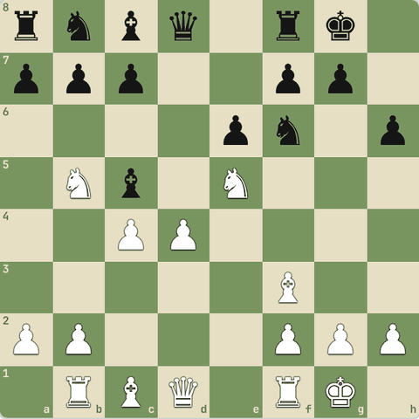
(White ki chaal)
Jawab:
1. dxc5
- Line: dxc5.
- Ek chaal ne doosre piece ki line kholi.
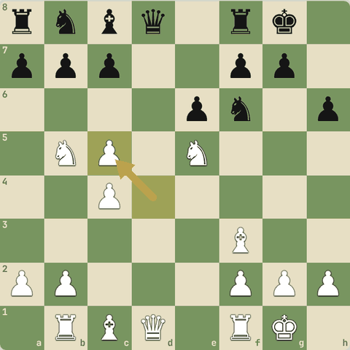
Chaal ke baad

3.9.10 Abhyaas: In-effect clause
In-effect clause: chaal ka poore board par asar dekho.
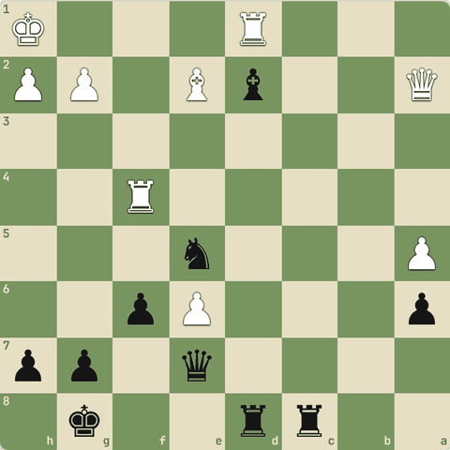
(Black ki chaal)
Jawab:
1… Bxf4 2. Rxd8+ Rxd8
- Line: Bxf4 Rxd8+ Rxd8.
- Ek chaal ne doosre piece ki line kholi.
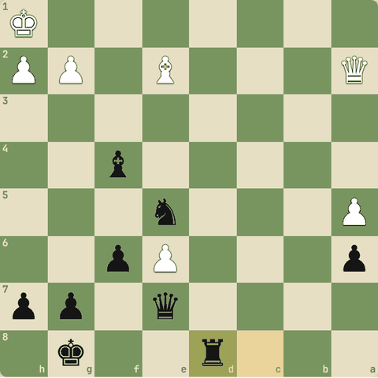
Line ke baad position

3.9.11 Abhyaas: In-effect clause
In-effect clause: chaal ka poore board par asar dekho.
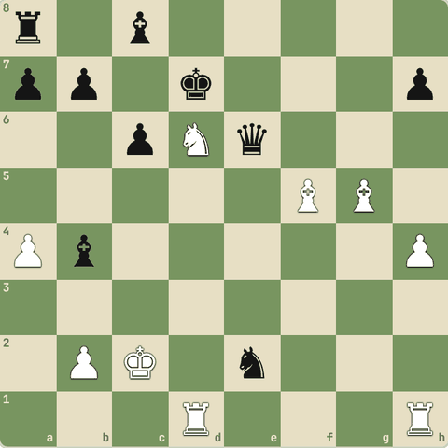
(White ki chaal)
Jawab:
1. Nxc8+ Kxc8 2. Bxe6+
- Line: Nxc8+ Kxc8 Bxe6+.
- Ek chaal ne doosre piece ki line kholi.
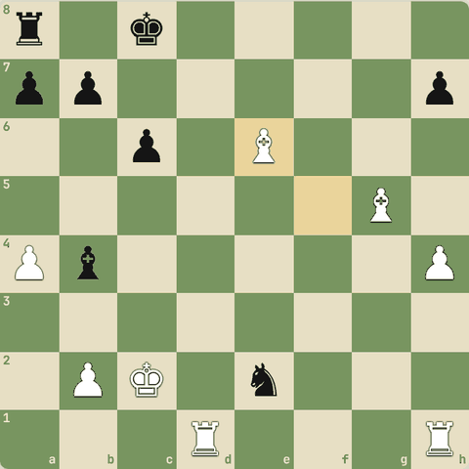
Line ke baad position

3.9.12 Squares ka pyaar
- Teeno rules ek hi baat kehte hain: chess squares ka khel hai.
- Pichli chaal ki kamzori = neglected squares, common squares = cooperation wale squares, in-effect = naye khule squares.
- Spassky ne Fischer ke against 1972 mein ek ajeeb chaal se key squares jeete.

3.9.13 Sawal 1: Teeno golden rules mein common cheez kya hai?
Teeno golden rules mein common cheez kya hai?
Jawab:
✓ Squares par kabza
- Chess is about squares.

3.10 Calculation aur visualization
Dimaag mein board dekhna
Yaad rakho
- 2-4 candidate moves chuno (pehle CCT).
- Har line ek-ek karke dekho, opponent ka sabse achha jawab socho.
- Line ke end mein position evaluate karo.
- Visualization: notation padh kar board dimaag mein dekho, blindfold puzzles karo.
- Visualization: board ke bina pieces ki jagah dimaag mein rakho (The Queen's Gambit mein Beth ceiling par board dekhti thi).

3.10.1 Calculation kaise karein
- Candidate moves chuno: 2-4 achhi chaalein (pehle CCT).
- Har ek ko ek-ek karke dekho, beech mein mat koodo.
- Opponent ka sabse achha jawab socho, sabse bura nahi.
- Line ke end mein position ko evaluate karo: kaun behtar?
- Forcing lines (check, capture) pehle aur gehri dekho: inme opponent ke option kam hote hain.
- Visualization badhane ke liye: blindfold puzzles, notation padh kar board dimaag mein dekhna.
- Iske liye Mind's Eye trainer (neeche Trainer tab) bana hi hai!

3.10.2 Sawal 1: Board nahi dikhega
Board nahi dikhega. Socho: White: Kg1, Ra1. Black: Kg8, pawns f7 g7 h7. White ki chaal. Mate in 1 kya hai?
White: Kg1 Ra1
Black: Kg8 f7 g7 h7
Jawab:
✓ Ra8#
- Back-rank mate: Ra8#.

3.10.3 Sawal 2: Dimaag mein
Dimaag mein: knight a1 se h8 tak sabse kam kitni chaal mein pahunchega?
Jawab:
✓ 6
- 6 chaal.
- Knight lambi doori par dheema hai.

3.10.4 Sawal 3: Bina board
Bina board: 1.e4 e5 2.Nf3 Nc6 3.Bb5 ke baad b5 bishop kis black piece ko attack kar raha hai?
Jawab:
✓ c6 knight
- Yeh Ruy Lopez hai: bishop c6 knight par.

3.10.5 Sawal 4: Bina board
Bina board: 1.e4 e5 2.Nf3 Nc6 3.Bc4 Nf6 4.Ng5 ke baad knight g5 kis black pawn par attack karta hai?
Jawab:
✓ f7
- Knight g5 aur bishop c4 dono f7 par: Fried Liver ka idea.

3.10.6 Sawal 5: Dimaag mein
Dimaag mein: White bishop c1 kitni chaal mein h6 pahunchega (board khaali)?
Jawab:
✓ 1
- c1-d2-e3-f4-g5-h6 ek hi diagonal: 1 chaal.

Level 4: Middlegame 2: Checkmate patterns
Mate ki kala, back-rank, smothered, aur 25+ famous mate patterns
- Mate patterns tactics ke "shortcut" hain: shakal pehchaan li to calculation turant ho jaati hai.
- Har pattern ka naam, idea aur practice.

4.1 Mate patterns: shuruaat aur mate ki kala
Escape squares band karo, quiet moves, famous patterns
Yaad rakho
- Strong players mate pattern pehchante hain, har baar calculate nahi karte.
- Back-rank, smothered, Anastasia, Arabian, Boden: shakal yaad karo.
- Legal's mate: pinned knight se queen sacrifice, teen minor pieces se mate.
- Greek gift Bxh7+: tab jab f6 par black knight na ho aur Ng5 safe ho.
- Philidor's legacy: Qg8+!! Rxg8 Nf7# smothered mate.
- Mate ki kala: pehle king ke escape squares band karo, phir check.
- Kabhi quiet chaal (bina check) mate se pehle zaroori hoti hai.
- Escape squares band ho gaye par check nahi to naya check dhundo.

4.1.1 Patterns kyun?
- Checkmate pattern = pieces ki jaani-pehchaani shakal jo mate deti hai.
- Pattern yaad ho to game mein dekhte hi pehchaan loge.
- Mate ki kala:
- 1.
- King ke escape squares gino aur unhe ek-ek karke band karo.
- 2.
- Kabhi quiet chaal (check nahi) loud chaal se behtar: pehle jaal bichhao, phir check.
- 3.
- Saare escape squares band, par check nahi?
- To naya check dhundo jo un squares ko band rakhe.

4.1.2 Patterns = shortcuts
- Strong players har mate ko calculate nahi karte, woh pattern pehchante hain.
- Yeh patterns yaad karo:
  - Back-rank mate: king apne pawns ke peeche band.
  - Smothered mate: king apne hi pieces se ghira, knight mate deta hai.
  - Anastasia mate: knight + rook, king kinare par.
  - Arabian mate: rook + knight corner mein.
  - Boden mate: do bishops criss-cross.
  - Legal mate: opening trap, queen sacrifice.
  - Greek gift: Bxh7+ sacrifice castled king par.

4.1.3 Abhyaas: Smothered mate in 1
Smothered mate in 1
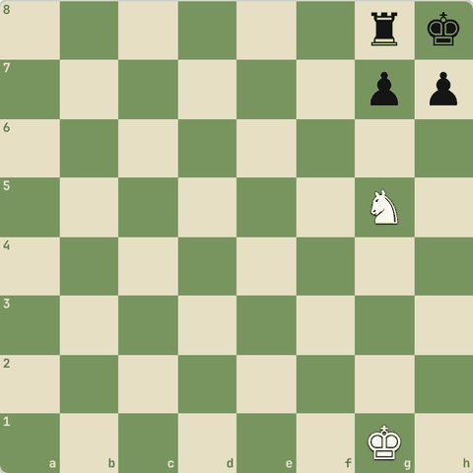
(White ki chaal)
Jawab:
1. Nf7#
- King apne rook aur pawns mein "dum ghut" kar mara gaya.
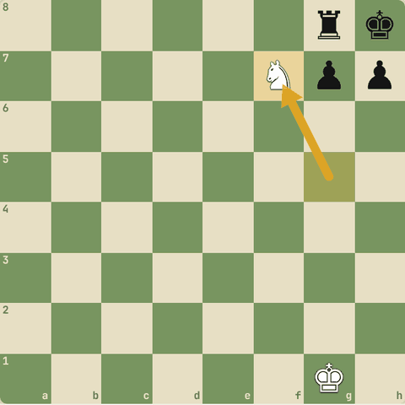
Chaal ke baad

4.1.4 Abhyaas: Anastasia mate in 1
Anastasia mate in 1
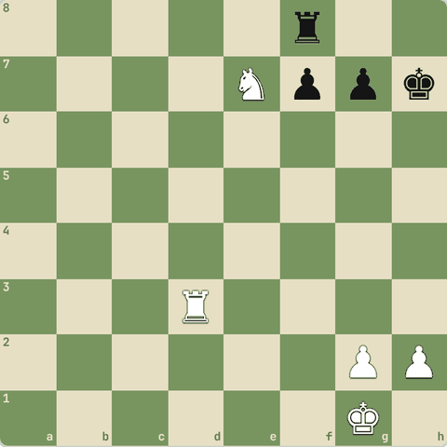
(White ki chaal)
Jawab:
1. Rh3#
- Ne7 ne g6 aur g8 band kiye, rook h-file par mate.
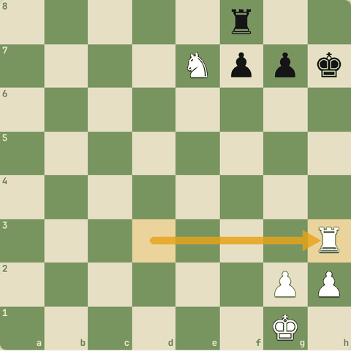
Chaal ke baad

4.1.5 Abhyaas: Arabian mate in 1
Arabian mate in 1
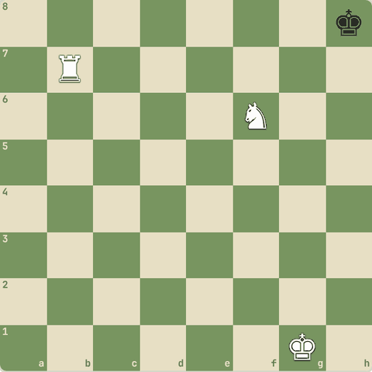
(White ki chaal)
Jawab:
1. Rh7#
- Knight f6 rook ko protect karta hai aur g8 band karta hai.
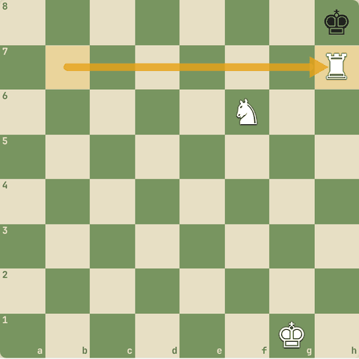
Chaal ke baad

4.1.6 Abhyaas: Boden mate in 1
Boden mate in 1
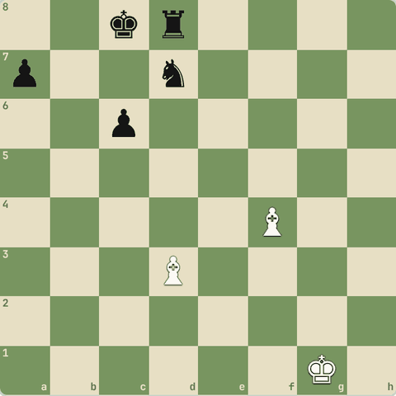
(White ki chaal)
Jawab:
1. Ba6#
- Do bishops: ek b8/c7 band karta hai, doosra check deta hai.
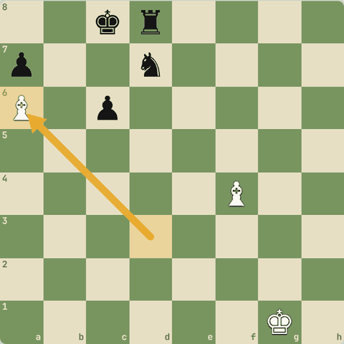
Chaal ke baad

4.1.7 Abhyaas: Mate in 1
Mate in 1: queen ka kiss
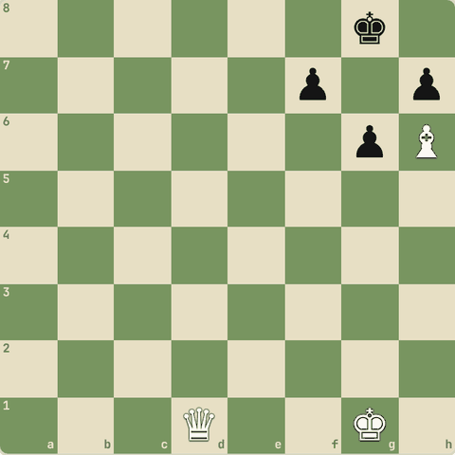
(White ki chaal)
Jawab:
1. Qd8#
- Bishop h6 ne g7 aur f8 band kiye.
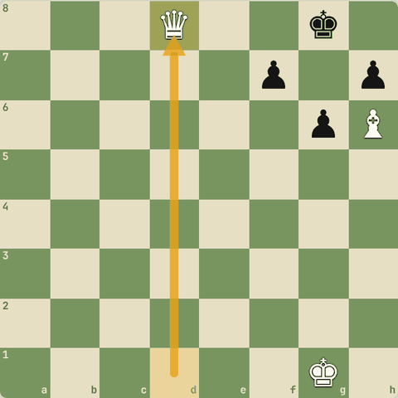
Chaal ke baad

4.1.8 Abhyaas: Philidor's legacy (smothered mate)
Philidor's legacy (smothered mate): mate in 5! Sirf checks.
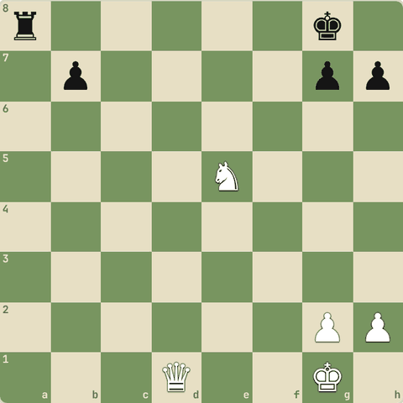
(White ki chaal)
Jawab:
1. Qd5+ Kh8 2. Nf7+ Kg8 3. Nh6+ Kh8 4. Qg8+ Rxg8 5. Nf7#
- `Qd5+ Kh8 Nf7+ Kg8 Nh6+ Kh8 Qg8+!!
- Rxg8 Nf7#`.
- Smothered mate: king apne hi rook se band.
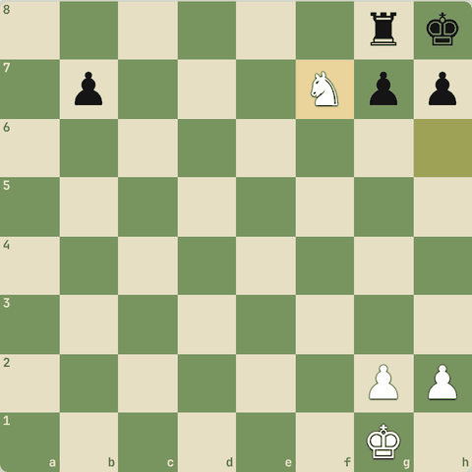
Line ke baad position

4.1.9 Abhyaas: Greek gift
Greek gift: h7 par sacrifice!
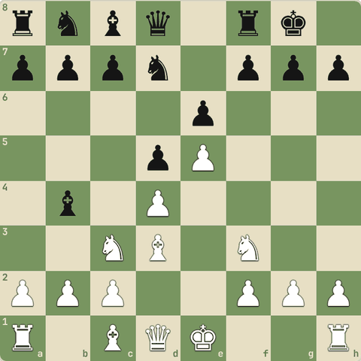
(White ki chaal)
Jawab:
1. Bxh7+ Kxh7 2. Ng5+
- Bxh7+ Kxh7 Ng5+ aur queen h5/d3 se attack.
- Shart: f6 par black knight na ho aur g5 par knight safe ho.
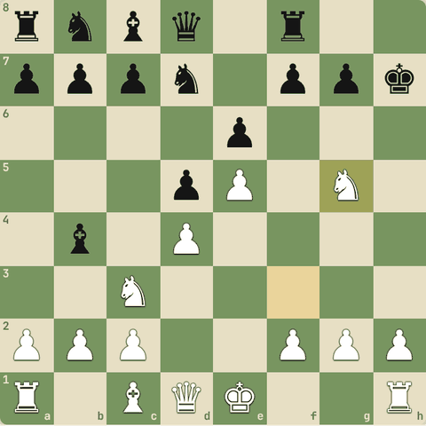
Line ke baad position

4.1.10 Abhyaas: Mate in 2
Mate in 2: escape squares band karo, phir mate.
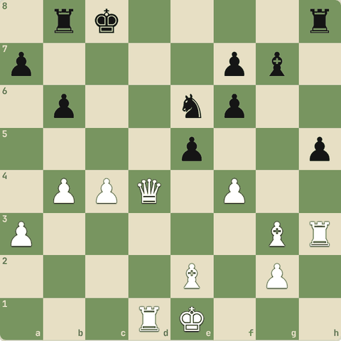
(White ki chaal)
Jawab:
1. Qd7#
- Line: Qd7#.
- Pehle king ke bhaagne ke raaste band, phir mate.
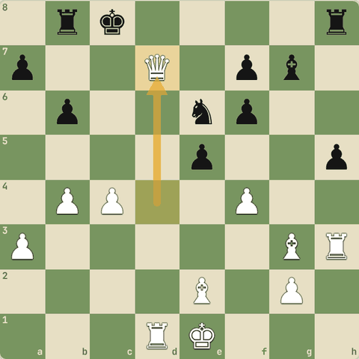
Chaal ke baad

4.1.11 Abhyaas: Mate in 2
Mate in 2: escape squares band karo, phir mate.
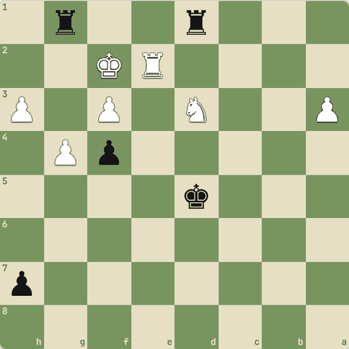
(Black ki chaal)
Jawab:
1… Rdf1#
- Line: Rdf1#.
- Pehle king ke bhaagne ke raaste band, phir mate.
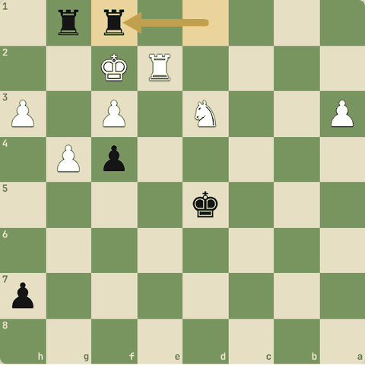
Chaal ke baad

4.1.12 Abhyaas: Mate in 2
Mate in 2: escape squares band karo, phir mate.
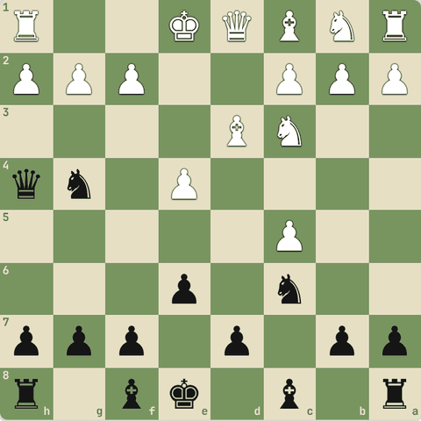
(Black ki chaal)
Jawab:
1… Qxf2#
- Line: Qxf2#.
- Pehle king ke bhaagne ke raaste band, phir mate.
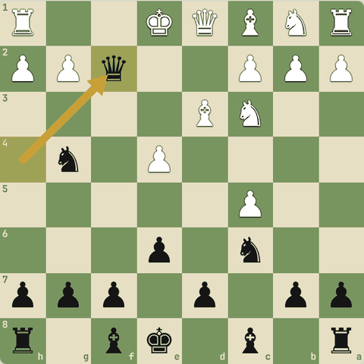
Chaal ke baad

4.1.13 Abhyaas: Mate in 2
Mate in 2: escape squares band karo, phir mate.
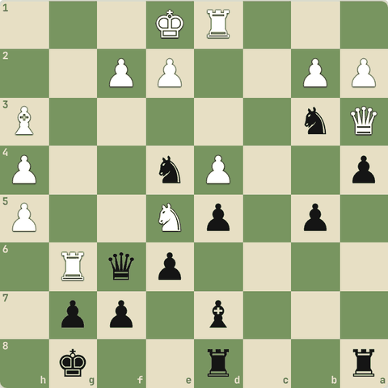
(Black ki chaal)
Jawab:
1… Qxf2#
- Line: Qxf2#.
- Pehle king ke bhaagne ke raaste band, phir mate.
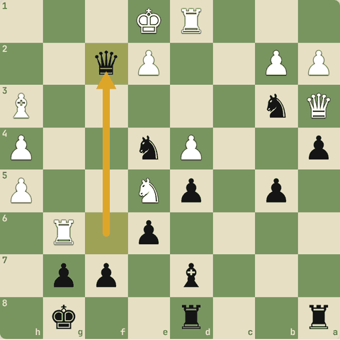
Chaal ke baad

4.1.14 Abhyaas: Mate in 2
Mate in 2: escape squares band karo, phir mate.
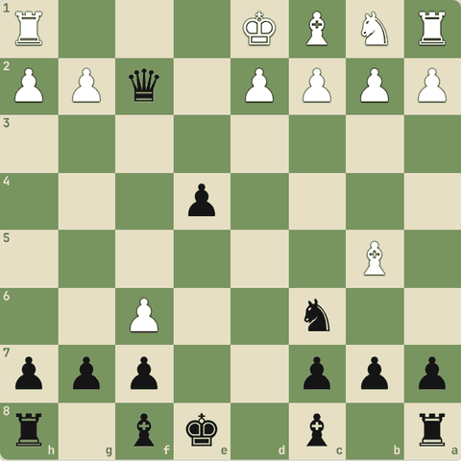
(Black ki chaal)
Jawab:
1… Bg4+ 2. Be2 Bxe2#
- Line: Bg4+ Be2 Bxe2#.
- Pehle king ke bhaagne ke raaste band, phir mate.
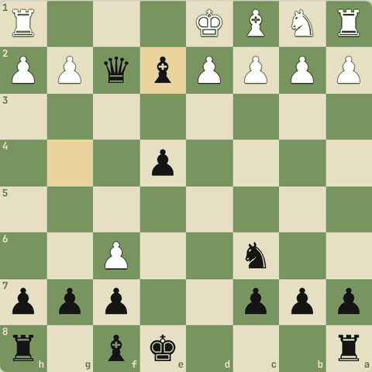
Line ke baad position

4.2 Back-rank mate
Apne hi pawns mein band king
Yaad rakho
- King back rank par, aage apne pawns: rook ya queen ka check = mate.
- Bachaav: "luft" (h3/h6 jaisi pawn chaal) se king ko saans do.
- Defender ko hatao ya deflect karo, phir back rank par ghuso.
- Famous: Carlsen-So, Bird-Zukertort, Averbakh-Ragozin, Polgar-Bareev, McShane-Mirumian, Bernstein-Capablanca.

4.2.1 Back-rank mate
- King apni pehli (back) rank par hai aur aage apne hi pawns use rok rahe hain.
- Rook ya queen ka back rank par check = mate.
- Bachaav: waqt mile to h3/h6 jaisi chaal se king ko luft (saans) do.
- Hamla: jo piece back rank bachata hai, use deflect ya overload karo.
- Famous: Carlsen-So, Bird-Zukertort, Orbaan-Kramer, Averbakh-Ragozin (1954), Cooper-Ivanov, Shapiro-Silman, Polgar-Bareev, McShane-Mirumian, Davidovich-Aguado.

4.2.2 Abhyaas: Back rank khula hai
Back rank khula hai. Mate in 1.
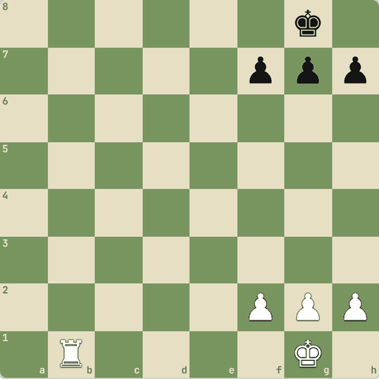
(White ki chaal)
Jawab:
1. Rb8#
- Pawns f7 g7 h7 ne king ko band kar rakha hai.
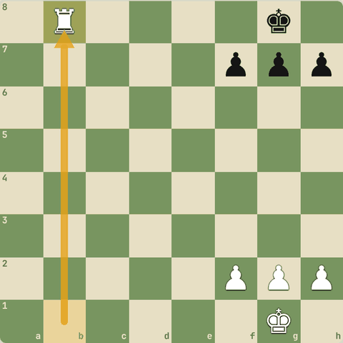
Chaal ke baad

4.2.3 Abhyaas: Do attackers vs do defenders, par aakhri capture mate hai!
Do attackers vs do defenders, par aakhri capture mate hai! Mate in 2.
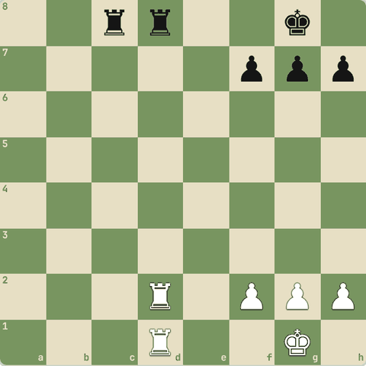
(White ki chaal)
Jawab:
1. Rxd8+ Rxd8 2. Rxd8#
- Rxd8+ Rxd8 Rxd8#.
- Aakhri capture tumhara, aur woh back rank par mate hai.
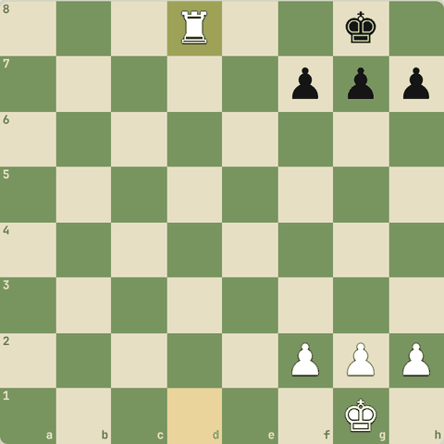
Line ke baad position

4.2.4 Abhyaas: Back-rank ki kamzori dhundo!
Back-rank ki kamzori dhundo!
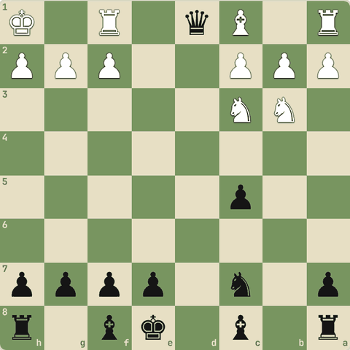
(Black ki chaal)
Jawab:
1… Qxf1#
- Line: Qxf1#.
- King apne pawns ke peeche band tha.
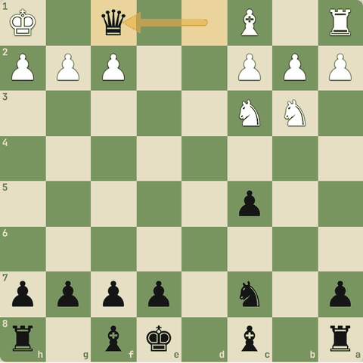
Chaal ke baad

4.2.5 Abhyaas: Back-rank ki kamzori dhundo!
Back-rank ki kamzori dhundo!
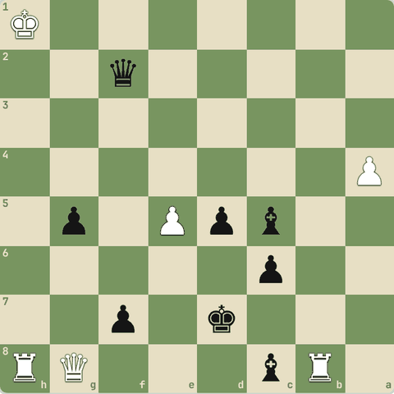
(Black ki chaal)
Jawab:
1… Qg1#
- Line: Qg1#.
- King apne pawns ke peeche band tha.
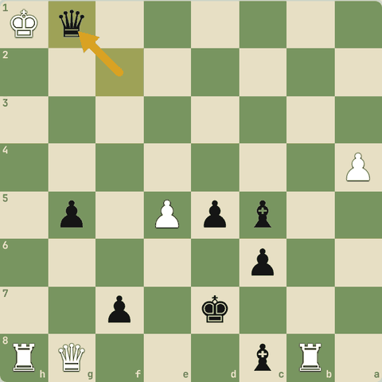
Chaal ke baad

4.2.6 Abhyaas: Back-rank ki kamzori dhundo!
Back-rank ki kamzori dhundo!
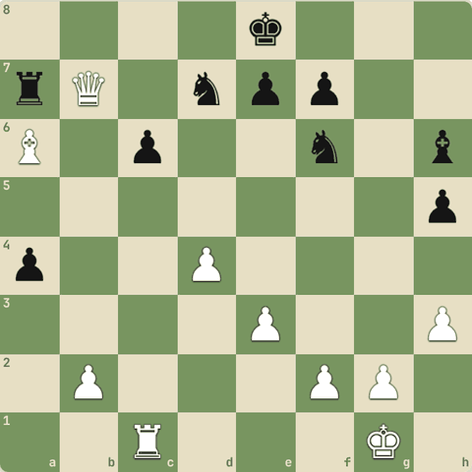
(White ki chaal)
Jawab:
1. Qc8#
- Line: Qc8#.
- King apne pawns ke peeche band tha.
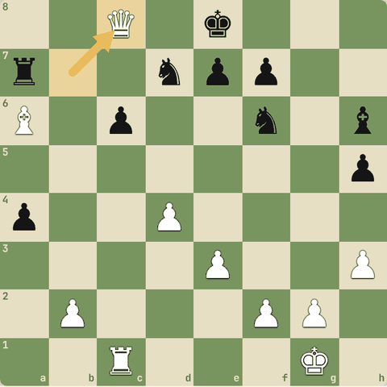
Chaal ke baad

4.2.7 Abhyaas: Back-rank ki kamzori dhundo!
Back-rank ki kamzori dhundo!
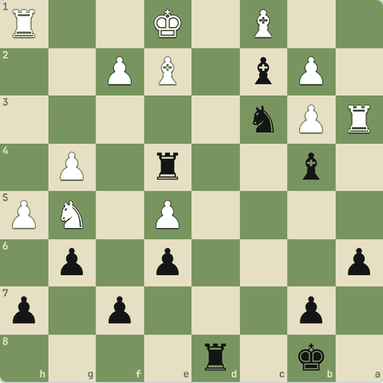
(Black ki chaal)
Jawab:
1… Rd1#
- Line: Rd1#.
- King apne pawns ke peeche band tha.
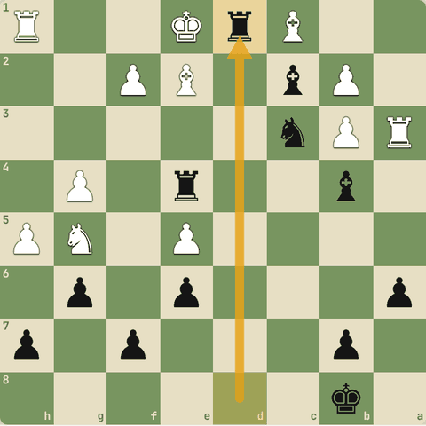
Chaal ke baad

4.2.8 Abhyaas: Back-rank ki kamzori dhundo!
Back-rank ki kamzori dhundo!
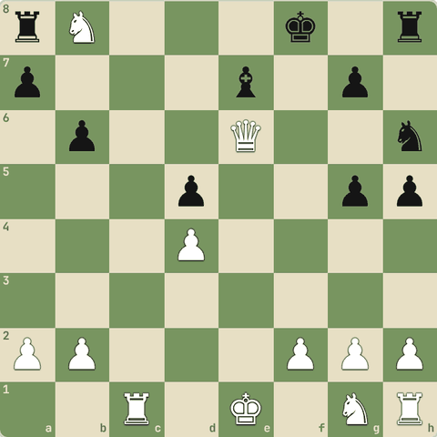
(White ki chaal)
Jawab:
1. Rc8+ Bd8 2. Rxd8#
- Line: Rc8+ Bd8 Rxd8#.
- King apne pawns ke peeche band tha.
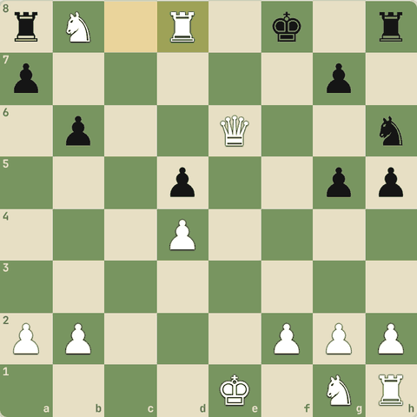
Line ke baad position

4.2.9 Abhyaas: Back-rank ki kamzori dhundo!
Back-rank ki kamzori dhundo!
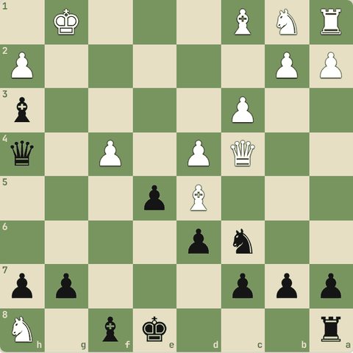
(Black ki chaal)
Jawab:
1… Qe1+ 2. Qf1 Qxf1#
- Line: Qe1+ Qf1 Qxf1#.
- King apne pawns ke peeche band tha.
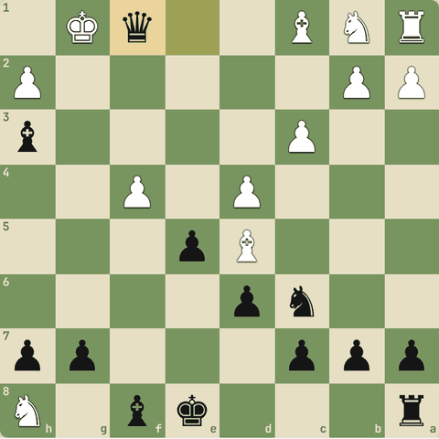
Line ke baad position

4.2.10 Sawal 1: Back-rank mate se bachne ka sabse simple tareeka?
Back-rank mate se bachne ka sabse simple tareeka?
Jawab:
✓ Waqt mile to ek pawn (h3/h6) chal kar king ko luft dena
- Luft = king ke liye ek escape square.

4.3 Smothered mate aur Philidor's legacy
Knight ka mate jab king apne pieces mein dab jaaye
Yaad rakho
- Smothered mate: king ke saare squares apne pieces se bhare, knight check deta hai.
- Philidor's legacy: queen check, knight checks, queen sacrifice g8 par, phir Nf7#.
- Suffocation (semi-smothered) mate: knight + doosra piece, king apne pieces mein phansa.
- Famous: McConnell-Morphy, Morphy vs NN (1856), Greco (1620), Morphy-Bryan (1859).

4.3.1 Smothered mate
- King ke saare aas-paas ke squares apne hi pieces se bhare hain, aur knight check deta hai (knight ka check block nahi hota).
- Sabse sundar mate!
- Famous: McConnell-Morphy, Morphy vs NN (New Orleans 1856), NN-Greco (1620, 1625), Bird/Dobell vs NN, Bischoff-Mueller, Morphy-Bryan (1859), Hendriks-Welling.

4.3.2 Abhyaas: Smothered mate in 1!
Smothered mate in 1!
(White ki chaal)
Jawab:
1. Nf7#
- King h8: g8 par rook, g7 h7 par pawns.
- Knight check = mate.
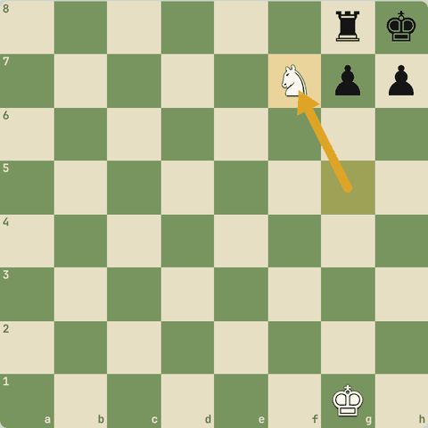
Chaal ke baad

4.3.3 Abhyaas: Doosre corner mein smothered mate
Doosre corner mein smothered mate.
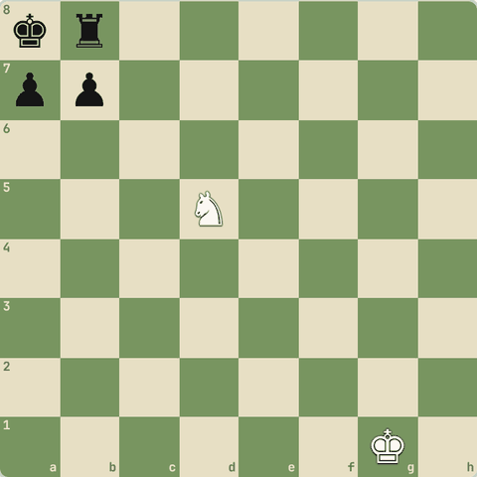
(White ki chaal)
Jawab:
1. Nc7#
- Knight ka check block nahi ho sakta aur king ke saare squares apne pieces se bhare.
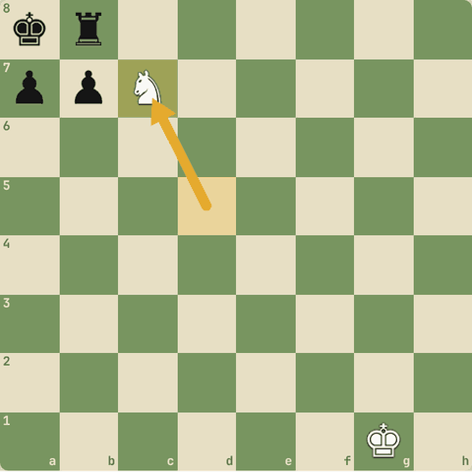
Chaal ke baad

4.3.4 Abhyaas: Philidor's legacy (chhota version)
Philidor's legacy (chhota version): mate in 2.
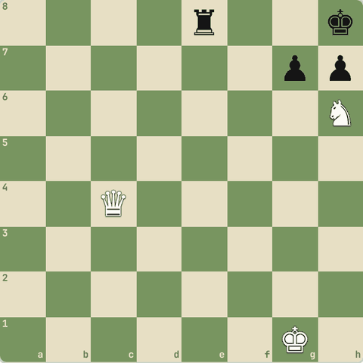
(White ki chaal)
Jawab:
1. Qg8+ Rxg8 2. Nf7#
- Queen sacrifice g8 par: rook ko wahan kheencha (decoy), phir smothered mate.
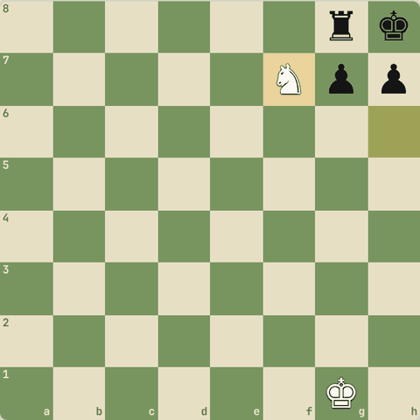
Line ke baad position

4.3.5 Suffocation mate (semi-smothered)
- Knight check deta hai, king ke kuch squares apne pieces se band, baaki kisi doosre piece (jaise bishop) se.
- King "dam ghut-ne" se marta hai.

4.3.6 Sawal 1: Smothered mate kis piece se hota hai?
Smothered mate kis piece se hota hai?
Jawab:
✓ Knight
- Sirf knight, kyunki uska check block nahi hota.

4.4 Rook aur knight/bishop ke mate patterns
Anastasia, Arabian, corner, Morphy, Pillsbury, Mayet, Opera, blind swine, Reti, hook, Vukovic
Yaad rakho
- Anastasia: knight e7 + rook h-file, king h7.
- Arabian: rook h7 + knight f6, king h8.
- Corner: rook g-file + knight f7, king h8 (pawn h7).
- Morphy: bishop long diagonal se check, rook g-file band.
- Pillsbury: rook g-file se check, bishop h8 band karta hai.
- Mayet: rook check, door se bishop support.
- Opera: rook back rank par, bishop support (Morphy ka Opera game).
- Blind swine: do rooks 7th rank par.
- Reti: bishop + rook, king apne pieces mein (Reti-Tartakower).
- Hook: rook + knight + pawn ek chain. Vukovic: rook + knight, king kinare par.

4.4.1 Rook + minor piece patterns
- Anastasia: knight e7 (g6, g8 band) + rook h-file par check, king h7. (Milosavljevic-Rakic)
- Arabian: rook h7 + knight f6, king h8. Sabse purana pattern. (Gunsberg-Janowski)
- Corner mate: rook g-file band kare, knight f7 se check, king h8 (pawn h7). (Myers-Poliakoff)
- Morphy: bishop long diagonal se check, rook g-file band.
- Pillsbury: ulta: rook g-file se check, bishop h8 band.
- Mayet: rook check, door se bishop support (killer common square ka type).
- Opera: rook back rank par check, bishop support. (Morphy ka Opera game)
- Blind swine: do rooks 7th rank par ("pigs"), king ko maarte hain.
- Reti: bishop + rook, king apne pieces mein (Reti-Tartakower).
- Hook: rook ko knight protect kare, knight ko pawn: ek chain. (Marshall-Napier)
- Vukovic: rook + knight, king kinare par. (Staunton-Williams)

4.4.2 Abhyaas: Anastasia's mate
Anastasia's mate: mate karo!
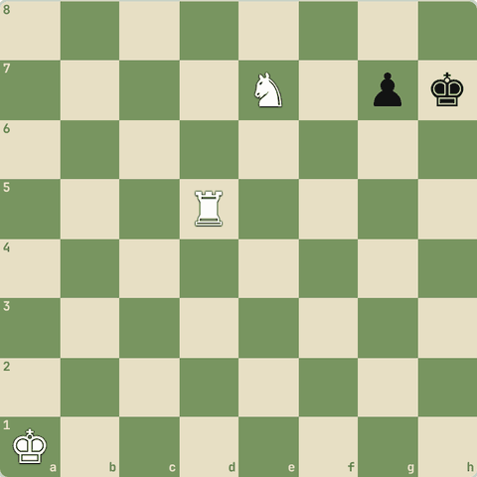
(White ki chaal)
Jawab:
1. Rh5#
- Knight e7 ne g6, g8 band kiye, rook ne h-file par mate kiya.
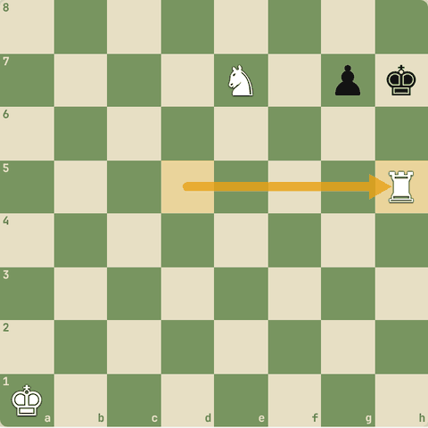
Chaal ke baad

4.4.3 Abhyaas: Arabian mate
Arabian mate: mate karo!
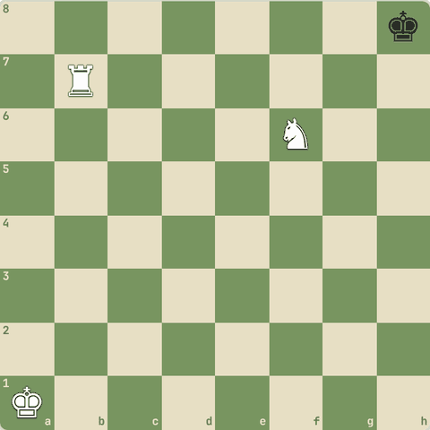
(White ki chaal)
Jawab:
1. Rh7#
- Rook h7 ko knight f6 bachata hai, knight g8 bhi band karta hai.
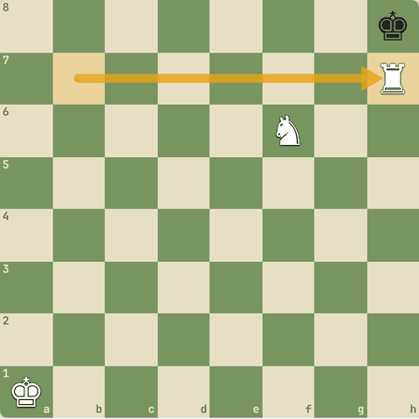
Chaal ke baad

4.4.4 Abhyaas: Corner mate
Corner mate: mate karo!
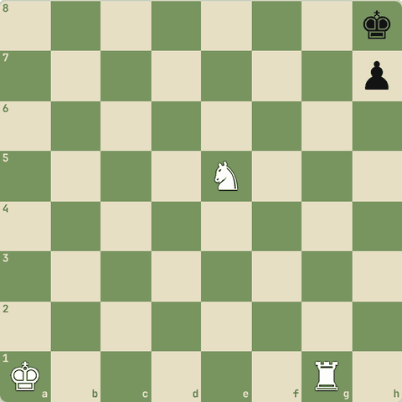
(White ki chaal)
Jawab:
1. Nf7#
- Rook ne g-file band ki, knight ne check diya, h7 apna pawn.
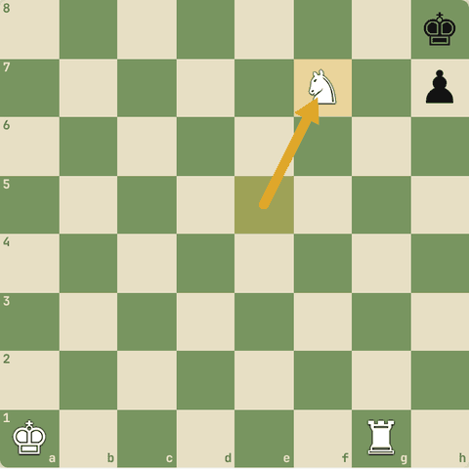
Chaal ke baad

4.4.5 Abhyaas: Morphy's mate
Morphy's mate: mate karo!
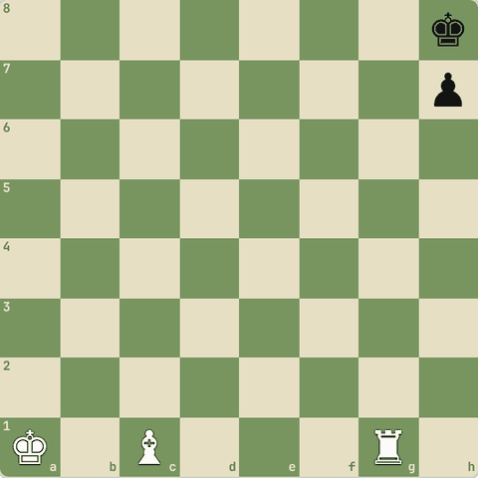
(White ki chaal)
Jawab:
1. Bb2#
- Bishop long diagonal se check, rook g7/g8 band.
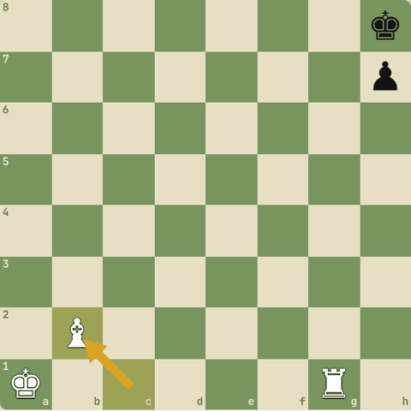
Chaal ke baad

4.4.6 Abhyaas: Pillsbury's mate
Pillsbury's mate: mate karo!
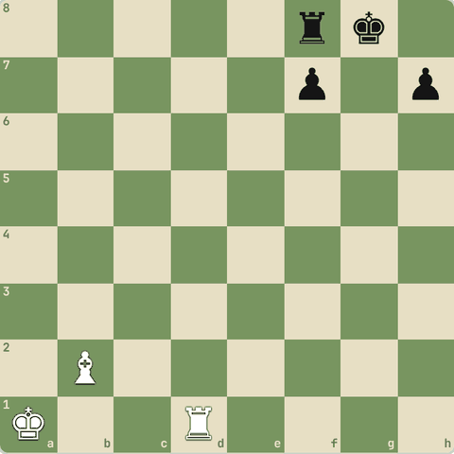
(White ki chaal)
Jawab:
1. Rg1#
- Rook g-file se check, bishop b2 ne g7 aur h8 band kiye.
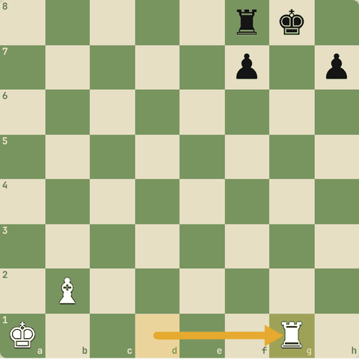
Chaal ke baad

4.4.7 Abhyaas: Mayet's mate
Mayet's mate: mate karo!
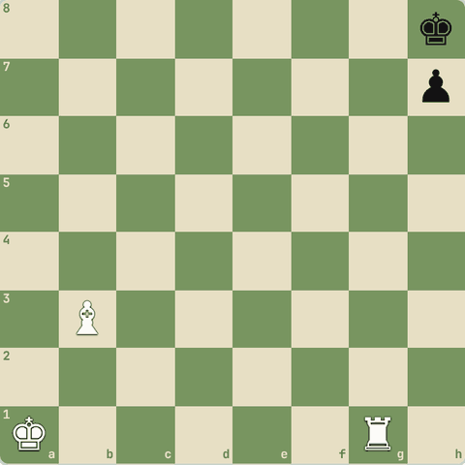
(White ki chaal)
Jawab:
1. Rg8#
- Rook g8 ko door se bishop b3 support karta hai.
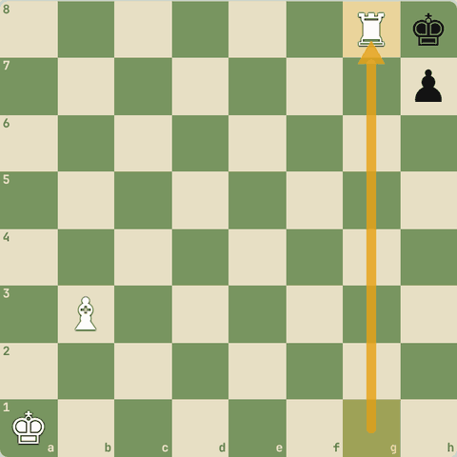
Chaal ke baad

4.4.8 Abhyaas: Opera mate
Opera mate: mate karo!
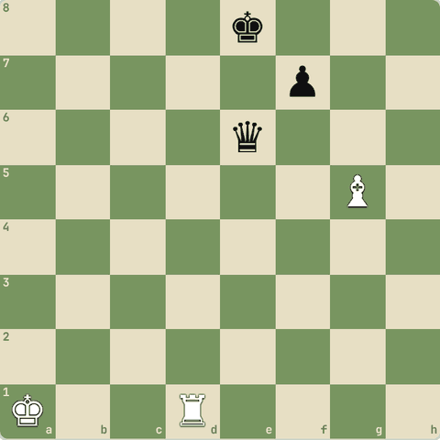
(White ki chaal)
Jawab:
1. Rd8#
- Rook back rank par, bishop g5 ne d8 aur e7 dono sambhale.
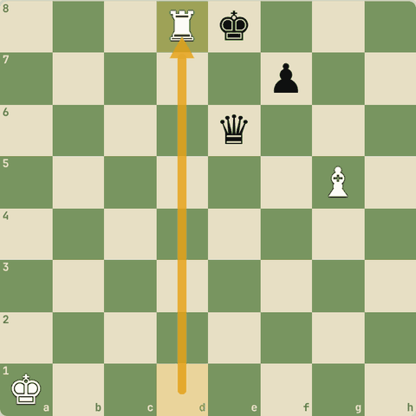
Chaal ke baad

4.4.9 Abhyaas: Blind swine mate (mate in 3)
Blind swine mate (mate in 3): mate karo!
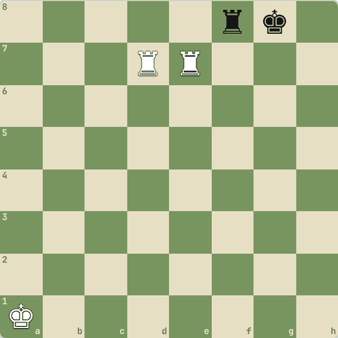
(White ki chaal)
Jawab:
1. Rg7+ Kh8 2. Rh7+ Kg8 3. Rdg7#
- Do rooks 7th rank par: king ko g8-h8 mein ghumao, phir mate.
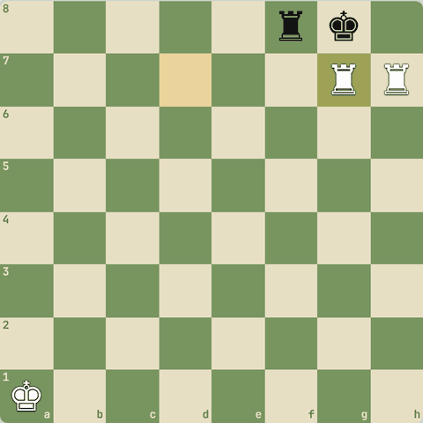
Line ke baad position

4.5 Queen, bishop aur pawn ke mate patterns
Damiano, Greco, Lolli, dovetail, swallow's tail, epaulette, Boden, Blackburne, double bishop, Max Lange, kill box, pawn mate
Yaad rakho
- Damiano: queen h7 par, pawn g6 support.
- Greco: bishop g8 band kare, queen/rook h-file par mate.
- Lolli: pawn f6 + queen g7 (thorn pawn).
- Dovetail: queen diagonal se, king ke peeche ke squares apne pieces se band.
- Swallow's tail (Gueridon): queen seedha saamne, king ke diagonal peeche apne rooks.
- Epaulette: king ke dono taraf apne rooks (kandhe), queen saamne se.
- Boden: do bishops crisscross (a6 + f4 jaisi diagonals).
- Blackburne: do bishops + knight. Double bishop: do bishops saath diagonals par.
- Max Lange: queen + bishop. Kill box: queen + rook ka box. Pawn mate (David & Goliath): pawn ka mate.

4.5.1 Queen, bishop aur pawn patterns
- Damiano: queen h7 par mate, pawn g6 support.
- Greco: bishop c4 ne g8 band kiya, queen/rook h-file par mate. (Short-Sokolov)
- Lolli (thorn pawn): pawn f6 + queen g7. (Blackburne-Steinkuehler)
- Dovetail: queen diagonal se check, king ke peeche ke do squares apne pieces se band.
- Swallow's tail / Gueridon: queen seedha saamne (protected), king ke diagonal peeche apne rooks.
- Epaulette: king ke dono kandhon par apne rooks, queen saamne se. (Carlsen-Ernst)
- Boden: do bishops crisscross diagonals par. (Canal vs NN)
- Blackburne: do bishops + knight.
- Double bishop: do bishops paas-paas diagonals par.
- Max Lange: queen + bishop ka chatur kaam.
- Kill box: queen + rook ek box banate hain.
- Queen's mate, Rook (box) mate: Level 2 mein seekhe.
- Pawn mate (David & Goliath): chhota sa pawn mate deta hai.
- Legal's mate: Level 2 ke traps mein seekha.

4.5.2 Abhyaas: Damiano's mate
Damiano's mate: mate karo!
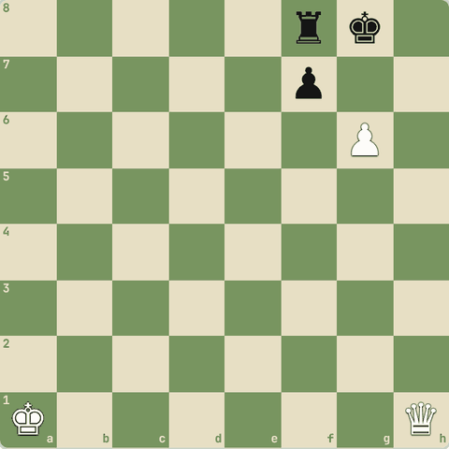
(White ki chaal)
Jawab:
1. Qh7#
- Queen h7, pawn g6 support.
- King ke saare raaste band.
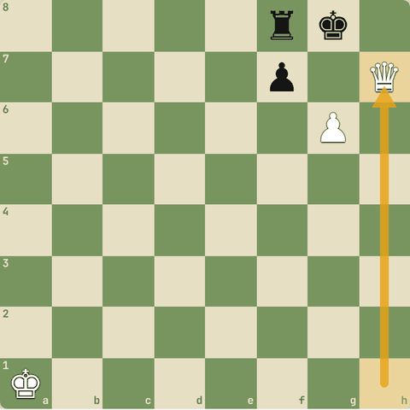
Chaal ke baad

4.5.3 Abhyaas: Greco's mate
Greco's mate: mate karo!
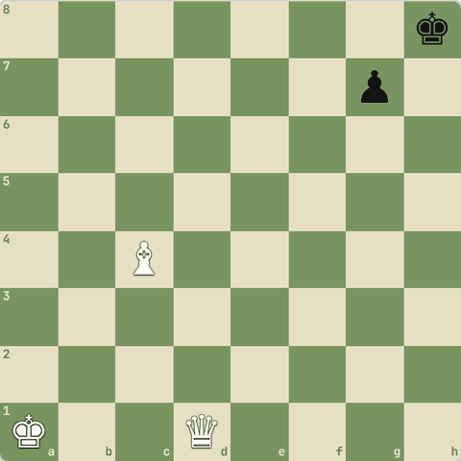
(White ki chaal)
Jawab:
1. Qh5#
- Bishop c4 ne g8 band kiya, g7 apna pawn.
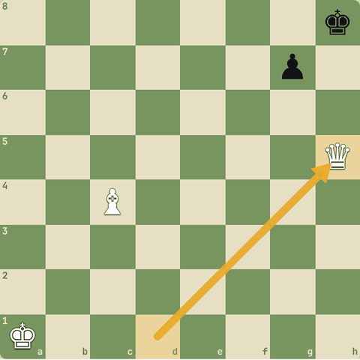
Chaal ke baad

4.5.4 Abhyaas: Lolli's mate (thorn pawn)
Lolli's mate (thorn pawn): mate karo!
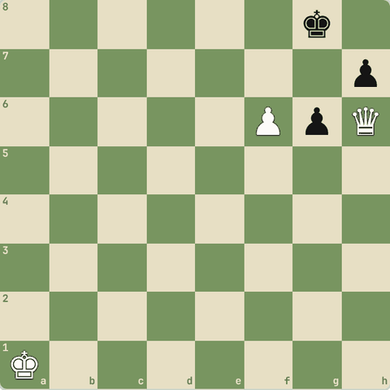
(White ki chaal)
Jawab:
1. Qg7#
- Pawn f6 (thorn pawn) queen ko support karta hai.
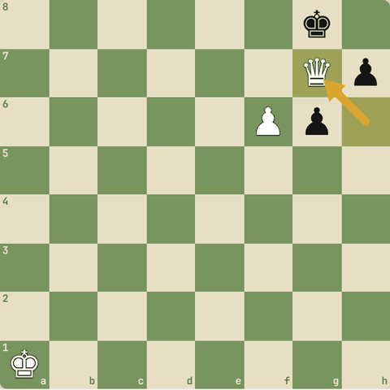
Chaal ke baad

4.5.5 Abhyaas: Dovetail mate
Dovetail mate: mate karo!
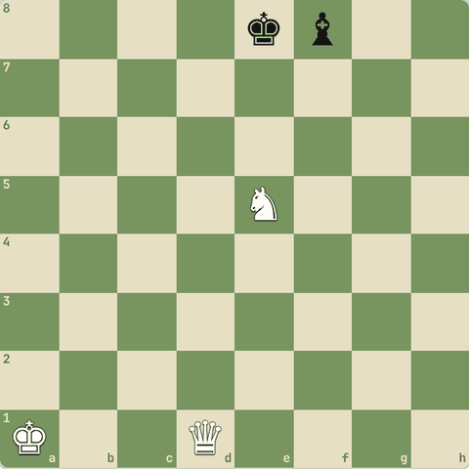
(White ki chaal)
Jawab:
1. Qd7#
- Queen diagonal se, knight support.
- f8 par apna bishop raasta band karta hai.
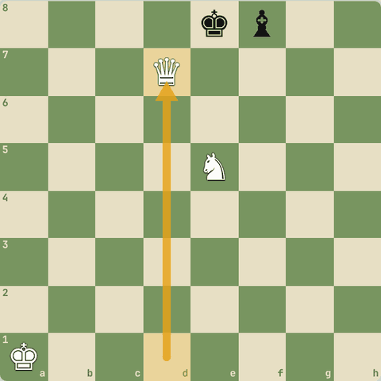
Chaal ke baad

4.5.6 Abhyaas: Swallow's tail mate
Swallow's tail mate: mate karo!
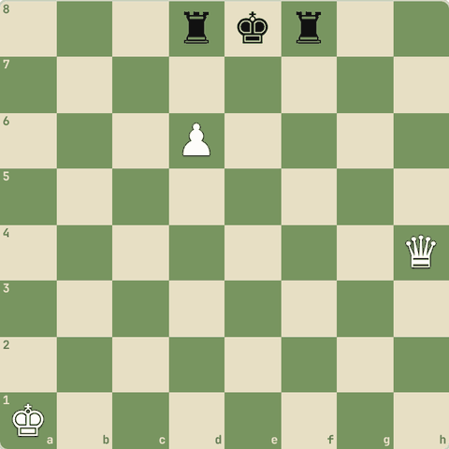
(White ki chaal)
Jawab:
1. Qe7#
- Queen seedha saamne, pawn d6 support.
- Diagonal peeche apne rooks.
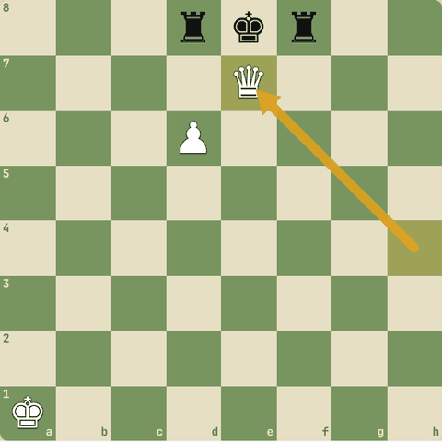
Chaal ke baad

4.5.7 Abhyaas: Epaulette mate
Epaulette mate: mate karo!
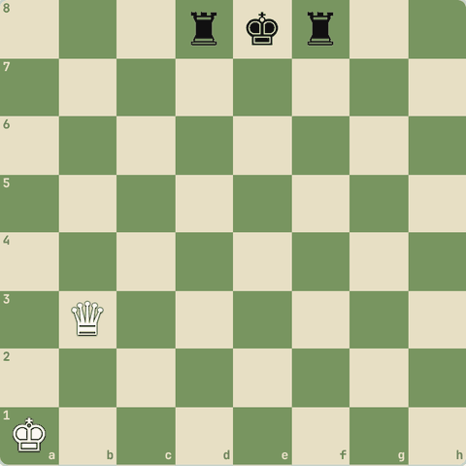
(White ki chaal)
Jawab:
1. Qe6#
- King ke dono taraf apne rooks: kandhe (epaulettes) jaise.
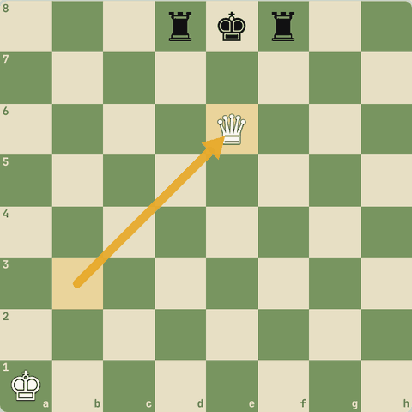
Chaal ke baad

4.5.8 Abhyaas: Boden's mate
Boden's mate: mate karo!
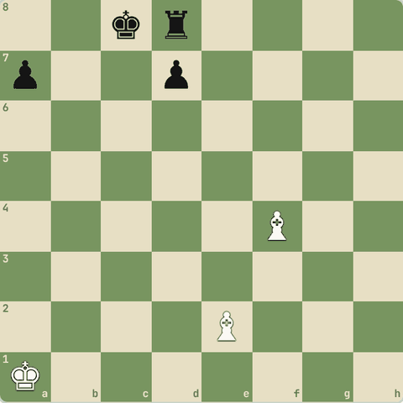
(White ki chaal)
Jawab:
1. Ba6#
- Do bishops crisscross: a6 aur f4.
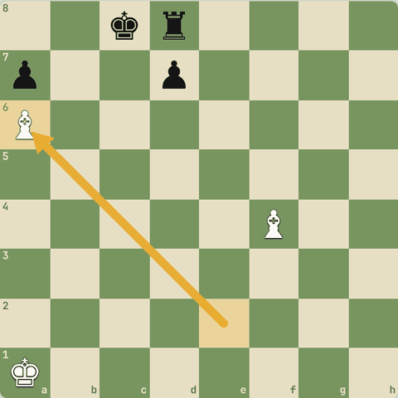
Chaal ke baad

4.5.9 Abhyaas: Blackburne's mate
Blackburne's mate: mate karo!
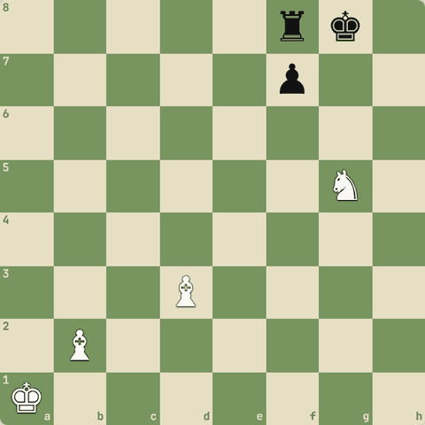
(White ki chaal)
Jawab:
1. Bh7#
- Bishop h7 check, knight support, doosra bishop g7/h8 band.
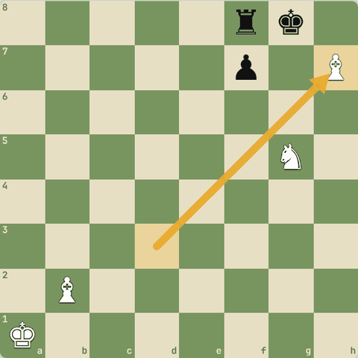
Chaal ke baad

4.5.10 Abhyaas: Pawn mate (David & Goliath)
Pawn mate (David & Goliath): mate karo!
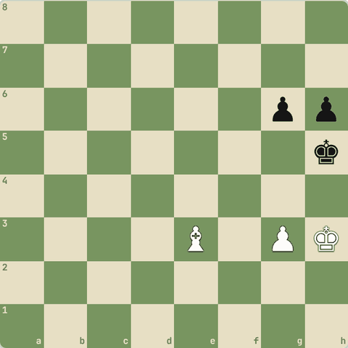
(White ki chaal)
Jawab:
1. g4#
- Chhote pawn ka mate!
- King h3 pawn ko bachata hai, bishop g5 band karta hai.
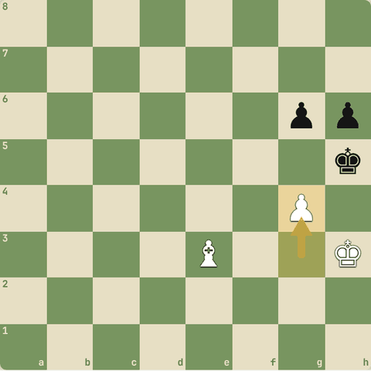
Chaal ke baad

Level 5: Middlegame 3: Strategy aur plan
Position ke elements, exchanges, pawn structure, weak squares, open files, plans, prophylaxis, sacrifices
- Jab koi tactic na ho, tab kya karein?
- Strategy: position ke elements samjho aur plan banao.

5.1 Position ke elements aur exchanges
Material, time, space, king safety, pawn structure; kab trade karein
Yaad rakho
- Material sab kuch nahi: time (development), space, king safety, pawn structure bhi ginti mein.
- Jeet rahe ho (material aage): pieces trade karo, pawns nahi.
- Haar rahe ho: pawns trade karo, pieces nahi (draw ke chances).
- King par heavy attack: attacking pieces trade karo.
- Tang (cramped) position: pieces trade karke saans lo, bure piece ko trade karo.

5.1.1 Position ke 5 elements
- Sirf "accountant" ki tarah material mat gino.
- Dekho:
- 1.
- Material (points)
- 2.
- Time (development, tempo)
- 3.
- Space (kitni jagah tumhare pieces ke paas)
- 4.
- King safety
- 5.
- Pawn structure
- Ek element mein aage hokar doosre mein peeche ho sakte ho.
- Jaise gambit: material kam, time zyada.

5.1.2 Material sab kuch nahi: Ed. Lasker vs Thomas (1912)
- Queen sacrifice aur phir Black king ka poore board par shikaar!
1. d4 e6 2. Nf3 f5 3. Nc3 Nf6 4. Bg5 Be7 5. Bxf6 Bxf6 6. e4 fxe4 7. Nxe4 b6 8. Ne5 O-O 9. Bd3 Bb7 10. Qh5 Qe7 11. Qxh7+ Kxh7 12. Nxf6+ Kh6 13. Neg4+ Kg5 14. h4+ Kf4 15. g3+ Kf3 16. Be2+ Kg2 17. Rh2+ Kg1 18. Kd2#
- 5.Bxf6 bishop dekar light squares par kabza.
- 10.Qh5 attack.
- 11.Qxh7+!! queen sacrifice.
- 12.Nxf6+ double check!
- 14.h4+ king ko aage kheencho.
- 18.Kd2# king ki chaal se mate (O-O-O# bhi tha)!
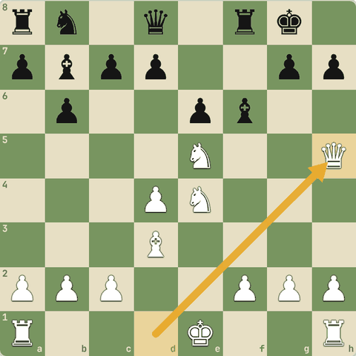
Position after 10.Qh5
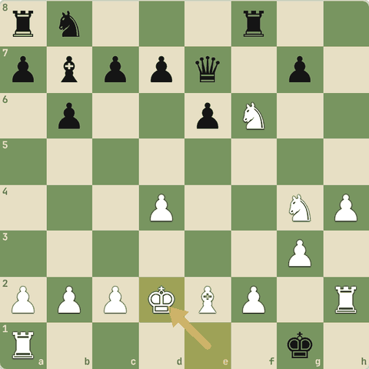
Final position (18.Kd2#)

5.1.3 Exchanges kab karein
- Material aage: pieces trade karo, pawns nahi. Kam pieces = tumhara extra material zyada bhaari. (Benko vs Fischer)
- Material peeche: pawns trade karo, pieces nahi. Kam pawns = draw ke chances (jaise sirf bishop bacha to mate nahi).
- King par heavy attack: attacking pieces trade karo, attack khatam.
- Tang (cramped) position: trade karke jagah banao, khaas kar apna bura piece trade karo.

5.1.4 Sawal 1: Tum ek rook aage ho
Tum ek rook aage ho. Opponent queen trade offer karta hai. Kya karoge?
Jawab:
✓ Trade karo: pieces kam = jeet aasaan
- Aage ho to pieces trade.

5.1.5 Sawal 2: Tum ek pawn peeche ho, endgame aa raha hai
Tum ek pawn peeche ho, endgame aa raha hai. Kya trade karna achha?
Jawab:
✓ Pawns
- Pawns kam honge to draw ke chances badhenge.

5.1.6 Sawal 3: Opponent ki queen, rook aur knight tumhare king par attack kar…
Opponent ki queen, rook aur knight tumhare king par attack kar rahe hain. Achha idea?
Jawab:
✓ Attacking pieces ko trade karo
- Attackers trade = attack khatam.

5.1.7 Sawal 4: Tumhari position tang hai aur ek bishop apne pawns ke peeche band…
Tumhari position tang hai aur ek bishop apne pawns ke peeche band (bura). Plan?
Jawab:
✓ Bure bishop ko trade karne ki koshish
- Cramped position mein trades se raahat.

5.2 Pawn structure
Isolated, doubled, backward, passed, chains
Yaad rakho
- Pawn moves permanent hain: structure decide karta hai pieces kahan achhe.
- IQP: kamzor pawn, par active pieces. IQP wala attack kare, doosra trade kare.
- Backward pawn ke aage ka square ek hole banta hai.
- Pawn chain: base par attack karo (Nimzowitsch).
- "Pawns chess ki aatma hain" (Philidor).
- Pawns peeche nahi jaate: har pawn chaal ek pakka faisla. Socho kaunse squares hamesha ke liye kamzor honge.
- Center ko pawns se bharna zaroori nahi: pieces se control bhi chalega (hypermodern, Reti vs Capablanca).
- Pawn kamzor tab hota hai jab use pawn se bachaya na ja sake (dependency pieces par).
- Pieces aur pawns ka harmony: bishop apne pawns ke opposite colour par.

5.2.1 Pawns: chess ki aatma
- "Pawns are the soul of chess" (Philidor).
- Pawn structure (formation) batata hai ki pieces kahan jaayenge aur plan kya hoga.
- Pawns peeche nahi jaate: har pawn chaal ek pakka faisla hai. Plaskett vs Adams aur Fischer vs Addison (probing strategy) mein galat pawn chaalon se hamesha ki kamzori bani.
- Center bharna zaroori nahi: Reti vs Capablanca: pieces se door se center control (hypermodern).
- Kamzor pawn = jise pawn se bachaya na ja sake, pieces par nirbhar.
- Harmony: pieces aur pawns saath kaam karein. Bishop apne pawns ke opposite colour par. (Karjakin-Adams, Kasparov-Adams, Nimzowitsch-Capablanca)
- Har structure ke upside aur downside hote hain: dono khelkar dekho.

5.2.2 Pawns = position ki haddi
- "Pawns are the soul of chess" (Philidor).
- Pawns peeche nahi jaate, isliye har pawn move permanent hai.
- Pawn structure decide karta hai pieces kahan achhe honge.

5.2.3 Isolated pawn (IQP)
- d4 pawn ke bagal (c, e files) mein koi apna pawn nahi: isolated.
- Kamzori: pawn se protect nahi hota, aur uske aage d5 square blockade ke liye perfect (Black knight d5 par).
- Taakat: active pieces, d5 break aur kingside attack.
- IQP wala attack kare, doosra pieces trade karke endgame mein jaaye.
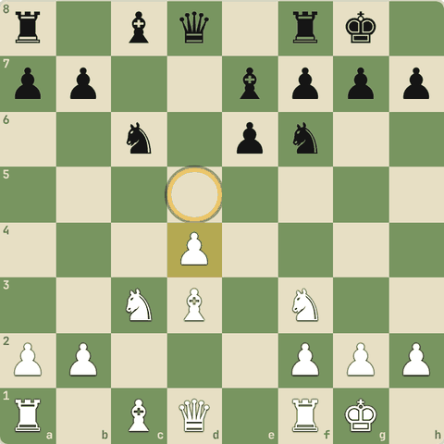

5.2.4 Doubled aur backward pawns
- Backward pawn: bagal ke pawns aage nikal gaye, aur yeh aage nahi badh sakta kyunki aage ka square dushman control karta hai.
- Yahan Black ka d6 backward hai aur d5 ek hole hai: White ke knight ke liye perfect ghar.
- Doubled pawns (ek file par do): aksar kamzor, par open file deta hai.
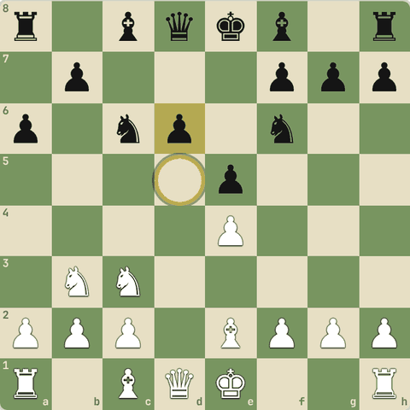

5.2.5 Pawn chain
- Pawn chain d4-e5 (White) aur e6-d5 (Black).
- Rule (Nimzowitsch): chain ki base par attack karo.
- Black ...c5 se d4 (base) par vaar karta hai.
- White kingside par (f4-f5) attack karta hai, kyunki chain ka sira us taraf ishaara karta hai.
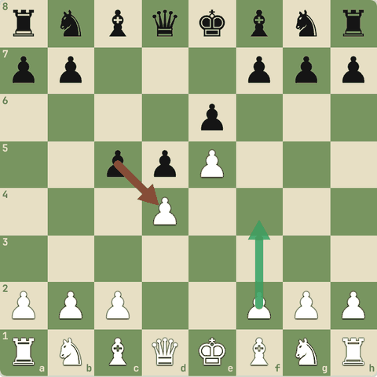

5.2.6 Sawal 1: Isolated pawn ke saamne wala square kis kaam ka hai?
Isolated pawn ke saamne wala square kis kaam ka hai?
Jawab:
✓ Dushman ke knight ke liye blockade ghar

5.2.7 Sawal 2: Pawn chain par attack kahan karna chahiye?
Pawn chain par attack kahan karna chahiye?
Jawab:
✓ Chain ki base par

5.2.8 Sawal 3: Tumhare center pawns light squares par hain
Tumhare center pawns light squares par hain. Kaunsa bishop "good" hai?
Jawab:
✓ Dark-square bishop
- Apne pawns ke opposite colour wala bishop free hota hai.

5.2.9 Sawal 4: Pawn chaal ko "irreversible" kyun kehte hain?
Pawn chaal ko "irreversible" kyun kehte hain?
Jawab:
✓ Pawn peeche nahi jaata, jo square chhoda woh hamesha ke liye
- Isliye pawn chaal soch-samajh kar.

5.3 Pawn structure: gehraai se
Pawn breaks, holes, minority attack, thorn pawn, passed, doubled, IQP, backward, hanging: upside aur downside
Yaad rakho
- Pawn break (lever): pawn se dushman ki chain par chot karke lines kholna.
- Hole: aisa square jise pawn kabhi control nahi kar sakta. Uske guard bishop ko trade karo.
- Minority attack: kam pawns (jaise a+b) se zyada pawns (a+b+c) par hamla karke kamzori banana.
- Thorn pawn: dushman king ke paas gehra ghusa pawn (f6/h6): mate ke mauke.
- Har structure ke dono pehlu: doubled, IQP, backward, hanging pawns kamzor bhi, strong bhi.

5.3.1 Pawn break aur hole
- Pawn break (lever): apne pawn se dushman ke pawn par chot karke lines kholna. Jaise French mein ...c5, King's Indian mein ...f5.
- Structural hole: aisa square jise koi pawn kabhi control nahi kar sakta (jaise d5 jab c aur e pawns aage chale gaye). Agar us square ka guard ek bishop hai, use trade karo: hole tumhara.

5.3.2 Minority attack
- Queen's Gambit Exchange structure: White ke 2 pawns (a, b) Black ke 3 pawns (a, b, c) par chadhte hain: b4-b5.
- Trade ke baad Black ke paas kamzor c-pawn (backward/isolated) bachta hai.
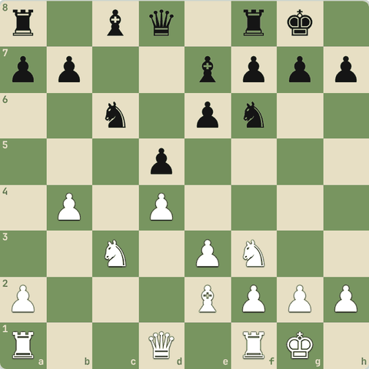

5.3.3 Sawal 1: Minority attack ka maksad?
Minority attack ka maksad?
Jawab:
✓ Dushman ke structure mein kamzor pawn banana
- Kamzor pawn = lambe samay ka target.

5.3.4 Thorn pawn
- Dushman king ke paas gehra ghusa pawn, jaise f6 ya h6 (Black castled king ke against).
- Yeh g7 jaise squares ko control karta hai aur mate ke patterns (Lolli) aasaan banata hai.
- Jeet ke chances bahut badh jaate hain.
- Examples: Lorenz-Orlov, Kramnik-Anand, Morales-Sanchez, Ivanovic-Popovic.
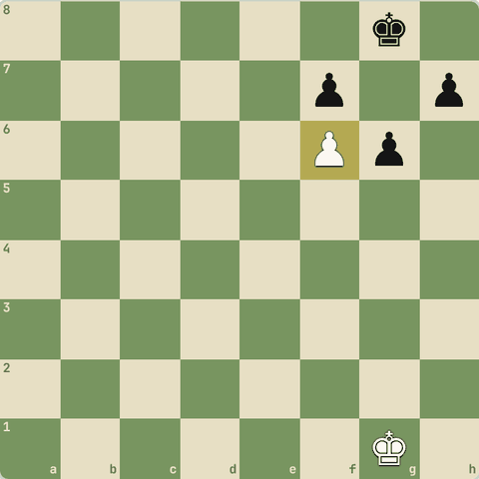

5.3.5 Structures: upside aur downside
- Passed pawn: jeet ke chances, "pushed" hone chahiye. (Torre vs NN)
- Doubled pawns: kamzor (ek doosre ko bacha nahi sakte), par open file aur center control de sakte hain. (Botvinnik vs Levenfish)
- IQP (isolated queen's pawn): kamzor endgame mein, par middlegame mein activity aur attack.
- Backward pawn: aage ka square hole ban jaata hai, par kabhi woh square aur pawn solid defense bhi.
- Hanging pawns (c + d saath, bagal mein koi nahi): aage badhkar dabaav, par target bhi.

5.3.6 Sawal 2: Doubled pawns ka ek upside?
Doubled pawns ka ek upside?
Jawab:
✓ Saath mein ek open/semi-open file milti hai
- Capture se file khulti hai: rook ke liye.

5.4 Weak squares aur outposts
Pieces ke liye ghar
Yaad rakho
- Outpost = jahan dushman pawn tumhare piece ko bhaga na sake.
- Outpost par knight rook jitna strong ho sakta hai.
- Bad bishop: apne hi pawns usi color par. Pawns bishop ke ulte color par rakho.

5.4.1 Outpost
- Outpost: aisa square jahan tumhara piece baith sake aur koi dushman pawn use bhaga na sake, aur aksar apne pawn se protected ho.
- d5 par knight: Black ke c aur e pawns use kabhi attack nahi kar sakte.
- Aisa knight ek rook jitna strong ho sakta hai!
- Weak square = jo pawns se protect na ho sake.
- Pawn move karte waqt socho: kaunse squares kamzor ho rahe hain?
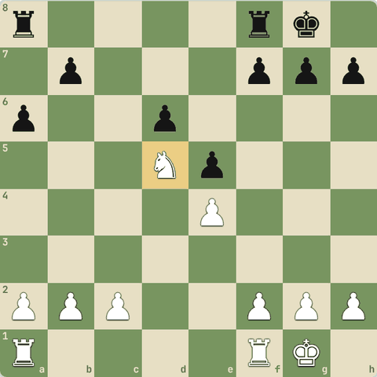

5.4.2 Good bishop vs bad bishop
- White ke pawns light squares par hain (c4, d5, e4), aur bishop bhi light-square ka hai: woh apne hi pawns se ruka hai = bad bishop.
- Rule: pawns ko apne bishop ke ulte color par rakho.
- Bad bishop ko trade karo ya pawns ke bahar laao.
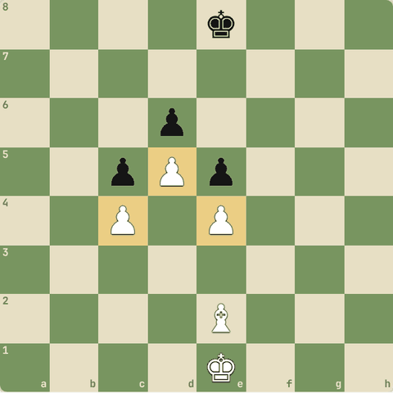

5.4.3 Sawal 1: Knight ke liye sabse achha square?
Knight ke liye sabse achha square?
Jawab:
✓ Center mein outpost jahan pawn bhaga na sake

5.5 Open files, 7th rank, piece activity
Rooks aur pieces ko zinda karo
Yaad rakho
- Rooks ko open / half-open files par lao, phir 7th rank par ghuso.
- Do rooks 7th par ("pigs on the 7th") aksar jeet.
- Golden rule: sabse kharab piece ko behtar karo.

5.5.1 Rooks ko kaam do
- Rooks ko open file (jisme koi pawn nahi) par lao, ya half-open file par.
- File kabze ke baad 7th rank par ghuso: wahan pawns aur king dono atakte hain. Do rooks 7th par = "pigs on the 7th", aksar jeet.
- Doubling: do rooks ek file par.
- General rule: sabse kharab piece ko behtar karo.
- Har position mein socho: mera kaunsa piece kuch nahi kar raha?
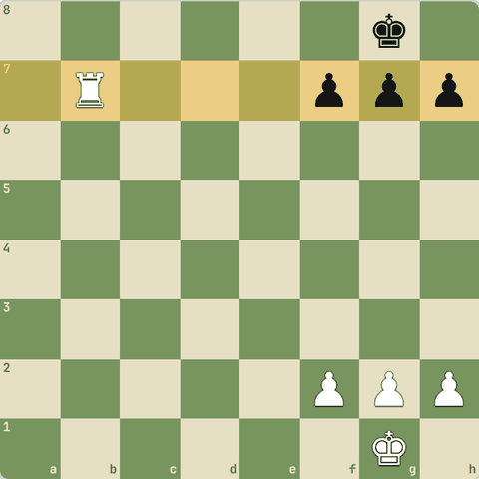

5.5.2 Sawal 1: Koi tactic nahi, koi threat nahi
Koi tactic nahi, koi threat nahi. Achha general plan?
Jawab:
✓ Sabse kharab piece ko behtar square par lao

5.5.3 Diagram: Rook open file se 7th rank par ("pig on the 7th")
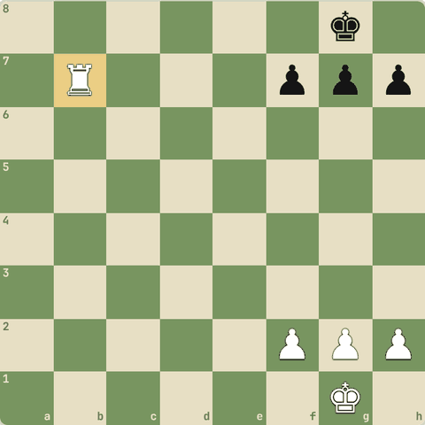
Rook open file se 7th rank par ("pig on the 7th")

5.6 Plan kaise banayein
Imbalances aur attack
Yaad rakho
- Plan imbalances se banta hai: material, minor pieces, pawn structure, space, files, king safety.
- Jahan strong ho wahan khelo.
- Opposite side castling = pawn storm race; same side castling mein center/queenside khelo.
- Minority attack (b4-b5): Carlsbad structure mein c6 par kamzor pawn banana.
- Piece activity: har piece ko kaam do; bure piece ko behtar square par lao.

5.6.1 Imbalances dekho
- Plan banane ke liye farq (imbalances) dekho:
  - Material: kaun aage?
  - Minor pieces: bishop vs knight, bishop pair?
  - Pawn structure: kamzor pawns, passed pawns, majorities
  - Space: kiske paas zyada jagah?
  - Open files / weak squares
  - Development aur king safety
- Phir: jahan tum strong ho wahan khelo.
- Space zyada hai to us taraf attack karo.
- Kamzori hai to use theek karo ya trades se bacho.

5.6.2 Opposite side castling = pawn storm
- Jab kings alag-alag taraf castle karein, to dono apne pawns dushman king ki taraf daudaate hain (pawn storm).
- Yahan speed sab kuch hai: jo pehle file kholega woh jeetega.
- Same side castle ho to pawns aage badhana apne king ko kamzor karta hai: wahan center ya queenside mein khelo.
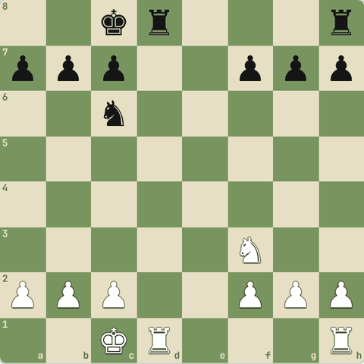

5.6.3 Minority attack
- Queen's Gambit structure (Carlsbad): White kam pawns wali side (queenside: a, b vs a, b, c) se attack karta hai: b4-b5.
- Maksad: c6 par ek kamzor pawn banana.
- Yeh dikhata hai: plan pawn structure se aata hai.
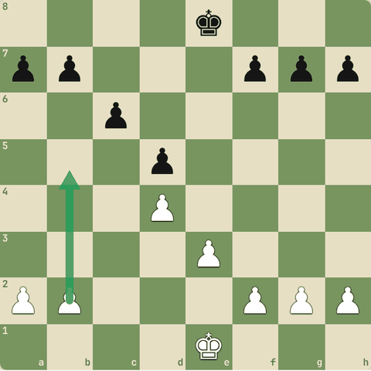

5.6.4 Sawal 1: Tumhare paas kingside mein zyada space hai aur kings alag taraf…
Tumhare paas kingside mein zyada space hai aur kings alag taraf castled hain. Plan?
Jawab:
✓ Kingside pawn storm aur attack

5.7 Prophylaxis aur restriction
Opponent ka plan pehle roko
Yaad rakho
- Har chaal se pehle: "Opponent kya chahta hai?" Use pehle roko.
- Misaal: h3 (...Bg4 roko), Kh1 (checks se pehle hi bacho).
- Restriction: dushman pieces ke achhe squares cheen lo.

5.7.1 Prophylaxis
- Prophylaxis (Nimzowitsch, Karpov, Petrosian): apni chaal se pehle poocho "Opponent kya karna chahta hai?" aur use pehle hi rok do.
- h3 khelna taaki ...Bg4 pin na ho
- Rook ko us file par rakhna jo khulne wali hai
- King ko pehle hi safe square (Kh1) par le jaana taaki baad mein checks na aayein
- Restriction: dushman pieces ke achhe squares cheen lo.
- Jo piece hil nahi sakta, woh piece nahi.

5.7.2 Sawal 1: Ruy Lopez mein White h3 kyun khelta hai?
Ruy Lopez mein White h3 kyun khelta hai?
Jawab:
✓ Black bishop ko g4 aane se rokne ke liye (prophylaxis)

5.8 Positional sacrifices
Material dekar position lena
Yaad rakho
- Exchange sac (rook dekar minor piece) position ke liye: Dragon ka ...Rxc3!.
- Kab: dushman king khule, dominant piece mile, ya dushman rook bekaar ho.
- Gambit = pawn dekar development / initiative.

5.8.1 Exchange sacrifice
- Exchange sacrifice: rook (5) dekar minor piece (3) lena, position ke liye.
- Sicilian Dragon mein ...Rxc3! famous hai: White ke king ke saamne pawns toot jaate hain, aur e4 kamzor hota hai.
- Kab karein: jab sacrifice se dushman king khul jaaye, ya tumhe dominant piece aur pawns milein, ya dushman ka rook kaam ka na ho.
- Pawn sacrifice (gambit) se bhi development, open lines ya initiative milta hai.
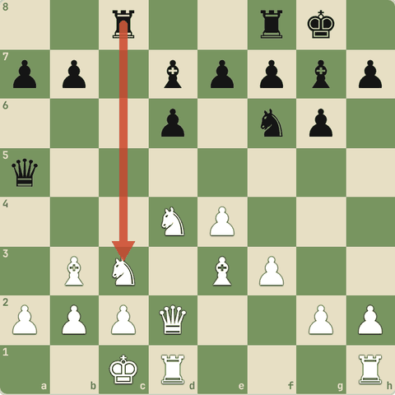

5.8.2 Sawal 1: Positional sacrifice ka maksad?
Positional sacrifice ka maksad?
Jawab:
✓ Lambe samay ka fayda: king safety tootna, strong pieces, initiative

Level 6: Openings: shuruaat mazboot
Opening ke ideas, systems, e4 aur d4 openings, gambits, advanced traps, apna repertoire
- Pehle principles (Level 2), ab asli openings: unke naam, main ideas aur pehli 6-10 chaalein.
- Har line ko board par khud khel kar yaad karo.

6.1 Opening ke ideas
Center, development, king safety
Yaad rakho
- Har opening ke 3 kaam: center, development, king safety.
- Open games (1.e4 e5) tactical, semi-open (Sicilian/French/Caro-Kann), closed (1.d4 d5) positional, Indian (1.d4 Nf6) hypermodern.
- Openings ratne ki jagah har chaal ka idea samjho.
- Imbalance: opening asymmetric ho to dono taraf jeetne ke mauke (jaise Sicilian).
- Main line = sabse zyada khela gaya raasta; variation = side raasta. Har ek ka naam hota hai.
- Online opening databases (Lichess/Chess.com explorer): masters ki asli stats dekho, apni pasand ka bias kam karo.
- System = har jawab ke against lagbhag same setup (London, Colle, KIA): kam theory, par opponent ko kam pareshani.

6.1.1 Teen kaam
- Har opening teen kaam karti hai:
  - Center control (pawns aur pieces se)
  - Development (saare minor pieces bahar)
  - King safety (castling)
- Openings do family mein aati hain:
  - Open games 1.e4 e5: tez, tactical.
  - Semi-open 1.e4 ke against c5, e6, c6: Sicilian, French, Caro-Kann.
  - Closed 1.d4 d5: positional, plans lambe.
  - Indian 1.d4 Nf6: flexible, hypermodern (pieces se center control).
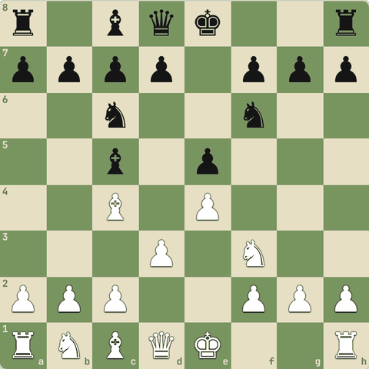

6.1.2 Sawal 1: 1.e4 e5 2.Nf3 ke baad Black ki sabse natural chaal?
1.e4 e5 2.Nf3 ke baad Black ki sabse natural chaal?
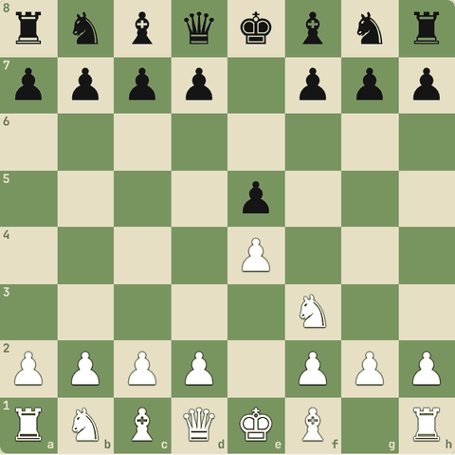
Jawab:
✓ Nc6
- Nc6 develop karta hai aur e5 ko protect.

6.1.3 Imbalances, main lines, variations
- Imbalance: dono side alag cheezein lein (ek ke paas center, doosre ke paas bishop pair). Imbalance = jeetne ke mauke.
- Main line: sabse popular raasta. Variation: side raasta. Har ek ka naam hota hai (Najdorf, Winawer...).
- Opening databases (Lichess Opening Explorer, Chess.com): masters aur aam players ki asli stats. Apni "pasand" se zyada data par bharosa karo.

6.1.4 Sawal 2: Sicilian 1.e4 c5 "imbalanced" kyun kehlaati hai?
Sicilian 1.e4 c5 "imbalanced" kyun kehlaati hai?
Jawab:
✓ Black ka pawn side se aata hai, structure alag-alag banti hai
- Alag structures = dono ke liye jeetne ke mauke.

6.1.5 Sawal 3: Nayi opening seekhne se pehle stats kahan dekho?
Nayi opening seekhne se pehle stats kahan dekho?
Jawab:
✓ Online opening database / explorer
- Database masters ke hazaaron games dikhata hai.

6.2 Opening systems
London, Colle, Torre, KIA, English Botvinnik, Benko, Nimzo-Larsen, Van Geet
Yaad rakho
- System = ek hi setup almost har jawab ke against. Fayda: kam theory. Nuksaan: opponent ko kam pareshaani, predictable.
- London: d4, Bf4, e3, c3, Nf3, Bd3. Colle: d4, Nf3, e3, Bd3, c3 (bishop andar).
- Torre: d4, Nf3, Bg5. KIA (King's Indian Attack): Nf3, g3, Bg2, O-O, d3, e4.
- English Botvinnik: c4, Nc3, g3, Bg2, e4 (center ka "pinja"). Benko's opening: 1.g3. Nimzo-Larsen: 1.b3. Van Geet: 1.Nc3.

6.2.1 System kya hai?
- System = ek setup jo tum lagbhag har jawab ke against khelte ho.
- Pehli 6-8 chaalein yaad, baaki plans.
- Fayda: kam theory, jaane-pehchaane plans, time bachta hai.
- Nuksaan: predictable, opponent ko aasaani se barabari mil sakti hai, aur kabhi exact jawab zaroori hota hai.

6.2.2 London System
- Ek "system": lagbhag har jawab ke against same setup.
- Club players mein bahut popular.
1. d4 d5 2. Bf4 Nf6 3. e3 e6 4. Nf3 c5 5. c3 Nc6 6. Nbd2 Bd6 7. Bg3 O-O 8. Bd3
- 2.Bf4 bishop pawn chain ke bahar, pehle.
- 3.e3
- 5.c3 triangle: c3-d4-e3 solid center.
- 6…Bd6 Black ...Bd6 se bishop trade maangta hai.
- 7.Bg3 bishop bacha, h-file khul sakti hai.
- 8.Bd3 Plan: O-O, Ne5, f4, kingside attack.
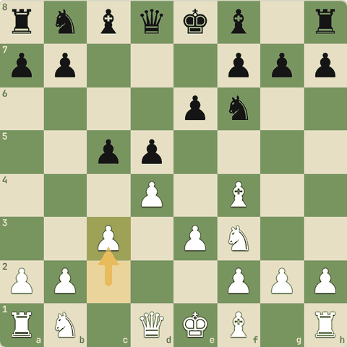
Position after 5.c3
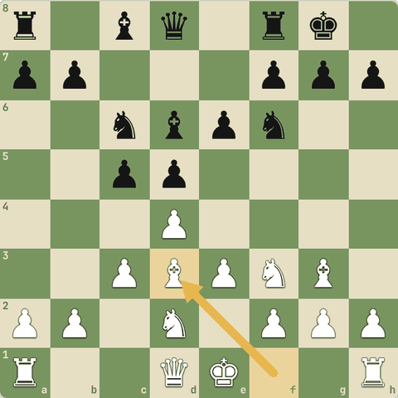
Final position (8.Bd3)

6.2.3 Colle System
- Bishop c1 andar, plan: e3-e4 break.
1. d4 d5 2. Nf3 Nf6 3. e3 e6 4. Bd3 c5 5. c3 Nc6 6. Nbd2 Bd6 7. O-O O-O
- 3.e3 bishop c1 ke peeche band (London se fark).
- 4.Bd3 bishop h7 ki taraf.
- 5.c3 "Colle triangle".
- 7.O-O Plan: Re1 aur e4.
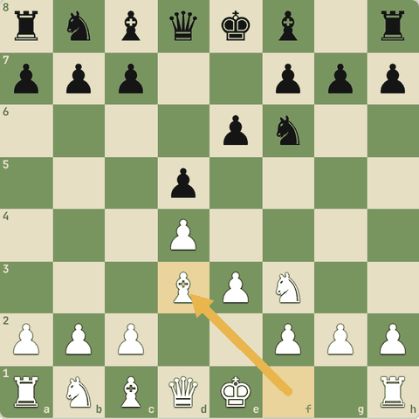
Position after 4.Bd3
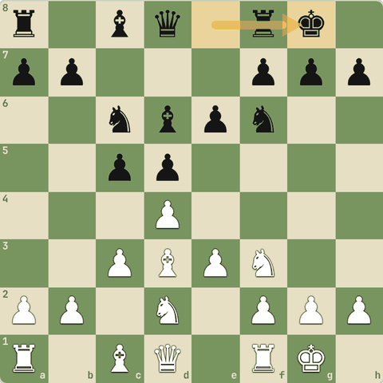
Final position (7…O-O)

6.2.4 Torre Attack
- 3.Bg5 knight f6 ko pin karta hai.
1. d4 Nf6 2. Nf3 e6 3. Bg5 c5 4. e3 Be7 5. Nbd2 b6 6. c3 Bb7 7. Bd3
- 3.Bg5 Torre!
- 4.e3 solid.
- 7.Bd3 Pieces natural squares par.
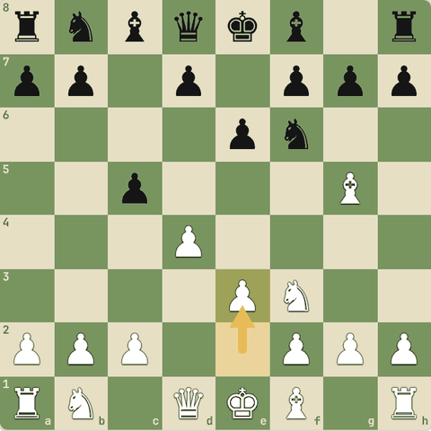
Position after 4.e3
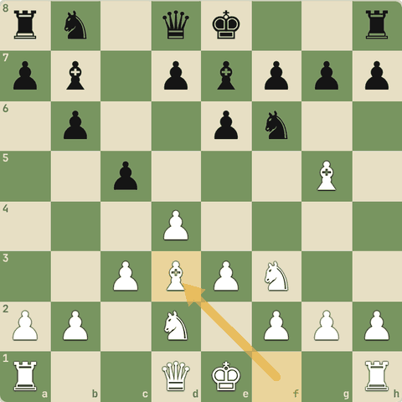
Final position (7.Bd3)

6.2.5 King's Indian Attack (KIA)
- King's Indian ka ulta setup White se.
- Fischer ki favourite.
1. Nf3 d5 2. g3 Nf6 3. Bg2 e6 4. O-O Be7 5. d3 O-O 6. Nbd2 c5 7. e4
- 2.g3 fianchetto.
- 4.O-O Jaldi castle.
- 5.d3
- 7.e4 center break. Baad mein e5 aur kingside attack.
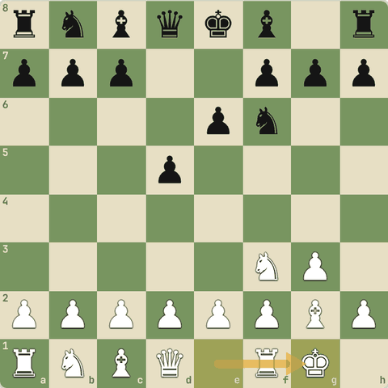
Position after 4.O-O
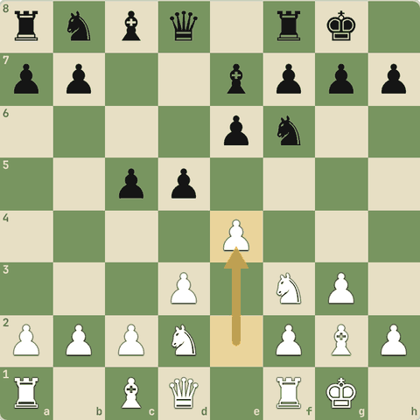
Final position (7.e4)

6.2.6 English: Botvinnik system
- Pawns c4 aur e4 se d5 square par kabza.
1. c4 e5 2. Nc3 Nc6 3. g3 g6 4. Bg2 Bg7 5. e4 d6 6. Nge2
- 1.c4 English.
- 3.g3 fianchetto.
- 5.e4! Botvinnik setup: d5 par pakad.
- 6.Nge2 knight e2 se, f-pawn free.
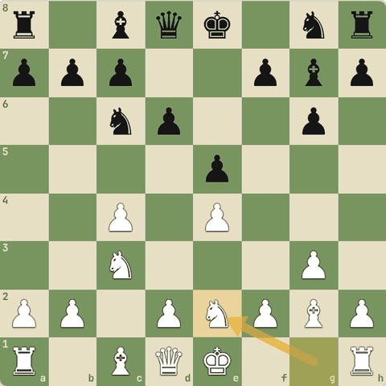
Final position (6.Nge2)

6.2.7 Benko's Opening, Nimzo-Larsen, Van Geet
- Kam khele jaane wale "surprise" systems:
  - Benko's Opening 1.g3: fianchetto, flexible.
  - Nimzo-Larsen 1.b3: bishop b2 se long diagonal.
  - Van Geet 1.Nc3: knight pehle (bahut naam hain: Dunst, Sleipner...).
- Yahan 1.g3 dekho.
1. g3 d5 2. Bg2 e5
- 1.g3
- 2.Bg2 bishop long diagonal par: e4, d5, b7 par nazar.
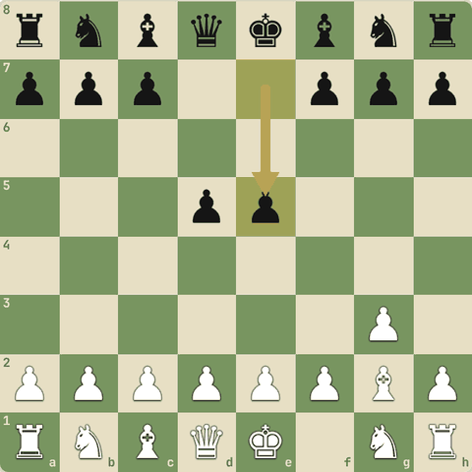
Final position (2…e5)

6.2.8 Sawal 1: Opening system ka sabse bada fayda?
Opening system ka sabse bada fayda?
Jawab:
✓ Kam theory: same setup har jawab ke against
- System = kam yaad karna, plans pe dhyan.

6.2.9 Sawal 2: 1.b3 kis naam se jaana jaata hai?
1.b3 kis naam se jaana jaata hai?
Jawab:
✓ Nimzo-Larsen Attack
- Larsen ka favourite.

6.3 Italian Game
1.e4 e5 2.Nf3 Nc6 3.Bc4
Yaad rakho
- 1.e4 e5 2.Nf3 Nc6 3.Bc4: bishop kamzor f7 ko dekhta hai.
- Giuoco Piano plan: c3 + d3, castle, Re1, Bb3, phir d4 break.
- Two Knights mein 4.Ng5 d5! 5.exd5 Na5! sahi. 5...Nxd5? par Fried Liver 6.Nxf7!.
- Two Knights mein 5...Nxd5? par 6.Nxf7! = Fried Liver attack. Sahi: 5...Na5.
- Italian ke traps: f7 par Ng5 + Bc4, aur opponent ke jaldi galtiyon ko saza.

6.3.1 Italian Game (Giuoco Piano)
- Beginners ke liye sabse achhi opening: simple development aur saaf plans.
1. e4 e5 2. Nf3 Nc6 3. Bc4 Bc5 4. c3 Nf6 5. d3 d6 6. O-O O-O 7. Re1 a6 8. Bb3 Ba7
- 1.e4 Center mein pawn aur bishop/queen ke liye raasta.
- 2.Nf3 Knight develop, e5 par attack.
- 3.Bc4 bishop f7 (kamzor square) ko dekhta hai.
- 3…Bc5 Black bhi bishop c5 par: f2 ko dekhta hai.
- 4.c3 idea: baad mein d4 se center.
- 5.d3 shaant aur solid (Giuoco Pianissimo).
- 6.O-O Castle! King safe.
- Re1 rook ko center file par.
- Bb3 bishop ko ...Na5 ya ...d5 se bachaya.
- 8…Ba7 Dono taraf development poora. Plan: White Nbd2-f1-g3, h3, aur d4 ka break.
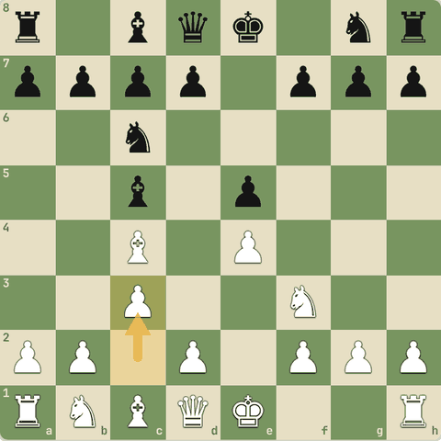
Position after 4.c3
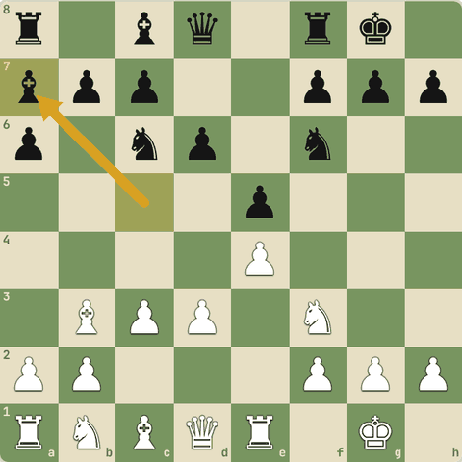
Final position (8…Ba7)

6.3.2 Two Knights: Fried Liver ka khatra
- 3...Nf6 ke baad White 4.Ng5 se f7 par attack karta hai.
1. e4 e5 2. Nf3 Nc6 3. Bc4 Nf6 4. Ng5 d5 5. exd5 Na5
- 4.Ng5 f7 par do attackers.
- 4...d5! sahi jawab: bishop ka raasta band.
- 5.exd5
- 5...Na5! Sahi! Agar 5...Nxd5? to 6.Nxf7! (Fried Liver): king bahar aata hai aur bada attack.
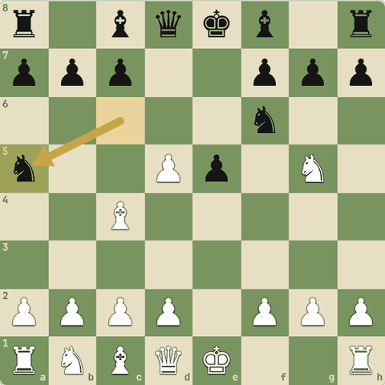
Final position (5…Na5)

6.3.3 Sawal 1: Italian Game mein White ka bishop c4 kis kamzor square ko target…
Italian Game mein White ka bishop c4 kis kamzor square ko target karta hai?
Jawab:
✓ f7
- f7 shuru mein sirf king protect karta hai.

6.3.4 Fried Liver Attack
- Agar Black 5...Nxd5? khele to White knight sacrifice karta hai.
1. e4 e5 2. Nf3 Nc6 3. Bc4 Nf6 4. Ng5 d5 5. exd5 Nxd5 6. Nxf7 Kxf7 7. Qf3+ Ke6 8. Nc3
- 5...Nxd5? galti.
- 6.Nxf7! knight sacrifice: king aur queen par fork.
- 6...Kxf7
- 7.Qf3+ king aur d5 knight par attack.
- 7...Ke6 king center mein!
- 8.Nc3 aur pin par aur attackers. White ka bada attack.
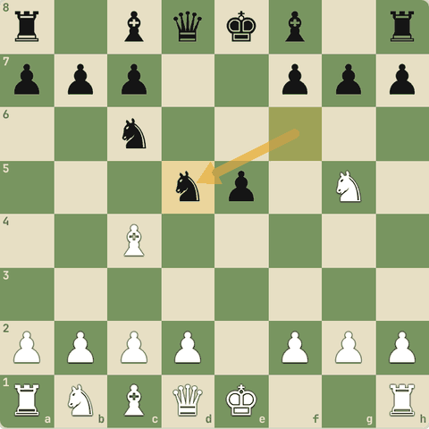
Position after 5…Nxd5
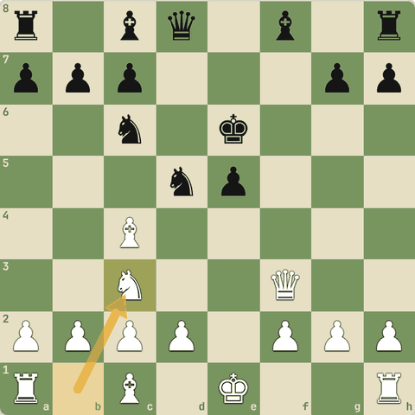
Final position (8.Nc3)

6.3.5 Abhyaas: Two Knights
Two Knights: White ne 4.Ng5 khela, phir 5.exd5. Black ki sabse sahi chaal?
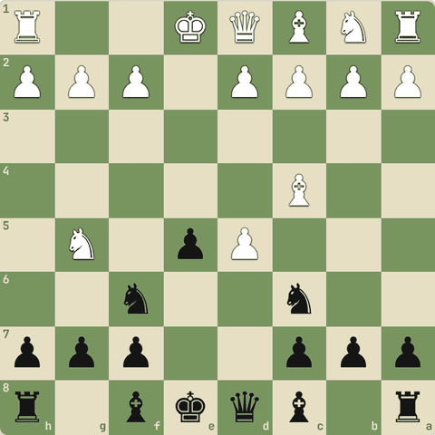
(Black ki chaal)
Jawab:
1… Na5
Ye bhi sahi: b5 Nd4
- 5...Na5! bishop c4 par attack, Nxd5? ke Fried Liver se bachao.
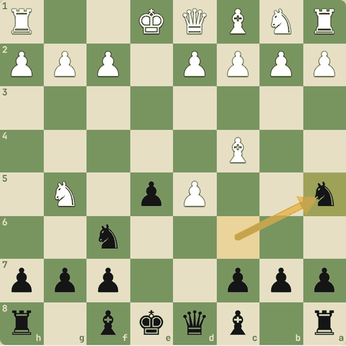
Chaal ke baad

6.4 Ruy Lopez (Spanish)
1.e4 e5 2.Nf3 Nc6 3.Bb5
Yaad rakho
- 3.Bb5: e5 ke defender c6 knight par pressure.
- Morphy Defense 3...a6, White Ba4, O-O, Re1, c3, h3.
- h3 = prophylaxis: ...Bg4 pin roka. Plan d4 aur Nbd2-f1-g3.
- Black ki 3rd chaal ke options: 3...a6 (Morphy, main), 3...Nf6 (Berlin), 3...d6 (Steinitz), 3...f5 (Schliemann), 3...Bc5 (Classical), 3...Nd4 (Bird).
- Exchange variation 4.Bxc6: Black ko doubled pawns, par bishop pair.

6.4.1 Ruy Lopez: main line
- World Championship level ki opening. 500 saal purani, aaj bhi sabse popular.
1. e4 e5 2. Nf3 Nc6 3. Bb5 a6 4. Ba4 Nf6 5. O-O Be7 6. Re1 b5 7. Bb3 d6 8. c3 O-O 9. h3
- 3.Bb5 e5 ke defender (c6 knight) par pressure.
- 3...a6 bishop se seedha sawaal (Morphy Defense).
- 4.Ba4 bishop pressure banaye rakhta hai.
- 5.O-O castle pehle. e4 pawn ka khatra nahi kyunki baad mein Re1.
- 6.Re1 e4 protect.
- 6...b5 bishop ko door kiya.
- 8.c3 taaki d4 khel sakein aur bishop ke liye c2 ka ghar.
- 9.h3 ...Bg4 pin rokta hai. Plan: d4, Nbd2-f1-g3.
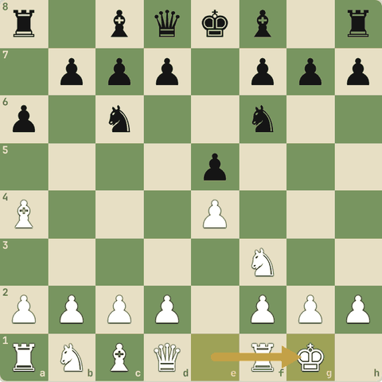
Position after 5.O-O
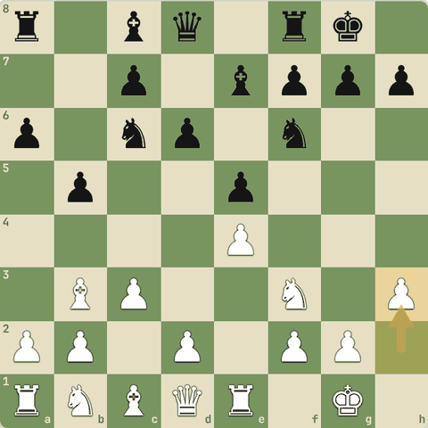
Final position (9.h3)

6.4.2 Sawal 1: Ruy Lopez mein 3.Bb5 ka main idea?
Ruy Lopez mein 3.Bb5 ka main idea?
Jawab:
✓ e5 ke defender (Nc6) par pressure

6.4.3 Ruy Lopez: Black ke 3rd move options
- 1.e4 e5 2.Nf3 Nc6 3.Bb5 ke baad:
  - 3...a6 Morphy Defense (main line).
  - 3...Nf6 Berlin (bahut solid, Kramnik ne Kasparov ke against 2000 mein use kiya).
  - 3...d6 Steinitz, 3...Bc5 Classical, 3...f5 Schliemann (gambit), 3...Nd4 Bird.
  - 4.Bxc6 Exchange variation: Black ke doubled pawns, par bishop pair.

6.4.4 Sawal 2: Ruy Lopez mein 3...Nf6 ka naam?
Ruy Lopez mein 3...Nf6 ka naam?
Jawab:
✓ Berlin Defense
- Berlin: "Berlin Wall".

6.4.5 Exchange Variation
- White bishop de kar Black ke pawns double karta hai.
1. e4 e5 2. Nf3 Nc6 3. Bb5 a6 4. Bxc6 dxc6 5. O-O f6 6. d4
- 4.Bxc6 exchange.
- 4...dxc6 Black ke c-pawns doubled, par bishops dono.
- 6.d4 center kholo. Endgame mein White ka 4 vs 3 kingside majority strong.
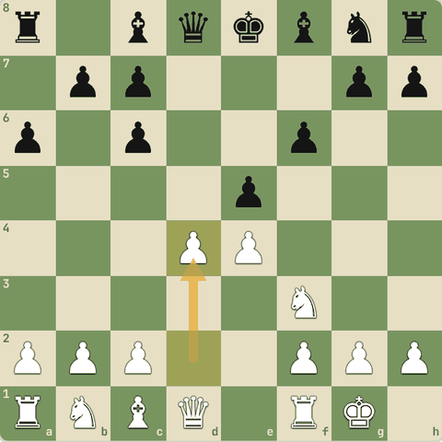
Final position (6.d4)

6.5 Sicilian Defense
1.e4 c5: sabse fighting jawab
Yaad rakho
- 1...c5: side se center par attack, asymmetric position = jeet ke chances.
- Open Sicilian: 2.Nf3 3.d4 cxd4 4.Nxd4. Black ko extra center pawn milta hai.
- Najdorf 5...a6. English Attack (Be3, f3, Qd2, O-O-O, g4) = opposite castling attack race.
- 2.Nf3 ke baad Black: 2...d6 (Najdorf/Dragon), 2...e6 (Taimanov/Kan/Scheveningen), 2...Nc6 (Classical, Sveshnikov).
- White ke anti-Sicilians: 2.c3 Alapin, 2.Nc3 Closed, Grand Prix (f4), Smith-Morra gambit (2.d4 cxd4 3.c3).

6.5.1 Open Sicilian: Najdorf
- Sicilian 1.e4 ke against sabse popular aur jeetne wala jawab.
- Kasparov aur Fischer ki favourite.
1. e4 c5 2. Nf3 d6 3. d4 cxd4 4. Nxd4 Nf6 5. Nc3 a6 6. Be3 e5 7. Nb3 Be6 8. f3
- 1...c5 side se center par attack. Position asymmetric = jeet ke chances.
- 3.d4 White center kholta hai.
- 3...cxd4 Black ko extra center pawn mila (d-pawn).
- 4...Nf6 e4 par attack.
- 5...a6 Najdorf! b5 square control aur flexible.
- 6...e5 center mein space, knight ko bhagaya.
- 7...Be6 development.
- 8.f3 English Attack: f3, Qd2, O-O-O, g4. Dono taraf opposite castling = tez attack race.
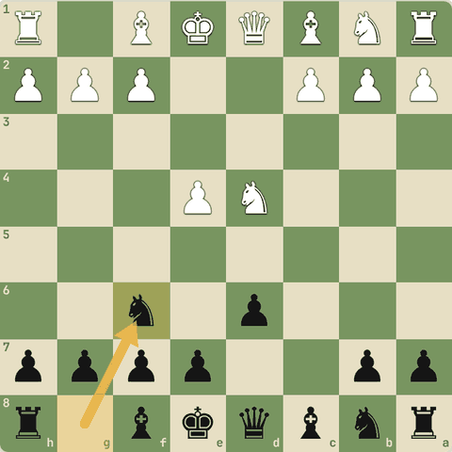
Position after 4…Nf6
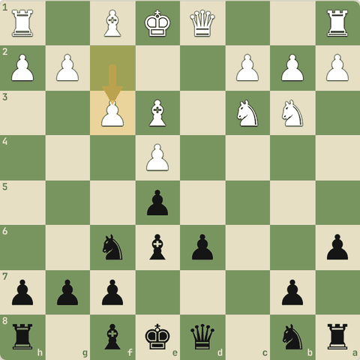
Final position (8.f3)

6.5.2 Sawal 1: Sicilian (1...c5) kyun popular hai?
Sicilian (1...c5) kyun popular hai?
Jawab:
✓ Position asymmetric hoti hai: Black jeet ke liye khel sakta hai

6.5.3 Sicilian ke parivar
- 1.e4 c5 2.Nf3 ke baad:
  - 2...d6: Najdorf (5...a6), Dragon (...g6), Classical, Scheveningen.
  - 2...e6: Taimanov, Kan, Scheveningen setups.
  - 2...Nc6: Classical, Sveshnikov (...e5), Accelerated Dragon.
- White bina Nf3/d4: Alapin 2.c3, Closed 2.Nc3, Grand Prix (f4), Smith-Morra gambit.

6.5.4 Alapin Sicilian (2.c3)
- White c3 se d4 ki taiyaari: Open Sicilian ki theory se bachao.
1. e4 c5 2. c3 Nf6 3. e5 Nd5 4. d4 cxd4 5. Nf3 Nc6 6. cxd4 d6
- 2.c3 Alapin.
- 2...Nf6 e4 par attack.
- 3.e5 knight bhagao.
- 6…d6 Center White ka, Black ke pieces active.
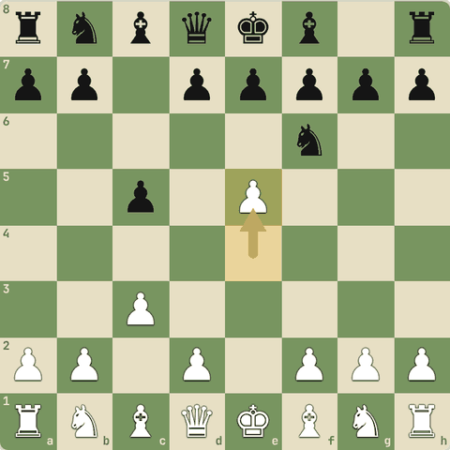
Position after 3.e5
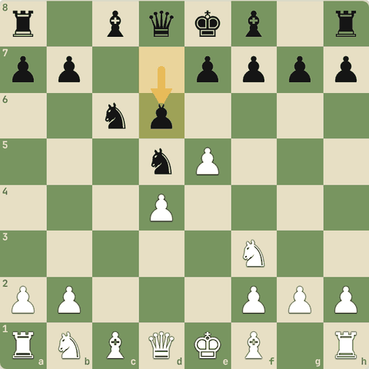
Final position (6…d6)

6.5.5 Sawal 2: 1.e4 c5 2.Nf3 d6 3.d4 cxd4 4.Nxd4 Nf6 5.Nc3 g6 ka naam?
1.e4 c5 2.Nf3 d6 3.d4 cxd4 4.Nxd4 Nf6 5.Nc3 g6 ka naam?
Jawab:
✓ Dragon
- ...g6 + bishop g7 = Dragon (shape dragon jaisi).

6.6 French aur Caro-Kann
1.e4 e6 aur 1.e4 c6: solid defenses
Yaad rakho
- French 1...e6 2...d5: pawn chain d4-e5 banti hai, Black ...c5 se base par vaar karta hai.
- French ki kamzori: c8 bishop band (bad bishop).
- Caro-Kann 1...c6 2...d5: solid, aur light bishop ...Bf5 se bahar aata hai.
- French ke variations: Advance (3.e5), Winawer (3.Nc3 Bb4), Tarrasch (3.Nd2), Exchange (3.exd5).
- Caro-Kann ke variations: Classical (4...Bf5), Advance (3.e5), Exchange, Panov (c4).
- French Advance trap: 6...cxd4 7.cxd4 Nxd4?? 8.Nxd4 Qxd4 9.Bb5+ (discovered attack, queen gayi).

6.6.1 French Defense
- Solid aur counter-attacking.
- Pawn chain samajhna zaroori.
1. e4 e6 2. d4 d5 3. Nc3 Nf6 4. e5 Nfd7 5. f4 c5 6. Nf3 Nc6 7. Be3
- 1...e6 taiyaari d5 ki.
- 2...d5 center ko challenge.
- 4.e5 space! Ab pawn chain bani: d4-e5.
- 5.f4 chain ko mazboot.
- 5...c5! chain ki base (d4) par attack: French ka main idea.
- 7.Be3 Black ki problem: c8 bishop band hai (bad bishop). Plan: ...Qb6, ...cxd4, ...f6.
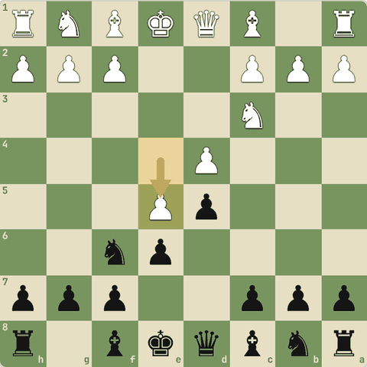
Position after 4.e5
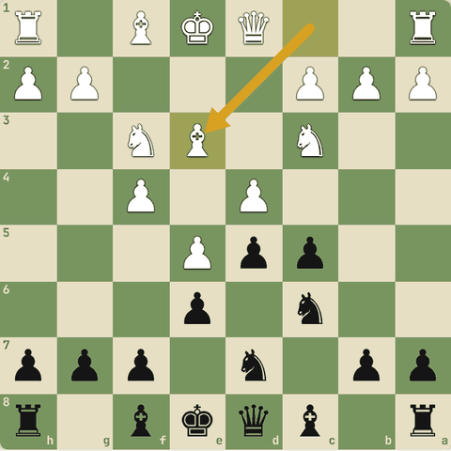
Final position (7.Be3)

6.6.2 Caro-Kann Defense
- Bahut solid.
- French jaisa, par light bishop bahar aata hai.
1. e4 c6 2. d4 d5 3. Nc3 dxe4 4. Nxe4 Bf5 5. Ng3 Bg6 6. h4 h6 7. Nf3 Nd7 8. h5 Bh7
- 1...c6 taiyaari d5 ki, bina bishop band kiye.
- 3...dxe4 Classical.
- 4...Bf5 bishop bahar! French se fark.
- 5...Bg6 bishop peeche hata.
- 6.h4 bishop ko pareshan.
- 6...h6 bishop ke liye h7 ka ghar.
- 8…Bh7 Solid position: plan ...e6, ...Ngf6, ...Be7, ...c5.
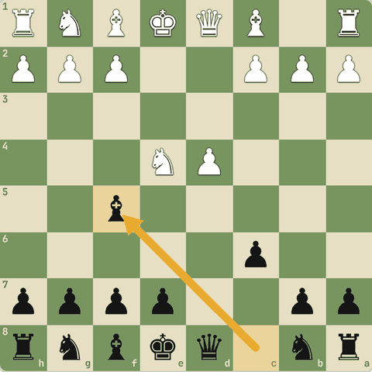
Position after 4…Bf5
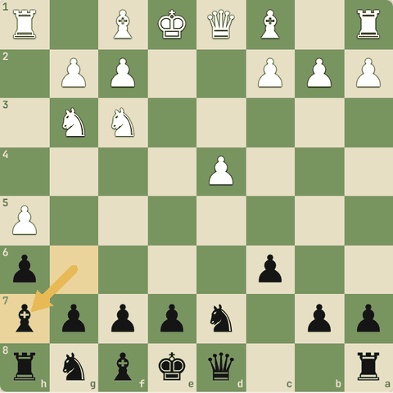
Final position (8…Bh7)

6.6.3 Sawal 1: French Defense mein Black ka sabse common pawn break?
French Defense mein Black ka sabse common pawn break?
Jawab:
✓ ...c5 (chain ki base par attack)

6.6.4 French Winawer
- Black bishop b4 se knight pin karta hai: sharp aur imbalanced.
1. e4 e6 2. d4 d5 3. Nc3 Bb4 4. e5 c5 5. a3 Bxc3+ 6. bxc3 Ne7
- 3...Bb4 Winawer.
- 4.e5 space.
- 5...Bxc3+ bishop dekar doubled pawns.
- 6…Ne7 White ke paas bishop pair, Black ka structure behtar.
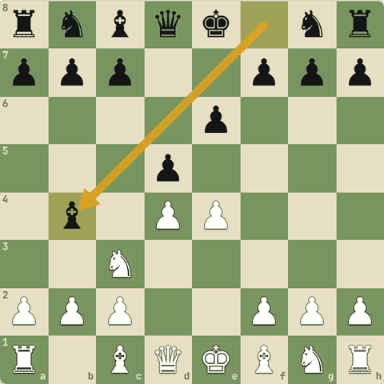
Position after 3…Bb4
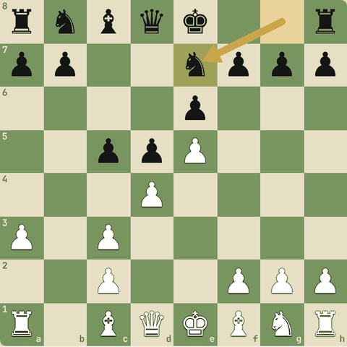
Final position (6…Ne7)

6.6.5 French Advance: famous trap (discovered attack)
- White d4 pawn "chhod" deta hai.
- Agar Black lalach kare...
1. e4 e6 2. d4 d5 3. e5 c5 4. c3 Nc6 5. Nf3 Qb6 6. Bd3 cxd4 7. cxd4 Nxd4 8. Nxd4 Qxd4 9. Bb5+
- 6.Bd3 d4 ka defender (queen) ki line band, lagta hai pawn free.
- 7...Nxd4?
- 8...Qxd4??
- 9.Bb5+! bishop hata aur d1 queen ka attack d4 par khula: discovered attack. Black check ka jawab dega, queen gayi.
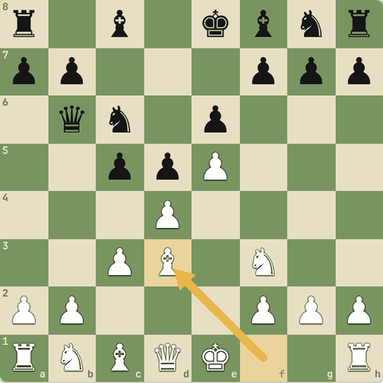
Position after 6.Bd3
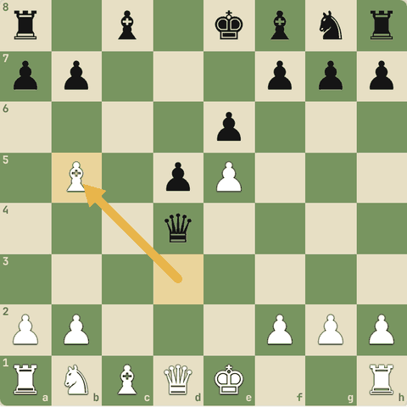
Final position (9.Bb5+)

6.6.6 Caro-Kann ke variations
- Classical: 3.Nc3 dxe4 4.Nxe4 Bf5 (yeh line course mein hai).
- Advance: 3.e5 Bf5.
- Exchange: 3.exd5 cxd5.
- Panov-Botvinnik: 3.exd5 cxd5 4.c4 (IQP positions).
- Two Knights: 2.Nc3 d5 3.Nf3.

6.6.7 Sawal 2: French mein Black ka main plan?
French mein Black ka main plan?
Jawab:
✓ Pawn chain ki base (d4) par ...c5 aur ...f6 se attack
- Chain ki base par attack: French ka dil.

6.7 Queen's Gambit aur Slav
QGD, QGA, Slav
Yaad rakho
- Queen's Gambit 1.d4 d5 2.c4: pawn asli mein free nahi.
- QGD 2...e6: solid. White plan minority attack b4-b5.
- Slav 2...c6: d5 support aur light bishop bahar.
- London Bf4, e3, c3, Nf3, Nbd2, Bd3: har jawab ke against same setup.
- Queen's Gambit asli gambit nahi: 2...dxc4 ke baad pawn bachane ki koshish Black ki position kharab karti hai.
- QGA: 2...dxc4 3.e3/e4, White center lekar pawn wapas leta hai.

6.7.1 Queen's Gambit Declined
- Classical aur strategic.
- "Gambit" naam hai par pawn asli mein free nahi.
1. d4 d5 2. c4 e6 3. Nc3 Nf6 4. Bg5 Be7 5. e3 O-O 6. Nf3 Nbd7 7. Rc1 c6
- 2.c4 side se d5 par attack. Agar ...dxc4, White aksar pawn wapas le leta hai.
- 2...e6 Declined: d5 ko pawn se support.
- 4.Bg5 f6 knight ka pin.
- 5.e3 solid.
- 7.Rc1 c-file par pressure.
- 7…c6 Plans: White minority attack (b4-b5), Black ...dxc4 aur ...e5/...c5 breaks.
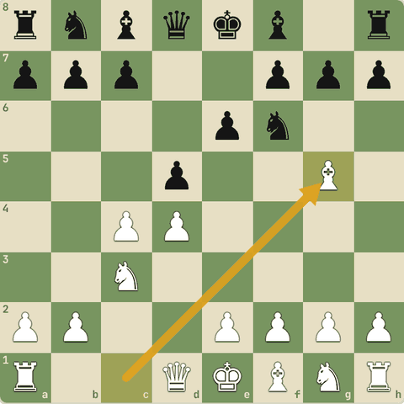
Position after 4.Bg5
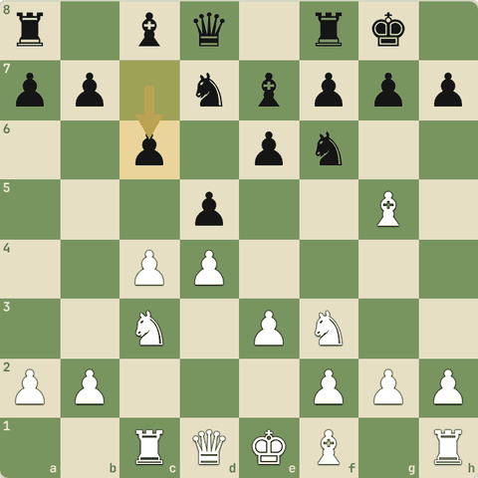
Final position (7…c6)

6.7.2 Slav Defense
- 2...c6 se d5 support, aur light bishop band nahi hota.
1. d4 d5 2. c4 c6 3. Nf3 Nf6 4. Nc3 dxc4 5. a4 Bf5 6. e3 e6 7. Bxc4
- 2...c6 Slav.
- 4...dxc4 pawn liya, b5 se bachane ki koshish ho sakti hai.
- 5.a4 ...b5 roka.
- 5...Bf5 bishop bahar.
- 7.Bxc4 White ne pawn wapas liya. Barabar position.
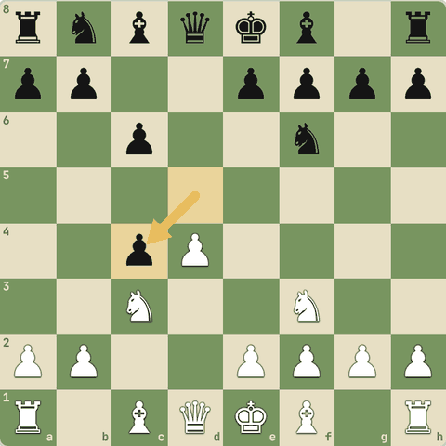
Position after 4…dxc4
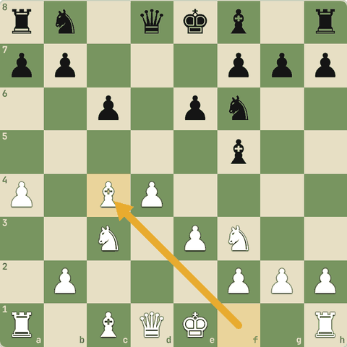
Final position (7.Bxc4)

6.7.3 Sawal 1: London System ki khaasiyat?
London System ki khaasiyat?
Jawab:
✓ Har jawab ke against same simple setup

6.7.4 Queen's Gambit Accepted (QGA)
- Black pawn le leta hai par use bachata nahi: development karta hai.
1. d4 d5 2. c4 dxc4 3. Nf3 Nf6 4. e3 e6 5. Bxc4 c5 6. O-O a6
- 2...dxc4 accepted.
- 4.e3 bishop ke saath pawn wapas.
- 5.Bxc4 pawn wapas, barabar development.
- 5...c5 center par chot.
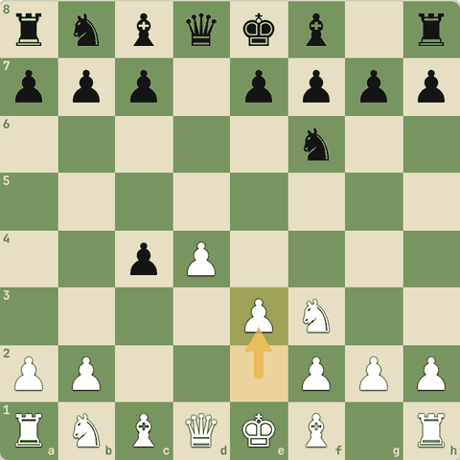
Position after 4.e3
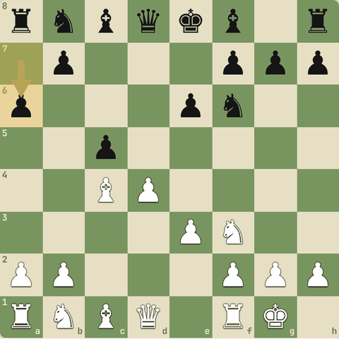
Final position (6…a6)

6.7.5 Sawal 2: 1.d4 d5 2.c4 dxc4
1.d4 d5 2.c4 dxc4: Black ko pawn bachane ke liye ...b5 khelna chahiye?
Jawab:
✓ Aam taur par nahi: queenside kamzor hota hai aur pawn wapas jaata hai
- Dekho traps lesson: 3.e3 b5? 4.a4 c6 5.axb5 cxb5 6.Qf3 rook gaya.

6.8 Indian defenses aur English
King's Indian, Nimzo-Indian, Grunfeld, English
Yaad rakho
- King's Indian: Black center White ko deta hai, phir ...e5/...f5 se vaar. Center band ho to Black kingside, White queenside.
- Nimzo-Indian 3...Bb4: c3 knight ka pin aur e4 par control.
- English 1.c4: ulta Sicilian, g3 + Bg2 fianchetto.
- Grunfeld: Black White ko bada center deta hai, phir ...d5 aur bishop g7 se center par hamla.

6.8.1 King's Indian Defense
- Black White ko center lene deta hai, phir ...e5/...f5 se attack.
- Fischer aur Kasparov ki pasand.
1. d4 Nf6 2. c4 g6 3. Nc3 Bg7 4. e4 d6 5. Nf3 O-O 6. Be2 e5 7. O-O Nc6 8. d5 Ne7
- 2...g6 fianchetto ki taiyaari.
- 3...Bg7 bishop long diagonal par.
- 4.e4 White ne bada center liya.
- 5…O-O Pehle castle.
- 6...e5 center par vaar.
- 8.d5 center band. Ab White queenside (c5), Black kingside (...f5, ...g5) par attack karega.
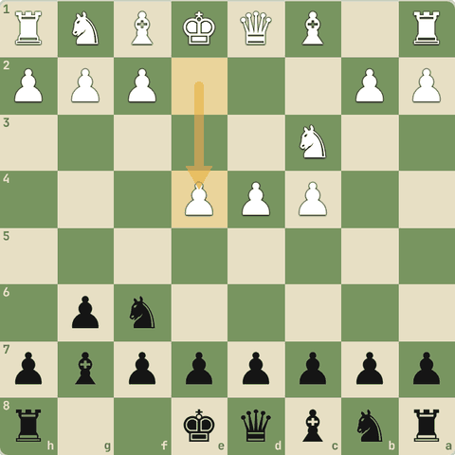
Position after 4.e4
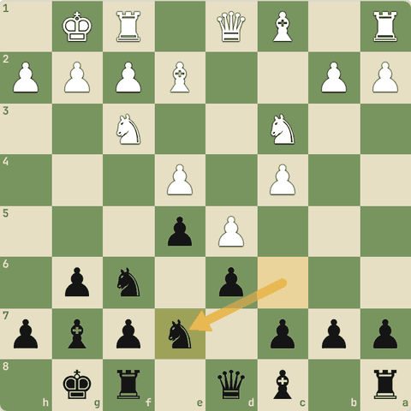
Final position (8…Ne7)

6.8.2 Nimzo-Indian Defense
- 3...Bb4 knight ko pin karta hai aur e4 ko rokta hai.
1. d4 Nf6 2. c4 e6 3. Nc3 Bb4 4. Qc2 O-O 5. a3 Bxc3+ 6. Qxc3 b6
- 3...Bb4 pin!
- 4.Qc2 (Classical) doubled pawns se bachne ke liye.
- 5…Bxc3+ Bishop pair dekar knight liya.
- ...b6 aur ...Bb7 se e4 par control.
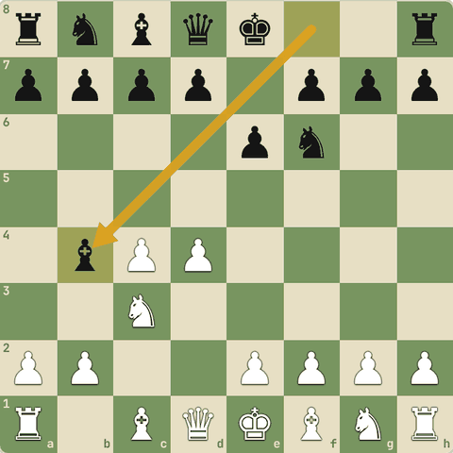
Position after 3…Bb4
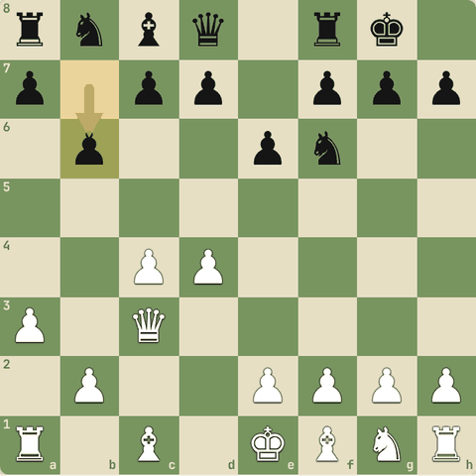
Final position (6…b6)

6.8.3 English Opening
- 1.c4: ulta Sicilian.
- Flexible aur positional.
1. c4 e5 2. Nc3 Nf6 3. g3 d5 4. cxd5 Nxd5 5. Bg2 Nb6 6. Nf3 Nc6
- 1.c4 side se d5 control.
- 3.g3 fianchetto: bishop g2 se long diagonal.
- 5.Bg2 Bishop g2 b7 aur center ko dekhta hai.
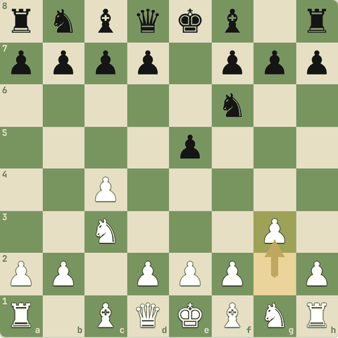
Position after 3.g3
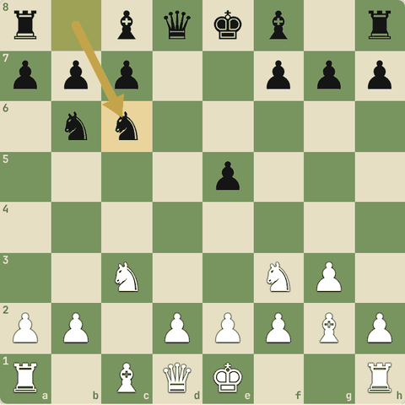
Final position (6…Nc6)

6.8.4 Sawal 1: King's Indian mein center band hone ke baad Black kahan attack…
King's Indian mein center band hone ke baad Black kahan attack karta hai?
Jawab:
✓ Kingside (...f5, ...g5)

6.8.5 Grunfeld Defense
- Hypermodern: center doosre ko do, phir use tod do.
1. d4 Nf6 2. c4 g6 3. Nc3 d5 4. cxd5 Nxd5 5. e4 Nxc3 6. bxc3 Bg7
- 3...d5 Grunfeld.
- 5...Nxc3 knight trade.
- 6.bxc3 White ka bada center c3-d4-e4.
- 6...Bg7 bishop d4 par. Aage ...c5.
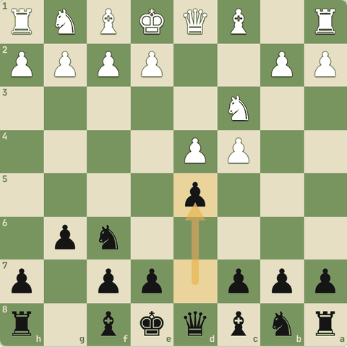
Position after 3…d5
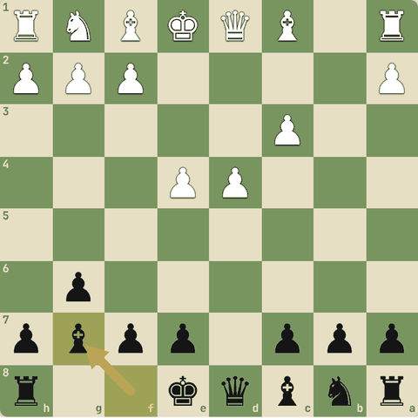
Final position (6…Bg7)

6.8.6 Sawal 2: Grunfeld mein Black ka idea?
Grunfeld mein Black ka idea?
Jawab:
✓ White ko center dena, phir pieces aur ...c5 se attack
- Hypermodern soch.

6.9 Gambits
Kyun gambit, semi-open files, King's, Danish, Evans, Albin, Benko, Blackmar-Diemer, Smith-Morra, Staunton, Reti gambit
Yaad rakho
- Gambit = development (tempo) aur open lines ke liye pawn dena.
- Semi-open (half-open) file: sirf dushman ka pawn. Rook ke liye attack ka raasta. Gambits aksar yeh files aur tempo dete hain.
- White gambits: King's (2.f4), Danish (d4, c3), Evans (b4), Smith-Morra (vs Sicilian), Blackmar-Diemer (d4 e4), Staunton (vs Dutch), Reti gambit (b3 vs French), Queen's Gambit.
- Black gambits: Albin (2...e5 vs QG), Benko (3...b5).

6.9.1 Gambit kyun?
- Gambit = shuru mein pawn (kabhi piece) dekar badle mein development (tempo), open lines aur attack lena.
- Semi-open (half-open) file: jisme sirf dushman ka pawn ho.
- Tumhare rook ke liye attack ka raasta.
- Gambits aksar aisi files aur tempo dete hain.
- Gambit khelo to tez development aur attack zaroori.
- Jawab dena ho to: development karo, aur sahi waqt par pawn wapas de do.

6.9.2 King's Gambit
- 19vi sadi ka sabse romantic gambit.
- f-file khulti hai.
1. e4 e5 2. f4 exf4 3. Nf3 g5 4. Bc4 Bg7 5. O-O
- 2.f4 King's Gambit.
- 2...exf4 accepted.
- 3...g5 pawn bachane ki koshish.
- 5.O-O aur f-file par rook: f7 par pressure.
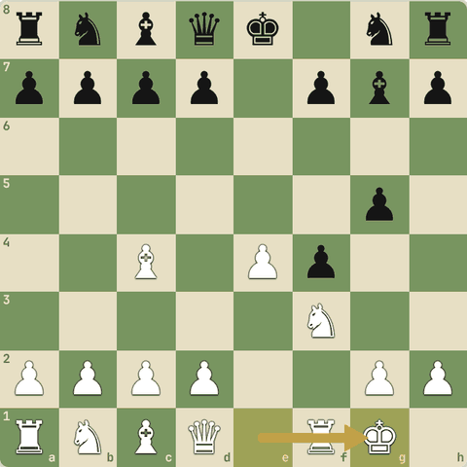
Final position (5.O-O)

6.9.3 Danish Gambit
- Do pawns de kar do bishops seedhe Black ke king ki taraf.
1. e4 e5 2. d4 exd4 3. c3 dxc3 4. Bc4 cxb2 5. Bxb2
- 3.c3
- 4.Bc4 doosra pawn bhi.
- 5.Bxb2 bishops c4 aur b2: f7 aur g7 par nishaana.
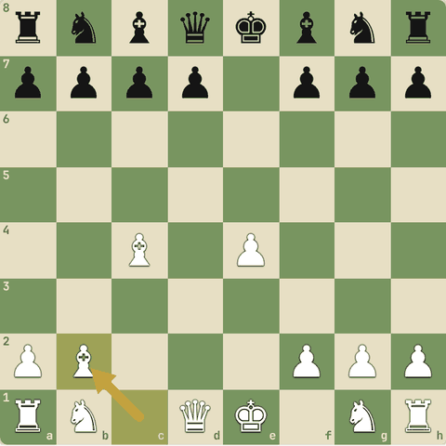
Final position (5.Bxb2)

6.9.4 Evans Gambit
- Italian mein pawn dekar c3-d4 se tez center.
- (Kabhi TV advert mein bhi aaya!)
1. e4 e5 2. Nf3 Nc6 3. Bc4 Bc5 4. b4 Bxb4 5. c3 Ba5 6. d4 exd4 7. O-O
- 4.b4 Evans.
- 5.c3 tempo ke saath bishop par attack.
- 6.d4 center khula.
- 7.O-O Tez development, Black ka king center mein.
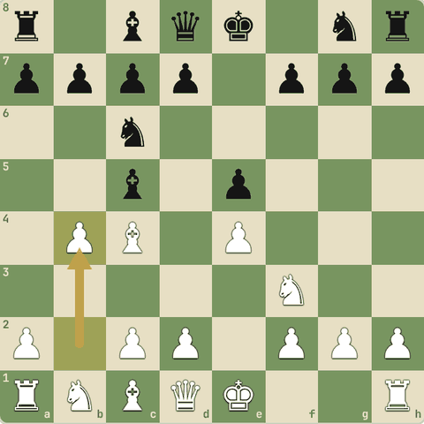
Position after 4.b4
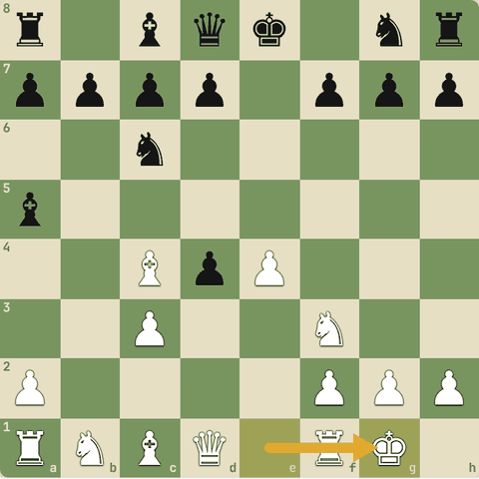
Final position (7.O-O)

6.9.5 Smith-Morra Gambit (vs Sicilian)
- Pawn ke badle open c- aur d-files aur tez development.
1. e4 c5 2. d4 cxd4 3. c3 dxc3 4. Nxc3 Nc6 5. Nf3 d6 6. Bc4 e6 7. O-O
- 3.c3 Morra.
- 4.Nxc3 knight bahar.
- 7.O-O White ke rooks jaldi c1/d1 par.
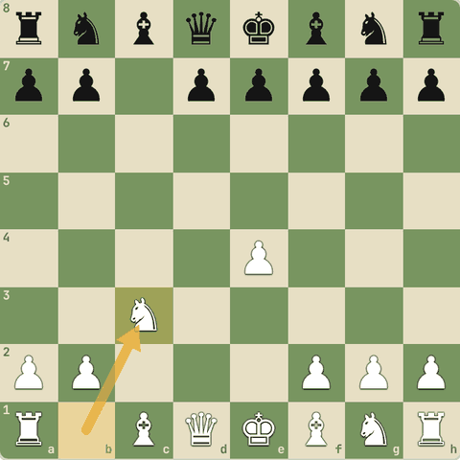
Position after 4.Nxc3
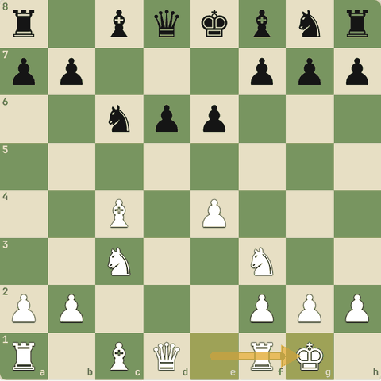
Final position (7.O-O)

6.9.6 Blackmar-Diemer Gambit
- 1.d4 players ka sharp hathiyaar.
- (Scandinavian 1.e4 d5 2.d4 se bhi aa sakta hai.)
1. d4 d5 2. e4 dxe4 3. Nc3 Nf6 4. f3 exf3 5. Nxf3
- 2.e4!?
- 4.f3 pawn de kar f-file.
- 5.Nxf3 tez development, Bd3, O-O, Qe1-h4 plan.
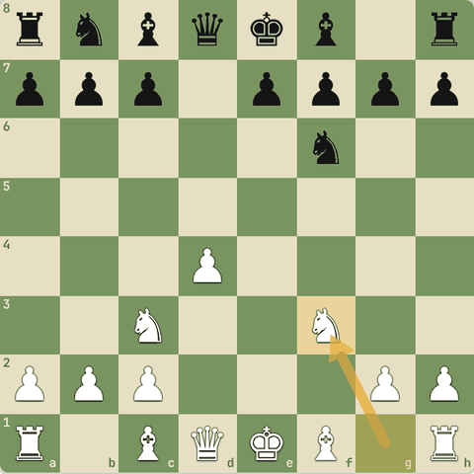
Final position (5.Nxf3)

6.9.7 Staunton Gambit (vs Dutch)
- Dutch 1...f5 ke against pawn dekar king ki kamzor diagonal par attack.
1. d4 f5 2. e4 fxe4 3. Nc3 Nf6 4. Bg5
- 2.e4!? Staunton.
- 4.Bg5 knight par pressure, f3 se pawn wapas ya attack.
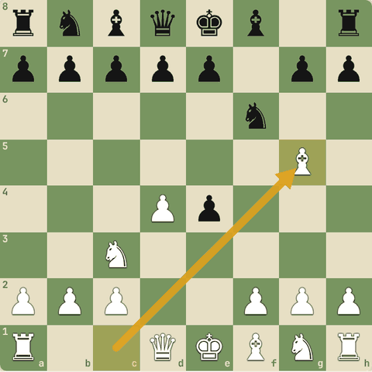
Final position (4.Bg5)

6.9.8 Reti Gambit (vs French)
- e4 pawn chhod kar bishop b2 long diagonal, queen e2, aur long castle ke saath attack.
1. e4 e6 2. b3 d5 3. Bb2 dxe4 4. Nc3 Nf6 5. Qe2
- 2.b3
- 3.Bb2 pawn gaya.
- 5.Qe2 pawn wapas ya O-O-O aur g4 se attack.
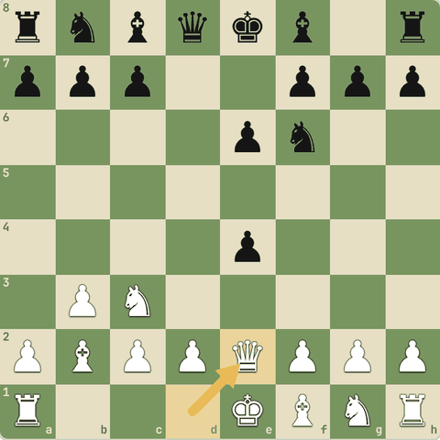
Final position (5.Qe2)

6.9.9 Albin Counter-Gambit (Black)
- Black Queen's Gambit ke against khud pawn deta hai.
- d4 pawn White ko dabata hai.
1. d4 d5 2. c4 e5 3. dxe5 d4 4. Nf3 Nc6
- 2...e5!? Albin.
- 3...d4 space.
- 4...Nc6 pawn wapas lene ki taiyaari, tez development.
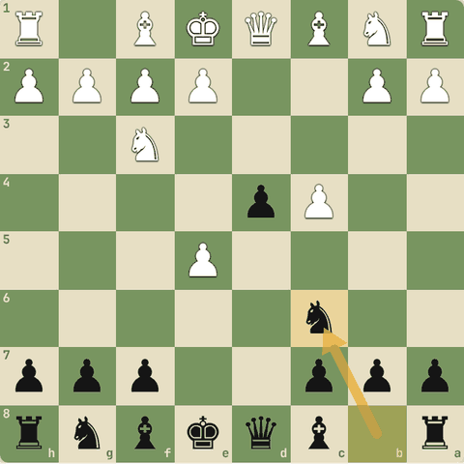
Final position (4…Nc6)

6.9.10 Benko Gambit (Black)
- Pawn ke badle a- aur b-files par lamba pressure.
- Endgame mein bhi asar.
1. d4 Nf6 2. c4 c5 3. d5 b5 4. cxb5 a6 5. bxa6 Bxa6 6. Nc3 d6
- 3...b5 Benko.
- 5...Bxa6 semi-open a- aur b-files.
- 6…d6 Rooks a8, b8 par aayenge.
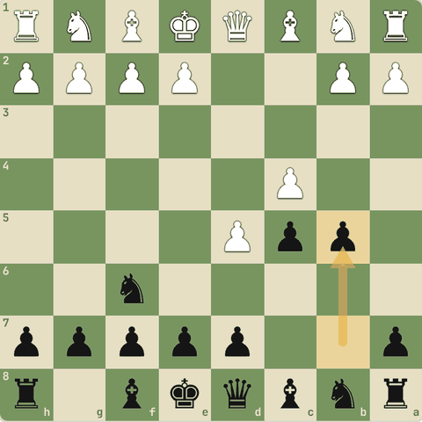
Position after 3…b5
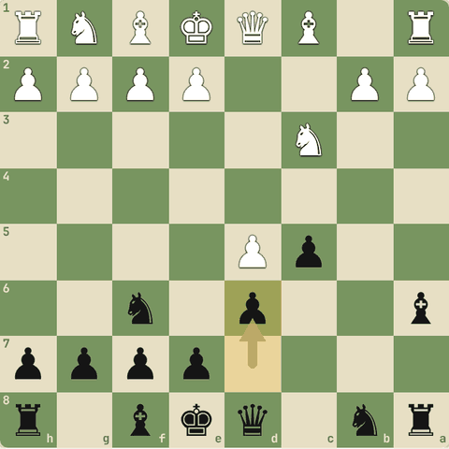
Final position (6…d6)

6.9.11 Sawal 1: Gambit dene wale ko badle mein kya chahiye?
Gambit dene wale ko badle mein kya chahiye?
Jawab:
✓ Tez development (tempo), open lines, attack
- Material ke badle time aur activity.

6.9.12 Sawal 2: Semi-open file kya hai?
Semi-open file kya hai?
Jawab:
✓ Jisme sirf dushman ka pawn hai
- Rook ke liye attack ka raasta (dushman pawn par).

6.10 Advanced opening traps
Lasker, Caro-Kann, Three Knights, Petrov copycat, QGA, Cambridge Springs, Mortimer, Noah's Ark, Fischer, Siberian, Stafford, Vienna
Yaad rakho
- Opponent koi pawn "free" chhode to pehle socho: trap to nahi?
- Blackburne Shilling: 3...Nd4 ke baad 4.Nxe5? lalach, ...Qg5! aur smothered mate.
- Sahi jawab: 4.Nxd4 ya 4.O-O.
- Traps khud na bhi khelo, unke tactical ingredients (pin, fork, discovered attack, underpromotion) seekho.
- Copycat mat bano: opponent ki nakal (Petrov) se trap mein phans sakte ho.
- Bishop trap (Noah's Ark): ...c5-c4 se bishop b3 band.

6.10.1 Sawal 1: Jab opponent koi pawn "free" chhod de, sabse pehle kya socho?
Jab opponent koi pawn "free" chhod de, sabse pehle kya socho?
Jawab:
✓ Yeh trap to nahi? Lene ke baad unki CCT kya hai?

6.10.2 Advanced traps: ingredients seekho
- Yeh traps alphabetical order mein, har opening se ek.
- Agar tum woh opening kabhi na bhi khelo, ingredients seekho: pin, fork, discovered attack, underpromotion, trapped piece.
- Yahi patterns middlegame mein bhi aate hain.

6.10.3 Albin: Lasker trap (underpromotion!)
- Black ka pawn aakhir mein knight banta hai!
1. d4 d5 2. c4 e5 3. dxe5 d4 4. e3 Bb4+ 5. Bd2 dxe3 6. Bxb4 exf2+ 7. Ke2 fxg1=N+
- 4.e3? galti.
- 4...Bb4+
- 5...dxe3!
- 6.Bxb4?
- 6...exf2+
- 7.Ke2
- 7...fxg1=N+! knight promotion check ke saath. 8.Rxg1 Bg4+ aur queen gayi.
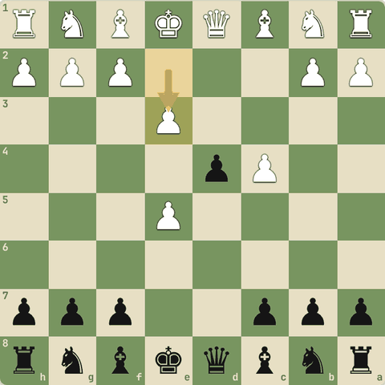
Position after 4.e3
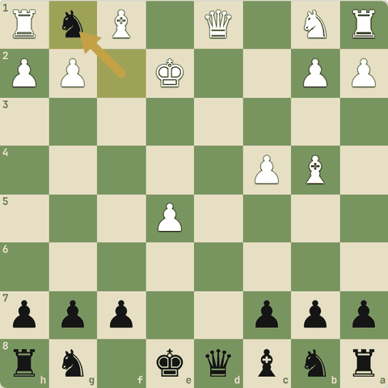
Final position (7…fxg1=N+)

6.10.4 Caro-Kann trap
- Natural lagne wali chaal se smothered mate!
1. e4 c6 2. d4 d5 3. Nc3 dxe4 4. Nxe4 Nd7 5. Qe2 Ngf6 6. Nd6#
- 5.Qe2 trap set: e7 pawn pinned.
- 5...Ngf6??
- 6.Nd6# e7 pawn pinned hai, isliye capture nahi kar sakta. Smothered mate!
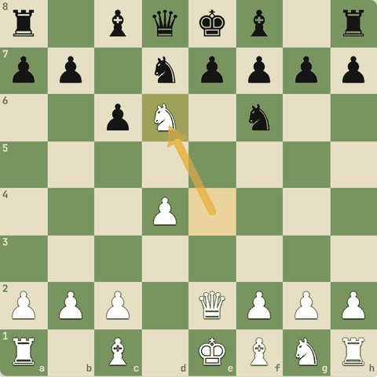
Final position (6.Nd6#)

6.10.5 Three Knights: `Nxe5` trick
- 3...Bc5? natural lagta hai par 4.Nxe5! (fork trick) se White center jeetta hai.
1. e4 e5 2. Nf3 Nc6 3. Nc3 Bc5 4. Nxe5 Nxe5 5. d4 Bd6 6. dxe5 Bxe5
- 3...Bc5? behtar 3...Nf6.
- 4.Nxe5! piece "sacrifice".
- 5.d4 fork: bishop aur knight. Piece wapas aur bada center.
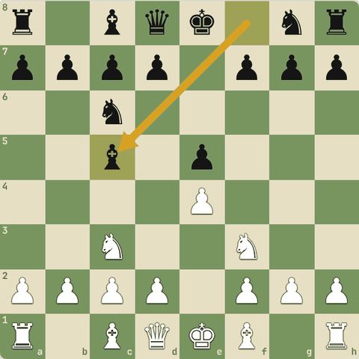
Position after 3…Bc5
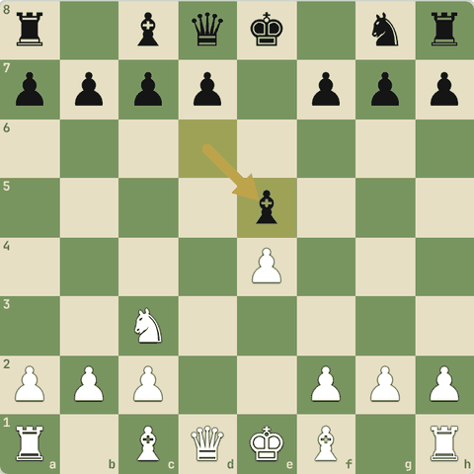
Final position (6…Bxe5)

6.10.6 Petrov: copycat ki saza
- Black ne White ki nakal ki (3...Nxe4?).
1. e4 e5 2. Nf3 Nf6 3. Nxe5 Nxe4 4. Qe2 Nf6 5. Nc6+
- 3...Nxe4? nakal. Sahi: pehle 3...d6.
- 4.Qe2 knight par pin wali threat.
- 4...Nf6??
- 5.Nc6+ discovered check: queen d8 gayi.
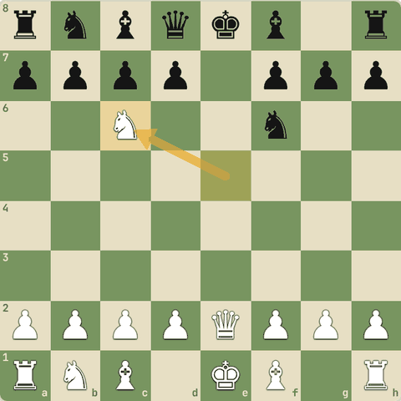
Final position (5.Nc6+)

6.10.7 Queen's Gambit Accepted trap
- Pawn bachane ka lalach: a8 rook gaya.
1. d4 d5 2. c4 dxc4 3. e3 b5 4. a4 c6 5. axb5 cxb5 6. Qf3
- 3...b5?
- 4.a4 pawn chain todo.
- 5...cxb5
- 6.Qf3! fork: rook a8 (long diagonal) par attack.
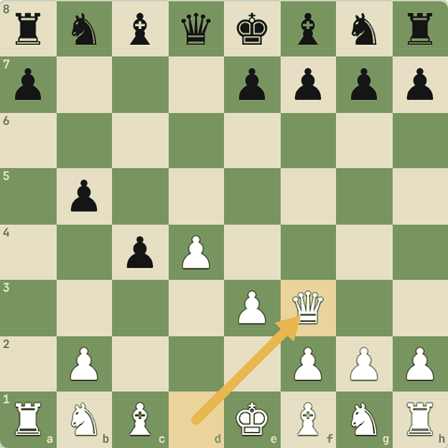
Final position (6.Qf3)

6.10.8 Cambridge Springs trap
- Elephant trap se shuru, phir queen a5 se pin.
1. d4 d5 2. c4 e6 3. Nc3 Nf6 4. Bg5 Nbd7 5. e3 c6 6. Nf3 Qa5 7. Bd3 dxc4 8. Bxc4 Ne4
- 4...Nbd7 (elephant trap set).
- 6...Qa5 Cambridge Springs: c3 knight pinned.
- 7.Bd3? common galti.
- 7...dxc4! bishop ko hataya.
- 8...Ne4! c3 par double pressure aur g5 bishop par attack.
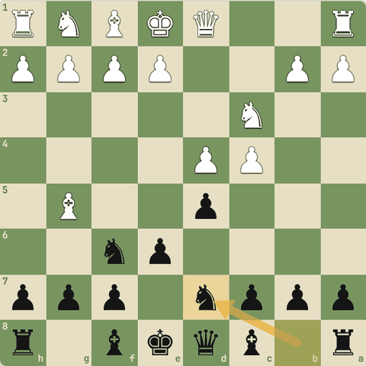
Position after 4…Nbd7
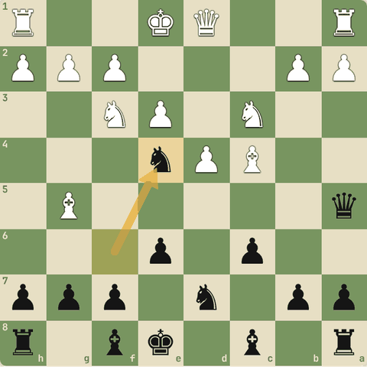
Final position (8…Ne4)

6.10.9 Ruy Lopez: Mortimer trap
- 4...Ne7 galti lagti hai, par trap hai.
1. e4 e5 2. Nf3 Nc6 3. Bb5 Nf6 4. d3 Ne7 5. Nxe5 c6 6. Ba4 Qa5+
- 4...Ne7 trap.
- 5.Nxe5? free pawn?
- 5...c6 bishop par attack.
- 6...Qa5+ check aur fork: e5 knight gaya.
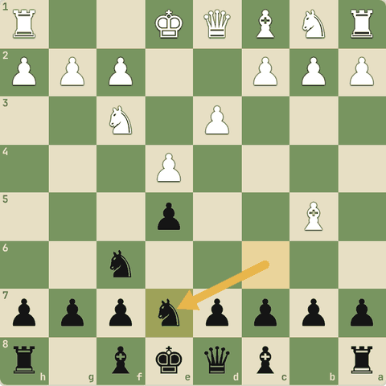
Position after 4…Ne7
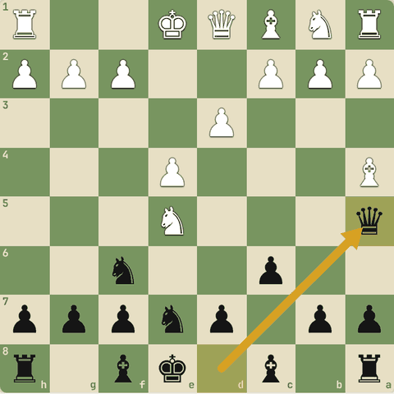
Final position (6…Qa5+)

6.10.10 Ruy Lopez: Noah's Ark trap
- White ka bishop b3 pawns mein qaid!
1. e4 e5 2. Nf3 Nc6 3. Bb5 a6 4. Ba4 d6 5. d4 b5 6. Bb3 Nxd4 7. Nxd4 exd4 8. Qxd4 c5 9. Qd5 Be6 10. Qc6+ Bd7 11. Qd5 c4
- 8.Qxd4?? (sahi: 8.Bd5)
- 8...c5! queen bhagao.
- 11...c4 bishop b3 trap: "Noah's Ark".
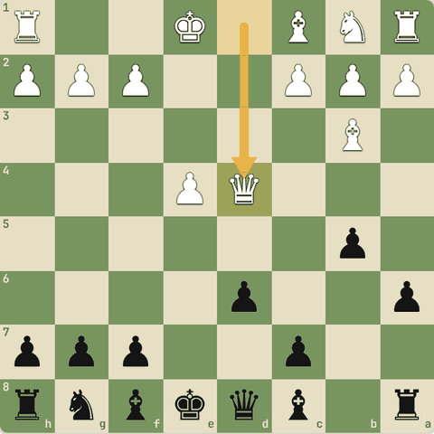
Position after 8.Qxd4
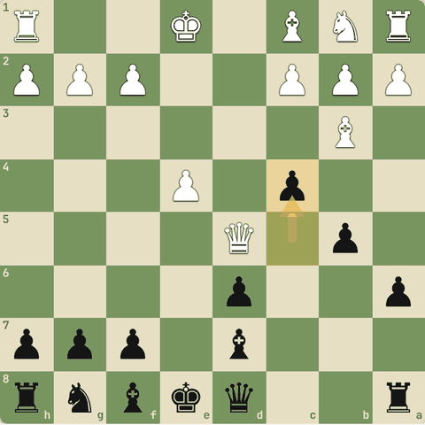
Final position (11…c4)

6.10.11 Sicilian: Fischer trap (Fischer vs Reshevsky 1958)
- Accelerated Dragon mein 8...Na5? ki saza.
1. e4 c5 2. Nf3 Nc6 3. d4 cxd4 4. Nxd4 g6 5. Nc3 Bg7 6. Be3 Nf6 7. Bc4 O-O 8. Bb3 Na5 9. e5 Ne8 10. Bxf7+ Kxf7 11. Ne6
- 8...Na5?
- 9.e5! knight bhagao.
- 10.Bxf7+!!
- 11.Ne6!! agar dxe6 to Qxd8; queen trapped. White jeet raha hai.
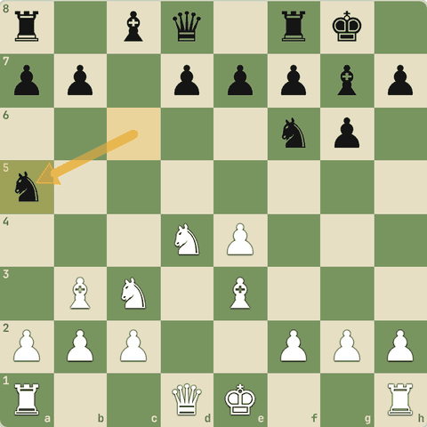
Position after 8…Na5
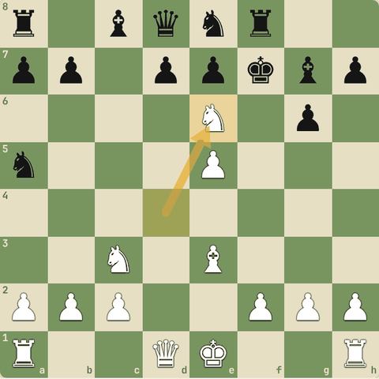
Final position (11.Ne6)

6.10.12 Smith-Morra: Siberian trap
- Black ki taraf se trap: Qh2# ki threat.
1. e4 c5 2. d4 cxd4 3. c3 dxc3 4. Nxc3 Nc6 5. Nf3 e6 6. Bc4 Qc7 7. O-O Nf6 8. Qe2 Ng4 9. h3 Nd4
- 8...Ng4 h2 par nishaana.
- 9.h3??
- 9...Nd4! queen par attack. Agar Nxd4 to Qh2#. Queen jaati hai.
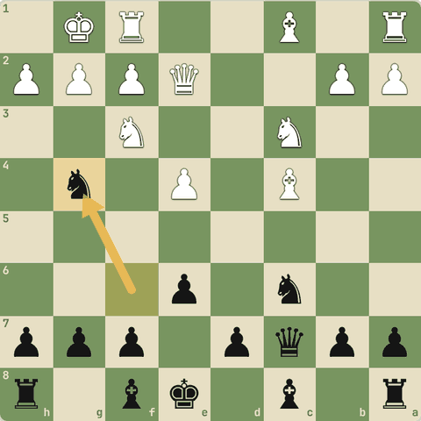
Position after 8…Ng4
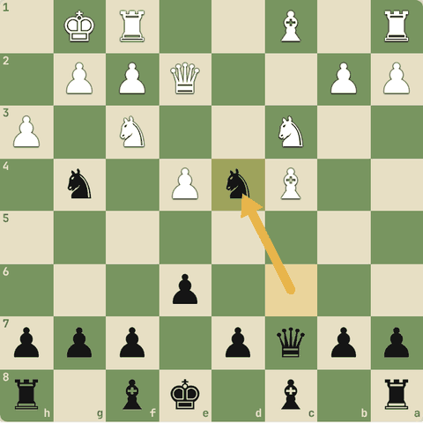
Final position (9…Nd4)

6.10.13 Stafford Gambit trap
- Online popular gambit: White lalach mein queen le, Black mate karta hai.
1. e4 e5 2. Nf3 Nf6 3. Nxe5 Nc6 4. Nxc6 dxc6 5. d3 Bc5 6. Bg5 Nxe4 7. Bxd8 Bxf2+ 8. Ke2 Bg4#
- 6.Bg5?
- 6...Nxe4! queen ki parwah nahi.
- 7.Bxd8??
- 7...Bxf2+
- 8...Bg4# Mate!
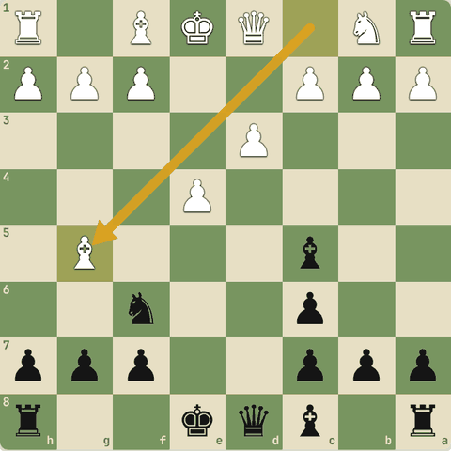
Position after 6.Bg5
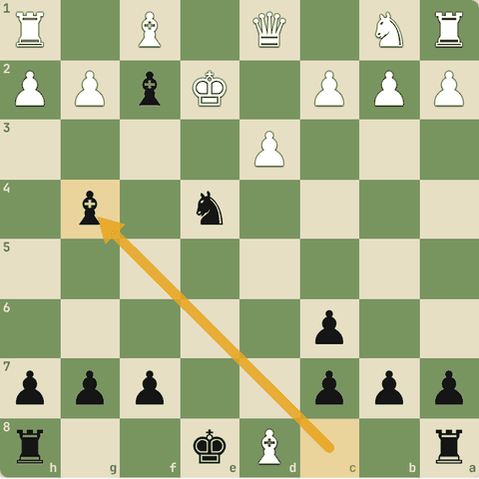
Final position (8…Bg4#)

6.10.14 Vienna Game trap
- "Frankenstein-Dracula" variation: dono taraf jungli chaalein.
1. e4 e5 2. Nc3 Nf6 3. Bc4 Nxe4 4. Qh5 Nd6 5. Bb3 Nc6 6. Nb5 g6 7. Qf3 f5 8. Qd5 Qe7 9. Nxc7+ Kd8 10. Nxa8
- 3...Nxe4 fork trick.
- 4.Qh5 mate threat f7.
- 7.Qf3 f7 par phir.
- 8.Qd5 mate threat aur c7.
- 9.Nxc7+
- 10.Nxa8 rook jeeta (par Black ke paas compensation hai).
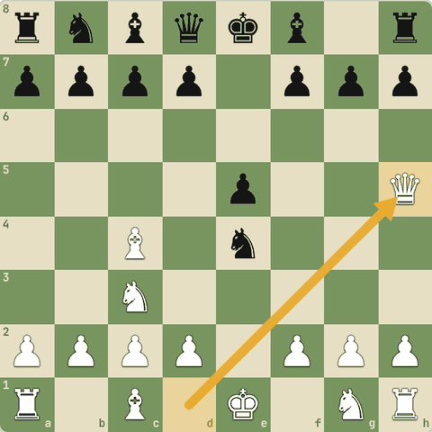
Position after 4.Qh5
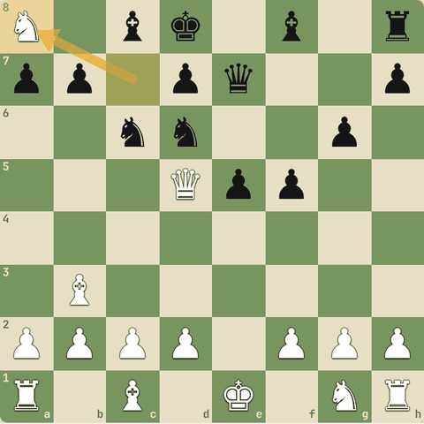
Final position (10.Nxa8)

6.11 Apna repertoire banao
Kya khelna hai, kaise yaad karna hai
Yaad rakho
- White: 1.e4 + Italian (ya 1.d4 + London).
- Black vs 1.e4: 1...e5 ya Caro-Kann. Black vs 1.d4: QGD ya Slav.
- Pehle 6-8 chaalon ke ideas; har game ke baad opening check karo.

6.11.1 Simple repertoire (beginner se club level)
- White: 1.e4 aur Italian Game. (Ya 1.d4 + London System agar positional pasand ho.)
- Black vs 1.e4: 1...e5 (open games) ya Caro-Kann (solid).
- Black vs 1.d4: Queen's Gambit Declined ya Slav.
- Kaise seekhein:
- Pehle 6-8 chaalon ke ideas samjho, lambi theory nahi.
- Har game ke baad dekho kahan opening se bahar aaye, wahan ka sahi move note karo.
- 1600+ ke baad dheere-dheere gehri lines aur sideline traps.
- Master games dekho apni openings ke: plans wahi se aate hain.

6.11.2 Sawal 1: 1200 rating par opening kaise padhni chahiye?
1200 rating par opening kaise padhni chahiye?
Jawab:
✓ Ideas aur principles, 6-8 chaal

Level 7: Endgames: jeet pakki karo
Endgame ke themes, do bishops se mate, opposition, square rule, triangulation, pawn endings, rook endings, theory
- Endgame mein king ladta hai aur pawns queen bante hain.
- Yahan woh positions seekhoge jo har player ko pata honi chahiye.

7.1 Endgame ke bade themes
Active king, passed pawn ka safar, rook 7th rank par
Yaad rakho
- Endgame mein king ko center aur aage lao: mate ka khatra kam, king strong piece.
- Passed pawn ko safe raasta do: king ya rook se escort, blockade todo.
- Rook 7th rank par: pawns aur king dono atakte hain (Capablanca-Tartakower).
- Famous: Tal-Lisitsin (aggressive king), Seirawan-Kasparov (passed pawn ka safar).

7.1.1 Endgame ke 3 bade themes
- Aggressive king: endgame mein king center aur aage jaata hai, pawns khaata hai, apne pawns ko support karta hai. (Tal vs Lisitsin)
- Passed pawn ka safe safar: passed pawn ko escort karo (king/rook se), blockader ko hatao. (Seirawan vs Kasparov)
- Rook on the 7th: rook dushman ki 7th rank par: pawns par attack aur king band. (Capablanca vs Tartakower, 1924)

7.1.2 Khud khelo: Pawn ko queen banao
King ko active karo: pawn ko escort karke queen banao (20 chaal).
Hint: Pehle king aage (pawn se aage), opposition lo, phir pawn.
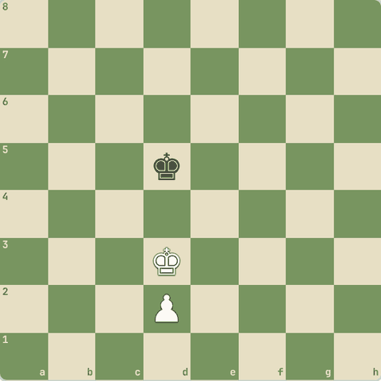
(White ki chaal)

7.1.3 Abhyaas: Rook ko 7th rank par lao
Rook ko 7th rank par lao: pawns aur king dono par dabaav.
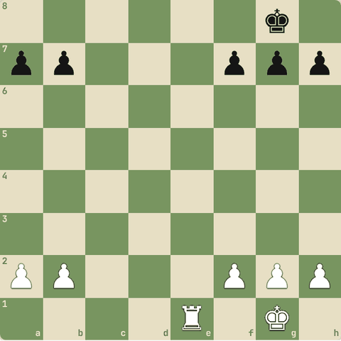
(White ki chaal)
Jawab:
1. Re7
- Re7! 7th rank par rook b7 aur a7 ko dekhta hai aur king ko 8th rank par band rakhta hai.
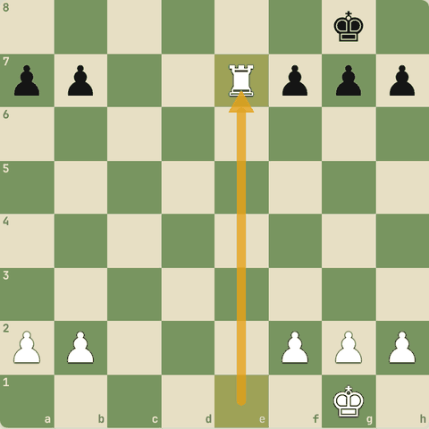
Chaal ke baad

7.1.4 Sawal 1: Endgame mein king kahan hona chahiye?
Endgame mein king kahan hona chahiye?
Jawab:
✓ Center mein, active
- Endgame = king attack karta hai.

7.2 Do bishops se mate
K+B+B vs K, endgame mates ka revision
Yaad rakho
- Do bishops saath-saath diagonals par ek "deewar" banate hain.
- King ko kone (corner) mein dhakelo; apna king saath laao.
- Stalemate ka dhyan: king ko hamesha ek chaal chhodo jab tak mate na ho.
- Revision: Q, R, do rooks, Q+R ke mates Level 2 mein; back-rank mate Checkmate patterns mein.

7.2.1 Do bishops se mate
- Do bishops paas-paas diagonals par milkar ek deewar banate hain jo king ko kaat deti hai.
- 1.
- Bishops center ke paas, king ko ek kone ki taraf dhakelo.
- 2.
- Apna king saath lao: bina king ke mate nahi hota.
- 3.
- King kone mein aaye to bishops se check aur band.
- 4.
- Stalemate ka dhyan: har chaal par dekho ki king ke paas chaal bachi hai.
- Yaad: queen, rook, do rooks, queen+rook ke mates Level 2 mein seekhe.

7.2.2 Abhyaas: Do bishops
Do bishops: mate in 1.
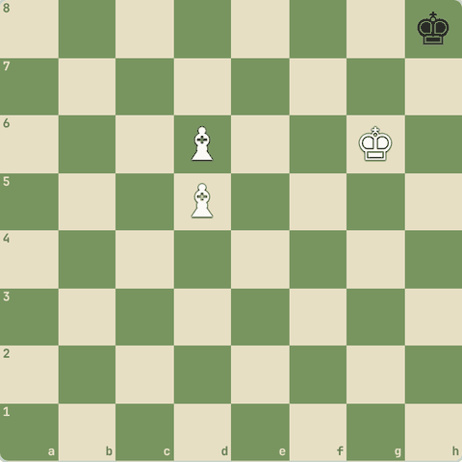
(White ki chaal)
Jawab:
1. Be5#
- Bishop e5 long diagonal se check, doosra bishop aur king ne baaki raaste band kiye.
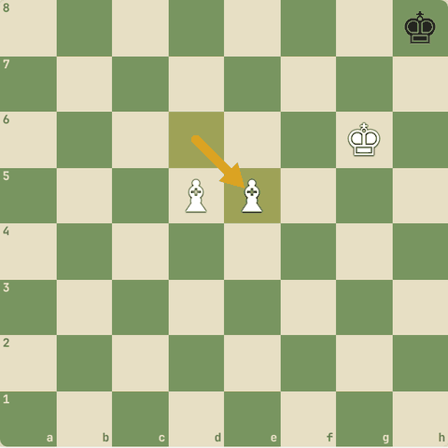
Chaal ke baad

7.2.3 Khud khelo: Checkmate karo
Do bishops se 35 chaal mein mate karo.
Hint: Bishops ko saath rakho (jaise e4 aur e5 par), king ko kone ki taraf.
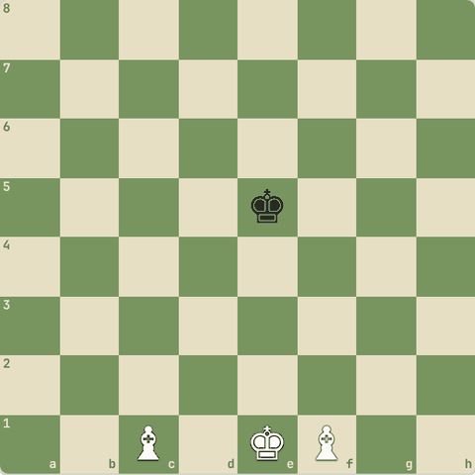
(White ki chaal)

7.3 King aur pawn: opposition
K+P vs K, key squares
Yaad rakho
- Endgame mein king center mein lao: woh fighter hai (~4 points).
- Opposition: kings aamne-saamne, beech mein ek square; jisne chaal nahi chalni uske paas opposition.
- Key squares: pawn ke 2 square aage ki row ke 3 squares. King wahan = pawn queen.
- Square ka rule: dushman king pawn ke box mein aa sake to pawn pakda jaayega.
- K+P vs K: king pawn ke aage ho aur opposition tumhare paas = jeet. Kiski chaal hai, usse result badalta hai.

7.3.1 Endgame mein king ladta hai
- Endgame mein king ko center mein lao: woh ek strong piece hai (lagbhag 4 points).
- Opposition: jab kings ek hi line mein ho aur beech mein ek square ho, to jisne chaal nahi chalni uske paas opposition hai.
- Opposition wala king doosre ko peeche dhakelta hai.
- Key squares: pawn ke 2 square aage wali row ke 3 squares.
- Agar tumhara king wahan pahunch gaya, pawn queen banega.
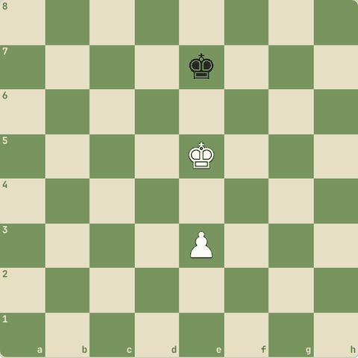

7.3.2 Sawal 1: Black ki chaal hai
Black ki chaal hai. Opposition kiske paas hai?
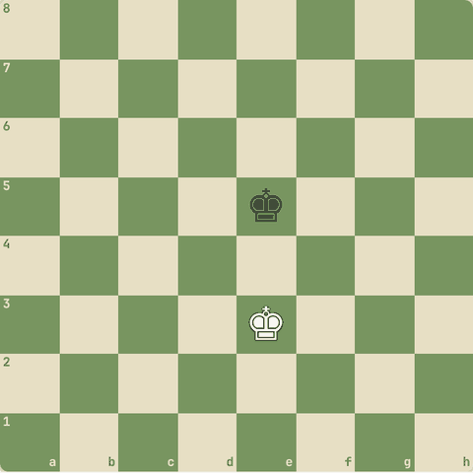
Jawab:
✓ White
- Kings aamne-saamne, beech mein ek square, aur Black ko chalna padega: White ke paas opposition.

7.3.3 Khud khelo: Pawn ko queen banao
King ko aage lao, opposition lo, aur pawn ko queen banao (25 chaal).
Hint: Pehle king aage, pawn baad mein. Pawn ko king ke peeche rakho.
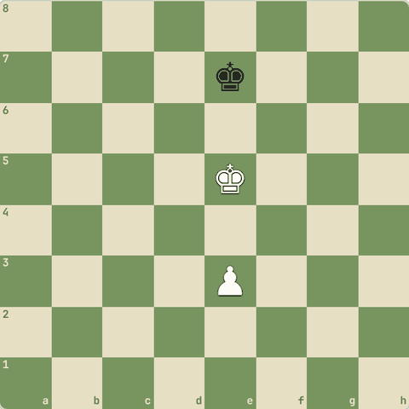
(White ki chaal)

7.3.4 Sawal 2: White king e5 (pawn ke aage), pawn e4, Black king e7
White king e5 (pawn ke aage), pawn e4, Black king e7. White ki chaal. Result?
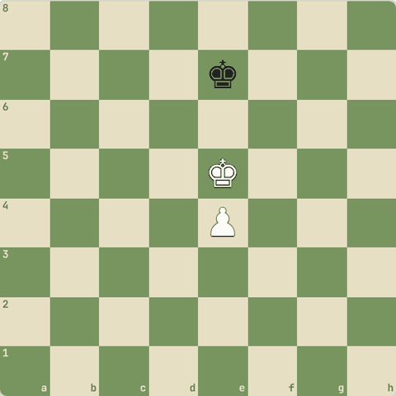
Jawab:
✓ Draw
- Kings aamne-saamne, aur chaal White ki: opposition Black ke paas.
- White aage nahi badh sakta: draw.

7.3.5 Sawal 3: Same position, ab Black ki chaal
Same position, ab Black ki chaal. Result?
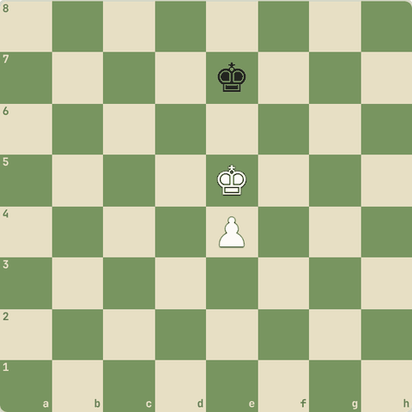
Jawab:
✓ Jeet (White)
- Ab opposition White ke paas.
- Black ko hatna padega, White king aage (Kd6/Kf6) aur pawn queen banega.

7.3.6 Khud khelo: Pawn ko queen banao
Rule: king pawn ke aage 6th rank par ho to hamesha jeet. Karke dikhao (queen banao, 20 chaal).
Hint: King se key squares (d7/f7) lo, pawn baad mein.
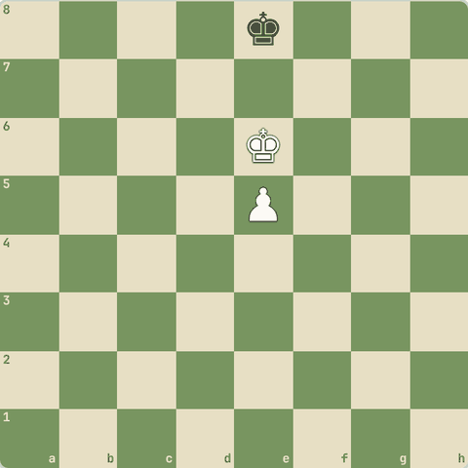
(White ki chaal)

7.4 Square rule aur triangulation
King pawn ko pakad sakta hai? Reti ka study, tempo ka khel
Yaad rakho
- Square rule: pawn se promotion tak ek box. Dushman king (apni chaal ke saath) box mein aa sake to pawn pakdega.
- Reti study: king ek saath do kaam kar sakta hai (pawn pakadna aur apna pawn support): diagonal chaal ka jaadu.
- Triangulation: king teen squares ke triangle mein ghoom kar ek tempo "khota" hai, taaki opponent ko chaal chalni pade (Alburt-Kasparov).

7.4.1 Square ka rule
- Pawn se promotion square tak ek square (box) banao.
- Agar dushman king (apni chaal ke saath) is box ke andar aa sakta hai, to woh pawn ko pakad lega.
- Yahan Black ki chaal hai aur king e5 box ke andar hai: woh pawn pakad lega.
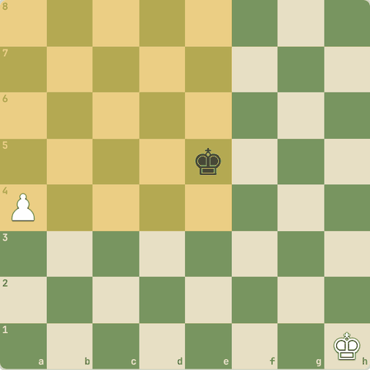

7.4.2 Sawal 1: White ki chaal
White ki chaal. Kya Black king f5 pawn ko pakad sakta hai?
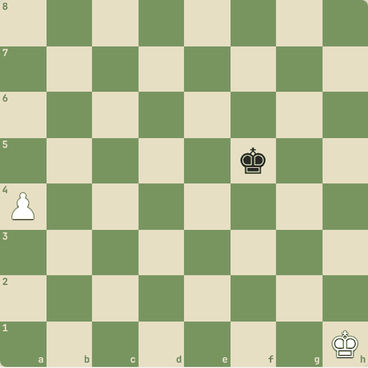
Jawab:
✓ Nahi: pawn queen banega
- a5 ke baad box a5-d5-d8-a8 hai.
- f5 king bahar hai: pakad nahi payega.

7.4.3 Sawal 2: Black ki chaal
Black ki chaal. Kya Black king a5 pawn ko pakad lega?
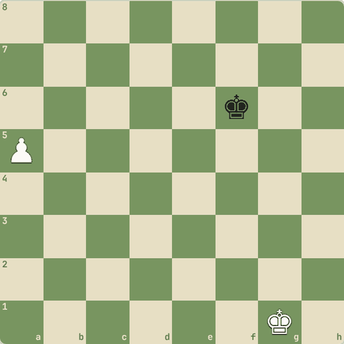
Jawab:
✓ Nahi
- Box a5-a8-d8-d5.
- King f6 box se bahar, apni chaal ke saath bhi e6 tak hi: nahi pakad sakta.

7.4.4 Reti ka jaadu (1921)
- White: king h8, pawn c6.
- Black: king a6, pawn h5.
- Lagta hai White haar gaya: black pawn bahut aage, white king door.
- Par king diagonal chal kar do kaam ek saath karta hai: black pawn ki taraf bhi aur apne pawn ki taraf bhi.
- 1.Kg7! h4 2.Kf6 Kb6 3.Ke5! aur ab ya to pawn pakdega ya apna pawn queen karega.
- Draw!
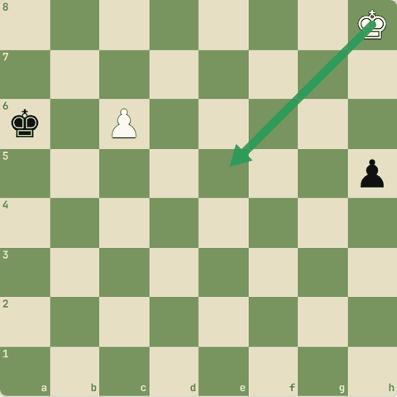

7.4.5 Reti study: chaal-dar-chaal
- Diagonal king ka kamaal.
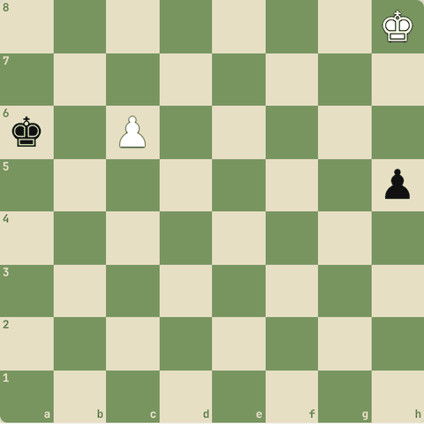
(White ki chaal) Shuruaati position
1. Kg7 h4 2. Kf6 Kb6 3. Ke5 Kxc6 4. Kf4
- 1.Kg7! diagonal: dono taraf ke kareeb.
- 2.Kf6 box ke kareeb.
- 2...Kb6 (agar 2...h3 3.Ke7 h2 4.c7 dono queen banenge)
- 3.Ke5! ab c6 ko support bhi.
- 3...Kxc6
- 4.Kf4 pawn pakda. Draw!
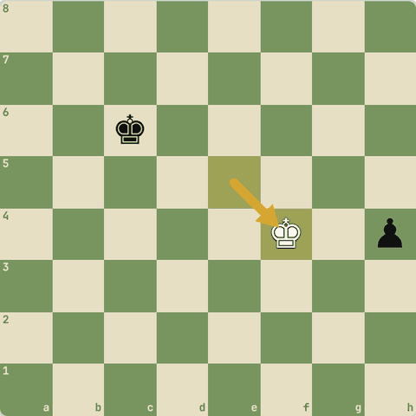
Final position (4.Kf4)

7.4.6 Khud khelo: Draw bachao
Ab tum karo: Reti study mein draw bachao (10 chaal).
Hint: King ko diagonal par chalao: Kg7, Kf6, Ke5.
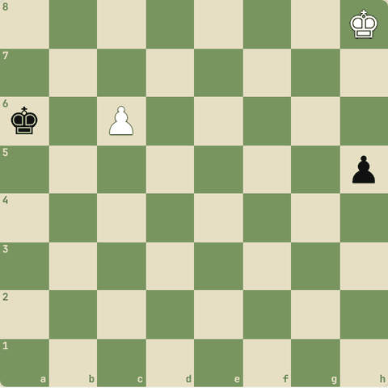
(White ki chaal)

7.4.7 Triangulation
- Kabhi position aisi hoti hai ki jiski chaal ho woh haare (zugzwang).
- Agar tumhari chaal hai, to king ko teen squares ke triangle mein ghumao: tum 3 chaal mein wapas wahin, opponent ke paas sirf 2 squares ka aana-jaana.
- Ek tempo kho kar ab opponent ki chaal wali wahi position!
- Famous: Alburt vs Kasparov.

7.4.8 Sawal 3: Triangulation ka maksad?
Triangulation ka maksad?
Jawab:
✓ Ek tempo khona taaki wahi position opponent ki chaal ke saath aaye
- Zugzwang ka fayda uthane ke liye.

7.5 Pawn endgame tricks
Breakthrough, outside passer, triangulation
Yaad rakho
- Passed pawn ko aage badhao: "passed pawns must be pushed".
- Outside passed pawn dushman king ko kinare kheenchta hai.
- Triangulation: king teen squares mein ghoom kar tempo waste karta hai.
- Breakthrough: 3 vs 3 pawns mein b6! jaisi sacrifice se passed pawn.

7.5.1 Passed pawn
- Passed pawn: jiske raste mein ya bagal ki files mein koi dushman pawn na ho.
- "Passed pawns must be pushed!"
- Outside passed pawn (kinare wala): dushman king ko door kheenchta hai, tumhara king doosri taraf pawns kha leta hai.
- Protected passed pawn: apne pawn se protected = bahut strong.
- Triangulation: king teen squares ka triangle bana kar ek tempo waste karta hai taaki opposition mile.

7.5.2 Abhyaas: Breakthrough!
Breakthrough! Teen pawns vs teen pawns.
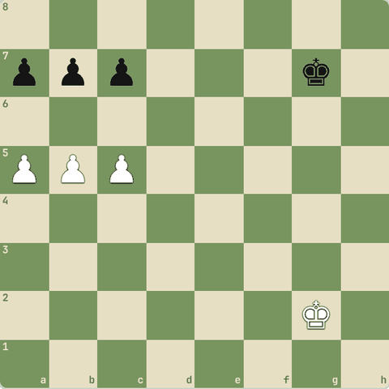
(White ki chaal)
Jawab:
1. b6 axb6 2. c6 bxc6 3. a6
- 1.b6! agar cxb6 to 2.a6! aur bxa6 3.c6 queen banega.
- Agar axb6 to 2.c6!.
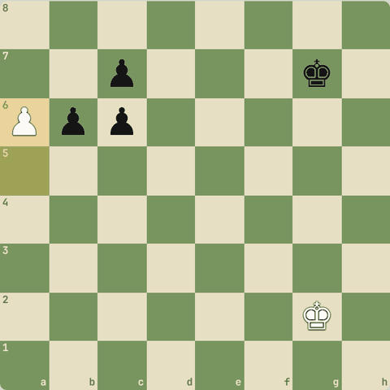
Line ke baad position

7.5.3 Sawal 1: Pawn endgame mein "outside passed pawn" kyun strong hai?
Pawn endgame mein "outside passed pawn" kyun strong hai?
Jawab:
✓ Dushman king ko ek kinare kheench leta hai, apna king doosri taraf jeet jaata hai

7.6 Rook endgames: Lucena aur Philidor
Sabse common endgame
Yaad rakho
- Aadhe endgames rook endgames hote hain.
- Lucena (jeet): rook 4th rank par la kar bridge banao.
- Philidor (draw): rook 6th rank par; pawn aage aaye to rook peeche jaa kar checks.
- Tarrasch rule: rook passed pawn ke peeche. Active rook > passive rook.
- Vancura defense: rook side se (f6 jaisi rank par) a-pawn par attack aur side se checks. Rook pawn + rook vs rook ka draw.
- Philidor jab pawn 5th rank par shuru ho: rook 6th rank par jab tak pawn 6th par na aaye, phir peeche se checks.

7.6.1 Rook endgames sabse zyada aate hain
- Lagbhag aadhe endgames mein rooks hote hain. 2 positions zaroor yaad karo:
  - Lucena (jeet): pawn 7th rank par, king uske aage. Technique: "bridge banao" rook se.
  - Philidor (draw): defending side ka rook 3rd rank (apni taraf se 6th) par, jab tak pawn aage na aaye. Pawn aaya to rook peeche jaa kar check dete raho.
- Aur rule: rook passed pawn ke peeche rakho (Tarrasch rule), aage nahi.
- Active rook passive rook se behtar.

7.6.2 Lucena: bridge banana
- White ka king b8 pawn ke aage atka hai.
- Black rook side se check dega.
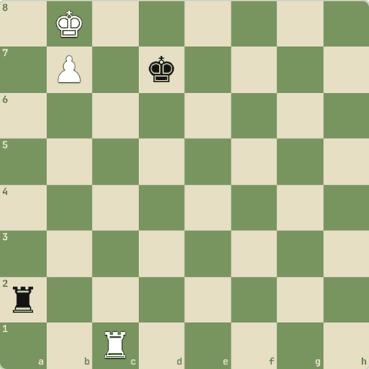
(White ki chaal) Shuruaati position
1. Rd1+ Ke7 2. Rd4 Ra1 3. Kc7 Rc1+ 4. Kb6 Rb1+ 5. Kc6 Rc1+ 6. Kb5 Rb1+ 7. Rb4
- 1.Rd1+ black king ko ek file door dhakelo.
- 2.Rd4! rook 4th rank par: yahi bridge banega.
- 3.Kc7 king bahar.
- 3…Rc1+ Checks shuru.
- 4.Kb6 King rook ki taraf aata hai.
- 7.Rb4! Bridge! Checks khatam, pawn queen banega.
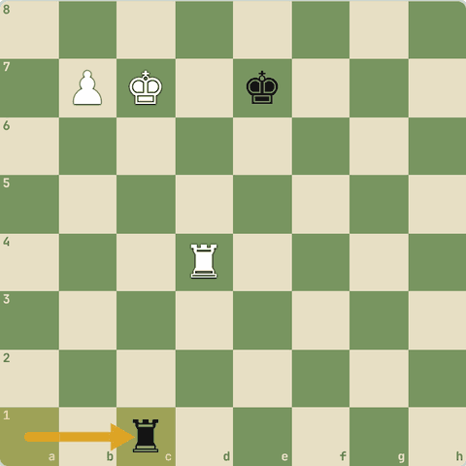
Position after 3…Rc1+
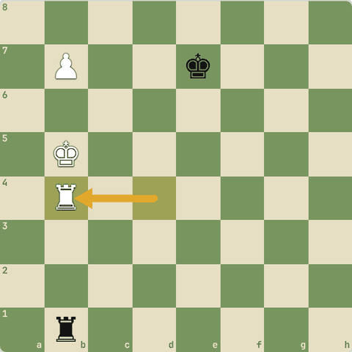
Final position (7.Rb4)

7.6.3 Khud khelo: Pawn ko queen banao
Ab tum Lucena jeeto: pawn ko queen banao (20 chaal).
Hint: Rd1+, phir rook 4th rank par (Rd4), phir king bahar.
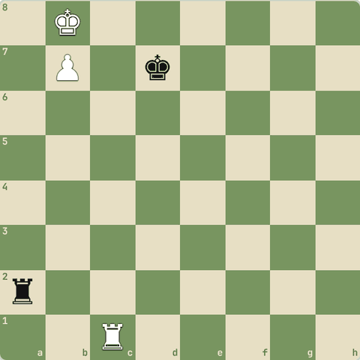
(White ki chaal)

7.6.4 Philidor: draw kaise bachayein
- Black ka rook 6th rank par white king ko aage aane se rokta hai.
- Agar White e6 khele, to ab king ke liye 6th rank par koi chhupne ki jagah nahi.
- Tab Black rook ko peeche (1st rank) le jaata hai aur peeche se checks deta rehta hai.
- Draw!
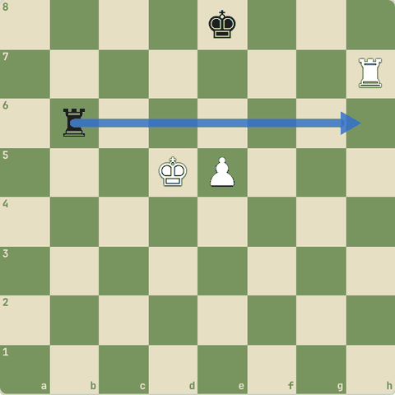

7.6.5 Khud khelo: Draw bachao
Tum Black ho. 15 chaal tak draw bachao. Rook 6th rank par rakho jab tak pawn e6 na aaye.
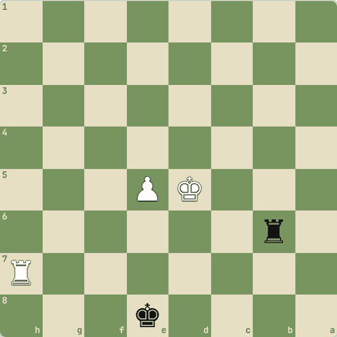
(Black ki chaal)

7.6.6 Sawal 1: Passed pawn ke saath rook kahan rakhna chahiye?
Passed pawn ke saath rook kahan rakhna chahiye?
Jawab:
✓ Pawn ke peeche
- Tarrasch rule: rook pawn ke peeche se uske saath aage badhta hai, aur zyada active hota hai.

7.6.7 Vancura defense
- Rook + a-pawn vs rook, jab White rook pawn ke aage (a8) ho aur pawn a6 par.
- Black rook side se (f6) pawn par attack karta hai.
- White king paas aaye to side se checks.
- Black king g7/h7 par.
- Result: draw.
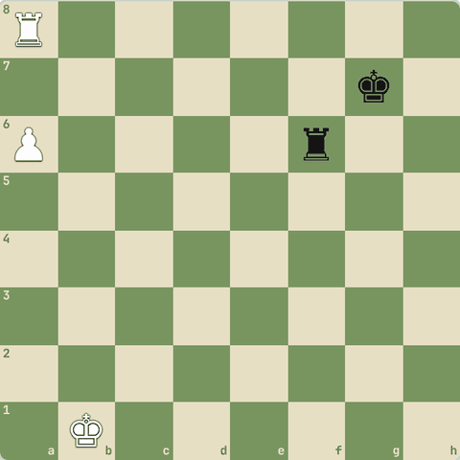

7.6.8 Khud khelo: Draw bachao
Vancura: tum Black ho. 15 chaal draw bachao. Rook se a6 pawn par nazar aur side se checks.
Hint: Rook ko 6th rank par rakho, pawn ko attack karte raho.
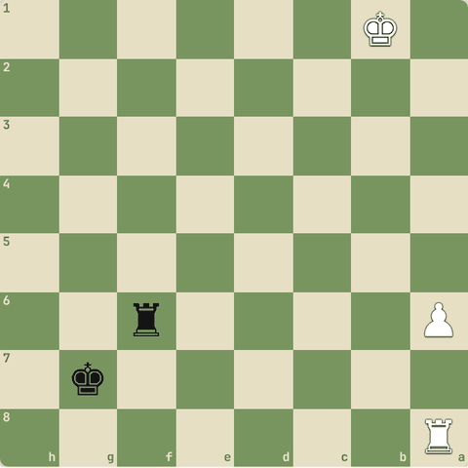
(Black ki chaal)

7.6.9 Sawal 2: Philidor position mein Black rook kahan rehta hai jab tak pawn 6th…
Philidor position mein Black rook kahan rehta hai jab tak pawn 6th rank par nahi aata?
Jawab:
✓ Apni 3rd rank (6th rank) par
- Rook 6th rank par White king ko aane se rokta hai.
- Pawn 6th par aaye to rook peeche jaakar checks.

7.7 Minor pieces aur theory
Good/bad bishop, wrong corner, kaun jeetta hai
Yaad rakho
- K+Q vs K, K+R vs K jeet. K+B vs K, K+N vs K, K+N+N vs K draw.
- K+B+N vs K jeet par mushkil: bishop ke color wale corner mein mate.
- Wrong bishop + h-pawn: corner ka color bishop se alag = draw.
- Open board, dono kinaron par pawns = bishop behtar. Band position = knight.
- Opposite color bishops: aksar draw.

7.7.1 Kaunse endgames jeet, kaunse draw
- K+Q vs K, K+R vs K: jeet
- K+B+N vs K: jeet par mushkil (corner us color ka jo bishop control karta hai)
- K+N+N vs K: draw (force nahi kar sakte)
- K+B vs K, K+N vs K: draw
- K+Q vs K+R: aksar jeet (technique lambi)
- K+R vs K+B, K+R vs K+N: aksar draw
- K+R+P vs K+R: depends: Lucena jeet, Philidor draw
- Opposite color bishops + pawns: aksar draw chahe ek-do pawn zyada ho

7.7.2 Sawal 1: Wrong bishop
Wrong bishop: White ke paas h-pawn aur light-square bishop hai. Black king h8 corner mein. Result?
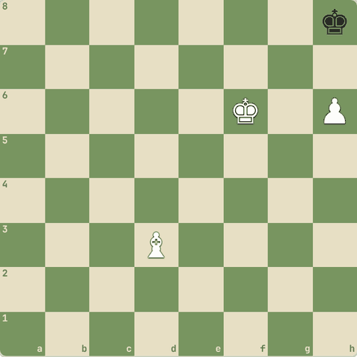
Jawab:
✓ Draw: bishop h8 (dark square) control nahi karta
- Corner square ka color bishop se alag hai, king nikala nahi ja sakta.
- Famous draw!

7.7.3 Sawal 2: K + do knights vs akela K?
K + do knights vs akela K?
Jawab:
✓ Draw (force nahi hota)

7.7.4 Sawal 3: Bishop vs knight endgame
Bishop vs knight endgame: pawns dono kinaron par hain, board open hai. Kaun behtar?
Jawab:
✓ Bishop
- Bishop lambi doori se dono taraf kaam karta hai.
- Knight band positions mein behtar.

7.7.5 Diagram: Wrong bishop
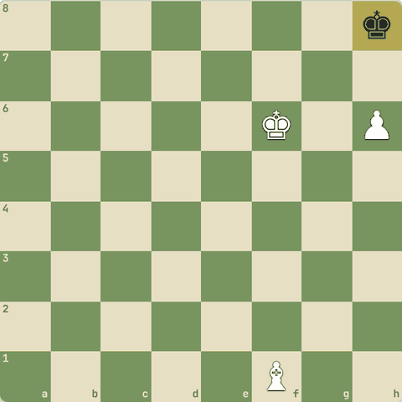
Wrong bishop: light bishop h8 (dark) control nahi karta = draw

Level 8: Pro level: practical chess
Deep calculation, time, psychology, analysis, improve aur jeetne ke tips, world champions, Queen's Gambit series, quotes, training plan
- Ab practical player banna hai: tournament mein sahi faisle, apni galtiyon se seekhna, aur masters se prerna.

8.1 Deep calculation
Grandmaster ki tarah sochna
Yaad rakho
- Candidate moves ka tree banao, har branch ek baar.
- Kotov rule: line baar-baar mat dekho, ek baar gehra dekho aur faisla karo.
- Forcing line ke beech quiet moves mat bhoolo.
- Aakhri check: opponent ka sabse forcing jawab kya hai?

8.1.1 Calculation ke pro tips
- Tree banao: candidate moves → har ek ke 1-2 best jawab → aage. Har branch ek baar, saaf.
- Kotov rule: ek line ko baar-baar mat dekho. Ek baar gehra dekho, faisla karo.
- Comparison: aksar perfect calculation ki zaroorat nahi, bas kaunsi line behtar hai.
- Quiet moves ko mat bhoolo: forcing line ke beech ek shaant chaal bhi hoti hai.
- Blunder check (aakhri 10 second): "Opponent ka sabse forcing jawab kya hai?"
- Intuition + calculation: pehle feel, phir calculation se check.
- Training: roz 15-30 min tough puzzles bina board chhuye solve karo, poori line dimaag mein.

8.1.2 Abhyaas: Calculate karo
Calculate karo: mate in 5! (Philidor's legacy, saari chaalein forcing)
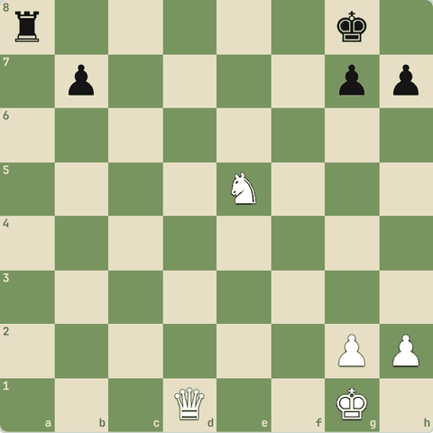
(White ki chaal)
Jawab:
1. Qd5+ Kh8 2. Nf7+ Kg8 3. Nh6+ Kh8 4. Qg8+ Rxg8 5. Nf7#
- `Qd5+ Kh8 Nf7+ Kg8 Nh6+ Kh8 Qg8+!
- Rxg8 Nf7#`.
- Smothered mate: forcing moves ko end tak calculate karna seekho.
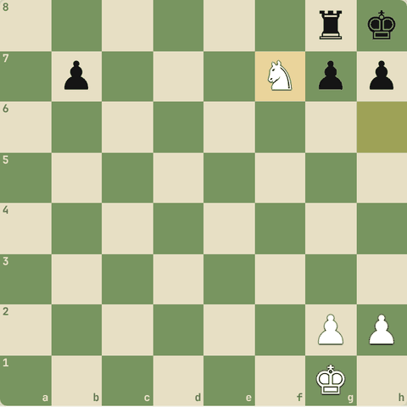
Line ke baad position

8.1.3 Sawal 1: Calculation ke end mein sabse zaroori kya hai?
Calculation ke end mein sabse zaroori kya hai?
Jawab:
✓ Blunder check: opponent ke checks/captures/threats

8.2 Time management
Clock bhi opponent hai
Yaad rakho
- Classical 60+ min, rapid 10-60, blitz ≤10, bullet <3. +2 = har chaal par 2 second.
- Opening jaldi, time critical positions mein lagao.
- Ek chaal par total time ka 10% se zyada kam hi.
- Time trouble mein simple, safe chaalein.

8.2.1 Clock ka khel
- Time controls (FIDE):
  - Classical: har player 60+ minute (jaise 90 min + 30 sec/move)
  - Rapid: 10 se 60 minute
  - Blitz: 10 minute ya kam (jaise 3+2, 5+0)
  - Bullet: 3 minute se kam (online)
- Increment (+2): har chaal ke baad 2 second judte hain.
- Tips:
- Opening jaldi (jo aata hai), sabse zyada time critical positions mein (jab plan badle, ya tactics ho).
- Ek chaal par total time ka 10% se zyada kam hi lagao.
- Time trouble se bacho: simple, safe chaalein.
- Opponent ke time mein bhi socho (general plans).

8.2.2 Sawal 1: 5+3 blitz mein "+3" ka matlab?
5+3 blitz mein "+3" ka matlab?
Jawab:
✓ Har chaal ke baad 3 second judte hain

8.2.3 Sawal 2: Sabse zyada time kahan lagana chahiye?
Sabse zyada time kahan lagana chahiye?
Jawab:
✓ Critical positions: tactics, plan badalne ka mauka

8.3 Psychology aur practical play
Dimaag ko control karo
Yaad rakho
- Haar ke baad gussa (tilt) = break lo.
- Stronger opponent se mat daro, normal achhi chaalein.
- Jeeti position mein relax mat ho; haarti position mein resist karo.
- Neend, paani, fitness aur warm-up routine.

8.3.1 Mental game
- Tilt: ek haar ke baad gusse mein games mat khelo. Break lo.
- Stronger opponent: darr ke draw mat khelo, normal achhi chaalein. Rating board par nahi khelti.
- Jeeti position: relax mat ho. "The hardest game to win is a won game." Safe moves, counterplay rokna.
- Haarti position: resist karo! Complications, traps, time pressure: comeback hote hain.
- Draw offers: position aur tournament situation dekh kar.
- Fitness, neend, paani: lambe games mein bahut fark padta hai.
- Routine: game se pehle halka warm-up (puzzles), phone door.

8.3.2 Sawal 1: Lagaataar 3 blitz haar gaye aur gussa aa raha hai
Lagaataar 3 blitz haar gaye aur gussa aa raha hai. Kya karein?
Jawab:
✓ Break lo, phir analyse karo

8.4 Apne games analyse karo
Sabse tez improvement
Yaad rakho
- Pehle khud analyse karo, phir engine.
- Critical moments dhundo, aur engine ki chaal kyun best hai samjho.
- Galtiyon ki category banao (tactic, blunder, time, plan, endgame) aur wahi train karo.

8.4.1 Analysis ka sahi tareeka
- Game ke baad pehle khud analyse karo (bina engine): kahan socha, kya miss kiya. Apne thoughts likho.
- Critical moments dhundo: jahan eval bada badla ya plan badla.
- Opening: kahan theory se bahar aaye? Sahi chaal note karo.
- Phir engine se check karo. Sirf "best move" mat dekho: kyun best hai, samjho.
- Galtiyon ko category mein daalo: tactic miss, blunder, time, plan, endgame technique. Jo zyada ho, wahi train karo.
- Haare games sabse zyada sikhate hain.
- Is app ke Trainer mein Stockfish coach tumhare games ki galtiyan samjhata hai.
- Aur yahan ka 🤖 AI coach se bhi pooch sakte ho.

8.4.2 Sawal 1: Game ke baad engine kab use karein?
Game ke baad engine kab use karein?
Jawab:
✓ Pehle khud analysis, phir engine se check

8.5 Improve aur jeetne ke tips
Self analysis, thoda strong opponent, feedback, tactical monster, golden goose, opening stats, Art of War
Yaad rakho
- Apne games khud analyse karo (engine se pehle).
- Thoda strong opponents se khelo: sabse zyada seekhoge.
- Alag-alag tareeke try karo: OTB, online, rapid, classical, puzzles, books, coach.
- Bahar ke feedback (engine eval, logon ki raay) par andhaa bharosa mat karo: samjho kyun.
- Priority: "tactical monster" bano. Tactics = undo button: galti hui to tactics se wapsi.
- Golden goose: sirf jeet (ande) mat dekho, apna improvement (hans) bachao. Kamzor opponents ko pita kar khush mat ho.
- Jeet ke liye: piece activity, king attack, lagaataar pressure, opening aur middlegame ka link.
- Opening wahi khelo jisme tumhare stats achhe (Chess for Tigers). Kasparov ki nakal mat karo bina samjhe.
- Art of War: khud ko, opponent ko aur maidan (time control, situation) ko jaano.

8.5.1 Improve kaise karein
- Self analysis: har game ke baad pehle khud analyse karo, apne thoughts likho, phir engine.
- Thoda strong opponents: unse haar kar sabse zyada seekhoge.
- Experience ke alag tareeke: OTB tournaments, online, rapid/classical, puzzles, books, coach. Dekho kya kaam karta hai.
- Bahar ke feedback se savdhaan: engine ka number ya kisi ki raay bina samjhe mat maano.
- Knowledge ki priority: "tactical monster" bano. Teichmann: "chess 99% tactics hai." Tactics har phase mein hain aur tumhara undo button hain.

8.5.2 Sawal 1: Sabse zyada seekhne ke liye kisse khelo?
Sabse zyada seekhne ke liye kisse khelo?
Jawab:
✓ Thode strong players
- Challenge = growth.

8.5.3 Sawal 2: Course ke "undo button" model mein undo button kya hai?
Course ke "undo button" model mein undo button kya hai?
Jawab:
✓ Tactics ki taakat
- Strong tactics se galti ke baad bhi wapsi ho sakti hai.

8.5.4 Jeetne ke tips
- Golden goose ka khayal: sirf jeet (ande) ke peeche mat bhaago, apna improvement (hans) zyada keemti.
- Piece activity: Fischer ki tarah pieces hamesha active; nahi to counterplay.
- King attack aur pressure: lagaataar dabaav se opponent galti karta hai.
- Opening-middlegame link: opening ke plans middlegame tak samjho.
- Opening choice: apne games ke stats dekho (book "Chess for Tigers"), jisme jeet zyada woh khelo. Kasparov mat bano: GM ki chaalein bina samjhe copy mat karo.
- Context aur Art of War: khud ko, opponent ko aur maidan (time control, zaroori result, thakaan) jaano. "Pehle khud ko haar se bachao, phir attack."

8.5.5 Sawal 3: Opening chunne ka practical tareeka?
Opening chunne ka practical tareeka?
Jawab:
✓ Jisme tumhare apne games ke stats achhe hain aur jiske plans samajhte ho
- Apna data + samajh.

8.5.6 Sawal 4: "Golden goose" kis cheez ka prateek hai?
"Golden goose" kis cheez ka prateek hai?
Jawab:
✓ Tumhara lambi-avadhi ka improvement
- Ande (jeet) aate rahenge agar hans (improvement) zinda hai.

8.6 Master games aur chess ka itihaas
Opera Game, world champions
Yaad rakho
- Opera Game (Morphy 1858): development + open lines = attack.
- Chess ka janam Bharat mein: Chaturanga (6th century).
- Pehle World Champion Steinitz (1886). Bharat: Anand (5 baar), Gukesh (2024, sabse kam umar).
- Chess apne zamane ki culture, history aur technology dikhata hai (romantic era ke gambits se aaj ke engines tak).

8.6.1 Opera Game: Morphy vs Duke & Count (1858)
- Sabse famous game: development, open lines aur sacrifices ka perfect example.
1. e4 e5 2. Nf3 d6 3. d4 Bg4 4. dxe5 Bxf3 5. Qxf3 dxe5 6. Bc4 Nf6 7. Qb3 Qe7 8. Nc3 c6 9. Bg5 b5 10. Nxb5 cxb5 11. Bxb5+ Nbd7 12. O-O-O Rd8 13. Rxd7 Rxd7 14. Rd1 Qe6 15. Bxd7+ Nxd7 16. Qb8+ Nxb8 17. Rd8#
- 3...Bg4?! bishop jaldi trade hoga.
- 5.Qxf3 White ki queen active, development aage.
- 7.Qb3! f7 aur b7 dono par attack.
- 9.Bg5 ek aur piece develop. Black ke pieces bandh rahe hain.
- 10.Nxb5! sacrifice: lines kholo!
- 12.O-O-O rook seedha d-file par.
- 13.Rxd7! aur sacrifice.
- 15.Bxd7+
- 16.Qb8+!! Queen sacrifice!
- 17.Rd8# Mate! Seekh: development + open lines = attack.
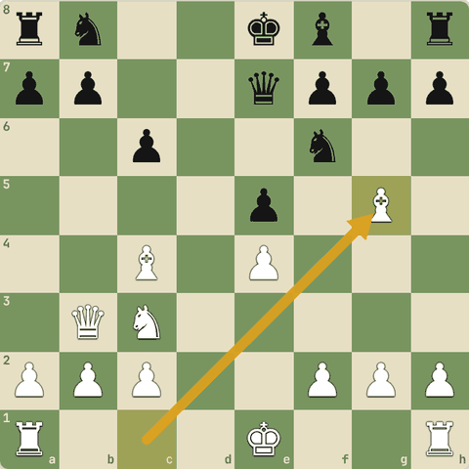
Position after 9.Bg5
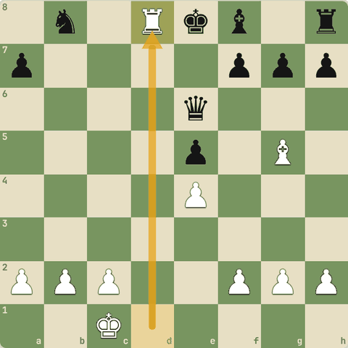
Final position (17.Rd8#)

8.6.2 Chess ki kahani
- Chess ka janam Bharat mein hua: 6th century ka Chaturanga (4 ang: haathi, ghoda, rath, paidal).
- Persia mein Shatranj, phir Europe. ~1475 mein Spain mein modern queen aur bishop ki chaal.
- Pehle official World Champion: Wilhelm Steinitz (1886).
- Legends: Capablanca, Alekhine, Botvinnik, Tal, Bobby Fischer, Karpov, Garry Kasparov, Magnus Carlsen.
- Bharat ke heroes: Viswanathan Anand (5 baar World Champion), aur D. Gukesh jo 2024 mein sabse kam umar ke World Champion bane. Praggnanandhaa, Arjun Erigaisi, Koneru Humpy, Divya Deshmukh bhi top par.
- Chess960 (Freestyle): pieces ki starting position random, theory kam, samajh zyada.

8.6.3 Sawal 1: Chess ka janam kahan hua?
Chess ka janam kahan hua?
Jawab:
✓ Bharat (Chaturanga)

8.6.4 Sawal 2: Opera Game ka main lesson?
Opera Game ka main lesson?
Jawab:
✓ Development aur open lines se attack

8.6.5 Chess aur zamana
- Har daur ka chess apne zamane ko dikhata hai: 19vi sadi ka romantic daur (gambits, sacrifices), phir scientific daur (Steinitz ke principles), Soviet school, aur aaj engines aur online chess.
- Chess ke itihaas mein culture aur technology dono dikhte hain.

8.7 World champions: Anderssen se Euwe tak
Immortal game, Steinitz, Lasker, Capablanca, Alekhine, Euwe
Yaad rakho
- Anderssen: Immortal Game (1851): dono rooks, bishop aur queen de kar mate.
- Morphy: Opera Game (1858): development aur open lines.
- Steinitz (1886-1894): pehle official champion, positional principles ke pita.
- Lasker (1894-1921): 27 saal champion, practical fighter; Lasker-Bauer: do bishops ka sacrifice.
- Capablanca (1921-1927): saaf, simple chess aur endgame ke jaadugar.
- Alekhine (1927-35, 1937-46): attack aur combinations. Euwe (1935-37): amateur jo champion bana.

8.7.1 Immortal Game: Anderssen vs Kieseritzky (1851)
- Romantic daur ka sabse famous game: White ne dono rooks, ek bishop aur queen de diye!
1. e4 e5 2. f4 exf4 3. Bc4 Qh4+ 4. Kf1 b5 5. Bxb5 Nf6 6. Nf3 Qh6 7. d3 Nh5 8. Nh4 Qg5 9. Nf5 c6 10. g4 Nf6 11. Rg1 cxb5 12. h4 Qg6 13. h5 Qg5 14. Qf3 Ng8 15. Bxf4 Qf6 16. Nc3 Bc5 17. Nd5 Qxb2 18. Bd6 Bxg1 19. e5 Qxa1+ 20. Ke2 Na6 21. Nxg7+ Kd8 22. Qf6+ Nxf6 23. Be7#
- 2.f4 King's Gambit.
- 17.Nd5! material ki parwah nahi.
- 18.Bd6!! rook g1 bhi de diya.
- 19.e5! queen ko a1 tak jaane do.
- 21.Nxg7+
- 22.Qf6+!! queen bhi!
- 23.Be7# Teen minor pieces ka mate.
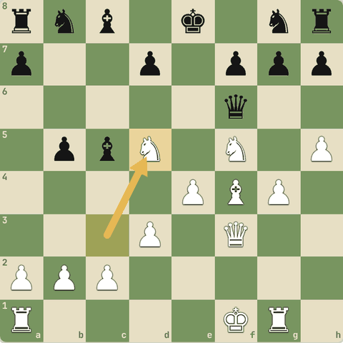
Position after 17.Nd5
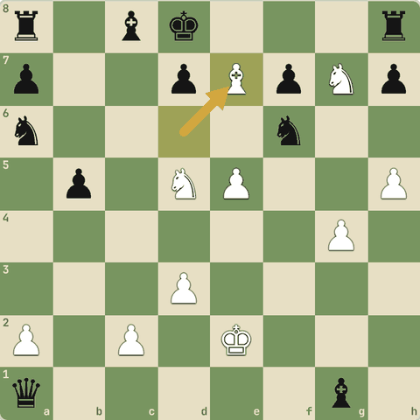
Final position (23.Be7#)

8.7.2 Pehle champions
- Wilhelm Steinitz (1886-1894): pehle official World Champion. Positional chess ke principles diye (weak squares, bishop pair, defense).
- Emanuel Lasker (1894-1921): 27 saal champion. Psychology aur practical chess. Famous: Lasker vs Bauer (1889): Bxh7+ aur Bxg7 do bishops ka sacrifice.
- Jose Raul Capablanca (1921-1927): simple, saaf, endgame ka jaadugar. "Endgame pehle padho."
- Alexander Alekhine (1927-1935, 1937-1946): bhayankar attack aur gehri combinations. Champion rehte hue hi guzre.
- Max Euwe (1935-1937): maths teacher, amateur jo Alekhine ko hara kar champion bane; baad mein FIDE president.

8.7.3 Lasker vs Bauer (1889): do bishops ka sacrifice
- Pehli baar famous "double bishop sacrifice".
1. f4 d5 2. e3 Nf6 3. b3 e6 4. Bb2 Be7 5. Bd3 b6 6. Nc3 Bb7 7. Nf3 Nbd7 8. O-O O-O 9. Ne2 c5 10. Ng3 Qc7 11. Ne5 Nxe5 12. Bxe5 Qc6 13. Qe2 a6 14. Nh5 Nxh5 15. Bxh7+ Kxh7 16. Qxh5+ Kg8 17. Bxg7 Kxg7 18. Qg4+ Kh7 19. Rf3
- 15.Bxh7+! pehla bishop.
- 16.Qxh5+
- 17.Bxg7!! doosra bishop.
- 18.Qg4+
- 19.Rf3 rook h-file par aayega: queen bachane ke liye Black ko queen deni padegi.
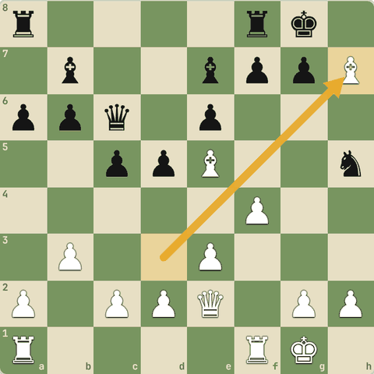
Position after 15.Bxh7+
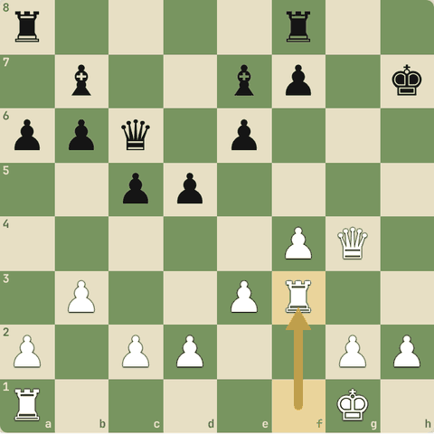
Final position (19.Rf3)

8.7.4 Sawal 1: Pehle official World Champion?
Pehle official World Champion?
Jawab:
✓ Steinitz
- 1886 mein Steinitz.

8.7.5 Sawal 2: Sabse lambe samay (27 saal) tak champion kaun raha?
Sabse lambe samay (27 saal) tak champion kaun raha?
Jawab:
✓ Lasker
- 1894-1921.

8.8 World champions: Botvinnik se Kasparov tak
Soviet school, Tal, Petrosian, Spassky, Fischer, Karpov, Kasparov
Yaad rakho
- Botvinnik (1948-57, 58-60, 61-63): Soviet school ke pita, scientific training.
- Smyslov (1957-58): harmony aur endgame.
- Tal (1960-61): "Riga ka jaadugar", sacrifices.
- Petrosian (1963-69): prophylaxis aur defense ("Iron Tigran").
- Spassky (1969-72): universal style.
- Fischer (1972-75): Spassky ko 1972 mein hara kar, akele Soviet system ke against.
- Karpov (1975-85): positional squeeze. Kasparov (1985-93/2000): dynamic, sabse dominant.

8.8.1 Soviet daur aur uske baad
- Mikhail Botvinnik (1948-57, 1958-60, 1961-63): scientific preparation, Soviet chess school.
- Vasily Smyslov (1957-58): harmonious positional play, endgames.
- Mikhail Tal (1960-61): Riga ka jaadugar: bold sacrifices.
- Tigran Petrosian (1963-69): prophylaxis, defense, exchange sacrifices.
- Boris Spassky (1969-72): universal style.
- Bobby Fischer (1972-75): 1972 Reykjavik mein Spassky ko hara kar Soviet daur toda.
- Anatoly Karpov (1975-85): positional squeeze, boa constrictor.
- Garry Kasparov (1985-1993, classical 2000 tak): dynamic, deep preparation, 20 saal no. 1.

8.8.2 Sawal 1: "Riga ka jaadugar" kaun?
"Riga ka jaadugar" kaun?
Jawab:
✓ Tal
- Mikhail Tal ke sacrifices.

8.8.3 Sawal 2: Prophylaxis (opponent ka plan pehle rokna) ke master?
Prophylaxis (opponent ka plan pehle rokna) ke master?
Jawab:
✓ Petrosian
- Iron Tigran.

8.8.4 Sawal 3: 1972 mein Spassky ko hara kar champion kaun bana?
1972 mein Spassky ko hara kar champion kaun bana?
Jawab:
✓ Fischer
- Reykjavik match.

8.8.5 Abhyaas: Champion jaisi nazar
Champion jaisi nazar: tactic dhundo.
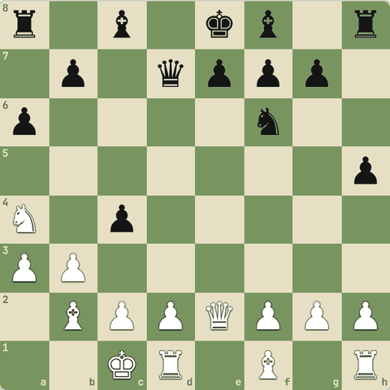
(White ki chaal)
Jawab:
1. Nb6 Qc6 2. Nxa8
- Line: Nb6 Qc6 Nxa8.
- Do nishaane ek saath.
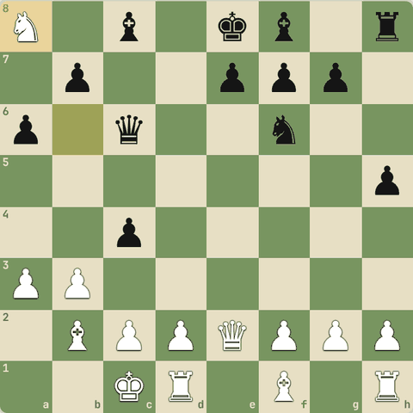
Line ke baad position

8.8.6 Abhyaas: Champion jaisi nazar
Champion jaisi nazar: tactic dhundo.
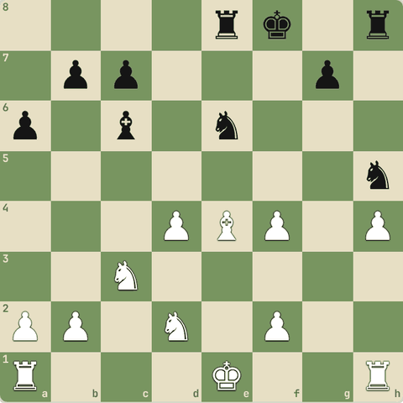
(White ki chaal)
Jawab:
1. d5 Nd4 2. dxc6
- Line: d5 Nd4 dxc6.
- Do nishaane ek saath.
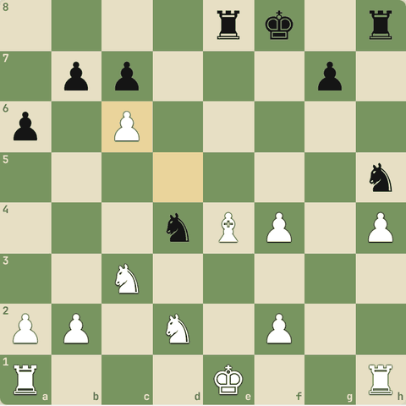
Line ke baad position

8.9 The Queen's Gambit series se sabak (1)
Episode 1-4: pitfalls, passed pawn, exchanges, doubled pawns
Yaad rakho
- Ep 1: Shaibel ka pehla sabak: opening pitfalls (jaldi queen, lalach); passed pawn breakthrough; ek sundar mate.
- Ep 2: Exchanges ki samajh (Beth vs Cooke), endgame mein tactics (Townes vs Beth), Beltik game (Nezhmetdinov-Kasparian 1955 par based).
- Ep 3: Doubled pawns ka upside (Caro-Kann, Cincinnati); Benny doubled pawns allow karke Beth ko harata hai.
- Ep 4: Fischer-Larsen game; jeet rahe ho to pieces trade (Anand-Kasparov); Bernstein-Capablanca back-row mate; Borgov vs Beth (Stein ka game).

8.9.1 Episode 1 aur 2
- Game 1: Beth ka pehla sabak: opening ka pitfall (Shaibel ne jaldi aayi queen ko saza di). Level 2 ke traps yaad karo.
- Game 2: ek aur opening pitfall: lalach.
- Game 3: passed pawn breakthrough (Endgames level ka pawn trick).
- Game 4: ek sundar checkmate.
- Ep 2: Beth vs Cooke: exchanges sahi waqt par. Townes vs Beth: endgame mein bhi tactics. Beth vs Beltik: Nezhmetdinov vs Kasparian (1955) ke famous game par based.

8.9.2 Sawal 1: Episode 1 game 3 ka idea kaunsa endgame trick tha?
Episode 1 game 3 ka idea kaunsa endgame trick tha?
Jawab:
✓ Passed pawn breakthrough
- Teen pawns vs teen pawns, sacrifice se queen.

8.9.3 Episode 3 aur 4
- Ep 3: Doubled pawns ka upside: Caro-Kann mein doubled pawns ke saath bhi strong position. Benny Watts ne US Championship mein doubled pawns allow karke Beth ko haraya: har structure ke dono pehlu.
- Ep 4: Beth ne Fischer vs Larsen ka game follow kiya. Jeet rahe ho to pieces trade karo, pawns nahi (Anand vs Kasparov). Episode ka naam "Middle game": Bernstein vs Capablanca ka famous back-row mate. Borgov vs Beth: Leonid Stein ke game par based.

8.9.4 Sawal 2: Episode 4 mein jeet rahe player ke liye sabak?
Episode 4 mein jeet rahe player ke liye sabak?
Jawab:
✓ Pieces trade karo, pawns nahi
- Middlegame 3 (Strategy): exchanges.

8.10 The Queen's Gambit series se sabak (2)
Episode 5-7: fork, mate in 3 problems, Opera game, Borgov ke saath final
Yaad rakho
- Ep 5 ("Fork"): Smyslov-Botvinnik ka game dikhaya: fork ki taakat.
- Ep 6: Wexler ka mate-in-3 problem; Beth ne Benny ko haraya (Kasparov-Van Wely par based); blitz simul mein Opera game; Paris mein Averbakh-Tolush (1963) jaisi jeet; thakaan mein Borgov se haar.
- Ep 7: Shaibel ki deewar par mate-in-3 puzzle; Hellstrom vs Beth (Topalov-Kasparov 1995); Borgov ke saath final mukabla.
- Sabak: preparation, team work aur saaf dimaag (thakaan aur nasha game kharab karte hain).

8.10.1 Episode 5, 6, 7
- Ep 5 "Fork": Smyslov vs Botvinnik ka fork wala game.
- Ep 6: Hilton Wexler ka mate in 3 chess problem. Beth ne Benny ko haraya (Kasparov vs Van Wely par based). Blitz simul ke teesre game mein Opera Game (Morphy). Paris (1967) mein Averbakh vs Tolush (1963) jaisi jeet. Paris mein thakaan/hangover ke saath Borgov se doosri haar.
- Ep 7: Shaibel ki deewar par lage mate in 3 puzzle. Moscow mein Hellstrom vs Beth (Topalov vs Kasparov 1995). Aur Borgov ke saath final: dosto ki help (adjournment analysis) aur saaf dimaag se jeet.

8.10.2 Sawal 1: Paris mein Borgov se haar ki ek badi wajah?
Paris mein Borgov se haar ki ek badi wajah?
Jawab:
✓ Thakaan aur nasha: dimaag saaf nahi tha
- Practical sabak: neend aur saaf dimaag.

8.10.3 Sawal 2: Ep 6 ke blitz simul mein Beth ne kaunsa famous game khela?
Ep 6 ke blitz simul mein Beth ne kaunsa famous game khela?
Jawab:
✓ Opera Game
- Morphy ka Opera Game (masters lesson mein dekha).

8.10.4 Abhyaas: Episode 5 "Fork"
Episode 5 "Fork": fork dhundo!
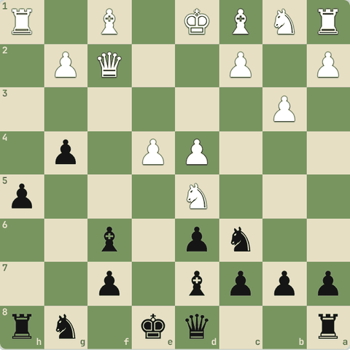
(Black ki chaal)
Jawab:
1… Bxd4 2. Qd2 Bxa1
- Line: Bxd4 Qd2 Bxa1.
- Double attack.
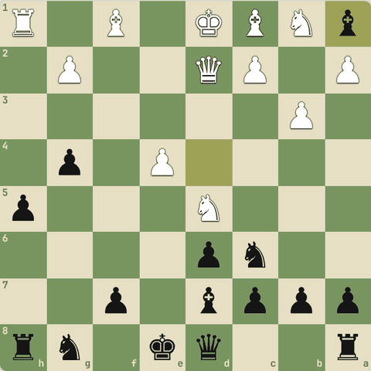
Line ke baad position

8.10.5 Abhyaas: Episode 5 "Fork"
Episode 5 "Fork": fork dhundo!
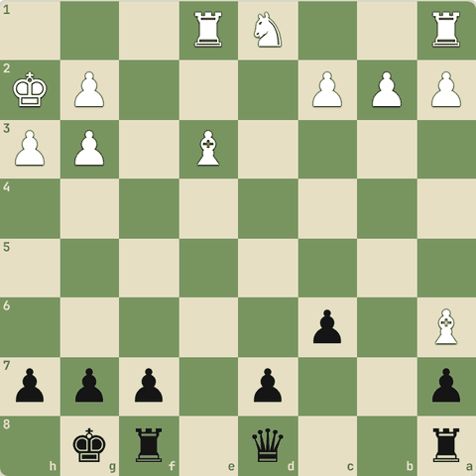
(Black ki chaal)
Jawab:
1… Qa5 2. Nc3 Qxa6
- Line: Qa5 Nc3 Qxa6.
- Double attack.
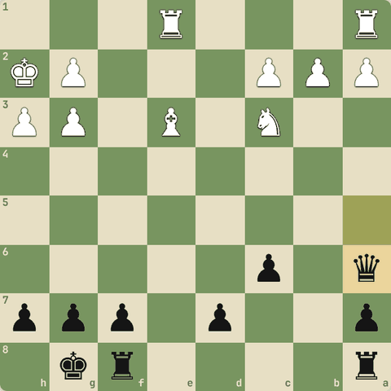
Line ke baad position

8.10.6 Abhyaas: Shaibel ki deewar jaisa
Shaibel ki deewar jaisa: mate dhundo.
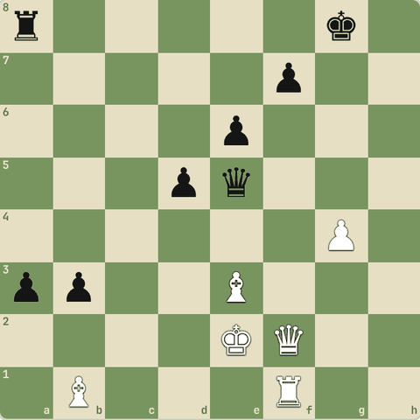
(White ki chaal)
Jawab:
1. Qxf7+ Kh8 2. Qh7#
- Line: Qxf7+ Kh8 Qh7#.
- Forcing moves se mate.
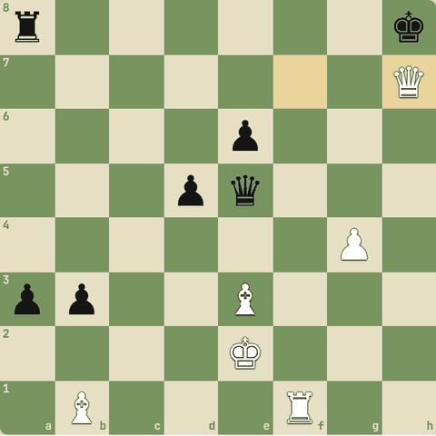
Line ke baad position

8.10.7 Abhyaas: Shaibel ki deewar jaisa
Shaibel ki deewar jaisa: mate dhundo.
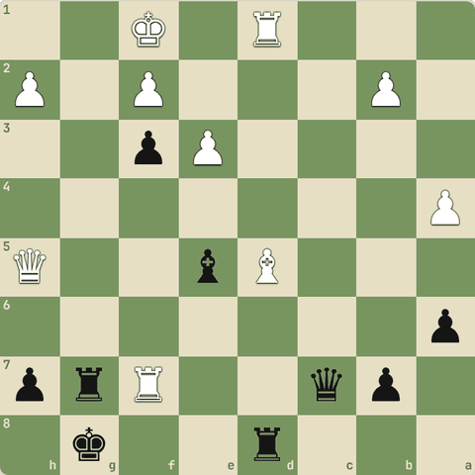
(Black ki chaal)
Jawab:
1… Qc4+ 2. Rd3 Qxd3+ 3. Ke1 Qe2#
- Line: Qc4+ Rd3 Qxd3+ Ke1 Qe2#.
- Forcing moves se mate.
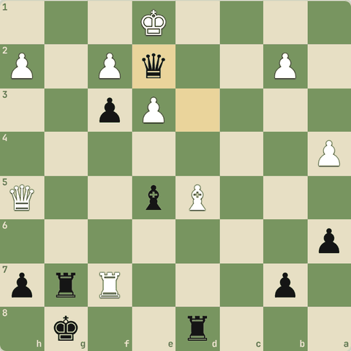
Line ke baad position

8.11 Opening, middlegame aur endgame ke famous quotes
Teen phases ke liye yaad rakhne layak baatein
Yaad rakho
- "Opening ko kitaab ki tarah, middlegame ko jaadugar ki tarah, endgame ko machine ki tarah khelo." (Spielmann)
- "Knights before bishops." (Lasker/Tarrasch ki salah)
- "Tactics: jab karne ko kuch ho to kya karna; strategy: jab kuch na ho to kya karna." (Tartakower)
- "Endgame pehle padho." (Capablanca)

8.11.1 Opening quotes
- "Opening ko kitaab ki tarah, middlegame ko jaadugar ki tarah, endgame ko machine ki tarah khelo." (Rudolf Spielmann)
- "Knights before bishops."
- "Apne pieces ki madad karo, woh tumhari madad karenge." (Paul Morphy)
- "Opening mein ek piece ko do baar mat chalao, jab tak zaroori na ho."

8.11.2 Middlegame quotes
- "Tactics = jab karne ko kuch ho to kya karna. Strategy = jab karne ko kuch na ho to kya karna." (Tartakower)
- "Achhi chaal dikhe to behtar dhundo." (Lasker)
- "Threat execution se zyada strong hoti hai." (Nimzowitsch)
- "Chess 99% tactics hai." (Teichmann)

8.11.3 Endgame quotes
- "Apna game behtar karna hai to endgame sabse pehle padho." (Capablanca)
- "Endgame mein king ek taakatwar piece hai."
- "Rook endings hamesha draw hote hain" (Tartakower ka mazaak: kyunki defence ke tareeke hote hain).
- "Passed pawns must be pushed."

8.11.4 Sawal 1: Spielmann ke hisaab se endgame kaise khelo?
Spielmann ke hisaab se endgame kaise khelo?
Jawab:
✓ Machine ki tarah
- Saaf, sateek technique.

8.11.5 Sawal 2: Tartakower
Tartakower: "jab karne ko kuch na ho to kya karna"?
Jawab:
✓ Strategy
- Plan banana = strategy.

8.12 Elo badhane ka training plan
Roz kya karein
Yaad rakho
- 0-1000: rules, hanging pieces, basic mates. 1000-1400: tactics. 1400-1800: calculation + endgames. 1800+: strategy.
- Roz 45-60 min: puzzles, lesson, ek slow game, analysis.
- Roz thoda, lagaataar: 3 mahine ki consistency = bada jump.
- Weak link in chain: tumhari sabse kamzor kadi (opening/middlegame/endgame) pehle mazboot karo.
- Concentric circles badhaate raho: principles, phir processes/patterns, phir details aur exceptions.

8.12.1 Rating ke hisaab se focus
- 0-1000: rules pakke, hanging pieces na dena, basic mates (Level 1-2). Roz 20 easy puzzles.
- 1000-1400: tactics, tactics, tactics aur mate patterns (Level 3-4). Opening principles. 15+10 rapid games.
- 1400-1800: calculation, basic endgames (Level 7), ek repertoire, apne games analyse.
- 1800-2200: strategy (Level 5), master games, gehri endgame theory, classical games.
- 2200+: coach, deep opening prep, tournaments, physical aur mental training.

8.12.2 Roz ka routine (45-60 min)
- 15 min: puzzles (is app ka Puzzles tab + review)
- 15 min: ek lesson ya endgame study
- 20 min: ek slow game (15+10 ya zyada), blitz kam
- 10 min: us game ka analysis
- Hafte mein ek baar: ek master game dhyan se
- Books (jab taiyaar ho): "Logical Chess: Move by Move" (Chernev), "Silman's Complete Endgame Course", "How to Reassess Your Chess" (Silman), "My System" (Nimzowitsch), "Dvoretsky's Endgame Manual" (advanced).
- Sabse badi baat: roz thoda, lagaataar. 3 mahine ki consistency = bada jump.

8.12.3 Sawal 1: 1200 rating par sabse zyada fayda kisse?
1200 rating par sabse zyada fayda kisse?
Jawab:
✓ Roz tactics puzzles + slow games + analysis

8.12.4 Course ka antim sandesh: weak link in chain
- Tumhari chess ek chain jaisi hai: sabse kamzor kadi jitni strong, utne tum.
- Apne games se pata karo kamzori kahan hai (opening, tactics, endgame, time) aur pehle wahi sudhaaro.
- Aur concentric circles badhaate raho: principles → processes/patterns → details/exceptions, teeno phases mein.

8.12.5 Sawal 2: Improvement ka "weak link in chain" model kya kehta hai?
Improvement ka "weak link in chain" model kya kehta hai?
Jawab:
✓ Sabse kamzor hissa pehle mazboot karo
- Chain sabse kamzor kadi se toot-ti hai.
Notes course.html ke lessons se bane hain. Course mein har lesson interactive hai: wahan khud khel kar pakka karo.

