**DETAILED PROJECT DESCRIPTION**

**Project Objectives:**

* To design an Electrical System for COVID-19 Decontamination for Industrial & Domestic purposes.
* To enhance indoor air quality to nullify any virus agents.

**Project Deliverables:**

* Fabricated Prototype of Installable Components in HVAC Systems such as Air Purifiers, Air Conditioners that act as a virus filter.
* Standalone Prototype Units which work for individual disinfection.
* Testing of Indoor Air Quality (IAQ) purification and test reports based on comparisons of the obtained results and previous measures of IAQ.
* 3-D simulations of working principles involved.
* Project Report with detailed diagrams and execution photographs of the suggested prototype.

**Abstract :**

This project aims at modifying existing HVAC Systems to install filtration components for COVID-19 disinfection by the theory of Electrical Charge Repulsion. Although the main focus on this project is for the novel coronavirus, we claim that this project will generalize in decontamination of any virus whatsoever as each and every virus carries some charged dipolar proteins.

Apart from inventing new systems, this research will attempt modifications to already existing systems in an inexpensive manner.

**Prerequisite Courses :**

PW-EE 781 - Project stage-I, ME 604A - Refrigeration and Air Conditioning, PC-EE 303- Electromagnetic Field Theory.

**Need for this Project:**

• The COVID-19 pandemic is growing exponentially and as people are spending more time indoors, proper methods of filter designs are necessary to battle the spread of this deadly virus.

• This research project proposes an economically viable electrically charged filtration system and aims at improving indoor air quality (IAQ) with a high-efficiency rating that provides a healthy atmosphere free from the virus.

• Existing Filters in the HVAC Industry are insufficient to eliminate the novel coronavirus from the filtered air as these particles are often much smaller than the diameter of the virus agent.

• The existing state-of-the-art technology of HEPA (High-Efficiency Particulate Air) Filters which is capable of filtering particles with AED (Aerodynamic Equivalent Diameter) of 0.3-microns (0.3 μm) with a high efficiency of 99.97% (Particulate Matter-PM0.3). However, the problem with these filters is that virus agents often have an AED<PM0.3. Hence, these particles pass through the virus unfiltered.

• Hence, the proposed solution requires a change in the classical systems, and postulates the use of mutually perpendicular electrical and magnetic fields for the suitable deflection of the virus particles, causing them to subsequently be rejected by the air passing to as input to the system and can be used to enhance indoor air quality.

• This technology can be further explored for installation and extension into different air purification technologies and can help prevent viral infections in the future, should the need/requirement arise.

**Status of the work done:**

Attempts to eliminate the novel coronavirus have been made but none of them proposes complete rejection of the virus with 100% efficiency. Our research proposes an idea that is fully resistant to any viral infection in the air particles and is aimed at Indoor Air Quality Improvement.

**Detailed Methodology:**

Every single virus has some dipolar charges associated with its protein fibers and this can also be used against the virus itself with the help of some electrical & properties of dipoles.

Therefore, in this project, we provide an alternative to the traditional filtering systems and replace them with electrical systems that eliminate viruses by the principle of charge induction with the help of mutually perpendicular Electrical and Magnetic Fields.

[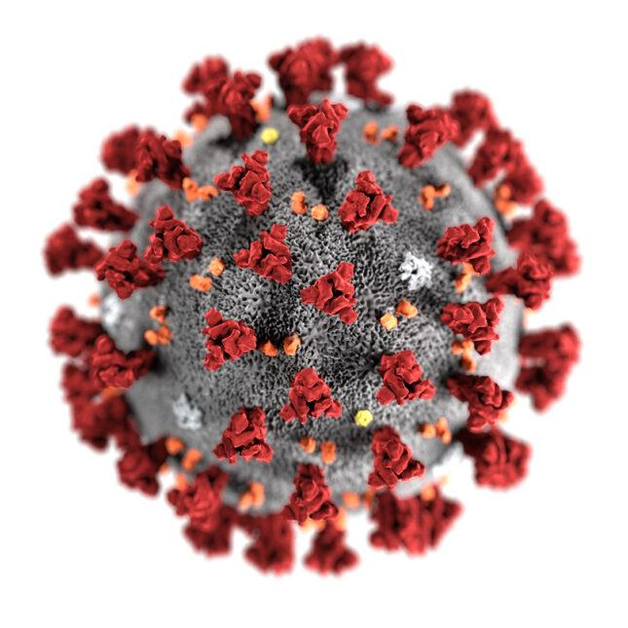](https://www.statnews.com/wp-content/uploads/2020/02/Coronavirus-CDC-645x645.jpg)

**Fig.1 Visualization of the novel coronavirus on a microscope**

*Image Source*: StatNews[1]

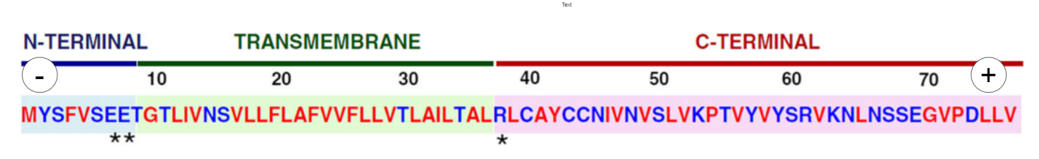

# *Image Source*: Coronavirus envelope protein: Current knowledge[2]

**Fig. 2 Visual Interpretation of the coronavirus Protein Chain Polymers as Electric Dipoles:** Amino Acid Sequence and Domains of the SARS-CoV E Protein display dipole like properties: The amino (N) - terminal domain consists of negatively charged amino acids, the transmembrane domain (TMD) is neutral, and the carboxy (C)-terminal domain consists of positively charged Amino Acids. Amino acid properties are indicated: hydrophobic (red), hydrophilic (blue), polar, charged (asterisks).

**Overview and Operating Principle Involved:**

In the proposed system, intake air is sent to a filtration unit where the air is divided into a streamlined beam-like flow with the help of a pressure valve. This is obtained by maintaining pressure gradients and uniform elevation. Hence, Bernoulli’s Theorem is applicable to the air particles at this portion of the system.

Mathematically,

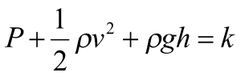

where,

P=Pressure of Air passing through the Filtration Unit

*ρ*=Density of the Air passing through the Filtration Unit

v=Velocity of the Air passing through the Filtration Unit

g=Acceleration due to gravity

h=Elevation of the Filtration Unit

k=Some Arbitrary Constant

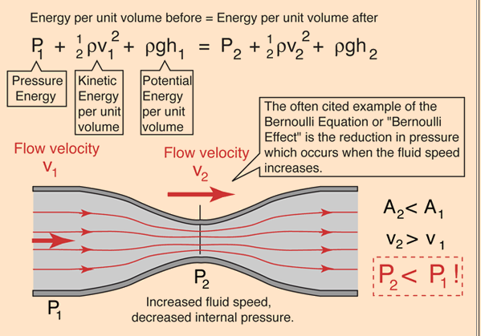

*Image Source:* Quora[3]

**Fig 3. Bernoulli’s Theorem:** To vary the output velocity (v2) of the fluid, the output pressure (P2) needs to get adjusted accordingly. This procedure for varying the velocity of the fluid to a desired value is done by using a pressure valve.

This equation can be further simplified as,

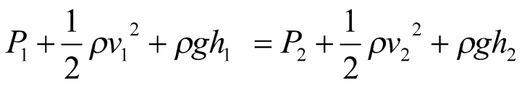



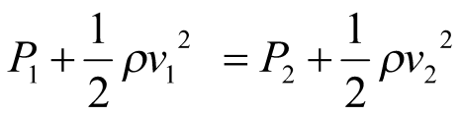

(Assuming elevation is same, h1=h2)

where,

1=Initial Intake before Entering the Filtration Unit

2=Intermediate Air Passing through the Filtration Unit

From the above equation, the value of Output Velocity (v2) can be obtained knowing the other variables.

Now, the virus particles which basically consist of protein chain polymers and are dipoles can be exposed to mutually perpendicular electrical and magnetic fields.

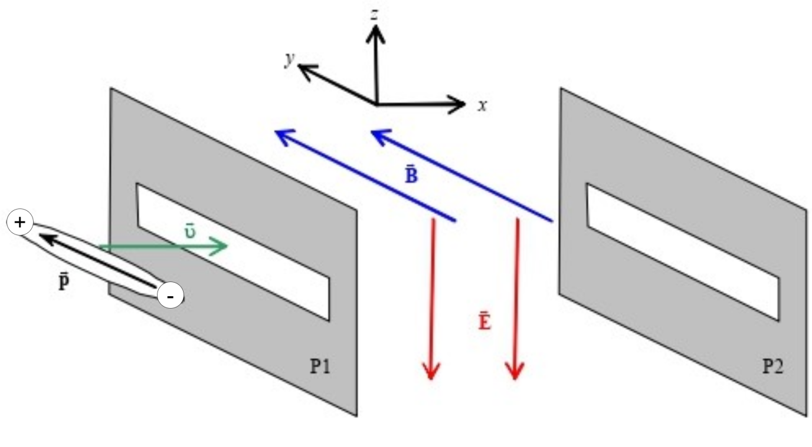

*Image Source:*  Motion of an electric dipole in a static electromagnetic field[4]

**Fig 4. Schematic Diagram of a Molecular Polarizer:** Two horizontal molecular polarizers P1 and P2 sandwich a region of crossed magnetic and electric fields directed along the +y and –z axes, respectively. A long molecule with an electric dipole moment oriented along its axis is shown entering the device with a translation velocity at the +x direction.

This dipole when experiencing mutually perpendicular Electric and Magnetic fields, begins to rotate due to an induced Torque ( ), given by the mathematical equation,



where,

=Net Torque acting on the dipole P

= Dipole Moment of the dipole P

= Applied Electric Field to the Dipole P

= Applied Magnetic Field to the Dipole P &

= Translational Velocity of the Dipole P

Hence, a suitable static electromagnetic field is generated across the passing air through the Filtration Unit which screens the coronavirus cells by rotating them at 90 degrees in motion. However the suitable distance (d) between the two polarizers can only be obtained after experimentation with the virus protein dipole itself.

Since these virus agents also have some initial translatory motion associated with them, the vector addition result of this linear motion and rotation leads them to separation from the initial air sample by the polarizer apparently rejecting the rotating the dipoles when kept at the distance (d).

After extraction, these virus agents are sent to a collector, where the virus is stored till it becomes inactive or it is destroyed using some chemicals. This process is explained in detail below.

**Components Required:**

• Air Purification System – Basic Initial System that purifies air using HEPA Filters. This can be any preliminary system such as Air Purifiers or Air Conditioners over which our project will install additional equipment on existing systems and will have minimum interference with the standalone working of such classical systems.

• Pipes – To circulate the intake air to the proposed system.

• Input Pressure Valve – To control and modify the input velocity of the air to be fed into the system.

• Polarizers – a polarizer by milling nano-sized slits through an impermeable membrane[6].

• Electric and Magnetic Field Generator Setups – This can be done using the principle of Electromagnetic Field Induction (EMI) with Solenoids and Rotating Coils of an AC Motor to induce the Fields using the AC Supply.

• Output Pressure Valve- To control and modify the output velocity of the air to be fed into the classical HEPA system.

**Integration into existing HVAC Systems:**

This project aims at modifying existing HVAC Systems to install filtration components for COVID-19 disinfection by the theory of Electrical Charge Repulsion. Although the main focus on this project is for the novel coronavirus, we claim that this project will generalize in decontamination of any virus whatsoever as each and every virus carries some charged dipolar proteins.

Apart from inventing new systems, this research will attempt modifications to already existing systems in an inexpensive manner. A schematic diagram for the setup used in collaboration with the existing HVAC Systems. In the figure below in place of the normal air filter, we will use our proposed air filter with the default air filtration system.

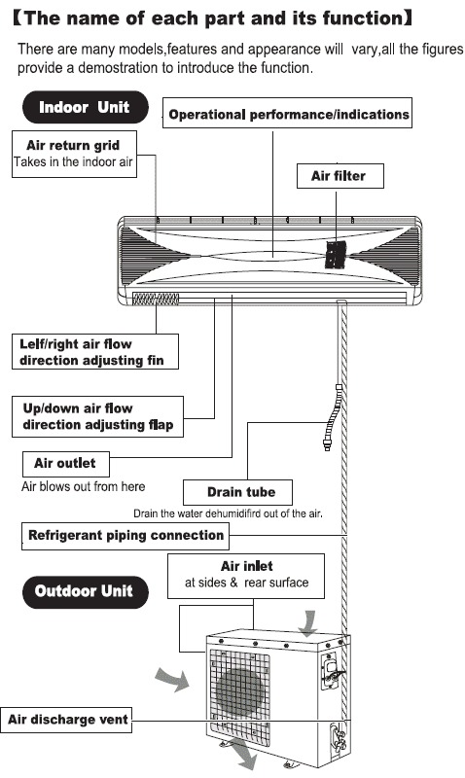

**Fig 5. Schematic Diagram of the Proposed System:** The proposed filter will not change the working dynamics of the existing classical systems; instead it will attempt to be installed in these systems with suitable modifications.

**Future Scope and Research:**

The major disadvantage of the methodology mentioned in the project is that the coronavirus cells are aggregated in the collector and remain active for some days before finally becoming dead cells. It would be best to destroy these cells at the time of entry detection itself. But this procedure itself poses its own problem and issues.

To solve this issue, a high electromagnetic field is generated across the passing air and this leads to unstable coronavirus cells, which ultimately leads to the decomposition of these viruses by destroying their protein chain polymers. However, such high fields are almost impossible to generate, require specialized equipment, and can be dangerous to handle itself.

However, administering the cleansing of the collector can be done using many techniques but requires safety precautions and can be done using some chemical compounds through suitable reactions for virus destruction[5]. Some of the methods are:

1. Using 0.1% Sodium Hypochlorite Solution (NaClO-Cl2 Bleach Solution) or 0.5% Hydrogen Peroxide Solution (H2O2) to oxidize and destroy virus proteins and genetic material.
2. Using 70% Alcohol Solution (Isopropanol) to dissolve virus fat layers and damage virus protein structures.

**Authors with Contact Details**

* Rounik Roy, Mob.: 9609003695,   
  Mail ID: [rounikroy72@gmail.com](mailto:kundutiyasa1999@gmail.com)
* Namrata Das, Mob.: 9679166333,   
  Mail ID: [namratads.blg@gmail.com](mailto:namratads.blg@gmail.com)
* Farhan Hai Khan, Mob.: 746402755,   
  Mail ID: [njrfarhandasilva10@gmail.com](mailto:njrfarhandasilva10@gmail.com)

**Review and References:**

[1] Observed Coronavirus Particles under a Microscope, Highly Magnified, Statnews.

[statnews.com/wp-content/uploads/2020/02/Coronavirus-CDC-645x645.jpg](https://www.statnews.com/wp-content/uploads/2020/02/Coronavirus-CDC-645x645.jpg)

[2] Schoeman, D., Fielding, B.C. Coronavirus envelope protein: current knowledge. *Virol J* 16, 69 (2019). [doi.org/10.1186/s12985-019-1182-0](https://doi.org/10.1186/s12985-019-1182-0)

[3] Bernoulli’s Equation, A. Shrikoti, IITR. [quora.com/What-is-the-statement-of-Bernoullis-equation](https://www.quora.com/What-is-the-statement-of-Bernoullis-equation)

[4] Mungan, Carl & Lasinski, Andrew. (2008). Motion of an electric dipole in a static electromagnetic field. Latin-American Journal of Physics Education. 2. 192-194. [researchgate.net/publication/26568536_Motion_of_an_electric_dipole_in_a_static_electromagnetic_field](https://www.researchgate.net/publication/26568536_Motion_of_an_electric_dipole_in_a_static_electromagnetic_field)

[5] Four Ways to Destroy Coronavirus, Compound Interest. [compoundchem.com/2020/03/31/destroy-coronavirus/](https://www.compoundchem.com/2020/03/31/destroy-coronavirus/)

[6] Frabboni, S., Gazzadi, G. C., and Pozzi, G., Young’s double-slit interference experiment with electrons Am. J. Phys. 75, 1053–1055 (2007). [doi.org/10.1119/1.2757621](https://doi.org/10.1119/1.2757621)

*Miscellaneous*

[6] Air Pollution Control Technology EPA CICA Fact Sheet, Fabric Filter: HEPA and ULPA Types, Particulate Matter Size and AED. <https://www3.epa.gov/ttncatc1/cica/files/ff-hepa.pdf>

**National Status Review**

1. Dipole Orientation in Molecular Proteins: Insights.
2. Electromagnetic Wave Amplitude Modulation.
3. Understanding Mutually Perpendicular Electric & magnetic Fields.
4. Spectral Results and Analysis of Electrical Dipole Rotation.
5. Virus Detection using Protein Chain Polymers containing Charges.

1. Vasanthi, G, Krishnaswamy, S, Dipole moment analysis of membrane proteins suggests role in orientation in the membrane, NISCAIR-CSIR, India, 93-100, IJBB Vol.39(2) [April 2002]. hdl.handle.net/123456789/19757

2. M S Sodha, A K Arora and P K Kaw, Amplitude modulation of electromagnetic waves by alternating magnetic fields, Journal of Physics A:

General Physics, Vol 1, No 1. doi.org/10.1088/0305-4470/1/1/312

3. K.V. Bhagwat, Selvakumar V. Nair, P. Chaddah, Mutually perpendicular magnetic fields parallel to a slab a test case for the critical state model,

Physica C: Superconductivity, Vol 227, (1–2), p.p. 176-182. doi.org/10.1016/0921-4534(94)90371-9

4. Lakshman, S V.J.; Rangachar, M R, Selection rules in electric dipole, magnetic dipole and electric quadrupole transitions, Indian J. Pure Appl. Phys Vol: 19:8, p.p. 698-708. osti.gov/etdeweb/biblio/6299703

5. Kaushik, A., Yndart, A., Kumar, S. *et al.* A sensitive electrochemical immunosensor for label-free detection of Zika-virus protein. *Sci Rep* 8, 9700 (2018). doi.org/10.1038/s41598-018-28035-3

**International Status Review**

1. Comprehensive Structure of the Coronavirus Agent:

Protein Fibres and Charge Distribution.

2. Protein Data Bank of the Coronavirus Agent.

3. Electromagnetic Field Theory: Dynamics for an

Electric Dipole.

4. Virus Detection in Ventilation Filters.

5. HVAC Microbiological Control for Indoor Air Quality

improvement.

1. Schoeman, D., Fielding, B.C. Coronavirus envelope protein: current knowledge. Virol J 16, 69 (2019). doi.org/10.1186/s12985-019-1182-0

2. Li, W. Structurally Observed Electrostatic Features of the COVID-19 Coronavirus-Related Experimental Structures inside Protein Data Bank: A Brief Update. Preprints 2020, 2020030081. doi.org/10.20944/preprints202003.0081.v1

3. Mungan, Carl & Lasinski, Andrew. (2008). Motion of an electric dipole in a static electromagnetic field. Latin-American Journal of Physics Education. 2. 192-194. researchgate.net/publication/26568536_Motion_of_an_electric_dipole_in_a_static_electromagnetic_field

4. Goyal, Sagar M *et al.* “Detection of viruses in used ventilation filters from two large public buildings.” *American journal of infection control* vol. 39,7 (2011): e30-8. doi.org/10.1016/j.ajic.2010.10.036

5. Schmidt, M.G., Attaway, H.H., Terzieva, S. *et al.* Characterization and Control of the Microbial Community Affiliated with Copper or Aluminum Heat Exchangers of HVAC Systems. *Curr Microbiol* 65, 141–149 (2012). doi.org/10.1007/s00284-012-0137-0