



**MINISTRY OF HEALTH AND FAMILY WELFARE**

Government of India

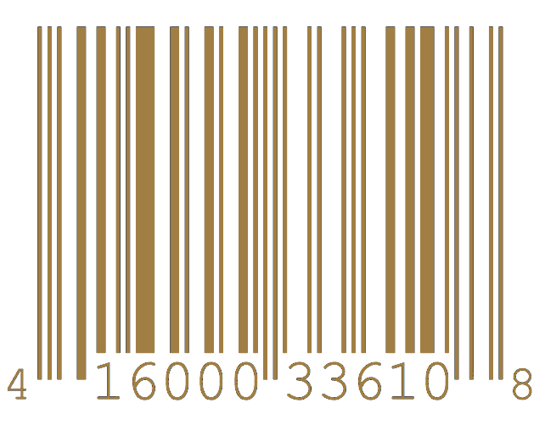

***Certificate of Virtual Checkup***



FARHAN_HAI_KHAN

Radiologist Department of Biotechnology

N. Misra

NIRMALYA_MISRA

Automation Engineer AI Cell

**TH I S E L E C T R O N I C H E A L T H C H E C K U P I S P R E S E N T E D T O**

Damik_Dhar

Coronavirus Scale : 00.00%

Automated Tests : Passed_1 Manual Tests : Passed_2

Comments : Fit for Travel

# UID (Aadhaar) : XXXX-XXXX-XXXX

Certificate ID : AAAA-AAAA-AAAA

F. H. Khan