

**MINISTRY OF HEALTH AND FAMILY WELFARE**

Government of India

***Certfificate of Virtual Checkup***

**THIS ELECTRONIC HEALTH CHECKUP IS PRESENTED TO**

**Farhan Hai Khan**

(FARHAN HAI KHAN)

Coronavirus Scale : 00.00%

Automated Tests : Passed_1

Manual Tests : Passed_2

Comments : Brief_Description

UID (Aadhaar) : XXXX-XXXX-XXXX

Certificate ID : AAAA-AAAA-AAAA

Generated : MMDDYYYY_TT

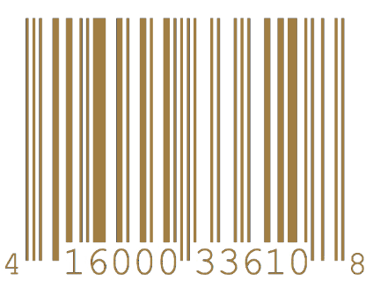

Rameshwar Manav

RAMESHWAR MANAV

Person_Designation

Signature_2

RAMESHWAR MANAV_2

Chief Engg. DVC_2