

**MINISTRY OF HEALTH AND FAMILY WELFARE**

Government of India

***Certfificate of Virtual Checkup***

**THIS ELECTRONIC HEALTH CHECKUP IS PRESENTED TO**

**Farhan Hai Khan**

(FARHAN HAI KHAN)

Coronavirus_Scale_Percentage

Automated_Test_Results

Manual_Reports

Summary_Brief_Description

UID (Aadhaar) : XXXX_XXXX_XXXX

Certificate ID : AAAA_AAAA_AAAA

Generated : MMDDYYYY_TT

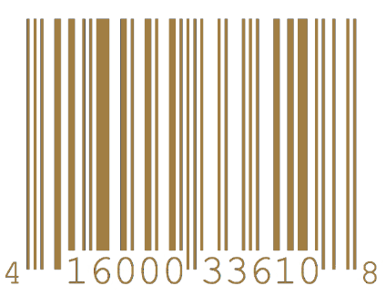

Rameshwar Manav

RAMESHWAR MANAV

Respected_Designation

Shreya Shambhavi

SHREYA SHAMBHAVI

Person_Post