A
SYNOPSIS
ON
SCIENTIFIC CALCULATOR
BY
Arnold Nigel Demta XII A 09307
&
Farhan Hai Khan XII A 08172

NAME : ARNOLD NIGEL DEMTA &
FARHAN HAI KHAN

PROJECT : SCIENTIFIC CALCULATOR

SCHOOL : ST. XAVIER’S SCHOOL

SESSION : 2017-2018

INTERNAL GUIDE : SAWAN SHUBHAM

EMAIL : andsf107@gmail.com
njrfarhandasilva10@gmail.com

INTRODUCTION

The project titled SCIENTIFIC CALCULATOR is a program which is designed to automate the calculation procedure. Making less paper work and automate the process of calculation as the user’s input.

This software helps to calculate the result of any calculations in seconds. It also ensures less use of paper.

Reaching the need of users for easy calculations.

ACKNOWLEDGEMENTS

The students of St. Xavier’s School gratefully acknowledge the valuable contributions of the individuals and organizations involves in the development of this COMPUTER SCIENCE project for class XII. The acknowledgements are also due to the following practicing teachers and subject experts for reviewing the draft manuscript and giving useful suggestions for its improvement in a workshop.
Mr. Sawan Shubham, & Mr. Samir Chattaraj,
C++ specialists &
Computer Science Teachers,
St. Xavier’s Hazaribag;

We also thank our fellow mates for their various ideas for unrelenting efforts in editing the project and bringing it to the presentable shape.

Table of Contents
A Synopsis on Scientific Calculator ……….………(i)
Introduction………………………………………..(iii)
Acknowledgements………………………...………(iv)
System Analysis……………………………………(vi)
Newton Raphson Numeric Method……………….(viii)
Literature Review………………………………….(xii)
Modules……………………………………………(xiii)
Hardware/Software Requirements ………………..(xxi)
System Implementation…………………………...(xxii)
Software Testing………………………………….(xxiii)
Conclusion…………………………………………(xxv)
References & Bibliography……………………….(xxvi)
SYSTEM ANALYSIS
Present System:
The existing systems face a lot of problem such as inappropriate values of the trigonometric functions and increased errors as the values taken as outputs are not very accurate.
Inverse functions have been made error free and the ranges of the functions have been considered carefully.
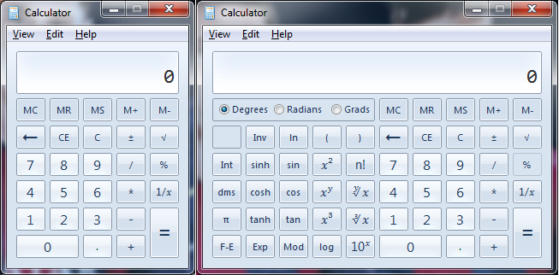

Proposed System:

This software helps in getting exact values of any type of functions, & also simplifies ideas on the part of method of working of the calculator.
We have made our best efforts to get the highest no. of precision and accuracy and for the same have used the Newton Raphson Numeric Method to evaluate near-exact values of the solution of any function.
Most of the mathematical functions that we come across in our lifetime have been covered here.
Also the entire program has been written in such a way that an amateur programmer can also read or fully understand the whole of the program in a single go.

The whole program is assisted by single/multiline comments wherever a new concept is introduced or wherever explanation seems necessary.

Newton Raphson Numeric Method
To evaluate any function’s exact value is given by this method. It is a quite repetitive method which is suitable for computers only as it involves a high amount of calculations. It uses techniques of differential calculus to give near-exact values for expressions.
For example, take the solution of the equation of the equation:
4x²=1
It can be written as
4x²-1=0
OR f (x) = 4x²-1
Now, the differential of this equation is given by the function
f`(x) = 8x
According to this method,
x_{n+1}=x_{n}-R OR x_{new}=x_{old}-error
Where R= f(x)÷f`(x)
Here, R is a ratio between the function of x & its differential which tells us the current error that we have for the solution right now.
In other words, it is a parameter which tells us how far we are from the accurate answer.
We can take any random value of x to start with, we have:
f (x) = 4x²-1;
f`(x) = 8x;
R=4x²-1÷8x= f (x) ÷f`(x)
The following Flow Chart illustrates the given procedure:
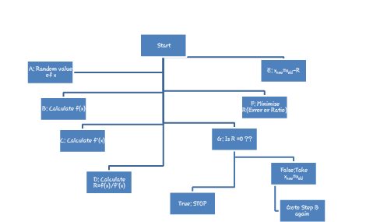

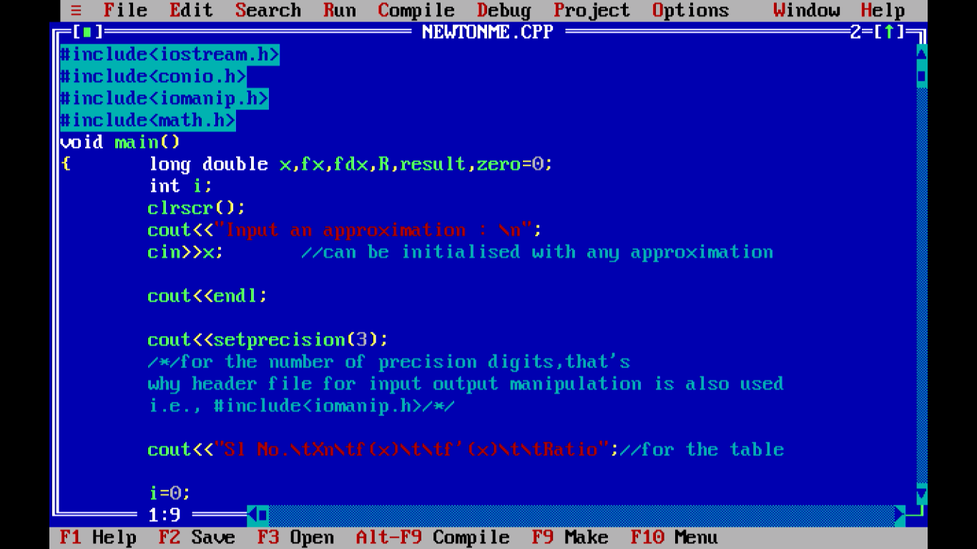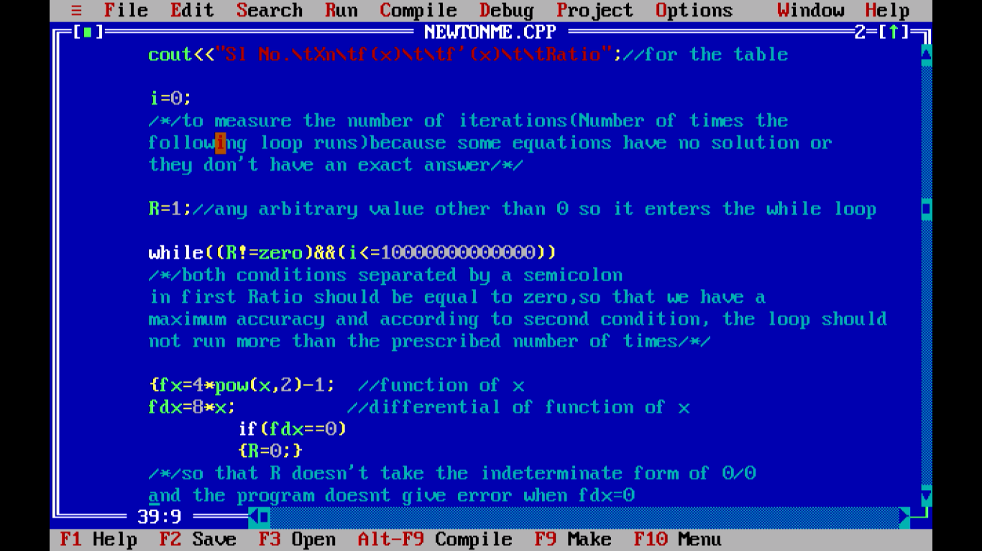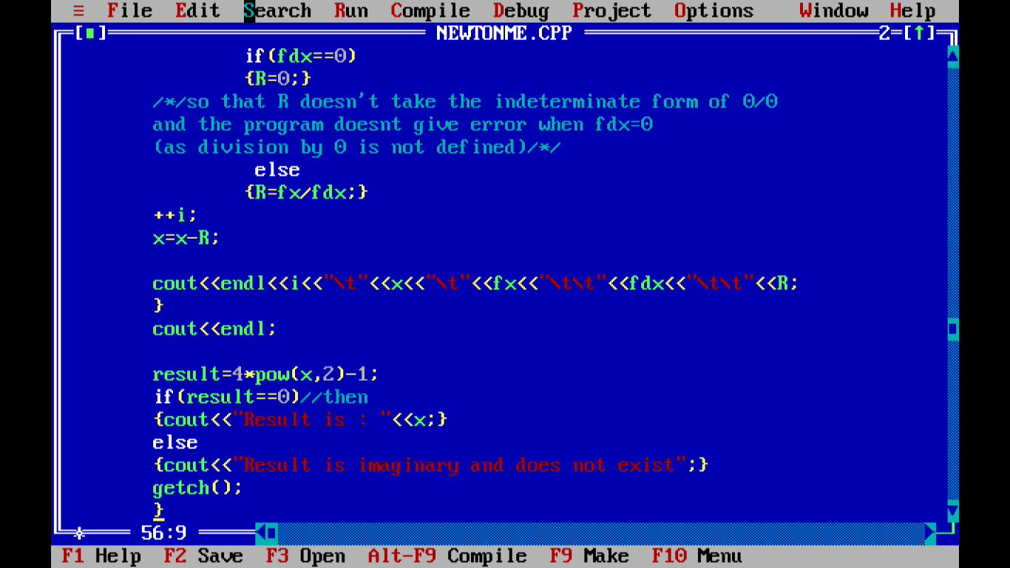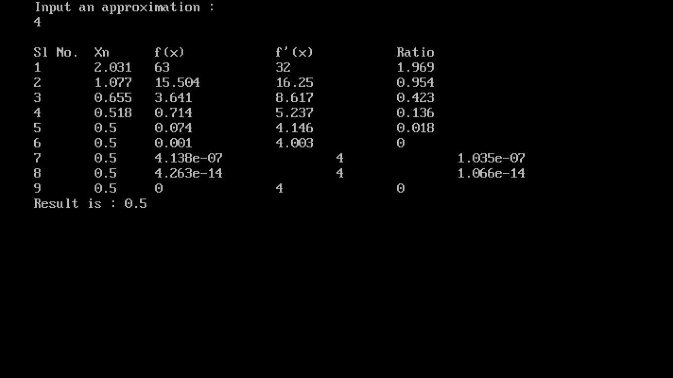

Till now, Modules of the whole program are ready with a flow chart that illustrates the continuous flow of data in the program.

All effort has been put in to create the program as error free and simple as possible keeping in mind the accuracy of resultant values.

However, we deeply appreciate any feedback/ suggestions / complaints that we receive from users all across the world through the emails given at the beginning of the project.
The calculator that we have devised is a simple step to make calculation processes simpler than they are today. Reaching out the need of the people for fast computation and easier life.

Modules

All the important Mathematical functions reside under math.h and hence the following code is vital to be put to use during the use of the following module:
#include<math.h>
Trigonometric Functions:
For the first module it utilizes the function acot(x) which is a replacement of
cot⁻¹(x) in Mathematics…
Also the functions sec⁻¹(x) & sin⁻¹(x) are shown in the screenshots below…
Proper labels have been used in the program to demarcate the use of a particular function...
These labels can also be called in the later modules if required...
Similarly the modules of sin(x), cos(x), tan(x) can be formed by using the respective functions of the same name from header file math.h
Proper conversions in degrees & radians have also been shown in the following screen shots ::
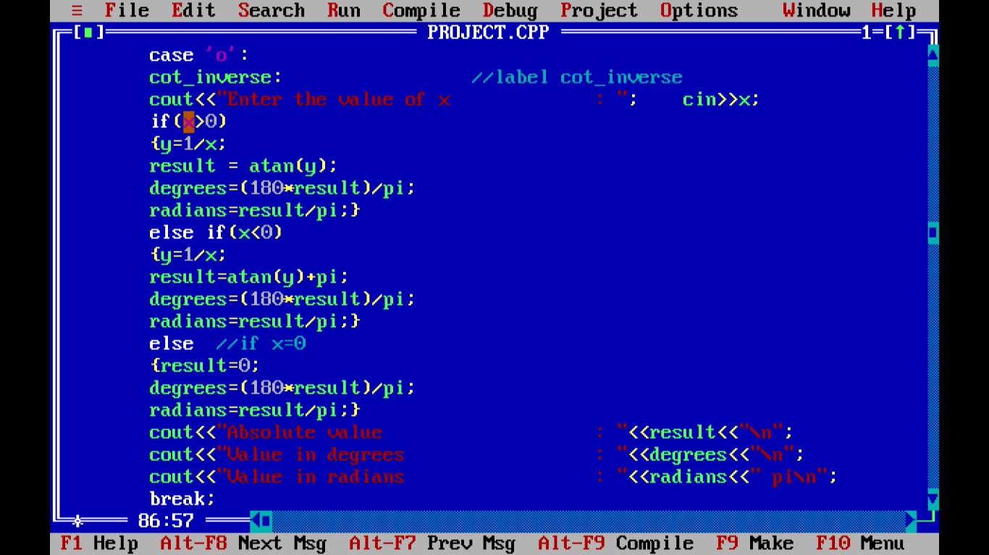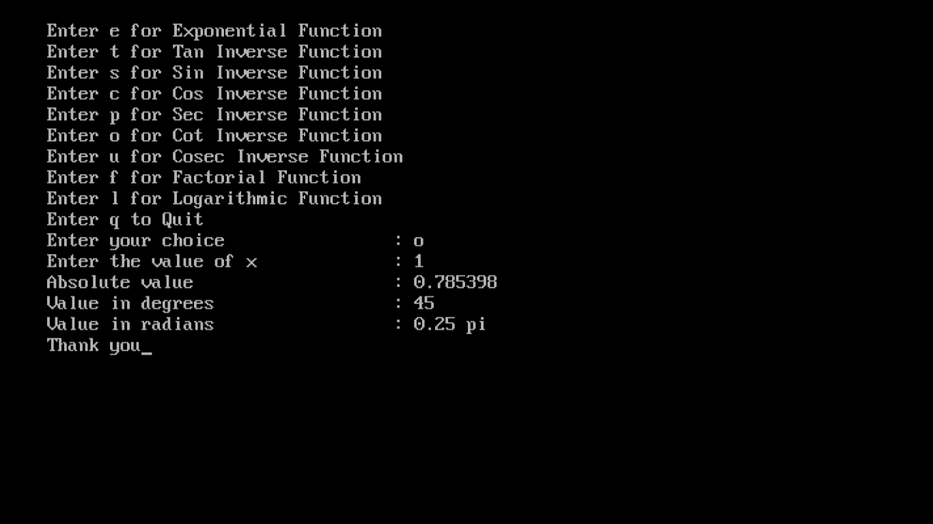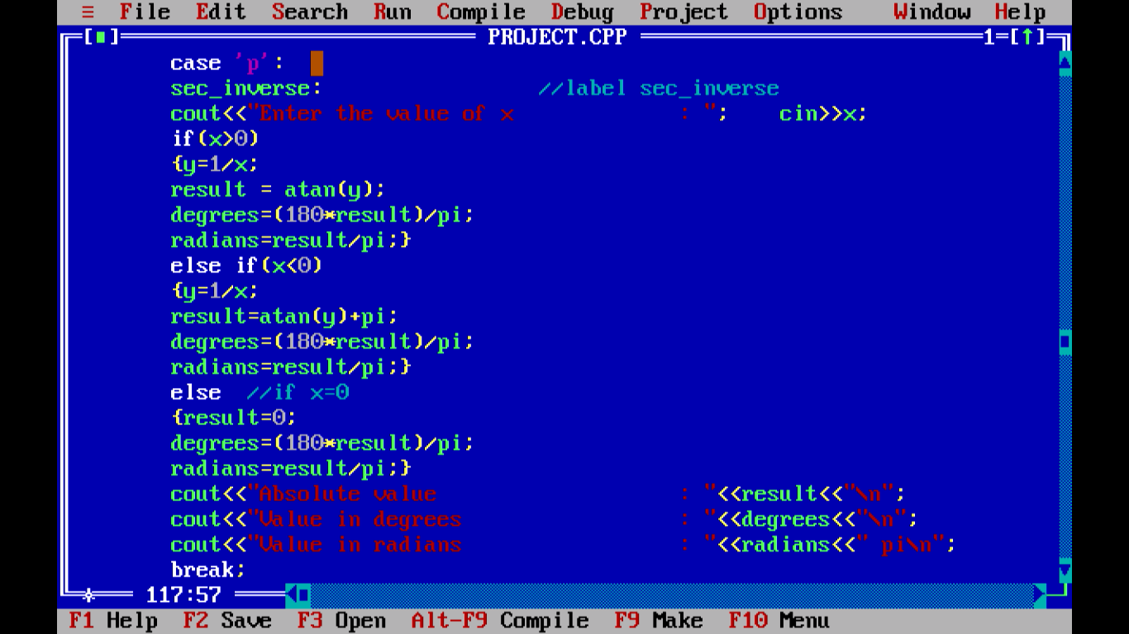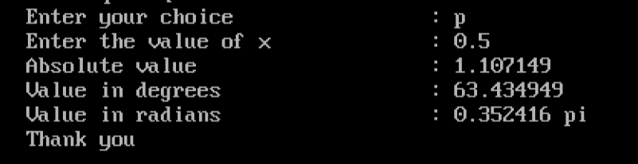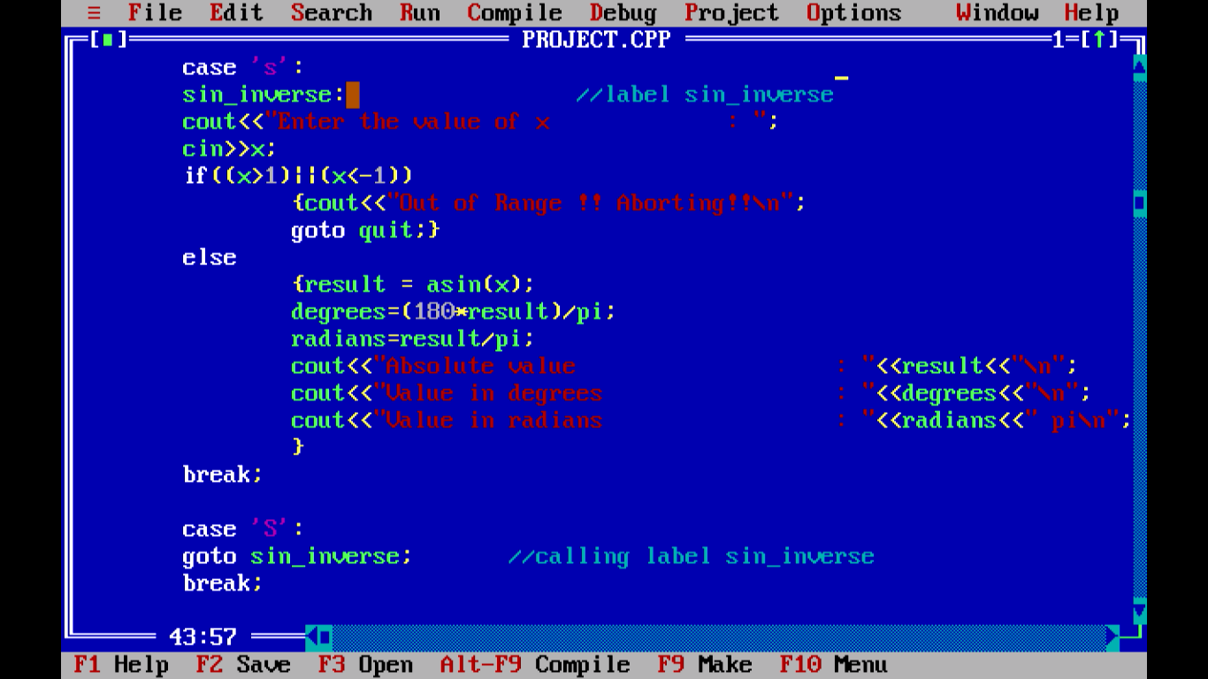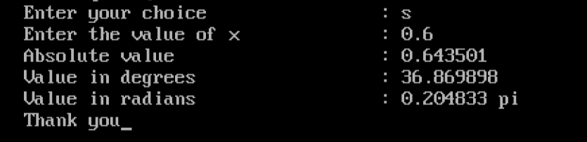
Exponential Functions ::
The value of the constant e can be calculated as::
e^{x}=(x⁰÷0!)+ (x¹÷1!)+ (x²÷2!)+ (x³÷3!)+…. till ∞
OR e^{x}=∑ ^{n=∞}_{n=0} x^{n}÷n! [From n=0 to ∞ (Summation) ]
The following module calculates the value of e^{x} using the above technique or calling the function exp(x) from the header file math.h.
Also let b^{x}=d…………………(1)
Then log_{b}d=x
Or d=antilog_{b}(x)………………(2)
But from (1) d=b^{x}

Hence, combining (1) & (2) we come to a very important conclusion:
antilog_{b}(x) =b^{x}
Using this relation,
antilog₁₀(x) =10^{x}
antilog_{e}(x)= antiln(x) =e^{x}
Hence the antilogarithm function is basically an exponential function. The following module shows its working :
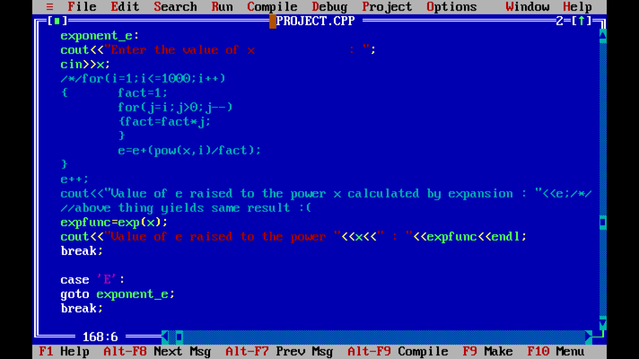
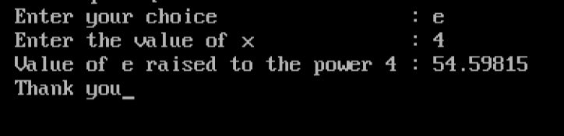

Logarithmic Functions ::
The logarithms of any base have been made into the program using the rule log_{b}a=log_{m}a÷log_{m}b
Where b is the base of the logarithm,
a is its domain, &
m is any arbitrary value.
Our program uses the following technique to convert logarithm of any base to a logarithm of base 10:
log_{b}a=log₁₀a÷log₁₀b
then the logarithm of any number to any base can be found by using log base 10 values…
The following module illustrates how logarithm to base 10 is implemented in a program:
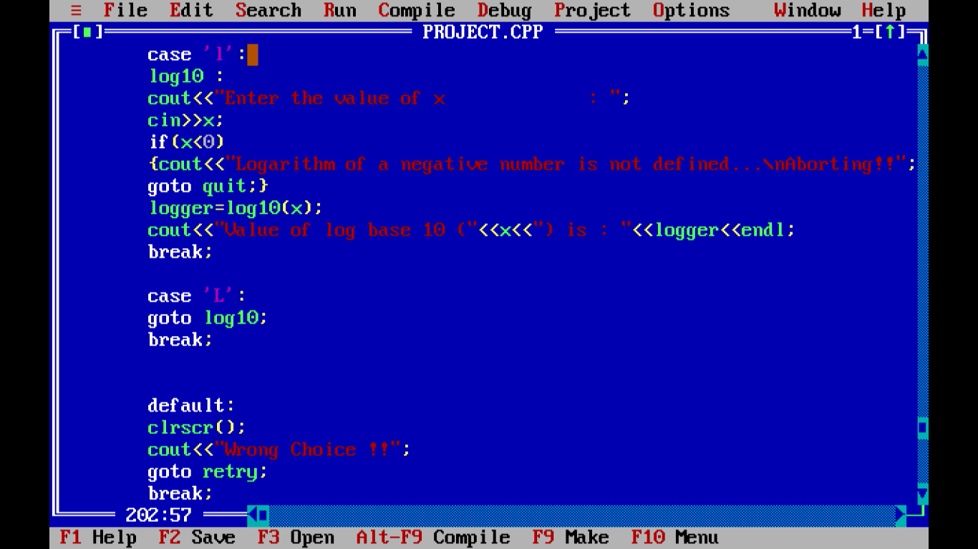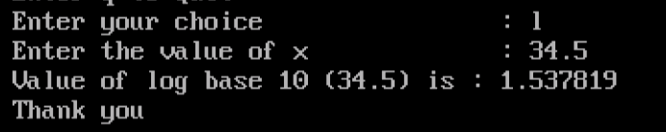

Factorial Function:
The factorial of a number n is mathematically defined as:
n! =1×2×3×4×5×……..×(n-2)×(n-1)×n
For example,
4! =1×2×3×4=24
Also 0! and 1! are defined as 1
The logic used in the below module is that the factorial is a product of the number continually as the number decreases to 1.
The following is its module: 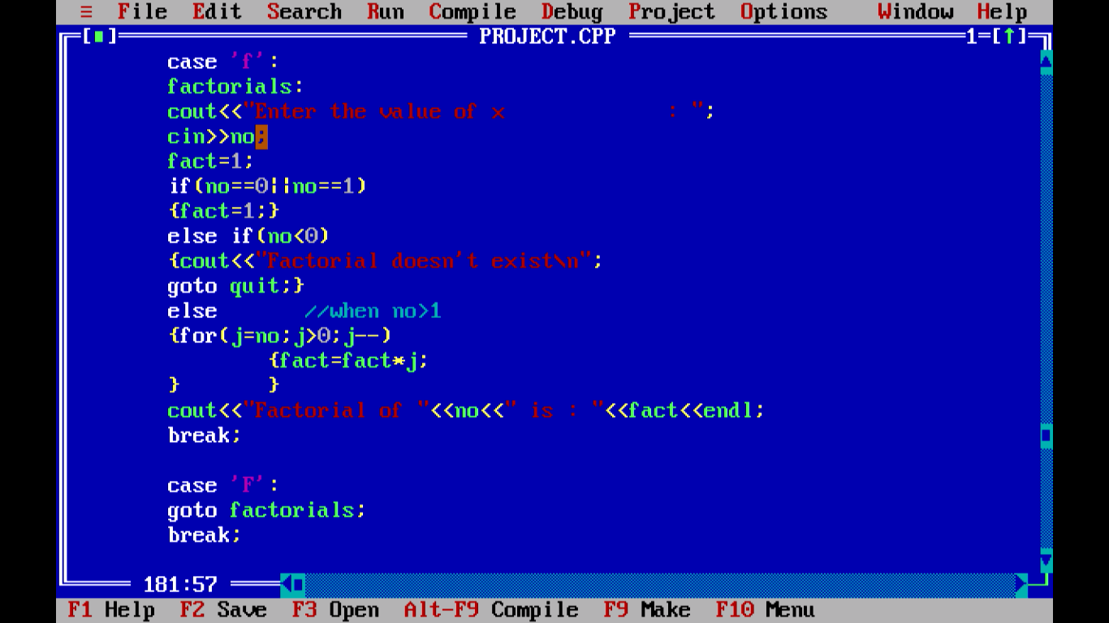
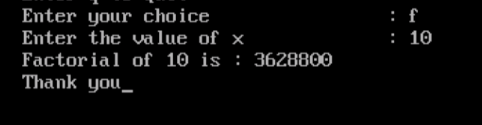
Hardware and Software Requirements
Hardware Requirements:
Processor : i3 Processor
Main Memory : 4 GB
Hard Disk : 500 GB
Network : 32 bit

Software Requirements:
Platform : Windows XP, 7, 8, 8.1, 10
Language : C++
Database Connectivity: MS-Access 2007

The codes written for the program are quite simple and truncated. However to explain the proper working of the program as a User Manual we will include a file named ReadMe.txt and proper proofs for theorems and explanations for the amateurs and the layman in a Word file.
If required a proper working demonstration will be provided that is supposed to be free of cost.

If any user experiences any difficulty to comprehend the codes for the program, he/she can get in contact with us with the following email addresses – andsf107@gmail.com & njrfarhandasilva10@gmail.com . We would like to get the feedback and queries on the same email address.

Software Testing
Black Box Testing:

We have received various inputs from each of our fellow classmates for the different functions that potentially could be included in the program as per the requirements of a pioneer.
Some of these include the antilog, cube root & inverse trigonometric functions which they had no knowledge about as it is not straightaway provided in a single calculator and we had to download these different “types” of calculators from the Internet.
Most of these softwares for Android or Windows occupy useless spaces as they are ad-centered and sometimes cost a huge sum of money.
Our program is completely free of cost and just needs a few basic software/hardware requirements opposed to the high cost complicated applications provided by the Internet.

White Box Testing:

We have basically tried to make an error free program by testing it several times with different input values of data.

The structure has been made as such that that it does not affect the platform in which it is run and is mostly portable.
We had some problems in the Numeric method for which we introduce a new data member i which counts the number of times the while loop runs for.
The whole program has Compiled successfully and Warnings have been mostly been averted by the help of close scrutiny.
We hope the program meets the need of the users for years to come.

Conclusion

Our project is only a humble venture to satisfy the need in a calculator. Several user friendly coding have also adopted. This package shall prove to be powerful in satisfying all the requirements of a calculator.

The objective of software planning is to provide a framework that enables the user to calculate exact values of a function defined at the beginning of this software project.

We have successfully established the project with various functions that normal calculators do not offer such as logarithm and anti-logarithms of any base {log_{a}(b), antilog_{m}(n) } , Exponential Functions { a^{x}, x^{1/y}}, Inverse Trigonometric Functions { tan⁻¹(x) , sin⁻¹(x) , cos⁻¹(x) }, Trigonometric Functions { cot(x) , cosec(x) , sec(x) } and various other functions are also covered.

www.google.co.in
www.wikipedia.scientificcalculator.com
www.scientificcalculator.com
Computer Science books (Class 11&12);
Computer Science in C++: Sumita Arora
All in One

