PartyBash Final Report
  - A multiplayer 3D party game project report
Course 3D Programming | Final Project 2026
Group: Party Bash
Lecturer: Trần Thế Vũ
Presentation date: ................................
Team member | Student ID
Trần Ngọc Quân | 23020020
Ngô Hoàng Nhật Khang | 23020004

Executive summary
PartyBash combines an interactive 3D lobby, a turn based party board and short competitive minigames. Players earn gold, use items and open treasure chests to collect Cups. Minigame results provide rewards and determine the next round’s turn order, connecting the individual activities to one match objective.
The current source declares version 0.1.1 and connects player control, board rules, inventory, gameplay UI, victory handling and a return to the lobby. The primary advanced feature is online multiplayer through Photon Fusion Shared Authority. The inventory system and seeded obstacle generation provide additional technical depth.
This report explains the game concept, implementation, development evidence and submission requirements. It distinguishes implemented code from recorded historical tests and from the acceptance checks that the submission build still needs to complete. The accompanying weekly reports follow the four assessment stages and identify concrete artefacts for each presentation.
Evidence: project.godot; main.gd; board/pha_ban_co.gd; minigame/quan_tro_minigame.tscn. Source baseline: commit 3c156b5, 12 October 2026.

1 Game concept and player experience
We selected a party game because interaction between friends creates meaningful competition without requiring a long campaign. The target audience is groups of PC players who enjoy accessible controls, short challenges and unpredictable social situations. Rooms are configured for up to 10 players; a demonstration with two to four players is easier to follow and explain.

Objective and game loop
The player with the most Cups at the end of the configured rounds wins. Equal Cup totals are resolved by gold, then by the existing turn order. A treasure chest costs 100 gold by default and awards one Cup. Board income and minigame rewards therefore contribute directly to match progression.
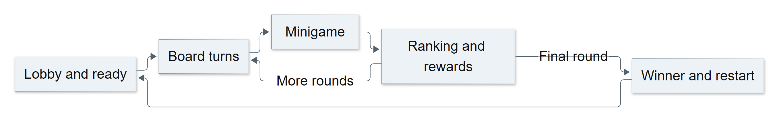
Figure 1 Mermaid overview of the match loop with detailed decisions in Appendix A
After a board round, the game coordinator launches a minigame. Its ranking drives rewards and the next turn order. If rounds remain, play returns to the board. Otherwise, the winner is displayed for six seconds, board state is cleared and players return to the lobby for another match.

Project specific design decisions
Two substantial adaptations are the Cup economy linked to minigame rankings and the item system with several targeting modes on a graph based board. A common minigame completion contract allows new challenges to join the match flow without rewriting the board coordinator.
Evidence: board/luat_ruong.gd; board/kinh_te.gd; main.gd::_khi_het_vong, _khi_xong_minigame, _khi_thang; minigame/mini_game.gd.

2 Mapping the course requirements
The following matrix links mandatory requirements to the implementation and the behaviour that must be visible during assessment. Source code evidence supports the explanation; the submitted build must also demonstrate that behaviour in practice.
Requirement | Implementation and demonstration evidence
Player system | CharacterBody3D movement, jumping and interaction; a local camera for the owning player.
Gameplay objective | Open chests for Cups; compare Cups, gold and turn order at the end of the match.
Challenge system | Opponents, land taxes, traps and limited health; lasers, bombs, collapsing tiles or falling rocks.
Game progression | Round advancement, persistent resources, rewards and changing turn order; timed difficulty in selected games.
Game states | Menu, lobby, countdown, playing, victory display, return to lobby and a new match.
Gameplay UI | Health, gold, Cups, round, turn and inventory; minigame scores and timers.
At least four techniques | Collision, physics, raycasts, camera control, animation, spawning, audio, state management and inventory.
Advanced feature | Photon Fusion Shared Authority for rooms, player replication, shared state and discrete events.
Independent development | The Cup economy and reward flow; targeted board items; the shared minigame interface.
Individual understanding | Each member explains relevant scripts and changes a small gameplay parameter during assessment.

Evidence needed before submission
Acceptance must include a complete match result and a fresh restart with at least two clients. The submission package consists of source, a playable build, a three to five minute video, a README and an individual contribution table. Section 14 provides a ten to twelve minute presentation outline.
Evidence: Final Project 2026 brief, sections 3 to 10 and 12 to 14; report/requirement/3D_Programming_Final_Project_2026.docx_2.pdf.

3 Architecture and source organisation
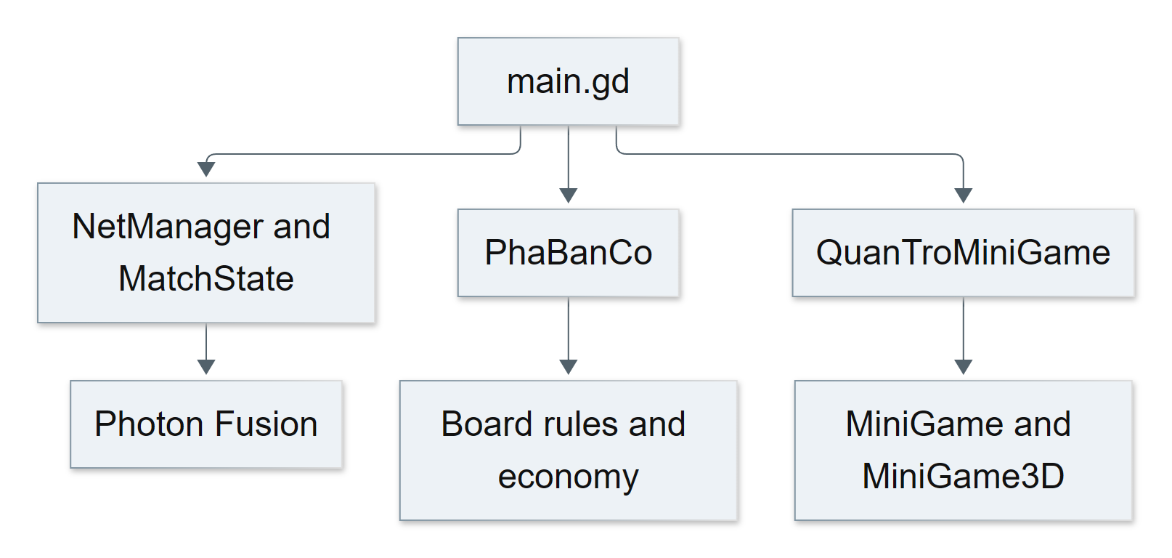
Figure 2 Mermaid architecture overview with responsibilities expanded in Appendix B
main.gd coordinates signals and scene flow instead of containing every rule. MatchState stores room settings and phase information. PhaBanCo manages board turns, networking and scenes. LuatBan, LuatDo, LuatBay, LuatRuong, LuatTanCong and KinhTe operate on Dictionary state, allowing many rules to be checked independently of a live online match.
Directory | Responsibility
autoload/ and net/ | Connection, performance, UI navigation, room state, chat and music.
player/ and lobby/ | Player control, cameras, appearance and persistent lobby interactions.
board/ | Board graph, rules, turns, economy, inventory and world effects.
minigame/ | Coordinator, base contracts, arenas and individual game implementations.
ui/ and tests/ | Menus, HUD and gameplay rule tests.

The UI observes state and issues interaction requests; rule classes decide the resulting state changes. Minigames emit xong(xep_hang) to return a ranking. The board needs that ranking rather than the internal details of a laser, tank or crown challenge.
Evidence: main.tscn; main.gd::_ready; board/pha_ban_co.gd; minigame/mini_game.gd; tests/test_gameplay_rules.gd.

4 Player controls and cameras
Player processes input on the owning client; remote clients observe its motion through FusionSharedReplicator. The character uses CharacterBody3D with a default speed of 6 m/s, a jump height of 1.2 m and up to two jumps. Raycasts identify interaction targets within a default reach of 3.2 m.
CameraRig rotates the body horizontally and limits vertical viewing angles. A raycast from the viewing pivot towards the desired camera position pulls the camera closer when a wall intervenes. Seating, board viewing and item aiming use separate camera settings and Tween transitions. The board also supports free flight and player following modes.
Context | Main controls
Lobby and 3D arenas | WASD to move, Space to jump and the mouse to look.
Lobby objects | E to interact; hold and release E to charge and throw a held object; Q to drop.
Appearance | M opens character selection while in the lobby.
Free board camera | WASD or arrow keys to move, mouse wheel to move forward or back, Shift for faster travel.
Branches and targets | Z and X change the selection; follow the HUD prompt to confirm.
Board camera mode | C changes camera mode; V changes the followed player in attached mode.
Inventory | Quick slots use 1 to 5; storage is managed through the UI; one item may be used per turn.
Minigames | Follow each game’s instruction card; Tank uses J or Space to fire.
In game menu | Esc opens the menu; the online session continues running.

Separating Z/X from WASD prevents board selection from competing with free camera movement. Presentation material must use the current bindings: an earlier commit used A/D for target selection.
Evidence: player/player.gd; player/camera_rig.gd; board/camera_tu_do.gd; board/pha_ban_co.gd; project.godot; ui/pause_menu.gd.

5 Board rules and match economy
The board is a graph with a main loop and additional edges. Numbered OBan nodes are placed in the scene; BanDuong builds adjacency and directional connections. At a junction, the active player selects a route. The master resolves dice and tile rules, then distributes the resulting state so clients display the same outcome.
Default setting | Value | Purpose
Maximum health and starting gold | 10 and 0 | Equal initial resources.
Land / health / money / item tiles | 40 / 20 / 25 / 15 percent | Distribution must total 100.
Health and money tile gain | 3 health and 15 gold | Replenish resources between challenges.
Treasure chest cost | 100 gold | Exchange gold for one Cup and relocate the chest.
Health and money taxes | 2 health and 10 gold | Land ownership pressures other players.
Weapon damage | 4 health | A shield can block the attack.
Automatic round count | 11 for 4 players; 7 for 10 | Derived from the economy time model.

KinhTe models a match of approximately 35 minutes using estimated turn and minigame durations. This is a design target rather than a measured completion time. The host can override the round count, including for a shorter assessment demo. Gold rewards are multiplied by 1.5 during the final two rounds.
All participants earn gold based on rank rather than rewarding only the winner. The first player receives an item, additional item recipients scale with room size and a last place participant can receive a common item when enough players participate. Gold and inventory survive the transition to a new round.
Evidence: board/ban_duong.gd; board/gameplay_settings.gd; board/kinh_te.gd; board/luat_ban.gd; tests/test_gameplay_rules.gd.

6 Inventory and item interactions
VatPham defines 20 items with rarity, selection weight, targeting mode and range. Inventory contains five quick slots and sixteen storage slots, for a total capacity of 21. Using an item leaves an empty slot so other items retain their positions. New items fill the first available slot. Stored items must be moved into a quick slot before use.
Interaction type | Example in English | Gameplay effect
Automatic | Basket shield | Blocks an attack without a manual use command.
Self use | Healing porridge; double dice | Restores health or modifies the dice action.
Ray targeting | Slingshot; fishing rod | Uses the camera aim direction and a valid target in range.
Cone targeting | Fishing net | Affects targets within an area in front of the player.
Player or tile selection | Falling coconut; swap charm; toy cannon cart | Selects a target through the board interface before requesting use.
Minigame selection | Referee whistle | Selects the challenge launched after a board round.

LuatDo validates the selected slot and conditions of use, including one item per turn. LuatTanCong, LuatBay and LuatHieuUng resolve damage, barriers, traps and persistent effects. Separating decisions from presentation makes the rules easier to test without waiting for an animation.

World effects
DungDo creates an effect scene from data distributed with the board state. A contact signal coordinates the visible hit with the target’s movement or visual update. Pulling, pushing and swapping therefore have an observable action in the world as well as a numerical result in the HUD.
A useful demonstration moves an item between storage and a quick slot, blocks an attack with a shield, activates double dice and attempts a second item use in the same turn to show rejection.
Evidence: board/vat_pham.gd; board/dung_do.gd; board/luat_do.gd; board/luat_tan_cong.gd; board/hieu_ung/; ui/kho_do.gd; commit 3f8ecf8. Item labels above are English descriptions of the in game catalogue.

7 Multiplayer as the advanced feature
PartyBash uses Photon Fusion Godot SDK 3.0.0 Preview Build 555 in Shared Authority mode. NetManager handles identity, connection and room creation or joining. Each client owns its player object; the master coordinates shared rules. Photon Cloud provides connectivity, and the project does not implement a dedicated server.
Data or event | Synchronization method | Reason
Player motion and appearance | FusionSharedReplicator | The owner writes while remote clients observe.
Phase, settings, light and music | Properties on MatchState | Late joiners can receive current room settings.
Board turns, gold, items and tiles | RPC containing the full state Dictionary as JSON | The master distributes one outcome for a board event.
Minigame startup | Game code, seed and player IDs | Clients create matching initial content.
3D minigame ranking | The master finalizes and broadcasts the ranking | Avoids comparing different clients’ local clocks.

A player action issues a request. The responsible authority checks the conditions, changes the data and distributes the result. Receiving clients update the scene and UI. The /mg chat command is executed only when issued by the master itself and helps select registered games during demonstrations or testing.

Synchronization limits
MatchState uses replicated room properties, but PhaBanCo distributes its board Dictionary through RPCs. Lobby late join support therefore does not establish complete recovery of an ongoing board match. Late join during play, disconnection and master changes require separate acceptance checks. Shared Authority suits a friends based party game, while client trust remains a limitation.
Evidence: autoload/net_manager.gd; net/match_state.gd and .tscn; board/pha_ban_co.gd::_phat; minigame/chung/mini_game_3d.gd; net/lenh_chat.gd; GUIDE.md.

8 Registered minigames
The current coordinator scene registers ten games. This is the active selection list; a script existing in the directory does not necessarily mean that its game can be randomly selected. Tank is a 2D overlay inside the wider 3D game, so a demonstration of 3D programming should include an arena such as Laser Leap or Rockslide.
Scene code | Game and challenge | Progress or ranking
tank_battle | Tank 1990; movement and shooting | Survival during a 75 second match.
breaking_blocks | Breaking Blocks; tiles crack and collapse | Survival order.
laser_leap | Laser Leap; read and jump over lasers | Survive changing laser patterns.
spotlights | Searing Spotlights; avoid lit areas | Survive light and darkness cycles.
explosive | Explosive Exchange; E passes the bomb | Avoid holding it when it explodes.
magma | Magma and Mages; fireball combat | Survive a shrinking safe area.
crown | Crown Capture; touch to steal the crown | Accumulate crown holding time.
word_wars | Word Wars; stand on letters and press E | Complete the assigned word.
dem_thu | Animal Counting; observe and submit a count | Correct answers, then response speed.
lo_da | Rockslide; climb and avoid falling rocks | Finish, progress and survival.

MiniGame defines bat_dau(nguoi_choi, hat_giong) and the xong(xep_hang) signal. MiniGame3D reuses player objects, arena cameras, survival tracking and ranking logic. QuanTroMiniGame shows instructions, a three second countdown and a five second results display. Board input is suspended while the minigame is active.
Rockslide derives obstacle schedules and the pursuing meteor field from time and a shared seed. This avoids sending each obstacle’s position every frame. Player motion, elimination events and final rankings still require synchronization.
Evidence: minigame/quan_tro_minigame.tscn; minigame/mini_game.gd; minigame/chung/mini_game_3d.gd; minigame/lo_da/lo_da.gd. Temporal Trails has source files but is not in this ten scene registration list.

9 3D techniques and presentation quality
Technique | Application in PartyBash
Transforms and cameras | Position players at tiles, seats and spawns; lobby, board, aiming and arena views.
Collision and triggers | CharacterBody3D floor contact; Area3D ready pads and interaction regions.
Physics and raycasts | Pick up and throw objects; select targets and prevent camera obstruction.
Animation and Tween | Character animation, camera transitions, UI motion and item effects.
Lighting and materials | Lobby lighting, imported materials and shared room light colours.
Audio | Room music selected by a shared key; interaction and minigame feedback assets.
Spawning and randomness | FusionSpawner for network objects; seeded challenge generation.
State management and inventory | Lobby, countdown and playing phases; quick slots, storage and target selection.

UI and feedback
The HUD consolidates resources, round and turn information, branch selection, targets and taxes. Player colours, name labels and speech bubbles help identify participants in a shared space. The theme includes Baloo 2 and Nunito. Menus, instructions and settings provide supporting navigation for new players.

Adaptive graphics quality
PerformanceManager provides Auto, Performance, Balanced and Quality modes. Auto starts at a 0.77 render scale and stays between 0.59 and 1.0. It samples performance every second after a four second warmup. Repeated low FPS samples reduce the scale and adjust the LOD threshold, while UI resolution remains unchanged.
The 60 FPS setting is a control target in the implementation rather than a measured benchmark. Performance acceptance should record hardware, player count, scene and observed FPS before drawing conclusions about improvement.
Evidence: player/camera_rig.gd; lobby/; ui/hud.gd; ui/theme/; autoload/performance_manager.gd; net/music_box.gd; physics scenes.

10 Testing and acceptance criteria
tests/test_gameplay_rules.gd contains twelve test functions in the gameplay_rules suite. They cover configuration, resources across rounds and interactions with a high risk of rule errors. Several minigames also include kiem_luat.gd scripts for obstacle schedules, geometry and scoring rules.
Test group | Cases present in the source
Configuration and initialization | Tile weights total 100; equal starting tile, ten health and zero gold.
Land and taxation | Transfers of gold, land or equipment; tax choice persists into another round.
Economy and victory | Round counts, ranked rewards, persistent inventory, chest purchase and winner selection.
Combat and effects | Miss, shield and hit cases; reduced trap steps; barriers; damage reduction and snap back.
Inventory | One item per turn; empty slot preservation; full storage; quick slot and storage swapping.

Submission build acceptance scenarios
ID | Action and passing criterion
T01 | Join the same room on two clients; names, colours, players and settings agree.
T02 | Become ready, then leave a pad during countdown; the countdown cancels.
T03 | Complete a board round; gold, health, tile positions and inventory agree across clients.
T04 | Open a minigame; pressing Space does not roll board dice underneath it.
T05 | Finish the minigame; ranking, rewards and next turn order agree.
T06 | Finish a shortened match; display the winner, return to the lobby and restart with clean state.
T07 | Test late join, disconnection and master changes in each phase; record the supported behaviour.

Record the date, commit, devices and screenshots or video for an acceptance run. These scenarios define the final checks; they are not a substitute for recorded execution results.
Evidence: tests/test_gameplay_rules.gd; minigame/*/kiem_luat.gd; GUIDE.md; historical network test notes in ROADMAP.md.

11 Bug fixes and remaining risks
Recorded issue | Implemented response | Evidence
Space fires Tank and rolls board dice | The bat_dau signal sets tam_dung; completion restores board input. | main.gd; PhaBanCo
Players overlap on one tile | Positions are distributed around the centre using turn order, without extra network events. | ROADMAP.md; _cho_dung
Different clocks produce incorrect rankings | MiniGame3D uses the master’s elimination reception order and broadcasts the final ranking. | mini_game_3d.gd
Camera and board selection share controls | Board selection moves to Z/X; WASD controls free flight. | 3c156b5
Crash while filtering released bombs | Git records an array assignment fix in Acidic Atoll. | 0f8fd46

The Acidic Atoll change is historical bug fixing evidence; that game is no longer registered for selection. Older notes about a three Cup victory target or fifteen minigames must be read in their historical context. The current source ends by round count and registers ten minigames.
Risk or limitation | Action before submission
Old build versus source version 0.1.1 | Export from the final commit and run on another machine with the Fusion DLL.
Late join and master changes during play | Test lobby, board and minigame phases; declare only behaviour verified in practice.
Large game and item catalogue | Select stable demo content; regress victory and restart before expanding scope.
Performance and room size | Measure target hardware; start with two machines, then increase participation.
Incomplete asset licence records | Resolve models marked as unverified in CREDITS before distributing them.

Evidence: ROADMAP.md, six player test notes; main.gd; board/pha_ban_co.gd; CREDITS.md; export_presets.cfg.

12 Development milestones and contributions
The milestones below summarize the development history recorded in Git. The four weekly reports follow the course assessment stages. Presentation dates remain blank for the group to enter according to the class schedule.
Stage | Git evidence dates | Main output
Week 1 Foundation | 13 September 2026 | Lobby skeleton, interaction scenes, models and collision shapes.
Week 2 Prototype | 28 to 30 September 2026 | Build 0.0.6, board map, 3D dice and camera adjustments.
Week 3 Integrated alpha | 1 to 2 October 2026 | Board to minigame flow, settings, networking, scores, performance and balancing.
Week 4 Polish | 10 to 12 October 2026 | Item effects, double dice, input and camera improvements, fonts and UI.

Contribution review and presentation responsibilities
Member | Area to present and review | Commits to cross check
Trần Ngọc Quân  23020020 | Player and camera, board map, UI, settings and performance. | a812ca1; 76c2297; 51c1110; 3c156b5
Ngô Hoàng Nhật Khang  23020004 | Networking, board rules, economy, minigame framework, items and results. | 506ee48; 2e1589c; 062b6c5; 3f8ecf8

Git records the author accounts khang-ngo4444 and Akio Ckist. Both members should confirm the account mapping, shared work and scope of implementation before signing off the contribution table. Commit counts do not establish contribution percentages or hours worked.

Coordination workflow
The proposed workflow uses an issue owner and a runnable completion criterion for each task, feature branches and review by the other member before integration. Changes to networking or phase flow require the same two client scenario on both machines. GUIDE and CREDITS should be updated with relevant changes, and actual hours recorded in the weekly tables.
Evidence: git log; git shortlog; readme.md, Contributing; the four accompanying weekly reports.

13 Setup and delivery status

Running from source
1. Clone https://github.com/khang-ngo4444/Partyyy and open project.godot in Godot 4.7.1 or a compatible 4.7 build verified by the team.
2. Restore Photon Fusion Preview 555 under addons/fusion and confirm the GDExtension is loaded.
3. Check Fusion Connection settings using the team’s App ID and the Asia region.
4. Allow assets to import, then run main.tscn with F5. Reimport if the global script class cache is stale.
5. Run a second client, join the same room and compare identity and settings before becoming ready.

Submission components
Component | Current status and required action
Source | Project configuration, scenes, scripts, addons and documentation are present; select the final commit.
Windows build | builds/PartyBash-0.0.6.zip and an extracted folder exist. This is an older build; export one matching source version 0.1.1.
Export preset | Windows x86_64 with embedded PCK; target ../build/PartyBash-0.1.1/PartyBash.exe.
Three to five minute video | Record core gameplay, the advanced feature and the final match result.
README | Setup and architecture exist; update registered games, victory rules, exact controls, team details and contributions.
Credits and AI | CREDITS exists; confirm model licences and identify the scope of AI assistance.
Submission schedule | Follow the LMS and class schedule; enter the presentation date when confirmed.

Package the required Fusion DLL with the executable and test the extracted package on another machine. If export fails, prepare an editor demonstration from the same commit with imports completed and connectivity tested. The course brief permits this fallback when a technical build limitation prevents packaging.
Evidence: readme.md; export_presets.cfg; builds/; project.godot; course brief, sections 10 and 11.

14 Presentation and demonstration plan
Time | Content | Visible evidence
0 to 2 minutes | Introduce the concept, audience and Cup objective. | Game loop and the resources leading to victory.
2 to 4 minutes | Join with two players, customize, become ready and play a board turn. | Synchronized identity, dice, branching, tax or an item.
4 to 7 minutes | Play a 3D minigame and return to the board. | Challenge, timer or score, matching rank and rewards.
7 to 10 minutes | Explain authority, RPCs and properties; change a parameter. | Actual scripts and the effect of round count or chest cost.
10 to 12 minutes | Show the match result, restart and answer individual questions. | Victory display, clean state and each member’s understanding.

Use a small round count in the room setup and rehearse the timing in advance. The host can enter /mg to list games and a valid scene code, such as /mg laser_leap, to select one. A command can shorten a demonstration, but the automatic transition from a completed board round to a minigame must also be demonstrated.

A four minute video outline
Allow 30 seconds for the concept and objective, 60 seconds for the lobby and board, 90 seconds for a 3D challenge with two clients, 30 seconds for rewards and the next round, and 30 seconds for victory and restart. Record the video against the final submission commit.

Questions for the technical explanation
Why do persistent room values use replicated properties? Who may change the board rules? Why are obstacle positions not sent every frame? Where is board input blocked during a minigame? Why do resources persist between rounds but reset between matches? What state is required when joining late or changing the master?
Evidence: Course brief, sections 10.3, 10.5 and 13; main.gd; net/match_state.gd; board/pha_ban_co.gd; minigame/lo_da/lo_da.gd.

15 Resources and assistance disclosure
Source | Resources and licences recorded in the project
Godot and Exit Games | Game engine, Photon Fusion Godot SDK Preview 555 and Photon Cloud.
Kenney | Mini Characters, Playing Cards, Minigolf, Impact Sounds, Interface Sounds and Game Icons; CC0.
Kay Lousberg and KayKit | Board Game Bits, Adventurers 2.0 and Skeletons 1.1; CC0.
MrEliptik | Ghost chess set; CC0 according to CREDITS.
jeremy and Poly by Google | Chicken and Penguin; CC BY 3.0 attribution recorded in CREDITS.
gabrielmendesm and Prof_Monke | Whack a mole models; CC BY 4.0.
Baloo 2 and Nunito | Ek Type; Vernon Adams, Cyreal and Jacques Le Bailly; SIL OFL 1.1.

Model attribution recorded in CREDITS:
Chicken by jeremy [CC-BY] (https://creativecommons.org/licenses/by/3.0/) via Poly Pizza (https://poly.pizza/m/1YE8U35HXsI)
Penguin by Poly by Google [CC-BY] (https://creativecommons.org/licenses/by/3.0/) via Poly Pizza (https://poly.pizza/m/fBXvsC6pe_V)
"Whack-A-Mole Animations" (https://sketchfab.com/3d-models/whack-a-mole-animations-95a0dc66906b4da585d390dd7ef46622) by gabrielmendesm is licensed under Creative Commons Attribution (http://creativecommons.org/licenses/by/4.0/).
"Whack em All/Whack a mole machine" (https://sketchfab.com/3d-models/whack-em-allwhack-a-mole-machine-66e181857962436ab4b7a806618cab61) by Prof_Monke is licensed under Creative Commons Attribution (http://creativecommons.org/licenses/by/4.0/).
Basketball, chair and dartboard models are marked for licence verification in CREDITS. Complete those records before distributing packages containing the assets.

Tutorial and AI assistance
The project credits Godot Your First Multiplayer Game: https://www.youtube.com/watch?v=n8D3vEx7NAE. CREDITS lists Claude for architecture, scripts and documentation; members should confirm the specific scope used. Codex assisted with source review, report drafting and DOCX formatting for this report set. Team members remain responsible for understanding, testing and explaining submitted work.
Evidence: CREDITS.md; asset licence files; ui/theme/fonts/; GUIDE.md; readme.md; ROADMAP.md; MINIGAME.md; SWOT.md; GAMEPLAY_BALANCE_PLAN.md; HUD_CARTOON_PLAN.md; report/requirement/.

Appendix A1 Readiness and board turns
The first half of the match flow shows readiness cancellation, an optional item, dice, movement and completion of a board round. Continue with A2 after every player has taken a turn.
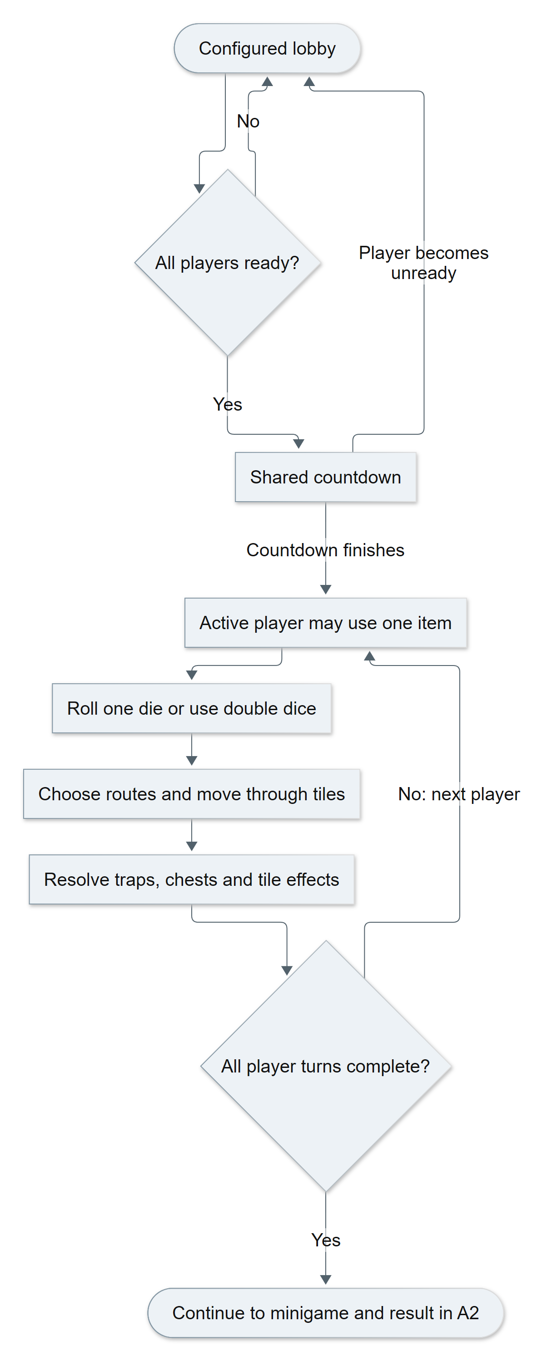
Figure A1 Detailed readiness and board flow generated from Mermaid
Evidence: Source baseline 3c156b5; net/match_state.gd; board/pha_ban_co.gd; main.gd. Editable source: report/diagrams/board_flow_detailed.mmd.

Appendix A2 Minigame rewards and match completion
The second half connects the minigame ranking to rewards, another round or a final winner. The labelled return nodes refer to the lobby and board flow in A1.
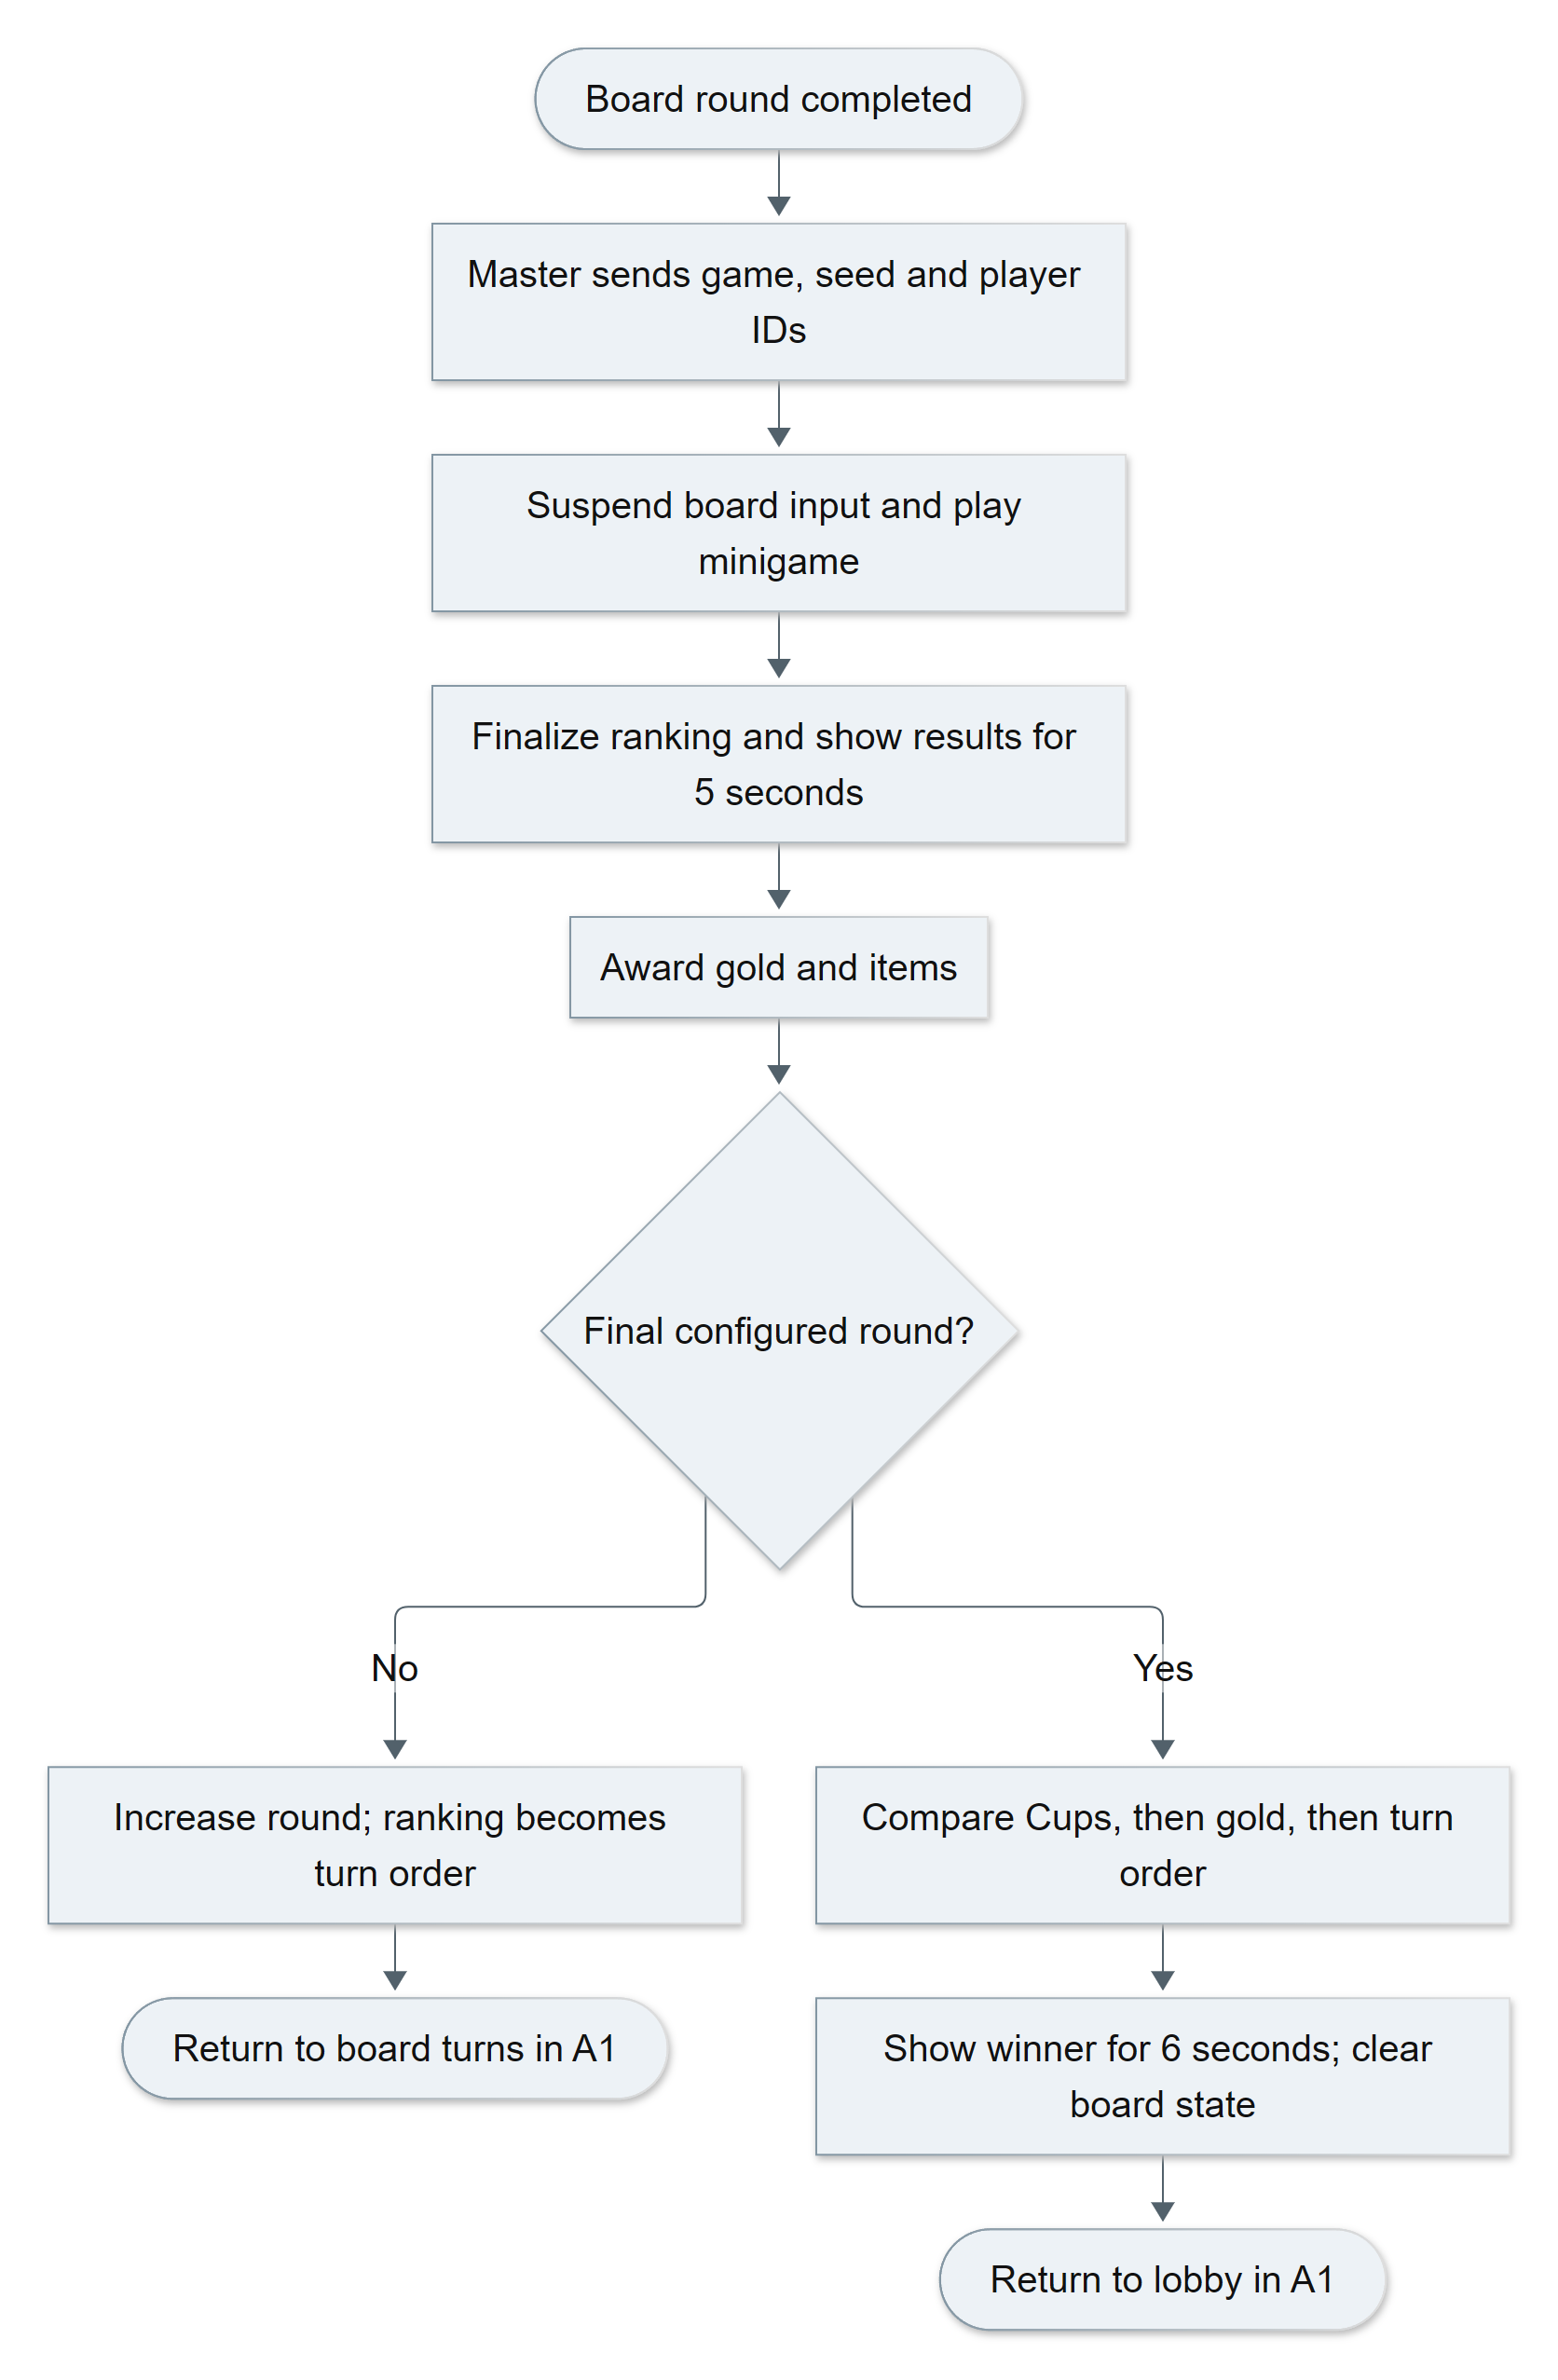
Figure A2 Detailed minigame and match result flow generated from Mermaid
Evidence: Source baseline 3c156b5; minigame/quan_tro_minigame.gd; board/kinh_te.gd; board/luat_ruong.gd; main.gd. Editable source: report/diagrams/match_flow_detailed.mmd.

Appendix B Detailed system architecture
Arrows show coordination and dependencies, not inheritance. Room properties and RPC events have different lifetimes; rule results are presented through the board and HUD.
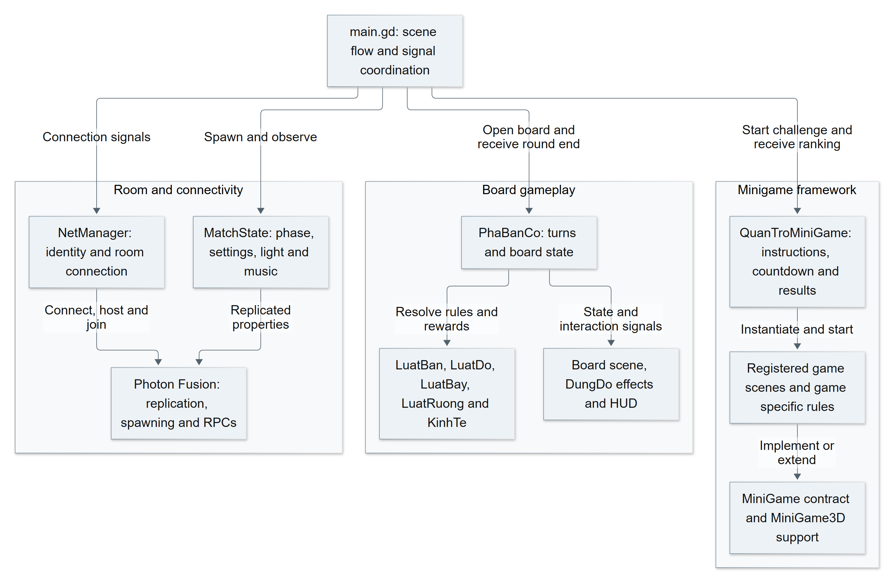
Figure B Detailed architecture generated from Mermaid
Evidence: Source baseline 3c156b5; main.gd; net/match_state.gd; board/pha_ban_co.gd; minigame/quan_tro_minigame.gd. Editable source: report/diagrams/system_architecture_detailed.mmd.

Appendix C Multiplayer event sequence
The master control flow combines main.gd and PhaBanCo. This sequence follows the common 3D arena path; Tank has a separate implementation. Photon transports messages while game code resolves rules.
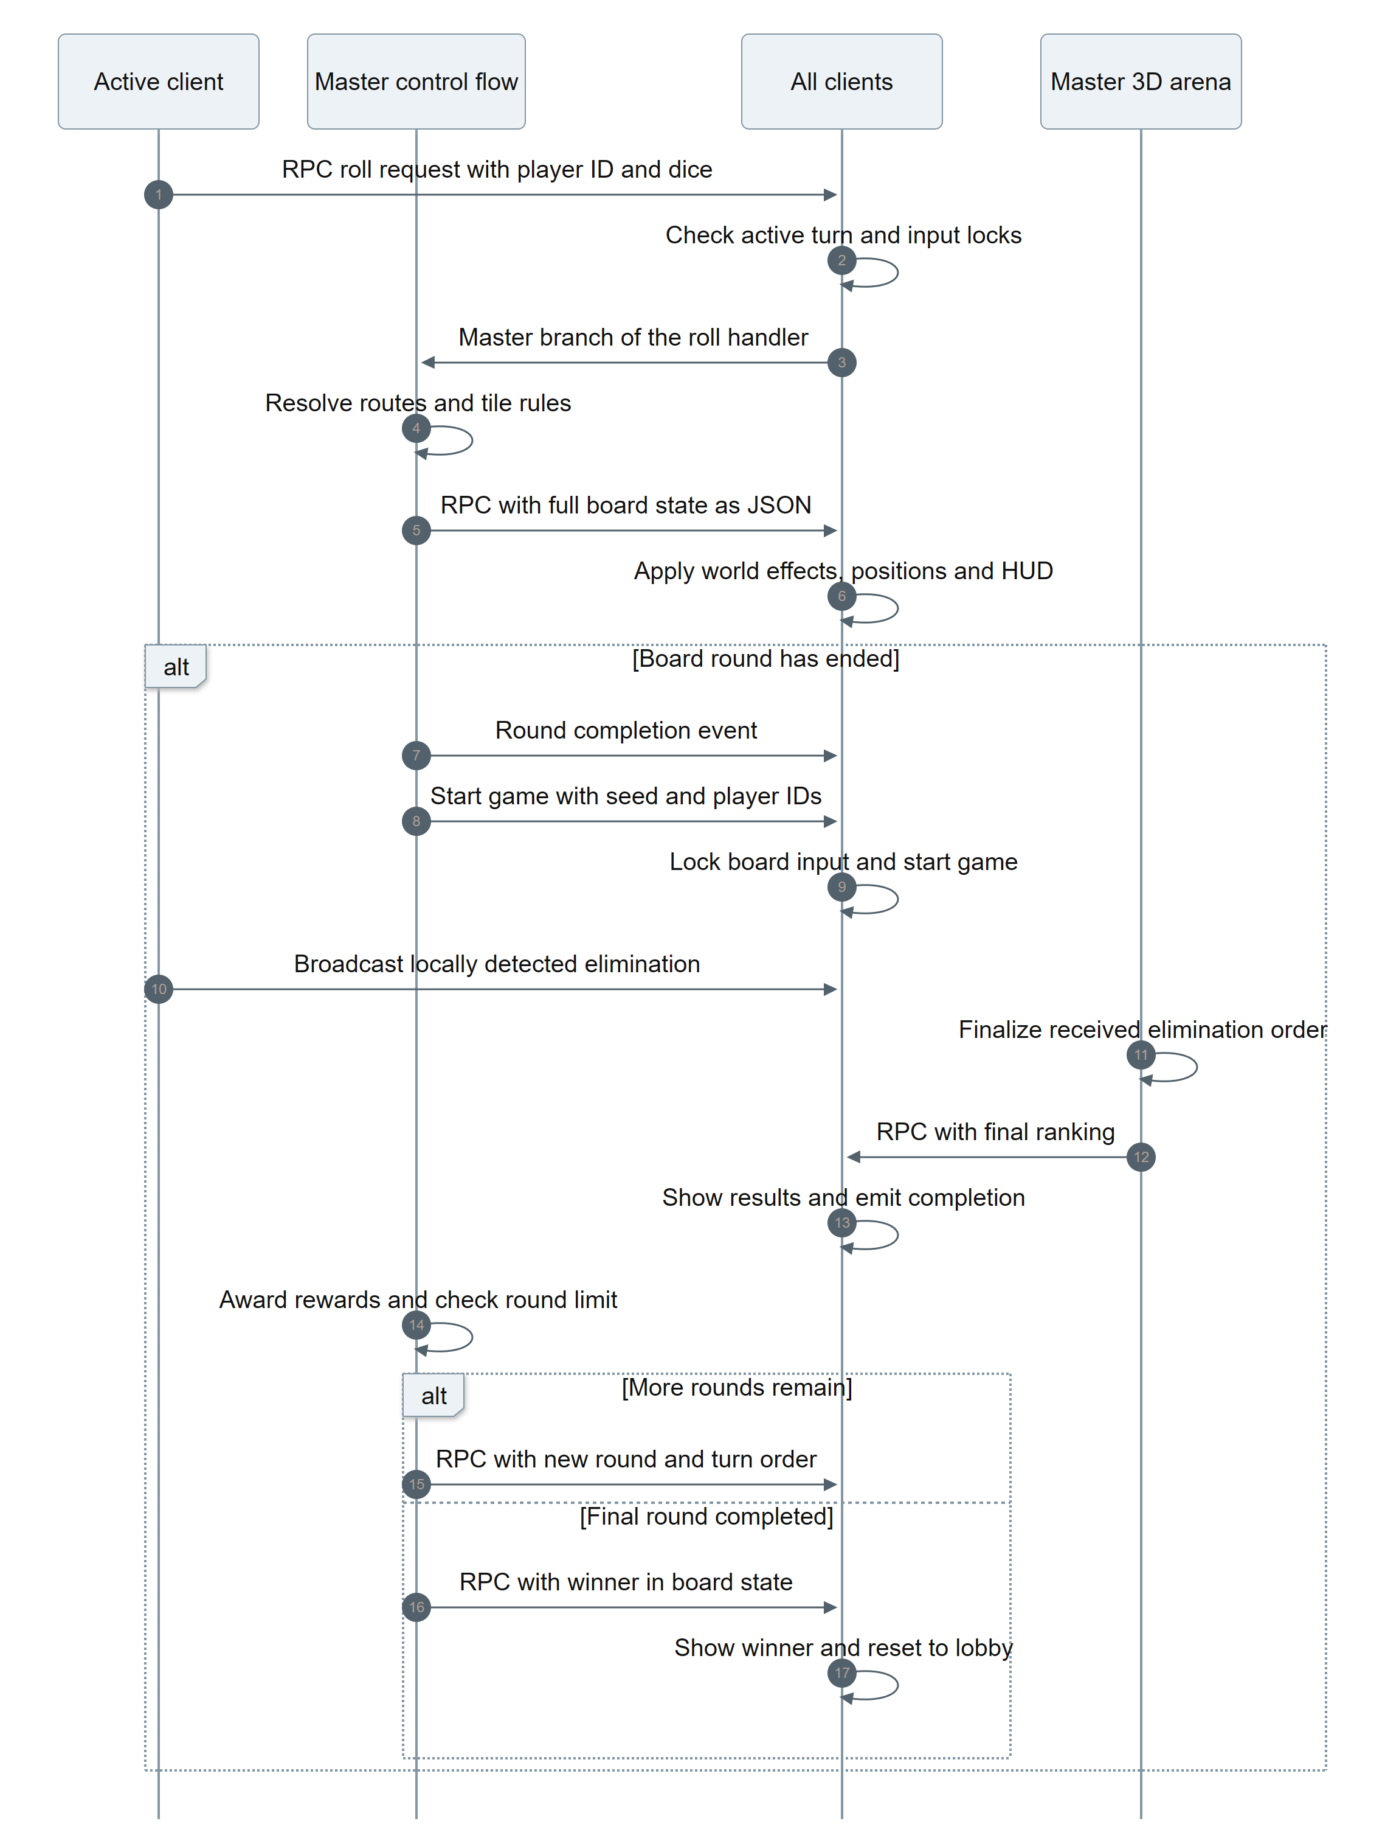
Figure C Board and minigame event sequence generated from Mermaid
Evidence: Source baseline 3c156b5; board/pha_ban_co.gd; main.gd; minigame/chung/mini_game_3d.gd. Editable source: report/diagrams/multiplayer_sequence.mmd.

