PartyBash Weekly Report Week 2
  - Core gameplay prototype
Course 3D Programming | Final Project 2026
Group: Party Bash
Lecturer: Trần Thế Vũ
Presentation date: ................................
Team member | Student ID
Trần Ngọc Quân | 23020020
Ngô Hoàng Nhật Khang | 23020004

Main outcome
The prototype establishes movement in a 3D environment, object interaction and readable camera coverage. Git evidence from 28 to 30 September 2026 includes build 0.0.6, the Rumble Reef board model, 3D dice and camera adjustments for a larger map. The demonstration prioritizes movement and jumping together with picking up, dropping or throwing an object.
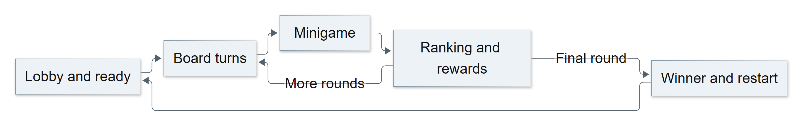
Mermaid overview of the intended game loop with detailed flow in Appendix A
The lobby is the first place to validate control and physics before board integration. The board introduces routes and turns; minigame results and match progression are the Week 3 integration target. The diagram describes the full intended loop, while this milestone demonstrates the prototype interactions available at its baseline.
Evidence: a65eec3, 28 September; 3bfefc1, a812ca1, 5b6a69e and eda5944, 30 September 2026; builds/PartyBash-0.0.6.zip.

1 Week 2 progress update
Reporting item | Weekly update
What | Player controller, camera, interactive lobby, board blockout, 3D dice and the Windows 0.0.6 milestone package.
When | End of Week 2: demonstrate movement and at least two gameplay interactions; carry the board framework into Week 3 integration.
Why | Control, visibility and interaction must be feasible before adding more game rules and content.
Who | Quan: player, camera, UI and settings. Khang: networking, board rules and minigames. Each member presents the artefacts they are responsible for.
How much | Proposed estimate for Week 2: Quan 12 hours; Khang 12 hours. Actual Quan: .... hours; Khang: .... hours. Variance and explanation: ................................
Top risks | Obstructed cameras, invalid collisions or incorrect object ownership; inspect layers, raycasts and two clients in one room.
Major changes | Added Rumble Reef, 3D dice and terrain changes; adjusted the camera for a larger game space.
Key issues | Build 0.0.6 is a historical milestone. The board to minigame transition requires the next integration stage and network checks.

Mechanics to demonstrate live
Mechanic | Action | Visible passing criterion
Movement and jumping | Run through the lobby, change direction and jump. | The player stays on the floor, respects obstacles and has the correct camera.
Object interaction | Approach an object, pick it up and drop or throw it. | Holding changes to falling and collision; the second client observes the action.
Board dice | Run the relevant dice prototype at this milestone. | A visible die and result can feed the subsequent turn system.

Evidence: player/player.gd; player/camera_rig.gd; lobby/objects/pickable.gd; board/xuc_xac_3d.gd; Git history.

2 Blockout and prototype techniques

Environment and player path
The lobby groups activities while keeping room for movement and object testing. Rumble Reef provides space for tile based board routes. Identify spawn points, walkable floors, obstacles, activity groups and intended movement paths during the blockout explanation. Detailed models support readability but do not replace a functional path.

Collision and physics
CharacterBody3D controls the player and CollisionShape3D defines its collision body. Pickable objects have their own scenes and shapes. Raycasts identify interaction targets; layers distinguish target types. Check movement against a wall, jumping near an edge and interaction outside the valid reach.

Camera implementation
A camera belonging to the local player prevents one client from controlling another player’s view. Commit eda5944 records a CameraRig adjustment for the larger map. The current source also has obstruction raycasts and board specific views; distinguish later improvements from the prototype milestone when discussing progress.

Updated work breakdown
Work package | Milestone status | Next action
Scenes and base assets | Scenes and a map are available. | Review collision and unused resources.
Controller and camera | Control foundations and camera commits exist. | Check usability with two clients.
Board and dice | The board map and 3D dice exist. | Connect turns, tile rules and UI.
Minigames and progression | Scheduled for Week 3 integration. | Return rankings to board progression.
Build and documentation | Package 0.0.6 is available. | Cross check source and update instructions.

Evidence: lobby/lobby.tscn; player/player.tscn; board/ban_party.tscn; 3bfefc1; a812ca1; eda5944; GUIDE.md.

3 Week 2 presentation and live demo
Step | Demonstration | Explanation
1 | Show the game loop. | Cups are the eventual objective; this prototype proves control and interaction.
2 | Move, look, jump and approach a wall. | Identify Player, its camera and collision setup.
3 | Pick up and drop or throw an object. | Explain interaction range and physics.
4 | Observe from a second client. | Distinguish local input from synchronized data.
5 | Open the board map and dice. | Identify blockout, tiles and the intended route.
6 | Show both members’ Git evidence. | Review a812ca1 and eda5944 alongside a65eec3 and foundation scenes.

Speaking responsibilities
Quan demonstrates and explains the controller, camera, map and dice. Khang operates the second client and explains networking and object ownership. Both members review the WBS and identify the work required for the integrated alpha.

Acceptance and next steps
The tutor should see a moving player and at least two working gameplay interactions live. For failures, record reproduction steps, the source baseline and logs. The next milestone connects ready state, board turns, minigames, ranking and resources into one playable flow.
Bring the prototype package, collision scene evidence, the game loop, commits from both members and a short fallback video. If the current build is used to illustrate later work, state that it is newer than the 30 September prototype milestone.
Evidence: Week 2 requirements; readme.md; builds/PartyBash-0.0.6.zip; Git history, 28 to 30 September 2026.

Appendix A1 Readiness and board turns
The first half of the match flow shows readiness cancellation, an optional item, dice, movement and completion of a board round. Continue with A2 after every player has taken a turn.
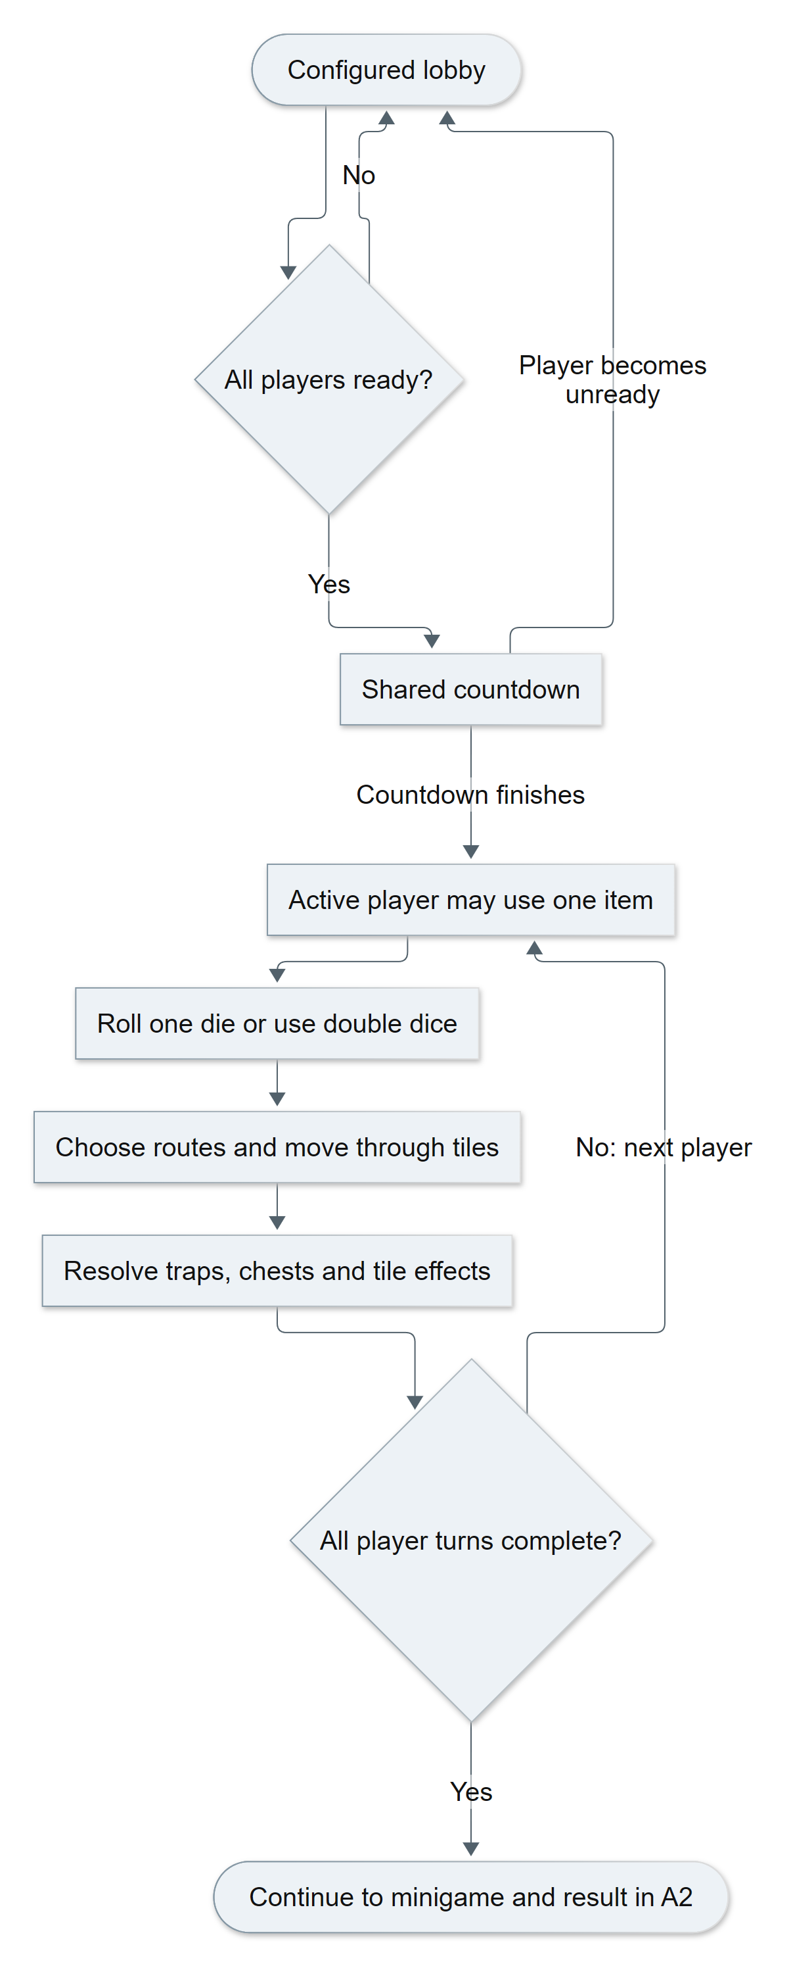
Figure A1 Detailed readiness and board flow generated from Mermaid
Evidence: Source baseline 3c156b5; net/match_state.gd; board/pha_ban_co.gd; main.gd. Editable source: report/diagrams/board_flow_detailed.mmd.

Appendix A2 Minigame rewards and match completion
The second half connects the minigame ranking to rewards, another round or a final winner. The labelled return nodes refer to the lobby and board flow in A1.
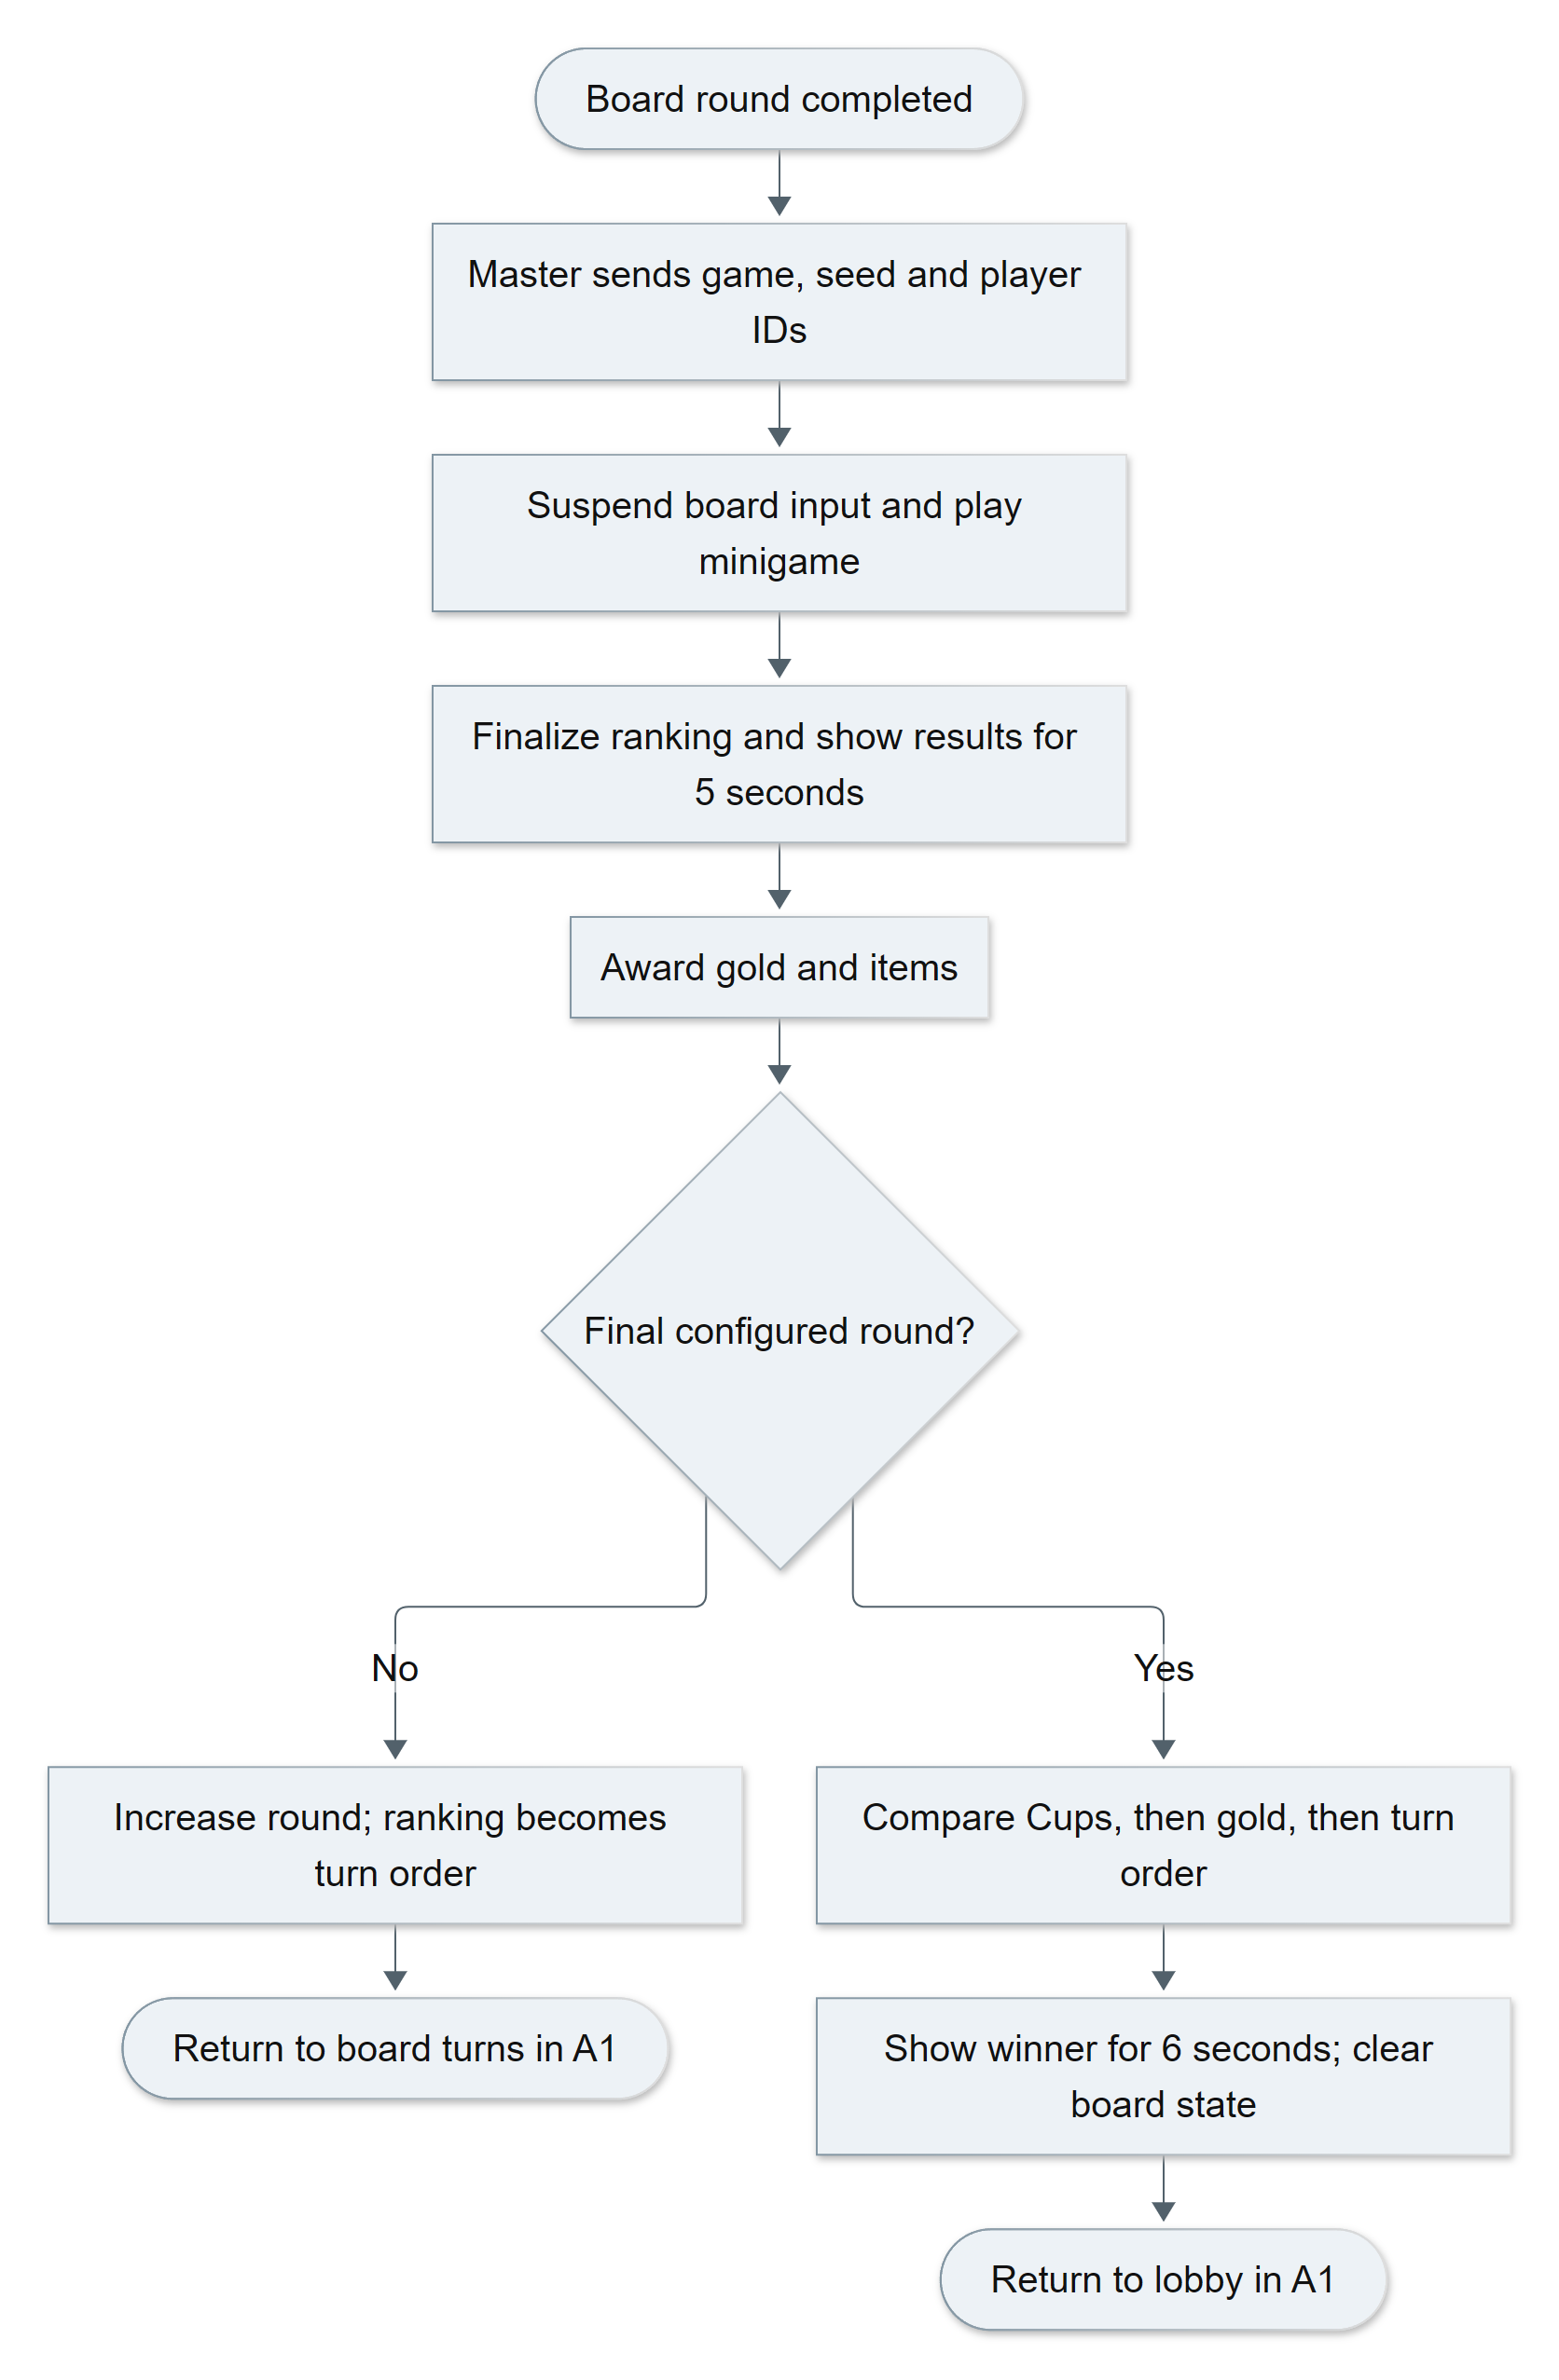
Figure A2 Detailed minigame and match result flow generated from Mermaid
Evidence: Source baseline 3c156b5; minigame/quan_tro_minigame.gd; board/kinh_te.gd; board/luat_ruong.gd; main.gd. Editable source: report/diagrams/match_flow_detailed.mmd.

