PartyBash Weekly Report Week 3
  - System integration and playable alpha
Course 3D Programming | Final Project 2026
Group: Party Bash
Lecturer: Trần Thế Vũ
Presentation date: ................................
Team member | Student ID
Trần Ngọc Quân | 23020020
Ngô Hoàng Nhật Khang | 23020004

Main outcome
The 1 to 2 October 2026 milestone connects the prototype into an integrated flow: a completed board round launches a minigame and the returned ranking determines the next turn order. The same period adds synchronized settings, appearance options, weapons, a shared score display and graphics quality management. The advanced feature is multiplayer demonstrated through two clients sharing one challenge.
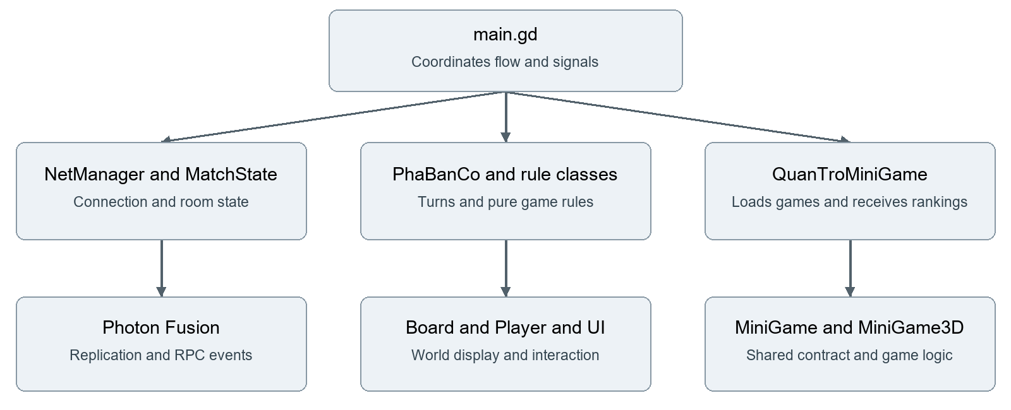
Alpha architecture connecting the coordinator to networking, the board and minigames
The alpha must demonstrate that systems contribute to one progression loop. Show resources changing on the board, a challenge in a 3D arena and a result returning to the next board round. Visual polish and balancing remain work for the final stage.
Evidence: 2e1589c; 76c2297; 51c1110; 062b6c5; 91c2871; 46ade48; main.gd; MINIGAME.md.

1 Week 3 progress update
Reporting item | Weekly update
What | Board to minigame integration, synchronized room settings, score HUD, challenge rules and graphics performance controls.
When | By the alpha milestone: run from menu to progression and ranking. Reserve Week 4 for victory, restart, export and submission checks.
Why | Board rules and challenges must affect resources and turn order to create meaningful progression.
Who | Quan: player, camera, UI and settings. Khang: networking, board rules and minigames. Each member presents the artefacts they are responsible for.
How much | Proposed estimate for Week 3: Quan 12 hours; Khang 12 hours. Actual Quan: .... hours; Khang: .... hours. Variance and explanation: ................................
Top risks | Ranking disagreement, input passing through overlays and low FPS; master finalized rankings, suspended board input and performance sampling.
Major changes | Integrated random minigame selection, settings, weapons and shared scores; revised networking and minigame rules.
Key issues | Select the demo catalogue and prioritize outcome affecting bugs. Test late join, master changes and state after round transitions.

Connected objectives and challenges
Board turns change gold, health, items and land ownership. Minigames challenge players through opponents, timers, obstacles or dangerous regions. Results create rewards and a new turn order. To demonstrate progression, compare one resource or state value before and after the minigame.

Gameplay UI and advanced feature
Use two clients to compare names, colours and resources, then run a minigame and compare the ranking. Explain which values are replicated properties and which actions use RPCs. The HUD should expose the round, turn and instructions; the challenge should show a readable score or timer.
Evidence: main.gd; net/match_state.gd; board/pha_ban_co.gd; minigame/quan_tro_minigame.gd; ui/hud.gd.

2 Integration findings and fixes
The project notes record the following integration issues. Each provides a specific cause and response for the technical explanation. Recheck them on the alpha or submission baseline and keep fresh execution evidence.
Recorded issue | Impact | Response and regression check
Board input remains active under a minigame | Space can fire Tank and also roll board dice. | Connect bat_dau to tam_dung; verify that firing does not change board turns on either client.
Players overlap on a shared tile | Participants and the active turn are difficult to identify. | Distribute positions around the tile by turn order; inspect several players on one tile.
Rankings differ between machines | Rewards and the next turn order may disagree. | The master finalizes ranking; MiniGame3D avoids cross machine clock comparison. Compare final results.
Camera obstruction or weak framing | Players cannot read the arena clearly. | Adjust camera framing and repeat a fixed route and wall approach test.

Remaining checks
A successful run in two windows does not establish behaviour for ten players or machines with different latency. Record commit, client count, devices and reproduction steps. Check round transitions, room departure, late join and the viewing experience after elimination separately.

Work breakdown update
The source contains integrated coordination, challenges, HUD and settings. Remaining final week work includes scope freeze, victory and restart acceptance, outdated documentation, performance measurements and a build matching the source. A planned game list is not execution evidence.
Evidence: ROADMAP.md, six player test notes; MINIGAME.md; main.gd; mini_game_3d.gd; 062b6c5; 91c2871; 2431145.

3 Week 3 presentation and live demo
Step | Action | Visible passing criterion
1 | Create a room, join with another client and become ready. | Both clients enter the playing phase.
2 | Play a board turn and use an item or resolve a tile. | Resources, position and UI reflect the same outcome.
3 | Finish the board round and allow automatic minigame startup. | Instructions and countdown appear without manually changing scenes.
4 | Play and finish a 3D challenge. | Opponents, score or timer and a final result are visible.
5 | Return to the board. | Ranking, rewards and next turn order agree.
6 | Open the implementation and explain three integration issues. | Members identify signals, RPCs and the input suspension logic.

Final week ownership
Member | Remaining work and completion target
Trần Ngọc Quân | Review camera and controls, HUD readability, inventory and graphics settings; prepare controller and UI explanations.
Ngô Hoàng Nhật Khang | Review rules, rankings, rewards, items and completion flow; prepare networking, minigame and rule test explanations.
Both | Test two machines, confirm contributions, select the final commit, export, record the video and complete documentation.

The alpha outcome is a coherent gameplay flow and a prioritized remaining issue list. Mark scenarios complete only after rerunning them and save the evidence for comparison with the final package.
Evidence: Week 3 requirements; main.gd; board/kinh_te.gd; tests/test_gameplay_rules.gd; commits dated 1 to 2 October 2026.

