Sekaiju5.9
MIDI Sequencer software
User's Manual

2020/01/05 The 59th edition publish

(C)2020 kuzu / OpenMIDIProject
E-mail: ee65051@yahoo.co.jp (Temporary)
URL:https://openmidiproject.osdn.jp/index_en.html

Thank you for downloading or receiving Sekaiju 5.9. First, please read “readme_en.txt” before reading this manual.

This user's manual is written by using OpenOffice 4.1.5.

Attention

(1) This software is released under the terms of MPL2.0 (Mozilla Public License 2.0). You can modify or redistribute this software under the terms of MPL2.0.
(2) This library is distributed WITHOUT ANY WARRANTY. The author does not assume any responsibility.
(3) This software uses (depends on) MIDIIO.dll, MIDIData.dll, MIDIClock.dll, MIDIStatus.dll, and MIDIInstrument.dll. They are all released under the terms of LGPL from openmidiproject.
(4) All brand names and product names are registered trademarks of their respective companies.

Index
1. Install and Execute 2
1-1. Install 2
1-2. Execute 3
1-3. Setup of language 3
1-4. Setup of MIDI device and instrument 3
1-5. Exit 4
1-6. Uninstall 4
2. Operations 5
2-1. Main window 5
2-1-1. Menu and Toolbar 5
2-1-2. Status Bar 16
2-2. Track List Window 18
2-2-1. Toolbar 18
2-2-2. Track's Property 19
2-2-3. Tempo Property 21
2-2-4. Time Signature Property 22
2-2-5. Key Signature Property 22
2-2-6. Marker Property 23
2-3. Piano Roll Window 23
2-3-1 Toolbar 24
2-3-2. Note Property 26
2-3-3. Tempo Property 27
2-3-4. Time Signature Property 28
2-3-5. Key Signature Property 28
2-3-6. Marker Property 29
2-4. Event List Window 29
2-4-1 Toolbar 30
2-4-2. Explanation of Event's Kind 32
2-5. Musical Score Window 35
2-5-1 Toolbar 36
2-5-2. Note Property 40
2-5-3. Tempo Property 41
2-5-4. Time Signature Property 41
2-5-5. Key Signature Property 42
2-5-6. Marker Property 42
2-6. “Open” Dialog 43
2-7. “Save As” Dialog 43
2-8. “Property of this MIDIData” Dialog 44
2-9. “Modify Event's Track” Dialog 46
2-10. “Modify Event's Time” Dialog 46
2-11. “Modify Event's Channel” Dialog 47
2-12. “Modify Note Key” Dialog 48
2-13. “Modify Event's Velocity” Dialog 48
2-14. “Modify Event's Duration” Dialog 49
2-15. “Modify Event's Value” Dialog 49
2-16. “Modify Event's Tempo” Dialog 50
2-17. “Quantize” Dialog 50
2-18. “Break up note and Make Trill” Dialog 51
2-19. “Scan Beat and Insert Tempo” Dialog 51
2-20. “Stroke” Dialog 52
2-21. “MIDI Device and Instrument” Dialog 53
2-21-1. MIDI In Device 53
2-21-2. MIDI Out Device 53
2-21-3. MIDI Inst Def (Normal) 53
2-21-4. MIDI Inst Def (Drum) 54
2-21-5. MIDI Thru 54
2-22. “MIDI Sync Mode” Dialog 55
2-22-1. MIDI Sync (Receive) 55
2-22-2. MIDI Sync (Send) 55
2-23. “Metronome” Dialog 56
2-24. “Auto Save” Dialog 56
2-25. “Language” Dialog 57
2-26. “Options” Dialog 58
2-26-1. General 58
2-26-2. Color 60
2-26-3. Font 60
2-26-4. Track List (1) 61
2-26-5. Track List (2) 61
2-26-6. Piano Roll 62
2-26-7. Event List 62
2-26-8. Musical Score 63
3. How to make MIDI sequence 64
3-1. Create New MIDI sequence 64
3-2. Set the Property of this MIDI sequence 64
3-3. Set the each track's property 65
3-4. Insert note events in the piano roll window. 65
3-5. Edit events in the event list window 66
3-6. Playing the MIDI sequence 67
3-7. Saving the MIDI sequence 67
4. Trouble shooting 68
4-1. Error messages 68
4-2. If no sound is played 70
5. MIDI Implementation 71
5-1. Receive data 71
5-2. Send data 72
5-3. MIDI Implementation Chart 73
6. Specification 74
6-1. Specification of software 74
6-2. Required Environment 74
6-3. Required Dynamic Link Library (*.dll) 74

1. Install and Execute

This software doesn't have an installer. You only need to extract zip file.

1-1. Install

Please extract Sekaiju5.9.zip to a folder. Following files and folders will appear. Please check all files and folders are present.

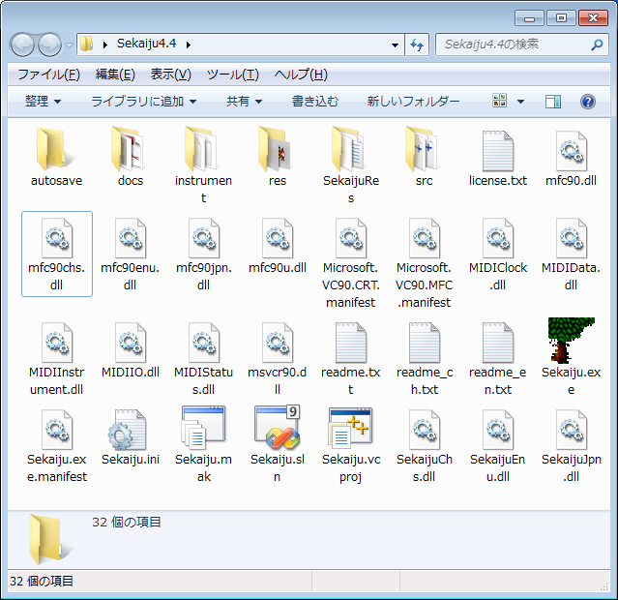

* If “Hide hidden files and folders” is selected in My computer or Window explorer's folder option dialog, files such as “*.dll” are not shown. Please select “Show all files and folders” to check “*.dll” files are present.

* Don't put Sekaiju in the “c:\program files” or “c:\ program files(x86)” or “c:\windows” folder. These folder is controlled by Windows User Account Control (UAC) feature so writing configuration file (*.ini) is blocked.

File name | Description
Sekaiju.exe | Main program.
Sekaiju.exe.manifest | A manifest file to recognize Microsoft's dll.
Sekaiju.ini | A configuration file.
Sekaiju.sln | A solution file for Microsoft Visual C++ 2008 Standard Edition SP1.
Sekaiju.vcproj | Project file for Microsoft Visual C++ 2008 Standard Edition SP1.
Sekaiju.mak | A make file for C/C++.
Microsoft.VC90.CRT.manifest | A manifest file to recognize Microsoft C Runtime Library
Microsoft.VC90.MFC.manifest | A manifest file to recognize Microsoft MFC Runtime Library
msvcr90.dll | C Runtime Library.
mfc90.dll | MFC Runtime Library (for ANSI).
mfc90u.dll | MFC Runtime Library (for Unicode)
mfc90chs.dll | MFC Chinese language resource DLL.
mfc90enu.dll | MFC English language resource DLL.
mfc90jpn.dll | MFC Japanese language resource DLL.
SekaijuChs.dll | Sekaiju Chinese language resource DLL.
SekaijuEnu.dll | Sekaiju English language resource DLL.
SekaijuJpn.dll | Sekaiju Japanese language resource DLL.
MIDIIO.dll | MIDI message input or output library.
MIDIClock.dll | MIDI clock measuring library.
MIDIData.dll | MIDI data creating / editing library.
MIDIStatus.dll | MIDI module's status keeping library.
MIDIInstrument.dll | MIDI instrument definition file (*.ins) library.
readme.txt | Please read me first (Japanese).
readme_ch.txt | Please read me first (Chinese).
readme_en.txt | Please read me first (English).
license.txt | License (LGPL)
autosave | A folder for auto save file (*.skj)
docs | A folder for documentations (*.odt) (*.pdf) .
instrument | A folder for instrument definition files (*.ins)
src | A folder for C/C++ source files (*.cpp), C/C++ header files (*.h), and resource script file (*rc).
SekaijuRes | A language depending resource script(*.rc) folder.
res | A folder for resource files such as *.bmp, *.ico, *.cur, and so on.

1-2. Execute

Please double click Sekaiju.exe in “My computer” or “Explorer”. Following main window will appear.

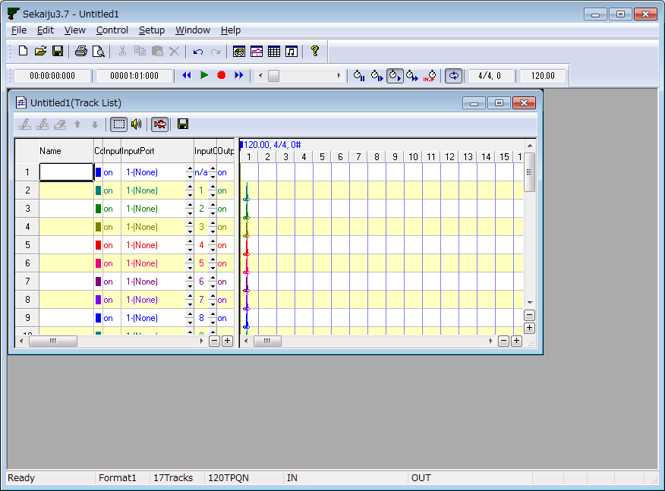

* Sekaiju must be executed on the local computer that “Sekaiju.exe” is installed. Execution from the network computer will cause some trouble.

1-3. Setup of language

Sekaiju is made in Japan, therefore default GUI language is Japanese. You may select English language, there are two ways to change language: (1) from GUI, (2) from text editor.

(1) Select "Setup"-"Language..." from the menu and select language in the dialog, then restart Sekaiju. If it is difficult to select the menu because of character corruption, press [Alt]+[S] key and then [Alt]+[L] key, and you may open the dialog.

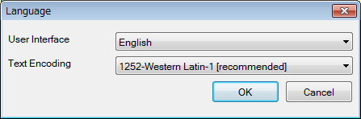

(2) Open "Sekaiju.ini" in your text editor and change "UserInterface=Japanese" into "UserInterface=English" or "UserInterface=Chinese", and then execute Sekaiju.

1-4. Setup of MIDI device and instrument

First you must select MIDI In device, MIDI Out device, MIDI Instrument definition (normal) and MIDI Instrument definition (drum) so as to fit your using MIDI device or MIDI instrument from "Setup" - "MIDI Device and Instrument" menu. See also 2-16. “MIDIDevice and Instrument” dialog.

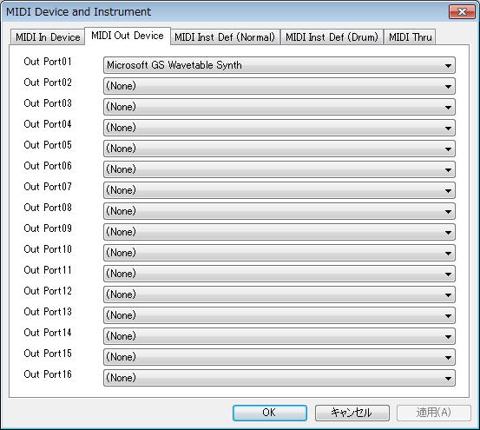

You must select at least out port 01's MIDI out device to play the sounds. Windows XP has internal “Microsoft GS Wavetable SW Synth” and Windows Vista / 7 has internal “Microsoft GS Wavetable Synth”. If you don't own your MIDI module or Synthesizer, please select them.

Instrument definition (normal) and instrument definition (drum) must be selected using your MIDI module or Synthesizer. If your module is not in the list, please search suitable instrument definition file in the internet. Sekaiju's instrument definition file is compatible with Cakewalk's instrument definition file(*.ins), therefore “Cakewalk instrument definition file” may be the best search string. And then copy the instrument definition file (*ins) into the “instrument” folder and execute Sekaiju again, then the new instrument definition will appear.

1-5. Exit

Push left-top button, or select “File” - “Exit Application” menu, or press [Alt] + [F4] key.

If the MIDI sequence has been modified, a message box which asks whether you want to save the MIDI sequence or not will pop up. To save, click “Yes”, otherwise click “No”, to cancel exit, click “Cancel”.

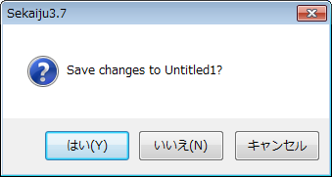

1-6. Uninstall

Simply delete the “Sekaiju5.9” folder which contains “Sekaiju.exe”.

2. Operations

2-1. Main window

Main window has one menu bar, two toolbars, a client area (shown as dark gray area) and one status bar. Toolbar and status bar can be shown or hidden from the “view” menu. Because Sekaiju is a MDI (Multiple Document Interface) application, you may open multiple MIDI sequence files to the client area. But you can also select SDI (Single Document Interface), by selecting “Setup” - “Options...” menu and uncheck “Allow multiple open”.

2-1-1. Menu and Toolbar

File - New (Ctrl + N)

Create New MIDI sequence. A new Track list window of the MIDI sequence will appear.

New MIDI sequence is format 1, and has one conductor track and 16 MIDI tracks, summary 17 tracks. First track is called as "conductor track", in which track name, tempo, time signature, key signature, and end of track event have been inserted by default. The second and following tracks are normal tracks, in which track name, basic control change, program change, and end of track event have been inserted by default.

New MIDI sequence is TPQN (Ticks Per Quarter Note) base and resolution is setted 120 ticks per quaerter note. You may change this time mode and time resolution from "File" – "Property..." menu to your favorite value like 480 ticks per quarter note.

File – Open.... (Ctrl + O)

Open an existing MIDI file (Sekaiju sequence file (*.skj), Early Cakewalk sequence file (*.wrk), Cherry sequence file (*.chy) standard MIDI File (*.mid), MIDICSV file (*.csv ) or Mabinogi MML file (*mmml)). For detail, see also 2-6. “Open” dialog.

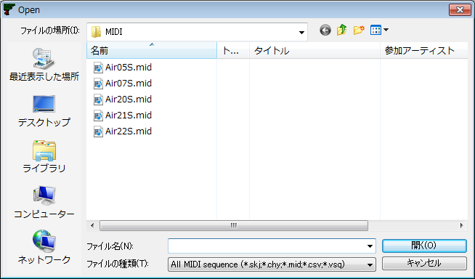

This software is MDI (Multi Document Interface) method. Therefore multiple MIDI sequence can be opened. You may also use it as SDI (Single Document Interface) method, by selecting “Setup” - “Options...” menu and uncheck “ Allow multiple open”, and single MIDI sequence will be opened, the previous MIDI sequence is automatically closed.

To start playing automatically whenever MIDI sequence is opened, select “Setup” - “Options...” and check “Start playing automatically when MIDIData is opened.”

File - Close

Close current active MIDI sequence. If the MIDI sequence is modified but not saved, the following message box is shown. To save and close, click “Yes”, to not save click “No”, to cancel to close, click “cancel”.

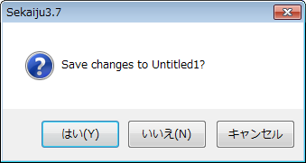

Once one MIDI file is closed, all windows (track list windows, piano roll windows, event list windows, and musical score windows) related to the MIDI sequence are also closed.

File - Save (Ctrl + S)

Save current active MIDI sequence as the same file name and same file extension.

File – Save As...

Save current active MIDI sequence as the user's specified file name and file extension (*.skj, *.chy, *.mid or *.csv). For detail, see also 2-7. “Save as” dialog,

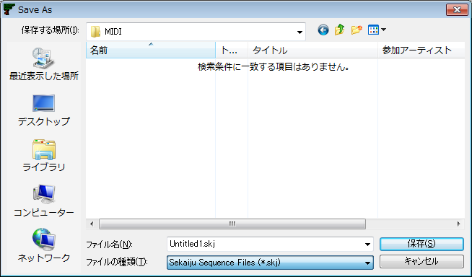

If you specify existing file name and file extension, the following message box is shown.

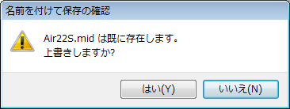

To overwrite, select “Yes”. To cancel saving, select “No”.

When saving format 1 MIDI sequence as Standard MIDI file (*.mid), all MIDI channel event's channel values must correspond to the track's output channel which the event belongs to. Containing multiple MIDI event's channel in one track is not allowed. If not, following message box is shown.

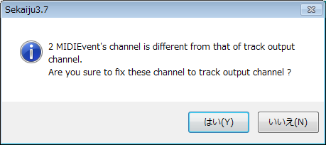
If you select “Yes”, each event's channel is corrected automatically. If you select “No” MIDI event's channel is not corrected, so wrong Standard MIDI File will be written out. Almost all MIDI sequencers (except Sekaiju) or MIDI players will cause some errors when loading this wrong SMF.

File – Property....

Show current active MIDI sequence's property dialog. This dialog shows title, subtitle, copyright, comment, number of tracks, number of events, and music length of this MIDI sequence. This dialog can be used to convert SMF Format 0 / 1 / 2, time mode (TPQN base or SMPTE 24 /25 / 29/ 30 base) and the time resolution. For detail, see also 2-8. “Property of this MIDIData” dialog.

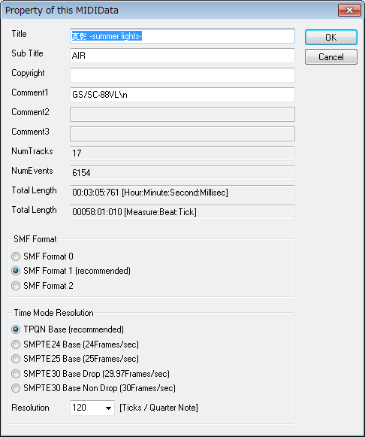

File– Print... . (Ctrl+P)

Print the current window in the specified printer, specified range, specified circulation. The printer must be color, otherwise, all text will be printed in white or black.

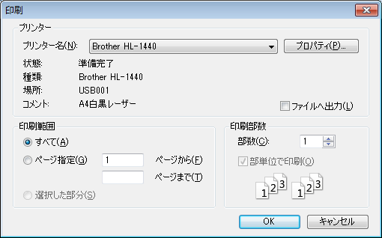

File – Print Preview...

Show the print preview. The printer must be color, otherwise, all text will be printed in white or black.

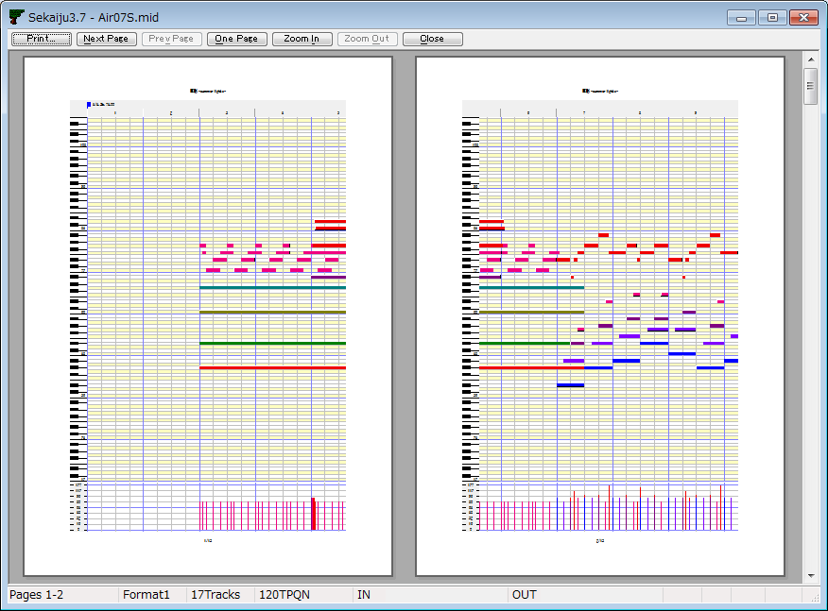

File – Printer Setup...

Specify the printer you want to use, the paper size, the paper feeding way, the direction (portrait or landscape). Printing is not done. This setup is reflected to the print preview.

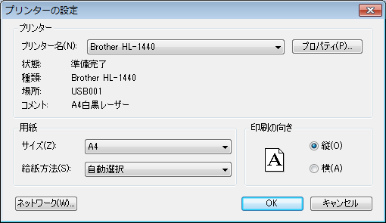

File – Exit application (Alt+F4)

Exit Sekaiju application. If MIDI sequence have been modified but not saved, the following message box is shown. If you select “Cancel”, Sekaiju will cancel to exit.

Edit - Undo (Ctrl+Z)

Cancel the most recently operation.

Edit - Redo (Ctrl+Y)

Restore the operation which has been canceled by undo.

Edit – Initialize history

Delete and initialize operation history, and disable undo or redo. The memory allocation which is used for undo or redo becomes free.

Edit - Cut (Ctrl+X)

Copy all selected events to the clipboard, and delete these selected events.

Edit - Copy (Ctrl+C)

Copy all selected events to the clipboard.

Edit - Paste (Ctrl+V)

Paste from the clipboard's events to current MIDI sequence. The paste position is the measure's head which contains current playing position. After pasting, the pasted events are selected automatically and can be moved in the Track list window.

Edit - Delete (Ctrl+Del)

Delete all selected events.

Edit – Select All (Ctrl+A)

Select all events.

Edit – Select None (Ctrl+D)

Deselect all events.

Edit - Select Events Before Cur Position

Select all events before current playing position.

Edit - Deselect Events Before Cur Position

Deselect all events before current playing position.

Edit - Select Events After Cur Position

Select all MIDI events after current playing position.

Edit - Deselect Events After Cur Position

Deselect all events after current playing position.

Edit – Modify Event's Track...

Modify all selected event's belonging track at once. For detail, see also 2-9. “Modify Event's Track” dialog.

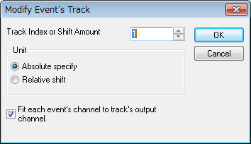

Edit – Modify Event's Time...

Modify all selected event's time at once. For detail, see also 2-10. “Modify Event's Time” dialog.

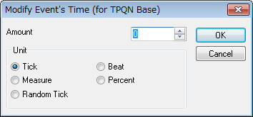

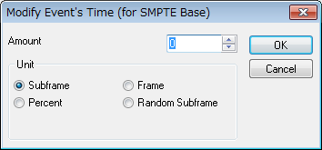

Edit – Modify Event's Channel...

Modify all selected MIDI channel events' channel (note on, note off, key after touch, control change, program change, channel after touch and pitch bend ) at once. For details, see also 2-11. “Modify Event's Channel” dialog.

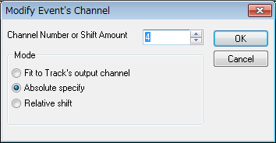

Edit – Modify Event's Key...

Modify all selected note off, note on, key after touch event's key at once. For details, see also 2-12. “Modify Event's Key” dialog.

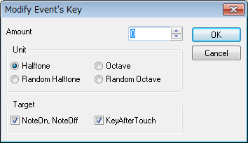

Edit – Modify Event's Velocity...

Modify all selected note off and note on event's velocity at once. For details, see also 2-13. “Modify Event's Velocity” dialog.

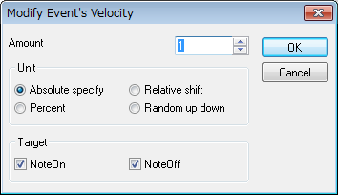

Edit – Modify Event's Duration...

Modify all selected note on event's duration at once. For details, see also 2-14. “Modify Event's Duration” dialog.

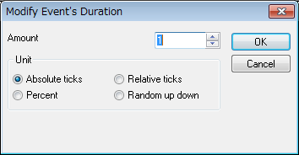

Edit – Modify Event's Value...

Modify all selected channel after touch events, control change events, key after touch events, pitch bend event's value at once. For details see also 2-15. “Modify Event's Value” dialog.

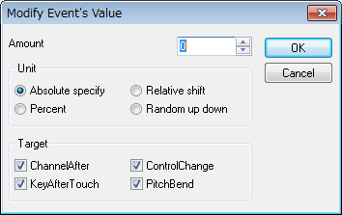

Edit – Modify Event's Tempo...

Modify all Selected tempo events' tempo values at once. For details see also 2-16. “Modify Event's Tempo” dialog.

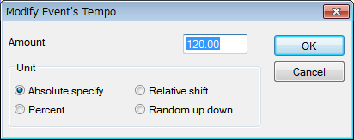

Edit – Quantize...

Align all selected note on and note off events' note on time and note off time to the specified interval. This function is used mainly after real-time input to correct time errors. For details, see also 2-17. “Quantize” dialog.

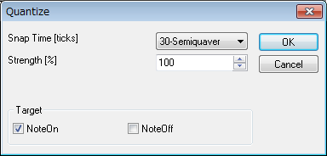

Edit - Break up notes and Make Trill...

Divide all selected note events to the specified duration, and make roll note. Also shift the note key only even note, make trill, if need.

This function enables you to input flute's trill or timpani's roll easily from one long note event. For detail, see also 2-18. “Break up notes and Make Trill...” dialog.

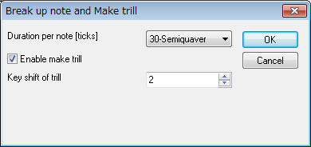

Edit - Scan beat and Insert tempo...

Detect specified track's selected note events as beat signal, and align beat to specified interval with all other events in the selected range. Also, insert tempo to keep original speed, if needed.

This function enables you to real-time input at free speed by ignoring tempo, and align all events to fit measure and beat, later. To use this function, beat track is required, which is written one note per beat. For details, see also 2-19. “Scan beat and Insert tempo” dialog.

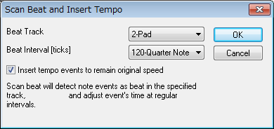

Edit – Stroke...

Stroke feature, detects a chord note which start at the same time from the selected note events, and displace the note on time in ascending or descending order. For details, see also 2-20. “Stroke” dialog.

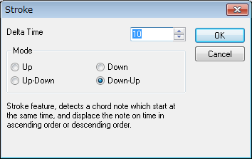

Edit – Insert measure...

Insert new measures (=bars) at the specified position and the following events are moved forwards.

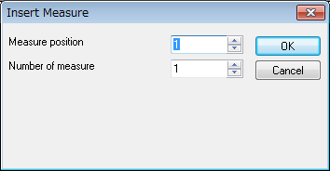

Edit – Remove measure...

Remove specified measures (=bars) at specified number and the following events are moved backwards.

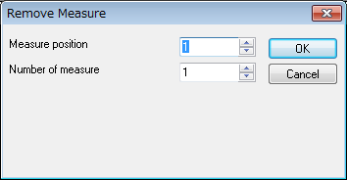

Edit – SAL (Sekaiju Application Language)...

SAL (Sekaiju Application Language) is an external module of MIDI sequencer software Sekaiju. By writing a script with your text editor, you can make your original editing command. It is executed by selecting SAL file from "Edit(E)"- "SAL(Sekaiju Application Language)..." menu of Sekaiju. SAL is an interpreter script which is similar to LISP, easy to learn if you have some programming experience. If script doesn't stop while SAL running, you can stop it by pressing ESC key. If the result of executing SAL script isn't so good, you can redo it by pressing Ctrl+Z.

If you want to use SAL, you need to put SAL.dll, SALJpn.dll, SALEnu.dll, SALChs in Sekaiju5.9's folder additionally.

NOTE: SAL is not included in the Sekaiju software. It is not free software so it must be downloaded in SAL's page and must be purchased in you want to use for 30 days or more.

View – Redraw (F5)

Redraw all windows.

View – ToolBar1

Show or hide the first toolbar. By default it is shown.

View - ToolBar2

Show or hide the second toolbar. By default it is shown.

View - StatusBar

Show or hide the status bar. By default it is shown.

View – Show new Track list window

Create and show a new Track list window. Multiple Track list windows can be opened for one MIDI sequence. For details, see also 2-2 . Track list window .

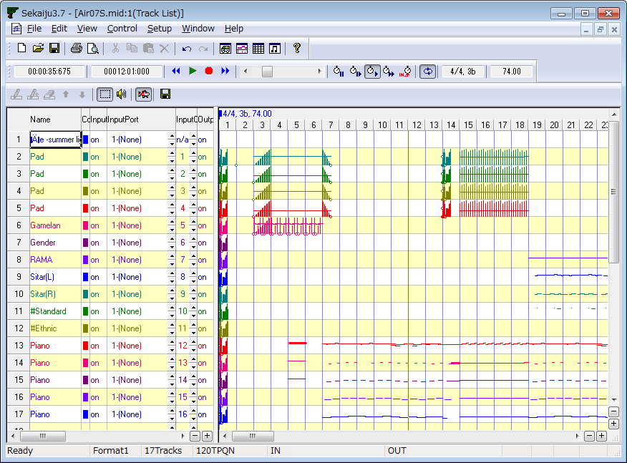

View – Show new Piano roll window

Create and show a new piano roll window. Multiple piano roll windows can be opened for one midi sequence. For details, see also 2-3 . Piano roll window .

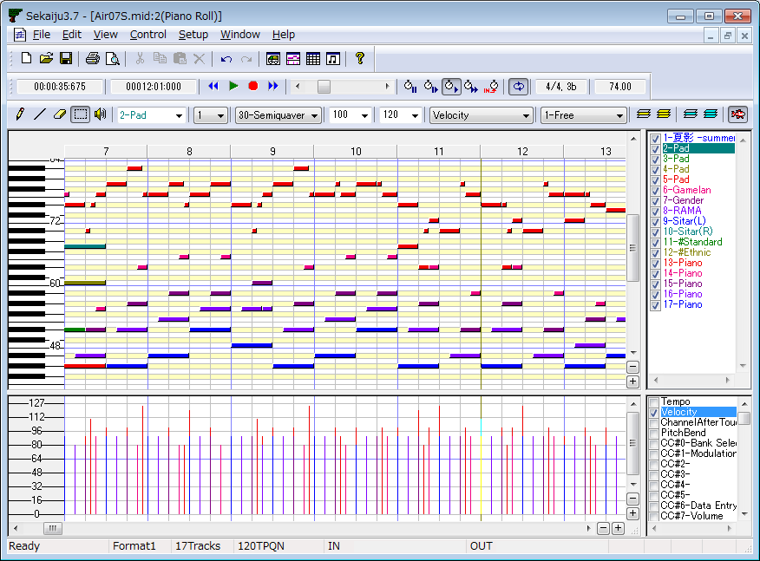

View – Show new Event list window

Create and show a new event list window. Multiple event list windows can be opened for one MIDI sequence. For details, see also 2-4. Event list window.

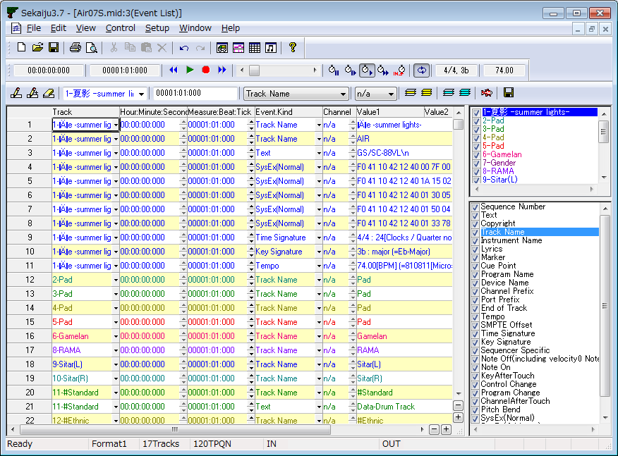

View – Show new Musical score window

Create and show a new musical score window. Multiple musical score windows can be opened for one midi sequence. For details, see also 2-5. Musical score window.

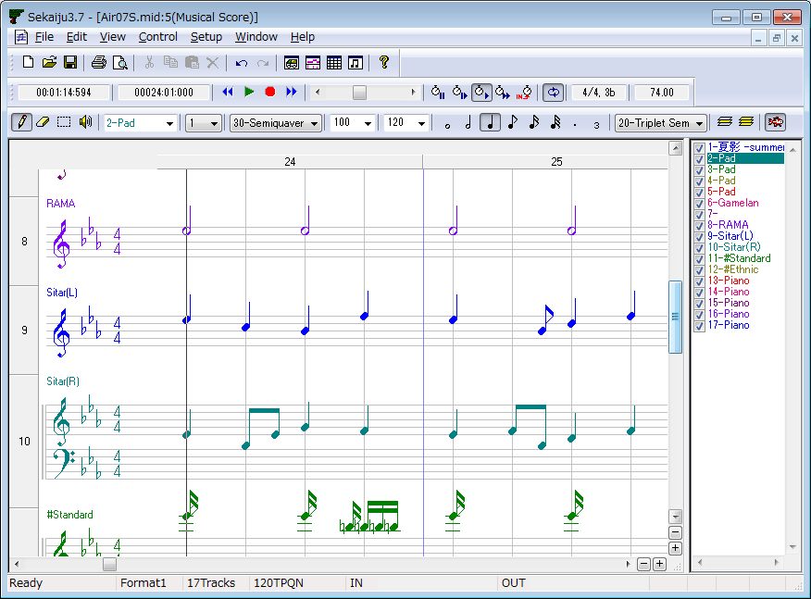
Hour : Minute : Second : Millisec

It shows the current playing or Real-time Input position by Hour : “Minute : Second : Millisecond” format.

Measure : Beat: Tick

It shows the current playing or Real-time Input position by “Measure : Beat: Tick” format. Measure number and beat number are 1 origin, tick value is 0 at the origin. If the MIDI sequence is SMPTE base, it shows by “Frame : Subframe” format. Frame number and Subframe value are 0 origin.

Control - Jump to Begin (Ctrl+Home)

Jumps current playing or real-time input position to the beginning of the MIDI sequence. If applied during playing or Real-time Input, it will automatically stop.

Control - Playback (Space)

Start or stop playing (playback) of the MIDI sequence in real time.

Usually MIDI data can't be played correctly whenever you start playing from the middle of the MIDI sequence in almost all MIDI sequencers or players, because sending control change, program change, pitch bend and so on before current position is omitted. But Sekaiju's “Intelligent play” searches the most recent control change, program change, pitch bend and so on, and send these MIDI messages if needed, so you can start playing MIDI sequence correctly at any position. Also, if you start playing in the middle of a long note, the note will be played in Sekaiju.

Control - Real-time Input (Ctrl+R)

Start or stop real-time input to the MIDI sequence. You may not use real-time input at speed = 0%; if speed = 0%, it works as “Synchronized recording start”, which starts real-time input when Sekaiju detects the first MIDI message from your MIDI keyboard, and the speed becomes normal automatically.

Control – Jump to End (Ctrl+End)

Jumps current playing or real-time input position to the end of the MIDI sequence. If during playing or real-time input, it will automatically stop.

Control – Prev Measure (Ctrl+PgUp、 Ctrl+←)

Move current playing or real-time input position 1 measure back. If the MIDI sequence is SMPTE base, jump to 10 frames before.

This operation is also enabled by turning mouse wheel with [Ctrl] key pressing, and by clicking position scroll bar's left scroll area.

Control – Next Measure (Ctrl+PgDn、 Ctrl+→)

Move current playing or real-time input position 1 measure forth. If the MIDI sequence is SMPTE base, jump to 10 frames after.

This operation is also enabled by turning mouse wheel with Ctrl key pressing, and by clicking position scroll bar's right scroll area.

Current playing or real-time input position scroll bar

This scroll bar shows current playing or real-time input position, and enables you to move the current playing position. Left side means the beginning of the MIDI sequence, right side means the end of MIDI sequence.

By moving the thumb left or right, the current playing position moves in real time. By clicking left or right scroll area, the current playing position moves by 1 measure back or forth. By clicking left or right button, the current playing position moves by 1 beat back or forth.

In the SMPTE base MIDI sequence, by clicking left or right scroll area, the current playing position moves by 10 frames back or forth. By clicking left or right button, the current playing position moves by 1 frame back or forth.

The current position can be moved during stop or playing, but not during real-time input.

The current position can be moved by pressing [Left] or [Right] key with [Ctrl] key pressed, or by turning the mouse wheel with [Ctrl] key pressed.

Whenever you moved the current position, Sekaiju searches the most recent control change, program change, pitch bend and so on, and sends these MIDI message if needed, so MIDI module's status fits the expected one at the new position (Intelligent Play).

Control – Speed = Pause

Sets the playing speed to 0%. The notes that were sounding when paused keep sounding, like when Famicom (NES) hunged up.

You may not perform real-time input at speed = 0%. if speed = 0%, it works as “Synchronized recording start”, which starts when Sekaiju detects the first MIDI message from your MIDI keyboard, and then the speed becomes normal automatically.

Control - Speed = Slow

Sets the playing or real-time input speed at 50%. This speed can be changed from “Setup” - “Options...” menu at 1% interval.

Control – Speed = Normal

Sets the playing or real-time input speed at 100%. This speed can be changed from “Setup” - “Options...” menu at 1% interval.

Control – Speed = Fast

Sets the playing or real-time input speed at 200%. This speed can be changed from “Setup” - “Options...” menu at 1% interval.

Control - Speed = Slave to other machine

Sets the playing or real-time input speed slave to the other machine. Synchronized signal must be MIDI Clock or SMPTE/MTC (MIDI Time Code quarter frame). They must be input from your MIDI keyboard or clock generator to the specified MIDI in port. If no signal is detected, the current playing position will not go forth. The kind of synchronized signal to be detected can be selected in “MIDI Sync dialog”, which can be opened from “Setup” - “Options...“ the menu. If no signal is selected, this mode will not works.

Control – Auto Repeat

If this is checked, when current position reaches the end of the MIDI sequence during playing, it jumps to the beginning of the MIDI sequence automatically and continue playing.

In case that “Loop from CC#111 position when auto repeat (“RPG Maker” method)” is checked in the option dialog, which is opened from “Setup” - “Options...” menu, and CC#111 event is contained in the MIDI sequence, it jumps to the CC#111 position automatically and continue playing. Also if “loopEnd” Marker is detected, it jumps to the “loopStart” Marker's position automatically and continue playing (FINAL FANTASY VII method).

Control – Key Shift

Rises or lowers all output note or key-aftertouch event's key within ±12 half tones (= ±1octave). This feature doesn't affect tracks whose view mode is “drum”. This feature may be used to test how the music sounds in the other key, when you have no idea etc.

This setup is not saved to the MIDI file, but kept in software level. So please be careful not to forget to clear zero after using this feature. If you don't have an absolute pitch, please be careful not to create music with wrong key.

Time signature / Key signature

It shows current position's time signature and key signature. Time signature is defined by time signature event. Key signature is defined by key signature event. Time signature and key signature can be defined as many times in one MIDI sequence, so they may be changed through one MIDI sequence. Time signature event and Key signature event can be inserted, modified, deleted in the event list window.

Time signature events and key signature events are for view only, they have no influence on the playing MIDI message. So these events may be omitted, but the view becomes strange.

Key signature is shown as the number of # (sharp) or b (flat). 0 means that has no # or b, which is C-Major or A-minor. Following list shows all pattern.

* In Sekaiju, flat sign “b” is shown as the lower case of “B”.

K.S. | key with # or b | Major | Minor
7# | F, C, G, D, A, E, B | C#-Major | A#-minor
6# | F, C, G, D, A, E | F#-Major | D#-minor
5# | F, C, G, D, A | B-Major | G#-minor
4# | F, C, G, D | E-Major | C#-minor
3# | F, C, G | A-Major | F#-minor
2# | F, C | D-Major | B-minor
1# | F | G-Major | E-minor
0 |  | C-Major | A -minor
1b | B | F-Major | D-minor
2b | B, E | Bb-Major | G-minor
3b | B, E, A | Eb-Major | C-minor
4b | B, E, A, D | Ab-Major | F-minor
5b | B, E, A, D, G | Db-Major | Bb-minor
6b | B, E, A, D, G, C | Gb-Major | Eb-minor
7b | B, E, A, D, G, C, F | Cb-Major | Ab-minor

Tempo[BPM]

It shows current position's tempo as [BPM] unit. This value means the number of quarter note per 1 minute. It is well known as the metronome = value in the musical score. Tempo is defined by tempo events. Tempo can be defined as many times in one MIDI sequence, so it may be changed through one MIDI sequence. Tempo events can be inserted, modified, deleted in the event list window.

In the case of SMPTE base MIDI sequence, tempo value is ignored, but the value is shown.

Setup - MIDI Device and Instrument...

Shows dialog to select MIDI Input device, MIDI output device, MIDI Instrument definition file (Normal), and MIDI Instrument definition file (Drum), and MIDI Thru. For details, see also 2-21. “MIDI Device and Instrument...” dialog .

You must select at least port 01 MIDI out device to play the sounds. Microsoft ships windows XP with “Microsoft GS Wavetable SW Synth” and ships windows Vista or later with “Microsoft GS Wavetable Synth”. If you don't have a MIDI module or synthesizer connected to the computer, please select them.

Setup - MIDI Sync Mode...

Shows dialog to select MIDI input synchronized signal and MIDI output synchronized signal. For details, see also 2-22 “MIDI Sync Mode” dialog ,

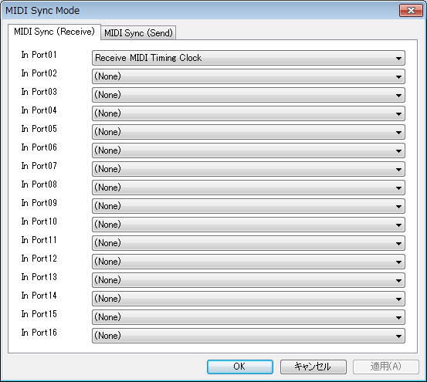

Setup - Metronome...

Shows dialog to setup metronome. For details, see also 2-23. “Metronome” dialog .

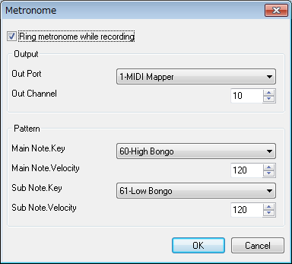

Setup – Auto Save...

Shows dialog to setup auto save. For details, see also 2-24. “Auto save” dialog .

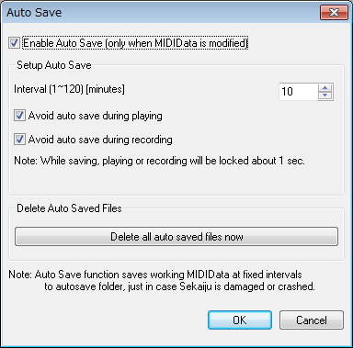

Setup – Language...

Shows dialog to select user interface's language and each file's text encoding. For details, see also 2-25 . “Language” dialog .

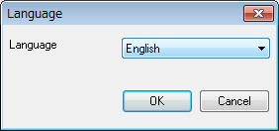

Setup – Options...

Shows dialog to setup options about Sekaiju. For details, see also 2-26 . “Option” dialog .

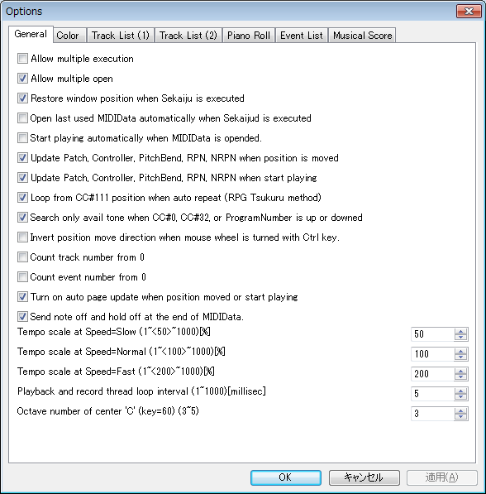

Window - New

Creates a new window to current MIDI sequence.

Window - Cascade

Cascade windows.

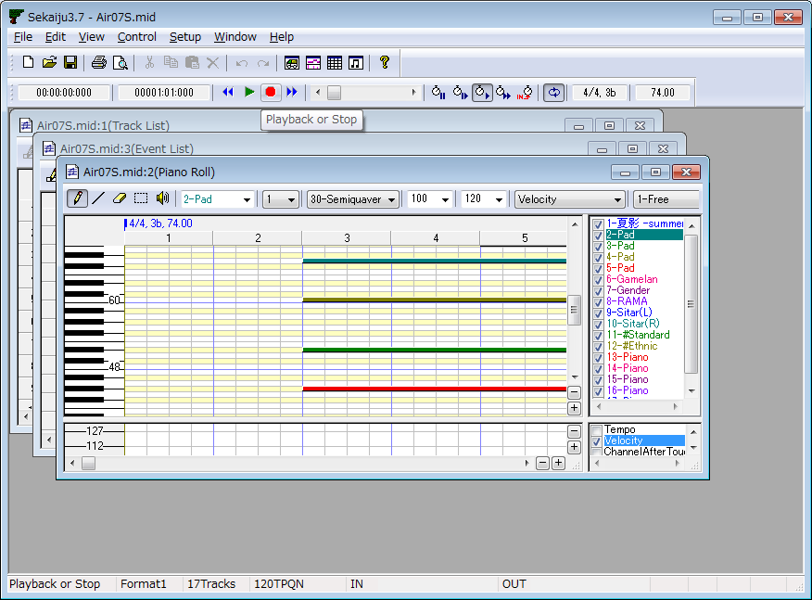

Window – Horz Tile

Layout windows top to bottom.

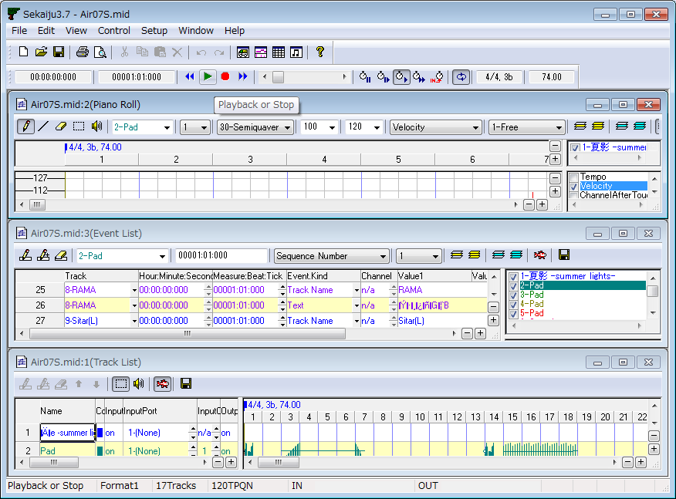

Window – Vert Tile

Layout windows left to right.

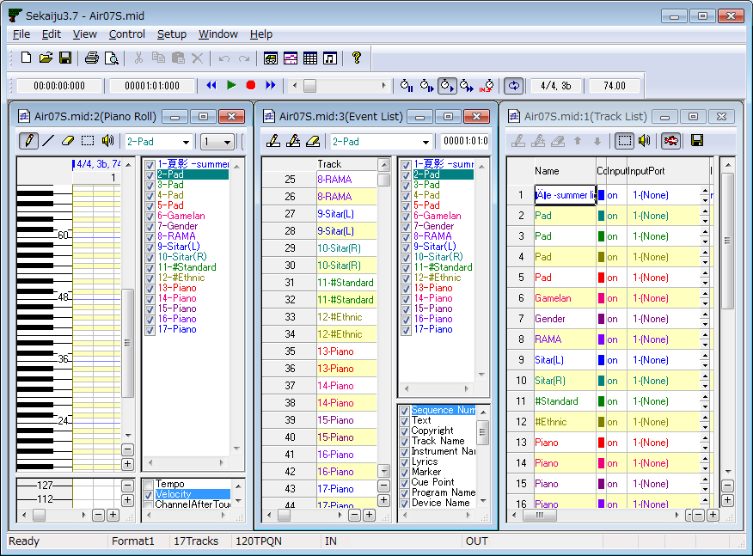

Window – Arrange Icon

Layout iconic windows left-bottom to right-bottom.

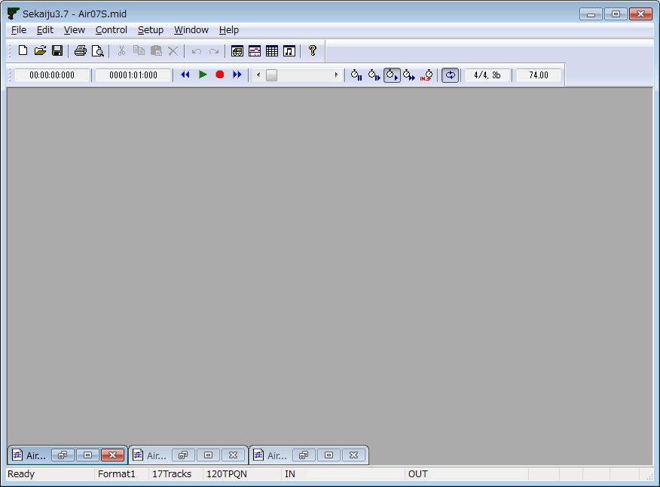

Help – Readme_en.txt....

Shows readme_en.txt in your using text editor.

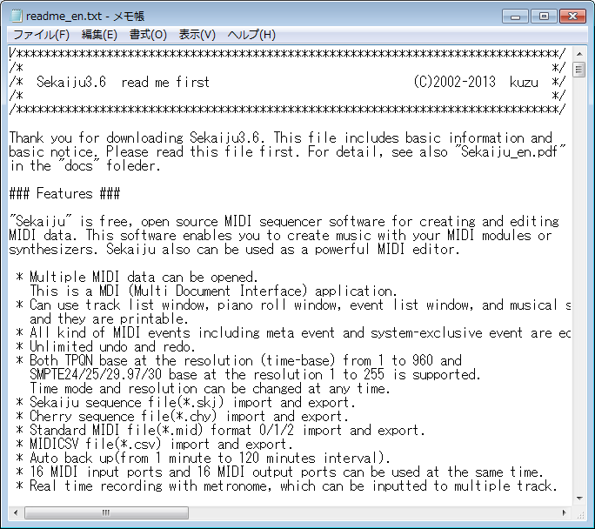

Help - License...

Shows license.txt in your using text editor. This software is released under the terms of MPL (Mozilla Public License) 2.0.

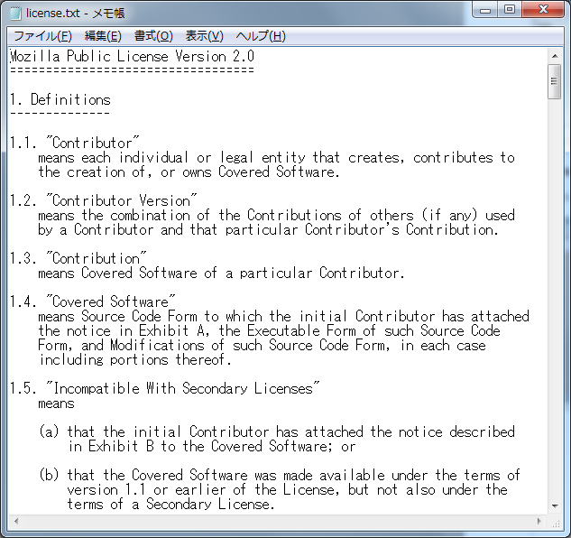

Help – Documentation (PDF)...

Shows this operation manual (.\docs\sekaiju_en.pdf) in your using PDF viewer.

Help – Project Web Page....

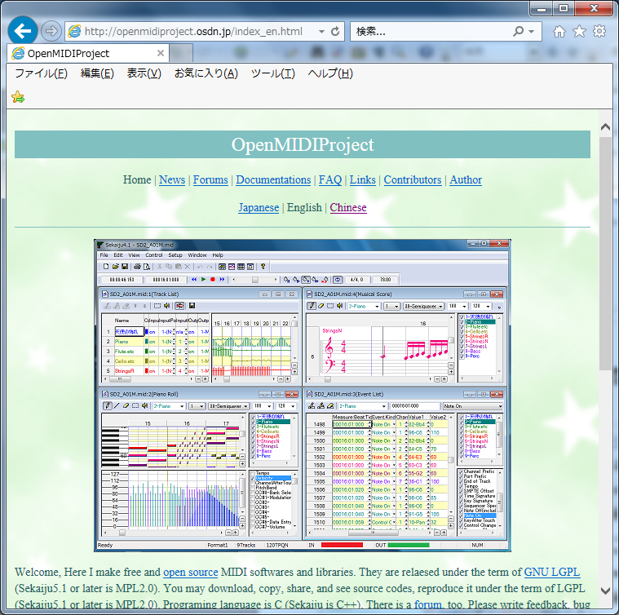

Shows the openmidiproject's web page (http://openmidiproject.osdn.jp/) in your web browser. This function requires an Internet connection.

Help – About...

Shows this software's name, version, year, copyright and so on.

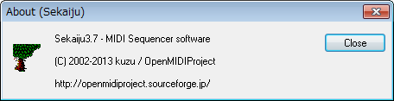

2-1-2. Status Bar

Description

This shows the description of current selected menu or current toolbar button.

Format, NumTracks, TimeBase

This shows current editing MIDIData's property, which is format, number of tracks and time base (time mode and resolution)

If you double click this area, following “Property of this MIDIData” dialog will be opened.

Input Velocity Meter

This shows current max input velocity received from input port 1~16. This detects note-on velocity, so even if CC#7(volume) or CC#11(expression) = 0, if Sekaiju receives a note-on event the velocity meter moves.

If you double click this area, the “MIDI Device and Instrument” dialog's MIDI In device page will be opened.

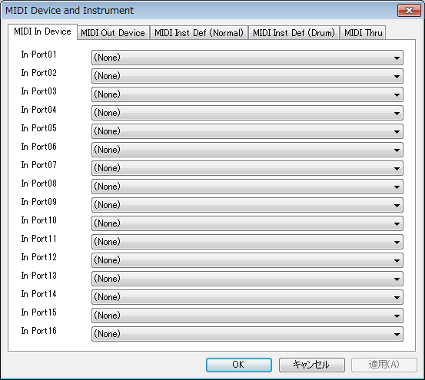

OutputVelocity Meter

This shows current max output velocity sent to output port 1~16. This detects note-on velocity, so even if CC#7(volume) or CC#11(expression) = 0, if Sekaiju sends note-on event the velocity meter moves.

If you double click this area, the “MIDI Device and Instrument” dialog's MIDI Out device page will be opened.

2-2. Track List Window

Track list window shows each track's property and overview of events containing each track.

On the other hand, track list window is inadequate for the editing each events. For editing each events, use piano roll window, event list window or musical score window.

The track list window has two views. The left view shows each track's property and the right view shows an overview of events containing each track.

On the track list window, you can scroll up or down by turning mouse wheel. Also you can move current playing position back or forth by turning mouse wheel with [Ctrl] key pressed. Also you can move current playing position back or forth by pressing [←] or [→] key with [Ctrl] key.

On the cell, you can directly input values by using the number keys. On the cell, if you left-click [▲][▼] button, or press [+] [-] key, the value will be up or down by 1 step. On the cell, if you right-click [▲][▼] button, or press [+] [-] key with [shift] key, the value will be up or down by 10 step.

2-2-1. Toolbar

Insert Track (Ins)

Inserts a new track before current focused track in the right view. In the case of format 0 MIDI sequence, MIDI sequence can have only one track, so you may not insert any further track.

Duplicate Track (Ctrl+Ins)

Duplicates the current focused track in the right view. In the case of format 0 MIDI sequence, MIDI sequence can have only one track, so you may not duplicate the track.

Delete Track (Del)

Deletes the current focused track in the right view In the case of format 0 MIDI sequence, MIDI sequence can have only one track, so you may not delete it. In the case of format 1 MIDI sequence, though MIDI sequence can have multiple tracks, but the first track can't be deleted, which is conductor track.

Move up Track

Moves up the current focused track in the right view. In the case of format 0 MIDI sequence, MIDI sequence can have only one track, so you may not move the track. In the case of format 1 MIDI sequence, the first track (conductor track) can't be moved.

Move down Track

Moves down the current focused track in the right view. In the case of format 0 MIDI sequence, MIDI sequence can have only one track, so you may not move the track. In the case of format 1 MIDI sequence, the first track (conductor track) can't be moved.

Select (Ctrl+S)

This tool is used to select events in the right view by dragging mouse. Selected event's color becomes black and selected measure's back color becomes light-blue. If there is no event in the selected range, nothing will occur. By dragging the mouse with [Ctrl] key, you may select more events additionally.

If you drag the mouse on the selected measure, you may move events in the selected area to other place. If you drag the mouse on the selected measure with [Ctrl] key, you may duplicate events in the selected area to other place.

Preview (Ctrl+B)

This tool is used to preview (listen) the sound at the clicked or dragged position in the right view.

Auto Page Update

If this is checked, the page is updated automatically during playing MIDI sequence. Whenever you start playing or move current position, it becomes checked automatically (This behavior may be changed in the option dialog). And whenever you move the view's scroll bar or click zoom up or zoom down button, it becomes unchecked automatically.

Save this list as CSV or Text

Saves current track list as comma separated text (*.csv) or tab separated text (*.txt) format.

The following “Save as” dialog will appear. Select folder, input file name, select file format (csv or txt) and then click save button.

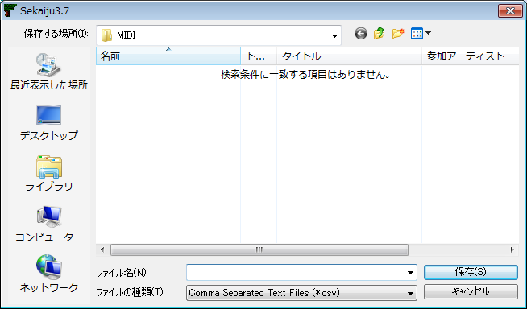

The following sample is the view of output result in notepad. If you use Excel or Calc, you will see the list with the column aligned.

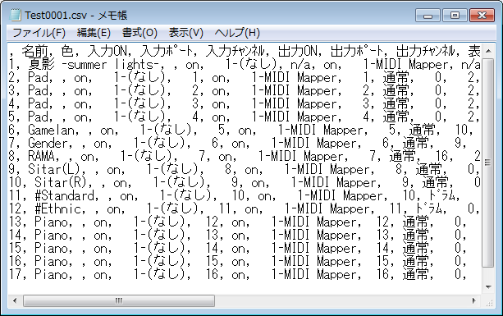

2-2-2. Track's Property

Name

In the case of format 0 MIDI sequence, this means the title of this MIDI sequence. In the case of format 1 MIDI sequence, the first track's name means the title of this MIDI sequence, and the second and following track's name means the name of the track (for example, “Main”, “Bass”) . This column is the same as the first track name / sequence name event of each track.

Color

The color of this track's character or graph. Following dialog will be opened by double clicking or pressing [Enter] key, and you may select arbitrary color for the track. By default, each track's color is set to preset color.

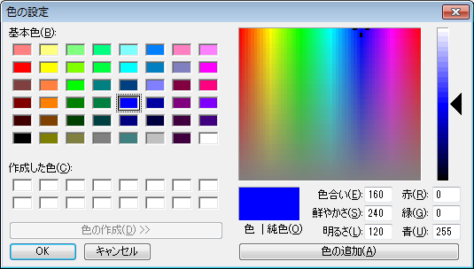

Input

“On” or ”off”. If this is “off”, this track records nothing when real-time inputting.

Input port

This shows Input Port Number (1 to 16) and MIDI In device name assigned to specified port. Port assign can be setup from “Setup” - “MIDI Device and Instrument” menu.

Input channel

If this is “n/a”, this track records only system exclusive events. If this is 1 to 16, this track records only the specified MIDI channel's MIDI message (note off, note on, key after touch, control change, program change, channel after touch, pitch bend).

Output

“On” or “off” . If this is “off”, this track is muted and plays no sounds.

Output port

This shows output port number (1 to 16) and MIDI Out device name assigned to specified port. Port assign can be setup from “Setup” - “MIDI Device and Instrument” menu.

Output channel

If this is “n/a”, output channel depends on each MIDI event's channel. If this is 1 to 16 , MIDI channel message is output to specified channel and each MIDI event's channel is ignored.

When saving format 1 MIDI sequence as Standard MIDI file (*.mid) , each MIDI channel event's channel must be same as track's output which is belongs to. Containing multiple MIDI event's channel in one track is not allowed. If not, the following message box is shown.

If you select “Yes”, each event's channel is corrected automatically. If you select “No” MIDI event's channel is not corrected, so wrong Standard MIDI File will be written out. Almost all MIDI sequencers (except Sekaiju) or MIDI players will cause some errors when attempting to load this wrong SMF.

View Mode

This shows view mode whether this track is shown as “Normal” or “Drum”. Select view type of instrument name and key name. Instrument name and key name list may be selected from “Setup” - “MIDI Device and Instrument”. By default, Channel 10 is drum mode, and others are normal mode.

This affects only view, it does not affect playing MIDI message. Whether the channel play a sound as normal or drum is determined by MIDI events, like control change, program change or system exclusive message.

In GM, channel 10 is drum and others are normal. In GS, channel 10 is drum and others are normal as well, but additional drum channel can be defined by writing system exclusive events. In XG or GM2, CC#0 and CC#32 's value determine drum or normal.

CC#0 (Bank Select MSB)

This shows the first CC#0 (Bank select MSB – most significant byte--) event's value (0 to 127) in this track. Though CC#0 can be defined many times in one track to change voice in midstream, this shows only the first CC#0 event's value. To change CC#0 value in the midstream of MIDI sequence, insert CC#0 event in the event list window. If no CC#0 event is found in this track, it shows “---”.

CC#32 (Bank Select LSB)

This shows the first CC#32 (Bank select LSB –least significant byte--) event's value (0 to 127) in this track. Though CC#32 can be defined many times in one track to change tone in midstream, this shows only the first CC#0 event's value. To change CC#32 value in the midstream of MIDI sequence, insert CC#32 event in the event list window. If no CC#32 event is found in this track, it shows “---”.

Program Number

This shows the first program change event's value (0 to 127) and the tone's name in this track. Though program change can be defined many times in one track to change tone in midstream, this shows only the first program change event's value. To change program change value in the midstream of MIDI sequence, insert program change event in the event list window. If no program change event is found in this track, it shows “---”.

If you select “Search and select voice...” menu of right click menu, the following dialog box will appear, and you can select voice number from the voice name list. The voice name list is depend on MIDI module or synthesizer that you are using. At first, please select suitable instrument from the “Setup” - “MIDIDevice and instrument...” menu. In default, “Microsoft GS Wavetable Synth” is selected.

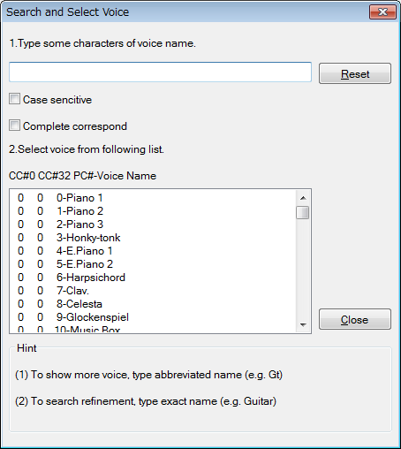

Volume

This shows the first CC#7 (Volume) event's value (0 to 127) in this track. Though CC#7 can be defined many times in one track to change volume in midstream, this shows only the first CC#7 event's value. To change CC#7 value in the midstream of MIDI sequence, insert CC#7 event in the event list window. If no CC#7 event is found in this track, it shows “---”.

Pan

This shows the first CC#10 (Pan) event's value (0 to 127) in this track. Though CC#10 can be defined many times in one track to change volume in midstream, this shows only the first CC#10 event's value. To change CC#10 value in the midstream of MIDI sequence, insert CC#10 event in the event list window. If no CC#10 event is found in this track, it shows “---”.

Reverb

This shows the first CC#91 (Reverb) event's value (0 to 127) in this track. Though CC#91 can be defined many times in one track to change volume in midstream, this shows only the first CC#91 event's value. To change CC#91 value in the midstream of MIDI sequence, insert CC#91 event in the event list window. If no CC#91 event is found in this track, it shows “---”.

Chorus

This shows the first CC#93 (Chorus) event's value (0 to 127) in this track. Though CC#93 can be defined many times in one track to change volume in midstream, this shows only the first CC#93 event's value. To change CC#93 value in the midstream of MIDI sequence, insert CC#93 event in the event list window. If no CC#93 event is found in this track, it shows “---”.

Delay

This shows the first CC#94 (Delay) event's value (0 to 127) in this track. Though CC#94 can be defined many times in one track to change volume in midstream, this shows only the first CC#94 event's value. To change CC#94 value in the midstream of MIDI sequence, insert CC#94 event in the event list window. If no CC#94 event is found in this track, it shows “---”.

Time+ (-127～0～+127)

Plays this track's events delayed by specified amount of ticks. This value affects only playing MIDI message, does not affect MIDI sequence. This value is not saved in standard MIDI file (*.mid).

Key+ (-127～0～+127)

Plays this track's Note events key shifted by specified value. This value affects only playing MIDI message, does not affect MIDI sequence. This value is not saved in standard MIDI file (*.mid).

Velocity+ (-127～0～+127)

Plays this track's Note events velocity up at specified value. This value affects only playing MIDI message, does not affect MIDI sequence. This value is not saved in standard MIDI file (*.mid).

NumEvents

The number of events in this track. This value includes all kind of event, including meta events and system exclusive events. Note on and note off event are counted as separated events each other.

2-2-3. Tempo Property

By right clicking in the tempo, time signature, key signature and marker display area of the track list window, and by selecting “Insert Tempo...”, or “Modify Tempo...” menu, the following tempo property dialog will be shown.

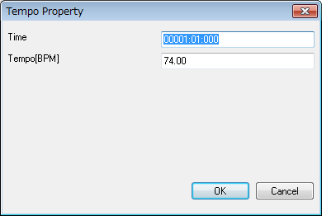

Time

Specify time of this event. The unit is “Measure:Beat:Tick” (in the case of TPQN base), or “Frame:Sub frame” (in the case of SMPTE base).

Tempo[BPM]

Specify tempo by BPM.

OK

Confirm this property and insert the new tempo event or modify the existing tempo event.

Cancel

Close this dialog and nothing happens.

2-2-4. Time Signature Property

By right clicking in the tempo, time signature, key signature and marker display area of the track list window, and by selecting “Insert Time Signature...”, or “Modify Time Signature...” menu, the following time signature property dialog will be shown.

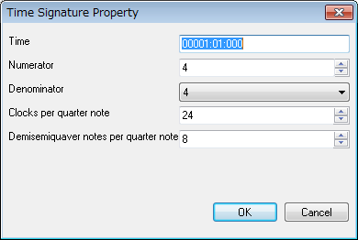

Time

Specify time of this event. The unit is “Measure:Beat:Tick” (in case TPQN base), or “Frame:Sub frame” (in case SMPTE base). Generally, time signature event must be put at the beginning of the measure, whose beat = 01 and tick = 000.

Numerator

Specify numerator from 1 to 255.

Denominator

Select denominator from 1, 2, 4, 8, 16, or 32.

Clocks per quarter note

Specify number of clocks per quarter note. Generally this value must be 24.

Demisemiquaver notes per quarter note

Specify number of demisemiquaver per quarter note. Generally, this value must be 8.

OK

Confirm this property and insert new time signature event or modify existing time signature event.

Cancel

Close this dialog and nothing happens.

2-2-5. Key Signature Property

By right clicking in the tempo, time signature, key signature and marker display area of the track list window, and by selecting “Insert Key Signature...”, or “Modify Key Signature...” menu, the following key signature property dialog will be shown.

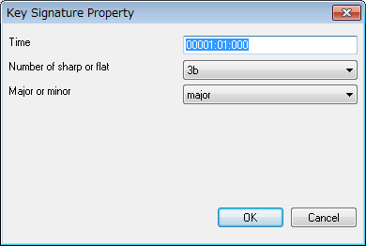

Time

Specify time of this event. The unit is “Measure:Beat:Tick” (in the case of TPQN base), or “Frame:Sub frame” (in the case of SMPTE base). Generally, key signature event must be put at the beginning of the measure, whose beat = 01 and tick = 000.

Number of sharp or flat

Select number of sharps or flats from 7b, 6b, 5b, 4b, 3b, 2b, 1b, 0#, 1#, 2#, 3#, 4#, 5#, 6#, or 7#.

Major or minor

Select major or minor

OK

Confirm this property and insert new key signature event or modify existing key signature event.

Cancel

Close this dialog and nothing happens.

2-2-6. Marker Property

By right clicking in the tempo, time signature, key signature and marker display area of the track list window, and by selecting “Insert Marker...”, or “Modify Marker...” menu, the following marker property dialog will be shown.

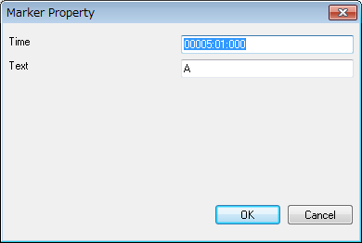

Time

Specify time of this event. The unit is “Measure:Beat:Tick” (in the case of TPQN base), or “Frame:Sub frame” (in the case of SMPTE base).

Text

Write a note or comment.

OK

Confirm this property and insert new key signature event or modify existing key signature event.

Cancel

Close this dialog and nothing happens.

2-3. Piano Roll Window

Piano roll window enables you to edit note event (note on, note off, control change event, and pitch bend event in graphical. Sekaiju's piano roll window can show multiple track's data at once.

Piano roll window has 4 views. At top-left, there is piano roll view, which shows key at vertical, time at horizontal. At bottom-left, there is graph view, which shows value at vertical, time at horizontal. At top-right, track list is shown. At bottom-right, graph list is shown.

By turning mouse wheel on the piano roll view or graph view, the view scrolls up or down. And by turning mouse wheel on the piano roll view or graph view with [Ctrl] key pressed, the current playing position moves back and forth. Also you can move current playing position back or forth by pressing [←] or [→] key with [Ctrl] key.

If you press [F9] key, turn to single track view mode.
If you press [F10] key, turn to all tracks view mode.
If you press [F11] key, turn to single graph kind view mode.
If you press [F12] key, turn to all graph kind view mode.

On the cell, you can directly input value by using number keys. On the cell, if you left-click [▲][▼] button, or press [+] [-] key, the value will be up or down by 1 step. On the cell, if you right-click [▲][▼] button, or press [+] [-] key with [shift] key, the value will be up or down by 10 step.

2-3-1 Toolbar

Pen (P) (D)

This tool is used to put a new note event on the piano roll view, to move an existing note event, and draw arbitrary graph on the graph view.

To put a new note event, left click on the void area of piano roll view. The inserting track, note's channel, velocity, duration [tick] are determined by the toolbar's value. The note's key and note on time are determined by the position that you release the mouse button. If you press [Esc] or [Del] key before you release the mouse button, Sekaiju cancels placing a new note event.

By dragging on an existing note bar, you can move the note. In case you click the center of the note bar, the bar can be moved up, down, left and right. In case you click the left 1/4 of the note bar, the note on time can be moved back and forth. In case you click the right 1/4 of the note bar, the note of time can be moved back and forth. If you press [Del] key before you release the mouse button, Sekaiju deletes the note events.

Additionally, if you left-click an existing note bar, the toolbar's track number, channel number, velocity value, and duration [tick] are updated to fit the note event (absorb note's property to the toolbar). By using this feature, you can input note events quickly.

To draw a graph on the graph view, drag mouse on the graph area. You should select inserting track, channel, and the kind of graph on the toolbar, before drawing.

Line (L)

This tool is used to put new note events which is along the line on the piano roll view. And this tool is used to draw liner graph on the graph view.

To put note events, drag on the void area on the piano roll window, and note events are inserted from start point to end point. The inserting track, note's channel, and velocity are determined by the toolbar's value. This is useful to insert glissando quickly.

To draw graph on the graph view, drag mouse on the graph area. You should select inserting track, channel, and the kind of graph on the toolbar, before drawing. While drawing line, by right clicking, the line mode changes to straight line, quadratic curve (begin horizontal), quadratic curve (end horizontal).

Eraser (E)

This tool is used to erase existing note events or existing graph (tempo, channel after touch, control change, or pitch bend events).

Select (S)

This tool is used to select existing note events or existing graph (tempo, channel after touch, control change or pitch bend events). The selected event's color becomes black.

In case dragging mouse left to right, the events inside the rectangle are selected. In case dragging mouse right to left, the events inside the rectangle and the events crossing the rectangle are selected.

If you select with [Ctrl] key pressed, more events are added to the selection, even non-consecutive events.

If you drag on the selected note bar, the selected events can be moved up, down, left, and light. If you drag on the selected note bar with [Ctrl] key, the selected note events can be duplicated up, down, left and right.

If you drag on the selected note bar's left side or right side, the selected event's note on time or note off time can be moved simultaneously. This feature can be used as unquantize or humanize.

Preview (B)

This tool is used to preview (listen) the sound at the clicked or dragged position in the right view.

Track

This shows the current track of this piano roll window. When inserting events by pen tool or line tool, the events are inserted to this track. If you change current track, the current channel is also changed automatically to fit selected track. Also when you click an existing note bar, this value will be updated automatically to correspond to the note's belonging track.

If you have inserted events to wrong track, you may correct event's track at once from “Edit” - “Modify Event's Track”.

This combo box is associated with track list view's selected track.

Channel

This shows current channel of this piano roll window. When inserting events by pen tool or line tool, the event's channel becomes the specified channel here. If you change current track, the current channel is also changed automatically to fit selected track. Also when you click an existing note bar, this value will be updated automatically to correspond to the note's channel.

If you have inserted wrong channel events, you can correct the note event's channel by selecting “This event's property...” from right click menu or “Edit” - “Modify event's channel...” from the main menu.

If you have inserted an event whose channel is different from the track's output channel in the track list window, the event's channel becomes this box's value, but it is output to the track's output channel when playing. In the format 1 MIDI sequence, you can use only one channel for each track. If an event's channel is different from track's output channel, you are asked if you want to correct them automatically when saving as Standard MIDI File.

Snap [tick]

This shows current snap time [tick] of this piano roll window. When inserting or moving note event, note on time is aligned to a multiple of this time. For example, in case your MIDI sequence is TPQN based and the time resolution is 120 [ticks per quarter note], if this value is “120-quarter”, note on time is aligned to quarter border whenever inserting or moving note event. If this value is “60-quaver”, note on time is aligned to quaver border whenever inserting or moving note event. If this value is “1-free”, note on time isn't aligned anywhere.

Velocity

This shows current velocity of this piano roll window. Specify the velocity value of note you want to insert. The velocity is the velocity with which the key is pressed, equivalent to the strength with which the key is hit, which can be set from 1 (weak) up to 127 (strong). Also when you click an existing note bar, this value will be updated automatically to correspond to the note's velocity.

If you have inserted note events at wrong velocities, you can correct a note event's velocity by selecting “This event's property...” from right click menu or “Edit” - “Modify event's velocity...” from the main menu.

Duration [tick]

This shows current duration of this piano roll window. Specify the duration of the note you want to insert. For example, when your MIDI sequence is TPQN based and the time resolution is 120 [ticks per quarter note], the value 120 means quarter note, the value 60 means quaver note, and the value 30 means semiquaver note. Also when you click an existing note bar, this value will be updated automatically to correspond to the note's velocity.

Ref : Duration of each note at each resolution of TPQN base
Resolution | 48 | 120 | 480
Whole note | 192 | 480 | 1920
Dotted half note | 144 | 360 | 1440
Half note | 96 | 240 | 960
Triplet half note | 64 | 160 | 640
Dotted quarter note | 72 | 180 | 720
Quarter note | 48 | 120 | 480
Triplet quarter note | 32 | 80 | 320
Dotted quaver note | 36 | 90 | 360
Quaver note | 24 | 60 | 240
Triplet quaver note | 16 | 40 | 160
Dotted semiquaver note | 18 | 45 | 180
Semiquaver note | 12 | 30 | 120
Triplet semiquaver note | 8 | 20 | 80
Demisemiquaver note | 6 | 15 | 60
Triplet demisemiquaver note | 4 | 10 | 40

If you have inserted note events with wrong duration, you can correct a note event's duration by selecting “This event's property...” from right click menu or “Edit” - “Modify event's duration...” from the main menu.

Graph Kind

This shows the current graph kind of this piano roll window. When drawing graph by pen tool or line tool, events of the specified kind are inserted.

This combo box is associated with the graph kind highlighted in the graph kind list at the bottom left.

Graph Snap [tick]

This shows the current graph snap time [tick] for this piano roll window. This value means the interval between events inserted when drawing a graph. If this value is specified as 1-Free, then the graph is drawn as precisely as possible. But when a constant value is drawn, only one event is recorded. On the other hand, if this value is specified as a semiquaver for example, then events are inserted only at semiquaver intervals. This lets the MIDI sequence easy to see or edit, and lets the MIDI sequence small size.

Show Only Current Track (F9)

If this is checked, this piano roll window shows only current track. It is useful in case you want to see each one track quickly.

To show or hide an arbitrary track, uncheck this button and check only the track you want to see in the track list view at the top-right.

Show All Track(F10)

If this is checked, this piano roll window shows all tracks. It is useful in case you want to see all tracks quickly.

To show or hide an arbitrary track, uncheck this button and check only the track you want to see in the track list view at the top-right.

Show Only Current Graph (F11)

If this is checked, this piano roll window shows only current kind of graph. It is useful in case to see each one kind of graph quickly.

To show or hide arbitrary kind of graph, uncheck this button and check only the kind of graph you want to see in the graph kind view at the bottom-right.

Show All Graph (F12)

If this is checked, this piano roll window shows all kind of graph. It is useful in case you want to see all kind of graph quickly.

To show or hide an arbitrary kind of graph, uncheck this button and check only the kind of graph you want to see in the graph kind view at the bottom-right.

Auto Page Update

If this is checked on, the page is updated automatically while playing MIDI sequence. Whenever you start playing or move current position, it is checked automatically (This behavior may be changed in the option dialog). And whenever you move the view's scroll bar or click zoom up or zoom down button, it is unchecked automatically.

2-3-2. Note Property

If you right click an existing note bar on the piano roll window and you select “This even's property...” menu, the dialog to edit the note event will open. By using this dialog, you can see or edit each note event's property without using the event list window.

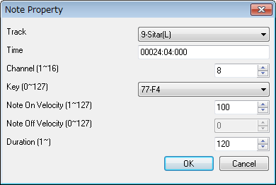

Track

This shows the track number and track name that this note event belongs to. In case format 1 MIDI sequence, note event can't be moved to the first track, which is called conductor track. To move many note events at once, it is more useful to use “Edit” - “Modify Event's Track...” rather than this dialog.

Time

This shows the note on time of this note event. The unit is “Measure:Beat:Tick” (in case TPQN base), or “Frame:Sub frame” (in case SMPTE base). To modify many note event's time at once, it is more useful to use “Edit” - “Modify Event's Time...” rather than this dialog.

Channel (1～16)

This shows the output channel of this note event. If the output channel is selected 1 to 16 in track list window, Sekaiju regards the output channel as the track list window's output channel. In format 1 MIDI sequence, multiple channels in one track is not allowed. To modify many note events' channel at once, it is more useful to use “Edit” - “Modify Event's Channel...” rather than this dialog.

Key (0～127)

This shows the key number and key name (ex: “60-C3”) of this note event. To modify many note events' key at once, it is more useful to use “Edit” - “Modify Event's Key...”, rather than this dialog.

Note on Velocity (1～127)

This shows the note on velocity of the note event. To modify many note event's note on velocity at once, it is more useful to use “Edit” - “Modify Event's Velocity...” than this dialog.

Note off Velocity (0～127)

This shows the note off velocity of the note event. There are two types of note event. One is note on + note off and the other is note on + note on (velocity 0). Note off velocity is available only in a type of note on + note off event. Generally, note on + note on (velocity 0 ) events are used.

Duration (1~65535)

This shows the duration of the note event. The unit is [tick] in case TPQN base, and sub frame in case SMPTE base. For example, in case TPQN base and time resolution is 120 ticks per quarter note, 120 means quarter note and 60 means quaver note. To modify many note events' duration at once, it is more useful to use “Edit” - “Modify Event's Duration...”, rather than this dialog.

Ref : Duration of each note at each resolution of TPQN base
Resolution | 48 | 120 | 480
Whole note | 192 | 480 | 1920
Dotted half note | 144 | 360 | 1440
Half note | 96 | 240 | 960
Triplet half note | 64 | 160 | 640
Dotted quarter note | 72 | 180 | 720
Quarter note | 48 | 120 | 480
Triplet quarter note | 32 | 80 | 320
Dotted quaver note | 36 | 90 | 360
Quaver note | 24 | 60 | 240
Triplet quaver note | 16 | 40 | 160
Dotted semiquaver note | 18 | 45 | 180
Semiquaver note | 12 | 30 | 120
Triplet semiquaver note | 8 | 20 | 80
Demisemiquaver note | 6 | 15 | 60
Triplet demisemiquaver note | 4 | 10 | 40

OK

Close this dialog and update the note event's property.

Cancel

Cancel to change the note event.

2-3-3. Tempo Property

By right clicking on the tempo, time signature, key signature and marker display area of the piano roll window, and by selecting “Insert Tempo...”, or “Modify Tempo...” menu, the following tempo property dialog will be shown.

Time

Specify time of this event. The unit is “Measure:Beat:Tick” (in the case of TPQN base), or “Frame:Sub frame” (in the case of SMPTE base).

Tempo[BPM]

Specify tempo by BPM.

OK

Confirm this property and insert new tempo event or modify existing tempo event.

Cancel

Close this dialog and nothing happens.

2-3-4. Time Signature Property

By right clicking on the tempo, time signature, key signature and marker display area of the piano roll window, and by selecting “Insert Time Signature...”, or “Modify Time Signature...” menu, the following time signature property dialog will be shown.

Time

Specify time of this event. The unit is “Measure:Beat:Tick” (in the case of TPQN base), or “Frame:Sub frame” (in the case of SMPTE base). Generally, time signature event must be put at the beginning of measure, whose beat = 01 and tick = 000.

Numerator

Specify numerator from 1 to 255.

Denominator

Select denominator from 1, 2, 4, 8, 16, or 32.

Clocks per quarter note

Specify number of clocks per quarter note. Generally this value must be 24.

Demisemiquaver notes per quarter note

Specify number of demisemiquaver per quarter note. Generally, this value must be 8.

OK

Confirm this property and insert new time signature event or modify existing time signature event.

Cancel

Close this dialog and nothing happens.

2-3-5. Key Signature Property

By right clicking on the tempo, time signature, key signature and marker display area of the piano roll window, and by selecting “Insert Key Signature...”, or “Modify Key Signature...” menu, the following key signature property dialog will be shown.

Time

Specify time of this event. The unit is “Measure:Beat:Tick” (in case TPQN base), or “Frame:Sub frame” (in case SMPTE base). Generally, key signature event must be put at the beginning of measure, whose beat = 01 and tick = 000.

Number of sharp or flat

Select number of sharps or flats from 7b, 6b, 5b, 4b, 3b, 2b, 1b, 0#, 1#, 2#, 3#, 4#, 5#, 6#, or 7#.

Major or minor

Select major or minor

OK

Confirm this property and insert new key signature event or modify existing key signature event.

Cancel

Close this dialog and nothing happens.

2-3-6. Marker Property

By right clicking on the tempo, time signature, key signature and marker display area of the piano roll window, and by selecting “Insert Marker...”, or “Modify Marker...” menu, the following marker property dialog will be shown.

Time

Specify time of this event. The unit is “Measure:Beat:Tick” (in the case of TPQN base), or “Frame:Sub frame” (in the case of SMPTE base).

Text

Write a note.

OK

Confirm this property and insert new key signature event or modify existing key signature event.

Cancel

Close this dialog and nothing happens.

2-4. Event List Window

Event list window enables you to see and edit all kind of events which is defined in MIDI.

Event list window has three views. At the left, event list view is shown. At the top-right, track list view is shown, which can be used to show or hide arbitrary track. At the bottom-right, event kind view which can be used to show or hide arbitrary kind of event.

By turning the mouse wheel on the event list view, the view can be scrolled up or down. And by turning the mouse wheel with [Ctrl] key, the current playing position can be moved back and forth. Also you can move the current playing position back and forth by pressing [←] or [→] key with [Ctrl] key.

If you press [F9] key, turn to single track view mode.
If you press [F10] key, turn to all tracks view mode.
If you press [F11] key, turn to single event kind view mode.
If you press [F12] key, turn to all event kind view mode.

On the cell, you can directly input value by using the number keys. On the cell, if you left-click [▲][▼] button, or press [+] [-] key, the value will be up or down by 1 step. On the cell, if you right-click [▲][▼] button, or press [+] [-] key with [shift] key, the value will be up or down by 10 step.

2-4-1 Toolbar

Insert Event (Ins)

Inserts a new event before active cell. The track to insert, time to insert, the kind of event, the channel of event must be specified in the toolbar in advance.

If you move the active cell left, right, up, down or you click cell on the event list view, the toolbar's track, time, event kind, and channel will be updated to fit the cell.

Duplicate Event (Ctrl+Ins)

Duplicates an active cell's event. By duplicating, the same event appears at the same time, so you must correct the event's time, kind, etc., immediately.

Delete Event (Del)

Deletes an active cell's event. But deleting the last end of track event is not allowed.

Move up Event

Move up the current focused event. But moving the last end of track event is not allowed.

Move down Event

Move up the current focused event. But moving the last end of track event is not allowed.

Track

This shows the current track of this event list window. When inserting a new event, the event is inserted to this track. If you change the current track, the current channel is also changed automatically to fit the selected track.

If you have inserted events to the wrong track, you may correct event's track at once from “Edit” - “Modify Event's Track”.

This combo box is associated with track list view's selected track.

Time

This shows the current time of this event list window. Whenever inserting a new event, the new event is inserted at this time.

Event Kind

This shows the current event kind of this event list window. When inserting a new event, the event is inserted as this event kind.

This combo box is associated with track event kind view's selected track.

Channel

This shows the current channel of this event list window. When inserting a new event, the event's channel becomes the specified channel here. If you change current track, the current channel is also changed automatically to fit the selected track.

Channel's value (1 to 16) is available only for MIDI channel event (note off, note on, key after touch, control change, program change, channel after touch, and pitch bend). In the other events, the channel's value becomes always “n/a”.

If you have inserted wrong channel events, you can correct event's channel at once from “Edit” - “Modify Event's Channel”.

If you have inserted an event whose channel is different from the track's output channel in the track list window, the event's channel becomes this box's value, but it is output to the track's output channel when playing. In the format 1 MIDI sequence, you can use only one channel for each track. If an event's channel is different from the track's output channel, you are asked if you want to correct them automatically when saving as Standard MIDI File.

Show Only Current Track (F9)

If this is checked on, this event list window shows only the current track. It is useful in case you want to see each one track quickly.

To show or hide arbitrary track, uncheck this button and check only the track you want to see in the track list view at the top right.

Show All Track (F10)

If this is checked, this event list window shows all tracks. It is useful in case to see all tracks quickly.

To show or hide arbitrary track, check off this button and check on only the track you want to see in the track list view at the top right.

Show Only Current Event Kind (F11)

If this is checked, this event list window shows only the current event kind. It is useful in case you want to see each one kind of event quickly.

To show or hide arbitrary kind of event, uncheck this button and check only the event kind you want to see in the event list view at the bottom right.

Show All Event Kind (F12)

If this is checked, this event list window shows all kind of events. It is useful in case to see all kind of events quickly.

To show or hide arbitrary kind of event, uncheck this button and check only the event kind you want to see in the event list view at the bottom right.

Auto Page Update

If this is checked, the event list view's page is updated automatically during playing MIDI sequence. Whenever you start playing or move current position, this is automatically checked on (This behavior may be changed in the option dialog). And whenever you move the view's scroll bar or click zoom up or zoom down button, this is automatically unchecked.

Save Event List As CSV or Text

Save current event view list as comma separated text (*.csv) or tab separated text(*.txt) format.

The following “Save as” dialog will appear. Input select folder, input file name, select file format (csv or txt) and then click save button.

The following sample is the view of output result in notepad. If you use Excel or Calc, you will see the list with the column aligned.

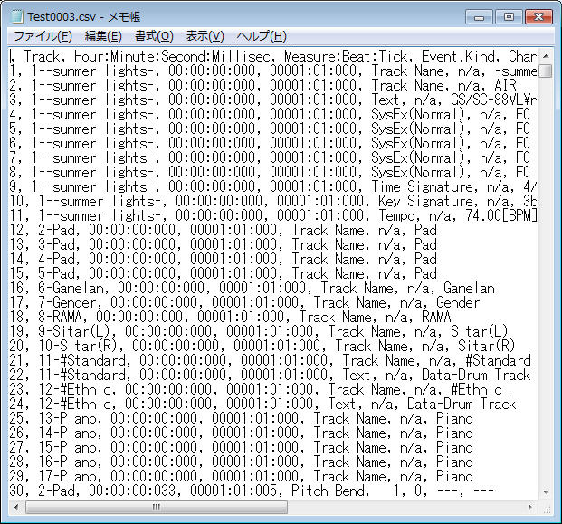

The CSV file output by this button shows current event list view's text. This CSV file can't be loaded in Sekaiju again. To save as CSV file for loading again, use main menu's File – Save As... and select “MIDICSV(*csv)” type.

2-4-2. Explanation of Event's Kind

In the event list window, all kind of event defined in MIDI can be edited. Here is an explanation of each event kind.

Sequence Number

Sequence number is a unique number 0 to 65535 that identifies MIDI sequence from some machine. This event is seldom used. This event has no influence on playing MIDI message.

Text

Text event is used to insert arbitrary strings or comments in the MIDI sequence. This event can be inserted in any track and anywhere. Especially, it is recommended to comment by text event about RPN change, NRPN change, system exclusive event. The first track's the first text event (at time 0) is usually whole MIDI sequence's comment. This event has no influence on playing MIDI message.

By the way, in the text related event, TAB, LF and CR are visible and editable as “\t”, “\r” and “\n”. However, it is not recommended to use these control characters in the text related event's string. And “\” is visible and editable as “\\”.

In the text related event, following 5 tags are available to specify string's character code.

begin with “{@LATIN}” : 1252-Western Latin-1
begin with “{@JP}” : 932-Japanese Shift-JIS
begin with “{@UTF-16LE}” : 1200-Unicode UTF 16-LE
begin with “{@UTF-16BE}” : 1201-Unicode UTF 16-BE
begin with “{@UTF-8}” : 65001-Unicode UTF-8

Once specifying character code, following same kind event in the track are also applied. If no character code is specified, the character code selected in the Language dialog's Text Encoding is used. ”{@UTF-16LE}” and ”{@UTF-16BE}” and “{@UTF-8}” are stored as {0xFF, 0xFE} and {0xFE, 0xFF} and {0xEF, 0xBB, 0xBF}. According to the Standard MIDI File RP-026, this feature is only for lyric event, but in Sekaiju, this feature can be used for text, copyright, track name, instrument name, lyrics, marker, cue point, program name, and device name event.

Copyright

Copyright event is used to insert copyright string in the MIDI sequence. This event is usually inserted in the first track's at time 0. This event has no influence on playing MIDI message. The specification of character code is the same as Text event.

Sequence Name / Track Name

Sequence name / Track name event is also a string. In format 0 MIDI sequence, this means the MIDI sequence's title. In format 1 MIDI sequence, the first track's (which is called as conductor track) this event means the MIDI sequence's title and the second or following tracks this event means the track's title. As the track's title, the role of the track should be written. For example, “Main”, “Bass”, “Piano(L)”, “Piano(R)”, “Strings(L)”, “Strings(R)” And this event is usually placed at time 0 of each track. This event has no influence on playing MIDI. The specification of character code is the same as Text event.

Instrument Name

Instrument name event is also a string. This means the instrument or MIDI module name to be used to play this track. For example, “Roland SC-88Pro”, “YAMAHA MU-128”. And this event is usually placed at time 0 of each track. This event is often omitted in case that only a single instrument is used or the MIDI sequence's type is GM / GS / XG based. This event has no influence on playing MIDI message. The specification of character code is the same as Text event.

Lyrics

Lyrics event is also a string. This means each note event's lyrics and placed each note on event if the music has lyrics. This event is used to show lyrics in some MIDI player. This event has no influence on playing MIDI message. The specification of character code is the same as Text event.

Marker

Marker event is also a string. This is used to write a section's name. For example, “Intro”, “A”, “B”, and so on. This event is usually placed in the first track. This event has no influence on playing MIDI message. The specification of character code is the same as Text event.

Cue Point

This event is also a string. This is used to the same way to Marker event. One MIDI sequence should include either marker or cue point event. This event has no influence on playing MIDI message. The specification of character code is the same as Text event.

Program Name

Program name is also a string. This means the voice name like “Piano1”, “Organ1”, “Nylon_Guitar”, to be played on this track. This event should be inserted for each program change event. But this event is usually omitted. This event has no influence on playing MIDI message. The specification of character code is the same as Text event.

Device Name

Device Name is also a string. This means the port name like “Roland Serial MIDI Out A” to be played this track. This event is not important so is usually omitted. This event has no influence on playing MIDI message. The specification of character code is the same as Text event.

Channel Prefix

Channel prefix is number 1 to 16. MIDI channel events (note off, note on, key after touch, control change, program change, and pitch bend) have their own channel information to be output. But the other events doesn't have their own channel information to be output because they are not output as MIDI Message or they are channel-independent. This event enables to define output channel for these events, if needed, by inserting this event previous the target event. But this event is seldom used. This event has no influence on MIDI channel event's channel.

Port Prefix

Port Prefix event is number 1 to 16. If you use multiple MIDI modules in one MIDI sequence, this event becomes an identifier to notify output port number in standard MIDI file (*.mid). In Sekaiju, each track's output port can be specified in the track list view, and saves this information in Sekaiju sequence file (*.skj), so this event may be omitted. But output port number is not saved in standard MIDI file (*.mid), then the port number for each track is notified by this event. If you use only single module, this event is usually omitted.

End of Track

This event means end of track and has no data. This event must be placed end of track. No events can't be placed after this event.

Tempo

Tempo event is a value which is specified as BPM [Beat per minutes] unit in Sekaiju, and it is stored as microsecond per quarter note unit. This event can be put many times in one MIDI sequence. In format 1 MIDI sequence, this event must be put in the first track, which is called “conductor track”. This event must be put at least at time 0. If there is no tempo event in the MIDI sequence, the tempo becomes 120 [BPM] in Sekaiju. In case of SMPTE base MIDI sequence, this event has no influence on playing MIDI, but stored for view.

SMPTE Offset

SMPTE offset event is a time value that is specified as “HH : MM : SS : FF : SubFrame” format. This event means offset of SMPTE time, it is usually 3 seconds. This event can be placed only one time at time 0 in one MIDI sequence. In format 1 MIDI sequence, this event must be placed in the first track, which is called “conductor track”. This event is usually omitted.

Time Signature

Time signature consists of four values, which is a numerator, a denominator, number of MIDI clock per quarter note, and number of demisemiquaver (32nd note) per quarter note. A numerator is 1 to 255, but normally 1, 2, 3, 4, 5, 6, 7, or 8. A denominator is normally 1, 2, 4, 8, 16, or 32. Number of MIDI clock is normally 24. Number of demisemiquaver (32nd note) per quarter note is normally 8. This event can be inserted at the beginning of the measure and can be inserted many times in one MIDI sequence. In format 1 MIDI sequence, this event must be placed in the first track, which is called “conductor track”. This event must be placed at least at time 0. If there is no time signature at time 0, time signature becomes 4/4, 24[clocks / quarter note], 8 [demisemiquaver notes / quarter note] in Sekaiju. This event is used for formatting view only. This event has no influence on playing MIDI.

Key Signature

Key signature consists of two values, which is number of # (sharp) or b (flat), and major or minor. For example “2b major” means Bb major key signature. In Sekaiju, flat sign is lower case of “B”. This event can be inserted at the beginning of the measure and can be inserted many times in one MIDI sequence. In format 1 MIDI sequence, this event must be put in the first track, which is called “conductor track”. This event must be placed at least at time 0. If there is no key signature at time 0, key signature becomes 0-major (C-Major) in Sekaiju. This event is used for formatting view only. This event has no influence on playing MIDI.

Sequencer specific

This event is binary array which is specific for each sequencer. The top of 1 byte or 3 bytes means product company's ID, which is assigned by MMA, and following data is specific.

Note Off

This is one of the MIDI channel event. This event means the specified key is released. This event's parameter is note key (0 to 127) and note off velocity (0 to 127). This event must be placed as a pair of note on - note off events. See also Note On.

Note On

This is one of the MIDI channel event. This event means the specified key is pressed. This event's parameter is note key (0 to 127) and note on velocity (0 to 127). This event must be placed as a pair of note on - note off events. The duration is automatically determined, which is, note off time – note on time. Velocity 0's note on event means note off event. To release key, there are two ways, which is, one is note off event, and the other is note on event with velocity 0. Usually note on event with velocity 0 is used.

Key After Touch

This is one of the MIDI channel event. This event means the pressure of specified key and make the tone swings. The swing type depends on the MIDI module or instruments, for example, the volume becomes larger or sharper, or vibration becomes larger, or growl becomes larger when the key pressure becomes larger. This event's parameter is note key and pressure value (0 to 127).

Control Change

This is one of the MIDI channel events. This event adjust various parameter of the channel like volume, pan and so on. This event's parameter is control change number (CC#) and it's value. Following control change numbers (CC#) are well known.

CC# | Name | meaning
0 | Bank Select MSB | Top 7 bit of bank number when selecting tone by program change.
1 | Modulation | Vibrato level.
6 | Data Entry | Set specific RPN or NRPN value
7 | Volume | Volume (for each track's balance)
10 | Pan | Pan (Left=0, Center=64, Right=127)
11 | Expression | Volume (for crescendo or decrescendo)
32 | Bank Select LSB | Bottom 7 bit of bank number when selecting tone by program change.
64 | Hold Pedal | Switch on piano's sustain pedal on=127, pedal off=0.
91 | Reverb | Reverb send level
93 | Chorus | Chorus send level
94 | Delay | Delay send level
98 | NRPN LSB | Bottom 7 bit of NRPN type when specifying specific value by CC#6 (Data Entry) event.
99 | NRPN MSB | Top 7 bit of NRPN type when specifying specific value by CC#6 (Data Entry) event.
100 | RPN LSB | Bottom 7 bit of RPN type when specifying specific value by CC#6 (Data Entry) event.
101 | RPN MSB | Top 7 bit of RPN type when specifying specific value by CC#6 (Data Entry) event.

CC#6 (Data Entry) must be used with CC#98 and CC#99, or, CC#101 and CC#100. For example, to set pitch bend sensitivity plus or minus 1 octave, (= 12 semitones), write event like following list.
* CC#101 (RPN MSB) value=0
* CC#100 (RPN LSB) value=0
* CC#6 (Data Entry) value=12
Each event must be put at an increasing time about 5 tick interval. If put at the same time, computer's buffer or module's buffer sometimes becomes full and sometimes does not work well.

Program Change.

This is one of the MIDI channel events. This event is used to select the voice like piano, guitar, strings and so on. This event has one parameter, which is, program number (0 to 127). But by using this event, you may select only from 128 kind of voices. To select from more kinds of voices, you may use CC#0 (Bank Select MSB) and CC#32 (Bank Select LSB) with program change. Following example is to select Bank Select MSB=16, Bank Select LSB=3, Program Change=48's strings. By this way, 128x128x128=2097152 tones can be selected.
* CC#0(Bank Select MSB) value=16
* CC#32(Bank Select LSB) value=3
* Program Change number=48
Each event must be put at an increasing time about 5 tick interval. If put at the same time, computer's buffer or module's buffer sometimes becomes full and sometimes not works well. The list of available voices is written in the each MIDI module's operation manual.

If you select “Search and select voice...” menu of right click menu, the following dialog box will appear, and you can select voice number from the voice name list. The voice name list is depend on MIDI module or synthesizer that you are using. At first, please select suitable instrument from the “Setup” - “MIDIDevice and instrument...” menu. In default, “Microsoft GS Wavetable Synth” is selected.

Channel After Touch

This is one of the MIDI channel events. This event means the pressure of pressed key in this channel is changed and makes the tone swings. .The swing type depends on the MIDI module or instruments, for example, the volume becomes louder or sharper, or vibrato becomes larger, or growl becomes larger when the key pressure becomes larger. This event's parameter is pressure value (0 to 127) only.

Pitch Bend

This is one of the MIDI channel events. This event means the pitch bend wheel is turned and make the frequency go up or down. This event's parameter is pitch bend value (-8192 to 8191) only. 0 is center, and pitch bend sensitivity is specified in RPN#0 and CC#6 (see also control change). If pitch bend sensitivity is 12, -8192 means 1 octave (= 12 semitones) down and +8191 means 1 octave (= 12 semitones) up.

System Exclusive (Normal)

System exclusive events are used to send commands which are specific to the MIDI module. For example, master fine tune, master coarse tune, master volume, master reverb, master chorus, and master equalize. System exclusive event (normal) is binary array, which begins F0 and ends F7, and inside F0 and F7 the values are 00 to 7F. In Sekaiju, each value is written in hexadecimal value. The command depends on MIDI module, so see also your MIDI module's operation manual. The following list is major system exclusive message, which can be recognized by many MIDI modules.

Command Name | System Exclusive Data Binary Array
GM1 Reset | F0 7E 7F 09 01 F7
GM2 Reset | F0 7E 7F 09 03 F7
GM System Off | F0 7E 7F 09 02 F7
GS Reset | F0 41 10 42 12 40 00 7F 00 41 F7
XG Reset | F0 43 10 4C 00 00 7E 00 F7
Master Volume | F0 7F 7F 04 01 ll mm F7
Master Fine Tuning | F0 7F 7F 04 03 ll, mm, F7
Master Coarse Tuning | F0 7F 7F 04 03 ll, mm, F7
* ll means bottom 7 bit of 14 bit value. Normally, it must be 00.
* mm means top 7 bit of 14 bit value. It becomes 00 to 7F.

Also, by right-clicking on the system exclusive data and selecting the menu, you can save the data to a file(*.syx) or load from a file(*.syx).

System Exclusive (Arbitrary)

This is used to send arbitrary MIDI message. Normally system exclusive message begins F0 and ends F7, and the values inside F0 and F7 are 00 to 7F. But this arbitrary system exclusive message is allowed to use any value (00 to FF) at any position. This is very dangerous message, so you must not use this event.

Main purpose of this event is to send divided system exclusive message, which is longer than 128 bytes. For a reason of load, too long system exclusive message is not recommended. So if system exclusive message you want to send is 1024 bytes, you should insert 128 bytes message 8 times with time difference.

Also, by right-clicking on the system exclusive data and selecting the menu, you can save the data to a file(*.syx) or load from a file(*.syx).

2-5. Musical Score Window

In the musical score window, only note event (note on and note off ) can be shown and edited graphically. In the musical score window, multiple tracks can be shown and edited at the same time.

The musical score window has two views. At the left, there is a musical score. At the right, there is a track list box, which turns on or off each track's visibility.

By moving the mouse wheel over the musical score view, the view scrolls up or down. And by moving the mouse wheel over the musical score view with [Ctrl] key pressed, the current playing position moves back and forth. Also you can move current playing position back or forth by pressing [←] or [→] key with [Ctrl] key.

If you press [F9] key, turn to single track view mode.
If you press [F10] key, turn to all tracks view mode.

Sekaiju is not a notation program but a MIDI sequencer, so the musical score window is intended to show MIDI sequence (standard MIDI file) as exactly as possible. Therefore, the rest sign or auxiliary sign which can't be defined in the MIDI sequence are not shown. Also, MIDI sequence's note on time and note off time can be defined by 1 tick step, but musical score can't show them exactly by normal notation. In the musical score window, note on time and note off time are rounded to specified view resolution, like triplet semiquaver. Supported odd divided note is up to triplet. Quintuplet or more is not supported.

However, the musical score window has the capacity of showing time signature, key signature, accidental (double sharp, sharp , natural, flat, and double flat for each note) and tie sign (when it is necessary to show the note event).

The triplet note event is shown only when they are placed at 1/3 beat time step exactly and 2 or more notes are placed in one beat. Otherwise note on time and note off time are rounded to non triplet place.

The notes are shown only when your MIDI sequence is TPQN based. No notes are shown when your MIDI sequence is SMPTE based.

2-5-1 Toolbar

Pen (P)(D)

This tool is used to put a new note event on musical score view and to move an existing note event

To put a new note event, left click on the void area of musical score view. The channel, velocity, duration [tick] of the note to insert are determined by the toolbar's value. The note's track, note's key and note on time are determined by the position at which you release the mouse button. If you right click before you release the mouse button, the note key will be up (sharped) or downed (flattened) half pitch. If you press [Esc] or [Del] key before you release the mouse button, Sekaiju cancels putting a new note event.

By dragging on an existing note you can move the note up, or down, left or right. If you press [Del] key before you release the mouse button, Sekaiju deletes the note events.

Additionally, if you left-click an existing note bar, the toolbar's track number, channel number, velocity value, and duration [tick] are updated to fit the note (absorb note's property to the toolbar). By using this feature, you can input note events quickly.

# (sharp) or b (flat) is determined automatically by the key signature of the time you put the note. For example, in case the key signature is “0#”, no key is sharped or flatted, in case of “2#”, F key and C key are sharped automatically, in case of “2b”, B key and E key are flatted automatically. The key signature event can be put or added by yourself to each measure in the event list window. If you desire to put note half key pitch up or downed, right click while you are dragging the note. However the enharmonic (the same key but with different note names like “F#” and “Gb”) is automatically determined as the pattern generally used in the key signature. You can't specify which sign to use.

* In Sekaiju, flat sign “b” is shown as the lower case of “B”.

K.S. | key with # or b | Major | Minor
7# | F, C, G, D, A, E, B | C#-Major | A#-minor
6# | F, C, G, D, A, E | F#-Major | D#-minor
5# | F, C, G, D, A | B-Major | G#-minor
4# | F, C, G, D | E-Major | C#-minor
3# | F, C, G | A-Major | F#-minor
2# | F, C | D-Major | B-minor
1# | F | G-Major | E-minor
0 |  | C-Major | A -minor
1b | B | F-Major | D-minor
2b | B, E | Bb-Major | G-minor
3b | B, E, A | Eb-Major | C-minor
4b | B, E, A, D | Ab-Major | F-minor
5b | B, E, A, D, G | Db-Major | Bb-minor
6b | B, E, A, D, G, C | Gb-Major | Eb-minor
7b | B, E, A, D, G, C, F | Cb-Major | Ab-minor

Eraser (E)

This tool is used to erase an existing note.

Select (S)

This tool is used to select an existing note. The selected event's color becomes black.

If you select with [Ctrl] key pressed, more notes are selected additionally.

Preview (B)

This tool is used to preview (listen) the sound at the clicked or dragged position in the left view.

Track

This shows the current track of this musical window. When inserting events with the pen tool, this value is updated to the track you've inserted. If you change the current track, the current channel is also changed automatically to fit the selected track. Also when you click an existing note, this value will be updated automatically to correspond to the note's track.

If you have inserted events into the wrong track, you can correct the event's track by selecting “This event's property...” from right click menu or “Edit” - “Modify Event's Track...” from the main menu.

This combo box is associated with the track selected in the track list box.

Channel

This shows current channel of this musical window. When inserting events with the pen tool, the event's channel becomes the channel specified here. If you change the current track, the current channel is also changed automatically to fit the selected track. Also when you click an existing note, this value will be updated automatically to correspond to the note's channel.

If you have inserted events with the wrong channel, you can correct event's channel by selecting “This event's property...” from the right click menu or “Edit” - “Modify Event's Channel...” from the main menu.

If you have inserted an event whose channel is different from the track's output channel in the track list window, the event's channel becomes this box's value, but it is output to the track's output channel when playing. In the format 1 MIDI sequence, you can use only one channel for each track. If an event's channel is different from the track's output channel, you are asked if you want to correct them automatically when saving as Standard MIDI File.

Snap [tick]

This shows current snap time [tick] of this musical score window. When you insert or move note event, note on time is aligned to a multiple of this time automatically. For example, in case your MIDI sequence is TPQN based and the time resolution is 120 [ticks per quarter note], if this value is “120-quarter”, note on time is aligned to quarter border whenever inserting or moving note event. If this value is “60-quaver”, note on time is aligned to quaver border whenever inserting or moving note event. If this value is “1-free”, note on time isn't aligned anywhere.

Velocity

This shows current velocity of this musical score window. Specify the velocity value of note you want to insert. The velocity is the strength of hitting the key, which is defined 1(weak) up to 127(strong). Also when you click an existing note, this value will be updated automatically to correspond to the note's velocity.

If you have inserted note events with wrong velocity, you can correct note event's velocity by selecting “This event's property...” from right click menu or “Edit” - “Modify event's velocity...” from the main menu.

Duration [tick]

This shows current duration of this musical score window. Specify the duration of note you want to insert. For example, when your MIDI sequence is TPQN based and the time resolution is 120 [ticks per quarter note], the value 120 means quarter note, the value 60 means quaver note, and the value 30 means semiquaver note. Also when you click an existing note, this value will be updated automatically to correspond to the note's duration.

If you have inserted note events with wrong duration, you can correct the note event's duration by selecting “This event's property...” from right click menu or “Edit” - “Modify event's duration...” from the main menu.

Ref : Durations of each note in each resolution of TPQN base
Resolution | 48 | 120 | 480
Whole note | 192 | 480 | 1920
Dotted half note | 144 | 360 | 1440
Half note | 96 | 240 | 960
Triplet half note | 64 | 160 | 640
Dotted quarter note | 72 | 180 | 720
Quarter note | 48 | 120 | 480
Triplet quarter note | 32 | 80 | 320
Dotted quaver note | 36 | 90 | 360
Quaver note | 24 | 60 | 240
Triplet quaver note | 16 | 40 | 160
Dotted semiquaver note | 18 | 45 | 180
Semiquaver note | 12 | 30 | 120
Triplet semiquaver note | 8 | 20 | 80
Demisemiquaver note | 6 | 15 | 60
Triplet demisemiquaver note | 4 | 10 | 40

The duration should be specified not as you want to show on the musical score, but as actual duration you want to press the keyboard. For example, To insert staccato quaver note, you should specify not quaver note duration, but semiquaver note duration.

Whole note (1)

Specifies the note's duration to be inserted as a whole note. The duration [tick] value becomes whole note's duration automatically.

Half note (2)

Specifies the note's duration to be inserted as a half note. The duration [tick] value becomes half note's duration automatically.

Quarter note (4)

Specifies the note's duration to be inserted as a quarter note. The duration [tick] value becomes quarter note's duration automatically.

Quaver note (8)

Specifies the note's duration to be inserted as a quaver. The duration [tick] value becomes quaver note's duration automatically.

To show quaver note in the musical score, quaver or higher resolution must be selected in the resolution combo box.

Semiquaver note (6)

Specifies the note's duration to be inserted as a semiquaver. The duration [tick] value becomes semiquaver note's duration automatically.

To show semiquaver note in the musical score, semiquaver or higher resolution must be selected in the resolution combo box.

Demisemiquaver note (9)

Specifies the note's duration to be inserted as a demisemiquaver. The duration [tick] value becomes semiquaver note's duration automatically.

To show demisemiquaver note on the musical score, demisemiquaver or higher resolution must be selected in the resolution combo box.

Dotted (.)

Specifies that the note's duration to be inserted is dotted. The duration [tick]'s value becomes dotted note's duration automatically. If you click when dotted, dotted is turned off. This button can be used only when the duration value is exactly half note, dotted half note, quarter note, dotted quarter note, quaver, dotted quaver, semiquaver or dotted semiquaver duration.

To show dotted quarter note on the musical score, quaver or higher resolution must be selected in the resolution combo box. To show dotted quaver note, semiquaver or higher resolution must be selected in the resolution combo box. To show dotted semiquaver, demisemiquaver or higher resolution must be selected in the resolution combo box.

Triplet (3)

Specifies that the note's duration to be inserted is a triplet. The duration [tick] value becomes triplet note's duration automatically. If you click when triplet, triplet is turned off. This button can be used only when the duration value is exactly half note, triplet half note, quarter note, triplet quarter note, quaver note, triplet quaver note, semiquaver note, triplet semiquaver note, demisemiquaver note or triplet demisemiquaver duration.

To show triplet quaver note on the musical score, triplet quaver or higher resolution must be selected in the resolution combo box. To show triplet semiquaver on the musical score, semiquaver or higher resolution must be selected in the resolution combo box . To show triplet demisemiquaver on the musical score, triplet demisemiquaver must be selected in the resolution combo box.

Tie (t)

If the tie button is turned on, an existing note is not moved, but connects to previous or next same key's note. By connecting, 2 notes turn into 1 note. If the note can stand for the other note sign, it will be replaced with the new note.

Resolution [tick]

This shows the current view resolution [tick] of this musical score window. Select here the shortest note duration to be shown. Note-on time and note-off time may have a resolution of 1 tick step in the MIDI sequence, but musical score can't show them exactly by normal notation. Short or halfway time note events are shown as a multiple of this value, which is quarter note, quaver, triplet quaver, semiquaver, triplet semiquaver, demisemiquaver or triplet demisemiquaver. For example, if you select triplet semiquaver, semiquaver notes or triplet semiquaver notes are shown exactly, but demisemiquaver notes or triplet demisemiquaver notes are rounded to semiquaver notes or triplet semiquaver notes.

Selecting higher resolution lets showing MIDI sequence more exactly on the musical score, but the musical score will be filled with many short notes, which will make it difficult to read.

Fill

For viewing purposes, this feature pads rest space if the length is shorter than an eighth note (quaver), and the notes may get easy to see. This feature affects only the view, and doesn't affect the MIDI sequence.

Trim

For viewing purposes, this feature cut notes if the overlapped duration of two notes is shorter than an eighth note, and the notes may get easier to see. This feature affects only the view, and doesn't affect the MIDI sequence.

Show Only Current Track (F9)

If this is checked, this musical score window shows only the current track. It is useful in case you want to see each track quickly.
To show or hide an arbitrary track, uncheck this button and check only the track you want to see in the track list view.

Show All Track(F10)

If this is checked, this musical score window shows all tracks. It is useful in case you want to see all tracks quickly.
To show or hide an arbitrary track, uncheck this button and check only the track you want to see in the track list view.

Auto Page Update

If this is checked, the page is updated automatically during playing MIDI sequence. Whenever you start playing or move current position, it is checked automatically (This behavior may be changed in the option dialog). And whenever you move the view's scroll bar or click zoom up or zoom down button, it is unchecked automatically.

2-5-2. Note Property

If you right click an existing note on the musical score window and you select “This event's property...” menu, the dialog to edit the note event will open. By using this dialog, you can see or edit each note event's property without using the event list window.

Track

This shows the number and name of the track that this note event belongs to. In the case of format 1 MIDI sequence, note event can't be moved to the first track, which is called conductor track. To move many note events at once, it is more useful to use “Edit” - “Modify Event's Track...” than this dialog.

Time

This shows the note on time of this note event. The unit is “Measure:Beat:Tick” (in case TPQN base), or “Frame:Sub frame” (in case SMPTE base). To modify many note event's time at once, it is more useful to use “Edit” - “Modify Event's Time...” than this dialog.

Channel (1～16)

This shows the output channel of this note event. If the output channel is selected 1 to 16 in track list window, Sekaiju regards the output channel as the track list window's output channel. In a format 1 MIDI sequence, multiple channels in one track is not allowed. To modify many note event's channel at once, it is more useful to use “Edit” - “Modify Event's Channel...” than this dialog.

Key (0～127)

This shows the key number and key name (ex: “60-C3”) of this note event. To modify many note event's key at once, it is more useful to use “Edit” - “Modify Event's Key...”, than this dialog.

Note on Velocity (1～127)

This shows the note on velocity of the note event. To modify many note event's note on velocity at once, it is more useful to use “Edit” - “Modify Event's Velocity...” than this dialog.

Note off Velocity (0～127)

This shows the note off velocity of the note event. There are two types of note event. One is note on + note off and the other is note on + note on (velocity 0). Note off velocity is available only in a type of note on + note off event. Generally, note on + note on (velocity 0 ) events are used.

Duration (1~65535)

This shows the duration of the note event. The unit is [tick] in case TPQN base, and sub frame in case SMPTE base. For example, in case your MIDI sequence is TPQN based and the time resolution is 120 [ticks per quarter note], 120 means quarter note and 60 means quaver. To modify many note event's duration at once, it is more useful to use “Edit” - “Modify Event's Duration...”, than this dialog.

Ref: Durations of each note in each resolution of TPQN base
Resolution | 48 | 120 | 480
Whole note | 192 | 480 | 1920
Dotted half note | 144 | 360 | 1440
Half note | 96 | 240 | 960
Triplet half note | 64 | 160 | 640
Dotted quarter note | 72 | 180 | 720
Quarter note | 48 | 120 | 480
Triplet quarter note | 32 | 80 | 320
Dotted quaver note | 36 | 90 | 360
Quaver note | 24 | 60 | 240
Triplet quaver note | 16 | 40 | 160
Dotted semiquaver note | 18 | 45 | 180
Semiquaver note | 12 | 30 | 120
Triplet semiquaver note | 8 | 20 | 80
Demisemiquaver note | 6 | 15 | 60
Triplet demisemiquaver note | 4 | 10 | 40

OK

Close this dialog and update the note event's property.

Cancel

Cancel all changes to the note event.

2-5-3. Tempo Property

By right clicking on the tempo, time signature, key signature and marker display area of the musical score window, and by selecting “Insert Tempo...”, or “Modify Tempo...” menu, the following tempo property dialog will be shown.

Time

Specify the time of this event. The unit is “Measure:Beat:Tick” (in the case of TPQN base), or “Frame:Sub frame” (in the case of SMPTE base).

Tempo [BPM]

Specify tempo by BPM (beat per minute).

OK

Confirm this property and insert new tempo event or modify the existing tempo event.

Cancel

Close this dialog and nothing happens.

2-5-4. Time Signature Property

By right clicking on the tempo, time signature, key signature and marker display area of the musical score window, and by selecting “Insert Time Signature...”, or “Modify Time Signature...” menu, the following time signature property dialog will be shown.

Time

Specify the time of this event. The unit is “Measure:Beat:Tick” (in the case of TPQN base), or “Frame:Sub frame” (in the case of SMPTE base). Generally, time signature events must be put on the border of measure, whose beat = 01 and tick = 000.

Numerator

Specify numerator from 1 to 255.

Denominator

Select denominator from 1, 2, 4, 8, 16, or 32.

Clocks per quarter note

Specify number of clocks per quarter note. Generally this value must be 24.

Demisemiquaver notes per quarter note

Specify number of demisemiquarvers per quarter note. Generally, this value must be 8.

OK

Confirm this property and insert new time signature event or modify the existing time signature event.

Cancel

Close this dialog and nothing happens.

2-5-5. Key Signature Property

By right clicking on the tempo, time signature, key signature and marker display area of the musical score window, and by selecting “Insert Key Signature...”, or “Modify Key Signature...” menu, the following key signature property dialog will be shown.

Time

Specify the time of this event. The unit is “Measure:Beat:Tick” (in the case of TPQN base), or “Frame:Sub frame” (in the case of SMPTE base). Generally, key signature event must be put on the border of measure, whose beat = 01 and tick = 000.

Number of sharp or flat

Select number of sharps or flats from 7b, 6b, 5b, 4b, 3b, 2b, 1b, 0#, 1#, 2#, 3#, 4#, 5#, 6#, or 7#.

Major or minor

Select major or minor

OK

Confirm this property and insert new key signature event or modify the existing key signature event.

Cancel

Close this dialog and nothing happens.

2-5-6. Marker Property

By right clicking on the tempo, time signature, key signature and marker display area of the musical score window, and by selecting “Insert Marker...”, or “Modify Marker...” menu, the following marker property dialog will be shown.

Time

Specify the time of this event. The unit is “Measure:Beat:Tick” (in the case of TPQN base), or “Frame:Sub frame” (in the case of SMPTE base).

Text

Write a note.

OK

Confirm this property and insert new key signature event or modify the existing key signature event.

Cancel

Close this dialog and nothing happens.

2-6. “Open” Dialog

In this dialog, select the MIDI file that you want to open. This dialog can be opened from “File” - “Open...” menu.

File Place

Select the folder where the MIDI sequence is stored.

File Name

Specify the file name which you want to open. File extension must be(*.skj), (*wrk), (*.chy), (*.mid), (*.csv), (*mmml). Other file extensions can't be opened.

File Type

Select file type (extention) to be shown in the list.
* All MIDI sequence file (*.skj) (*.wrk) (*.chy) (*.mid) (*.csv) (*.mmml)
* Sekaiju sequence file (*.skj)
* Early Cakewalk sequence file (*.wrk)
* Cherry sequence file (*.chy)
* Standard MIDI File (*.mid)
* MIDICSV File (*.csv)
* Mabinogi MML File (*.mmml)
* All Files (*.*)

* Cherry is the most famous free MIDI sequencer software in Japan, which is created by Mr. Fumii.

Open

Open specified file.

Cancel (ESC)

Cancel to open file.

2-7. “Save As” Dialog

In this dialog, specify the name of MIDI file that you want to save. This dialog can be opened from “File” - “Save As...” menu.

Save Place

Select the folder where you want to save your MIDI sequence.

File Name

Specify the file name that you want to save. If file extension is omitted, file extension selected in File Type is automatically added. If the file name does already exist, the file is overwritten.

File Type

Select file type (extension) to be saved. Please note Sekaiju doesn't support saving as Cakewalk sequence file (*.wrk).
Type | Feature
Sekaiju MIDI sequence (*.skj) | Sekaiju specific file format. All status of the MIDI sequence, including each track's property, can be completely saved. File size is larger than the other formats. When composing music, this file type is recommended.
Cherry MIDI sequence (*.chy) | Cherry specific file format. Part of the MIDI sequence is saved. Track name, copyright, text, lyrics, tempo, time signature, key signature, marker, note on, note off, control change, program change, pitch bend, and system exclusive event are saved and the other events are not saved. Note event's duration is saved. Part of system exclusive event is saved as virtual control change. Each track's output port, output channel, time+, key+, and velocity+ are saved. The other track's properties are not saved.
Standard MIDI  File  (*.mid) | Standard MIDI File format. Almost all MIDI sequencers and MIDI players can load this format. All kind of MIDI events are saved, but note on and note off are chopped so note duration is not saved. Track's property like color, input on / off, input port, input channel, output on / off, output port, output channel, view mode, time+, key+, velocity+ are not stored. When releasing MIDI sequence, this file type is recommended.
MIDICSV  File  (*.csv) | MIDICSV File format. Text editors or spreadsheet software can read this format. All kind of MIDI events are saved, but note on and note off are chopped so note duration is not saved. Track's property like color, input on / off, input port, input channel, output on / off, output port, output channel, view mode, time+, key+, velocity+ are not stored. TAB, CR, and LF including in a text related event are output as “/011”, “/015”, “/012”. LF is used as a line break.

Whenever changing file type, file name's extension is automatically changed. If file extension is omitted in file name, specified file type's extension is automatically added. If file extension in file name is different from file type's extension, file name's extension is applied.

* About loading standard MIDI File (*.mid)

Standard MIDI file stores a number of track in MThd chunk, but Sekaiju ignores this value, and Sekaiju loads all MIDI tracks included the standard MIDI file as possible.

* About loading or saving XF data

XF data (*.mid) is extra format of standard MIDI File defined by YAMAHA. Sekaiju can load or save this data. XF data is always SMF format 0. There is a sequencer specific event that identifies this MIDI sequence as XF data in the first track, and two concerned extra tracks are stored. The second track is “XFIH” chunk, the third track is “XFKM” chunk.

* About Early Cakewalk sequence file (*.wrk)

Sekaiju loads only items (events) related to Standard MIDI File. Each track's output port and output channel can be loaded. Any other items are ignored. Since wrk file is proprietary format, analyzing it is difficult, so it is not necessary to load well, but load as possible. File version 2.0 (generated by Cakewalk3.x) or file version 3.0 (generated by Cakewalk5.x) can be loaded comparatively well.

* About Mabinogi MML File (*.mmml)

File format must be ANSI text format and the text must be one channel method like “t95v14l16o4eg#ab>c4&c8<a4.gb>cdd4e8<b4.” or multi channel method like “MML@[ch1],[ch2],[ch3];”.

2-8. “Property of this MIDIData” Dialog

This dialog shows basic property of the MIDI sequence. This dialog can be opened from “File” - “Property...”

Title

This shows the title of this MIDI sequence. This is related to the first track's the first track name / sequence name event.

Subtitle

This shows the subtitle of this MIDI sequence. This is related to the first track's the second track name / sequence name event.

Copyright

This shows the copyright of this MIDI sequence. This is related with the first track's the first copyright event.

Comment

This shows the comment of this MIDI sequence. This is related to the first track's the first text event.

Length

This shows total length of this MIDI sequence as both [Hour : Minute : Second : Millisec] format and [Measure : Beat : Tick] format (in SMPTE base MIDI sequence, [Frames : Subframes] format).This time corresponds to the last event's time in this MIDI sequence.

Format

This shows format 0 / 1/ 2 of this MIDI sequence, which is known as SMF format 0 / 1 / 2. In case of format 0, the MIDI sequence can have only one track, so it is difficult to show or edit the MIDI sequence. In case of format 1, the MIDI sequence can have multiple tracks, so it is useful to show or edit the MIDI sequence. The first track is called “conductor track”, which can include tempo, smpte offset, time signature, key signature, but can't be include MIDI channel events. MIDI channel events must be placed in the second or following tracks. In case of format 2, the MIDI sequence can have multiple tracks, and each track is same to format 0. Each track has independent data, and not played at the same time. Format 2 is seldom used.

Number of Track

This shows the total number of tracks contained in this MIDI sequence.

Number of Event

This shows the total number of events contained in this MIDI sequence.

Time Mode

This shows time mode of this MIDI sequence, which is TPQN base or SMPTE 24 base (24Frames / sec) or SMPTE 25 base (25Frames / sec) or SMPTE 29 base (29.97Frames /sec) or SMPTE 30 base (30 Frames /sec). Normally TPQN base is used. TPQN base means “Ticks Per Quarter Note”, which is useful to make music. SMPTE base is used to fit each event movie's frame. SMPTE base is seldom used because almost no MIDI sequencer or MIDI player can play SMPTE base MIDI sequence. In SMPTE base MIDI sequence, the tempo event is ignored. Time mode must be determined before making music. Default is TPQN base. If you convert time mode, some event's time will move over plus or minus 1.

Resolution

In the case of TPQN base, this shows resolution per quarter note [ticks / quarter note], which is, normally, 48, 72, 96, 120, 144, 168, 192, 216, 240, 360, 384, 480, 960. Higher resolution makes load and file size up. Normally, 120 or 480 is used.

In SMPTE base, this shows resolution per 1 frame [Subframes / frame], which is, normally 4, 8, 10, 40, 80, 100. In SMPTE 25 Base MIDI sequence, by using resolution 40, 1ms based MIDI sequence can be made.

The resolution must be determined before making music. Default is 120. If you convert resolution, some event's time will move over plus or minus 1.

OK

Update property. If format or time base or resolution is changed, MIDI sequence is converted.

Cancel

Close this dialog without changing anything.

2-9. “Modify Event's Track” Dialog

This dialog is used to modify the track that the selected events belong to at once. This dialog can be opened from “Edit” - “Modify Event's Track...” menu. In the case of format 0 MIDI sequence, MIDI sequence can have only a single track, so this dialog can't be used.

In Absolute specify mode, all selected events are moved to specified track index.

In Relative shift, all selected events are moved the specified number (positive or negative) from current track.

If format 1 MIDI sequence, the first track, called “conductor track” can't have MIDI channel event (note off, note on, key after touch, control change, program change, channel after touch, and pitch bend). And the second or following track can't have tempo, SMPTE offset, time signature, key signature. If you move some events to the wrong track, these event are not moved and an error message is shown.

OK

Change event's track.

Cancel

Cancel event's track change.

2-10. “Modify Event's Time” Dialog

This dialog is used to modify the selected events' time at once. This dialog can be opened from “Edit” - “Modify Event's Time...” menu. This dialog has two types, one is for TPQN base, the other is for SMPTE base.

Tick

Moves the selected events' time back or forward by the specified number of ticks. The length of 1 tick is defined by time resolution, which is shown in “Property of this MIDI data”. If time resolution is 120, 1 tick is 1/120 of a quarter note, and if time resolution is 480, 1 tick is 1/480 of a quarter note.

Beat

Moves the selected events' time back or forward by the specified number of beats. The length of 1 beat is defined by time signature event. If 4/4, 1 beat is 1 quarter note.

Measure

Moves the selected events' time back or forward by the specified number of measures. The length of 1 measure is defined by time signature event. If 4/4, 1 measure is 4 quarter notes.

Subframe

Moves the selected events' time back or forward by specified subframes. The length of 1 subframe is the time resolution of 1 frame, which is defined by time mode and time resolution, which is shown in “Property of this MIDI data”. If SMPTE 25 base and time resolution is 40 [Subframes / frame], 1 subframe is just 1 millisecond.

Frame

Moves selected events' time back or forward by the specified frames. The length of 1 frame is defined by time mode, which is shown in “Property of this MIDI data”. If SMPTE 24 base, 1 frame is 1/24 sec. If SMPTE 25 base, 1 frame is 1/25 sec. If SMPTE 29 base, 1 frame is 1/29.97 sec. If SMPTE 30 base, 1 frame is 1/30 sec.

Percent

Scales the selected events' time by the specified percent. The base point is the earliest selected event's time. Note event's duration is also scaled.

Random Tick

Moves the selected events' time back or forward by a random number of ticks, and the maximum displacement is specified amount..

Random Subframe

Moves the selected events' time back or forward by a random number of subframes, where the maximum displacement is specified amount.

OK

Change event's time.

Cancel

Cancel event's time change.

2-11. “Modify Event's Channel” Dialog

This dialog is used to modify the channel of the selected MIDI channel events (note off, note on, key after touch, control change, program change, channel after touch, and pitch bend) at once. This dialog can be opened from “Edit” - “Modify Event's Channel...” menu.

Fit to Track's output channel

Makes the selected events' channel the same as the track's output channel the event belongs to. If track's output channel is “n/a”, event's channel is not changed.

Absolute specify

Makes the selected events' channel the specified number (1 to 16).

Relative Shift

Shift the selected events' channel by the specified amount (-15 to 15).

In format 1 MIDI sequence, it is not allowed to put multiple channel events in one track. Each event's channel must always be the same as the track's output channel that the event belongs to.

Modify Event's channel is available only for note on, note off, key after touch, control change, program change, channel after touch, and pitch bend event. Channel number is clipped to 1 or 16 if channel number becomes less than 1 or bigger than 16.

OK

Change event's channel.

Cancel

Cancel event's channel change.

2-12. “Modify Note Key” Dialog

This dialog is used to modify the selected note off, note on, and key after touch events' key at once. This dialog can be opened from “Edit” - “Modify Event's Key...” menu.

Halftone

Moves the selected event's key up or down by the specified number of halftones.

Octave

Moves the selected event's key up or down by the specified number of octaves.

Random Halftone

Moves the selected event's key up or down by a random number of halftones, where the maximum up or down displacement is the specified number.

Random Octave

Moves the selected events' key up or down by a number of octaves, where the maximum up or down displacement is the specified number.

Modify Event's key is available only for note on, note off, and key after touch event. Event's key is clipped to 0 or 127 if key becomes less than 0 or more than 127.

OK

Change event's key.

Cancel

Cancel event's key change.

2-13. “Modify Event's Velocity” Dialog

This dialog is used to modify the selected note off and note on event's velocity at once. This dialog can be opened from “Edit” - “Modify Event's Velocity” menu.

Absolute

Sets all selected events' velocity to the specified value.

Relative shift

Increases or decreases the selected events' velocity by the specified value.

Percent

Scales the selected events' velocity by the specified percent.

Random up down

Increases or decreases the selected event's velocity by a random value, where the maximum up or down value is the specified number.

Modify Event's key is available only for note on and note off event. Note off event's velocity is clipped to 0 or 127. if velocity becomes less than 0 or more than 127. Note on event's velocity is clipped 1 to 127 if velocity becomes less than 1 or more than 127. Note on event with velocity 0 is used as note off event.

OK

Change event's velocity.

Cancel

Cancel event's velocity change.

2-14. “Modify Event's Duration” Dialog

This dialog is used to modify the selected note on events' duration at once. This dialog can be opened from “Edit” - “Modify Event's Duration...” menu.

Absolute ticks

Sets the duration of all selected events by the specified number of ticks.

Relative ticks

Increases or decreases the duration of selected events by the specified number of ticks.

Percent

Scales the duration of the selected events by the specified percent.

Random up down

Increases or decreases the duration of the selected events by a random number of ticks, where the maximum up or down value is specified amount.

Modify Event's duration is available only for note on event. Note on event's duration is clipped to 1 or 65535 if the duration becomes less than 1 or more than 65535.

OK

Change event's duration.

Cancel

Cancel event's duration change.

2-15. “Modify Event's Value” Dialog

This dialog is used to modify the selected key after touch, control change, program change, and channel after touch events' value at once. This dialog can be opened from “Edit” - “Modify Event's Value...” menu.

Absolute specify

Sets all selected events's value to the specified value.

Relative shift

Increases or decreases the selected events's value by the specified amount.

Percent

Scales the selected event's value by the specified percent.

Random up down

Increases or decreases the selected events' value by a random amount, where the maximum up or down value is the specified amount.

Modify Event's value is available only for control change, program change, channel after touch, and pitch bend event.
The key after touch, control change, and program change event's value are clipped to 0 or 127 if the value becomes less than 0 or more than 127. The pitch bend event's value is clipped to -8192 or 8191 if the value becomes less than -8192 or more than 8191.

OK

Change event's value

Cancel

Cancel event's value change.

2-16. “Modify Event's Tempo” Dialog

This dialog is used to modify the selected tempo events' tempo value at once. This dialog can be opened from “Edit” - “Modify Event's Tempo...” menu.

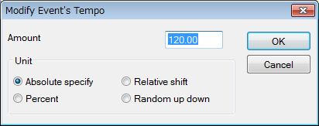

Absolute specify

Sets all selected events' value to the specified value.

Relative shift

Increases or decreases the selected events' value by the specified amount.

Percent

Scales the selected events' value by the specified percent.

Random up down

Increases or decreases the selected event's value by a random amount where the maximum up or down value is the specified amount.

Modify Event's tempo is available only for tempo event.

OK

Change event's value

Cancel

Cancel event's value change.

2-17. “Quantize” Dialog

This dialog is used to adjust the selected note on and note off events time that is real-time input. This dialog can be opened “Edit” - “Quantize...”

Snap Time [ticks]

This shows the quantization snap time in ticks. If TPQN base and time resolution is 120, 60 means that the time will be aligned to multiples of quaver, 30 means aligned to multiples of semiquaver. The MIDI sequence's time resolution can be changed “Property of MIDI data” dialog, which can be opened from “file” - “Property...” menu.

Strength [%]

If this value is 100%, note on time or note off time is moved to target aligned time completely. But this makes your musical performance not interesting. By adjusting this value 1 to 99%, note on time or note off time is moved close to (but not exactly) the target time, so you may preserve your musical performance a bit.

Target

To adjust note on time, check Note On. To adjust note off time, check Note Off. If only Note on is checked, note on time and note off time move back or forward together and note's duration is kept.

OK

Execute quantize.

Cancel

Cancel quantization.

2-18. “Break up note and Make Trill” Dialog

This dialog is used to break up selected note and make trill if needed. This dialog can be opened from “Edit” - “Break up note and Make Trill...” menu.

This function enables you to input a flute's trill or a timpani's roll easily from one long note event.

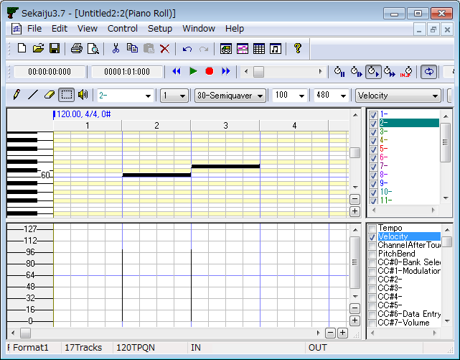Before break up note and trill

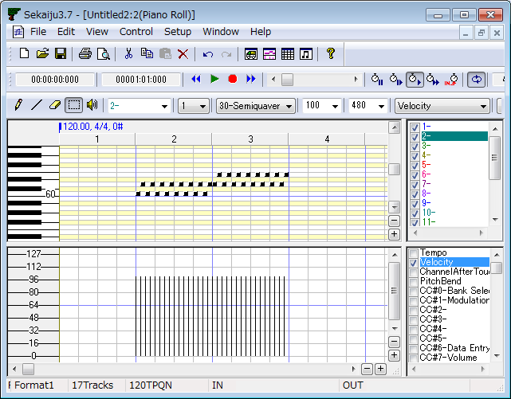
After break up note and trill

2-19. “Scan Beat and Insert Tempo” Dialog

This dialog is used to adjust the selected events to beat data and adjust the beat equal interval. And insert tempo event for every beat to keep speed automatically if needed.

This function enables real-time input at free speed by ignoring tempo, and aligns all events to fit measure and beat, later. It requires beat track, which is written one note per beat.

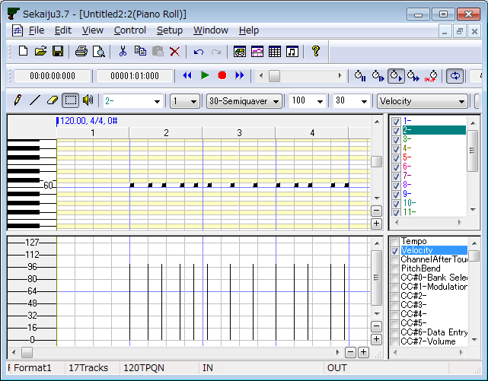
Before beat scan and insert tempo

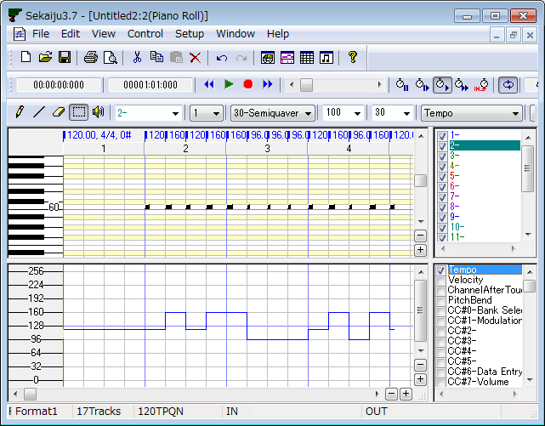
After beat scan and insert tempo

2-20. “Stroke” Dialog

Stroke feature, detects a chord note that starts at the same time from the selected note events, and displaces the note on time in ascending or descending order.

This function enables you to input especially guitar's stroke up or stroke down and alternating up and downor down and up from aligned chord notes.

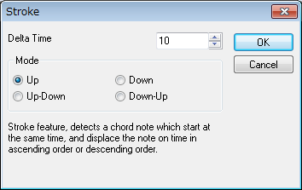

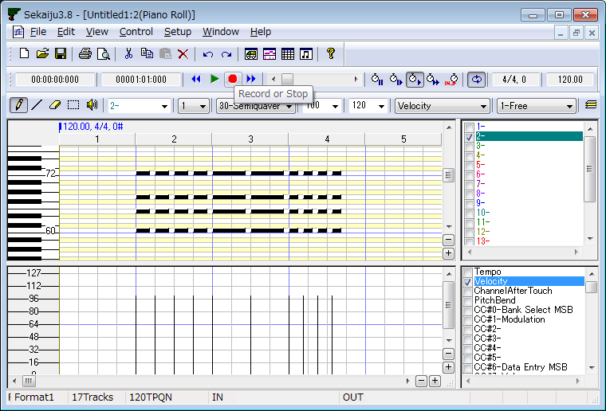
Before stroke (All chord notes start at the same time)

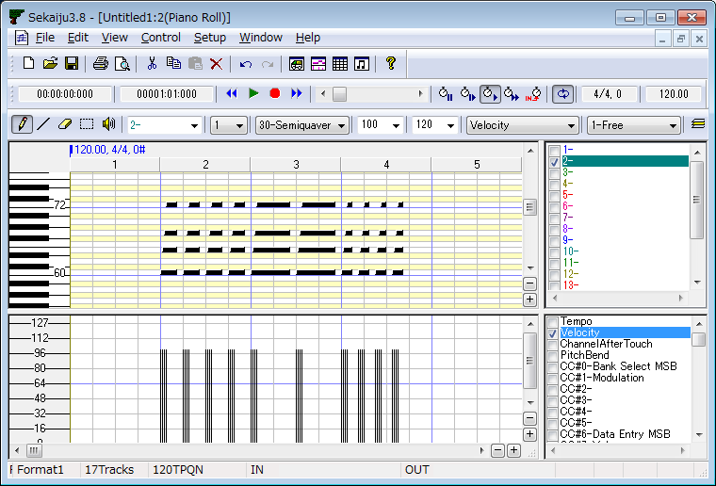
After Stroke (Mode = Up)

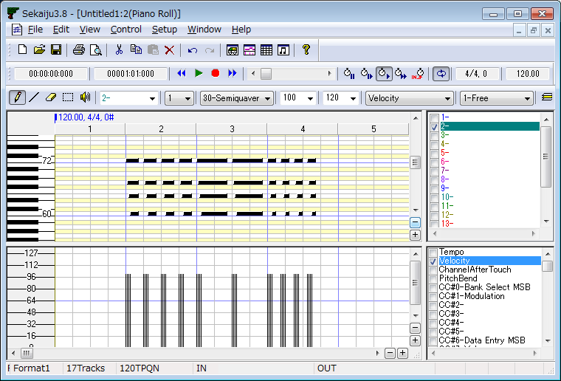
After Stroke (Mode = Down)

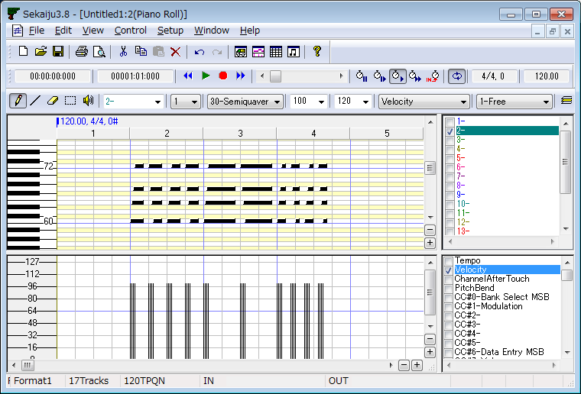
After Stroke (Mode = Up-Down)

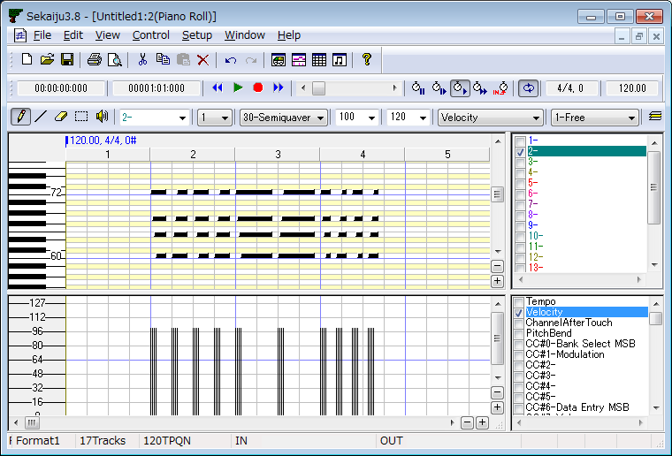
After Stroke (Mode = Down-Up)

2-21. “MIDI Device and Instrument” Dialog

This dialog is used to select MIDI In Device for each MIDI input port, MIDI Out Device for each MIDI output port, MIDI instrument definition (normal) for each MIDI output port, MIDI instrument definition (drum) for each MIDI output port, and MIDI Thru for each MIDI input port.

2-21-1. MIDI In Device

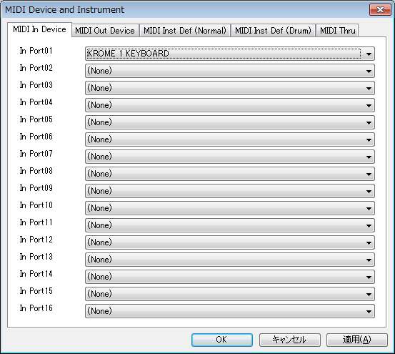

Select MIDI In Device for MIDI input port 01 to 16. In the combo box, MIDI in devices that are installed to Windows are listed. If you have not installed any MIDI in device, only “(None)” is listed.

2-21-2. MIDI Out Device

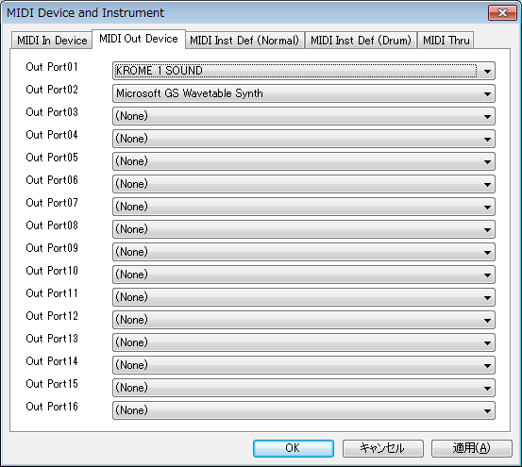
Select MIDI Out Device for MIDI output port 01 to 16. In the combo box, MIDI out devices that are installed to Windows are listed. If you have not installed any MIDI in device, “(None)”, “MIDI Mapper”, and “Microsoft GS Wavetable (SW) Synth” are listed. You must at least select port 01's MIDI out device, or no sound is played. “Microsoft GS Wavetable (SW) Synth” is the default Windows MIDI Synthesizer, but it has very poor sound samples.
“MIDI Mapper” is virtual output device, which is connected to one MIDI out device. This connection is defined by Windows MIDI mapper, which can be selected in control panel's sound and audio device in Windows XP, and which can be selected by using “MIDISelector” software in Windows Vista / 7, which is released from openmidiproject. Ideally, Some hardware MIDI module or hardware synthesizer is recommended.

2-21-3. MIDI Inst Def (Normal)

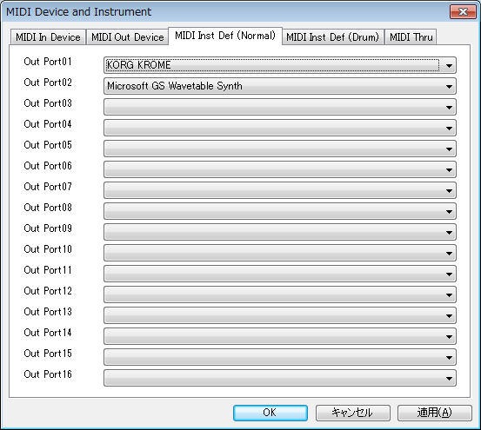

Select MIDI Instrument name (for normal instruments) for MIDI output port 01 to 16. In the combo box, MIDI instrument names that are defined in the “instrument” folder (in the Sekaiju install folder) are listed. This selection is needed for showing your MIDI module's voice name, controller name, and so on. If your MIDI module's instrument isn't listed, you need to search a suitable instrument definition file in the Internet, and put the file in the “instrument” folder, and execute Sekaiju again, and your instrument definition will appear in the combo box. Sekaiju's instrument definition file is compatible with Cakewalk's instrument definition file (*.ins), so “Cakewalk instrument definition file” is a good search string.

2-21-4. MIDI Inst Def (Drum)

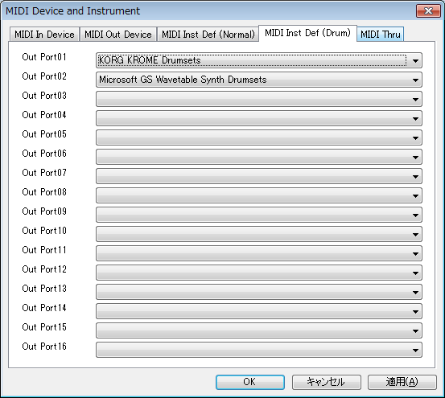

Select MIDI Instrument name (for drum set) for MIDI output port 01 to 16. In the combo box, MIDI instrument names that are defined in the “instrument” folder are listed. This selection is needed for showing your MIDI module's voice name, controller name, and so on. If your MIDI module's instrument definition file isn't listed, you need to search suitable instrument definition file in the Internet, and put the file in the “instrument” folder, and execute Sekaiju again, and your instrument definition will appear in the combo box. Sekaiju's instrument definition file is compatible with Cakewalk's instrument definition file (*.ins), so “Cakewalk instrument definition file” is a good search string.

2-21-5. MIDI Thru

It enables you to select whether MIDI message from each MIDI in port is output or not. Default setup is all on. If the message loops, turn off MIDI Thru.

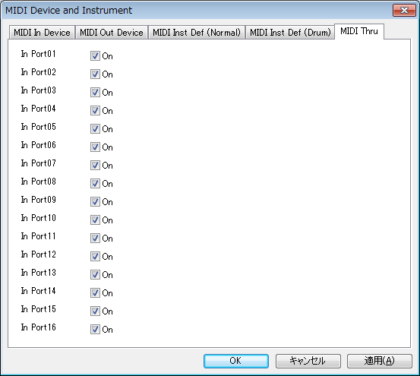
OK

Close this dialog and update and open MIDI In Device, MIDI Out Device, MIDI Instrument name (normal instruments), and MIDI Instrument (drum set).

Cancel

Close this dialog.

Apply

Update and open MIDI In Device, MIDI Out Device, MIDI Instrument name (normal instruments), and MIDI Instrument (drum set).

2-22. “MIDI Sync Mode” Dialog

This dialog is used to select MIDI synchronize mode. This dialog can be opened from “Setup” - “MIDI Sync Mode...” menu.

2-22-1. MIDI Sync (Receive)

Select type of MIDI synchronization signal for MIDI input port 01 to 16. The type of MIDI synchronization signal is selected from “(None)” or “Receive MIDI Clock” or “Receive SMPTE/MTC”. Synchronization signal can be input only from one port. Therefore, if you select some MIDI synchronization signal at one port, the others port becomes “(None)” automatically.

2-22-2. MIDI Sync (Send)

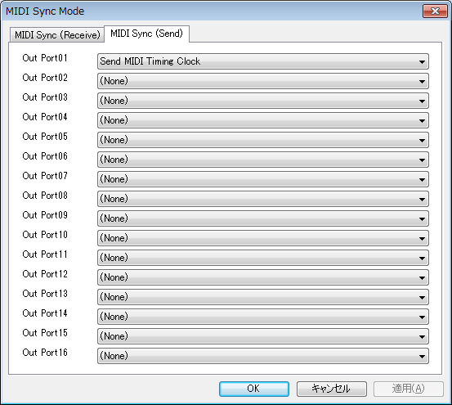

Select type of MIDI synchronization signal for MIDI output port 01 to 16. The type of MIDI synchronization signal for MIDI output port is selected from “(None)”, “Send MIDI Clock”, “Send SMPTE24/MTC”, “Send SMPTE25/MTC”, “Send SMPTE29.97/MTC”, and “Send SMPTE30/MTC”.

OK

Close this dialog and update MIDI synchronization signal type.

Cancel

Close this dialog.

Apply

Update MIDI synchronize signal type.

2-23. “Metronome” Dialog

This dialog is used to setup metronome that rings during real-time input. This dialog can be opened from “Setup” - “Metronome” menu.

Ring metronome while real-time input

If this is checked, metronome sound rings during real- time input. If not, metronome doesn't ring.

Out port and Out channel

Select output port (1 to 16) and output channel (1 to 16) where metronome sound is output. Output port can be selected only if the port MIDI out device is selected. Recommended output channel is 10 because normally MIDI module's channel 10 is assigned drum set.

Pattern

Specify metronome pattern.

Main Note Key / Velocity

Select note key and velocity that sounds at beat 1. Key should be unique and velocity should be over 100 to be easily heard.

Sub Note Key / Velocity

Select note key and velocity that rings at beat 2 or later. Key should be unique and velocity should be over 100 to be easily heard.

OK

Close this dialog and update metronome setup.

Cancel

Close this dialog.

2-24. “Auto Save” Dialog

This dialog is used to setup auto save function. This dialog can be opened from “Setup” - “Auto Save...” menu.

Enable Auto Save

If this is checked on, Sekaiju saves current MIDI sequence in “autosave” folder at specified interval. However, if current MIDI sequence isn't changed, it is not auto saved, and when it is next changed, it will be auto saved. The file name for auto saved file is “YYYYMMDDHHMMSS_XXXXXXXX.skj”. YYYY is year, MM is month, DD is day, HH is hour, MM is minute, SS is second, and XXXXXXXX is a unique hex value for the MIDI sequence.

Interval

Specify auto save interval in minutes from 1 to 120.

Avoid auto save during playing
Avoid auto save during real-time input

If this is checked on. Sekaiju doesn't auto save current MIDI sequence while some MIDI sequence is playing or real-time inputting. Auto save causes lock for about 1 second because of disc access, so playing or real-time inputting pauses for about 1 second while saving MIDI sequence. If this is checked on, saving is postponed until playing or real-time inputting ends.

Delete all auto saved files now

Delete all auto saved files in “autosave” folder immediately.

OK

Close this dialog and update auto save setup.

Cancel

Close this dialog.

2-25. “Language” Dialog

This dialog is used to select the user's interface language and to select default text-encoding of string in the text based event. This dialog can be opened from “Setup” - “Language...” menu.

The language can be selected from Japanese or English. In Japanese, MS UI Gothic font is used as main GUI font. In English, Microsoft Sans Serif font is used as main GUI font. (Except the part defined by the OS, like title bar, menu, controls, and so on). In English mode, Japanese characters can't be shown correctly.

Default Text Encoding is used when get or set string in the text based event for which no character code is specified. The following values can be used:

"0-Windows Control Panel ANSI Code Page"
"874-Thai"
"936-Chinese Simplified"
"932-Japanese Shift-JIS"
"949-Korean"
"950-Traditional Chinese"
"1250-Central European"
"1251-Cyrillic"
"1252-Western Latin-1 [recommended]"
"1253-Greek"
"1254-Turkish"
"1255-Hebrew"
"1256-Arabic"
"1257-Baltic"
"1258-Vietnamese"
"1200-Unicode UTF-16LE"
"1201-Unicode UTF-16BE"
"65001-Unicode UTF-8"

Only the following 5 type is allowed according to the Standard MIDI File RP-026.

"932-Japanese Shift-JIS"
"1252-Western Latin-1 [recommended]"
"1200-Unicode UTF-16LE"
"1201-Unicode UTF-16BE"
"65001-Unicode UTF-8"

Additionally, "932-Japanese Shift-JIS" can be read/written correctly only by Japanese MIDI sequencer, "1252-Western Latin-1 [recommended]" can be read/written correctly only by European or American MIDI sequencer, and "1200-Unicode UTF-16 Little Endian" or "1201-Unicode UTF-16 Big Endian" or "65001-Unicode UTF-8" can be read/write only by MIDI sequencer that support Unicode text.

OK

Close this dialog and update the language setup. If you click OK, the following message box is shown:

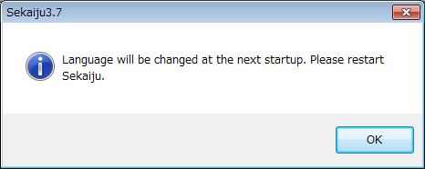

Language will be changed at the next start up. Please execute Sekaiju again.

Cancel

Close this dialog.

Hint:

Sekaiju is made in Japan, therefore, default User Interface language is Japanese and default text encoding is "0-Windows Control Panel ANSI Code Page". If you use non Japanese Windows, please select English language.

In non Japanese Windows, it may be difficult to open the “Setup” - “Language...” menu because of character corruption. Please use keyboard shortcut: First, press [Alt] + [S], next press [Alt] + [L] and you can open this dialog.

The GUI language can be changed by text editor, too. Open “Sekaiju.ini” in your text editor, and change "UserInterface=Japanese" into “UserInterface=English", or "UserInterface=Chinese" and then execute Sekaiju.

2-26. “Options” Dialog

This dialog is used to setup the whole Sekaiju. This dialog can be opened from “Setup” - “Options...” menu.

2-26-1. General

Allow multiple execution

If this is checked, multiple Sekaiju can be executed. And if the MIDI files like (*.skj) and (*.mid) are related to Sekaiju in Windows Explorer, whenever you open these file, new Sekaiju application is executed. Normally, it is recommended to be checked off multiple execution, because the almost all MIDI devices can be opened from only one application at a time.

Allow multiple open

If this is checked, multiple MIDI sequence can be opened in one Sekaiju. If this is unchecked, only a single MIDI sequence can be opened in one Sekaiju, that is, the previous MIDI sequence is closed automatically whenever you open a new MIDI sequence. If the previous MIDI sequence is modified and not saved, a message box to save will be appear.

Restore window position when Sekaiju is executed

If this is checked, when you execute Sekaiju, the main window's position is restored to the location where it was the last time you used it.

Open last used MIDIData automatically when Sekaiju is executed

If this is checked, when you execute Sekaiju, the MIDI sequence that you've opened last time is automatically opened. If this is checked off, a default untitled new MIDI sequence is ready.

Start playing automatically when MIDIData is opened.

If this is checked, when you open MIDI sequence, Sekaiju starts playing the MIDI sequence automatically.

Update Program, Controller, PitchBend, RPN, NRPN when position is moved

MIDI sequence can be played exactly when you start playing from the beginning, but played wrong when you start playing from the middle because MIDI player doesn't output preceding message that determine the status.

If this is checked, whenever you moved current playing position, Sekaiju send latest program change), control change, pitch bend, RPN change (CC#101, CC#100, CC#6), NRPN change (CC#99, CC#98, CC#6), and the master volume if need, and MIDI module's status is updated to fit the current time's status.

Update Program, Controller, PitchBend, RPN, NRPN when start playing

If this is checked, whenever you start playing MIDI sequence, Sekaiju send latest program change, control change, pitch bend, RPN change (CC#101, CC#100, CC#6), NRPN change (CC#99, CC#98, CC#6), and the master volume if need, and MIDI module's status is updated to fit the current time's status.

Update Program, Controller, PitchBend, RPN, NRPN when they are changed while playing

If this is checked, whenever you changed program change, control change, pitch bend, RPN change (CC#101, CC#100, CC#6), or NRPN change (CC#99, CC#98, CC#6), and the master volume while playing, MIDI module's status is updated to fit the current time's status if need.. This works only when playing the event's effect is available section. For example, if there are two program changes in one track, if you are playing the second program change's section, changing the first program change does nothing to the MIDI module.

Loop from CC#111 position when auto repeat (RPG Maker method)

If this is checked, when playing reaches the end of MIDI sequence and auto repeat button is checked, Sekaiju continues playing from CC#111 event position (RPG Marker method). And if “loopEnd” Marker is detected, Sekaiju continues playing from “loopStart” Marker's position (FINAL FANTASY VII method). If there is no CC#111 event or “loopEnd” and “loopStart” Marker, loop from the beginning.

If this is unchecked and auto repeat button is checked, Sekaiju continues playing from the begininng.

Search only avail tone when CC#0, CC#32, or Program Number is up or downed

In MIDI, by the combination of CC#0 (0 to 127), CC#32 (0 to 127), and program change (0 to 127) event, 2097152 kind of voices can be selected. But almost all MIDI modules or synthesizers have 127 to 2000 kinds of voices.

If this is checked, when you click up or down button or press '+' or '-' key of CC#0 or CC#32 or program change event, Only available voice numbers will be shown.

This function works normally only in case that exact instrument definition is selected to the output port from “Setup” - “MIDI Device and Instruments” menu, because available voice number's list is defined in the instrument definition. If not, it is recommended to uncheck this function.

Invert position move direction when mouse wheel is turned with Ctrl key

If this is checked, the current position moving direction is inverted when turning mouse wheel with ctrl key.

Count track number from 0

If this is checked, the track number is counted from 0. If not, counted from 1.

Count event number from 0

If this is checked, the event number is counted from 0. If not, counted from 1.

Turn on auto page update when position moved or start playing

If this is checked, Sekaiju checks auto page update function of track list window, piano roll window, and event list window and musical score window automatically whenever you start playing or you move current playing position. Each window's auto page update function is unchecked automatically whenever you scroll the view or you click zoom up or down button. Each window's auto page update can be checked on or off by clicking auto page update button (goldfish's icon) in the toolbar at any time.

Send note off and hold off at the end of MIDIData.

If this is checked, Sekaiju sends all note off (CC#123), hold1 off (CC#64), sostenuto off (CC#66), and hold2 off (CC#69) to all device when playing reaches to the end of MIDI sequence.

This function prevents causing sound panic if MIDI sequence ends without note off event, or hold off event. If MIDI sequence is designed to use auto repeat, this function may be unchecked because the MIDI sequence does not end at the end time, but continues at the start time or CC#111 event's time. But it is not recommended to make a MIDI sequence that ends without note off event or hold off event.

Tempo scale at Speed=Slow (1~<50>~1000)[%]
Tempo scale at Speed=Normal (1~<100>~1000)[%]
Tempo scale at Speed=Fast (1~<200>~1000)[%]

Specify tempo scale for “slow”, “Normal”, and “Fast” at percent unit. Default is Slow=50%, Normal=100%, and Fast=200%.

Playback and real-time input thread loop interval (1~1000)[millisec]

Specify MIDI message input / output interval at millisecond unit. If this value is lower, MIDI message is received or sent at more exact timing, but more CPU load is needed, so it may cause computer freeze. If this value is higher, MIDI message is received or sent at less exact timing, but less CPU load is needed, so your computer works smooth. 1 msec is ideal, but considering for load, 5 – 10 msec is the best.

Octave number of center 'C' (key=60) (3~5)

Specify octave number of center “C” (= key number 60). If this value is 3, the center “C” is called “C3” and the lowest key is called “C-2”. If this value is 5, the center “C” is called “C5” and the lowest key is called “C0”. This is only for view and it has no influence to playing MIDI sequence.

2-26-2. Color

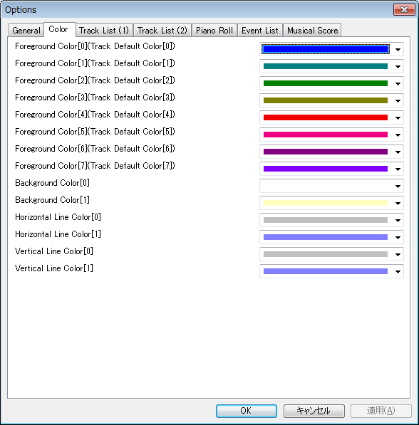
Foreground Color[0] (Track Default Color[0])
Foreground Color[1] (Track Default Color[1])
Foreground Color[2] (Track Default Color[2])
Foreground Color[3] (Track Default Color[3])
Foreground Color[4] (Track Default Color[4])
Foreground Color[5] (Track Default Color[5])
Foreground Color[6] (Track Default Color[6])
Foreground Color[7] (Track Default Color[7])

Specify default track color when new MIDI sequence is opened or loaded. Sekaiju sequence file (*.skj) can save track color, so the file's saved color is applied .Cherry sequence file (*.chy), Standard MIDI file (*.mid), and MIDICSV (*.csv) file doesn't save track color, so default track color is applied. Greater than [7] starts again cyclically from [0].

Background Color[0]
Background Color[1]

Specify GUI's background color. [0] is for even rows, [1] is for odd rows or for black key in the piano roll window.

Horizontal Line Color[0]
Horizontal Line Color[1]

Specify GUI's horizontal line color. [0] is for general line, [1] is for octave line or center line.

Vertical Line Color[0]
Vertical Line Color[1]

Specify GUI's vertical line color. [0] is for general line, [1] is for measure border line (BARline).

2-26-3. Font

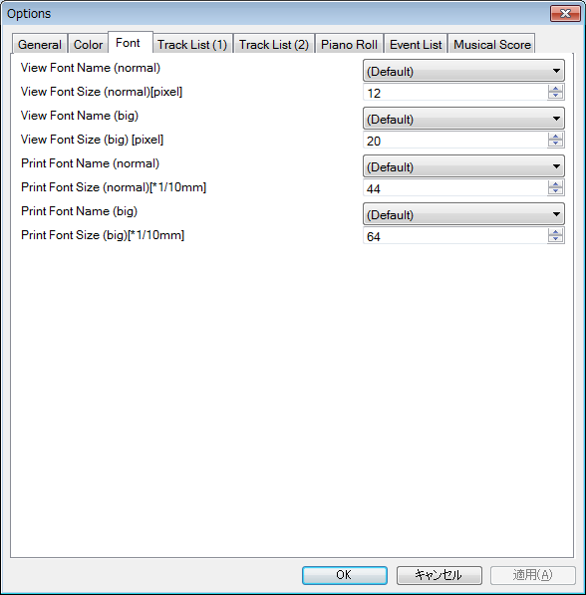
View Font (normal)

Track list, piano roll, event list, musical score window's view's font. The size is specified in pixel unit.

View Font (big)

Musical score window's view's time signature / key signature font. The size is specified in pixel unit.

Print Font (normal)

Track list, piano roll, event list, musical score window's printing font. The size is specified in 1/10 mm unit.

Print Font (big)

Musical score window's printing time signature / key signature font. The size is specified in 1/10 mm unit.

When selecting (Default), the default font (same as GUI's font) is used. The default font is “MS UI Gothic” in UserInterface=Japanese mode, and is “Microsoft Sans Serif” in UserInterface=English mode. Even if you select European font, Kanji can be shown by windows font link feature in the alternate font, but you should select better font in your language or environment.

2-26-4. Track List (1)

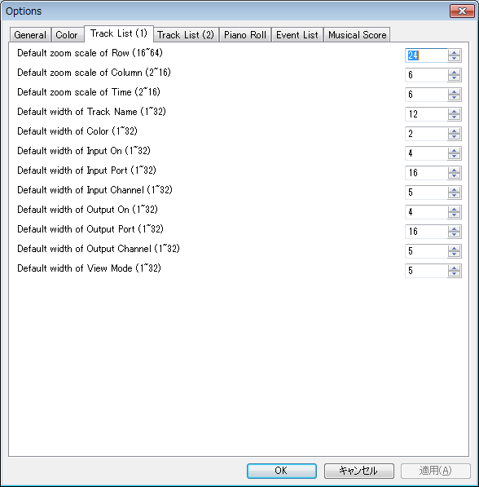

Default zoom scale of Row (16~64)
Default zoom scale of Column (2~16)
Default zoom scale of Time (2~16)

Specify default zoom scale when new track list window is opened.

Default width of Track Name (1~32)
Default width of Color (1~32)
Default width of Input On (1~32)
Default width of Input Port (1~32)
Default width of Input Channel (1~32)
Default width of Output On (1~32)
Default width of Output Port (1~32)
Default width of Output Channel (1~32)
Default width of View Mode (1~32)

Specify default cell width when new track list window is opened. The actual column width [pixel] becomes a multiple this value and zoom scale of column.

2-26-5. Track List (2)

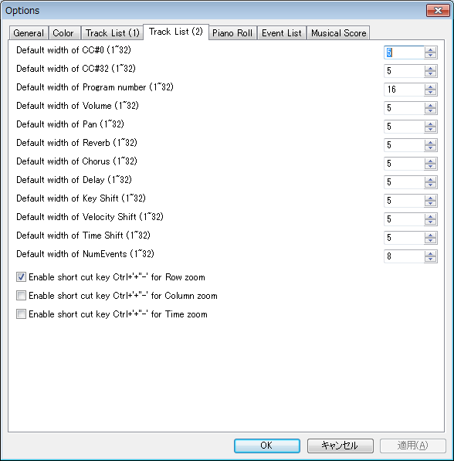

Default width of CC#0 (1~32)
Default width of CC#32 (1~32)
Default width of Program number (1~32)
Default width of Volume (1~32)
Default width of Pan (1~32)
Default width of Reverb (1~32)
Default width of Chorus (1~32)
Default width of Delay (1~32)
Default width of Key Shift (1~32)
Default width of Velocity Shift (1~32)
Default width of Time Shift (1~32)
Default width of NumEvents (1~32)

Specify default cell width when new track list window is opened. The actual column width [pixel] becomes a multiple this value and zoom scale of column.

Enable short cut key Ctrl + '+''-' for Row Zoom
Enable short cut key Ctrl + '+''-' for Column Zoom
Enable short cut key Ctrl + '+''-' for Time Zoom

Specify which zoom button enable by short cut key Ctrl + '+' '-'.

2-26-6. Piano Roll

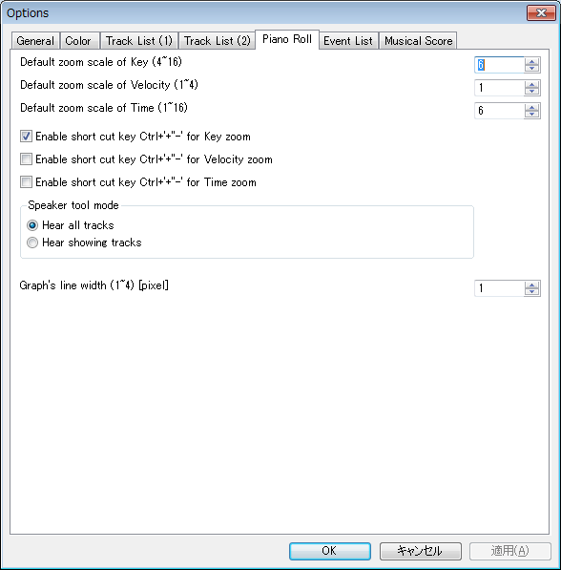

Default zoom scale of Key (4~16)
Default zoom scale of Velocity (1~4)
Default zoom scale of Time (1~16)

Specify default zoom scale when new piano roll window is opened.

Enable short cut key Ctrl + '+''-' for Key Zoom
Enable short cut key Ctrl + '+''-' for Velocity Zoom
Enable short cut key Ctrl + '+''-' for Time Zoom

Specify which zoom button enable by short cut key Ctrl + '+' '-'.

Speaker tool mode

Select which track you hear: all tracks or shown tracks when using the speaker tool.

Graph's line width (1～4) [pixel]

Specify graph's line width.

2-26-7. Event List

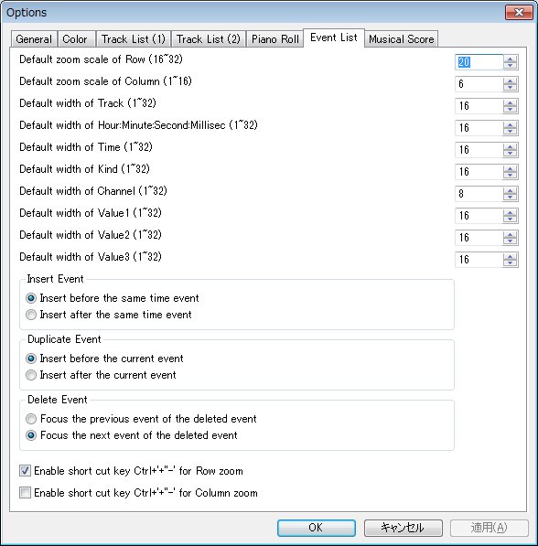

Default zoom scale of Row (16~32)
Default zoom scale of Column (1~16)

Specify default zoom scale when new event list window is opened.

Default width of Track (1~32)
Default width of Hour:Minute:Second:Millisec (1~32)
Default width of Time (1~32)
Default width of Kind (1~32)
Default width of Channel (1~32)
Default width of Value1 (1~32)
Default width of Value2 (1~32)
Default width of Value3 (1~32)

Specify default cell width when new event list window is opened. The actual column width [pixel] becomes a multiple this value and the zoom scale of column.

Insert Event

Select which position to insert, before active cell or after active cell when inserting new event.

Duplicate Event

Select which position to duplicate, before active cell or after active cell when duplicating event.

Delete Event

Select which event to focus, before the deleted event or after the deleted event after deleting event.

Enable short cut key Ctrl + '+''-' for Row Zoom
Enable short cut key Ctrl + '+''-' for Column Zoom

Specify which zoom button enable by short cut key Ctrl + '+' '-'.

2-26-8. Musical Score

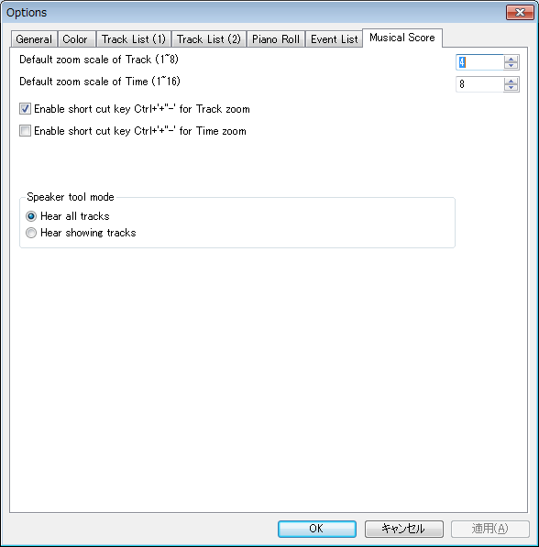

Default zoom scale of Track (1~8)
Default zoom scale of Time (1~16)

Specify default zoom scale when new musical score window is opened.

Enable short cut key Ctrl + '+''-' for Track Zoom
Enable short cut key Ctrl + '+''-' for Time Zoom

Specify which zoom button enable by short cut key Ctrl + '+' '-'.

Speaker tool mode

Select which track you hear: all tracks or shown tracks when using the speaker tool.

--------------------------------------------------------------------------

OK

Close this dialog and update the option setup.

Cancel

Close this dialog without changes.

3. How to make MIDI sequence

Here is an explanation to make short MIDI sequence “Chocho” by using Sekaiju. Following musical score is beginning 4 measure of “Chocho”.

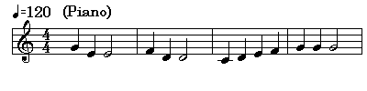

3-1. Create New MIDI sequence

To make a new MIDI sequence, Select “File”- “New” menu. There is already a new MIDI sequence named “Untitled1” just after you execute Sekaiju.

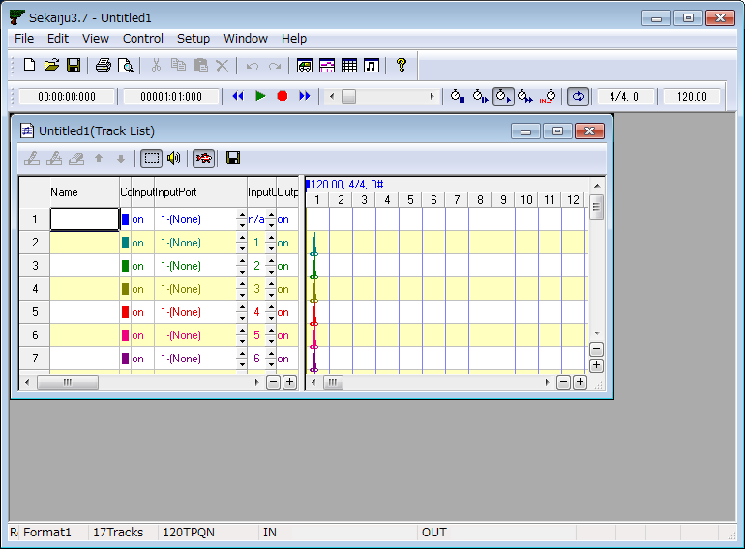

If “Start playing automatically when MIDIData is opened” is checked on in Options dialog, there is not a new MIDI sequence, but Sekaiju opens last opened MIDI sequence automatically. In this case, close the MIDI sequence, and create a new MIDI sequence.

3-2. Set the Property of this MIDI sequence

Set title, SMF Format (0/1/2), time mode, and time resolution and so on in the Property of MIDI sequence dialog, which can be opened from “File” - “Property...” menu. Following sample is title = “Sample1”, SMF Format = 1, time mode = TPQN base, resolution = 120 [Ticks per quarter note]. NumTracks =17 and NumEvent = 213 are default tracks and events contained in a new MIDI sequence, like track name, tempo, time signature, key signature, and end of track events.

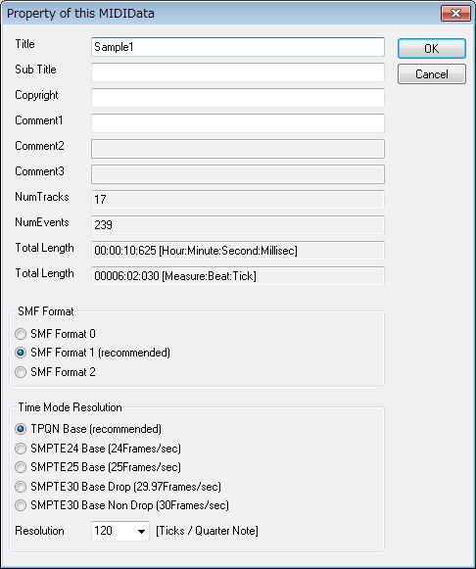

3-3. Set the each track's property

In case of piano music, generally, left hand and right hand should be written to separate track. This MIDI sequence is format 1, so the first track is conductor track, the second track is right hand track, the third track is left hand track. In the track list window, please write “Right Hand” and “Left Hand” in the “Name” column. And set instrument, volume, pan and so on. Following sample is instrument = “0-Piano1” volume = 100, pan = 80 (a little right) in right hand, pan= 48 (a little left) in left hand. The other tracks are not used, so you may delete the other tracks by clicking button.

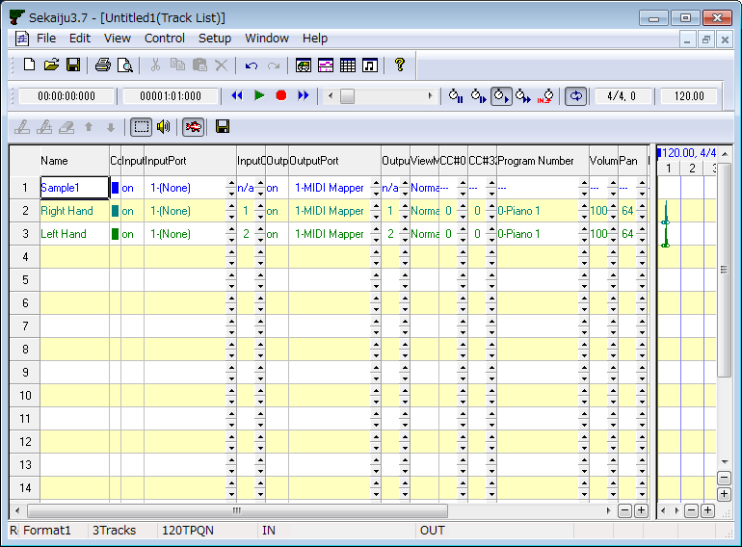

3-4. Insert note events in the piano roll window.

Open piano roll window by clicking button in the first toolbar. By using piano roll window, you can insert note events quickly.

Generally the first measure is used to insert track's setup info, the note begins from the second measure. Select Draw tool, and select “2-Right Hand” track, and select channel 1 and select snap “30-semiquaver”, select velocity 100, and select duration 120[tick] in the piano roll toolbar.

And then draw note events in the piano roll view by clicking or dragging mouse. The note bar's position can be modified by dragging the bar's center. The note bar's note on time can be modified by dragging the bar's left 1/4. The note bar's note off time can be modified by dragging the bar's right 1/4.

While inserting note bar by dragging, you can cancel to insert note bar by pressing [Esc] or [Del] key. While modifying note bar by dragging, you can delete the note bar by pressing [Del] key.

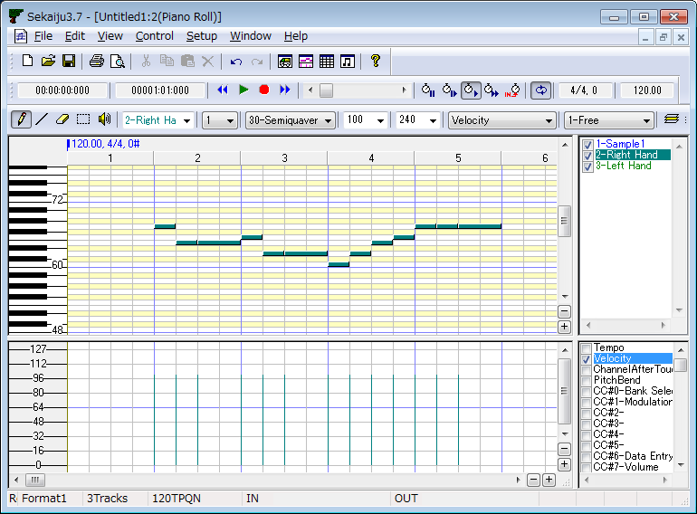

3-5. Edit events in the event list window

Open event list window by clicking button in the first toolbar. By using event list window, you can edit all kinds of events.

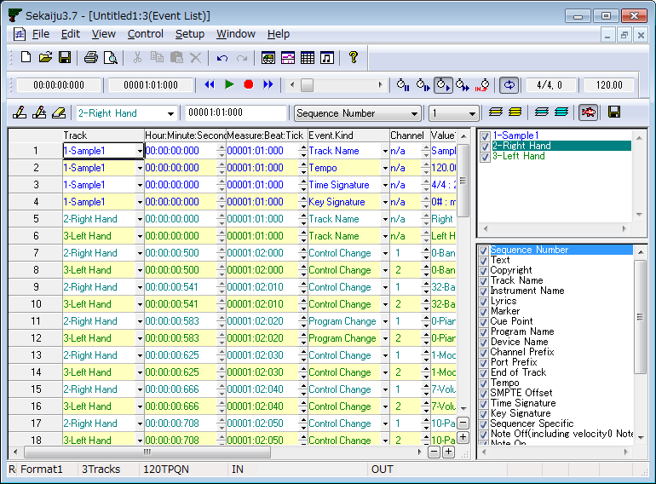

Set tempo

By default the first tempo is set 120.00[BPM]. If you want to change tempo, move the active cell to the tempo value, and press [Enter] key, and modify the value to a new one like “100.00” and press [Enter] key.

Set time signature

By default the first time signature is “4/4”. If you want to change time signature, move the active cell to the time signature value, and press [Enter] key, and modify the value to a new one like “6/8” and press [Enter] key. The time signature event is only for view, and has no influence to playing MIDI sequence.

Set Key signature

By default the first key signature is “0#, major” which means C Major. If you want to change key signature, move the active cell to the key signature's value , and press [Enter] key, and modify the value to a new one like “2b, minor” which means G minor, and press [Enter] key. The key signature event is only for view, and has no influence on how the MIDI sequence plays.

* In Sekaiju, “b” (lower letter of “B”) is used as a flat sign.

Edit track's setup events

Each track should be setup in the first measure. There are default events for setup in the first measure, CC#0(Bank Select MSB). CC#32(Bank Select LSB), Program number, CC#0(modulation), CC#7(volume), CC#10(pan), CC#11(expression), CC#91(reverb), CC#93(chorus), and CC#94(delay). Some of these event's value can be set in the track list window. Each event must be put with interval at least 5 ticks.

The following list is the second track (Right hand) 's setup events.

Measure:Beat:Tick | Event Kind | Values
'00001:02:000 | Control change | CC#0(Bank Select MSB)=0
'00001:02:010 | Control change | CC#32(Bank Select LSB)=0
'00001:02:020 | Program change | 0-Piano1
'00001:02:030 | Control change | CC#1(Modulation)=0
'00001:02:040 | Control change | CC#7(Volume)=100
'00001:02:050 | Control Change | CC#10(Pan)=80
'00001:02:060 | Control Change | CC#11(Expression)=127
'00001:02:070 | Control Change | CC#64(Hold1)=0
'00001:02:080 | Control Change | CC#91(Reverb)=40
'00001:02:090 | Control Change | CC#93(Chorus)=0
'00001:02:100 | Control Change | CC#94(Delay)=0

To edit these events, select the second track and show only the second track by clicking button. And then move the active cell to the target cell you want to modify. And then press [Enter] key and input new value and press [Enter] key. Also by left-clicking up or down button of the cell, the value can be increased or decreased by 1 step, and by right-clicking up or down button of the cell, the value can be increased or decreased by 10 or larger steps.

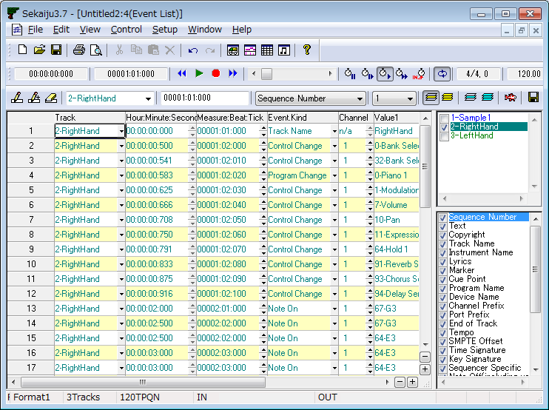

Patch change (CC#0, CC#32, and program change event) must be sent sequentially in this order. Also NRPN change (CC#99, CC#98, and CC#6 event) must be sent sequentially in this order. Also RPN change (CC#101, CC#100, and CC#6 event) must be sent sequentially in this order.

Insert system exclusive message for resetting the MIDI module or synthesizer.

The MIDI module or synthesizer should be reset at the beginning of the music. So GM System off, or GM1 Reset, or GM2 Reset, or GS Reset, or XG Reset must be inserted at the beginning of the music preceding MIDI channel event.

In case of Format 1 MIDI sequence, generally, the system exclusive event for resetting the module is inserted in the first track at the time 0. Here is example for inserting GM1 Reset “F0 7E 7F 09 01 F7”.

To insert system exclusive event, select the first track and show only the first track by clicking button. And then, select “1-Sample1” track, select time “00000:01:010”, and select kind “SysEx(Normal)” in the event list toolbar. And then insert new events by clicking button or pressing [Ins] key. In the event list view, a new system exclusive event is inserted. And then move to active cell to the value, and press [Enter] key, and write “F0 7E 7F 09 01 F7”, and press [Enter] key.

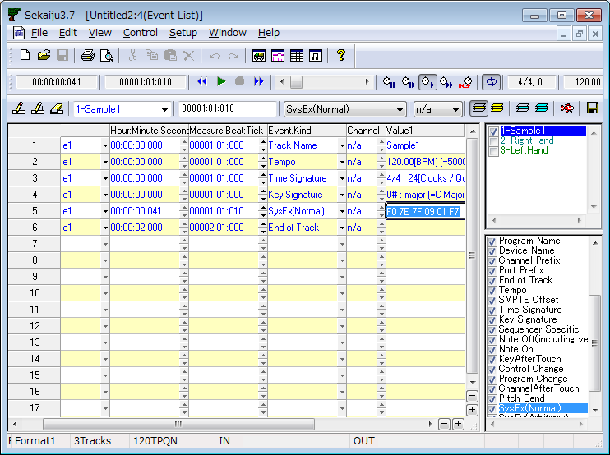
System exclusive events, especially Reset message, gives heavy load to the MIDI module or synthesizer. So enough interval must be required to the next event, at least 10 to 30 ticks in case of TPQN 120[ticks / quarter note].

3-6. Playing the MIDI sequence

To start playing the MIDI sequence or stop playing the MIDI sequence, click play () button or press [Space] key. To move current playing position, move thumbs or click scroll area of position scroll bar () or press [Left] or [Right] key with [Ctrl] key pressed, or turn mouse wheel with [Ctrl] key pressed.

Sometimes you may want to hear the playing sound to check the MIDI events you've input are not wrong.

3-7. Saving the MIDI sequence

MIDI sequence can be saved as Sekaiju sequence file (*.skj) or Cherry sequence file (*.chy) or Standard MIDI File (*.mid) or MIDICSV File (*.csv) from “File” - “Save” or “Save As...” menu. Specify file place and file name and file type and click “Save” button.

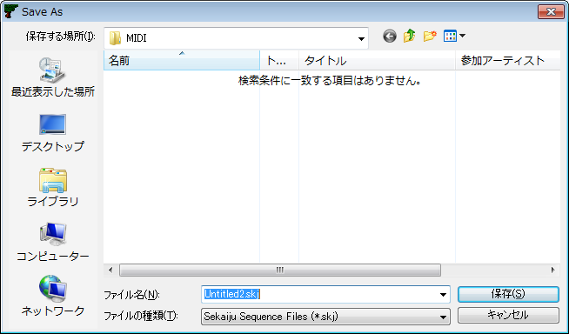

If you are making music, it is recommended to save as “Sekaiju MIDI sequence (*.skj)”, because this format can completely save all status of the MIDI sequence. If you release MIDI sequence, it is recommended to save as “Standard MIDI File (*.mid)”, because this format can be played in almost all MIDI players.

4. Trouble shooting

4-1. Error messages

MIDI in device open failed.

Sekaiju couldn't open specified MIDI in device. In this case, “(None)” is selected automatically. Check following list.

Reason | Solution
* You select the same MIDI in device redundantly for MIDI in port 01~16. | * Select different MIDI in device for each MIDI in port.
* Other application is using specified MIDI in device. *1 | * Close any other application using the specified MIDI In device.
* An application exited without closing specified MIDI in device. | * Reboot Windows.
* MIDI in device driver is broken. | * Uninstall the MIDI in device driver and then install the latest one again.
* Nothing is connected to MIDI in terminal. | * Check cable connection.
* Your Windows doesn't have the device. | * Select the other device.

*1 : Generally, one MIDI in device can be opened from only one application, except multiple client MIDI interface.

MIDI out device open failed.

Sekaiju couldn't open specified MIDI out device. In this case, “(None)” is selected automatically. Check the following list.

Reason | Solution
* You select the same MIDI out device redundantly for MIDI out Port 01~16. | * Select different MIDI out device for each MIDI out Port.
* Other application is using specified MIDI out device. | * Close any other application using the specified MIDI out device.
* An application exited without closing specified MIDI out device. | * Reboot Windows.
* MIDI out device driver is broken. | * Uninstall the MIDI out device driver and then install the latest one again.
* Nothing is connected to MIDI out terminal. | * Check cable connection.
* Your Windows doesn't have the device. | * Select the other device.

*1 : Generally, one MIDI Out Device can be opened from only one application, except multiple client MIDI interface.

Insufficient memory, Insufficient resource.

Reason | Solution
* Insufficient memory.  * Insufficient resource. | * Close other MIDI files.  * Exit other applications.  * Reboot Windows.

File load failed.

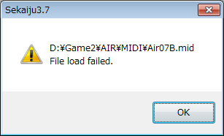

Sekaiju couldn't load specified MIDI file. Check the following list.

Reason | Solution
* Abnormal MIDI sequence. | * If it is saved in other sequencer, once open by the sequencer, fix bug, and then save again. Try saving in various file type, or SMF format 0 / 1, or the other time mode and time resolution.
* The disk storing the MIDI file is broken. | * Scan disk and repair disk.  * Copy the file to other device.
* Specified MIDI file is used by other application. | * Close other applications.
* Insufficient memory.  * Insufficient resource. | * Reboot Windows.

Sekaiju.exe – System Error
*.DLL File is not found.

Sekaiju.exe
WrongSide by Side

Microsoft VisualC++ Runtime Library
Runtime Error!

Sekaiju
*.DLL Load failed!!

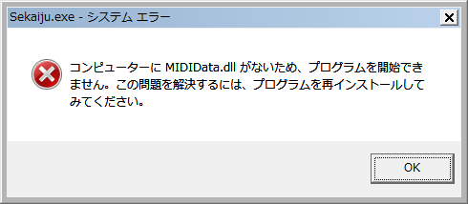

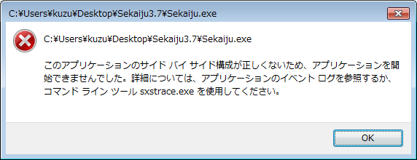

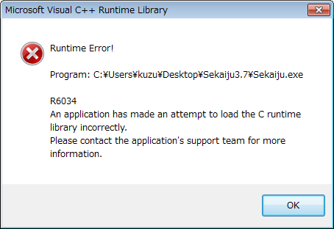

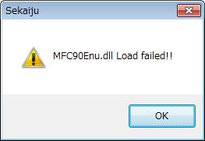

This message may be shown when executing Sekaiju. To execute Sekaiju, Following DLL files are required.

Made by OpenMIDIProject
SekaijuJpn.dll | Sekaiju Japanese language resource DLL.
SekaijuEnu.dll | Sekaiju English language resource DLL.
SekaijuChs.dll | Sekaiju Chinese language resource DLL.
MIDIIO.dll | MIDI message input output library.
MIDIClock.dll | MIDI clock measuring library.
MIDIData.dll | MIDI data creating editing library.
MIDIStatus.dll | MIDI module status keeping library.
MIDIInstrument.dll | MIDI instrument definition file (*ins) library.

Made by Microsoft (shipped with Sekaiju)
msvcr90.dll | C Runtime library.
mfc90.dll | MFC Runtime library (for ANSI).
mfc90u.dll | MFC Runtime library (for Unicode).
mfc90chs.dll | MFC Chinese resource DLL.
mfc90jpn.dll | MFC Japanese resource DLL.
mfc90enu.dll | MFC English resource DLL.
* These files can be recognized by using Sekaiju.manifest , Microsoft.VC90.CRT.manifest, and Microsoft.VC90.MFC.manifest.

These files must exist in the same folder as Sekaiju.exe folder. Please check following list.

Reason | Solution
* You forgot to extract Sekaiju5.9.zip. | * Extract Sekaiju5.9.zip and then execute.
* DLL file is broken.  * DLL's version is wrong. | * Download Sekaiju again.
* Manifest file is broken.  * Manifest's version is wrong. | * Download Sekaiju again.

4-2. If no sound is played

If no sound is played, check following list.

Reason | Solution
Amplifier's volume is 0 or amplifier has some problem. | Set volume up or use a headphone.
Loudspeaker's cable has some problem. | Check cable connection.  Change cable.
MIDI cable or USB cable has some problem. | Check cable connection.  Change cable.  Use shorter cable.
MIDI module's master volume is 0. | Send GM system off or GM Reset or GM2 reset of GS reset or XG reset.
MIDI module's channel volume level or expression level is 0. | Send GM system off or GM Reset or GM2 reset of GS reset or XG reset.
In case using software module, volume control is wrong. | Check mute button and volume value in windows volume control.
“(None)” is selected for MIDI out device. | Select some MIDI out device from “Setup” - “MIDI device and Instrument” menu.
There is no Note on event in the MIDI sequence.  Too low note on velocity. | Write Note on event to the MIDI sequence.  Specify higher note on velocity.
“Speed = Pause(0%)” is selected. | Select “Speed = Normal(100%)”.
“Speed = Slave to other machine” is selected but no clock message is detected. | Select “Receive MIDI Clock” or “Receive SMPTE/MTC” in MIDI in port which is sent clock message.
You have specified an unavailable voice number. | Change CC#0, CC#32, and program change to a value that is available in your MIDI module. For example, in case of “Microsoft GS Wavetable Synth”, CC#0 = 0 and CC#32 = 0 is available.
Lower volume level is specified by CC#7. | Specify a higher volume level by CC#7.
Lower expression level is specified by CC#11. | Specify a higher expression level by CC#11.
Sekaiju has crashed or caused some internal error. | Exit Sekaiju, and execute Sekaiju again.
Windows has crashed or caused some internal error. | Exit Windows, and reboot Windows.
MIDI module has crashed or caused some internal error.. | Turn off the MIDI module, and then turn on MIDI module again.

5. MIDI Implementation

Model: Sekaiju5.9
Date: 2020/01/05

5-1. Receive data

### Channel Voice Message ###

These messages are recorded specified track whose input channel is the same as at real-time input.

* Note Off
Status | Second byte | Third byte
8nH | kkH | vvH
9nH | kkH | 00H
n = MIDI Channel number : 0H-FH (ch.1~ch16)
kk = Note number : 00H-7FH (0~127)
vv = Note off velocity 01H-7FH (0 ~ 127)

* Note On
Status | Second byte | Third byte
9nH | kkH | vvH
n = MIDI Channel number : 0H-FH (ch.1~ch16)
kk = Note number : 00H-7FH (0~127)
vv= Note on velocity : 01H-7FH (1~127)

* Key After Touch
Status | Second byte | Third byte
AnH | kkH | vvH
n = MIDI Channel number : 0H-FH (ch.1~ch16)
kk = Note number : 00H-7FH (0~127)
vv= Key after touch : 00H-7FH (0~127)

* Control Change
Status | Second byte | Third byte
BnH | ccH | vvH
n = MIDI Channel number : 0H-FH (ch.1~ch16)
cc = Control change number : 00H-7FH (0~127)
vv= Control value : 00H-7FH (0~127)

* Program Change
Status | Second byte
CnH | ppH
n = MIDI Channel number : 0H-FH (ch.1~ch16)
pp = Program number : 00H-7FH (0~127)

* Channel After Touch
Status | Second byte
DnH | ppH
n = MIDI Channel number : 0H-FH (ch.1~ch16)
vv= Channel after touch : 00H-7FH (0~127)

* Pitch Bend Change
Status | Second byte | Third byte
EnH | llH | mmH
n = MIDI Channel number : 0H-FH (ch.1～ch16)
mm, ll = Pitch bend value : 00 00H - 40 00H - 7F 7FH (-8192~0~+8191)

### System Exclusive Message ###

This message is recorded specified track whose input channel is “n/a” at real-time input.

Status | Second byte | Last byte
F0H | vvH | F7H
vv = arbitrary value : 00H-7FH (0~127)

### System Common Message ###

These message is not recorded to the MIDI sequence.

* MIDI Time Code Quarter Frame
Status | Second byte
F1H | tvH
t = Frame type : 0H-7H (0~7)
v = 4 bit value : 0H-FH (0~127)
t | v
0 | Frame number (00~29) lower 4 bit
1 | Frame number (00~29) higher 4 bit
2 | Second (00～59) lower 4 bit
3 | Second (00～59) higher 4 bit
4 | Minute (00～59) lower 4 bit
5 | Minute (00～59) higher 4 bit
6 | Hour (00～23) lower 4 bit
7 | Constant 0 1bit, Frame rate (00~03) 2bit, Hour (00~23) higher 1bit

This message puts forward current playing position if “Receive SMPTE/MTC” is selected and “Speed = Slave to other machine” is selected.

* Song Position Selector
Status | Second byte | Third byte
F2H | llH | mmH
mm, ll = Position value : 00 00H - 40 00H - 7F 7FH(0～16383)

This message moves current playing position as semiquaver note = 1 unit if “Receive MIDI clock” is selected.

### System Real Time Message ###

These message is not recorded to MIDI sequence.

* MIDI Clock
Status
F8H

This message is sent 24 times per quarter note. This message is sent only when playing “Receive MIDI Clock” is selected and “Speed = Slave to other machine” is selected.

* Start
Status
FAH

Whenever receiving this message, Sekaiju starts playing from the beginning of the MIDI sequence. If while playing, this message is ignored.

* Continue
Status
FBH

Whenever receiving this message, Sekaiju starts playing from current playing position. If while playing, this message is ignored.

* Stop
Status
FCH

Whenever receiving this message, Sekaiju stops playing. If while not playing, this message is ignored.

5-2. Send data

### Channel Voice Message ###

* Note Off
Status | Second byte | Third byte
8nH | kkH | vvH
9nH | kkH | 00H
n = MIDI Channel number : 0H-FH (ch.1~ch16)
kk = Note number : 00H-7FH (0~127)
vv = Note off velocity 01H-7FH (0 ~ 127)

* Note On
Status | Second byte | Third byte
9nH | kkH | vvH
n = MIDI Channel number : 0H-FH (ch.1~ch16)
kk = Note number : 00H-7FH (0~127)
vv= Note on velocity : 01H-7FH (1~127)

* Key After Touch
Status | Second byte | Third byte
AnH | kkH | vvH
n = MIDI Channel number : 0H-FH (ch.1~ch16)
kk = Note number : 00H-7FH (0~127)
vv= Key after touch : 00H-7FH (0~127)

* Control Change
Status | Second byte | Third byte
BnH | ccH | vvH
n = MIDI Channel number : 0H-FH (ch.1~ch16)
cc = Control change number : 00H-7FH (0~127)
vv= Control value : 00H-7FH (0~127)

* Program Change
Status | Second byte
CnH | ppH
n = MIDI Channel number : 0H-FH (ch.1~ch16)
pp = Program number : 00H-7FH (0~127)

* Channel After Touch
Status | Second byte
DnH | ppH
n = MIDI Channel number : 0H-FH (ch.1~ch16)
vv= Channel after touch : 00H-7FH (0~127)

* Pitch Bend Change
Status | Second byte | Third byte
EnH | llH | mmH
n = MIDI Channel number : 0H-FH (ch.1～ch16)
mm, ll = Pitch bend value : 00 00H - 40 00H - 7F 7FH (-8192~0~+8191)

### System Exclusive Message ###

System exclusive message may be received at any time. This message is recorded specified track whose input channel is “n/a” at real-time input.

Status | Second byte | Last byte
F0H | vvH | F7H
vv = arbitrary value : 00H-7FH (0~127)

### System Common Message ###

* MIDI Time Code Quarter Frame
Status | Second byte
F1H | tvH
t = Frame type : 0H-7H (0~7)
v = 4 bit value : 0H-FH (0~127)
t | v
0 | Frame number (00~29) lower 4 bit
1 | Frame number (00~29) higher 4 bit
2 | Second (00～59) lower 4 bit
3 | Second (00～59) higher 4 bit
4 | Minute (00～59) lower 4 bit
5 | Minute (00～59) higher 4 bit
6 | Hour (00～23) lower 4 bit
7 | Constant 0 1bit, Frame rate (00~03) 2bit, Hour (00~23) higher 1bit

MIDI Time Code Quarter Frame is sent to notify current playing position at every frame while playing if “Send SMPTE/MTC” is selected.

* Song Position Selector
Status | Second byte | Third byte
F2H | llH | mmH
mm, ll = Position value : 00 00H - 40 00H - 7F 7FH(0～16383)

Song Position Selector moves current playing position as semiquaver note = 1 unit. This message is sent whenever current position is moved if “Send MIDI Clock” is selected.

### System Real Time Message ###

* MIDI clock
Status
F8H

MIDI clock is sent 24 times per quarter note This message is sent while playing if “Send MIDI Clock” is selected.

* Start
Status
FAH

This message causes to start playing from the beginning of the MIDI sequence. This message is sent whenever you start playing from the beginning of the MIDI sequence if “Send MIDI Clock” or “Send SMPTE/MTC” is selected.

* Continue
Status
FBH

This message causes to start playing from current playing position. This message is sent whenever you start playing from the middle of the MIDI sequence if “Send MIDI Clock” or “Send SMPTE/MTC” is selected.

* Stop
Status
FCH

This message causes to stop playing. Current playing position is not modified. This message is sent whenever you stop playing if “Send MIDI Clock” or “Send SMPTE/MTC” is selected.

5-3. MIDI Implementation Chart

Function |  | Send | Receive | Note
Note Off | Key number | O | O
Note Off | Velocity | O | O
Note  On | Key number | O | O
Note  On | Velocity | O | O
Key After Touch |  | O | O
Control Change |  | O | O
Program Change |  | O | O
Channel After Touch |  | O | O
Pitch Bend |  | O | O
System Exclusive Message |  | O | O
System Common Message | MIDI Time Code Quarter Frame  (0xF1) | O | O | *2
System Common Message | Song Position (0xF2) | O | O | *1
System Common Message | Song Select  (0xF3) | X | X
System Common Message | Tune request  (0xF6) | X | X
System Real Time  Message | MIDI Clock (0xF8) | O | O | *1
System Real Time  Message | Start (0xFA) | O | O | *3
System Real Time  Message | Continue (0xFB) | O | O | *3
System Real Time  Message | Stop (0xFC) | O | O | *3
System Real Time  Message | Active Sensing  (0xFE) | X | X
System Real Time  Message | System Reset (0xFF) | X | X
*1 : Send is available if “Send MIDI Clock” is selected.
*1 : Receive is available if “Receive MIDI Clock” is selected.
*2 : Send is available if “Send SMPTE/MTC” is selected.
*2 : Receive is available if “Receive SMPTE/MTC” is selected.
*3 : Send is available if “Send MIDI Clock” or “Send SMPTE/MTC” is selected.

6. Specification

Sekaiju : MIDI sequencer software.

6-1. Specification of software

Programming language and Compiler | C/C++ language / Win32API / MFC / Microsoft Visual Studio 2008 Standard Edition Service Pack 1
Threads | Multiple thread (Main thread, playing and real-time input thread)
MIDI Device I/O  capacity | Input : 16 port (WMME)  Output : 16 port (WMME)
File I/O capacity | Sekaiju sequence file (*.skj)  load / save  Early Cakewalk sequence file (*.wrk) load  Cherry sequence file (*.chy)  load / save  Standard MIDI file (*mid)  load / save  (format 0 / 1 / 2)  MIDICSV file (*.csv)  load / save  Mabinogi MML file (*mmml) load
Clock method | Master : Internal clock  (Windows multimedia timer)  Slave ; MIDI Clock or SMPTE/MTC (MIDI time code quarter frame)
Available number of track | MIDI : 65535 tracks  Audio : 0 tracks
Available number of events | Infinite (not limited)
Time mode | TPQN base  SMPTE 24 base  SMPTE 25 base  SMPTE 29.97 base  SMPTE 30 base
Resolution | 1~960[ticks per quarter note] (in case of TPQN base)  1~255[subframes per 1 frame] (in case of SMPTE base)
Available event kind | Sequence Number  Text  Copyright  Sequence Name / Track Name  Instrument Name  Lyrics  Marker  Cue Point  Program Name  Device Name  Channel Prefix  Port Prefix  End of Track  Tempo  SMPTE Offset  Time Signature  Key Signature  Sequencer Specific  Note Off  Note On  Key After Touch  Control Change  Program Change  Channel After Touch  Pitch Bend  System Exclusive

6-2. Required Environment

OS | WindowsXP/Vista/7/8.1/10
CPU | Core2Duo or higher
Memory | About 2GB
Hard disk | 50MB or more available
Monitor | 1024 x 768 pixel or larger full color monitor
MIDI module or Synthesizer | External MIDI module or Synthesizer and its device driver is required. Internal module (like “Microsoft GS Wavetable Synth”) is available. VSTi is NOT available.
MIDI controller or Keyboard | Optional. Those with MMC/MTC send function is better.

6-3. Required Dynamic Link Library (*.dll)

Made by OpenMIDIProject
SekaijuJpn.dll | Sekaiju Japanese language resource DLL.
SekaijuEnu.dll | Sekaiju English language resource DLL.
SekaijuChs.dll | Sekaiju Chinese language resource DLL.
MIDIIO.dll | MIDI message input output library.
MIDIClock.dll | MIDI clock measuring library.
MIDIData.dll | MIDI data creating editing library.
MIDIStatus.dll | MIDI module status keeping library.
MIDIInstrument.dll | MIDI instrument definition file (*ins) library.

Made by Microsoft (shipped with Sekaiju)
msvcr90.dll | C Runtime library.
mfc90.dll | MFC Runtime library (for ANSI).
mfc90u.dll | MFC Runtime library (for Unicode).
mfc90chs.dll | MFC Chinese resource DLL.
mfc90jpn.dll | MFC Japanese resource DLL.
mfc90enu.dll | MFC English resource DLL.
* These files can be recognized by using Sekaiju.manifest, Microsoft.VC90.CRT.manifest, and Microsoft.VC90.MFC.manifest.

